Supplementary Materials
for
Dispersion and advection-diffusion of artificial droplet and droplet nuclei and wind velocity in a domed all-weather multi-purpose stadium

Naohide Shinohara^{*,1}, Aya Iwai², Noboru Kurihara², Toshihiro Morioka², Toshiyuki Takatsuji², Masayuki Ogata³, Koichi Tatsu^{1,4}, Wataru Naito¹

¹ National Institute of Advanced Industrial Science and Technology (AIST), Research Institute of Science for Safety and Sustainability (RISS), 16-1 Onogawa, Tsukuba-City, Ibaraki 305-8569, Japan
² National Institute of Advanced Industrial Science and Technology (AIST), National Metrology Institute of Japan, 1-1-1, Umezono, Tsukuba-City, Ibaraki 305-8568, Japan
³ Tokyo Metropolitan University, 1-1 Minami-Osawa, Hachioji-shi, Tokyo 192-0397, Japan
⁴ Isuzu Motors Ltd., 8 Tsuchidana, Fujisawa, Kanagawa 252-8501, Japan

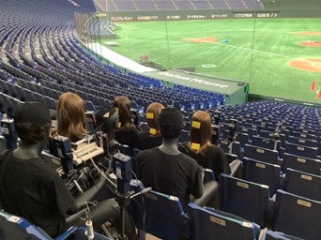
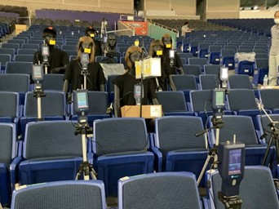
(B)
(A)

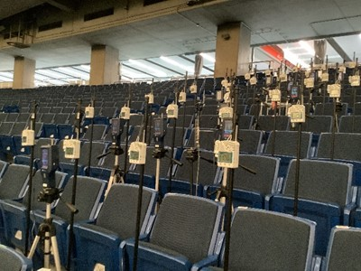
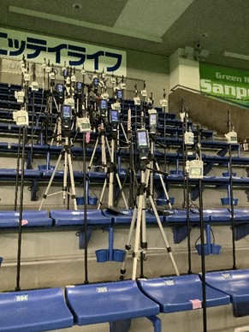
(E)
(C)
)

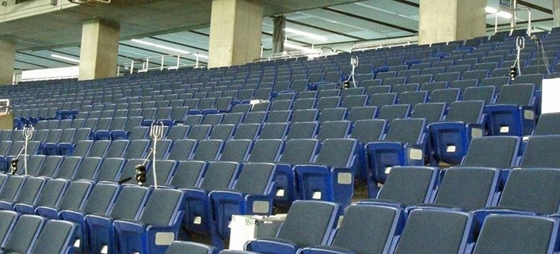
(D)

Fig. S1 Pictures of the measurement. (A), (B) the seating areas behind the back net, (C), (D) the lower stand of the first base side in the field, and (E) outfield (right stand).
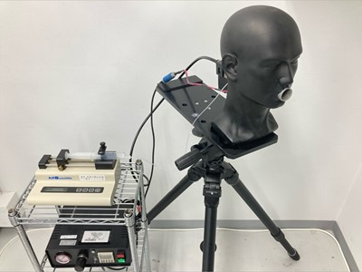
(A) Cough simulator

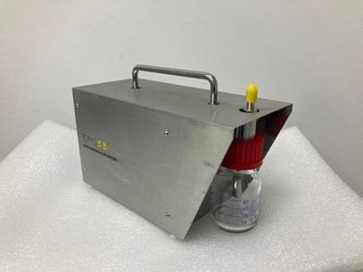
(B) atomizer

Fig. S2 Pictures of (A) Cough simulator and (B) atomizer.

Fig. S3 Schematic drawings of the ultrasonic anemometer and its probe.

Fig.S4 Spread of emitted artificial droplet nuclei (0.3 μm) (difference between the concentration during emission and background concentrations at each location) (average of three measurements of 10-minute average values during emission) and wind direction/velocities.
Fig. S5 Spread of emitted artificial droplet nuclei (0.5 μm) (difference between the concentration during emission and background concentrations at each location) (average of three measurements of 10-minute average values during emission) and wind direction/velocities.

Table S1. Dispersal of droplets from coughing to surrounding emission source and effectiveness of masks (volume of deposited droplet).
(A) Seating area behind the back net (Air conditioning setting before the renovation owing to COVID-19).

Table S1 (Cont.). Dispersal of droplets from coughing to surrounding emission source and effectiveness of masks (volume of deposited droplet).
(B) Upper stand seats on the first base side infield (Ventilation and air conditioning setting before the renovation owing to COVID-19)

Table S1 (Cont.). Dispersal of droplets from coughing to surrounding emission source and effectiveness of masks (volume of deposited droplet).
(C) Upper stand seats on the first base side infield (Air conditioning setting after the renovation owing to the COVID-19)

Table S2. Dispersal of droplets from coughs to surrounding seats when staggered seating arrangements are used. (Seating area behind the back net)

Table S3. Advection-diffusion of droplet nuclei surrounding emission source. (A) Seating area behind the back net (Ventilation and air conditioning setting before and after the renovation owing to COVID-19).

Table S3 (Cont.). Advection-diffusion of droplet nuclei surrounding emission source. (B) Lower stand seats on the first base side infield (Ventilation and air conditioning setting before and after the renovation owing to COVID-19).

Table S3 (Cont.). Advection-diffusion of droplet nuclei surrounding emission source. (C) Right outfield (Ventilation and air conditioning setting before and after the renovation owing to COVID-19).

Table S3 (Cont.). Advection-diffusion of droplet nuclei surrounding emission source. (D) Upper stand seats on the first base side infield (Ventilation and air conditioning setting before and after the renovation owing to COVID-19).

Table S4. Ratio of the artificial droplet nuclei concentration at each seat against the artificial droplet nuclei in exhaled air (Exposure concentration ratio). (A) Seating area behind the back net (Ventilation and air conditioning setting before and after the renovation owing to COVID-19).

Table S4 (Cont.). Ratio of the artificial droplet nuclei concentration at each seat against the artificial droplet nuclei in exhaled air (Exposure concentration ratio). (B) Lower stand seats on the first base side infield (Ventilation and air conditioning setting before and after the renovation owing to COVID-19).
Table S4 (Cont.). Ratio of the artificial droplet nuclei concentration at each seat against the artificial droplet nuclei in exhaled air (Exposure concentration ratio). (C) Right outfield (Ventilation and air conditioning setting before and after the renovation owing to COVID-19).

Table S4 (Cont.). Ratio of the artificial droplet nuclei concentration at each seat against the artificial droplet nuclei in exhaled air (Exposure concentration ratio). (D) Upper stand seats on the first base side infield (Ventilation and air conditioning setting before and after the renovation owing to COVID-19).

