Inhaled Corticosteroid Increased the Risk of Adrenal Insufficiency in Patients with Chronic Airway Diseases: A Nationwide Population-based Study

Hyewon Lee^{1,2}, Hee-Young Yoon³
¹Department of Health Administration and Management, College of Medical Sciences, Soonchunhyang University, Asan, Republic of Korea
²Department of Software Convergence, Soonchunhyang University Graduate School, Asan, Republic of Korea
³Division of Allergy and Respiratory Diseases, Department of Internal Medicine, Soonchunhyang University Seoul Hospital, Seoul, Republic of Korea

Fig. S1. Covariate balance before and after IPTW treatment
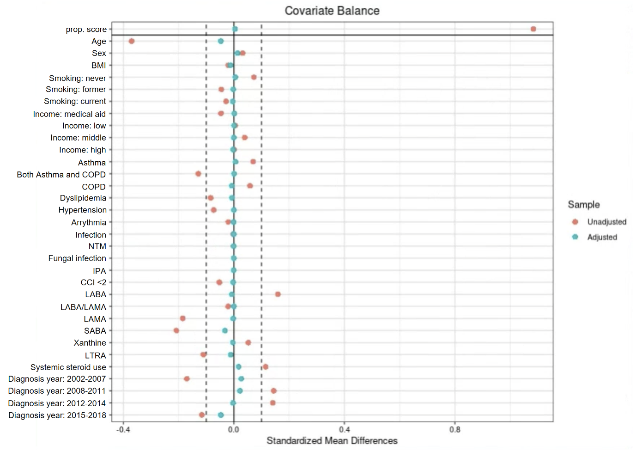
IPTW, inverse probability of treatment weighting; COPD, chronic obstructive pulmonary disease; NTM, non-tuberculous mycobacteria; IPA, invasive pulmonary aspergillosis; CCI, Charlson comorbidity index; ICS, inhaled corticosteroids; BMI, body mass index; LABA, long-acting beta agonist; LAMA, long-acting muscarinic antagonist; SABA, short-acting beta agonist; LTRA, leukotriene receptor antagonist

Table S1. ICD codes for other adrenal gland disorders
Description | KCD Code
Other disorders of adrenal gland | E27
Other adrenocortical overactivity | E27.0
Primary adrenocortical insufficiency | E27.1
Addisonian crisis | E27.2
Drug-induced adrenocortical insufficiency | E27.3
Other and unspecified adrenocortical insufficiency | E27.4
Adrenomedullary hyperfunction | E27.5
Other specified disorders of adrenal gland | E27.8
Disorder of adrenal gland, unspecified | E27.9

Table S2. Prescription details of ICS
Variables | N = 10,301 | Median dose, ug/day | Mean dose, ug/day
ICS ingredient
Fluticasone | 5,770 (56.0) | 250.0 (150.0-409.1) | 369.4 ± 505.6
Beclometasone | 1,371 (13.3) | 170.0 (100.0-302.0) | 299.5 ± 401.0
Budesonide | 5,818 (56.5) | 470.0 (214.8-507.8) | 533.2 ± 635.2
Ciclesonide | 441 (4.3) | 226.7 (160.0-420.0) | 396.5 ± 682.8
Quartiles
Q1 | 2,208 (21.4) | 100.0 (100.0–118.8) | 106.8 ± 25.4
Q2 | 2,737 (26.6) | 185.7 (160.0–207.1) | 188.6 ± 28.3
Q3 | 2,780 (27.0) | 300.0 (250.0–375.0) | 320.2 ± 75.1
Q4 | 2,576 (25.8) | 541.7 (500.0–962.6) | 778.2 ± 830.0
Data are presented as numbers (%), medians (IQR), and mean ± standard deviation.
ICS, inhaled corticosteroid; IQR, interquartile range

