Supplementary information: Fire and water: water quality impacts of landscape-scale disturbance by wildfire. Mark D Shenton, Ross M Thompson and Ben J Kefford.

Table S1. Water physicochemistry, riparian and stream habitat variables hypothesised to change in response to fire based on the literature. Key references are defined below this table.
Response Variable | Direction of change | Reported duration | Key references
Total Nitrogen (mg L⁻¹) | ↑ | Variable. 4 months to 2-3 years.  Or no improvement at 5 years. | [01], [02], [03], [04], [05], [06], [07]
Total Phosphorus (mg L⁻¹) | ↓ or ↑ | TP loads ↓ 50% to 60% for 3 years, then increased [3].  ↑ up to 12 months but effects detectable at 6-7 years have been reported. | [03], [06], [08], [09]
Turbidity (NTU) | ↑ | Increase turbidity above background for 3 to 5 years. | [07], [09], [10], [11], [12]
Electrical conductivity (EC, µS cm⁻¹) | ↓ or ↑ | Variable. 4 months to 3 yrs. | [06], [07], [10], [12], [13], [14]
pH | ↓ or ↑ | Up to 6 months | ↑ [15], [16]; ↓ [06], [07], [10]
Alkalinity (mg CaCO₃ L⁻¹) | ↓ | Typically large change in year 1 and 2. Return to background by year 5. | [09], [17]
Vegetation type (tree > 10m, tree < 10m, shrubs, grasses) | ↓ | Months to years. | [11], [18], [19], [20], [21]
Bank height (m) | ↑ | Reduced bank stability at least 2 years. | [21]
Bank width (m) | ↑ | Reduced bank stability at least 2 years. | [21]
% Native vegetation cover | NA | NA | [22]
% Exotic vegetation cover | ↑ | 12 months. Limited invasives in subalpine grasslands [23] | [22], [23]
Bedrock (%) | NA | NA | NA
Boulder (%) | NA | NA | NA
Cobble (%) | ↓ | At least 2 years | [21]
Pebble (%), Gravel (%), Sand (%), Silt (%), Clay (%) | ↑ | Highly variable. 2 to 7 years. Recovery faster in unregulated rivers. | [21], [24], [25], [26], [27], [28], [29]
Fines (%) | ↑ | At least 2 years. Worst in 1st year post-fire, especially after storm events [29]. | [21], [29], [30], [31]
Detritus % | ↓ | Decrease 3 to 5 years. | [03], [32], [33]
Muck % | ↑ | ↑ 15 months. Up to 4 years reported [36] | [07], [11], [31] [36].
Habitat score | ↓ | Not known | Logical argument. This index of stream condition is described in [34] & [35]

[01] Rhoades et al. (2019);
[02] Lane et al. (2008);
[03] Noske et al. (2010);
[04] Sheridan et al. (2007);
[05] Silins et al. (2014);
[06] Sherson et al. (2015);
[07] Earl and Blinn (2003);
[08] Emelko et al. (2016);
[09] Rhoades et al. (2011);
[10] Dahm et al. (2015);
[11] White et al. (2006);
[12] Reale et al. (2015);
[13] Lyon and O’connor (2008);
[14] Albin (1979);
[15] Cushing Jr and Olson (1963);
[16] Son et al. (2015);
[17] Lydersen et al. (2014);
[18] Minshall et al. (1997);
[19] Spencer et al. (2003);
[20] Jackson and Sullivan (2020);
[21] Oliver et al. (2012);
[22] Alba et al. (2015);
[23] Verrall and Pickering (2019);
[24] Vieira et al. (2004);
[25] Ice et al. (2004);
[26] Cooper et al. (2015);
[27] Bladon et al. (2014);
[28] Moody and Martin (2009);
[29] Lane et al. (2006);
[30] Leonard et al. (2017);
[31] Petticrew et al. (2006);
[32] Jackson et al. (2012);
[33] Cooper et al. (2015);
[34] Ladson et al. (1999);
[35] White and Ladson (1999);
[36] Verkaik et al. (2013)

Table S2. Site information for sampling sites located in Kosciuszko National Park. d/s= downstream, STP = sewage treatment plant.
Site number | Longitude | Latitude | Elevation (m ASL) | Site/Upstream Catchment Use | Waterway Name | Classification
011 | 148°17’37”E | 36°30’48”S | 1380 | Golf course, subalpine woodland | Thredbo River | Site Burnt
012 | 148°18’52”E | 36°29’56”S | 1360 | Ski resorts and township | Thredbo River | Catchment Burnt
013 | 148°19’13”E | 36°29’49”S | 1350 | 100 m d/s of STP, subalpine woodland | Thredbo River | Catchment Burnt
014 | 148°19’21”E | 36°29’48”S | 1340 | 500 m d/s of STP, subalpine woodland | Thredbo River | Catchment Burnt
105 | 148°19’5”E | 36°26’14”S | 1780 | Ski resort | Spencers Creek | Unburnt
106 | 148°20’01”E | 36°26’06”S | 1760 | Ski resort activities | Spencers Creek | Unburnt
107 | 148°20’12”E | 36°26’06”S | 1750 | STP | Spencers Creek | Unburnt
121 | 148°24’33”E | 36°24’45”S | 1735 | subalpine woodland | Rock Creek | Unburnt
122 | 148°24’38”E | 36°24’14”S | 1720 | Ski resorts and activities | Perisher Creek | Unburnt
123 | 148°24’32”E | 36°23’18”S | 1700 | STP | Perisher Creek | Unburnt
124 | 148°24’30”E | 36°22’48”S | 1600 | 700 m d/s STP | Perisher Creek | Site Burnt
128 | 148°25’39”E | 36°23’58”S | 1680 | subalpine woodland | Pipers Creek | Site Burnt
129 | 148°26’11”E | 36°23’40”S | 1640 | Ski resort activities | Pipers Creek | Site Burnt
160 | 148°31’22”E | 36°20’55”S | 1450 | Resort | Sawpit Creek | Catchment Burnt
161 | 148°33’45”E | 36°21’08”S | 1200 | d/s resort, subalpine woodland | Sawpit Creek | Site Burnt
162 | 148°34’08”E | 36°21’23”S | 1180 | Campground and subalpine woodland | Sawpit Creek | Site Burnt

Table S3. Site information for sampling sites located in ACT and surrounds.
Site | Longitude | Latitude | Elevation (m ASL) | Site/Upstream Catchment Use | Waterway Name | Classification
20 | 149° 4'1.23"E | 35°34'40.97"S | 615 | Field/pasture, grazing | Gudgenby River | Site Burnt
53 | 148°56'39.17"E | 35° 7'53.94"S | 395 | Field/pasture, grazing | Murrumbidgee River | Catchment Burnt
58 | 149° 3'35.52"E | 35°24'25.98"S | 540 | Residential | Tuggeranong Creek | Site Burnt
64 | 149° 1'51.47"E | 35°12'43.77"S | 560 | Residential | Ginninderra Creek | Unburnt
189 | 149° 04'41.67"E | 35°18'56.63"S | 550 | Recreation | Yarralumla Creek | Unburnt
195 | 149° 5'10.90"E | 35°12'56.91"S | 570 | Residential | Ginninderra Creek | Unburnt
196 | 149° 4'1.15"E | 35°13'8.48"S | 570 | Residential | Ginninderra Creek | Unburnt
235 | 149°14'5.47"E | 35°20'36.40"S | 570 | Residential | Queanbeyan River | Unburnt
242 | 149°14'25.73"E | 35°20'5.74"S | 565 | Grazing | Molonglo River | Unburnt
246 | 149° 9'59.69"E | 35°20'21.85"S | 570 | Grazing | Jerrabomberra Creek | Unburnt
10 | 148°57'8.41"E | 35°21'46.93"S | 550 | Pine forest | Paddy’s River | Site Burnt
15 | 148°56'44.97"E | 35°24'52.19"S | 645 | Field/pasture, grazing | Tidbinbilla River | Site Burnt
40 | 149° 6'32.20"E | 35°34'59.15"S | 690 | Field/pasture, grazing | Murrumbidgee River | Catchment Burnt
CM1 | 148°50'11.4"E | 35°31’59.2"S | 930 | Native forest | Cotter River | Site Burnt
CM2 | 148°49'40.57"E | 35°26’47.88"S | 775 | Native forest | Cotter River | Site Burnt
CM3 | 148°56'14.85"E | 35°19’39.17"S | 480 | Native forest, recreation | Cotter River | Site Burnt
CT1 | 148°52'12.2"E | 35°32’28.7"S | 1060 | Native forest | Kangaroo Creek | Site Burnt
CT2 | 148°50'15.55"E | 35°26’35.1"S | 680 | Native forest | Cowflat Creek | Site Burnt
CT3 | 148°56'21.17"E | 35°19’55.3"S | 480 | Native forest, pine forest | Paddy’s River | Site Burnt
GM1 | 148°42'57"E | 35°27’20"S | 680 | Native forest, grazing | Goodradigbee River | Site Burnt
GM2 | 148°43'42.2"E | 35°25’41.4"S | 650 | Grazing | Goodradigbee River | Site Burnt
GM3 | 148°44'43"E | 35°23’05"S | 620 | Grazing | Goodradigbee River | Catchment Burnt
GT1 | 148°42'53.7"E | 35°27’18.4"S | 700 | Native forest | Cooleman Creek | Site Burnt
GT2 | 148°43'34.2"E | 35°25’36.7"S | 670 | Native forest | Bullflat Creek | Site Burnt
GT3 | 148°44'21.3"E | 35°25’14.9"S | 650 | Native forest | Bramina Creek | Unburnt
QM1 | 149°18'10.47"E | 35°31’46.06"S | 750 | Reserve | Queanbeyan River | Unburnt
QM2 | 149°15'27.69"E | 35°24’54.07"S | 610 | Reserve | Queanbeyan River | Unburnt
QM3 | 149°15'17.81"E | 35°23’29.88"S | 600 | Field/pasture, residential | Queanbeyan River | Unburnt

Table S4. Variables that were transformed and/or standardised to account for site and/or seasonal differences.
Variable | How measured | Accuracy | Standardisation used at alpine sites | Standardisation used at montane sites
TN (mg/L) | Laboratory analysis (Standard Methods for the Examination of Water and Wastewater) | ± 0.003 mg/L at ≥ 0.01 mg/L. | Site AND season | Not analysed
TP (mg/L) | Laboratory analysis (Standard Methods for the Examination of Water and Wastewater) | ± 0.01 mg/L at ≥ 0.01 mg/L. | Site AND season | Not analysed
DO (mg/L) | Field measurement (multiprobe) | ± 0.2 mg/L @ <= 20 mg/L or  ± 0.6 mg/L @ > 20 mg/L | Site AND season | Site only
DO saturation (%) | Field measurement (multiprobe) | As above. | Site AND season | Site only
Conductivity (µS/cm @ 25°C) | Field measurement (multiprobe) | ± 1% of reading | Site AND season | Site only
pH | Field measurement (multiprobe) | ± 0.2 units | Site AND season | Site only
Turbidity (NTU) | Field measurement (multiprobe) | ± 5 NTU in the 1 to 100 NTU range. | Site AND season | Site only
Alkalinity (mg as CaCO₃/L) | Field titration to end point pH 4.5 | NA | Not measured | Site only
Reach bedrock (%) | Visual estimate | NA | Site only | Not analysed
Reach boulder (%) | Visual estimate | NA | Site only | Not analysed
Reach cobble (%) | Visual estimate | NA | Site only | Not analysed
Reach gravel (%) | Visual estimate | NA | Site only | Not analysed
Reach sand (%) | Visual estimate | NA | Site only | Not analysed
Reach silt (%) | Visual estimate | NA | Site only | Not analysed
Reach clay (%) | Visual estimate | NA | Site only | Not analysed
Reach fines (%) | Visual estimate | NA | Site only | Not analysed
Reach mud/muck (%) | Visual estimate | NA | Site only | Not analysed
Reach detritus (%) | Visual estimate | NA | Site only | Not analysed
Riffle bedrock (%) | Visual estimate | NA | Site only | Not analysed
Riffle boulder (%) | Visual estimate | NA | Site only | Not analysed
Riffle cobble (%) | Visual estimate | NA | Site only | Not analysed
Riffle gravel (%) | Visual estimate | NA | Site only | Not analysed
Riffle sand (%) | Visual estimate | NA | Site only | Not analysed
Riffle silt (%) | Visual estimate | NA | Site only | Not analysed
Riffle clay (%) | Visual estimate | NA | Site only | Not analysed
Riffle fines (%) | Visual estimate | NA | Site only | Not analysed
Riffle mud/muck (%) | Visual estimate | NA | Site only | Not analysed
Riffle detritus (%) | Visual estimate | NA | Site only | Not analysed
Riparian grass cover (%) | Visual estimate | NA | Site only | Site only
Riparian shrub/vine cover (%) | Visual estimate | NA | Site only | Site only
Riparian trees < 10 m (%) | Visual estimate | NA | Site only | Site only
Riparian trees > 10 m (%) | Visual estimate | NA | Site only | Site only
Native vegetation cover (%) | Visual estimate | NA | Site only | Site only
Exotic vegetation cover (%) | Visual estimate | NA | Site only | Site only
Total habitat score (out of 135) | Visual estimate | NA | Site only | Not analysed

Table S5. Results of statistical testing for an interaction between site type and time since fire for response variables at alpine sites. Rows where p-values are significant (α=0.05) are highlighted in bold text. ↑ = upward trend, ↓ = downward trend, NA = no clear trend.
Response variable | Trend | Site type | Post-fire period | df | t-value | p-value
Total nitrogen (TN) | ↑ | Catchment burnt | 1 month | 541 | 0.979102 | 0.328
Total nitrogen (TN) | ↑ | Catchment burnt | 1 to 4 months | 565 | 1.195576 | 0.2324
Total nitrogen (TN) | ↑ | Catchment burnt | 1 to 6 months | 573 | 1.281301 | 0.2006
Total nitrogen (TN) | ↑ | Catchment burnt | 1 to 9 months | 593 | 1.719247 | 0.0861
Total nitrogen (TN) | ↑ | Catchment burnt | 1 to 12 months | 617 | 1.700141 | 0.0896
Total nitrogen (TN) | ↑ | Site burnt | 1-12 months | 617 | 2.835564 | 0.0047
Total nitrogen (TN) | ↑ | Site burnt | 6-18 months | 605 | 2.678579 | 0.0076
Total nitrogen (TN) | ↑ | Site burnt | 13 to 24 months | 604 | 0.982308 | 0.3263
Total phosphorus (TP) | ↓ | Catchment burnt | 1 month | 541 | -2.25417 | 0.0246
Total phosphorus (TP) | ↓ | Catchment burnt | 1 to 4 months | 565 | -1.06381 | 0.2879
Total phosphorus (TP) | ↓ | Catchment burnt | 1 to 6 months | 573 | -0.79183 | 0.4288
Total phosphorus (TP) | ↓ | Catchment burnt | 1 to 9 months | 593 | -0.56327 | 0.5735
Total phosphorus (TP) | ↓ | Catchment burnt | 1 to 12 months | 617 | -1.55902 | 0.1195
Total phosphorus (TP) | NA | Site burnt | 1 month | 541 | 0.048707 | 0.9612
Total phosphorus (TP) | NA | Site burnt | 1 to 4 months | 565 | 0.036269 | 0.9711
Total phosphorus (TP) | NA | Site burnt | 1 to 6 months | 573 | 0.039031 | 0.9689
Total phosphorus (TP) | NA | Site burnt | 1 to 9 months | 593 | 0.056058 | 0.9553
Total phosphorus (TP) | NA | Site burnt | 1 to 12 months | 617 | 0.044855 | 0.9642
Conductivity (EC) | ↑ | Catchment burnt | 1 month | 541 | 2.431206 | 0.0154
Conductivity (EC) | ↑ | Catchment burnt | 1 to 4 months | 565 | 1.526565 | 0.1274
Conductivity (EC) | ↑ | Catchment burnt | 1 to 6 months | 573 | 0.645779 | 0.5187
Conductivity (EC) | ↑ | Catchment burnt | 1 to 9 months | 593 | 0.533216 | 0.5941
Conductivity (EC) | ↑ | Catchment burnt | 1 to 12 months | 617 | 0.493615 | 0.6218
Conductivity (EC) | ↑ | Site burnt | 1-12 months | 617 | 3.324992 | 0.0009
Conductivity (EC) | ↑ | Site burnt | 13 to 24 months | 604 | 3.195411 | 0.0015
Conductivity (EC) | ↑ | Site burnt | 19 to 30 months | 615 | 2.334007 | 0.0199
Conductivity (EC) | ↑ | Site burnt | 25 to 36 months | 615 | 0.943686 | 0.3457
pH | ↓ | Catchment burnt | 1 month | 541 | -1.02539 | 0.3056
pH | ↓ | Catchment burnt | 1 to 4 months | 565 | -1.52287 | 0.1283
pH | ↓ | Catchment burnt | 1 to 6 months | 573 | -2.03652 | 0.0422
pH | ↓ | Catchment burnt | 1 to 9 months | 593 | -2.21241 | 0.0273
pH | ↓ | Catchment burnt | 1 to 12 months | 617 | -2.03975 | 0.0418
pH | ↓ | Catchment burnt | 6 to 18 months | 605 | -0.82154 | 0.4117
pH | NA | Site burnt | 1 month | 541 | -0.57733 | 0.564
pH | NA | Site burnt | 1 to 4 months | 565 | -1.32181 | 0.1868
pH | NA | Site burnt | 1 to 6 months | 573 | -1.33723 | 0.1817
pH | NA | Site burnt | 1 to 9 months | 593 | -1.43165 | 0.1528
pH | NA | Site burnt | 1 to 12 months | 617 | -0.92414 | 0.3558
Turbidity | NA | Catchment burnt | 1 month | 541 | 0.030852 | 0.9754
Turbidity | NA | Catchment burnt | 1 to 4 months | 565 | 0.711101 | 0.4773
Turbidity | NA | Catchment burnt | 1 to 6 months | 573 | 1.084131 | 0.2788
Turbidity | NA | Catchment burnt | 1 to 9 months | 593 | 1.290408 | 0.1974
Turbidity | NA | Catchment burnt | 1 to 12 months | 617 | 1.281094 | 0.2006
Turbidity | NA | Site burnt | 1 month | 541 | -0.26869 | 0.7883
Turbidity | NA | Site burnt | 1 to 4 months | 565 | 0.114065 | 0.9092
Turbidity | NA | Site burnt | 1 to 6 months | 573 | 0.259807 | 0.7951
Turbidity | NA | Site burnt | 1 to 9 months | 593 | 0.281007 | 0.7788
Turbidity | NA | Site burnt | 1 to 12 months | 617 | 0.252391 | 0.8008
Bank height (m) | NA | Catchment burnt | 1 month | 541 | -0.03033 | 0.9758
Bank height (m) | NA | Catchment burnt | 1 to 4 months | 565 | -0.10625 | 0.9154
Bank height (m) | NA | Catchment burnt | 1 to 6 months | 573 | -0.14401 | 0.8855
Bank height (m) | NA | Catchment burnt | 1 to 9 months | 593 | -0.2251 | 0.822
Bank height (m) | NA | Catchment burnt | 1 to 12 months | 617 | -0.26993 | 0.7873
Bank height (m) | NA | Site burnt | 1 month | 541 | -0.07241 | 0.9423
Bank height (m) | NA | Site burnt | 1 to 4 months | 565 | -0.14833 | 0.8821
Bank height (m) | NA | Site burnt | 1 to 6 months | 573 | -0.14949 | 0.8812
Bank height (m) | NA | Site burnt | 1 to 9 months | 593 | -0.22154 | 0.8247
Bank height (m) | NA | Site burnt | 1 to 12 months | 617 | -0.26066 | 0.7944
Bank width (m) | ↑ | Catchment burnt | 1 month | 541 | 0.694803 | 0.4875
Bank width (m) | ↑ | Catchment burnt | 1 to 4 months | 565 | 1.093751 | 0.2745
Bank width (m) | ↑ | Catchment burnt | 1 to 6 months | 573 | 1.309436 | 0.1909
Bank width (m) | ↑ | Catchment burnt | 1 to 9 months | 593 | 1.575321 | 0.1157
Bank width (m) | ↑ | Catchment burnt | 1 to 12 months | 617 | 1.840778 | 0.0661
Bank width (m) | NA | Site burnt | 1 month | 541 | 0.262446 | 0.7931
Bank width (m) | NA | Site burnt | 1 to 4 months | 565 | -0.26307 | 0.7926
Bank width (m) | NA | Site burnt | 1 to 6 months | 573 | -0.41821 | 0.6759
Bank width (m) | NA | Site burnt | 1 to 9 months | 593 | -0.54091 | 0.5888
Bank width (m) | NA | Site burnt | 1 to 12 months | 617 | -0.7454 | 0.4563
% native vegetation cover | NA | Catchment burnt | 1 month | 541 | -1.02108 | 0.3077
% native vegetation cover | NA | Catchment burnt | 1 to 4 months | 565 | -1.41556 | 0.1575
% native vegetation cover | NA | Catchment burnt | 1 to 6 months | 573 | -1.34861 | 0.178
% native vegetation cover | NA | Catchment burnt | 1 to 9 months | 593 | -1.46452 | 0.1436
% native vegetation cover | NA | Catchment burnt | 1 to 12 months | 617 | -1.81143 | 0.0706
% native vegetation cover | ↑ | Site burnt | 1 month | 541 | 0.890526 | 0.3736
% native vegetation cover | ↑ | Site burnt | 1 to 4 months | 565 | 0.975397 | 0.3298
% native vegetation cover | ↑ | Site burnt | 1 to 6 months | 573 | 1.01873 | 0.3088
% native vegetation cover | ↑ | Site burnt | 1 to 9 months | 593 | 1.167561 | 0.2435
% native vegetation cover | ↑ | Site burnt | 1 to 12 months | 617 | 1.165467 | 0.2443
% exotic vegetation cover | NA | Catchment burnt | 1 month | 541 | 1.10914 | 0.2679
% exotic vegetation cover | NA | Catchment burnt | 1 to 4 months | 565 | 1.480994 | 0.1392
% exotic vegetation cover | NA | Catchment burnt | 1 to 6 months | 573 | 1.377325 | 0.1689
% exotic vegetation cover | NA | Catchment burnt | 1 to 9 months | 593 | 1.551984 | 0.1212
% exotic vegetation cover | NA | Catchment burnt | 1 to 12 months | 617 | 1.935022 | 0.0534
% exotic vegetation cover | ↓ | Site burnt | 1 month | 541 | -1.0376 | 0.2999
% exotic vegetation cover | ↓ | Site burnt | 1 to 4 months | 565 | -1.15288 | 0.2494
% exotic vegetation cover | ↓ | Site burnt | 1 to 6 months | 573 | -1.20766 | 0.2277
% exotic vegetation cover | ↓ | Site burnt | 1 to 9 months | 593 | -1.33596 | 0.1821
% exotic vegetation cover | ↓ | Site burnt | 1 to 12 months | 617 | -1.33844 | 0.1812
% trees in riparian zone > 10 m | NA | Catchment burnt | 1 month | 541 | -0.08707 | 0.9306
% trees in riparian zone > 10 m | NA | Catchment burnt | 1 to 4 months | 565 | 0.12518 | 0.9004
% trees in riparian zone > 10 m | NA | Catchment burnt | 1 to 6 months | 573 | 0.250156 | 0.8026
% trees in riparian zone > 10 m | NA | Catchment burnt | 1 to 9 months | 593 | 0.283042 | 0.7772
% trees in riparian zone > 10 m | NA | Catchment burnt | 1 to 12 months | 617 | 0.333379 | 0.739
% trees in riparian zone > 10 m | NA | Site burnt | 1 month | 541 | 0.504451 | 0.6141
% trees in riparian zone > 10 m | NA | Site burnt | 1 to 4 months | 565 | 0.94017 | 0.3475
% trees in riparian zone > 10 m | NA | Site burnt | 1 to 6 months | 573 | 1.126635 | 0.2604
% trees in riparian zone > 10 m | NA | Site burnt | 1 to 9 months | 593 | 1.285859 | 0.199
% trees in riparian zone > 10 m | NA | Site burnt | 1 to 12 months | 617 | 1.518988 | 0.1293
% trees in riparian zone < 10 m | NA | Catchment burnt | 1 month | 541 | -1.00837 | 0.3137
% trees in riparian zone < 10 m | NA | Catchment burnt | 1 to 4 months | 565 | -0.79992 | 0.4241
% trees in riparian zone < 10 m | NA | Catchment burnt | 1 to 6 months | 573 | -0.50926 | 0.6108
% trees in riparian zone < 10 m | NA | Catchment burnt | 1 to 9 months | 593 | -0.64219 | 0.521
% trees in riparian zone < 10 m | NA | Catchment burnt | 1 to 12 months | 617 | -0.8209 | 0.412
% trees in riparian zone < 10 m | NA | Site burnt | 1 month | 541 | 0.413997 | 0.679
% trees in riparian zone < 10 m | NA | Site burnt | 1 to 4 months | 565 | 0.470009 | 0.6385
% trees in riparian zone < 10 m | NA | Site burnt | 1 to 6 months | 573 | 0.385202 | 0.7002
% trees in riparian zone < 10 m | NA | Site burnt | 1 to 9 months | 593 | 0.462029 | 0.6442
% trees in riparian zone < 10 m | NA | Site burnt | 1 to 12 months | 617 | 0.571623 | 0.5678
% riparian shrub and vine cover | ↓ | Catchment burnt | 1 month | 541 | -0.63397 | 0.5264
% riparian shrub and vine cover | ↓ | Catchment burnt | 1 to 4 months | 565 | -1.23306 | 0.2181
% riparian shrub and vine cover | ↓ | Catchment burnt | 1 to 6 months | 573 | -1.51055 | 0.1315
% riparian shrub and vine cover | ↓ | Catchment burnt | 1 to 9 months | 593 | -1.27806 | 0.2017
% riparian shrub and vine cover | ↓ | Catchment burnt | 1 to 12 months | 617 | -1.51968 | 0.1291
% riparian shrub and vine cover | ↓ | Site burnt | 1-12 months | 617 | -10.0653 | 0
% riparian shrub and vine cover | ↓ | Site burnt | 13 to 24 months | 604 | -9.27732 | 0
% riparian shrub and vine cover | ↓ | Site burnt | 25 to 36 months | 615 | -10.5253 | 0
% riparian shrub and vine cover | ↓ | Site burnt | 37 to 48 months | 601 | -8.837 | 0
% riparian shrub and vine cover | ↓ | Site burnt | 49 to 60 months | 598 | -6.82456 | 0
% riparian shrub and vine cover | ↓ | Site burnt | 61 to 72 months | 594 | -5.45894 | 0
% riparian shrub and vine cover | ↓ | Site burnt | 73 to 84 months | 582 | -2.95515 | 0.0033
% riparian shrub and vine cover | ↓ | Site burnt | 85 to 96 months | 559 | -4.27365 | 0
% riparian grass cover | ↑ | Catchment burnt | 1-12 months | 617 | 5.675344 | 0
% riparian grass cover | ↑ | Catchment burnt | 13 to 24 months | 604 | 6.077992 | 0
% riparian grass cover | ↑ | Catchment burnt | 25 to 36 months | 615 | 5.797647 | 0
% riparian grass cover | ↑ | Catchment burnt | 37 to 48 months | 601 | 3.13971 | 0.0018
% riparian grass cover | ↑ | Catchment burnt | 49 to 60 months | 598 | 0.910705 | 0.3628
% riparian grass cover | ↓ | Site burnt | 1-12 months | 617 | -2.8424 | 0.0046
% riparian grass cover | ↑ | Site burnt | 13 to 24 months | 604 | 5.854334 | 0
% riparian grass cover | ↑ | Site burnt | 25 to 36 months | 615 | 5.067191 | 0
% riparian grass cover | ↑ | Site burnt | 37 to 48 months | 601 | 3.931026 | 0.0001
% riparian grass cover | ↑ | Site burnt | 49 to 60 months | 598 | 2.214365 | 0.0272
% riparian grass cover | ↑ | Site burnt | 61to 72 months | 594 | 1.692059 | 0.0912
% bedrock in the reach | ↑ | Catchment burnt | 1-12 months | 617 | 4.185164 | 0
% bedrock in the reach | ↑ | Catchment burnt | 13 to 24 months | 604 | 4.788047 | 0
% bedrock in the reach | ↑ | Catchment burnt | 25 to 36 months | 615 | 5.261625 | 0
% bedrock in the reach | ↑ | Catchment burnt | 37 to 48 months | 601 | 7.253173 | 0
% bedrock in the reach | ↑ | Catchment burnt | 49 to 60 months | 598 | 4.065178 | 0.0001
% bedrock in the reach | ↓ | Catchment burnt | 61 to 72 months | 594 | -1.55974 | 0.1194
% bedrock in the reach | NA | Site burnt | 1 month | 541 | 0.579509 | 0.5625
% bedrock in the reach | NA | Site burnt | 1 to 4 months | 565 | 0.724243 | 0.4692
% bedrock in the reach | NA | Site burnt | 1 to 6 months | 573 | 0.654701 | 0.5129
% bedrock in the reach | NA | Site burnt | 1 to 9 months | 593 | 0.782841 | 0.434
% bedrock in the reach | NA | Site burnt | 1 to 12 months | 617 | 0.892046 | 0.3727
% boulder in the reach | NA | Catchment burnt | 1 month | 541 | 0.568889 | 0.5697
% boulder in the reach | NA | Catchment burnt | 1 to 4 months | 565 | 0.569839 | 0.569
% boulder in the reach | NA | Catchment burnt | 1 to 6 months | 573 | 0.501315 | 0.6163
% boulder in the reach | NA | Catchment burnt | 1 to 9 months | 593 | 0.980511 | 0.3272
% boulder in the reach | NA | Catchment burnt | 1 to 12 months | 617 | 0.890019 | 0.3738
% boulder in the reach | NA | Site burnt | 1 month | 541 | 0.841611 | 0.4004
% boulder in the reach | NA | Site burnt | 1 to 4 months | 565 | 0.779281 | 0.4361
% boulder in the reach | NA | Site burnt | 1 to 6 months | 573 | 0.677385 | 0.4984
% boulder in the reach | NA | Site burnt | 1 to 9 months | 593 | 1.145592 | 0.2524
% boulder in the reach | NA | Site burnt | 1 to 12 months | 617 | 1.175732 | 0.2402
% cobble in the reach | ↓ | Catchment burnt | 1-12 months | 617 | -2.53918 | 0.0114
% cobble in the reach | ↓ | Catchment burnt | 6-18 months | 609 | -2.44323 | 0.0148
% cobble in the reach | ↓ | Catchment burnt | 13-24 months | 604 | -1.83756 | 0.0666
% cobble in the reach | NA | Site burnt | 1 month | 541 | -1.08511 | 0.2784
% cobble in the reach | NA | Site burnt | 1 to 4 months | 565 | -1.34132 | 0.1804
% cobble in the reach | NA | Site burnt | 1 to 6 months | 573 | -1.26347 | 0.2069
% cobble in the reach | NA | Site burnt | 1 to 9 months | 593 | -1.53598 | 0.1251
% cobble in the reach | NA | Site burnt | 1 to 12 months | 617 | -1.72553 | 0.0849
% pebble in reach | ↑ | Catchment burnt | 1 month | 541 | -0.01562 | 0.9875
% pebble in reach | ↑ | Catchment burnt | 1 to 4 months | 565 | -0.72589 | 0.4682
% pebble in reach | ↑ | Catchment burnt | 1 to 6 months | 573 | -0.10182 | 0.9189
% pebble in reach | ↑ | Catchment burnt | 1 to 9 months | 593 | 0.374011 | 0.7085
% pebble in reach | ↑ | Catchment burnt | 1 to 12 months | 617 | 0.310077 | 0.7566
% pebble in reach | NA | Site burnt | 1 month | 541 | 0.588169 | 0.5567
% pebble in reach | NA | Site burnt | 1 to 4 months | 565 | 0.07661 | 0.939
% pebble in reach | NA | Site burnt | 1 to 6 months | 573 | 0.186686 | 0.852
% pebble in reach | NA | Site burnt | 1 to 9 months | 593 | -0.06914 | 0.9449
% pebble in reach | NA | Site burnt | 1 to 12 months | 617 | -1.12734 | 0.26
% gravel in reach | NA | Catchment burnt | 1 month | 541 | 0.583102 | 0.5601
% gravel in reach | NA | Catchment burnt | 1 to 4 months | 565 | 0.670631 | 0.5027
% gravel in reach | NA | Catchment burnt | 1 to 6 months | 573 | 0.711852 | 0.4768
% gravel in reach | NA | Catchment burnt | 1 to 9 months | 593 | 0.965362 | 0.3348
% gravel in reach | NA | Catchment burnt | 1 to 12 months | 617 | 0.835153 | 0.404
% gravel in reach | NA | Site burnt | 1 month | 541 | 0.177947 | 0.8588
% gravel in reach | NA | Site burnt | 1 to 4 months | 565 | 0.673147 | 0.5011
% gravel in reach | NA | Site burnt | 1 to 6 months | 573 | 0.695198 | 0.4872
% gravel in reach | NA | Site burnt | 1 to 9 months | 593 | 1.310945 | 0.1904
% gravel in reach | NA | Site burnt | 1 to 12 months | 617 | 1.756824 | 0.0794
% sand in reach | NA | Catchment burnt | 1 month | 541 | 0.019876 | 0.9841
% sand in reach | NA | Catchment burnt | 1 to 4 months | 565 | 0.572267 | 0.5674
% sand in reach | NA | Catchment burnt | 1 to 6 months | 573 | 0.190753 | 0.8488
% sand in reach | NA | Catchment burnt | 1 to 9 months | 593 | -0.51772 | 0.6048
% sand in reach | NA | Catchment burnt | 1 to 12 months | 617 | -1.00078 | 0.3173
% sand in reach | NA | Site burnt | 1 month | 541 | 0.034694 | 0.9723
% sand in reach | NA | Site burnt | 1 to 4 months | 565 | 0.10364 | 0.9175
% sand in reach | NA | Site burnt | 1 to 6 months | 573 | 0.089859 | 0.9284
% sand in reach | NA | Site burnt | 1 to 9 months | 593 | -0.23727 | 0.8125
% sand in reach | NA | Site burnt | 1 to 12 months | 617 | -0.46317 | 0.6434
% silt in reach | NA | Catchment burnt | 1 month | 541 | 0.213197 | 0.8313
% silt in reach | NA | Catchment burnt | 1 to 4 months | 565 | 0.52843 | 0.5974
% silt in reach | NA | Catchment burnt | 1 to 6 months | 573 | 0.649971 | 0.516
% silt in reach | NA | Catchment burnt | 1 to 9 months | 593 | 0.074448 | 0.9407
% silt in reach | NA | Catchment burnt | 1 to 12 months | 617 | -0.44989 | 0.653
% silt in reach | NA | Site burnt | 1 month | 541 | 0.461184 | 0.6449
% silt in reach | NA | Site burnt | 1 to 4 months | 565 | 1.408006 | 0.1597
% silt in reach | NA | Site burnt | 1 to 6 months | 573 | 1.154 | 0.249
% silt in reach | NA | Site burnt | 1 to 9 months | 593 | 0.802048 | 0.4228
% silt in reach | NA | Site burnt | 1 to 12 months | 617 | 0.78882 | 0.4305
% fines in reach | NA | Catchment burnt | 1 month | 541 | 0.052988 | 0.9578
% fines in reach | NA | Catchment burnt | 1 to 4 months | 565 | 0.63986 | 0.5225
% fines in reach | NA | Catchment burnt | 1 to 6 months | 573 | 0.289386 | 0.7724
% fines in reach | NA | Catchment burnt | 1 to 9 months | 593 | -0.52139 | 0.6023
% fines in reach | NA | Catchment burnt | 1 to 12 months | 617 | -1.10849 | 0.2681
% fines in reach | NA | Site burnt | 1 month | 541 | 0.139286 | 0.8893
% fines in reach | NA | Site burnt | 1 to 4 months | 565 | 0.426076 | 0.6702
% fines in reach | NA | Site burnt | 1 to 6 months | 573 | 0.368011 | 0.713
% fines in reach | NA | Site burnt | 1 to 9 months | 593 | -0.01581 | 0.9874
% fines in reach | NA | Site burnt | 1 to 12 months | 617 | -0.23182 | 0.8168
% detritus in reach | ↑ | Catchment burnt | 1 month | 541 | 0.67162 | 0.5021
% detritus in reach | ↑ | Catchment burnt | 1 to 4 months | 565 | 2.669899 | 0.0078
% detritus in reach | ↑ | Catchment burnt | 1 to 6 months | 573 | 2.547486 | 0.0111
% detritus in reach | ↑ | Catchment burnt | 1 to 9 months | 593 | 1.486367 | 0.1377
% detritus in reach | ↑ | Catchment burnt | 1 to 12 months | 617 | 0.735932 | 0.4621
% detritus in reach | ↑ | Site burnt | 1 month | 541 | 1.484183 | 0.1383
% detritus in reach | ↑ | Site burnt | 1 to 4 months | 565 | 2.373751 | 0.0179
% detritus in reach | ↑ | Site burnt | 1 to 6 months | 573 | 2.517895 | 0.0121
% detritus in reach | ↑ | Site burnt | 1 to 9 months | 593 | 1.814349 | 0.0701
% detritus in reach | ↑ | Site burnt | 1 to 12 months | 617 | 1.583836 | 0.1137
% muck and mud in the reach | ↑ | Catchment burnt | 1-12 months | 617 | 4.090211 | 0
% muck and mud in the reach | ↑ | Catchment burnt | 13 to 24 months | 604 | 2.394237 | 0.017
% muck and mud in the reach | ↑ | Catchment burnt | 25 to 36 months | 615 | 2.640948 | 0.0085
% muck and mud in the reach | ↑ | Catchment burnt | 37 to 48 months | 601 | 3.025618 | 0.0026
% muck and mud in the reach | ↑ | Catchment burnt | 49 to 60 months | 598 | 1.411963 | 0.1585
% muck and mud in the reach | ↑ | Site burnt | 1-12 months | 617 | 2.835041 | 0.0047
% muck and mud in the reach | ↑ | Site burnt | 13 to 24 months | 604 | 3.29172 | 0.0011
% muck and mud in the reach | ↑ | Site burnt | 25 to 36 months | 615 | 2.380572 | 0.0176
% muck and mud in the reach | ↑ | Site burnt | 37 to 48 months | 601 | 2.794272 | 0.0054
% muck and mud in the reach | ↑ | Site burnt | 49 to 60 months | 598 | 1.795936 | 0.073
% bedrock in riffle | NA | Catchment burnt | 1 month | 541 | 0.028538 | 0.9772
% bedrock in riffle | NA | Catchment burnt | 1 to 4 months | 565 | 0.241577 | 0.8092
% bedrock in riffle | NA | Catchment burnt | 1 to 6 months | 573 | 0.344433 | 0.7306
% bedrock in riffle | NA | Catchment burnt | 1 to 9 months | 593 | 0.433992 | 0.6645
% bedrock in riffle | NA | Catchment burnt | 1 to 12 months | 617 | 0.496177 | 0.6199
% bedrock in riffle | NA | Site burnt | 1 month | 541 | -0.34968 | 0.7267
% bedrock in riffle | NA | Site burnt | 1 to 4 months | 565 | -0.47789 | 0.6329
% bedrock in riffle | NA | Site burnt | 1 to 6 months | 573 | -0.46586 | 0.6415
% bedrock in riffle | NA | Site burnt | 1 to 9 months | 593 | -0.48953 | 0.6246
% bedrock in riffle | NA | Site burnt | 1 to 12 months | 617 | -0.59403 | 0.5527
% boulder in riffle | NA | Catchment burnt | 1 month | 541 | 0.180325 | 0.857
% boulder in riffle | NA | Catchment burnt | 1 to 4 months | 565 | 0.229265 | 0.8187
% boulder in riffle | NA | Catchment burnt | 1 to 6 months | 573 | 0.26629 | 0.7901
% boulder in riffle | NA | Catchment burnt | 1 to 9 months | 593 | 0.215782 | 0.8292
% boulder in riffle | NA | Catchment burnt | 1 to 12 months | 617 | 0.974933 | 0.33
% boulder in riffle | NA | Site burnt | 1 month | 541 | 0.080722 | 0.9357
% boulder in riffle | NA | Site burnt | 1 to 4 months | 565 | 0.458046 | 0.6471
% boulder in riffle | NA | Site burnt | 1 to 6 months | 573 | 0.736942 | 0.4615
% boulder in riffle | NA | Site burnt | 1 to 9 months | 593 | 0.704353 | 0.4815
% boulder in riffle | NA | Site burnt | 1 to 12 months | 617 | 0.822705 | 0.411
% cobble in riffle | NA | Catchment burnt | 1 month | 541 | -0.31214 | 0.7551
% cobble in riffle | NA | Catchment burnt | 1 to 4 months | 565 | -0.40481 | 0.6858
% cobble in riffle | NA | Catchment burnt | 1 to 6 months | 573 | -0.49848 | 0.6183
% cobble in riffle | NA | Catchment burnt | 1 to 9 months | 593 | -0.60594 | 0.5448
% cobble in riffle | NA | Catchment burnt | 1 to 12 months | 617 | -1.14929 | 0.2509
% cobble in riffle | NA | Site burnt | 1 month | 541 | -0.82157 | 0.4117
% cobble in riffle | NA | Site burnt | 1 to 4 months | 565 | -1.36169 | 0.1738
% cobble in riffle | NA | Site burnt | 1 to 6 months | 573 | -1.52911 | 0.1268
% cobble in riffle | NA | Site burnt | 1 to 9 months | 593 | -1.44747 | 0.1483
% cobble in riffle | NA | Site burnt | 1 to 12 months | 617 | -1.95547 | 0.051
% pebble in riffle | ↑ | Catchment burnt | 1 month | 541 | -0.49311 | 0.6221
% pebble in riffle | ↑ | Catchment burnt | 1 to 4 months | 565 | -0.42765 | 0.6691
% pebble in riffle | ↑ | Catchment burnt | 1 to 6 months | 573 | -0.20725 | 0.8359
% pebble in riffle | ↑ | Catchment burnt | 1 to 9 months | 593 | 0.551505 | 0.5815
% pebble in riffle | ↑ | Catchment burnt | 1 to 12 months | 617 | 0.556089 | 0.5784
% pebble in riffle | NA | Site burnt | 1 month | 541 | -0.67261 | 0.5015
% pebble in riffle | NA | Site burnt | 1 to 4 months | 565 | -1.04014 | 0.2987
% pebble in riffle | NA | Site burnt | 1 to 6 months | 573 | -1.11664 | 0.2646
% pebble in riffle | NA | Site burnt | 1 to 9 months | 593 | -0.71462 | 0.4751
% pebble in riffle | NA | Site burnt | 1 to 12 months | 617 | -0.86536 | 0.3872
% gravel in riffle | NA | Catchment burnt | 1 month | 541 | -0.14266 | 0.8866
% gravel in riffle | NA | Catchment burnt | 1 to 4 months | 565 | -0.44853 | 0.6539
% gravel in riffle | NA | Catchment burnt | 1 to 6 months | 573 | -0.49279 | 0.6224
% gravel in riffle | NA | Catchment burnt | 1 to 9 months | 593 | -0.60964 | 0.5423
% gravel in riffle | NA | Catchment burnt | 1 to 12 months | 617 | -0.90666 | 0.3649
% gravel in riffle | NA | Site burnt | 1 month | 541 | 0.784824 | 0.4329
% gravel in riffle | NA | Site burnt | 1 to 4 months | 565 | 0.993762 | 0.3208
% gravel in riffle | NA | Site burnt | 1 to 6 months | 573 | 0.906177 | 0.3652
% gravel in riffle | NA | Site burnt | 1 to 9 months | 593 | 0.806803 | 0.4201
% gravel in riffle | NA | Site burnt | 1 to 12 months | 617 | 0.88133 | 0.3785
% sand in riffle | NA | Catchment burnt | 1 month | 541 | 0.341353 | 0.733
% sand in riffle | NA | Catchment burnt | 1 to 4 months | 565 | 0.247042 | 0.805
% sand in riffle | NA | Catchment burnt | 1 to 6 months | 573 | 0.136498 | 0.8915
% sand in riffle | NA | Catchment burnt | 1 to 9 months | 593 | -0.14829 | 0.8822
% sand in riffle | NA | Catchment burnt | 1 to 12 months | 617 | -0.33632 | 0.7367
% sand in riffle | NA | Site burnt | 1 month | 541 | 0.166216 | 0.868
% sand in riffle | NA | Site burnt | 1 to 4 months | 565 | 1.394863 | 0.1636
% sand in riffle | NA | Site burnt | 1 to 6 months | 573 | 1.352474 | 0.1768
% sand in riffle | NA | Site burnt | 1 to 9 months | 593 | 1.042467 | 0.2976
% sand in riffle | NA | Site burnt | 1 to 12 months | 617 | 1.011785 | 0.312
% silt in riffle | NA | Catchment burnt | 1 month | 541 | -0.24726 | 0.8048
% silt in riffle | NA | Catchment burnt | 1 to 4 months | 565 | -0.40241 | 0.6875
% silt in riffle | NA | Catchment burnt | 1 to 6 months | 573 | -0.43349 | 0.6648
% silt in riffle | NA | Catchment burnt | 1 to 9 months | 593 | -0.45054 | 0.6525
% silt in riffle | NA | Catchment burnt | 1 to 12 months | 617 | -0.54423 | 0.5865
% silt in riffle | NA | Site burnt | 1 month | 541 | 0.135596 | 0.8922
% silt in riffle | NA | Site burnt | 1 to 4 months | 565 | 0.134429 | 0.8931
% silt in riffle | NA | Site burnt | 1 to 6 months | 573 | 0.088808 | 0.9293
% silt in riffle | NA | Site burnt | 1 to 9 months | 593 | 0.140476 | 0.8883
% silt in riffle | NA | Site burnt | 1 to 12 months | 617 | -0.15616 | 0.876
% detritus in riffle | ↑ | Catchment burnt | 1 month | 541 | -0.61546 | 0.5385
% detritus in riffle | ↑ | Catchment burnt | 1 to 4 months | 565 | 0.614365 | 0.5392
% detritus in riffle | ↑ | Catchment burnt | 1 to 6 months | 573 | 0.82355 | 0.4105
% detritus in riffle | ↑ | Catchment burnt | 1 to 9 months | 593 | 0.346032 | 0.7294
% detritus in riffle | ↑ | Catchment burnt | 1 to 12 months | 617 | 0.21342 | 0.8311
% detritus in riffle | ↑ | Site burnt | 1 month | 541 | 1.293098 | 0.1965
% detritus in riffle | ↑ | Site burnt | 1 to 4 months | 565 | 1.422049 | 0.1556
% detritus in riffle | ↑ | Site burnt | 1 to 6 months | 573 | 1.477196 | 0.1402
% detritus in riffle | ↑ | Site burnt | 1 to 9 months | 593 | 0.748304 | 0.4546
% detritus in riffle | ↑ | Site burnt | 1 to 12 months | 617 | 0.766699 | 0.4436
% muck in riffle | ↑ | Catchment burnt | 1 month | 541 | 3.710364 | 0.0002
% muck in riffle | ↑ | Catchment burnt | 1 to 4 months | 565 | 2.372379 | 0.018
% muck in riffle | ↑ | Catchment burnt | 1 to 6 months | 573 | 1.998291 | 0.0462
% muck in riffle | ↑ | Catchment burnt | 1 to 9 months | 593 | 1.51677 | 0.1299
% muck in riffle | ↑ | Catchment burnt | 1 to 12 months | 617 | 1.64329 | 0.1008
% muck in riffle | NA | Site burnt | 1 month | 541 | 1.126309 | 0.2605
% muck in riffle | NA | Site burnt | 1 to 4 months | 565 | 1.644573 | 0.1006
% muck in riffle | NA | Site burnt | 1 to 6 months | 573 | 1.704939 | 0.0887
% muck in riffle | NA | Site burnt | 1 to 9 months | 593 | 1.465742 | 0.1432
% muck in riffle | NA | Site burnt | 1 to 12 months | 617 | 1.7797 | 0.0756
Habitat score (max 135) | NA | Catchment burnt | 1 month | 541 | 0.984451 | 0.3253
Habitat score (max 135) | NA | Catchment burnt | 1 to 4 months | 565 | 1.110142 | 0.2674
Habitat score (max 135) | NA | Catchment burnt | 1 to 6 months | 573 | 1.052078 | 0.2932
Habitat score (max 135) | NA | Catchment burnt | 1 to 9 months | 593 | 1.058432 | 0.2903
Habitat score (max 135) | NA | Catchment burnt | 1 to 12 months | 617 | 0.883892 | 0.3771
Habitat score (max 135) | ↓ | Site burnt | 1-12 months | 617 | -4.35973 | 0
Habitat score (max 135) | ↓ | Site burnt | 6-18 months | 609 | -3.18557 | 0.0015
Habitat score (max 135) | ↓ | Site burnt | 13-24 months | 604 | -1.51546 | 0.1302

Table S6. Results of statistical testing for an interaction between site type and time since fire for response variables at montane sites. Rows where p-values are significant at α=0.05 are highlighted in bold text. ↑ = upward trend, ↓ = downward trend, NA = no clear trend.
Response variable | Trend | Site type | Post-fire period | df | t-value | p-value
Conductivity (EC) | ↑ | Catchment burnt | 1 to 3 months | 118 | 2.099676 | 0.0379
Conductivity (EC) | ↑ | Catchment burnt | 1 to 6 months | 128 | 2.199106 | 0.0297
Conductivity (EC) | ↑ | Catchment burnt | 1 to 9 months | 142 | 1.335521 | 0.1838
Conductivity (EC) | ↑ | Catchment burnt | 1-12 months | 154 | 1.077607 | 0.2829
Conductivity (EC) | NA | Site burnt | 1 to 3 months | 118 | 1.92736 | 0.0563
Conductivity (EC) | NA | Site burnt | 1 to 6 months | 128 | 1.103391 | 0.2719
Conductivity (EC) | NA | Site burnt | 1 to 9 months | 142 | 1.458009 | 0.147
Conductivity (EC) | NA | Site burnt | 1-12 months | 154 | 1.113841 | 0.2671
pH | ↑ | Catchment burnt | 1 to 3 months | 118 | 2.004816 | 0.0473
pH | ↑ | Catchment burnt | 1 to 6 months | 128 | 1.914299 | 0.0578
pH | ↑ | Catchment burnt | 1 to 9 months | 142 | 1.20569 | 0.2299
pH | ↑ | Catchment burnt | 1 to 12 months | 154 | 1.647624 | 0.1015
pH | ↑ | Site burnt | 1 to 12 months | 154 | 2.142741 | 0.0337
pH | ↑ | Site burnt | 13 to 24 months | 156 | 2.440102 | 0.0158
pH | ↑ | Site burnt | 19 to 30 months | 161 | 1.671672 | 0.0965
pH | ↑ | Site burnt | 25 to 36 months | 160 | 0.44493 | 0.657
Turbidity | ↑ | Catchment burnt | 1 to 3 months | 118 | -2.13789 | 0.0346
Turbidity | ↑ | Catchment burnt | 1 to 6 months | 128 | -1.85387 | 0.0661
Turbidity | ↑ | Catchment burnt | 1 to 9 months | 142 | -1.16772 | 0.2449
Turbidity | ↑ | Catchment burnt | 1-12 months | 154 | -1.28409 | 0.201
Turbidity | ↑ | Site burnt | 1 to 3 months | 118 | -2.10627 | 0.0373
Turbidity | ↑ | Site burnt | 1 to 6 months | 128 | -2.57841 | 0.0111
Turbidity | ↑ | Site burnt | 1 to 9 months | 142 | -1.46268 | 0.1458
Turbidity | ↑ | Site burnt | 1-12 months | 154 | -1.69172 | 0.0927
Alkalinity (CaCO₃ mg/L) | ↑ | Catchment burnt | 1 to 3 months | 118 | 1.54632 | 0.1247
Alkalinity (CaCO₃ mg/L) | ↑ | Catchment burnt | 1 to 6 months | 128 | 1.499878 | 0.1361
Alkalinity (CaCO₃ mg/L) | ↑ | Catchment burnt | 1 to 9 months | 142 | 1.376141 | 0.1709
Alkalinity (CaCO₃ mg/L) | ↑ | Catchment burnt | 1-12 months | 154 | 1.217381 | 0.2253
Alkalinity (CaCO₃ mg/L) | ↑ | Site burnt | 1 to 12 months | 154 | 2.395147 | 0.0178
Alkalinity (CaCO₃ mg/L) | ↑ | Site burnt | 7 to 18 months | 156 | 1.629669 | 0.1052
Alkalinity (CaCO₃ mg/L) | ↑ | Site burnt | 13 to 24 months | 156 | 0.776522 | 0.4386
Bank height (m) | NA | Catchment burnt | 1 to 3 months | 116 | -0.06512 | 0.9482
Bank height (m) | NA | Catchment burnt | 1 to 6 months | 126 | -0.05765 | 0.9541
Bank height (m) | NA | Catchment burnt | 1 to 9 months | 140 | -0.08476 | 0.9326
Bank height (m) | NA | Catchment burnt | 1-12 months | 152 | -0.09629 | 0.9234
Bank height (m) | ↓ | Site burnt | 1 to 3 months | 116 | -0.1222 | 0.903
Bank height (m) | ↓ | Site burnt | 1 to 6 months | 126 | -1.06699 | 0.288
Bank height (m) | ↓ | Site burnt | 1 to 9 months | 140 | -1.0638 | 0.2893
Bank height (m) | ↓ | Site burnt | 1-12 months | 152 | -1.52361 | 0.1297
Bank width (m) | ↓ | Catchment burnt | 1 to 3 months | 116 | -1.38099 | 0.1699
Bank width (m) | ↓ | Catchment burnt | 1 to 6 months | 126 | -1.16609 | 0.2458
Bank width (m) | ↓ | Catchment burnt | 1 to 9 months | 140 | -1.68254 | 0.0947
Bank width (m) | ↓ | Catchment burnt | 1-12 months | 152 | -1.8496 | 0.0663
Bank width (m) | ↓ | Site burnt | 1-12 months | 152 | -3.24149 | 0.0015
Bank width (m) | ↓ | Site burnt | 7-18 months | 154 | -2.36902 | 0.0191
Bank width (m) | ↓ | Site burnt | 13-24 months | 154 | -1.72539 | 0.0865
% native vegetation | ↑ | Catchment burnt | 1-12 months | 152 | 2.046543 | 0.0424
% native vegetation | ↑ | Catchment burnt | 7-18 months | 154 | 2.085914 | 0.0386
% native vegetation | ↑ | Catchment burnt | 13-24 months | 154 | 1.699529 | 0.0912
% native vegetation | ↑ | Site burnt | 1 to 3 months | 116 | 1.948009 | 0.0538
% native vegetation | ↑ | Site burnt | 1 to 6 months | 126 | 0.154549 | 0.8774
% native vegetation | ↑ | Site burnt | 1 to 9 months | 140 | 0.821986 | 0.4125
% native vegetation | ↑ | Site burnt | 1-12 months | 152 | 1.14699 | 0.2532
% exotic vegetation | ↓ | Catchment burnt | 1 to 3 months | 116 | -1.53652 | 0.1271
% exotic vegetation | ↓ | Catchment burnt | 1 to 6 months | 126 | -1.289 | 0.1998
% exotic vegetation | ↓ | Catchment burnt | 1 to 9 months | 140 | -1.90475 | 0.0589
% exotic vegetation | ↓ | Catchment burnt | 1-12 months | 152 | -1.88644 | 0.0611
% exotic vegetation | ↓ | Site burnt | 1 to 3 months | 116 | -1.81528 | 0.0721
% exotic vegetation | ↓ | Site burnt | 1 to 6 months | 126 | 0.052245 | 0.9584
% exotic vegetation | ↓ | Site burnt | 1 to 9 months | 140 | -0.65681 | 0.5124
% exotic vegetation | ↓ | Site burnt | 1-12 months | 152 | -0.92859 | 0.3546
% trees in riparian zone > 10 m | NA | Catchment burnt | 1 to 3 months | 116 | 1.344337 | 0.1815
% trees in riparian zone > 10 m | NA | Catchment burnt | 1 to 6 months | 126 | 1.439924 | 0.1524
% trees in riparian zone > 10 m | NA | Catchment burnt | 1 to 9 months | 140 | 1.859679 | 0.065
% trees in riparian zone > 10 m | NA | Catchment burnt | 1-12 months | 152 | 1.602874 | 0.111
% trees in riparian zone > 10 m | ↓ | Site burnt | 1 to 3 months | 116 | 0.721629 | 0.472
% trees in riparian zone > 10 m | ↓ | Site burnt | 1 to 6 months | 126 | 0.854046 | 0.3947
% trees in riparian zone > 10 m | ↓ | Site burnt | 1 to 9 months | 140 | 1.124199 | 0.2629
% trees in riparian zone > 10 m | ↓ | Site burnt | 1-12 months | 152 | 0.046257 | 0.9632
% trees in riparian zone < 10 m | NA | Catchment burnt | 1 to 3 months | 116 | 1.286873 | 0.2007
% trees in riparian zone < 10 m | NA | Catchment burnt | 1 to 6 months | 126 | 1.109952 | 0.2691
% trees in riparian zone < 10 m | NA | Catchment burnt | 1 to 9 months | 140 | 1.618501 | 0.1078
% trees in riparian zone < 10 m | NA | Catchment burnt | 1-12 months | 152 | 0.928337 | 0.3547
% trees in riparian zone < 10 m | ↓ | Site burnt | 1 to 3 months | 116 | 1.449357 | 0.1499
% trees in riparian zone < 10 m | ↓ | Site burnt | 1 to 6 months | 126 | 0.086414 | 0.9313
% trees in riparian zone < 10 m | ↓ | Site burnt | 1 to 9 months | 140 | 0.398486 | 0.6909
% trees in riparian zone < 10 m | ↓ | Site burnt | 1-12 months | 152 | -0.41068 | 0.6819
% riparian shrub and vine cover | NA | Catchment burnt | 1 to 3 months | 116 | -0.27261 | 0.7856
% riparian shrub and vine cover | NA | Catchment burnt | 1 to 6 months | 126 | -0.10676 | 0.9152
% riparian shrub and vine cover | NA | Catchment burnt | 1 to 9 months | 140 | -0.25456 | 0.7994
% riparian shrub and vine cover | NA | Catchment burnt | 1-12 months | 152 | -0.30301 | 0.7623
% riparian shrub and vine cover | ↓ | Site burnt | 1-12 months | 152 | -3.66161 | 0.0003
% riparian shrub and vine cover | ↓ | Site burnt | 13 to 24 months | 154 | -2.98904 | 0.0033
% riparian shrub and vine cover | ↓ | Site burnt | 19 to 30 months | 157 | -2.07447 | 0.0397
% riparian shrub and vine cover | ↓ | Site burnt | 25 to 36 months | 156 | -1.44292 | 0.151
% riparian grass cover | NA | Catchment burnt | 1 to 3 months | 116 | 0.026241 | 0.9791
% riparian grass cover | NA | Catchment burnt | 1 to 6 months | 126 | -0.17779 | 0.8592
% riparian grass cover | NA | Catchment burnt | 1 to 9 months | 140 | -0.11447 | 0.909
% riparian grass cover | NA | Catchment burnt | 1-12 months | 152 | 0.205075 | 0.8378
% riparian grass cover | ↓ | Site burnt | 1-12 months | 152 | -3.03355 | 0.0028
% riparian grass cover | ↓ | Site burnt | 7-18 months | 154 | -1.41423 | 0.1593
% riparian grass cover | ↓ | Site burnt | 13-24 months | 154 | -1.47438 | 0.1424

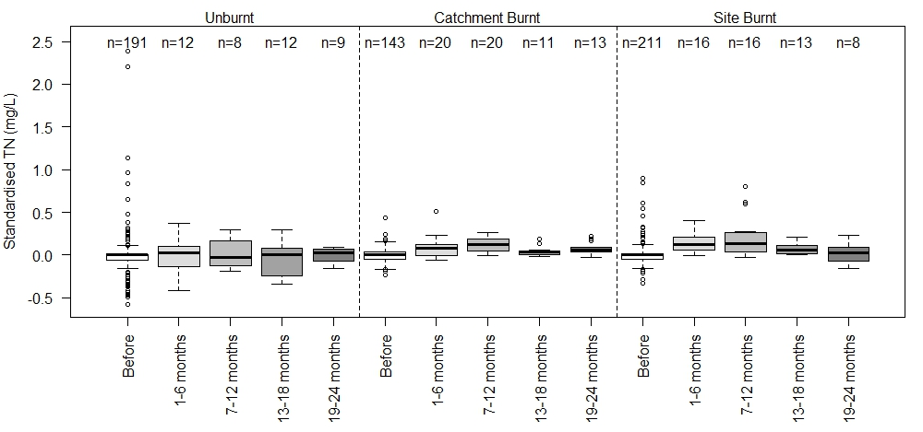
Figure S1.1 Boxplots illustrating changes in TN (mg/L) at alpine sites. Standardised refers to accounting for site and/or seasonal differences in the data by calculating the pre-fire mean of the relevant variable for each site and/or season (to obtain constants), and substracting this value (constant) from each observation.

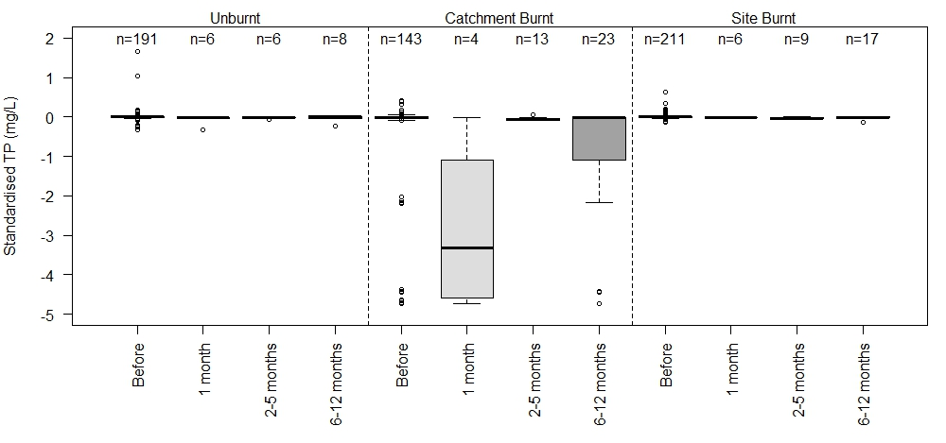
Figure S1.2. Boxplots illustrating changes in TP (mg/L) at alpine sites. Standardised refers to accounting for site and/or seasonal differences in the data by calculating the pre-fire mean of the relevant variable for each site and/or season (to obtain constants), and substracting this value (constant) from each observation.

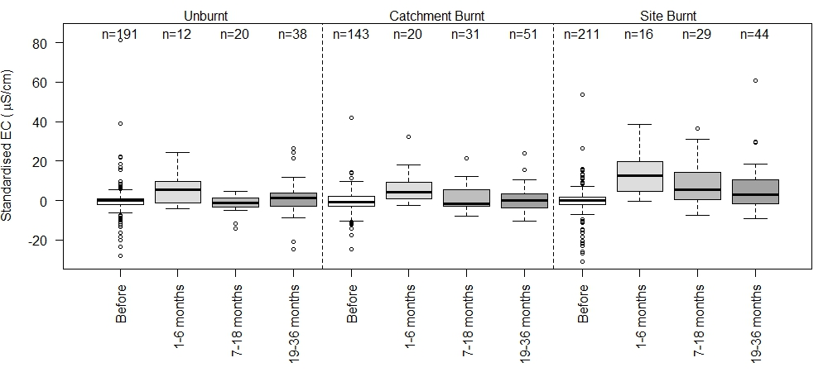
Figure S1.3. Changes in EC (µS/cm) at alpine sites. Standardised refers to accounting for site and/or seasonal differences in the data by calculating the pre-fire mean of the relevant variable for each site and/or season (to obtain constants), and substracting this value (constant) from each observation.

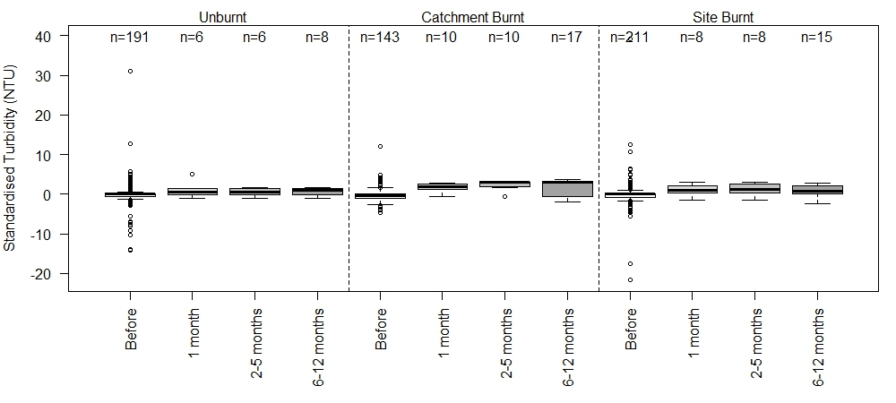
Figure S1.4. Changes in turbidity (NTU) at alpine sites. Standardised refers to accounting for site and/or seasonal differences in the data by calculating the pre-fire mean of the relevant variable for each site and/or season (to obtain constants), and substracting this value (constant) from each observation.

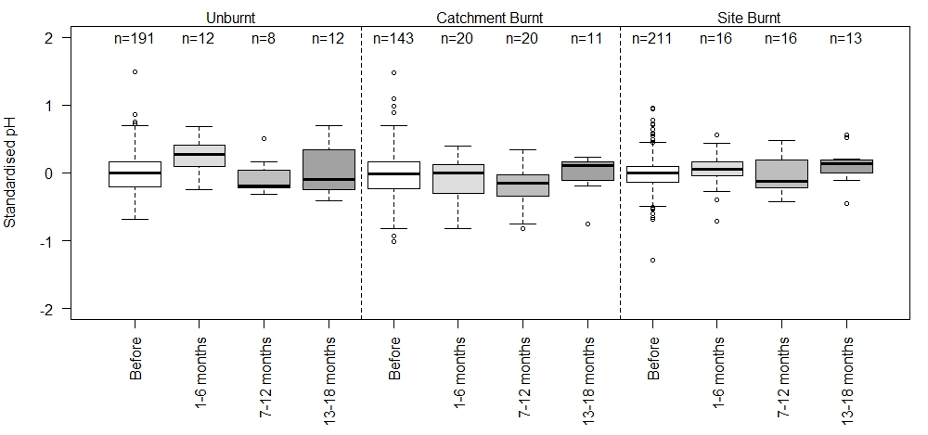
Figure S1.5. Changes in pH at alpine sites. Standardised refers to accounting for site and/or seasonal differences in the data by calculating the pre-fire mean of the relevant variable for each site and/or season (to obtain constants), and substracting this value (constant) from each observation.

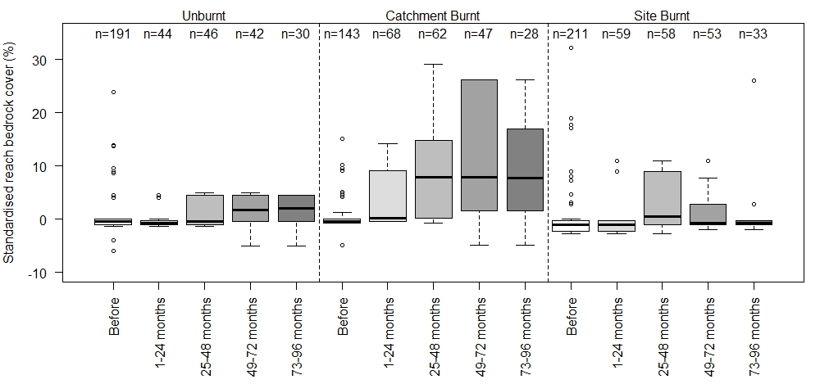
Figure S1.6. Changes in reach bedrock cover % at alpine sites. Standardised refers to accounting for site and/or seasonal differences in the data by calculating the pre-fire mean of the relevant variable for each site and/or season (to obtain constants), and substracting this value (constant) from each observation.

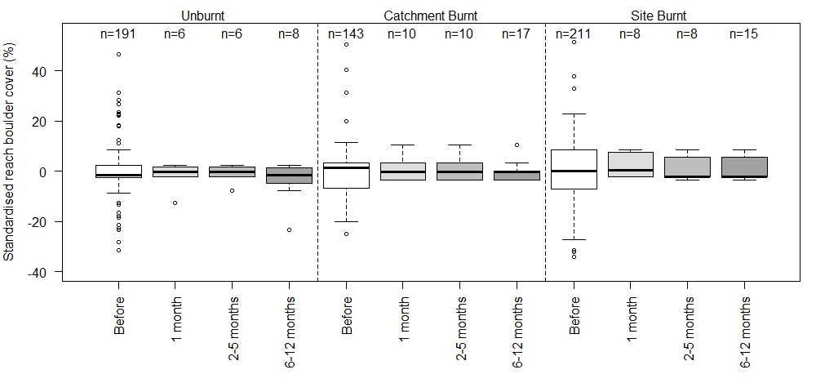
Figure S1.7. Changes in reach boulder cover % at alpine sites. Standardised refers to accounting for site and/or seasonal differences in the data by calculating the pre-fire mean of the relevant variable for each site and/or season (to obtain constants), and substracting this value (constant) from each observation.

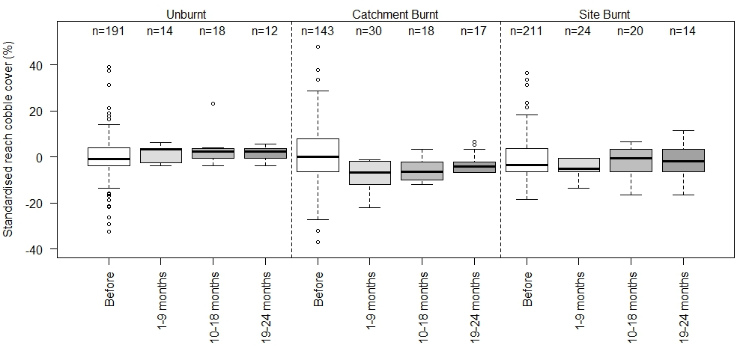

Figure S1.8. Changes in reach cobble cover % at alpine sites. Standardised refers to accounting for site and/or seasonal differences in the data by calculating the pre-fire mean of the relevant variable for each site and/or season (to obtain constants), and substracting this value (constant) from each observation.

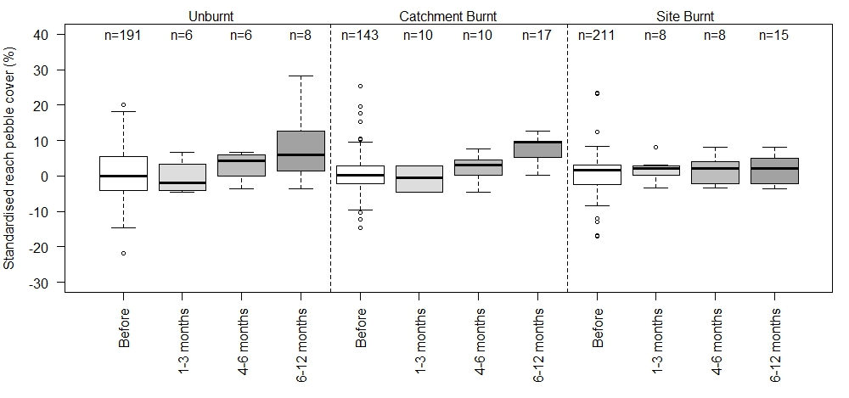
Figure S1.9. Changes in reach pebble cover % at alpine sites. Standardised refers to accounting for site and/or seasonal differences in the data by calculating the pre-fire mean of the relevant variable for each site and/or season (to obtain constants), and substracting this value (constant) from each observation.

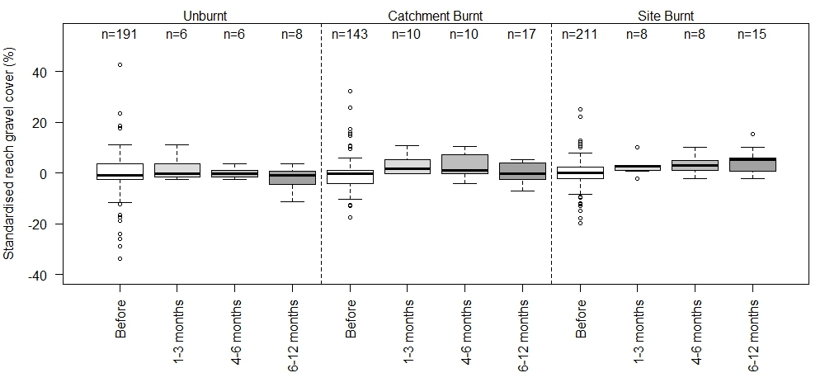
Figure S1.10. Changes in reach gravel cover % at alpine sites. Standardised refers to accounting for site and/or seasonal differences in the data by calculating the pre-fire mean of the relevant variable for each site and/or season (to obtain constants), and substracting this value (constant) from each observation.

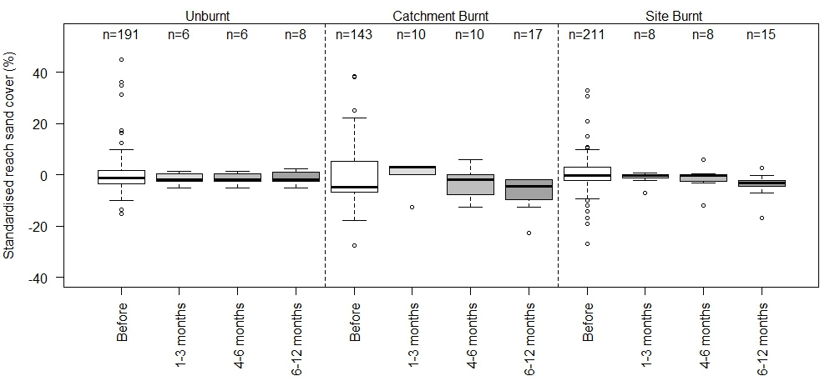
Figure S1.11. Changes in reach sand cover % at alpine sites. Standardised refers to accounting for site and/or seasonal differences in the data by calculating the pre-fire mean of the relevant variable for each site and/or season (to obtain constants), and substracting this value (constant) from each observation.

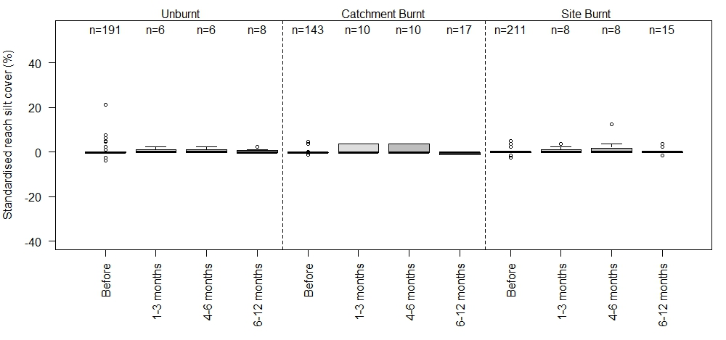
Figure S1.12. Changes in reach silt cover % at alpine sites. Standardised refers to accounting for site and/or seasonal differences in the data by calculating the pre-fire mean of the relevant variable for each site and/or season (to obtain constants), and substracting this value (constant) from each observation.

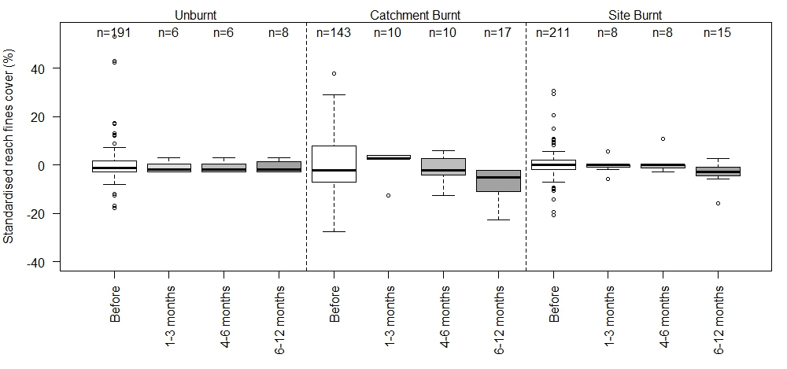
Figure S1.13. Changes in reach fines cover % at alpine sites. Standardised refers to accounting for site and/or seasonal differences in the data by calculating the pre-fire mean of the relevant variable for each site and/or season (to obtain constants), and substracting this value (constant) from each observation.

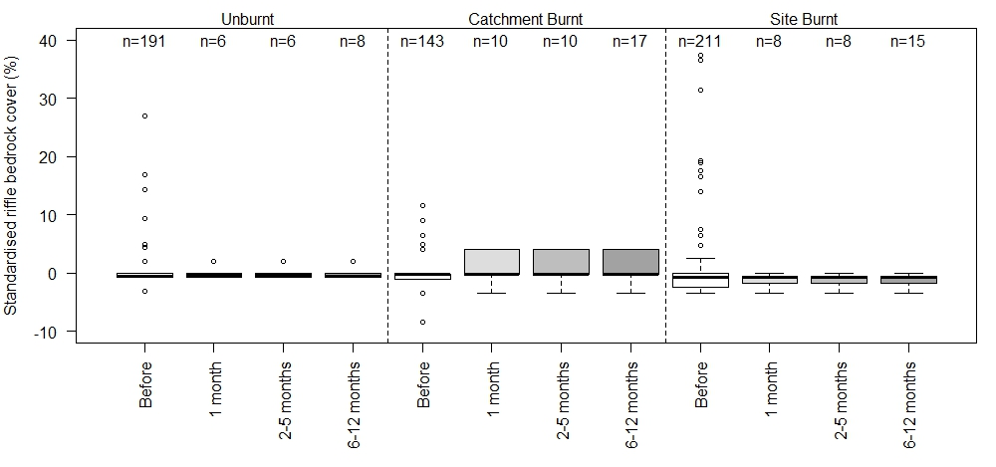
Figure S1.14. Changes in riffle bedrock cover % at alpine sites. Standardised refers to accounting for site and/or seasonal differences in the data by calculating the pre-fire mean of the relevant variable for each site and/or season (to obtain constants), and substracting this value (constant) from each observation.

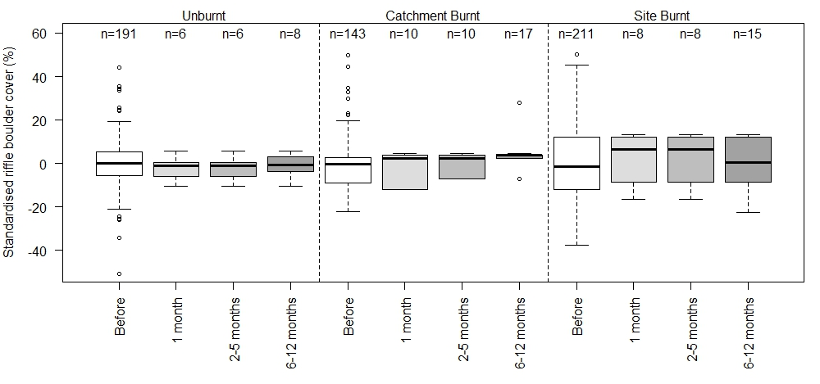
Figure S1.15. Changes in riffle boulder cover % at alpine sites. Standardised refers to accounting for site and/or seasonal differences in the data by calculating the pre-fire mean of the relevant variable for each site and/or season (to obtain constants), and substracting this value (constant) from each observation.

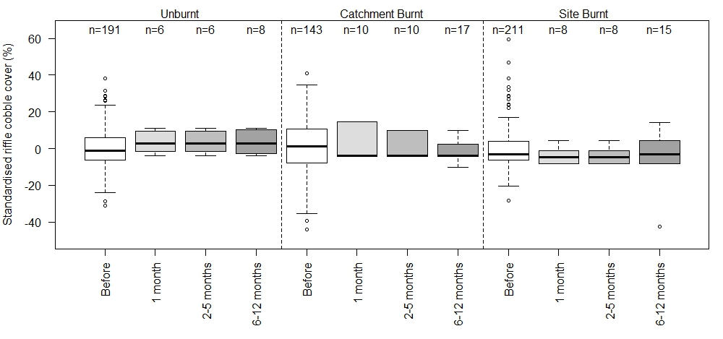
Figure S1.16. Changes in riffle cobble cover % at alpine sites. Standardised refers to accounting for site and/or seasonal differences in the data by calculating the pre-fire mean of the relevant variable for each site and/or season (to obtain constants), and substracting this value (constant) from each observation.

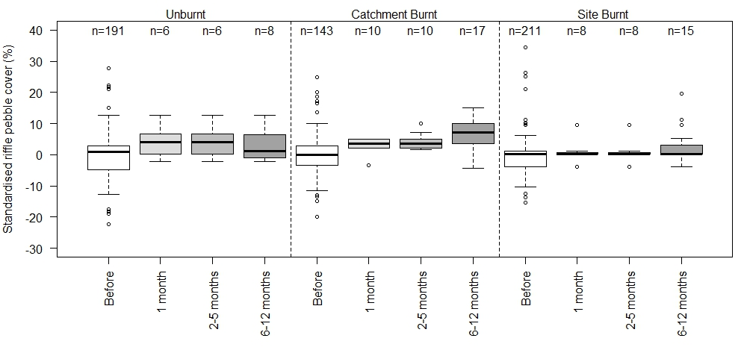
Figure S1.17. Changes in riffle pebble cover % at alpine sites. Standardised refers to accounting for site and/or seasonal differences in the data by calculating the pre-fire mean of the relevant variable for each site and/or season (to obtain constants), and substracting this value (constant) from each observation.

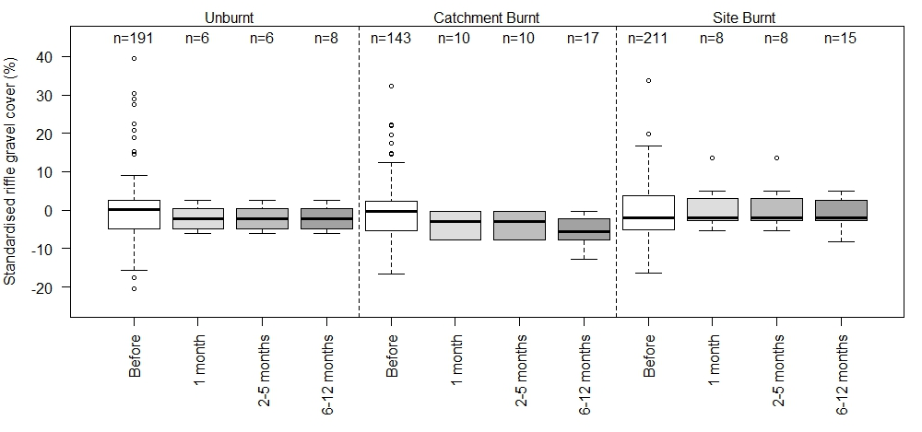
Figure S1.18. Changes in riffle gravel cover % at alpine sites. Standardised refers to accounting for site and/or seasonal differences in the data by calculating the pre-fire mean of the relevant variable for each site and/or season (to obtain constants), and substracting this value (constant) from each observation.

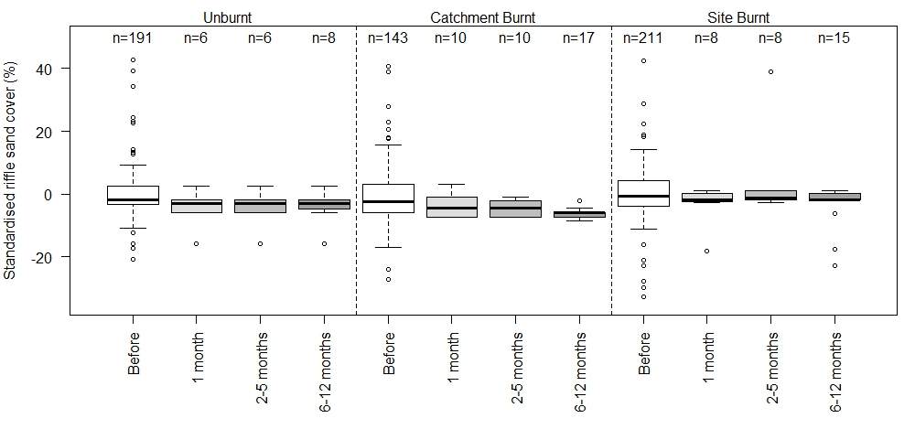
Figure S1.19. Changes in riffle sand cover % at alpine sites. Standardised refers to accounting for site and/or seasonal differences in the data by calculating the pre-fire mean of the relevant variable for each site and/or season (to obtain constants), and substracting this value (constant) from each observation.

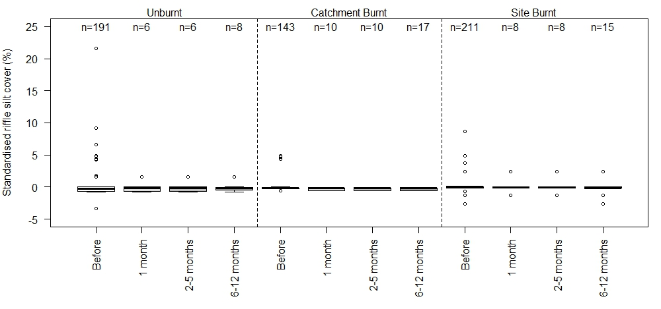
Figure S1.20. Changes in riffle silt cover % at alpine sites. Standardised refers to accounting for site and/or seasonal differences in the data by calculating the pre-fire mean of the relevant variable for each site and/or season (to obtain constants), and substracting this value (constant) from each observation.

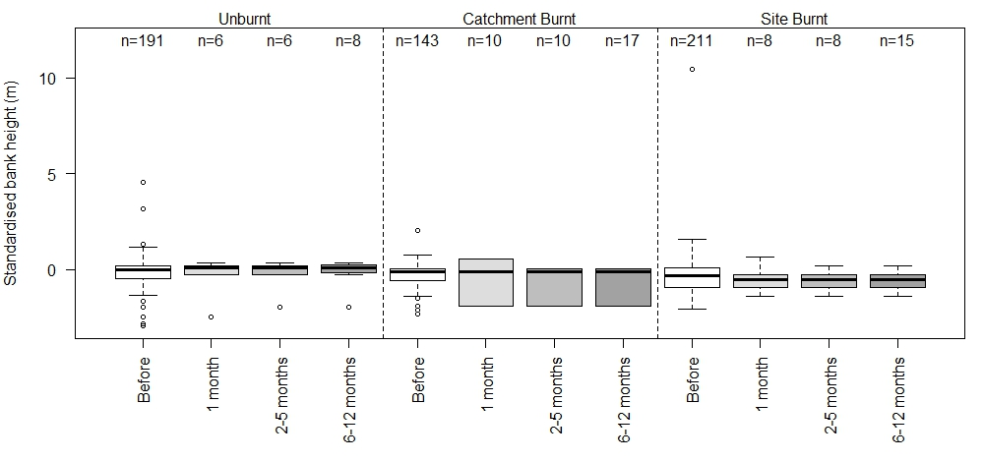
Figure S1.21. Changes in alpine bank height (m) at alpine sites. Standardised refers to accounting for site and/or seasonal differences in the data by calculating the pre-fire mean of the relevant variable for each site and/or season (to obtain constants), and substracting this value (constant) from each observation.

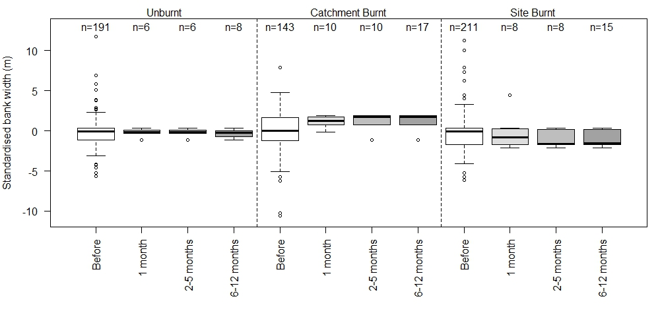
Figure S1.22. Changes in alpine bank width (m) at alpine sites. Standardised refers to accounting for site and/or seasonal differences in the data by calculating the pre-fire mean of the relevant variable for each site and/or season (to obtain constants), and substracting this value (constant) from each observation.

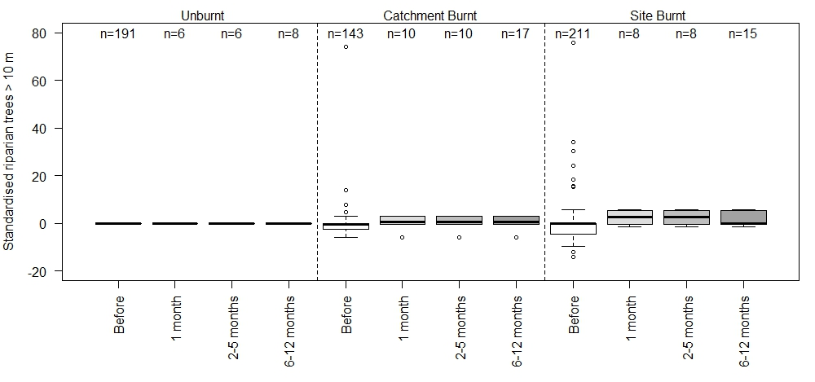
Figure S1.23. Changes in % riparian trees > 10 m at alpine sites. Standardised refers to accounting for site and/or seasonal differences in the data by calculating the pre-fire mean of the relevant variable for each site and/or season (to obtain constants), and substracting this value (constant) from each observation.

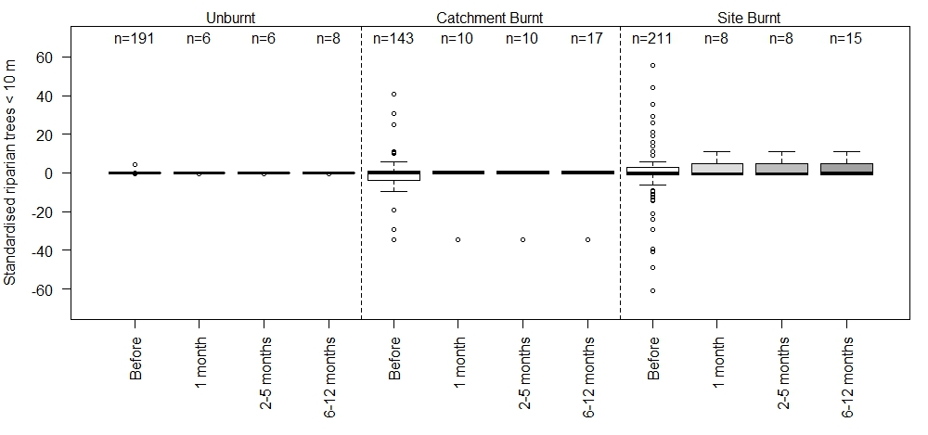
Figure S1.24. Changes in % riparian trees < 10 m at alpine sites. Standardised refers to accounting for site and/or seasonal differences in the data by calculating the pre-fire mean of the relevant variable for each site and/or season (to obtain constants), and substracting this value (constant) from each observation.

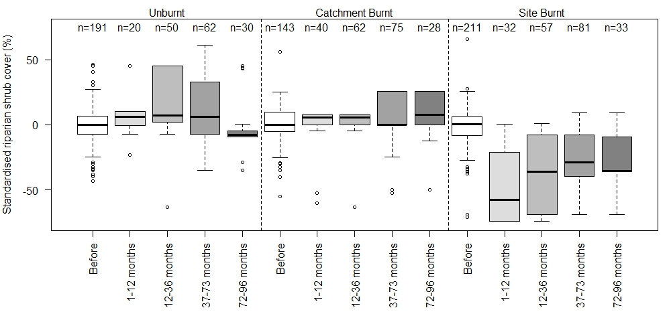
Figure S1.25. Changes in % riparian shrub cover at alpine sites. Standardised refers to accounting for site and/or seasonal differences in the data by calculating the pre-fire mean of the relevant variable for each site and/or season (to obtain constants), and substracting this value (constant) from each observation.

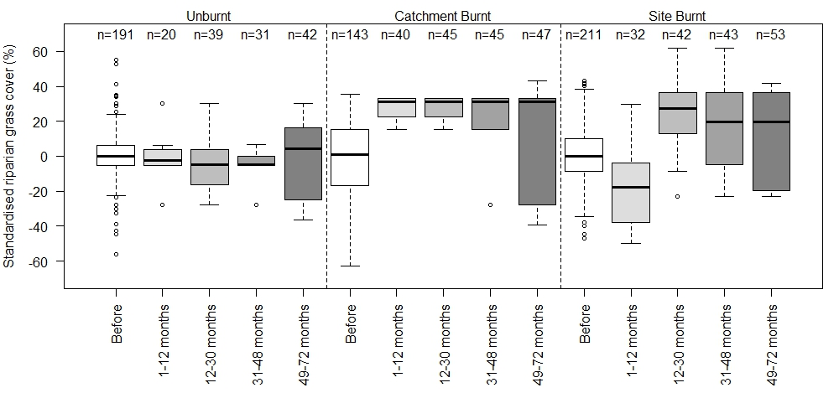
Figure S1.26. Changes in % riparian grass cover at alpine sites. Standardised refers to accounting for site and/or seasonal differences in the data by calculating the pre-fire mean of the relevant variable for each site and/or season (to obtain constants), and substracting this value (constant) from each observation.

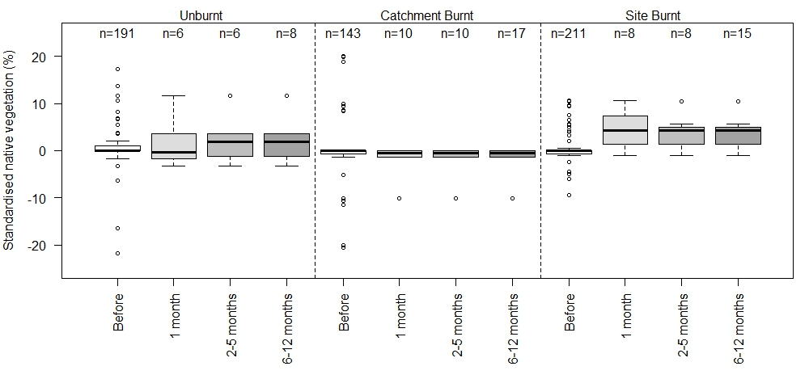
Figure S1.27. Changes in native vegetation (%) at alpine sites. Standardised refers to accounting for site and/or seasonal differences in the data by calculating the pre-fire mean of the relevant variable for each site and/or season (to obtain constants), and substracting this value (constant) from each observation.

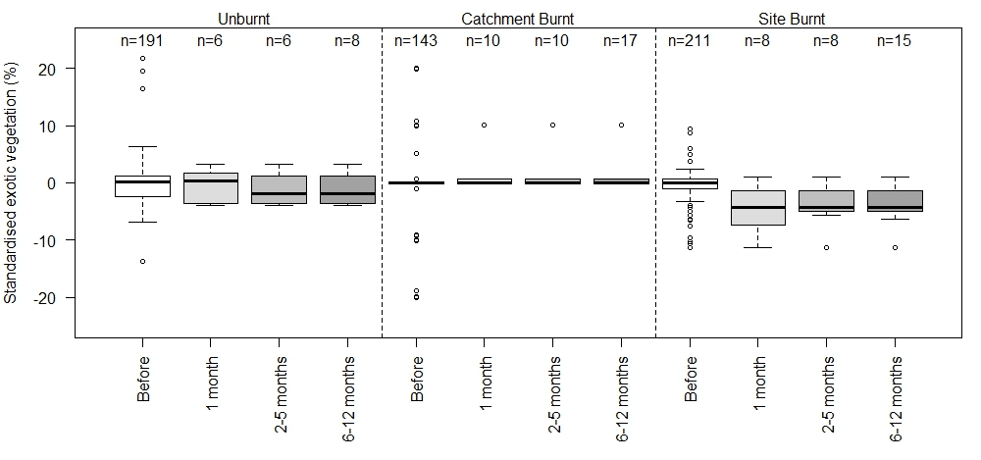
Figure S1.28. Changes in exotic vegetation (%) at alpine sites. Standardised refers to accounting for site and/or seasonal differences in the data by calculating the pre-fire mean of the relevant variable for each site and/or season (to obtain constants), and substracting this value (constant) from each observation.

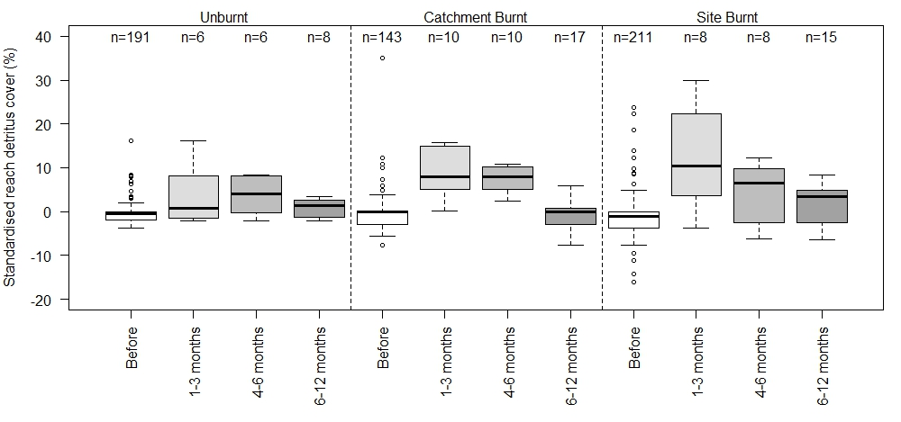
Figure S1.29. Changes in reach detritus cover % at alpine sites. Standardised refers to accounting for site and/or seasonal differences in the data by calculating the pre-fire mean of the relevant variable for each site and/or season (to obtain constants), and substracting this value (constant) from each observation.

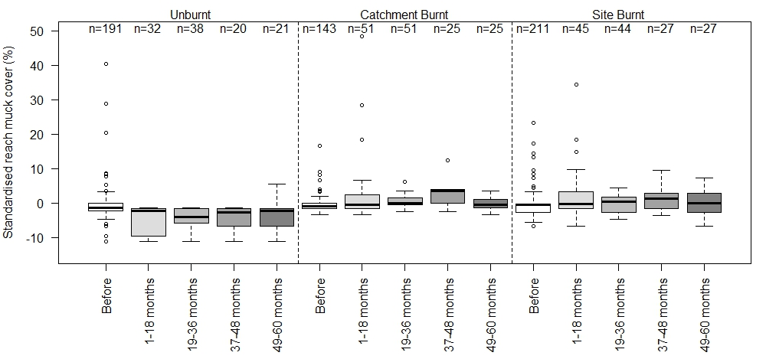
Figure S1.30. Changes in reach muck cover % at alpine sites. Standardised refers to accounting for site and/or seasonal differences in the data by calculating the pre-fire mean of the relevant variable for each site and/or season (to obtain constants), and substracting this value (constant) from each observation.

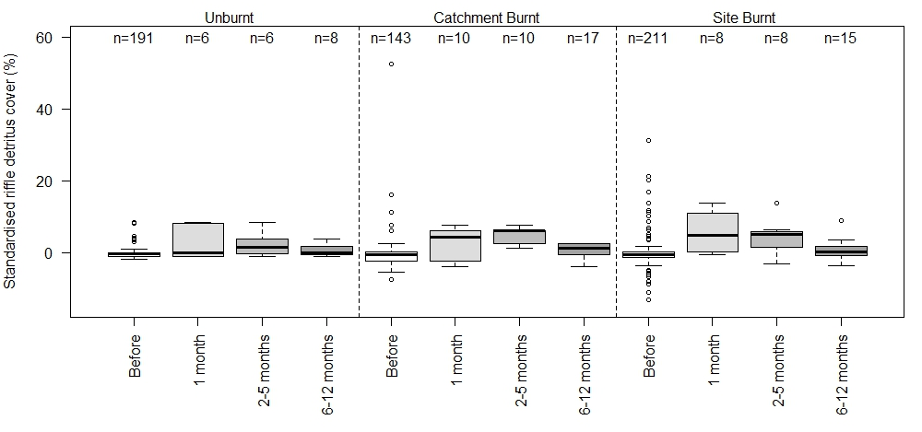
Figure S1.31. Changes in riffle detritus cover % at alpine sites. Standardised refers to accounting for site and/or seasonal differences in the data by calculating the pre-fire mean of the relevant variable for each site and/or season (to obtain constants), and substracting this value (constant) from each observation.

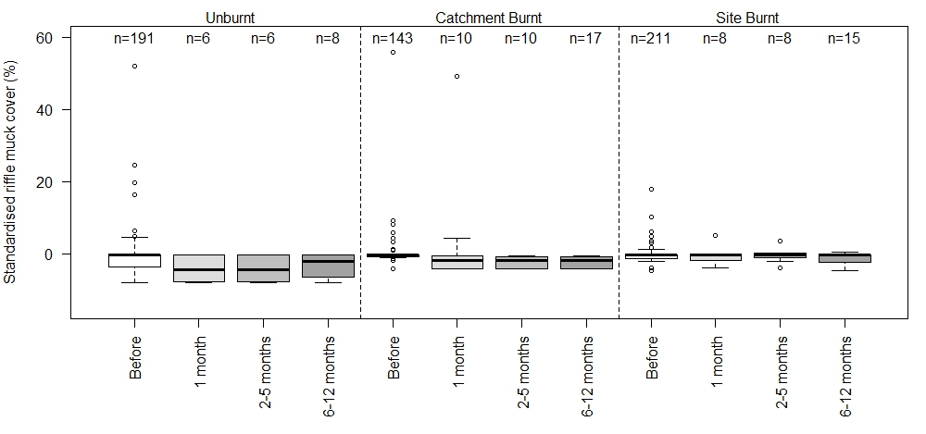
Figure S1.32. Changes in riffle muck cover % at alpine sites. Standardised refers to accounting for site and/or seasonal differences in the data by calculating the pre-fire mean of the relevant variable for each site and/or season (to obtain constants), and substracting this value (constant) from each observation.

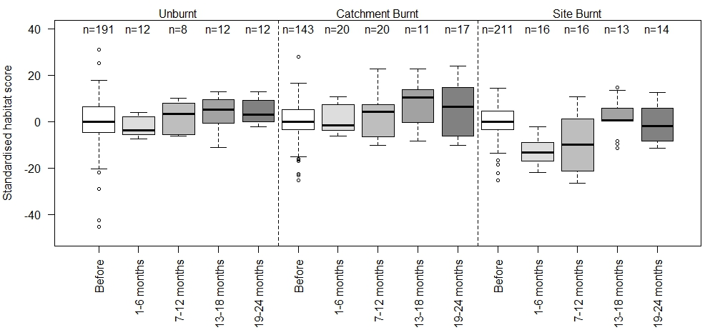
Figure S1.33. Changes in habitat scores at alpine sites. Standardised refers to accounting for site and/or seasonal differences in the data by calculating the pre-fire mean of the relevant variable for each site and/or season (to obtain constants), and substracting this value (constant) from each observation.

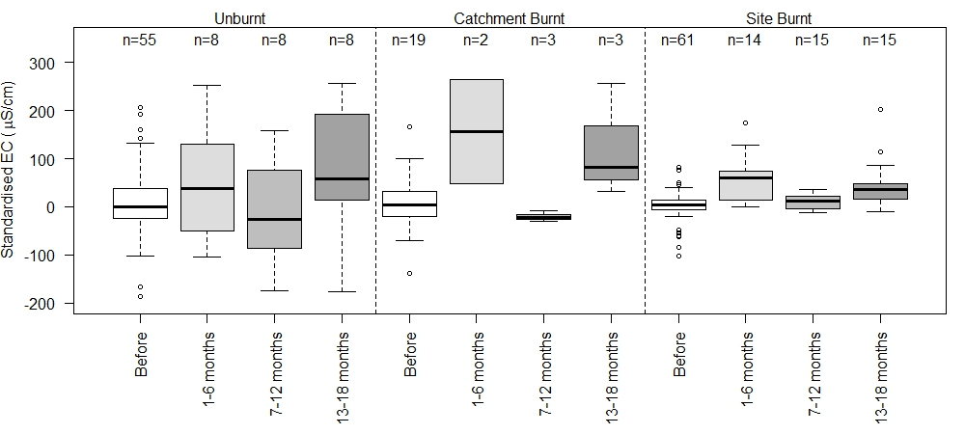
Figure S2.1. Changes in EC at montane sites. Standardised refers to accounting for site and/or seasonal differences in the data by calculating the pre-fire mean of the relevant variable for each site and/or season (to obtain constants), and substracting this value (constant) from each observation.

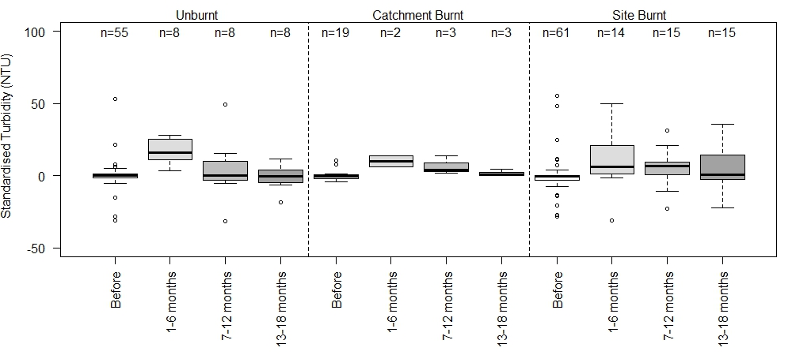
Figure S2.2. Changes in turbidity (NTU) at montane sites. Standardised refers to accounting for site and/or seasonal differences in the data by calculating the pre-fire mean of the relevant variable for each site and/or season (to obtain constants), and substracting this value (constant) from each observation.

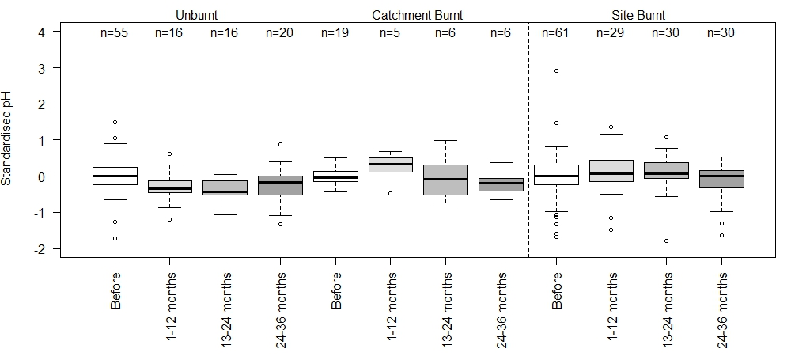
Figure S2.3. Changes in pH at montane sites. Standardised refers to accounting for site and/or seasonal differences in the data by calculating the pre-fire mean of the relevant variable for each site and/or season (to obtain constants), and substracting this value (constant) from each observation.

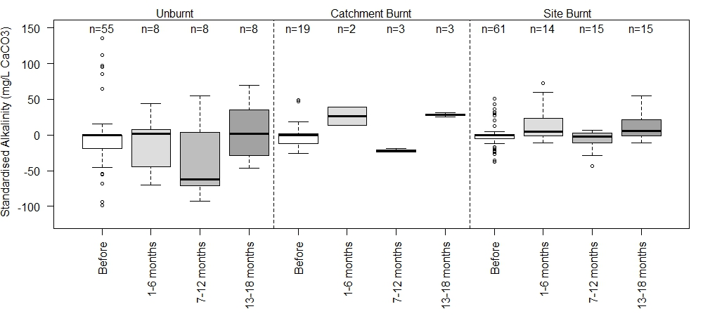
Figure S2.4. Changes in alkalinity (mg/L CaCO₃) at montane sites. Standardised refers to accounting for site and/or seasonal differences in the data by calculating the pre-fire mean of the relevant variable for each site and/or season (to obtain constants), and substracting this value (constant) from each observation.

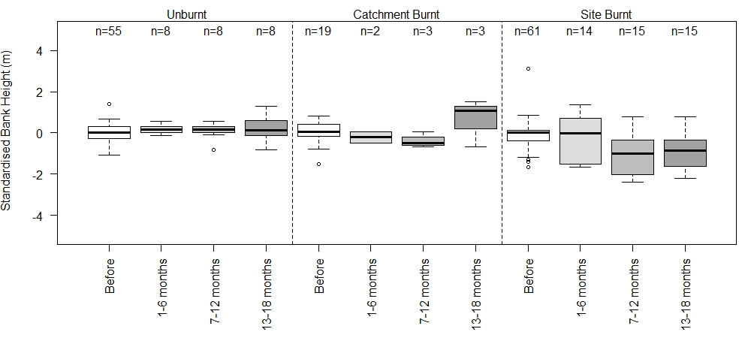

Figure S2.5. Changes in bank height (m) at montane sites. Standardised refers to accounting for site and/or seasonal differences in the data by calculating the pre-fire mean of the relevant variable for each site and/or season (to obtain constants), and substracting this value (constant) from each observation.

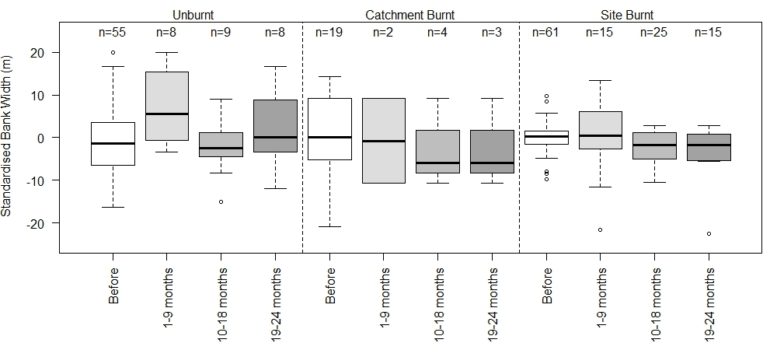
Figure S2.6. Changes in bank width (m) at montane sites. Standardised refers to accounting for site and/or seasonal differences in the data by calculating the pre-fire mean of the relevant variable for each site and/or season (to obtain constants), and substracting this value (constant) from each observation.

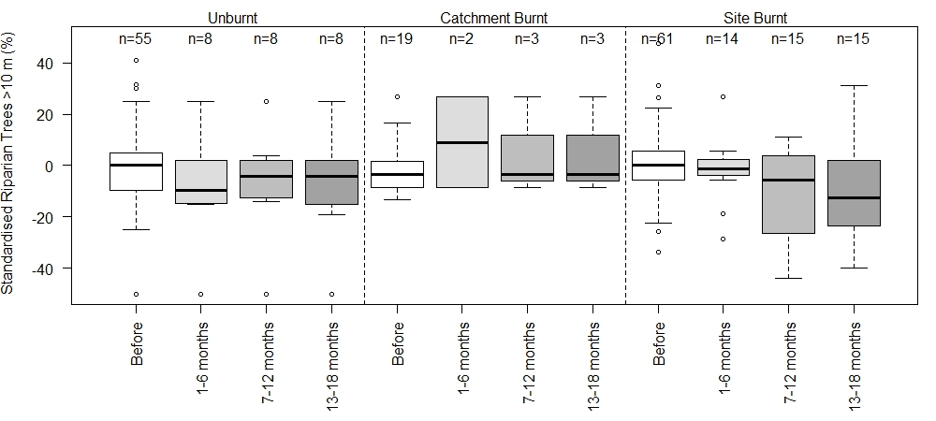
Figure S2.7. Changes in riparian trees > 10m (%) at montane sites. Standardised refers to accounting for site and/or seasonal differences in the data by calculating the pre-fire mean of the relevant variable for each site and/or season (to obtain constants), and substracting this value (constant) from each observation.

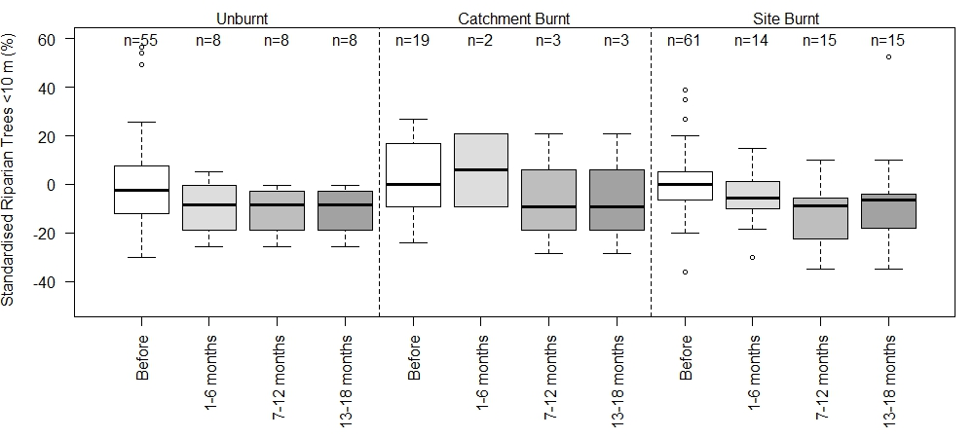

Figure S2.8. Changes in riparian trees < 10m (%) at montane sites. Standardised refers to accounting for site and/or seasonal differences in the data by calculating the pre-fire mean of the relevant variable for each site and/or season (to obtain constants), and substracting this value (constant) from each observation.

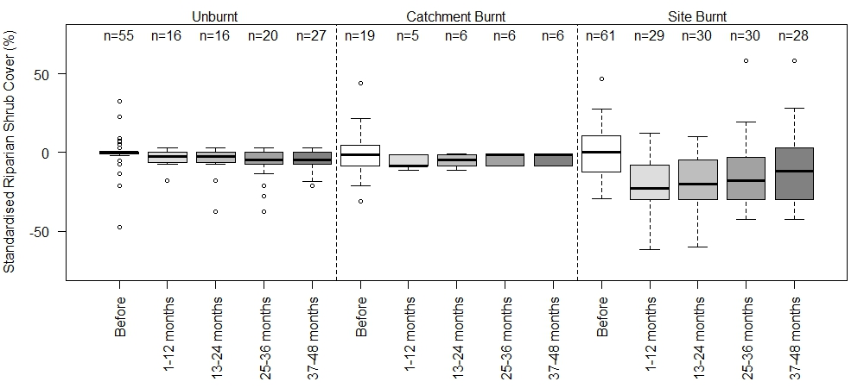
Figure S2.9. Changes in riparian shrub cover (%) at montane sites. Standardised refers to accounting for site and/or seasonal differences in the data by calculating the pre-fire mean of the relevant variable for each site and/or season (to obtain constants), and substracting this value (constant) from each observation.

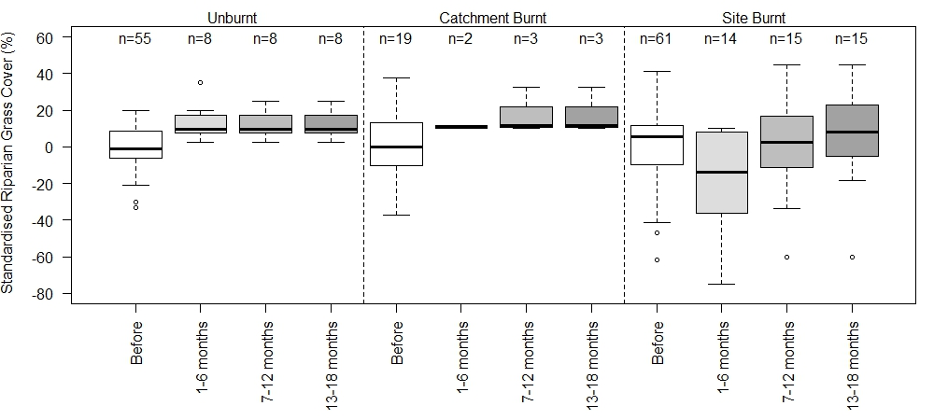
Figure S2.10. Changes in riparian grass cover (%) at montane sites. Standardised refers to accounting for site and/or seasonal differences in the data by calculating the pre-fire mean of the relevant variable for each site and/or season (to obtain constants), and substracting this value (constant) from each observation.

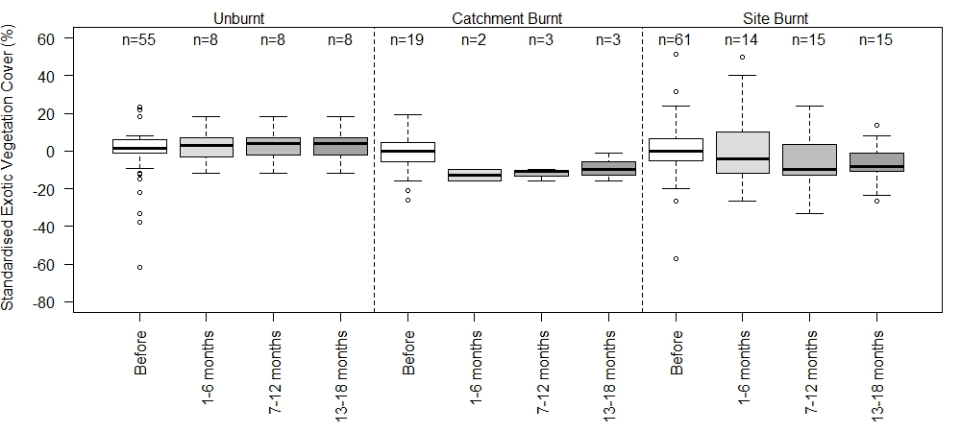
Figure S2.11. Changes in exotic vegetation % at montane sites. Standardised refers to accounting for site and/or seasonal differences in the data by calculating the pre-fire mean of the relevant variable for each site and/or season (to obtain constants), and substracting this value (constant) from each observation.

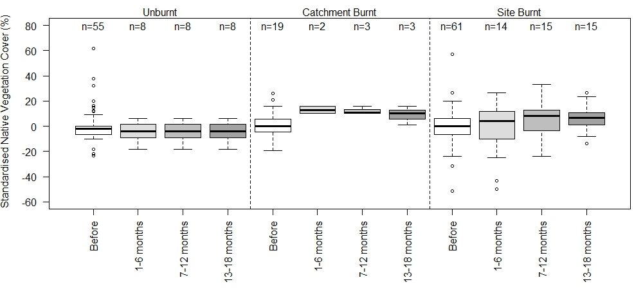
Figure S2.12. Changes in native vegetation % at montane sites. Standardised refers to accounting for site and/or seasonal differences in the data by calculating the pre-fire mean of the relevant variable for each site and/or season (to obtain constants), and substracting this value (constant) from each observation.

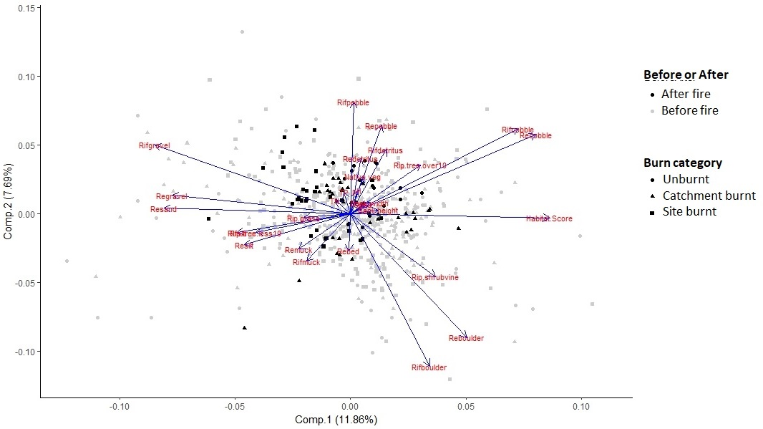
Figure S3.1. PCA ordination of alpine zone data, before data (grey) and 12 months post-fire (black).

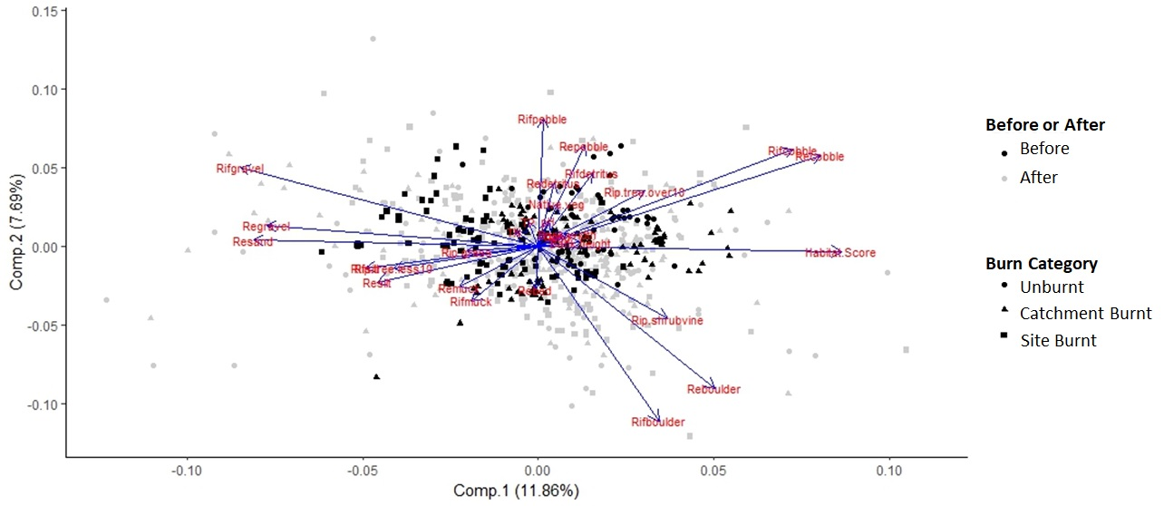
Figure S3.2. PCA ordination of alpine zone data, before data (grey) and 1 to 3 years post-fire (black).

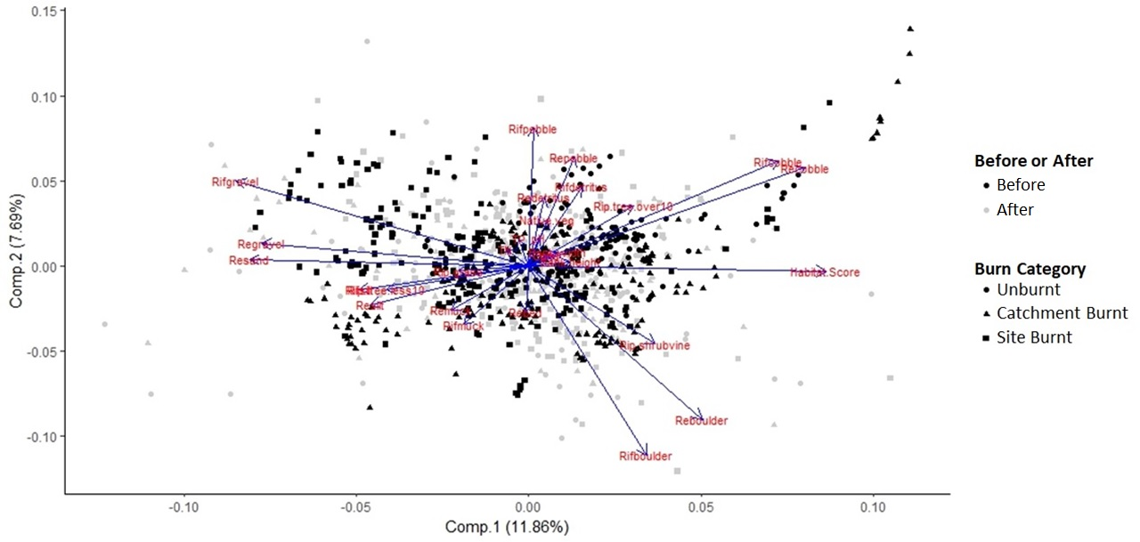
Figure S3.3. PCA ordination of alpine zone data, before data (grey) and post-fire years up to 2010 inclusive (black).

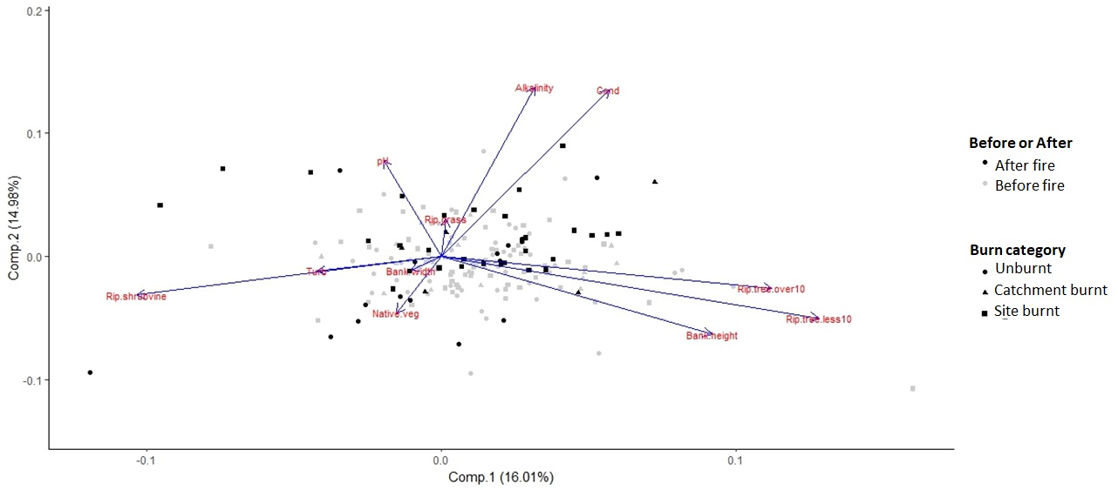
Figure S4.1. PCA ordination of montane zone data, before data (grey) and 12 months post-fire (black).

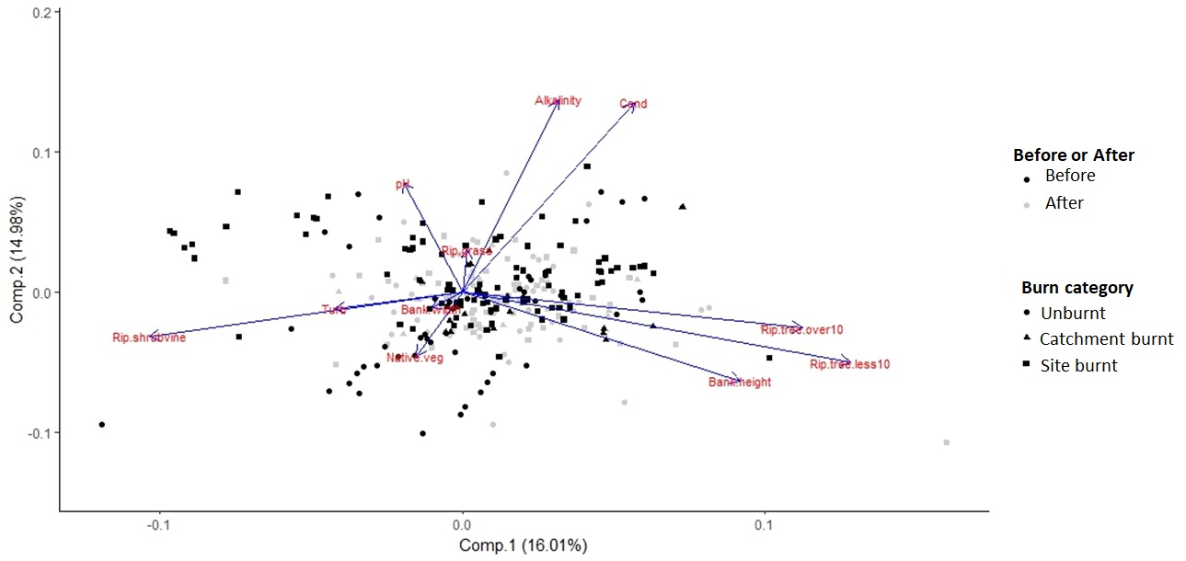
Figure S4.2. PCA ordination of montane zone data, before data (grey) and 1 to 3 years post-fire (black).

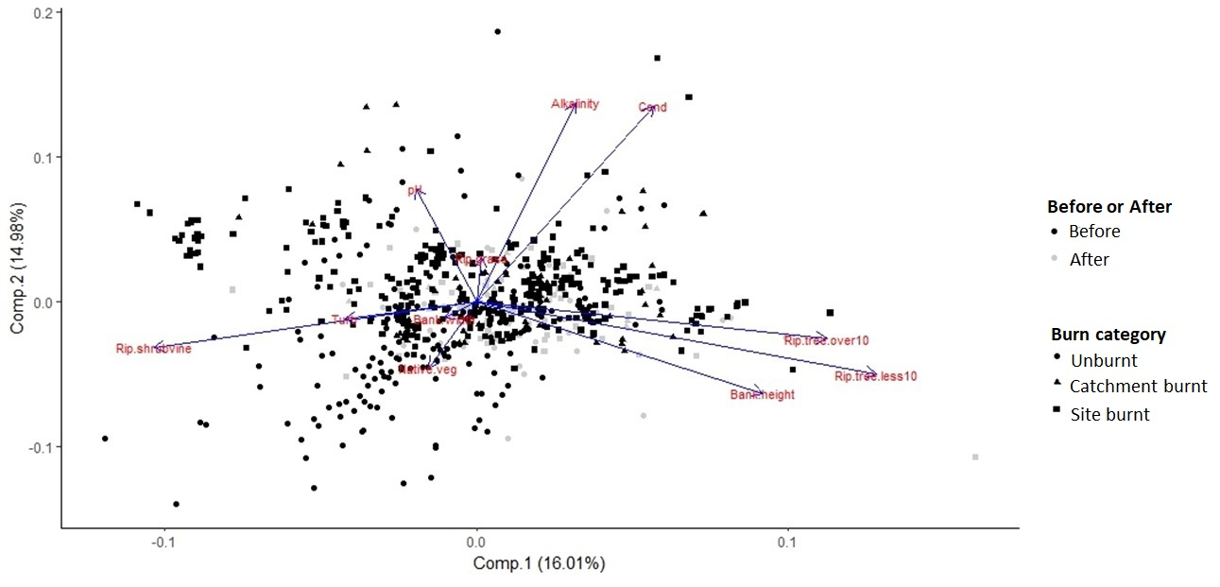
Figure S4.3. PCA ordination of montane zone data, before data (grey) and all data post-fire (black).

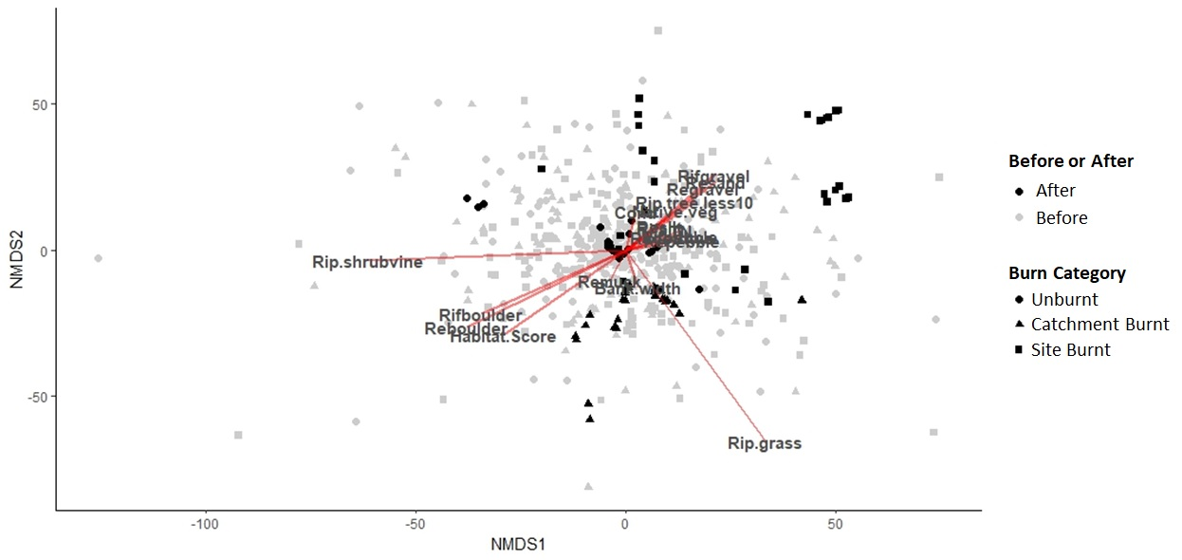
Figure S5.1. nMDS of alpine zone data up to 12 months post-fire (stress = 0.20).

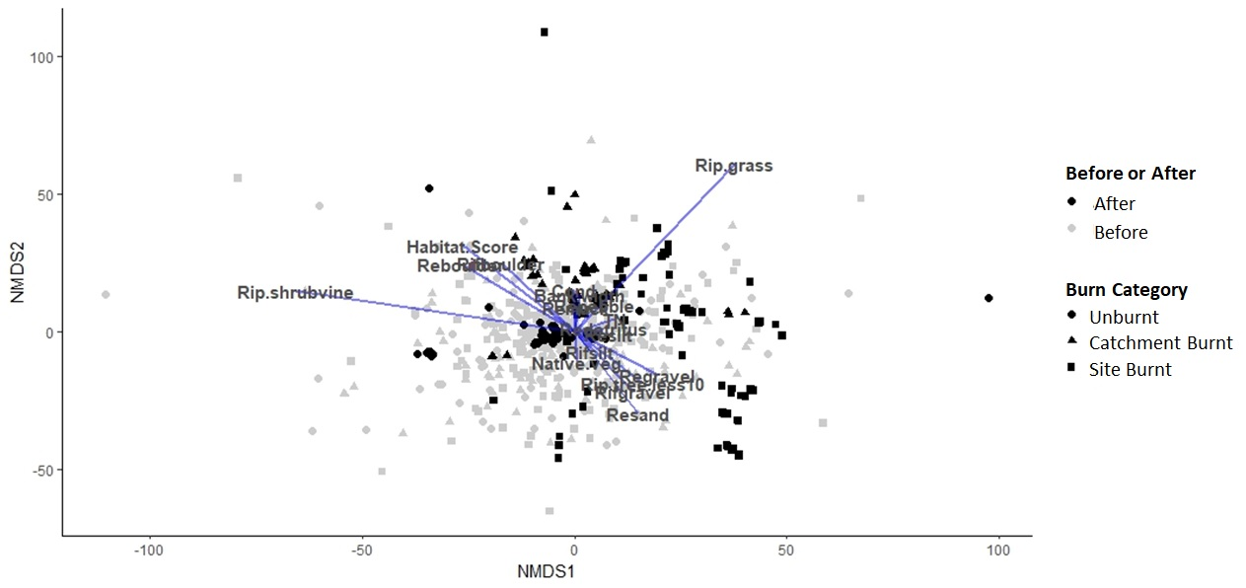
Figure S5.2. nMDS of alpine zone data up to 3 years post-fire (stress = 0.20).

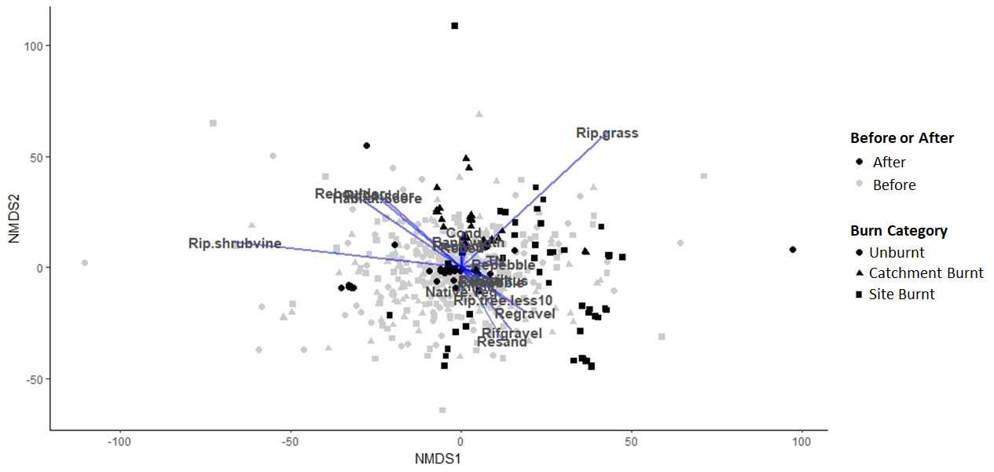
Figure S5.3. nMDS of alpine zone data up to 8 years post-fire (stress = 0.20).

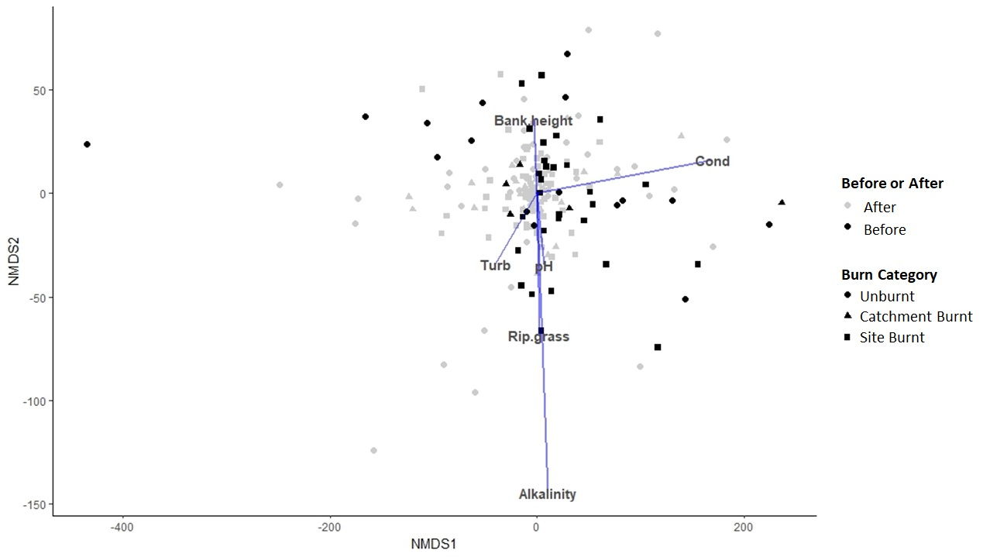
Figure S6.1. nMDS of montane zone data up to 12 months post-fire (stress = 0.10).

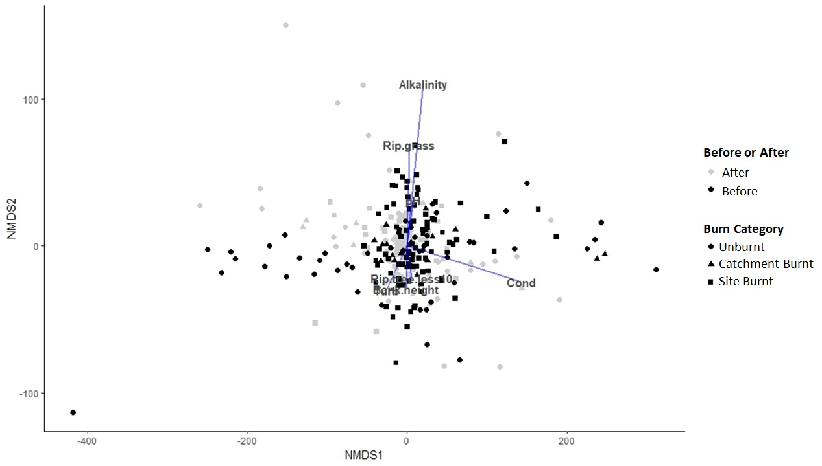
Figure S6.2. nMDS of montane zone data up to 3 years post-fire (stress = 0.10).

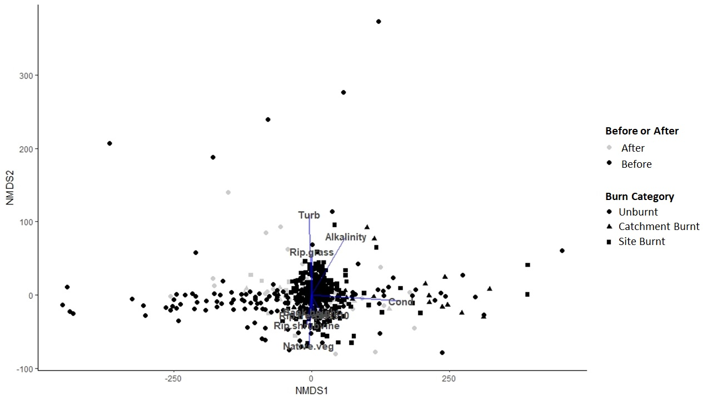
Figure S6.3. nMDS of montane zone data up to 8 years post-fire (stress = 0.10).

Table S7.1. Summary of results for statistical tests of individual principal components for alpine sites, for components explaining an arbitrarily selected >5% to total variation. The duration of change was determined using the linear mixed effects model with interaction term as described in the methods. Variables listed are the 3 highest and 3 lowest loading values for each principal component. Detailed results of statistical tests are provided in Tables S9.2 to S9.7.
 |  |  | Site Burnt |  | Catchment Burnt
Principle Component | Variable | Loading | Direction of Change | Duration | Direction of Change | Duration
1 (11.9%) | Habitat Score | 0.37462 | ↑ | Up to 96 months | NA | NSS
1 (11.9%) | % Reach cobble | 0.348617 | ↑ | Up to 96 months | NA | NSS
1 (11.9%) | % Riffle cobble | 0.315123 | ↑ | Up to 96 months | NA | NSS
1 (11.9%) | % Riffle gravel | -0.36781 | ↑ | Up to 96 months | NA | NSS
1 (11.9%) | % Reach gravel | -0.35095 | ↑ | Up to 96 months | NA | NSS
1 (11.9%) | % Reach sand | -0.33517 | ↑ | Up to 96 months | NA | NSS
2 (7.7%) | % Riffle pebble | 0.352909 | NA | NSS | NA | NSS
2 (7.7%) | % Reach pebble | 0.279035 | NA | NSS | NA | NSS
2 (7.7%) | % Riffle cobble | 0.267753 | NA | NSS | NA | NSS
2 (7.7%) | % Riffle boulder | -0.48093 | NA | NSS | NA | NSS
2 (7.7%) | % Reach boulder | -0.39025 | NA | NSS | NA | NSS
2 (7.7%) | % Reach gravel | -0.19842 | NA | NSS | NA | NSS
3 (6.6%) | % Reach detritus | 0.418421 | ↑ | Up to 60 months | ↑ | Up to 12 months
3 (6.6%) | % Riffle detritus | 0.395164 | ↑ | Up to 60 months | ↑ | Up to 12 months
3 (6.6%) | % Reach muck | 0.346258 | ↑ | Up to 60 months | ↑ | Up to 12 months
3 (6.6%) | % Reach pebble | -0.26344 | ↑ | Up to 60 months | ↑ | Up to 12 months
3 (6.6%) | % Riparian shrub cover | -0.25293 | ↑ | Up to 60 months | ↑ | Up to 12 months
3 (6.6%) | % Riffle pebble | -0.16552 | ↑ | Up to 60 months | ↑ | Up to 12 months
4 (6.4%) | pH | 0.348684 | ↓ | Up to 12 months | ↓ | Up to 36 months
4 (6.4%) | % Reach sand | 0.27198 | ↓ | Up to 12 months | ↓ | Up to 36 months
4 (6.4%) | % Reach bedrock | 0.228743 | ↓ | Up to 12 months | ↓ | Up to 36 months
4 (6.4%) | % Reach pebble | -0.37734 | ↓ | Up to 12 months | ↓ | Up to 36 months
4 (6.4%) | % Riffle pebble | -0.35949 | ↓ | Up to 12 months | ↓ | Up to 36 months
4 (6.4%) | % Reach muck | -0.26813 | ↓ | Up to 12 months | ↓ | Up to 36 months
5 (6.0%) | % Riffle cobble | 0.333423 | ↓ | Up to 24 months | ↓ | Up to 60 months
5 (6.0%) | % Reach cobble | 0.323082 | ↓ | Up to 24 months | ↓ | Up to 60 months
5 (6.0%) | % Riffle gravel | 0.213014 | ↓ | Up to 24 months | ↓ | Up to 60 months
5 (6.0%) | % Reach bedrock | -0.50144 | ↓ | Up to 24 months | ↓ | Up to 60 months
5 (6.0%) | % Reach pebble | -0.26837 | ↓ | Up to 24 months | ↓ | Up to 60 months
5 (6.0%) | Bank width (m) | -0.25094 | ↓ | Up to 24 months | ↓ | Up to 60 months
6 (5.3%) | % Riffle muck | 0.247209 | ↓ | Up to 12 months | NA | NSS
6 (5.3%) | TN (mg/L) | 0.146122 | ↓ | Up to 12 months | NA | NSS
6 (5.3%) | TP (mg/L) | 0.145107 | ↓ | Up to 12 months | NA | NSS
6 (5.3%) | % Reach silt | -0.55362 | ↓ | Up to 12 months | NA | NSS
6 (5.3%) | % Riffle silt | -0.52046 | ↓ | Up to 12 months | NA | NSS
6 (5.3%) | % Riffle detritus | -0.28782 | ↓ | Up to 12 months | NA | NSS

Table S7.2. Results of statistical testing of principle component 1 (PC1) using a linear mixed effects model with interaction term as described in the methods. Results provided are for the interaction term only.
Component | Time since fire | Burn category | df | t-value | p-value
PC1 | 1-12 months | Cat burnt | 611 | 0.7000912 | 0.4841
PC1 | 13-24 months | Cat burnt | 596 | -0.3591789 | 0.7196
PC1 | 1-12 months | Site burnt | 611 | 2.9672564 | 0.0031
PC1 | 13-24 months | Site burnt | 596 | 2.9325230 | 0.0035
PC1 | 25-36 months | Site burnt | 606 | 4.146679 | 0.0000
PC1 | 37-48 months | Site burnt | 594 | 3.857911 | 0.0001
PC1 | 49-60 months | Site burnt | 591 | 3.759468 | 0.0002
PC1 | 61-72 months | Site burnt | 587 | 3.403827 | 0.0007
PC1 | 73-84 months | Site burnt | 576 | 3.070957 | 0.0022
PC1 | 85-97 months | Site burnt | 552 | 2.553593 | 0.0109

Table S7.3. Results of statistical testing of principle component 2 (PC2) using a linear mixed effects model with interaction term as described in the methods. Results provided are for the interaction term only.
Component | Time since fire | Burn category | df | t-value | p-value
PC2 | 1-12 months | Cat burnt | 611 | 1.8091572 | 0.0709
PC2 | 13-24 months | Cat burnt | 596 | 1.703554 | 0.0890
PC2 | 1-12 months | Site burnt | 611 | 0.4404502 | 0.6598
PC2 | 13-24 months | Site burnt | 596 | 1.619650 | 0.1058

Table S7.4. Results of statistical testing of principle component (PC3) using a linear mixed effects model with interaction term as described in the methods. Results provided are for the interaction term only.
Component | Time since fire | Burn category | df | t-value | p-value
PC3 | 1-12 months | Cat burnt | 611 | -2.179651 | 0.0297
PC3 | 13-24 months | Cat burnt | 596 | -0.451551 | 0.6518
PC3 | 1-12 months | Site burnt | 611 | -4.956227 | 0.0000
PC3 | 13-24 months | Site burnt | 596 | -3.108062 | 0.0020
PC3 | 25-36 months | Site burnt | 606 | -3.679606 | 0.0003
PC3 | 37-48 months | Site burnt | 594 | -5.457106 | 0.0000
PC3 | 49-60 months | Site burnt | 591 | -3.808017 | 0.0002
PC3 | 61-72 months | Site burnt | 587 | -0.7947427 | 0.4271

Table S7.5. Results of statistical testing of principle component 4 (PC4) using a linear mixed effects model with interaction term as described in the methods. Results provided are for the interaction term only.
PC4 | 1-12 months | Cat burnt | 611 | 2.927573 | 0.0035
PC4 | 13-24 months | Cat burnt | 596 | 3.136479 | 0.0018
PC4 | 25-36 months | Cat burnt | 606 | 2.3946480 | 0.0169
PC4 | 37-48 months | Cat burnt | 594 | -1.3229904 | 0.1863
PC4 | 1-12 months | Site burnt | 611 | 2.383355 | 0.0175
PC4 | 13-24 months | Site burnt | 596 | 0.801764 | 0.4230

Table S7.6. Results of statistical testing of principle component 5 (PC5) using a linear mixed effects model with interaction term as described in the methods. Results provided are for the interaction term only.
PC5 | 1-12 months | Cat burnt | 611 | 3.1257166 | 0.0019
PC5 | 13-24 months | Cat burnt | 596 | 4.173082 | 0.0000
PC5 | 25-36 months | Cat burnt | 606 | 4.776239 | 0.0000
PC5 | 37-48 months | Cat burnt | 594 | 2.7702507 | 0.0058
PC5 | 49-60 months | Cat burnt | 591 | 2.045154 | 0.0413
PC5 | 61-72 months | Cat burnt | 587 | -0.511165 | 0.6094
PC5 | 1-12 months | Site burnt | 611 | -2.2612772 | 0.0241
PC5 | 13-24 months | Site burnt | 596 | -3.227485 | 0.0013
PC5 | 25-36 months | Site burnt | 606 | -1.473728 | 0.1411

Table S7.7. Results of statistical testing of principle component 6 (PC6) using a linear mixed effects model with interaction term as described in the methods. Results provided are for the interaction term only.
PC6 | 1-12 months | Cat burnt | 611 | -0.2513034 | 0.8017
PC6 | 1-12 months | Site burnt | 611 | -2.5103166 | 0.0123
PC6 | 13-24 months | Site burnt | 596 | -0.6525518 | 0.5143

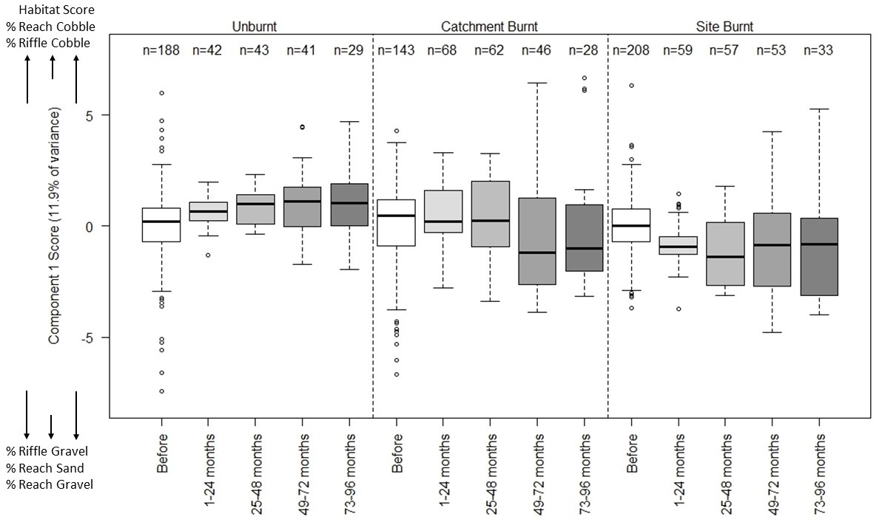
Figure S7.1. Boxplots of PCA component scores for principal component 1 at alpine sites. The variables labelled above and below the y-axis show their relationship of the component, with those above the y-axis tending to increase with high values of the component and those below the y-axis tending to increase with low values of the component.

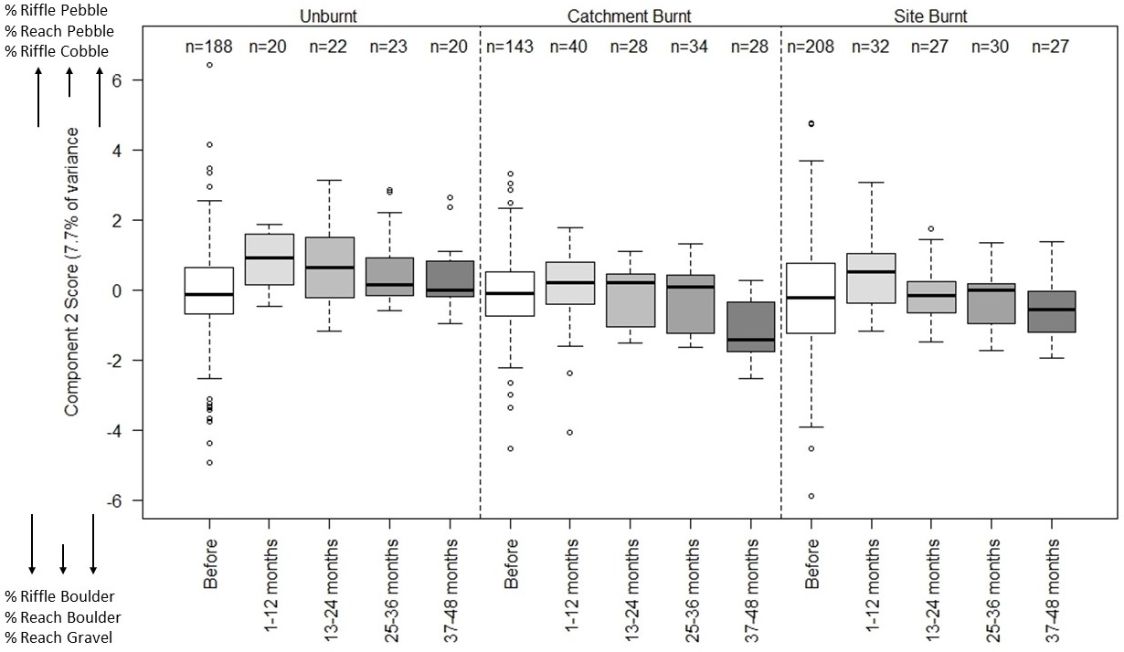

Figure S7.2. Boxplots of PCA component scores for principal component 2 at alpine sites. The variables labelled above and below the y-axis show their relationship of the component, with those above the y-axis tending to increase with high values of the component and those below the y-axis tending to increase with low values of the component.

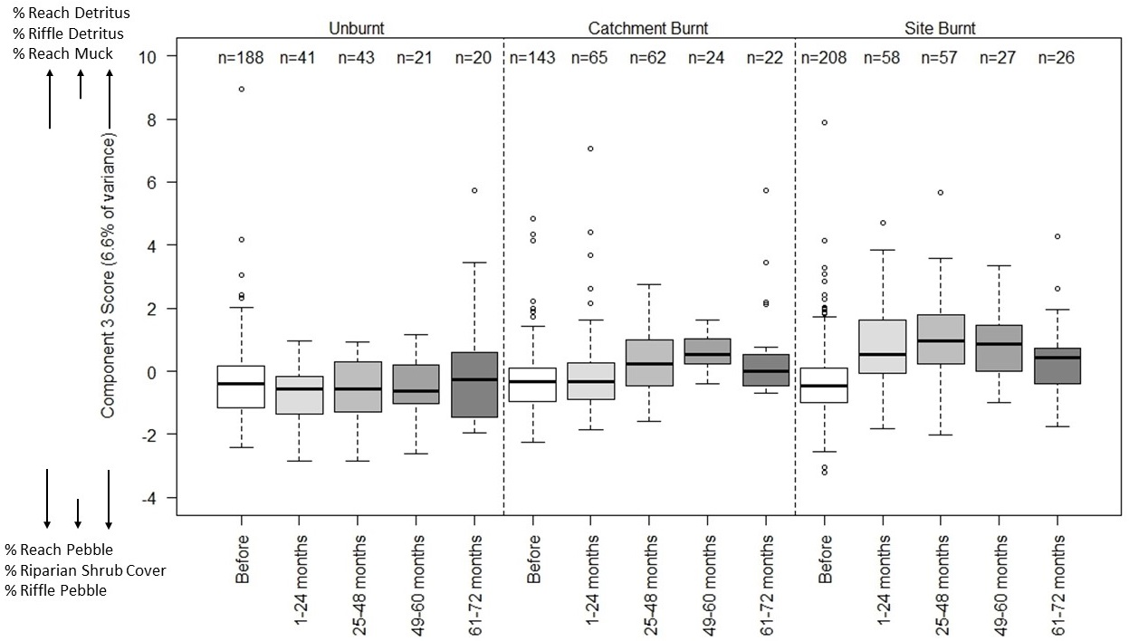
Figure S7.3. Boxplots of PCA component scores for principal component 3 at alpine sites. The variables labelled above and below the y-axis show their relationship of the component, with those above the y-axis tending to increase with high values of the component and those below the y-axis tending to increase with low values of the component.
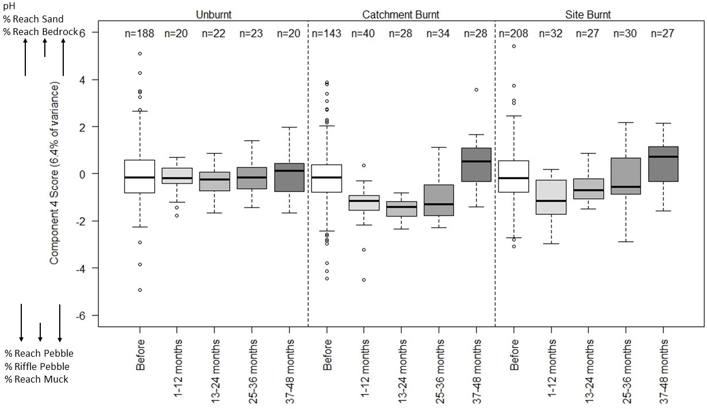

Figure S7.4. Boxplots of PCA component scores for principal component 4 at alpine sites. The variables labelled above and below the y-axis show their relationship of the component, with those above the y-axis tending to increase with high values of the component and those below the y-axis tending to increase with low values of the component.
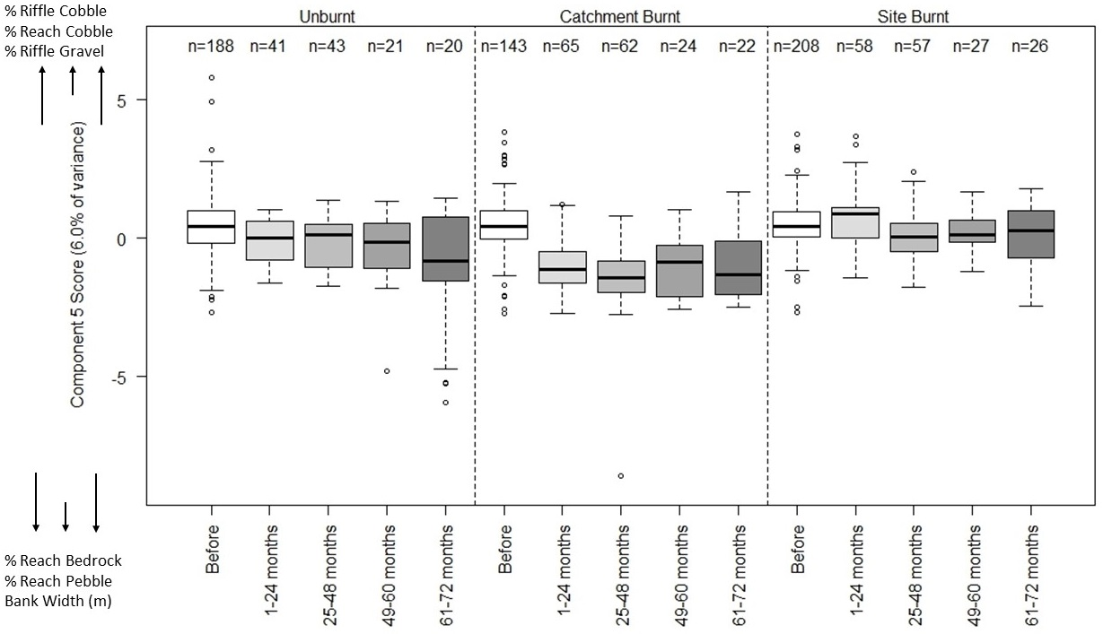

Figure S7.5. Boxplots of PCA component scores for principal component 5 at alpine sites. The variables labelled above and below the y-axis show their relationship of the component, with those above the y-axis tending to increase with high values of the component and those below the y-axis tending to increase with low values of the component.
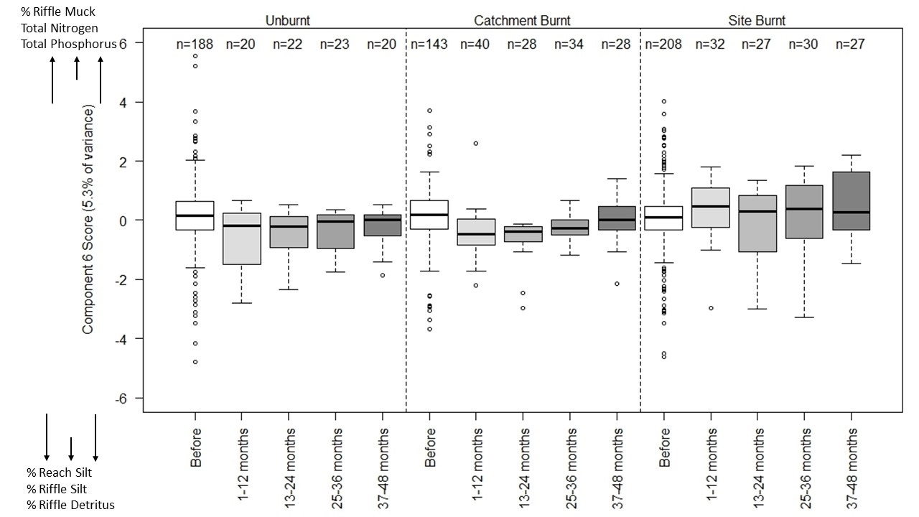

Figure S7.6. Boxplots of PCA component scores for principal component 6 at alpine sites. The variables labelled above and below the y-axis show their relationship of the component, with those above the y-axis tending to increase with high values of the component and those below the y-axis tending to increase with low values of the component.

Table S8.1. Summary of results for statistical tests of individual principal components for montane sites, for components explaining an arbitrarily selected >10% to total variation. The duration of change was determined using the linear mixed effects model with interaction term as described in the methods. Variables listed are the 3 highest and 3 lowest loading values for each principal component. Detailed results of statistical tests are provided in Tables S10.2 to S10.5.
 |  |  | Site Burnt |  | Catchment Burnt
Principle Component | Variable | Loading | Direction of Change | Duration | Direction of Change | Duration
1 (16.0%) | Rip trees > 10 m | 0.508554 | NA | NSS | NA | NSS
1 (16.0%) | Rip trees < 10 m | 0.489572 | NA | NSS | NA | NSS
1 (16.0%) | Bank height (m) | 0.359732 | NA | NSS | NA | NSS
1 (16.0%) | % Riparian shrub cover | -0.47114 | NA | NSS | NA | NSS
1 (16.0%) | Turbidity (NTU) | -0.17003 | NA | NSS | NA | NSS
1 (16.0%) | % Native vegetation | -0.12388 | NA | NSS | NA | NSS
2 (15.1%) | Alkalinity (mg/L CaCO₃) | 0.501808 | ↑ | Up to 12 months | NA | NSS
2 (15.1%) | Conductivity (µS cm⁻¹) | 0.500893 | ↑ | Up to 12 months | NA | NSS
2 (15.1%) | pH | 0.283612 | ↑ | Up to 12 months | NA | NSS
2 (15.1%) | Bank height (m) | -0.34201 | ↑ | Up to 12 months | NA | NSS
2 (15.1%) | % Native vegetation | -0.32394 | ↑ | Up to 12 months | NA | NSS
2 (15.1%) | Riparian trees < 10 m | -0.31175 | ↑ | Up to 12 months | NA | NSS
3 (14.2%) | % Native vegetation | 0.513648 | ↑ | Up to 12 months | ↑ | Up to 12 months
3 (14.2%) | Alkalinity (mg/L CaCO₃) | 0.360674 | ↑ | Up to 12 months | ↑ | Up to 12 months
3 (14.2%) | Conductivity (µS cm⁻¹) | 0.306884 | ↑ | Up to 12 months | ↑ | Up to 12 months
3 (14.2%) | % Riparian grass cover | -0.43806 | ↑ | Up to 12 months | ↑ | Up to 12 months
3 (14.2%) | Riparian trees > 10 m | -0.2286 | ↑ | Up to 12 months | ↑ | Up to 12 months
3 (14.2%) | Bank width (m) | -0.22389 | ↑ | Up to 12 months | ↑ | Up to 12 months
4 (10.0%) | Bank width (m) | 0.817721 | ↓ | Up to 36 months | NA | NSS
4 (10.0%) | % Riparian shrub cover | 0.325487 | ↓ | Up to 36 months | NA | NSS
4 (10.0%) | Bank height (m) | 0.294636 | ↓ | Up to 36 months | NA | NSS
4 (10.0%) | Turbidity (NTU) | -0.26103 | ↓ | Up to 36 months | NA | NSS
4 (10.0%) | Riparian trees < 10 m | -0.15365 | ↓ | Up to 36 months | NA | NSS
4 (10.0%) | pH | -0.01824 | ↓ | Up to 36 months | NA | NSS

Table S8.2. Results of statistical testing of principle component 1 (PC1) using a linear mixed effects model with interaction term as described in the methods. Results provided are for the interaction term only.
Component | Time since fire | Burn category | df | t-value | p-value
PC1 | 1-12 months | Cat burnt | 152 | -1.3312420 | 0.1851
PC1 | 13-24 months | Cat burnt | 154 | -0.8853711 | 0.3773
PC1 | 1-12 months | Site burnt | 152 | -0.9797048 | 0.3288
PC1 | 13-24 months | Site burnt | 154 | 0.2070722 | 0.8362

Table S8.3. Results of statistical testing of principle component 1 (PC2) using a linear mixed effects model with interaction term as described in the methods. Results provided are for the interaction term only.
Component | Time since fire | Burn category | df | t-value | p-value
PC2 | 1-12 months | Cat burnt | 152 | -0.7864925 | 0.4328
PC2 | 13-24 months | Cat burnt | 154 | 0.0257567 | 0.9795
PC2 | 1-12 months | Site burnt | 152 | 2.383355 | 0.0175
PC2 | 13-24 months | Site burnt | 154 | -1.0933839 | 0.2759

Table S8.4. Results of statistical testing of principle component 1 (PC3) using a linear mixed effects model with interaction term as described in the methods. Results provided are for the interaction term only.
Component | Time since fire | Burn category | df | t-value | p-value
PC3 | 1-12 months | Cat burnt | 152 | -2.598415 | 0.0103
PC3 | 13-24 months | Cat burnt | 154 | -1.389020 | 0.1668
PC3 | 1-12 months | Site burnt | 152 | -3.949269 | 0.0001
PC3 | 13-24 months | Site burnt | 154 | -1.571444 | 0.1181

Table S8.5. Results of statistical testing of principle component 1 (PC4) using a linear mixed effects model with interaction term as described in the methods. Results provided are for the interaction term only.
Component | Time since fire | Burn category | df | t-value | p-value
PC4 | 1-12 months | Cat burnt | 152 | 1.182486 | 0.2389
PC4 | 13-24 months | Cat burnt | 154 | 0.405254 | 0.6859
PC4 | 1-12 months | Site burnt | 152 | 3.524509 | 0.0006
PC4 | 13-24 months | Site burnt | 154 | 3.183426 | 0.0018
PC4 | 25-36 months | Site burnt | 156 | 2.0791951 | 0.0392
PC4 | 37-48 months | Site burnt | 160 | -0.305865 | 0.7601
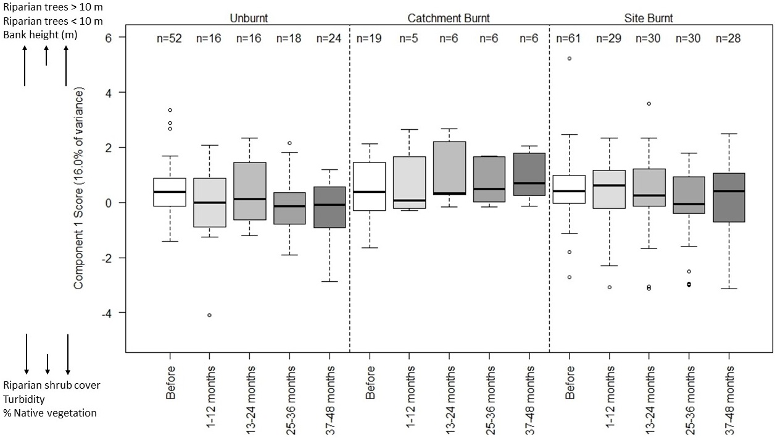

Figure S8.1. Boxplots of PCA component scores for principal component 1 at montane sites. The variables labelled above and below the y-axis show their relationship of the component, with those above the y-axis tending to increase with high values of the component and those below the y-axis tending to increase with low values of the component.

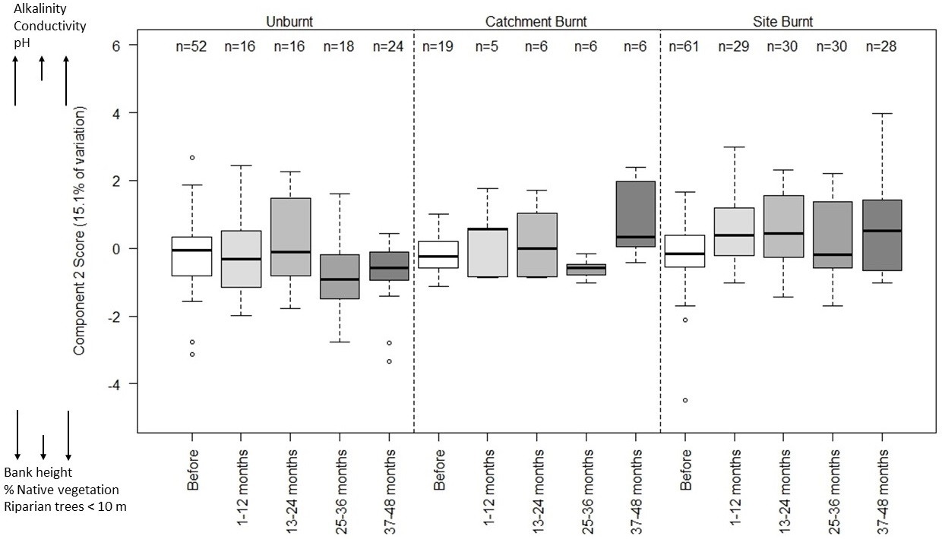
Figure S8.2. Boxplots of PCA component scores for principal component 2 at montane sites. The variables labelled above and below the y-axis show their relationship of the component, with those above the y-axis tending to increase with high values of the component and those below the y-axis tending to increase with low values of the component.

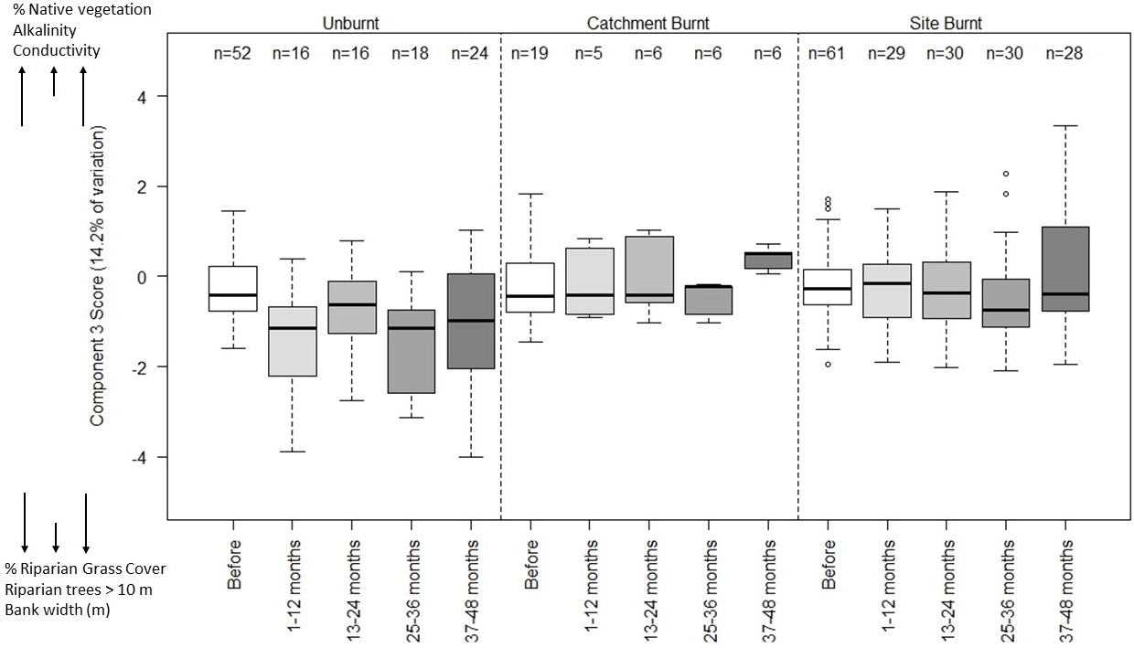
Figure S8.3. Boxplots of PCA component scores for principal component 3 at montane sites. The variables labelled above and below the y-axis show their relationship of the component, with those above the y-axis tending to increase with high values of the component and those below the y-axis tending to increase with low values of the component.

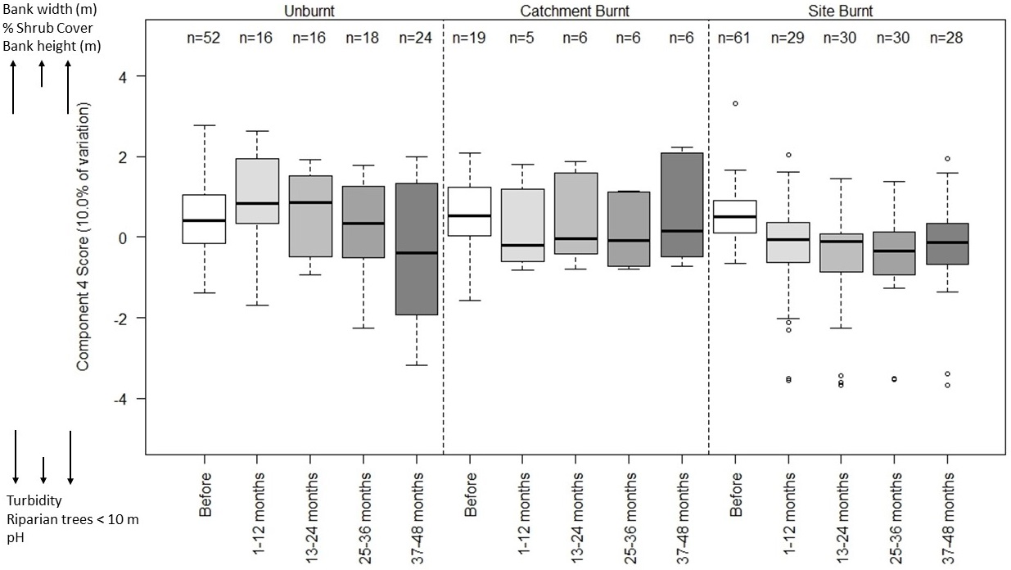
Figure S8.4. Boxplots of PCA component scores for principal component 4 at montane sites. The variables labelled above and below the y-axis show their relationship of the component, with those above the y-axis tending to increase with high values of the component and those below the y-axis tending to increase with low values of the component.

