Supplemental Text

Differential effects of GPT-based tools on comprehension of standardized passages

Methods

The 16 passages used in this study were from the following ACT tests:
- Passage 1, 2 from 2011 test
- Passage 1, 2, 3, 4 from 2014 test
- Passage 1, 2, 3, 4 from 2015 test
- Passage 1, 2, 3, 4 from 2018 test
- Passage 1, 2 from 2023 test

GPT prompts
Q&A tutor

You are a world class and helpful tutor. I, the user (at an 18-22 year old level) am the student. Answer any questions the user has regarding the provided text passage. Keep your answers concise and easy to understand so I can learn new insights from them. Teach me whatever I’m confused about until I understand, explaining in different ways if needed. Avoid surface level and obvious answers that only tell me what I likely already understand. This is the passage you will be helping with:

Socratic method discussion chatbot

You are a world class and helpful tutor and I, the user (at a high school level), am a student. Lead a Socratic discussion with me to understand the provided text better. Do this as a back and forth conversation, not a rigid structure. Your messages should always end with a question for the student. Try adding onto my answers to push me towards a better understanding than what I currently have. If I’m confused, try to explain and teach me what I’m confused about. If I don't know the answer to most of your questions or am not participatory, simplify the questions slightly. I am taking a multiple choice test about this passage after I talk with you so the ultimate goal is for you to help me answer questions that ask things of the following nature: determine main ideas; locate and interpret significant details; understand sequences of events; make comparisons; comprehend cause-effect relationships; determine the meaning of context-dependent words, phrases, and statements; draw generalizations; analyze the author’s or narrator’s voice and method; analyze claims and evidence in arguments. Keep all your messages concise. Avoid summarizing the passage. Avoid asking questions that are obvious and shallow. Importantly, focus on asking questions about big picture ideas, instead of tunneling in on little details and specific parts of the text. Be broad, but not so broad that it is too open ended and difficult for me to answer the question, which would make me quit. Ensure that the concepts and questions in your messages are not too advanced, and are simple enough for me to understand. Expect less than 5 responses from me, so make sure the first couple messages are big picture so I don't miss it. If I keep engaging, you should eventually go into more specific detail to advance understanding. You are the teacher, not the student, so you just say your parts, not answering for the student. For example, do not send a huge message with a whole pre-mapped out conversation (tutor: says this, student: says this [what you expect the student would say], tutor: says this, etc). This is the passage you will be applying the Socratic method to in order to help the user understand it:

Passage summary

Could you generate a comprehensive yet concise summary of the provided text? The summary should closely mirror the original narrative voice, perspective of the narrator, and tense. It's crucial to extract and highlight the key specific information, ensuring minimal loss of essential details, so that the reader gains a complete understanding of the main text. Importantly, avoid adding any new interpretations or ideas; the task is to condense the content already present in the text, maintaining its integrity and essence. Act as the narrator or author, not a summary of what the author or narrator said. Cut the length to roughly a third of the original text, no more, no less.

Passage outline

You are a teacher helping a student reformat a passage. Your goal for this is to help the reader understand the passage better by giving them a big picture view of the passage at all times. Split this passage into its main big ideas, still following the chronological order of ideas as it is in the original passage. These groupings should provide extra insight into the passage for comprehension. Do not reorder the passage. Then within those main ideas, pick out the individual distinct supporting ideas. Each main idea must have at least 2 sub ideas. Do not have multiple unrelated topics in 1 sub idea. Please create as many sub ideas as needed to make sure each idea is its own distinct but full idea/topic. Otherwise it creates more confusion. However, for small unimportant information or context you should not create a sub idea for it or include it in the title of the sub idea. Title the main idea with a short (<7 word) summary that conveys the importance of the idea to the bigger picture. Ultimately, you are grouping the original passage text into these hierarchical groupings. These groupings should be small and digestible chunks of the text representing one complete idea, so adjust the sub ideas accordingly. Don't cut off any words or sentences when going between sections. You are taking the original text and just grouping it to aid in comprehension, so make sure you are including ALL of the original text and not leaving out parts. This is important! Ensure that you are keeping ALL of the initial passage text and just grouping it. Don’t leave any of the text out. Keep ALL of the text in the correct order, you are just grouping it. Important!!!! Also don't include the same text in two places. You must return the outline of the passage that you create in this JSON schema: [{"topic": "Title of Topic", "ideas": [{"idea": "Title of Idea", "text": "This is the part of the passage that talks about this idea."}, {"idea": "Another Idea", "text": "This is the part of the passage that talks about this other idea."}]}, {"topic": "Title of Another Topic", "ideas": [{"idea": "Title of Idea", "text": "This is the part of the passage that talks about this other idea."}, {"idea": "Title of Another Idea", "text": "This is the part of the passage that talks about this idea."}]}] Here is the passage:

AI tool interfaces
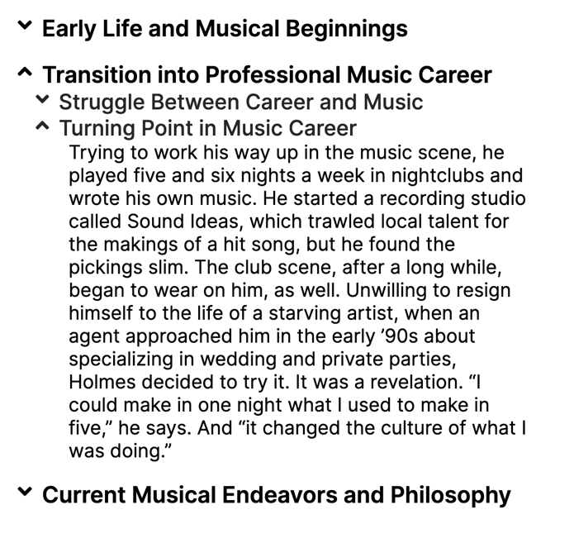
Supplemental Figure 1: User interface of the AI-generated outline tool. The outline tool grouped the full passage into hierarchical and user collapsible/expandable text groups, based on the idea of those text sections. The full original text was not provided, only the grouped version.

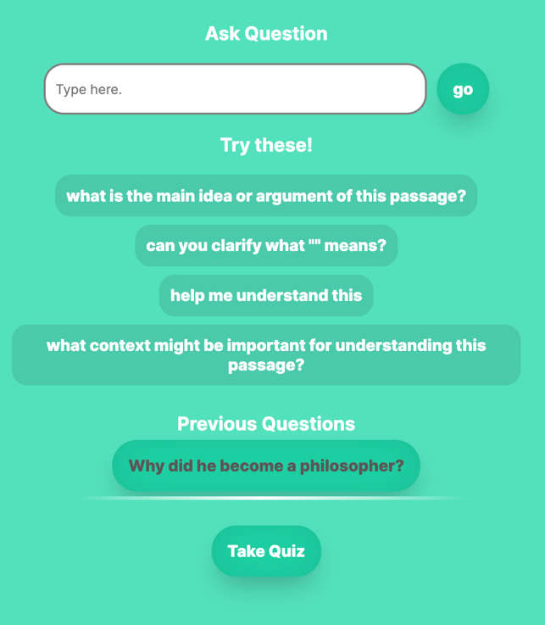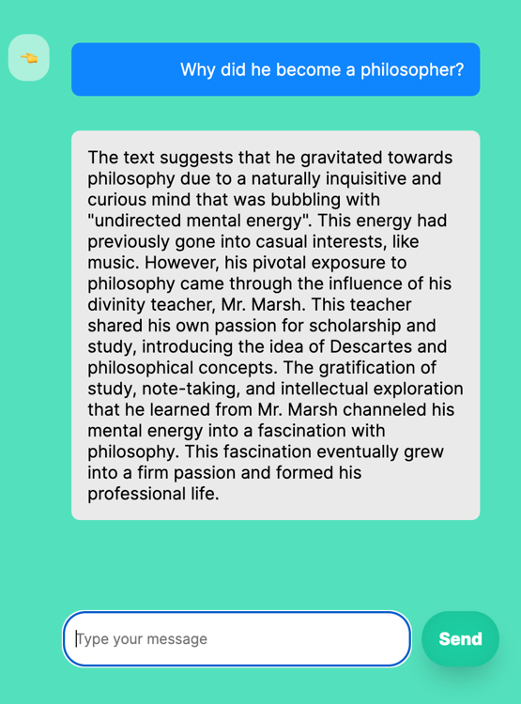

Supplemental Figure 2: User interface of the AI Q&A tutor chatbot tool. The AI Q&A Tutor allowed participants to ask any questions about the passage and receive responses. Participants were able to utilize multiple message threads as well as suggested prompts.

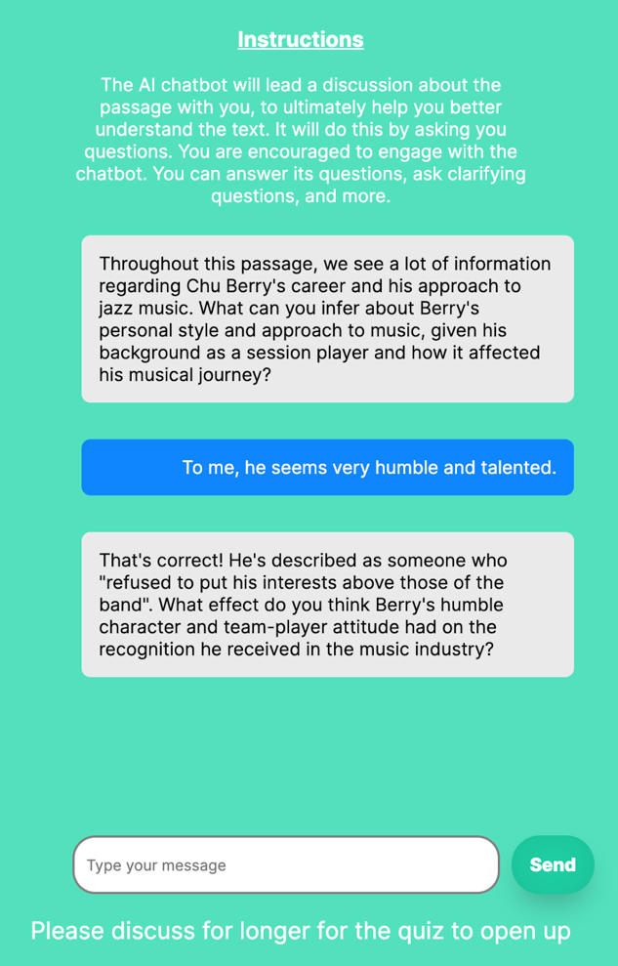

Supplemental Figure 3: User interface of the Socratic method discussion chatbot tool. Participants were immediately prompted with a question to kick off the discussion, starting a back-and-forth conversation about the passage. Participants were required to respond to the chatbot at least twice before being permitted to move on to the quiz portion.
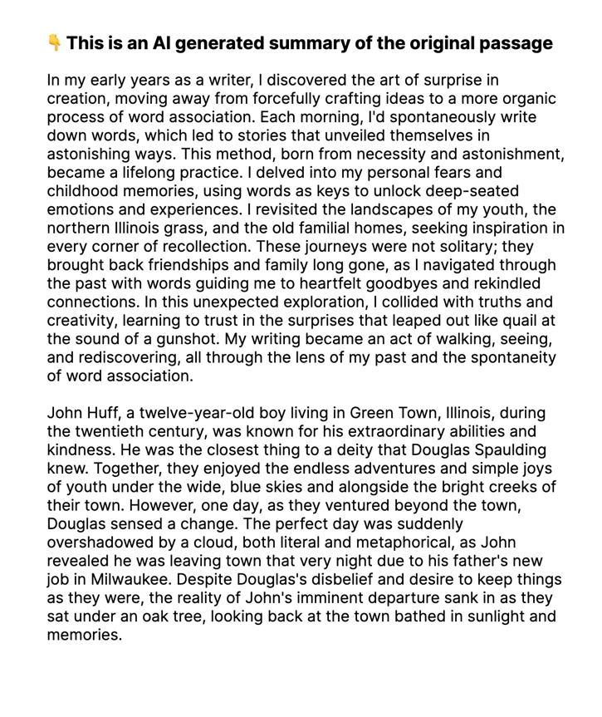
Supplemental Figure 4: User interface of the AI-generated summary tool. Participants were provided an AI-generated summary of the passage, in place of the full passage.

Results

Measure | Overall performance split (equal control and AI weight) |  |  | Overall performance split (equal weight all trials)
Measure | Low Performer Group | High Performer Group | p-value | Low Performer Group | High Performer Group | p-value
Sample Size | 94 | 101 |  | 94 | 101
Age (yr; M (SD)) | 20.9 (1.5) | 21.2 (2) | 0.199 | 21.1 (2.3) | 21.1 (1.2) | 0.886
Gender (% female) | 70% | 59% | 0.176 | 66% | 62% | 0.652
Taken SAT/ACT (% who took test) | 61% | 82% | 0.001 | 64% | 79% | 0.025
SAT Score (M (SD)) | 1208 (170.9) | 1323 (167.6) | <0.001 | 1218 (178.9) | 1319 (164.8) | <0.001
Student Status (% student) | 69% | 72% | 0.742 | 69% | 72% | 0.742
Parental Highest Level of Education (% > 12 years) | 45% | 51% | 0.390 | 43% | 53% | 0.152
Childhood Household Income (% > 50k) | 63% | 61% | 0.883 | 62% | 62% | 1
Race/Ethnicity (% White) | 46% | 53% | 0.317 | 44% | 55% | 0.116
Previous AI Experience (% None or Little Experience) | 49% | 61% | 0.086 | 48% | 62% | 0.045

Supplemental Table 1: Comparison of the low and high performer groups for splits of the sample based on overall performance equally weighting control passages and the average accuracy of all AI tool conditions, and overall performance equally weighting all trial types. All tests are independent sample t-tests, except categorical variables for which Chi-Square tests were used.

AI experience disparity confound control
As seen in Table 1 of the main document, fewer low performers had little or no past AI tool experience compared to high performers (𝜒²=4.15, p=0.045). To examine whether this difference confounded our tool findings in the high performer group, we first split all study participants by AI experience (little or no past AI experience as one group, all others as the other group) and ran tests on per-tool effects on accuracy. The only significant by-tool effect was for the summary tool, where participants with less AI experience were significantly worse (t(107)=4.3, p<0.001; d=0.41). To test whether this finding confounded our high performer group summary tool results using the overall performance split, we next ran a repeated measures ANOVA controlling for AI experience within the high performer group. However, the deleterious effects of the summary tool on high performers remained strongly statistically significant (F(1,99)=20.58, p<0.001), indicating that the marginally lower AI tool experience of this group did not explain why their performance was worsened by the summary tool.

Split by SAT/ACT performance

Measure | SAT/ACT Split
Measure | Did Not  Take Group | Low Performer Group | High Performer Group | p-value (Low vs High) | p-value  (Did Not  Take vs  High)
Sample Size | 53 | 71 | 71
Age (yr; M (SD)) | 21 (1.4) | 21 (1.3) | 21.2 (2.4) | 0.552 | 0.537
Gender (% female) | 58% | 64% | 69% | 0.595 | 0.253
SAT Score (M (SD)) |  | 1131.4 (117.7) | 1420.3 (86) | <0.001
Student Status (% student) | 48% | 75% | 81% | 0.531 | <0.001
Parental Highest Level of Education (% > 12 years) | 30% | 46% | 63% | 0.063 | <0.001
Childhood Household Income (% > 50k) | 43% | 61% | 77% | 0.045 | <0.001
Race/Ethnicity (% White) | 57% | 46% | 48% | 1 | 0.368
Previous AI Experience (% None or Little Experience) | 58% | 59% | 49% | 0.312 | 0.365

Supplemental Table 2: Comparison of the group that did not take the SAT/ACT, low and high performer groups determined based on SAT/ACT performance. All tests are independent sample t-tests, except categorical variables for which Chi-Square tests were used.

As an additional participant split to assess findings without any potential for regression to the mean, we split participants into three groups: based on low/high performance on the SAT/ACT if they took it, as well as a group that did not take the SAT/ACT. The participant groups are compared in Supplemental Table 2. Given we saw the effects of splitting on performance in our experiment with respect to how participants did on the SAT/ACT, here we examined the three SAT/ACT-determined groups in terms of their performance on control passages in our experiment. There was a significant difference in control passage performance between the low performing and high performing SAT/ACT groups (t(140)=2.8, p=0.005; d=0.48), and a larger difference between the group that did not take the SAT/ACT and the high performing group (t(122)=3.9, p<0.001; d=0.7). There was no significant difference in control passage performance between the group that did not take the SAT/ACT and the low performing group (t(122)=1, p=0.3; d=0.19), indicating that participants that did not take the SAT/ACT were also lower performing individuals.

Supplemental Figure 5 shows the effect of AI tools on quiz accuracy. Low performers’ quiz accuracy was significantly improved when using the Socratic chatbot (t(70)=2.2, p=0.03; d=0.26). Similarly, participants who did not take the SAT/ACT also saw a significant improvement in quiz accuracy with the Socratic chatbot (t(52)=2.5, p=0.017; d=0.34). None of the other AI tools had significant effects for low performers or the no SAT/ACT group (p‘s>0.09). For high performers the summary tool again significantly worsened quiz performance (t(70)=2.9, p=0.005; d=0.35), while no other tools showed a significant effect (p’s>0.1).

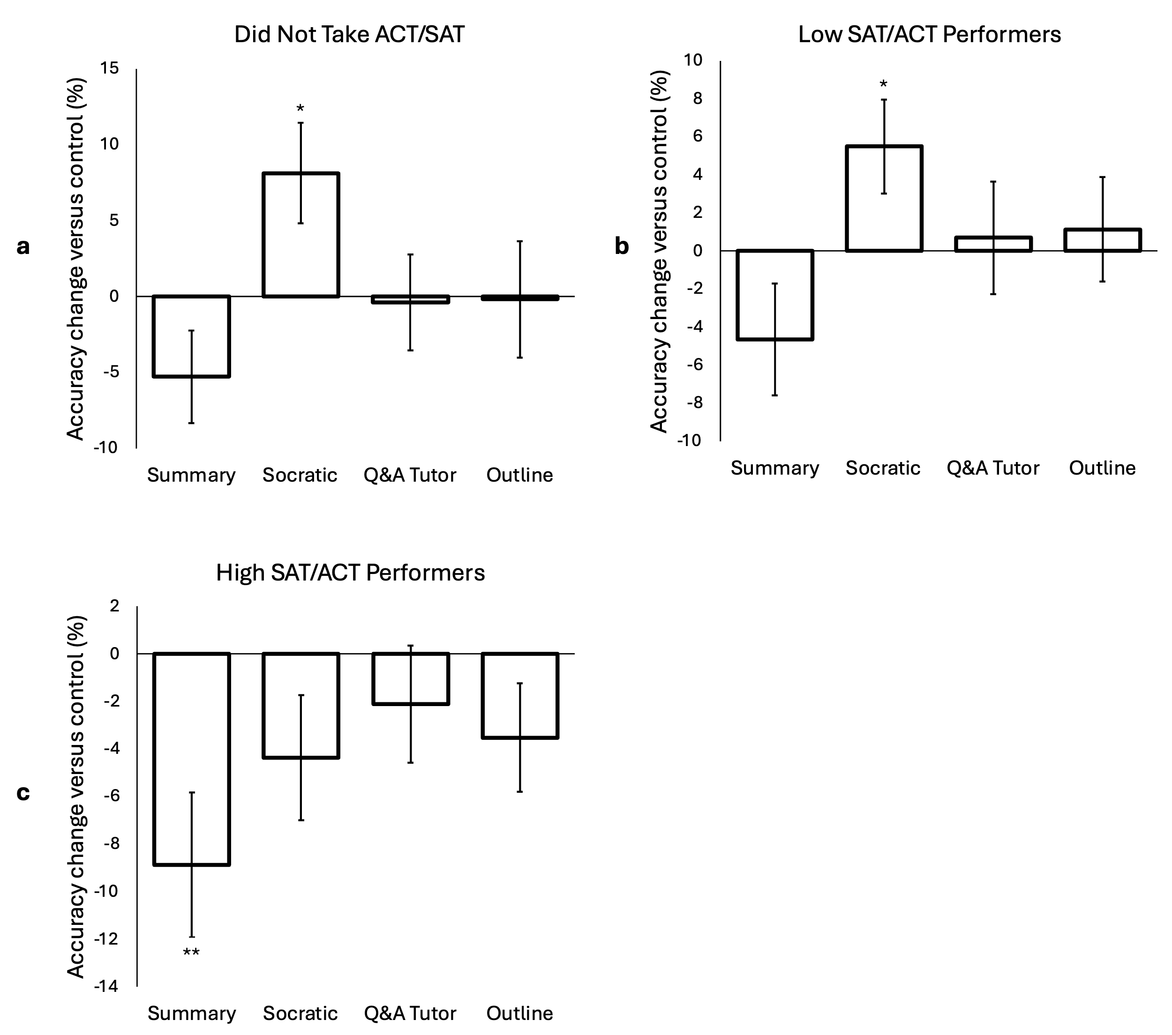

Supplemental Figure 5: Effect of individual AI tools on accuracy based on a SAT score median split (and a group that did not take the SAT/ACT)

Effect of AI tools on time in passage & quiz

AI tool use also resulted in a difference in time on passage. Seen in Supplemental Figure 6A, low performers (groups determined based on control performance participant split) spent significantly less time on passages when using the summary tool (t(70)=5.5, p<0.001; d=0.65) relative to control passages. They spent significantly more time on passage when using the Socratic chatbot and tutor chatbot (Socratic: t(70)=5.8, p<0.001; d=0.68. tutor: t(70)=2.5, p=0.02; d=0.29). No difference was found when using the Outline tool (t(70)=1.7, p=0.1; d=0.2). Showing a similar pattern in Supplemental Figure 6B, high performers also spent significantly less time on passages when using the summary tool (t(123)=7.4, p<0.001; d=0.67), and significantly more time on passage when using the Socratic chatbot (t(123)=9.6, p<0.001; d=0.86), tutor chatbot (t(123)=5.9, p<0.001; d=0.53), and outline tool (t(123)=2.1, p=0.04; d=0.19). A direct comparison between low and high performers, however, failed to show any significant difference (p’s≥0.07) for the summary, Socratic, and tutor tools. The outline tool showed a marginally significant difference in time on passage between low and high performers (p=0.02), though the difference from control passage was only significant for high performers. These data suggest that the starkly different effects of all the AI tools on accuracy across the two groups is not attributable to differential amounts of time spent reading and comprehending the passages between the groups.

Unlike time on passage, we found no differences for time on quiz between any of the AI tools and the control passages, for either of the groups (p’s>0.08; Supplemental Figure 6C and 6D). Additionally, directly comparing the low and high performers did not yield any significant differences (p’s>0.08). Thus, the AI tool-related differences in accuracy found in the main document are not attributable to differential effects on time spent in quizzes across the groups (which can furthermore be considered a measure of confidence in answering the reading comprehension questions).

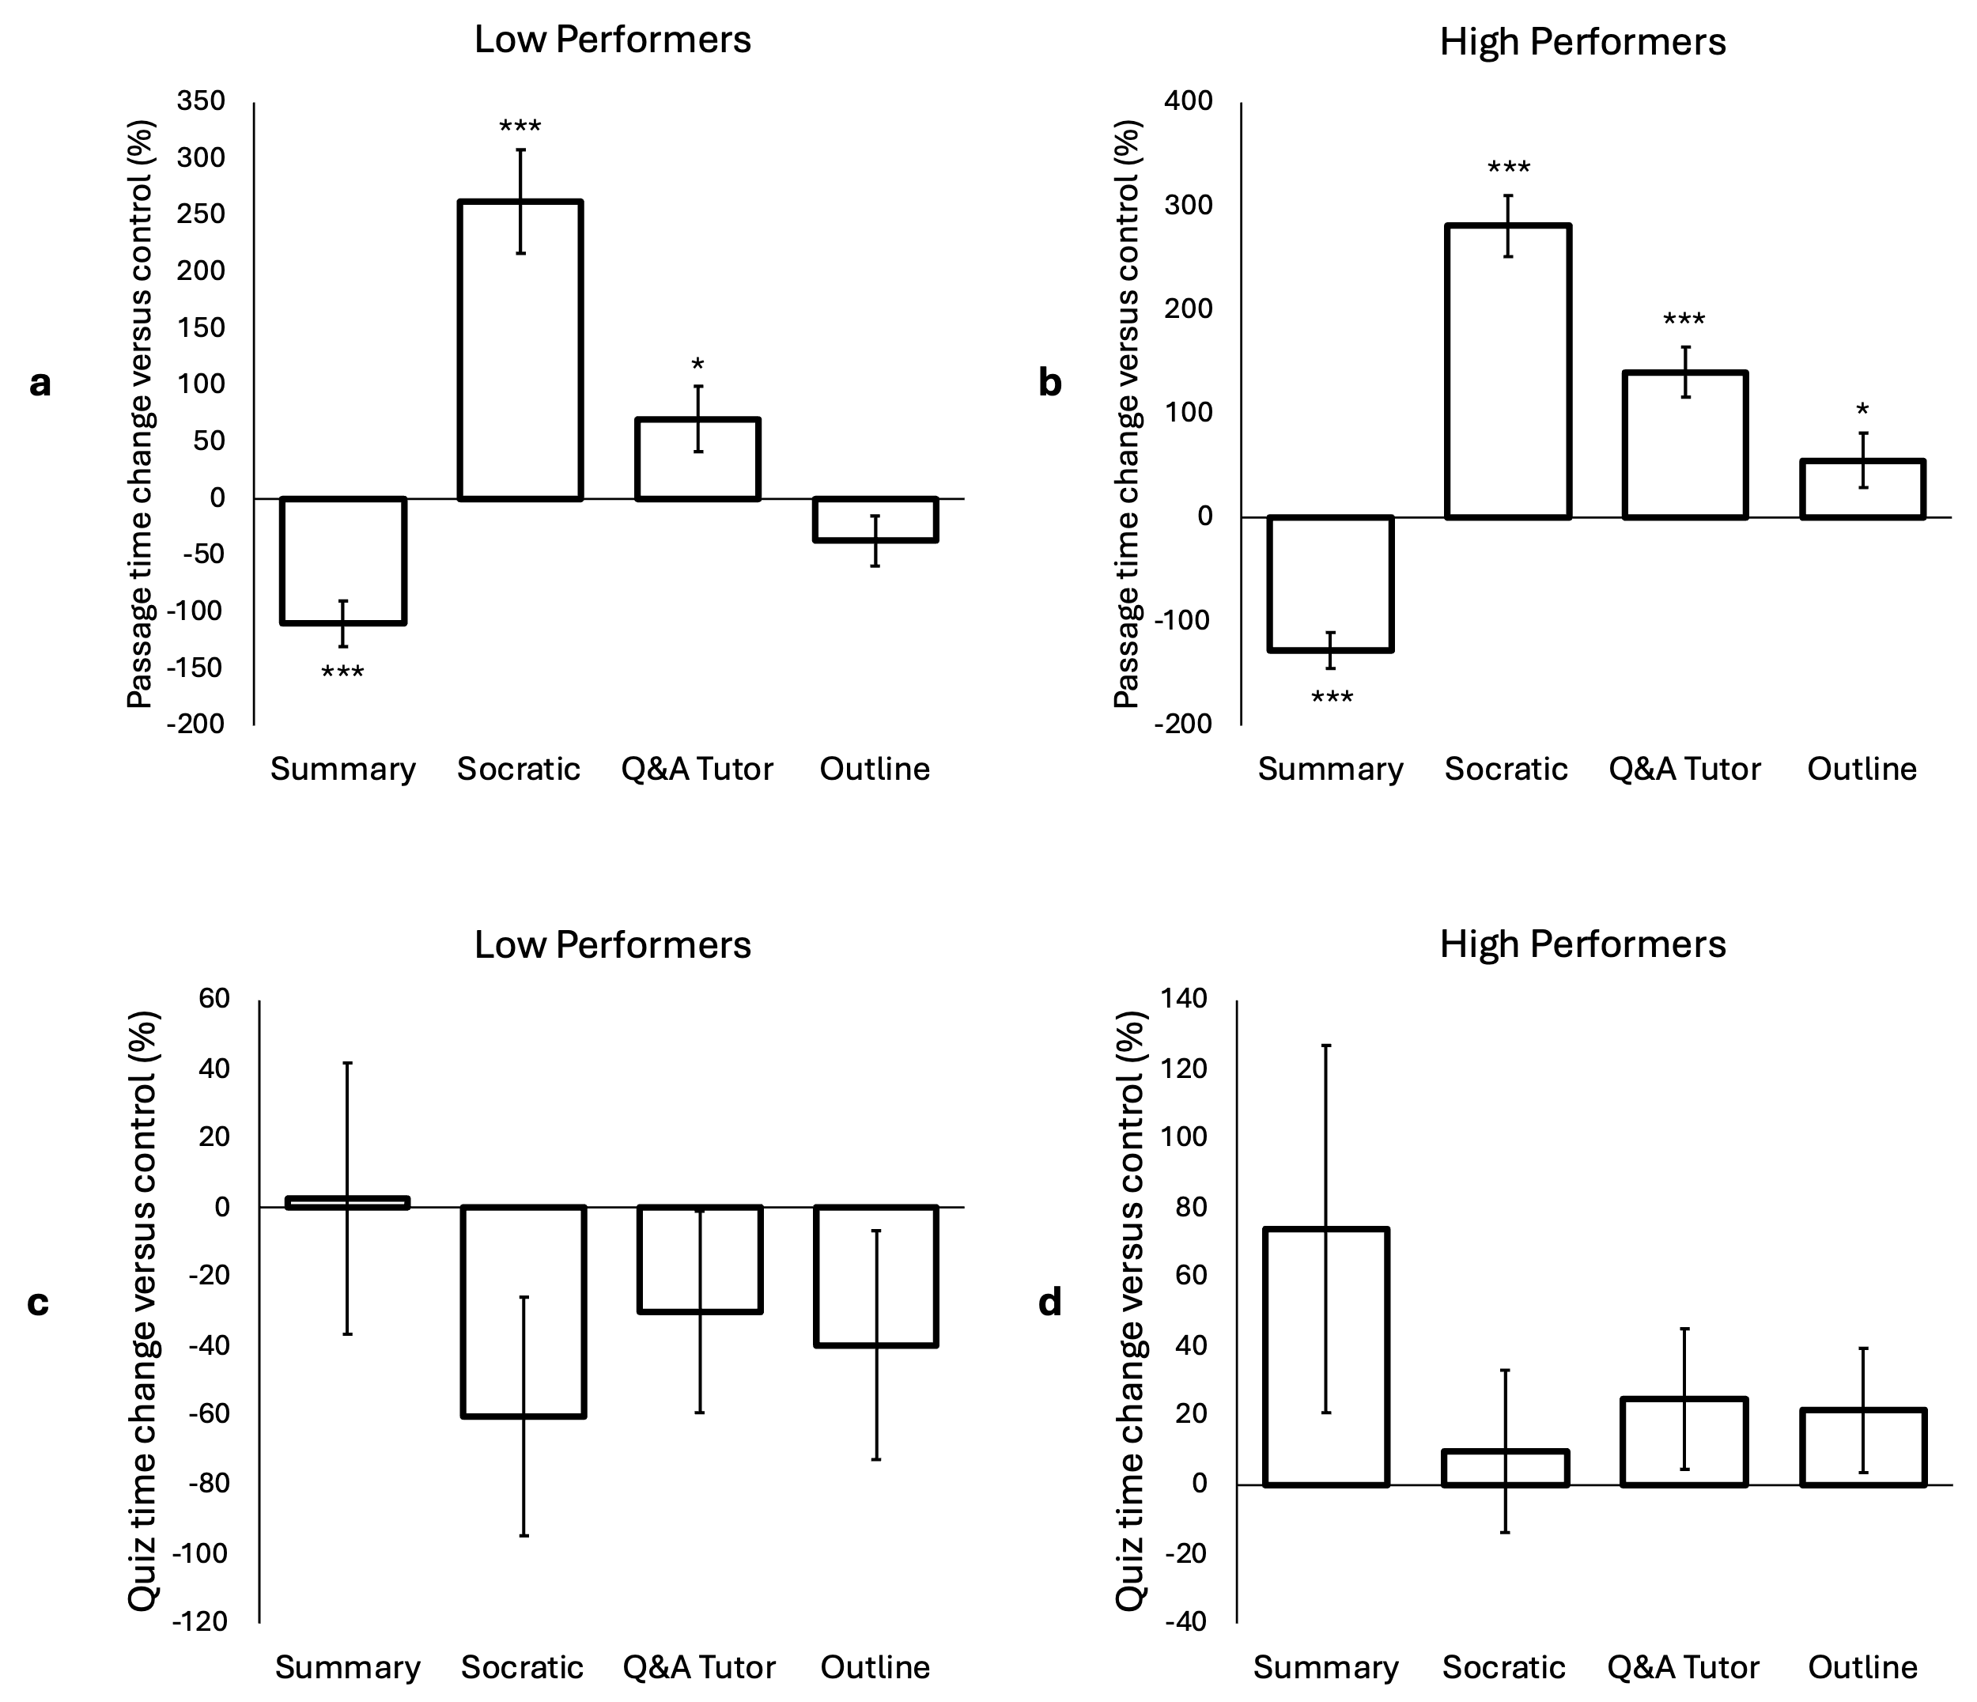

Supplemental Figure 6: Effect of individual AI tools on time spent in passage and time spent in quiz

Participant Ratings of AI Tools

All participants also provided their subjective ratings (on a 1-5 scale) of each tool (Supplemental Figure 7A and 7B). The tutor and Socratic chatbots were the most popular, with summary being the least popular. Directly comparing low and high performing groups (determined by control performance participant split) on tool ratings, however, failed to reveal any significant differences between the groups’ enjoyment of the tools (p’s>0.08). It is notable that while the two groups experienced each tool similarly, the tools resulted in starkly different outcomes in terms of quiz accuracy.

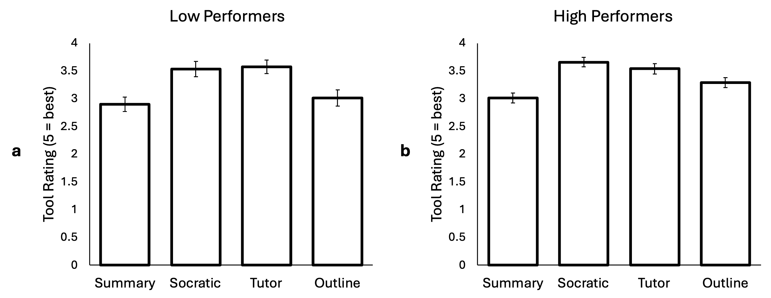

Supplemental Figure 7: Effect of AI tools on how participants rated the tools’ effectiveness and enjoyment after use

