Materials and Methods

1．Study Participants

This study involved a cohort of 20 healthy adult volunteers (5 males and 15 females) aged 18 to 75 years, with a mean age of (25.53±1.47) years. Their primary data, including gender, age, height, weight, and body mass index (BMI), were recorded.

Inclusion criteria: (1) age within 18 to 75 years; (2) general health criteria: (a) BMI ≤28 kg/m², (b) fasting blood glucose (FBG) <6.1 mmol/l, (c) OGTT 2-hour blood glucose <7.8 mmol/l, (d) glycated hemoglobin (HbA1c) <5.7%, (e) total cholesterol <200 mg/dL, (f) triglycerides (TG) <150 mg/dL, (g) high-density lipoprotein cholesterol (HDL-C) >50 mg/dL, (h) LDL-C <130 mg/dL; (3) willingness to provide informed consent and commitment to long-term follow-up.

Exclusion criteria: (1) impaired consciousness or inability to comply with treatment; (2) use of weight-loss medications; (3) pregnancy or lactation; (4) history of endocrine metabolic diseases; (5) severe respiratory diseases; (6) unstable heart failure or recent myocardial infarction; (7) recent clinical cardiovascular events such as stroke, heart attack, coronary intervention, bypass surgery, carotid intervention, lower limb arterial reconstruction, acute coronary syndrome, or abnormalities in cardiac tests; (8) History of gastrointestinal surgery; (9) history of acute or chronic pancreatitis; (10) history of liver diseases; (11) presence of proteinuria, including 24-hour urine protein ≥600 mg/d or urine protein-to-creatinine ratio ≥600 mg/g; (12) calculated glomerular filtration rate less than 60 ml/min/1.73m2 or undergoing renal dialysis; (13) severe chronic infections, such as pulmonary tuberculosis; (14) neurological disorders, including neurogenic anorexia, Alzheimer's disease, epilepsy, depression; (15) concurrent malignant tumors; (16) simultaneous participation in another clinical study; (17) other conditions deemed unsuitable for inclusion by researchers, such as: (a) past 12-month history of alcohol or drug abuse; (b) presence of other medical, psychological, or behavioral factors impacting study compliance.

The Jiangsu Provincial Hospital of Traditional Chinese Medicine and Western Medicine Ethics Committee approved this study. All participants provided written informed consent.

2. Study Protocol

To ensure robust baseline data collection, a randomized crossover study was designed. Healthy adults meeting inclusion criteria were randomly assigned to two groups: the eTRE group and the lTRE group. Collected were baseline data about height (Ht), weight, Wc, visceral fat area (VFA), body muscle mass (BMM), BP, heart rate (HR), FBG, 2-hour postprandial blood glucose (2hPBG), glycated hemoglobin (HbA1c), thyroid-stimulating hormone (TSH), fasting cortisol, free triiodothyronine (FT3), free thyroxine (FT4), serum adrenaline, liver function, kidney function, lipid profile, electrolytes, complete blood count, C-reactive protein (CRP). In addition, body composition analysis and the Pittsburgh Sleep Quality Index (PSQI) questionnaire survey were performed.

The study consisted of three phases: the eTRE intervention phase, the washout phase, and the lTRE intervention phase. The "16+8" TRE protocol for dietary intervention was adopted, eating during an 8-hour window and fasting during a 16-hour window daily. Specifically, the eTRE group had an eating window from 7:00 to 15:00 and a fasting window from 15:00 to the next 7:00. The lTRE group had an eating window from 11:00 to 19:00 and a fasting window from 19:00 to the next 11:00.

During the eating window, the participants were allowed to take in food of any type or calorie level. They were required to record the dietary information for each meal. In the fasting window, participants were limited to water or non-caloric beverages. Continuous glucose monitoring devices were used to track daily mean blood glucose levels and compliance with interventions throughout the study.

This was a 6-week randomized, controlled crossover clinical trial conducted in a population of healthy adult Chinese individuals. The study comprised two 2-week dietary intervention periods: (1) early TRE and (2) late TRE. After a 4-week run-in period, participants were randomly assigned to 2 weeks of eTRE or two lTRE as their first intervention. The first intervention phase was followed by a 2-week washout period before the second phase of TRE intervention, which was performed in an opposite time sequence.

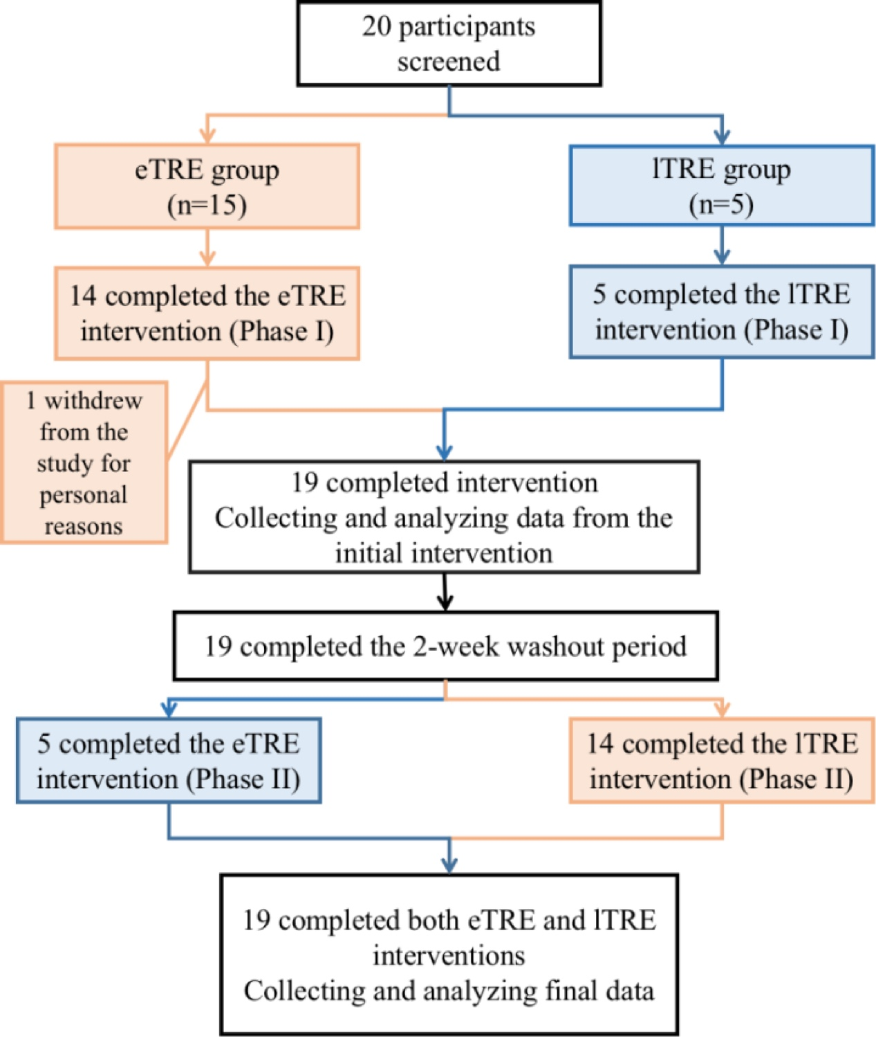
Figure 1 TRE flow chart
(1)TRE Protocol
1)Participants independently conducted eTRE/lTRE at home according to the intervention plan, with each TRE lasting two weeks.
2) Participants were provided Continuous glucose monitoring devices to track mean blood glucose levels throughout the intervention and increase participant compliance.
3)Dietary menus: A nutritionist designed menus for participants based on the 2011 "Chinese Dietary Guidelines."
4)eTRE: Participants had the first meal at 7:00, the second at 11:00, and the last at 15:00; all dietary intake during this period was recorded. Caloric intake was not restricted, and no food was taken in after 15:00.
5)lTRE: Participants had the first meal at 11:00, the second at 15:00, and the last at 19:00; all their dietary intake was recorded. Caloric restrictions and no food was taken in after 19:00.
6)Participants were encouraged to consume 2-3 liters of water daily and perform unrestricted daily activities and resistance exercises (e.g., push-ups, dumbbells, barbells, etc.; 10-20 minutes/set, 1-2 sets/day). Weekly communication with nutritionists allowed for monitoring subjective experiences (such as appetite and discomfort symptoms) and real-time adjustments for the intervention.
7)Self-monitoring during TRE: Participants maintained a "dietary diary," recording daily meals, morning weight, Wc, BP, heart rate (HR), and any adverse reactions.
8)Assessment of biological parameters: Biochemical markers, HbA1c, and sleep quality were assessed using the PSQI scale before and after two TRE interventions.
(2) Washout Protocol:
1)Duration: 2 weeks.
2)Dietary menus: Under a nutritionist's guidance, participants resumed their pre-intervention diet. No restrictions were imposed during the eating window. However, participants were strongly advised to avoid overeating or binge eating during the washout period.
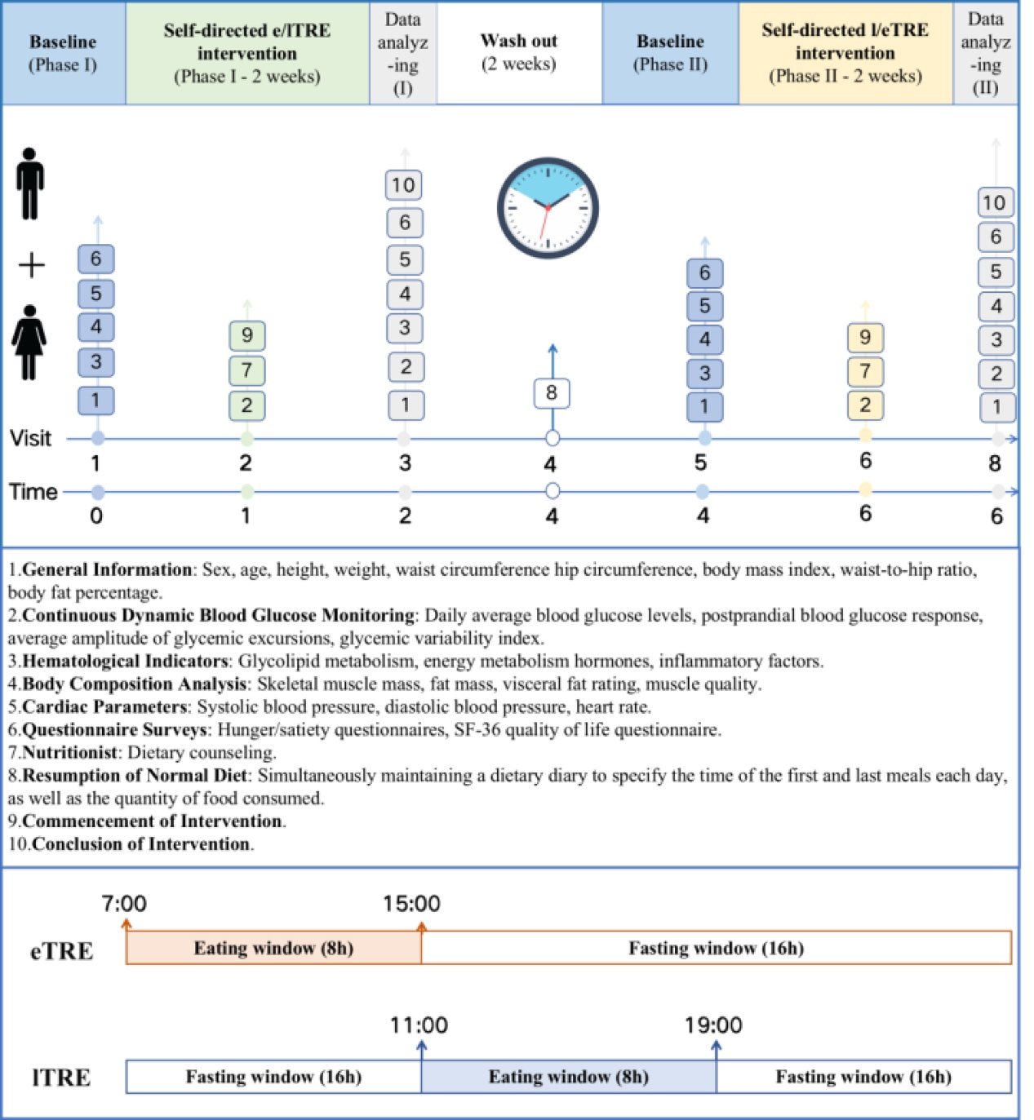
Figure 2 TRE flow chart

3. Assays

Venous blood samples were collected from participants at 8:00 am following a 10-hour overnight fast. The Roche Cobas 8000 system was utilized to analyze various parameters, including FBG, 2hPBG, aspartate aminotransferase (AST), alanine aminotransferase (ALT), alkaline phosphatase (ALP), serum creatinine (Scr), uric acid (UA), blood urea nitrogen (BUN), serum calcium (Ca), potassium (K), phosphate (P), sodium (Na), cortisol, and other relevant indicators. HbA1c levels were measured using ion-exchange high-performance liquid chromatography with reagents from BIO-RAD Corporation (USA). Fasting insulin (FINS) and C-peptide levels were determined via chemiluminescence using Roche Diagnostics Products (Shanghai) reagents.

4. Statistical Analysis

Statistical analyses were performed using Stata version 26.0 software. Normally distributed continuous variables were presented as mean±SEM, while non-normally distributed variables were expressed as median (interquartile range). Between-group comparisons were accomplished by independent sample t-tests, while within-group analyses by paired t-tests, with statistical significance set at P<0.05.

Additionally, a subgroup analysis was carried out to examine the impact of eTRE/lTRE interventions on sleep quality categorized as either "good" or "poor" sleep. A baseline PSQI total score of ≤5 was designated as having "good sleep quality," while >5 as "poor sleep quality."

