Supplementary Material:
Additional background on Brazil's Amazonian deforestation
Although the greenhouse-gas emission per unit of beef in Latin America is the greatest in the world (FAO, 2019), the region also has the largest mitigation potential for CO2 emissions by avoiding conversion of forest and by implementing reforestation projects (Griscom et al., 2020). We note that, in Amazonia, the first priority is controlling deforestation, not restoring already deforested areas, as the benefit for climate, biodiversity and traditional peoples is very much higher both per hectare and per unit of investment (Ferrante & Fearnside, 2021a). Reforestation and restoration will become priorities once deforestation has been halted.
In addition to deforestation and land-use change, forest degradation is another significant driver of carbon dioxide (CO₂) emissions in Amazonian forests (Covey et al., 2021; Qin et al., 2021). Forest degradation has surpassed deforestation in terms of its extent (Matricardi et al., 2020), emerging as a potential primary driver of carbon loss in the Brazilian Amazon (Lapola et al., 2023; Qin et al., 2021; Silva Junior et al., 2021b). The main processes associated with forest degradation are direct human interventions (selective logging and forest fires), edge effects (primarily caused by deforestation) and droughts (Albert et al., 2023; Berenguer et al., 2021; Boulton et al., 2022). Although monitoring forest degradation and disturbances in vast areas over the long term remains a challenge (e.g., Barni et al., 2021; da Silva et al., 2022; Dutra et al., 2023; Lapola et al., 2023), various recent studies have suggested that policies that address degradation should be integrated with efforts to curb deforestation in order to reduce CO2 emissions in Amazonian forests (e.g., Berenguer et al., 2021; Matricardi et al., 2020; Silva Junior et al., 2023).
The time series of deforestation shown in this study reveal the importance of supply-chain interventions and public policies in slowing the rate of forest loss in the Brazilian Legal Amazon. For example, the Action Plan for Prevention and Control of Deforestation in the Legal Amazon (PPCDAm) was launched in 2004, after combating deforestation in tropical forests became a priority in the international political agenda (Burgess et al., 2012; Stern, 2008). In 2008, the Brazilian Institute for the Environment and Renewable Natural Resources (IBAMA) created a “blacklist” of municipalities with high deforestation rates. Landholdings in municipalities listed on the blacklist were restricted from obtaining highly subsidized loans from government banks for agriculture and ranching and had to meet additional requirements to obtain licenses for forest management. In addition, they were subjected to enhanced enforcement by IBAMA. In the same year, the Brazilian Central Bank implemented a resolution (BACEN 3545/2008) blocking properties with fines pending in environmental agencies from receiving loans from government banks for agriculture and ranching (Fearnside, 2015). These measures were effective in reducing deforestation rates in these municipalities until 2012 (Arima et al., 2014; Cisneros et al., 2015). However, the prevalence of cleared patches of over 100 ha, which indicates medium and large actors, has increased steadily since 2010 and it surged substantially under the Bolsonaro administration in 2019 and 2020 (Trancoso, 2021).
The UK government wants to introduce a law to ensure that the products they sell (and the entire supply chains of larger companies) are free from illegal deforestation (EAC, 2024). According to this proposal, UK businesses must prove that commodities (i.e., soy, palm oil, beef and cacao) have not originated from illegal sources. Although the volume of Brazilian exports to the UK is much smaller than the volume exported to the US, trade restrictions proposed by the British government could trigger a reaction from the EU. A letter signed by 602 European scientists and two Brazilian Indigenous organizations urges the EU to support their principles of respecting human rights and dignity (Kehoe et al., 2019). The authors of the letter propose that trade between Brazil and the EU should be conditional on consulting indigenous people and local communities to define environmental criteria for traded commodities, improving procedures to trace commodities associated with illegal activities, and upholding the UN’s Declaration of Rights of Indigenous Peoples. However, as we have described the process of transformation of cattle pastures into soy plantations, this important role of soy escapes any effect of measures by the European Union or others banning imports of soy from areas deforested for this crop, even though a hectare of cattle pasture converted to soy has a much greater impact on deforestation than a hectare of forest that is cleared for soy (Fearnside, 2017).
On May 20, 2020, 43 British companies (including major supermarkets) signed a letter to Brazilian federal deputies and senators showing concern about the proposed “land-grabbers’ law” (PL 2633/2020) that would legalize private occupation in public lands, mostly in Amazonian forests. The proposed law would make permanent the provisions of a now-expired provisional measure (MP 910) issued by President Bolsonaro (“Provisional measures” are executive orders valid for 120 days) and would further facilitate legalizing large illegal claims to government land (Fearnside, 2020b). The bill continues to advance in the National Congress despite the change in presidential administrations (Fearnside, 2023e).
Both Bolsonaro and Lula have stated that the economic restrictions proposed by the European Union, the UK and the US are intended to isolate Brazil’s agribusiness, which is the “engine” of Brazil’s economy. Contrary to this assertion, we argue that Brazilian agribusiness does not depend on deforestation to maintain its leadership in the world (see Macedo et al., 2012); instead, illegal deforestation is simply thriving in the shadow of irresponsible natural resource mismanagement. For example, the Brazilian Climate, Forestry and Agriculture Coalition—262 entities linked to agribusiness, the financial sector, environmental organizations, and academia—sees the Brazilian government as one of the main actors responsible for environmental crimes that dominate the wood market in the country, given the fragility of law enforcement by government authorities in this sector (Esteves, 2019).
In 2009, four of the world’s largest cattle producers signed a zero-deforestation cattle agreement, committing them not to buy cattle from newly deforested areas and from ranches that use “slave” labor practices or that illegally occupy Indigenous lands or other protected areas in the Amazon. Although the agreement helped to reduce deforestation rates in supplying properties (Gibbs et al., 2015), it triggered a “cattle washing” effect, where, due to lack of traceability, ranchers use legalized ranches to conceal sales of cattle raised in illegal areas through false declarations of origin (Campos, 2019; Radwin, 2021).
In Brazil, the Bolsa Floresta Program (BFP) is a forest conservation initiative benefiting over 35 thousand individuals across 15 CUs in the State of Amazonas (Viana et al., 2012). This program integrates direct conditional payments with targeted investments in livelihoods. While the program had a small additional impact on the conservation of the CUs where it was implemented, it prioritized areas with low deforestation pressure, and greater additionality could be achieved by extending the project to larger areas with greater agricultural profit potential facing higher deforestation pressures (Cisneros et al., 2022). Although the implementation of a similar program in Brazil has the potential to curb deforestation, it must be accompanied by close monitoring and inspection to ensure that money earmarked for conservation is not reinvested in new deforestation projects in other locations, resulting in the leakage of the program benefits. Currently, CUs cover around 116 million ha, or 28% of the Brazilian Amazon (CNUC, 2024). In 2013, both the Federal and State Brazilian Courts of Auditors (TCU and TCE, respectively) found that only 4% of these CUs were effectively implemented, meaning they were receiving the necessary resources, tools, and infrastructure for their management and for successfully achieving their objectives. Inadequate or nonexistent implementation exposes the vast areas in these conservation units to illicit exploitation of resources (such as illegal logging) and to occupation by land grabbers. Araujo et al. (2016) found that 46 of the 50 (92%) most heavily deforested CUs in the Brazilian Amazon between 2012 and 2014 were under low or moderate levels of implementation.
Between 2017 and 2019 the emission of dangerous fine particulate pollutants by forest fires in the Apyterewa Indigenous Land located in the eastern of Brazilian Amazonia was 6258 Mg (tons) year⁻¹, a value almost 75% higher than the 3594 Mg year⁻¹ observed for the period between 2004 and 2016 (de Oliveira et al., 2020a). These particulate pollutants are a significant respiratory risk factor and were of even greater concern at the peak of the COVID-19 pandemic (de Oliveira et al., 2020b).
In 2018 the United States initiated tariffs of up to 25% on imports of Chinese goods, leading to a retaliatory response from the Chinese government, which imposed 25% tariffs on US goods. Consequently, US soybean exports to China declined by 50% in 2018 (Fuchs et al., 2019). This reduction raised substantial concern about a potential surge in tropical deforestation, as China has turned to Brazil and other major suppliers to fulfill its demand (Lu et al., 2020). Over the past two decades, the expanding global market for soybeans has already led to extensive deforestation in the Amazon rainforest (Brown, 2009; Morton et al., 2006; Silva et al., 2023; Voora et al., 2020). Prompt action is crucial from governments, producers, regulators, and consumers to address this situation and prevent the Amazon rainforest from enduring the consequences of the US-China trade war (e.g., Fuchs et al., 2019). China’s decisions on trade and investment not only have severe environmental impacts in Amazonia, they also give China the potential influence to promote a political shift and cause a rapid decrease in greenhouse-gas emissions by curbing deforestation and forest degradation in the Brazilian Amazon (Fearnside, 2021b).
President Bolsonaro rejected the US$20 million offered by the G7 in the first year of his administration. This money was intended to be used in implementing conservation policies and for enforcement of environmental laws. Bolsonaro also claimed he would denounce the international companies that buy illegal wood from Brazil (Chaib, 2020). However, most of the timber volume extracted in Brazil is consumed in the domestic market, and only 10% to 15% is exported (IMAZON, 2020), although the exported wood is more valuable and thus represents a larger proportion of the monetary value in the market. Nevertheless, the effect would be limited even if the export of illegal wood drops to zero.
In 2020, Jair Bolsonaro submitted a bill to the National Congress to open Indigenous lands to agriculture and mining, while his administration paralyzed the process of recognizing Indigenous land rights and froze funds that support IBAMA and other government agencies, such as the National Institute for Space Research (INPE) and the National Institute for Research in Amazonia (INPA) (Artaxo, 2019; Walker et al., 2020). These actions triggered a wave of land grabbing and speculation (Carrero et al., 2022; Ferrante et al., 2021b; Yanai et al., 2022), which, from 2019 until 2022, was reflected in an increased total area deforested and increased deforestation in conservation units (Figure 1). On September 17th, smoke released from burning in Amazonia and in the Pantanal wetlands blocked out the sun all the way to São Paulo (Buchanan, 2020). The bill to open Indigenous areas continues to advance towards approval in the ruralist-controlled National Congress despite the change of presidential administrations (Fearnside, 2023a).
Lula has promised to oppose Bolsonaro’s bill PL191/2020 that proposes allowing non-indigenous people and companies to mine inside Indigenous lands. Passage of this bill would be disastrous for Amazonian Indigenous peoples (Villén-Pérez et al., 2020, 2022). The bill states (Article 14, Paragraph 2) that even if the Indigenous communities are opposed, the request for authorization to carry out activities laid out in this law may be granted. If approved, this bill will favor mining companies and impose a major threat to many Indigenous communities located within potential extractive areas. On February 1, 2021 control of both houses of Brazil’s National Congress was won by the coalition of political parties that supported President Bolsonaro on all matters except the COVID-19 pandemic, and this bill was at the head of Bolsonaro’s list of 35 priority bills that he wanted to be passed before the end of his term in office (Ferrante & Fearnside, 2021b).
The profit for soybean cultivation also jumped upward substantially in 2020, magnifying the “Bolsonaro effect” on deforestation that was so evident from 2019 onwards. Unlike regions such as Rio Grande do Sul in Brazil and countries like the USA and Argentina, soybean cultivation areas in most agricultural areas of Amazonia are harvested twice a year. Despite the long-term trend of increasing yields, climate change could potentially reduce Brazil's soybean area and production by pushing agricultural land out of its optimal climate space (Rattis et al., 2021; Zilli et al., 2020). China is the main consumer of Amazonian soybeans, and China’s imports are a major driver of Brazilian deforestation (Fearnside & Figueiredo, 2016; Fearnside et al., 2013). China has recently indicated that it is taking global climate change much more seriously, and, if this were to translate into restrictions on imports that cause large amounts of greenhouse-gas emissions, such as Brazilian soy and beef, it would have an immediate effect on Brazil’s deforestation and emissions.
The statements by President Bolsonaro at the April 22, 2021 virtual climate summit convened by Biden exaggerated the potential for positive impact on lowering emissions that plans that had been announced by the Brazilian executive branch would have (Fearnside, 2021a). The same is true of Brazil’s promises at the November 2021 26th Conference of the Parties (COP-26) of the Climate Convention (Ferrante & Fearnside, 2021a). Brazil’s promise of “zero illegal deforestation” by 2030 can be met in two ways—by halting deforestation, and by legalizing the deforestation that is taking place—and it is the latter approach, which subverts the objective of reducing deforestation, that is predominating (Fearnside, 2021a). The legalization of illegal land claims, and associated legalization of deforestation, continues under President Lula (Fearnside, 2023e, 2024). The August 2023 “Amazon summit” and COP28 in November 2023 also resulted in discourse from President Lula that failed to address the drivers of Amazon deforestation (Fearnside, 2023c,f).
Under President Lula’s current administration, deforestation continued to increase for the first three months of 2023, but then declined to a lower level for the annual total (INPE, 2024), presumably due to the command-and-control efforts of the Lula administration’s Ministry of Environment. However, deforestation rates continue to be high and vast amounts of future deforestation are implied by projects being promoted by ministries other than the Ministry of Environment, such as the ministries of Mines and Energy, Transportation, Agrarian Development, and Agriculture (Fearnside, 2023c,d).
We highlight PES as a strategy to reduce deforestation and promote rural development assistance. In Costa Rica, approximately US$ 200 million was invested in PES from 1997 to 2004, providing additional income to more than 8000 landholders to protect over 460,000 ha of tropical forests (Ten Brink et al., 2009). At first, direct subsidies were provided to large landowners to protect their forests. Financial support was provided by a collaborative arrangement between the government, the private forest sector, and international grants, including voluntary agreements with water users.
Time is running short to reverse the climate crisis (Steffen et al., 2018). Although Bolsonaro denied that global warming is influenced by human emission of greenhouse gases (Fearnside, 2019b), he was sensitive to anything that affected Brazil’s agribusiness sector and the ruralist political block that was a key part of his support base (Ferrante & Fearnside, 2019). The sensitivity to demands of ruralists due to their power in the National Congress also applies to President Lula (Fearnside, 2023b). The supermajority of ruralists and their allies in the National Congress is sufficient to override any presidential veto, as well as to amend the constitution. These actions require only 60% of the votes in both houses of the congress, making it easy to revoke basic rights. Brazil’s current constitution has been amended 132 times since it was adopted in 1988 (Brazil, PR, 2024).
Methodology for analyzing the association of commodity exports with deforestation
We included both the production area and the corrected price of soybeans and beef paid to the producers as independent variables (fixed effects) in an automated model selection with an exhaustive screening of the candidate models approach using the glmulti package in R (Calcagno & de Mazancourt, 2010). We selected two generalized mixed models (GMMs), considering as random effects the political parties and as dependent variables the increase in deforestation in Brazil’s conservation units and total deforestation rates in Brazilian Amazonia. The parties included were the Workers' Party (PT: 2012 - 2016), the Party of the Brazilian Democratic Movement (PMDB: 2017 and 2018), and the Social Liberal Party (PSL / PL: 2019 - 2022). We considered only main effects without interactions, and the models were evaluated based on the Akaike Information Criterion (AIC). The estimated importance (or relative evidence weight), was computed for each term, as the sum of the relative evidence weights of all models in which the term appears. We selected the best 10 models (lowest AIC values), which were then ranked in function of information criteria (IC) values. Models that showed more than two IC units above the best model were ignored. The selected model for each dependent variable was the model with the highest adjusted R-squared was selected among the remaining models. We explored results in terms of standardized coefficients, adjusted marginal R² values (fixed effects), and adjusted conditional R² values.

Figures
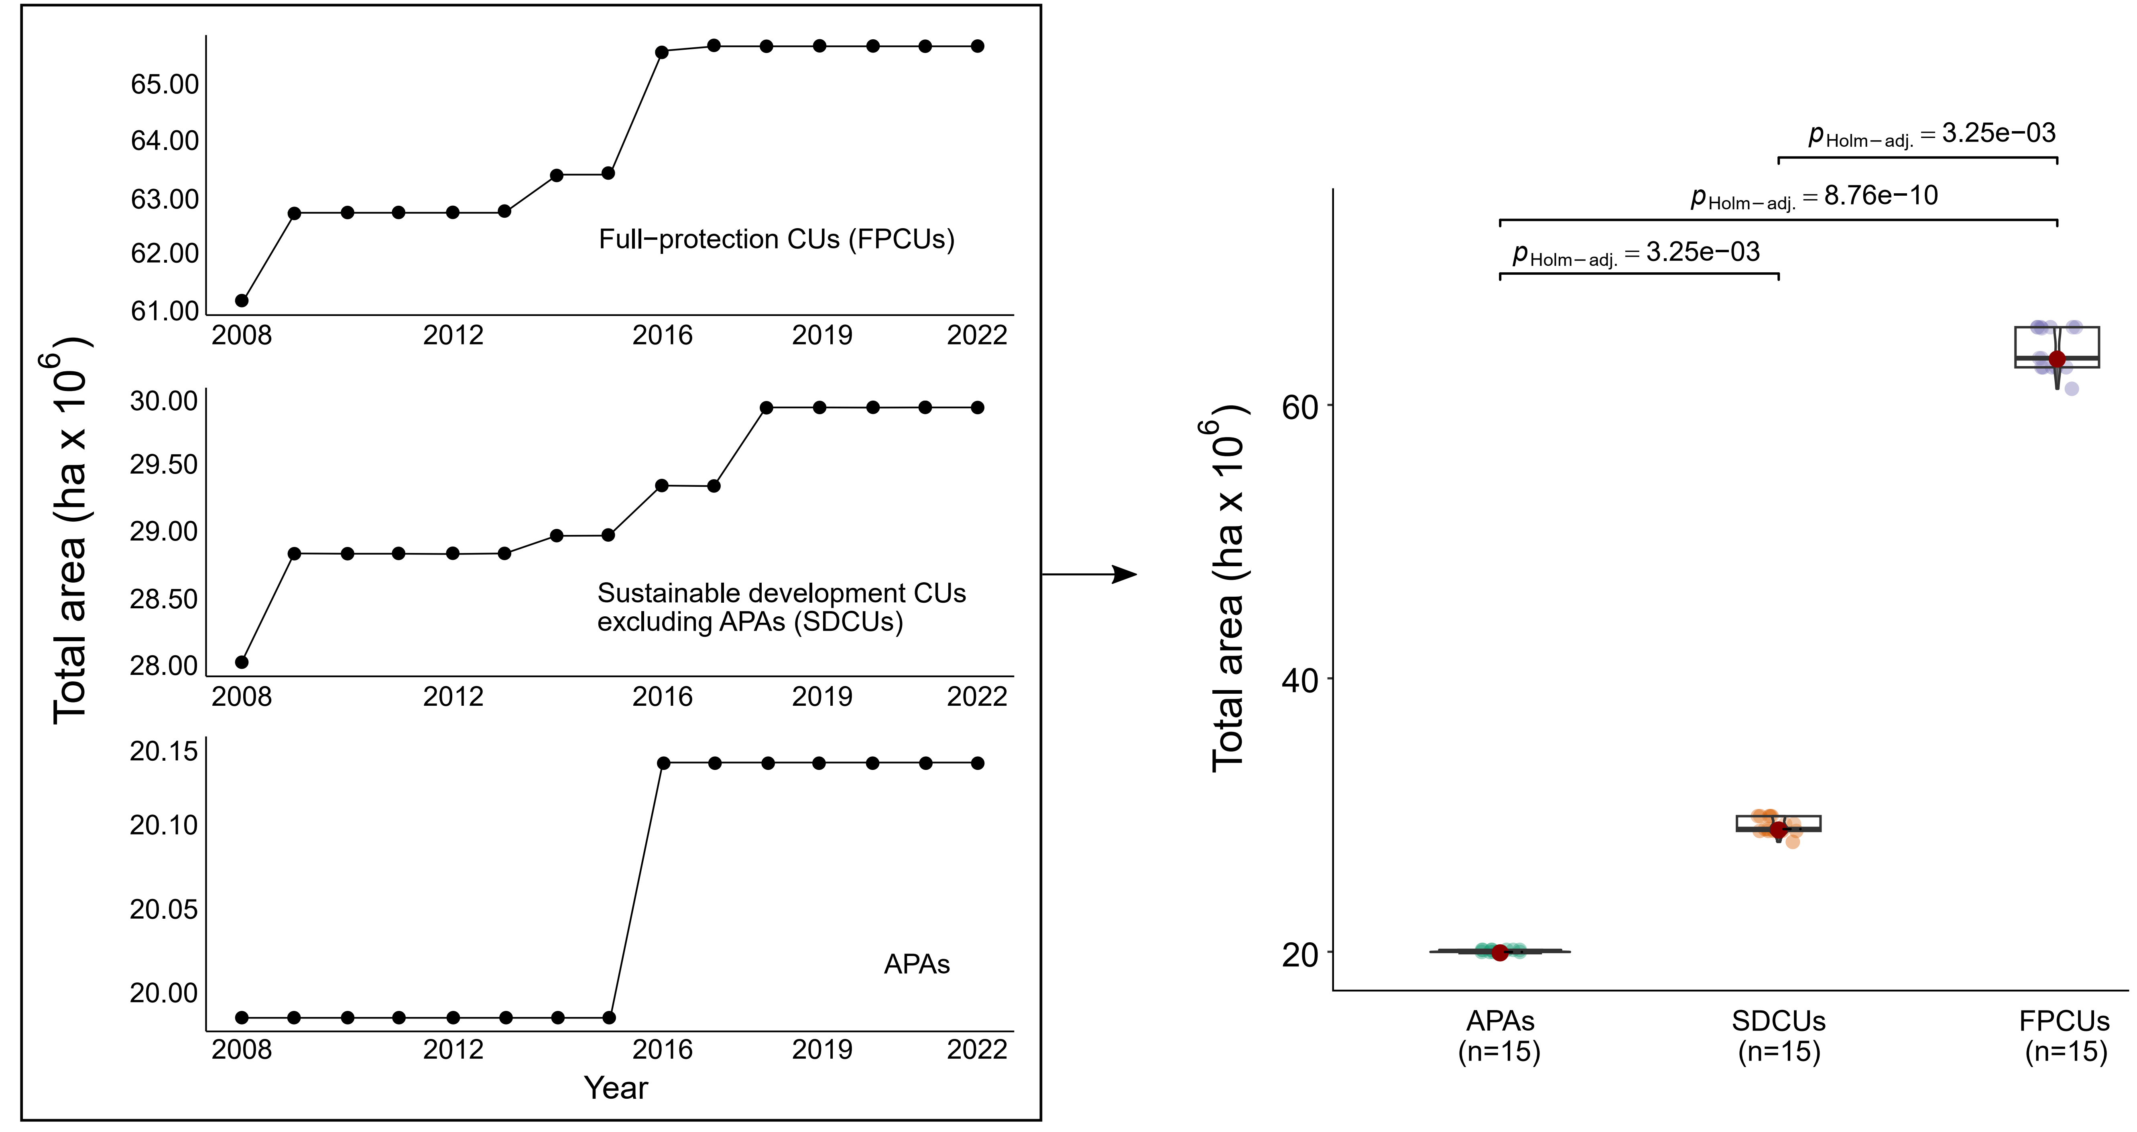
Figure S1: Total area covered by each category of CU obtained from PRODES (INPE, 2024). Boxplots show median values (red dots and horizontal lines), the interquartile range for the first (0-25%) and third (50-75%) percentiles (boxes), and the minimum and maximum values (whiskers) for the analyzed time series. Significant differences between treatments (Kruskal-Wallis & Dunn’s test) are indicated by adjusted p-values using the Holm-Bonferroni method.

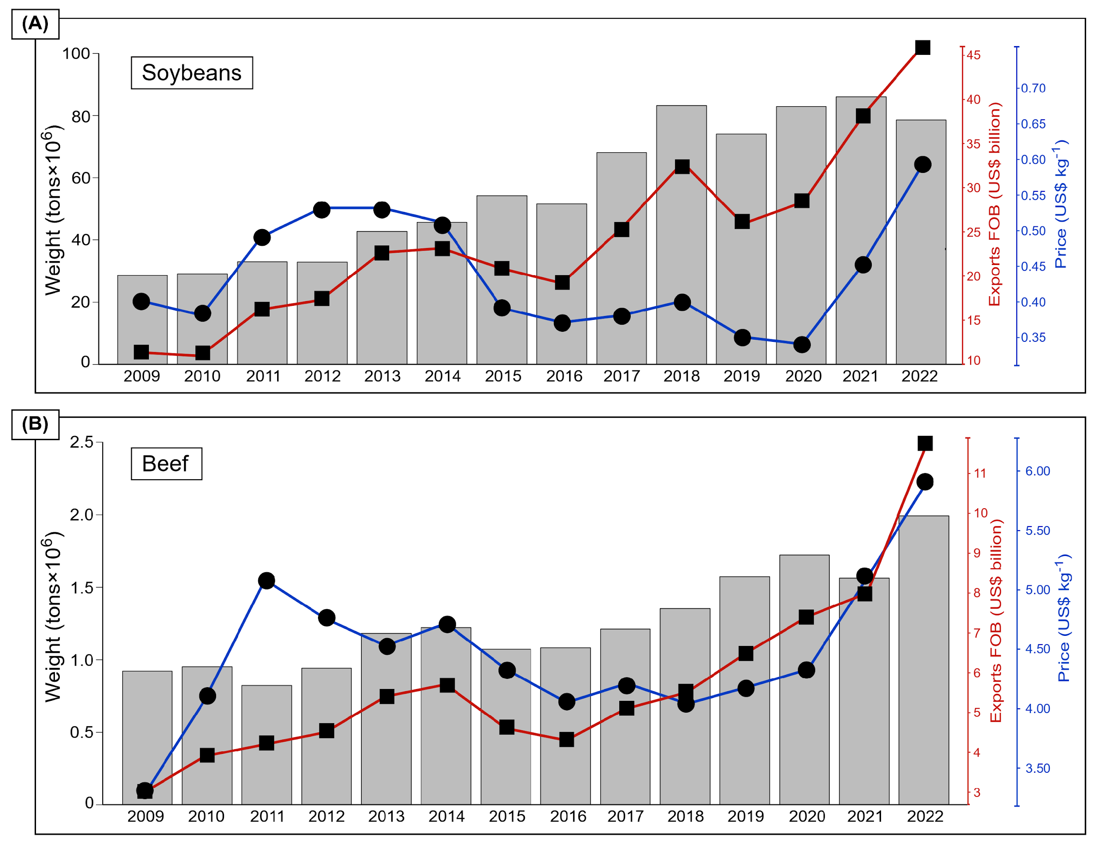
Figure S2: Time series of soy (A) and beef (B) exports showing the weight of exported products (gray bars), the gross financial returns (US$ billion FOB) of exports (red line, squares), and the annual average international price (blue line, circles). US dollars are corrected for inflation to 2022.

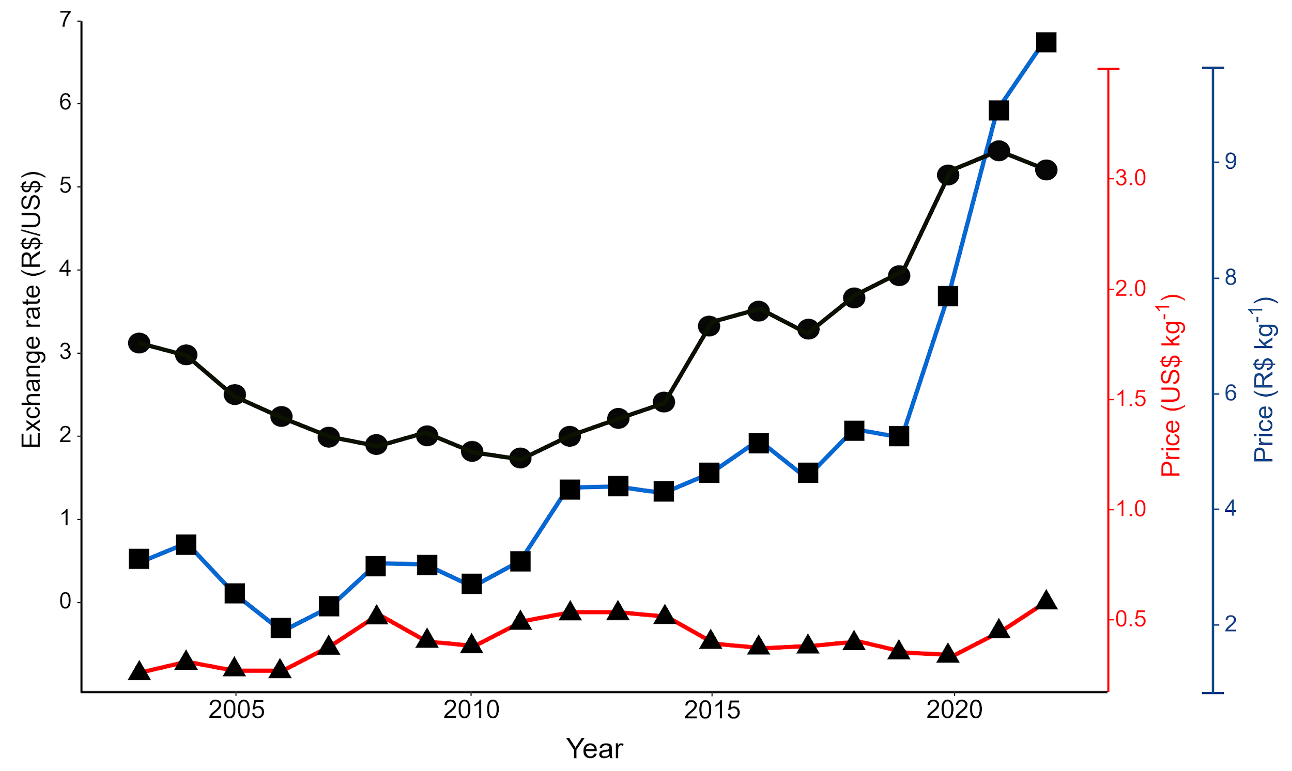
Figure S3: Time series of exchange rate of the Brazilian real against US dollar (R$/US$) (IPEA, 2023) (black line, circles), soybean price in Brazilian reais (R$/kg) (2003-2005 price FOB Gulf of Mexico from USDA, 2020 and 2006-2022 price paid to producers from CEPEA, 2023) (blue line, squares) and price on the international market in US dollars (US$/kg) (MDIC, 2023) (red line, triangles). Both the prices in reais and in dollars are nominal prices (without correction for inflation).

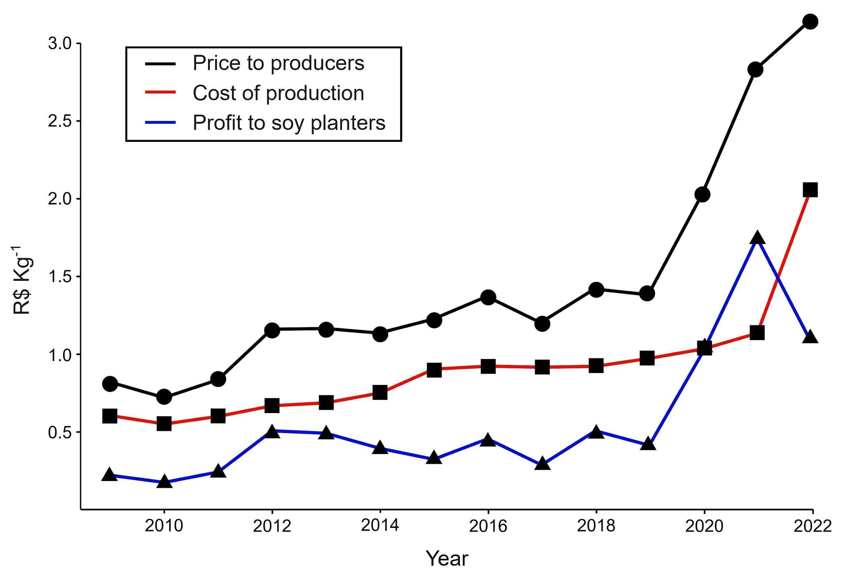
Figure S4: Cost of production (CONAB, 2023) (red line, squares), price of soy paid to producers (CEPEA, 2023) (black line, circles) and profit to soy planters (price to producers minus cost of production) (blue line, triangles). Annual costs were obtained from the average of seven locations: Cruz Alta (RS), Campo Muorão (PR), Rio Verde (GO), Dourados (MS), Chapadão do Sul (MS), Primavera do Leste (MT), Unaí (MG), Balsas (MA) and Pedro Afonso (TO).

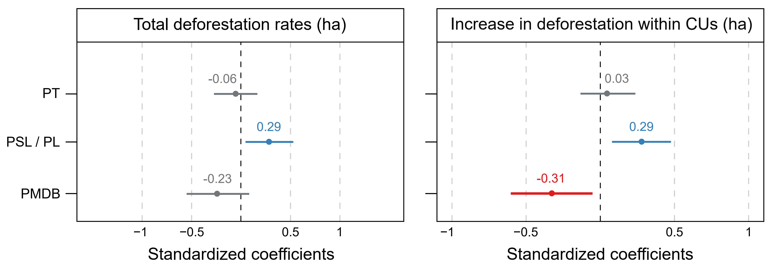
Figure S5: Standardized coefficients and confidence intervals of random effects in the GMMs. The red and blue colors represent negative and positive significant values, respectively (* p < 0.05; ** p < 0.01; *** p < 0.001).

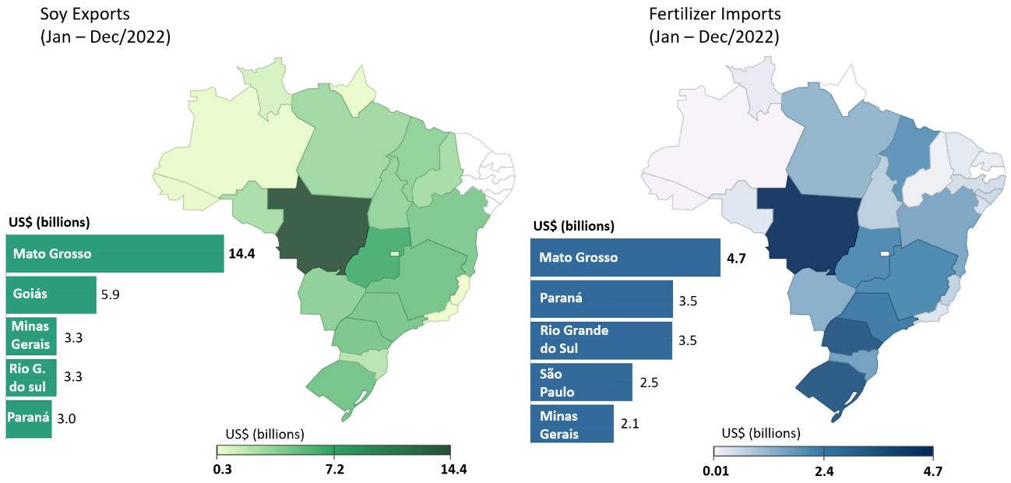
Figure S6: Values of soy exports and fertilizer imports per state (FOB, adapted from MDIC, 2023).

References
Albert, J. S., Carnaval, A. C., Flantua, S. G., Lohmann, L. G., Ribas, C. C., Riff, D., Carrillo, J. D., Fan, Y., Figueiredo, J. J., Guayasamin, J. M. and Hoorn, C. (2023). Human impacts outpace natural processes in the Amazon. Science, 379, art. 5003. doi: https://doi.org/10.1126/science.abo5003
Araujo, E., Barreto, P., Baima, S. and Gomes, M. (2016). Quais os planos para proteger as Unidades de Conservação vulneráveis da Amazônia?. Imazon. URL: https://bitly.cx/bFIID
Artaxo, P. (2019). Working together for Amazonia. Science, 363, 323-323. doi: https://doi.org/10.1126/science.aaw6986
Barni, P. E., Rego, A. C. M., Silva, F. D. C. F., Lopes, R. A. S., Xaud, H. A. M., Xaud, M. R., Barbosa, R. I. and Fearnside, P. M. (2021). Logging Amazon forest increased the severity and spread of fires during the 2015–2016 El Niño. Forest Ecology and Management, 500, art. 119652. doi: https://doi.org/10.1016/j.foreco.2021.119652
Berenguer, E., Armenteras, D., Alencar, A., Almeida, C., Aragão, L., Barlow, J., Bilbao, B., Brando, P., Bynoe, P., Fearnside, P. and Finer, M. (2021). Chapter 19: Drivers and ecological impacts of deforestation and Forest degradation. In: Amazon Assessment Report 2021. Technical Report. United Nations Sustainable Development Solutions Network, New York, USA. URL: http://bitly.ws/M5G6
Boers, N., Marwan, N., Barbosa, H. M. and Kurths, J. (2017). A deforestation-induced tipping point for the South American monsoon system. Scientific Reports, 7(1), art. 41489. doi: https://doi.org/10.1038/srep41489
Brazil, PR (Presidência da República) (2024). Emendas Constitucionais. URL: https://www.planalto.gov.br/ccivil_03/constituicao/emendas/emc/quadro_emc.htm
Brown, L. R. (2009). Growing demand for soybeans threatens Amazon rainforest. Earth Policy Institute. [www document]. URL: http://bitly.ws/M5Hg
Buchanan, E. (2020). Smoke from the fires in the Pantanal reaches the city of São Paulo. TV6 News, 19 September 2020 [www document]. URL: https://bityl.co/4iRE
Burgess, R., Hansen, M., Olken, B. A., Potapov, P. and Sieber, S. (2012). The political economy of deforestation in the tropics. The Quarterly Journal of Economics, 127(4), 1707-1754. doi: https://doi.org/10.1093/qje/qjs034
Campos, A. (2019). World’s biggest meatpackers buying cattle from deforesters in Amazon. Mongabay, 19 September 2019. URL: https://bit.ly/3JQMhFE
Chaib, J. (2020). Bolsonaro backs off and avoids criminalizing countries for illegal purchase of wood. Folha de São Paulo, 20 November 2020. URL: https://bit.ly/3t8KpjE
Cisneros, E., Zhou, S. L. and Börner, J. (2015). Naming and shaming for conservation: Evidence from the Brazilian Amazon. PloS one, 10(9), art. e0136402. doi: https://doi.org/10.1371/journal.pone.0136402
Cisneros, E., Börner, J., Pagiola, S. and Wunder, S. (2022). Impacts of conservation incentives in protected areas: The case of Bolsa Floresta, Brazil. Journal of Environmental Economics and Management, 111, art. 102572. doi: https://doi.org/10.1016/j.jeem.2021.102572
da Silva, S. S., de Melo, A. W. F., Oliveira, I. and Fearnside, P. M. (2022). Degradação florestal no estado do Acre: Estimativa da extensão dos incêndios florestais e exploração madeireira. pp. 146-159 In: M. V. A. Liesenfeld, R. M. de Souza, J. A. C. da Silva and E. Alves de Araújo (eds.) Ciencias Ambientais na Amazonia. Stricto Sensu Editora, Cruzeiro do Sul, Acre. 287 pp. doi: https://doi.org/10.35170/ss.ed.9786586283761.10
de Oliveira, G., Chen, J. M., Mataveli, G. A., Chaves, M. E., Seixas, H. T., Cardozo, F. D. S., Shimabukuro, Y. E., He, L., Stark, S. C. and dos Santos, C. A. (2020a). Rapid recent deforestation incursion in a vulnerable indigenous land in the Brazilian Amazon and fire-driven emissions of fine particulate aerosol pollutants. Forests, 11(8), art. 829. doi: https://doi.org/10.3390/f11080829
de Oliveira G, Chen J. M., Stark S. C., Berenguer E., Moutinho P., Artaxo P., Anderson L. O. and Aragão L. E. O. C. (2020b). Smoke pollution's impacts in Amazonia. Science. 369, 634-635. doi: https://doi.org/10.1126/science.abd5942. PMID: 32764060.
Dutra, D. J., Fearnside, P. M., Yanai, A. M., Graça, P. M. L. A., Dalagnol, R., Pessôa, A. C. M., Cabral, B. F., Burton, C., Jones, C., Betts, R., Ferro, P. D., Braga, D. A., de Aragão, L. E. O. E. C. and Anderson, L. O. (2023). Burned area mapping in different data products for the southwest of the Brazilian Amazon. Revista Brasileira de Cartografia, 75, art. 68393. doi: https://doi.org/10.14393/revbrascartogr
EAC (Environmental Audit Committee) (2024). The UK’s contribution to tackling global deforestation [www document]. URL: https://bitly.cx/Ac7Pz (Assessed 30 Feb. 2024).
Esteves, B. (2019). The environment as an obstacle - The declared war and the veiled war between the Bolsonaro government and the forces resisting deforestation [www document]. URL: https://bityl.co/4iR2
Fearnside, P. M., Figueiredo, A. M. R. and Bonjour, S. C. M. (2013). Amazonian forest loss and the long reach of China’s influence. Environment, Development and Sustainability, 15(2), 325-338. doi: https://doi.org/10.1007/s10668-012-9412-2
Fearnside, P. M. (2015). Natural riches of Amazonia, deforestation and its consequences. Global Land Project News, 12, 22-25. URL: https://bit.ly/3uzRyKm
Fearnside, P. M. (2021b). China’s carbon emissions in Brazil. Science, 373, 1209-1210. doi: https://doi.org/10.1126/science.abl9962
Fearnside, P. M. (2023b). The outlook for Brazil’s new presidential administration. Trends in Ecology and Evolution, 38(5), 387-388. doi: https://doi.org/10.1016/j.tree.2023.01.002
Fearnside, P. M. (2023c). What Brazil should have said at COP28 but didn’t (commentary). Mongabay, 4 December 2023. URL: https://news.mongabay.com/2023/12/what-brazil-should-have-said-at-cop28-but-didnt-commentary/
Fearnside, P. M. (2023d). Brazil’s “End-of-the-World” auction for oil and gas drilling (commentary). Mongabay, 16 December 2023. URL: https://news.mongabay.com/2023/12/brazils-end-of-the-world-auction-for-oil-and-gas-drilling-commentary/
Fearnside, P. M. (2023e). Lula e a questão fundiária na Amazônia. Amazônia Real, 17 January 2023. URL: http://bit.ly/3DFo3hr
Fearnside, P. M. (2023f). The deceptions of the Amazon Summit in Belém (commentary). Mongabay, 17 August 2023. URL: https://news.mongabay.com/2023/08/the-deceptions-of-the-amazon-summit-in-belem-commentary/
Ferrante, L., Andrade, M. B. T. and Fearnside, P. M. (2021b). Land grabbing on Brazil's Highway BR-319 as a spearhead for Amazonian deforestation. Land Use Policy, 108, art. 105559. doi: https://doi.org/10.1016/j.landusepol.2021.105559
Ferrante, L. and Fearnside, P. M. (2021a). Brazil’s deception threatens climate goals. Science, 374, 1569. doi: https://doi.org/10.1126/science.abn0693
Ferrante, L. and Fearnside, P. M. (2021b) Brazil’s political upset threatens Amazonia. Science 371, 898-899. doi: https://doi.org/10.1126/science.abg9786
Fuchs, R., Alexander, P., Brown, C., Cossar, F., Henry, R. C. and Rounsevell, M. (2019). Why the US–China trade war spells disaster for the Amazon. Nature, 567, 451-454. doi: https://doi.org/10.1038/d41586-019-00896-2
Gibbs, H. K., Munger, J., L'Roe, J., Barreto, P., Pereira, R., Christie, M., Amaral, T. and Walker, N. F. (2016). Did ranchers and slaughterhouses respond to zero‐deforestation agreements in the Brazilian Amazon? Conservation Letters, 9(1), 32-42. doi: https://doi.org/10.1111/conl.12175
Griscom, B. W., Busch, J., Cook-Patton, S. C., Ellis, P. W., Funk, J., Leavitt, S. M., Lomax, G., Turner, W. R., Chapman, M., Engelmann, J. and Gurwick, N. P. (2020). National mitigation potential from natural climate solutions in the tropics. Philosophical Transactions of the Royal Society B, 375, art. 20190126. doi: https://doi.org/10.1098/rstb.2019.0126
IMAZON (Instituto do Homem de Meio Ambiente na Amazônia) (2020). Acertando o Alvo: Consumo de Madeira no Mercado Interno Brasileiro e Promoção da Certificação Florestal. IMAZON, Belém, PA, Brazil. [www document]. URL: https://bityl.co/4iRK
Kehoe, L., Reis, T., Virah-Sawmy, M., Balmford, A., Kuemmerle, T., Knohl, A., Antonelli, A., Hochkirch, A., Vira, B., Massa, B. and Peres, C. A. (2019). Make EU trade with Brazil sustainable. Science, 364, 341. doi: https://doi.org/10.1126/science.aaw8276
Lapola, D. M., Pinho, P., Barlow, J., Aragão, L. E., Berenguer, E., Carmenta, R., Liddy, H. M., Seixas, H., Silva, C. V., Silva-Junior, C. H. and Alencar, A. A. (2023). The drivers and impacts of Amazon forest degradation. Science, 379, art eabp8622. doi: https://doi.org/10.1126/science.abp8622
Lu, J., Mao, X., Wang, M., Liu, Z. and Song, P. (2020). Global and national environmental impacts of the US–China trade war. Environmental Science & Technology, 54(24), 16108-16118. doi: https://doi.org/10.1021/acs.est.0c03863
Macedo, M. N., DeFries, R. S., Morton, D. C., Stickler, C. M., Galford, G. L. and Shimabukuro, Y. E. (2012). Decoupling of deforestation and soy production in the southern Amazon during the late 2000s. Proceedings of the National Academy of Sciences USA, 109(4), 1341-1346. doi: https://doi.org/10.1073/pnas.1111374109
Malhi, Y., Aragão, L. E., Galbraith, D., Huntingford, C., Fisher, R., Zelazowski, P., Sitch, S., McSweeney, C. and Meir, P. (2009). Exploring the likelihood and mechanism of a climate-change-induced dieback of the Amazon rainforest. Proceedings of the National Academy of Sciences USA, 106(49), 20610-20615. doi: https://doi.org/10.1073/pnas.0804619106
Matricardi, E. A. T., Skole, D. L., Costa, O. B., Pedlowski, M. A., Samek, J. H. and Miguel, E. P. (2020). Long-term forest degradation surpasses deforestation in the Brazilian Amazon. Science, 369, 1378-1382. doi: https://doi.org/10.1126/science.abb3021
Morton, D. C., DeFries, R. S., Shimabukuro, Y. E., Anderson, L. O., Arai, E., del Bon Espirito-Santo, F., Freitas, R. and Morisette, J. (2006). Cropland expansion changes deforestation dynamics in the southern Brazilian Amazon. Proceedings of the National Academy of Sciences USA, 103(39), 14637-14641. doi: https://doi.org/10.1073/pnas.0606377103
Nepstad, D. C., Stickler, C. M., Filho, B. S. and Merry, F. (2008). Interactions among Amazon land use, forests and climate: prospects for a near-term forest tipping point. Philosophical Transactions of the Royal Society B: Biological Sciences, 363, 1737-1746. doi: https://doi.org/10.1098/rstb.2007.0036
Qin, Y., Xiao, X., Wigneron, J. P., Ciais, P., Brandt, M., Fan, L., Li, X., Crowell, S., Wu, X., Doughty, R. and Zhang, Y. (2021). Carbon loss from forest degradation exceeds that from deforestation in the Brazilian Amazon. Nature Climate Change, 11(5), 442-448. doi: https://doi.org/10.1038/s41558-021-01026-5
Radwin, M. (2021). New permits for Brazilian beef exports to U.S. could lead to increased Amazon deforestation. Mongabay, 30 September 2021. URL: https://bit.ly/3uMPJwX
Rattis, L., Brando, P.M., Macedo, M. N., Spera, S. A., Castanho, A. D., Marques, E. Q., Costa, N. Q., Silverio, D. V. and Coe, M. T. (2021). Climatic limit for agriculture in Brazil. Nature Climate Change, 11(12), 1098-1104. doi: https://doi.org/10.1038/s41558-021-01214-3
Silva, R. F. B., Moran, E. F., Millington, J. D., Viña, A. and Liu, J. (2023). Complex relationships between soybean trade destination and tropical deforestation. Scientific Reports, 13(1), art. 11254. doi: https://doi.org/10.1038/s41598-023-38405-1
Silva Junior, C. H., Carvalho, N. S., Pessôa, A. C., Reis, J. B., Pontes-Lopes, A., Doblas, J., Heinrich, V., Campanharo, W., Alencar, A., Silva, C. and Lapola, D. M. (2021b). Amazonian forest degradation must be incorporated into the COP26 agenda. Nature Geoscience, 14(9), 634-635. doi: https://doi.org/10.1038/s41561-021-00823-z
Stern, N. (2008). The economics of climate change. American Economic Review, 98(2), 1-37. URL: http://www.aeaweb.org/articles.php?doi=10.1257/aer.98.2
Ten Brink, P., Bassi, S., Bishop, J., Harvey, C. A., Ruhweza, A., Varma, M. and Wertz-Kanounnikoff, S. (2009). Rewarding benefits through payments and markets. In The Economics of Ecosystems and Biodiversity for National and International Policy Makers. The Economics of Ecosystems and Biodiversity (TEEB), Wesseling, Germany. URL: https://bityl.co/4iQq
Viana, V., Tezza, J., Solidade, V., Marostica, S., Salviati, V. and Soares, A. (2012). Impactos do Programa Bolsa Floresta: Uma avaliação preliminar. Inclusão Social, 6(1).
Villén-Pérez, S., Moutinho, P., Nóbrega, C. C., de Marco, P. and Allison, S. (2020). Brazilian Amazon gold: Indigenous land rights under risk. Elementa: Science of the Anthropocene, 8, art. 31. doi: https://doi.org/10.1525/elementa.427
Villén-Pérez, S., Anaya-Valenzuela, L. F., da Cruz, D. C. and Fearnside, P. M. (2022). Mining threatens isolated Indigenous peoples in the Brazilian Amazon. Global Environmental Change, 72, art. 102398. doi: https://doi.org/10.1016/j.gloenvcha.2021.102398
Voora, V., Larrea, C. and Bermudez, S. (2020). Global market report: Soybeans. Winnipeg, Manitoba, Canada: International Institute for Sustainable Development. URL: https://www.jstor.org/stable/resrep26554
Walker, W. S., Gorelik, S. R., Baccini, A., Aragon-Osejo, J. L., Josse, C., Meyer, C., Macedo, M. N., Augusto, C., Rios, S., Katan, T. and de Souza, A. A. (2020). The role of forest conversion, degradation, and disturbance in the carbon dynamics of Amazon Indigenous territories and protected areas. Proceedings of the National Academy of Sciences USA, 117(6), 3015-3025. doi: https://doi.org/10.1073/pnas.1913321117
Zilli, M., Scarabello, M., Soterroni, A.C., Valin, H., Mosnier, A., Leclere, D., Havlik, P., Kraxner, F., Lopes, M. A. and Ramos, F. M. (2020). The impact of climate change on Brazil's agriculture. Science of the Total Environment, 740, art. 139384. doi: https://doi.org/10.1016/j.scitotenv.2020.139384

