Supplementary Information for
Ultrathin Glass-based Perovskite Solar Cells Employing Bilayer Electron Transport Layer
Wooyeon Kim^{1,‡}, Jian Cheng^{1,‡}, Joonwon Choi^{1,‡}, Yongwoo Lee¹, Seoyeong Lee¹, Doyeon Lee¹, and Min Jae Ko^{1,*}
¹ Department of Chemical Engineering, Hanyang University, Seoul, 04763, Republic of Korea
‡ These authors contributed equally: Wooyeon Kim, Jian Cheng, and Joonwon Choi
* Correspondence: mjko@hanyang.ac.kr (M. J. K.)

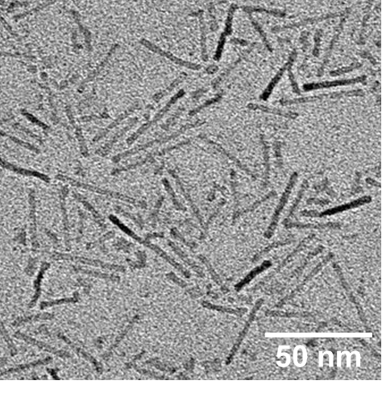
Fig. S1. Transmission electron microscopy (TEM) image of the TiO₂ nanocrystals.

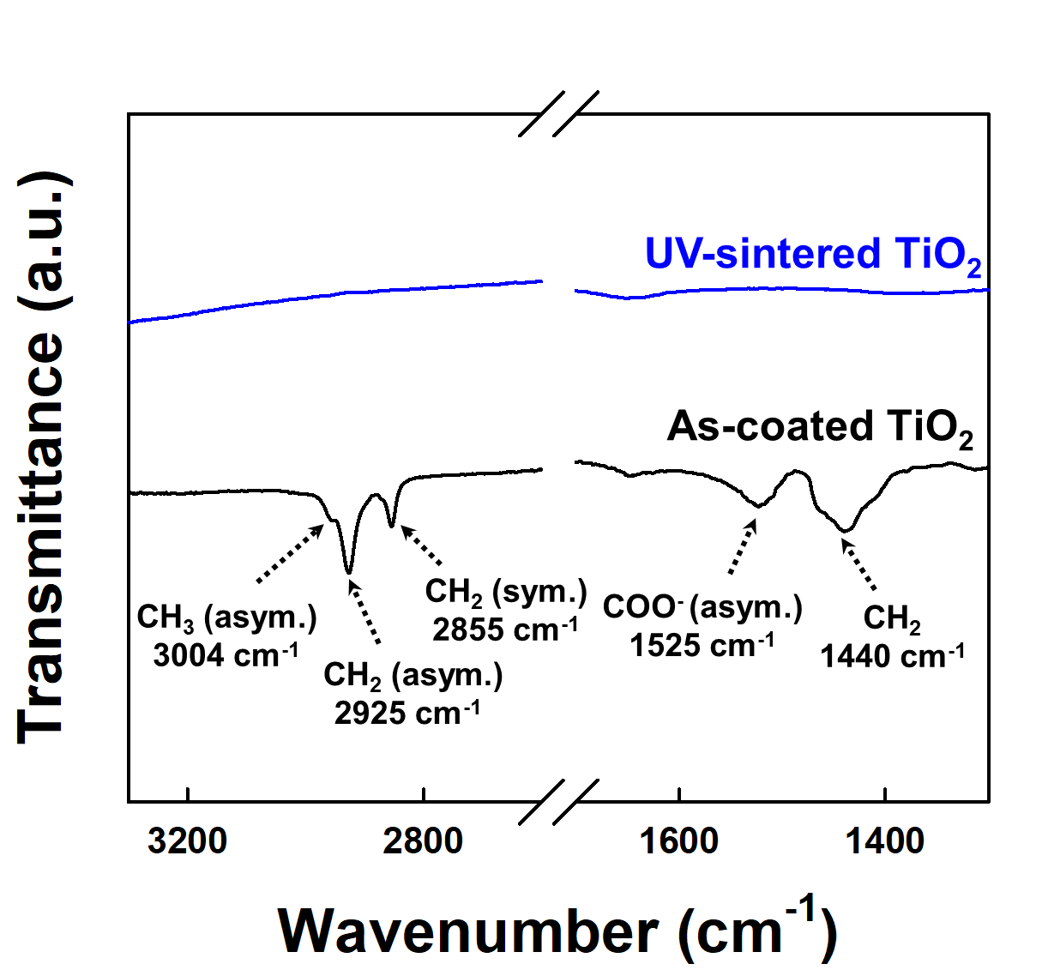
Fig. S2. Attenuated total reflectance–fourier transform infrared (ATR-FTIR) spectra of TiO₂ films before and after ultraviolet (UV) sintering.
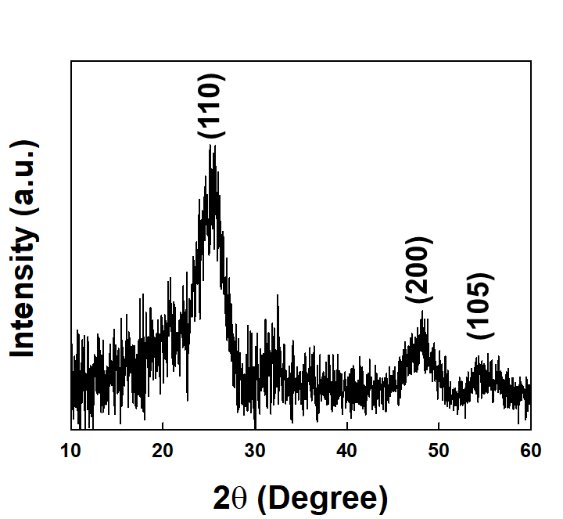
Fig. S3. X-ray diffraction (XRD) patterns of TiO₂ film
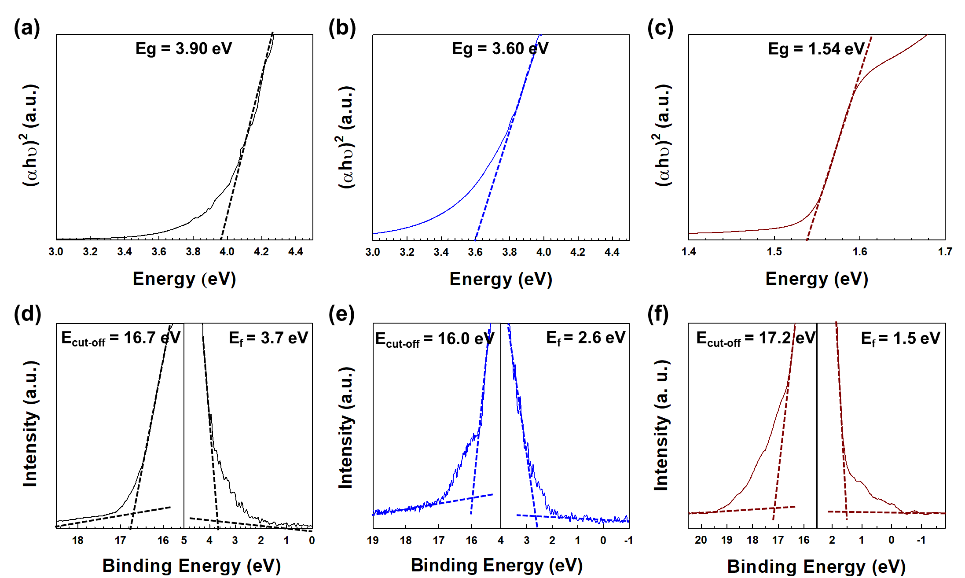
Fig. S4. a–c Tauc plots and optical bandgap energies of SnO₂, TiO₂, and perovskite films. d–f Linear extrapolations of ultraviolet photoelectron spectroscopy (UPS) spectra for each sample.
Sample | $A_{1}$ (%) | $τ_{1}$ (ns) | $A_{2}$ (%) | $τ_{2}$ (ns) | $τ_{ave}$ (ns)
Perovskite | 4.78 | 239.8 | 95.22 | 1569.63 | 1559.51
SnO₂ | 44.82 | 164.17 | 55.18 | 291.94 | 251.88
SnO₂ / TiO₂ | 49.59 | 71.65 | 50.41 | 206.44 | 172.13
Table S1. Time constants calculated from time resolved photoluminescence (TRPL) spectra. Lifetime decay components were fitted using a bi-exponential decay model (Fit function = $A_{1}e^{-t/τ_{1}}+A_{2}e^{-t/τ_{2}}$).
$$τ_{ave}=\sum{[(A_{1}τ_{1}^{2}}+A_{2}τ_{2}^{2})/(A_{1}τ_{1}+A_{2}τ_{2})]$$

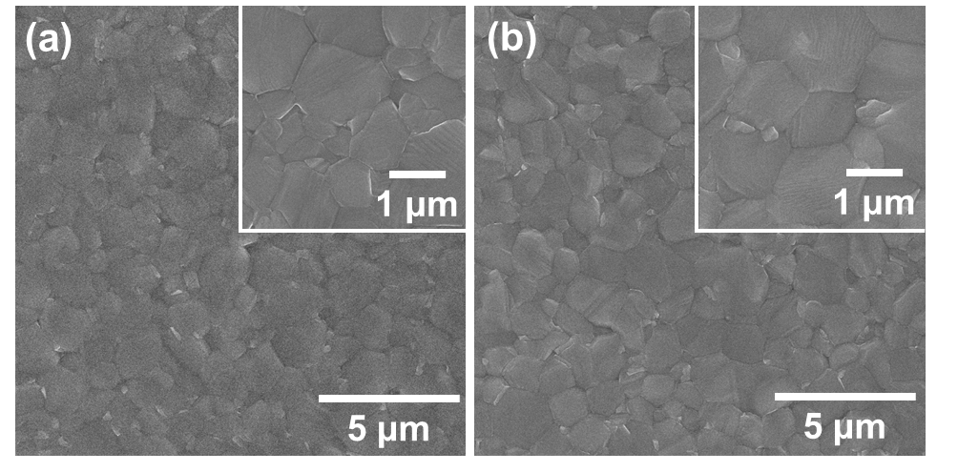
Fig. S5. Planar-view SEM images of the perovskite films on a SnO₂ layer and b SnO₂/TiO₂ bilayer.

ETL | V_{OC} (V) | J_{SC} (mA·cm⁻²) | FF (%) | PCE (%)
SnO₂ | 1.19 | 22.87 | 83.04 | 22.66
SnO₂/TiO₂ | 1.19 | 23.43 | 84.07 | 23.47
Table S2. Photovoltaic parameters of conventional glass/ITO substrate-based perovskite solar cells with various ETLs under 1 sun conditions.

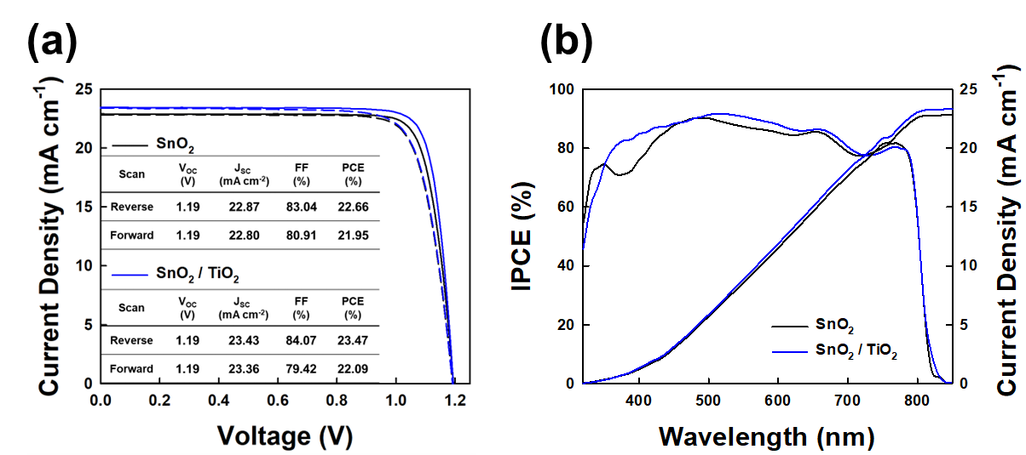
Fig. S6. a J–V characteristics measured in both reverse (solid lines) and forward (dashed lines) directions of each ETL-based perovskite solar cell. b IPCE spectra of perovskite solar cells with difference ETLs and integrated J_{SC} calculated from IPCE.

Fig. S7. Transmittance spectra of conventional glass/ITO (1100µm) and ultrathin glass (UTG)/ITO (50 µm).

Substrate | V_{OC} (V) | J_{SC} (mA·cm⁻²) | FF (%) | PCE (%)
PEN | 1.18 | 22.01 | 69.42 | 18.00
UTG | 1.17 | 22.13 | 58.44 | 15.18
Fig. S8. J−V curves and summarized photovoltaic parameters of polyethylene naphthalate (PEN)/ITO and UTG/ITO substrate-based PSCs.

