Supplementary online content
eTable 1 Definition of Comorbidities at Baseline and Postoperative Course
eTable 2 Patient Characteristics
eTable 3 Comparison of the prognostic performances of Body Composition
eTable 4 Intraoperative and Postoperative outcomes of patients by Group
eTable 5 Postoperative vitamin and biochemical parameters of patients by Group
eTable 6 BAROS assessment outcomes of patients by group

eFigure 1 The portal phase computed tomography image of the L3 level was used to measure the body composition. Red: SM, Skeletal muscle;Yellow: VAT, Visceral adipose tissue;Blue:SAT, Subcutaneous adipose tissue; (A) High FMI; (B) Low FMI
eFigure 2 Bariatric Analysis and Reporting Outcome System
eFigure 3 Percentage Excess Weight Loss (%EWL) and BMI for All Patients After Laparoscopic Sleeve Gastrectomy (LSG)
eFigure 4 Comparison of the prognostic performance between patients early and in the past three years of the study
eFigure 5 Changes in comorbidities by group

eTable 1 Definition of Comorbidities at Baseline and Postoperative Course
Comorbidity | Diagnostic Criteria
Fatty liver | Diagnosed by CT.
Hyperuricemia | Plasma uric acid concentrations >476 mmol/L or intake of antihyperuricemic drugs.
Hyperglycemia | Plasma glucose >11.1mmol/L or 2-hour oral glucose tolerance test >11.1mmol/L or intake of antidiabetic drug with or without insulin therapy.
Hyperlipidemia | HDL-C <50 mg/dL for women, <40 mg/dL for men, and/or triglycerides >150 mg/dL and/or low density lipoprotein cholesterol (LDL-C) >100 mg/dL or the use of statins.
Hypertension | Systolic blood pressure 140 mmHg or more and/or diastolic blood pressure ≥90 mmHg or if patients were on antihypertensive drug therapy.
OSAS | Presented with signs of obstructive sleep apnea
PCOS | Infertility with abnormal sex hormone or diagnosed by CT or ultrasound imaging.
Postoperative course | Definition
Aggravated | More symptoms or increase of therapy
Unchanged | Same symptoms and equivalent therapy
Improved | Less symptoms and/or less medical treatment/medication
Remission | No symptoms/without any medication
Abrreviation: OSAS = obstructive sleep apnea syndrome; PCOS = polycystic ovary syndrome

eTable 2 Patient Characteristics
Characteristics | Finding(N=244)
Characteristics | Mean±SD/N(%)
Age, y | 29.7±7.6
Gender
Male | 57(23.4)
Female | 186(76.6)
Weight, kg | 107.2±23.3
BMI, kg/m² | 38.4±6.1
Abdominal girth, cm | 115.2±16.2
Body composition
SMD, HU | 34.8±11.5
SMI, cm²/m² | 26.8±5.7
VAI, cm²/m² | 72.2±31.1
SAI, cm²/m² | 163.1±62.0
FFMI, cm²/m² | 10.2±1.8
FMI, cm²/m² | 14.1±3.3
Blood index,
Glucose, mg/L
TBIL, umol/L | 11.1±4.7
DBIL, umol/L | 2.7±1.3
HDL-C, mmol/L | 1.2±0.4
LDL-C, mmol/L | 3.3±0.9
CHOL, mmol/L | 4.9±1.1
TG, mmol/L | 2.2±2.0
Surgical outcomes
operation time, min | 107.1±24.1
intraoperative blood loss, ml | 12.6±7.2
postoperative hospital stay, day | 5.1±2.3
total cost, $ | 7993.7±5744.7
Early complication(0-30d)
leak | 3(1.3%)
infection | 2(0.8%)
stenosis | 1(0.4%)
Late complication(>30d) | none

eTable 3 Comparison of the prognostic performances of Body Composition
Body composition | FMI | SMD | SMI | VAI | SAI | FFMI
Harrell’s C  index | 0.747（0.683-0.811） | 0.500（0.423-0.577） | 0.657(0.584-0.730） | 0.694(0.625-0.764） | 0.629(0.550-0.705) | 0.660(0.586-0.735）
P value |  | <0.001* | 0.017* | 0.012* | <0.001* | 0.023*
Likelihood ratio chi-square | 80.487 | 28.280 | 20.840 | 34.812 | 48.988 | 10.776
P value |  | <0.001* | <0.001* | 0.001* | 0.004* | <0.001*

eTable 4 Intraoperative and Postoperative outcomes of patients by Group
Variable | Mean±SD/N(%) |  | P-value
Variable | High-FMI group | Low-FMI group | P-value
Surgical outcomes
Operation time, min | 108.7±22.6 | 103.5±22.4 | 0.110
Intraoperative blood loss, ml | 13.8±7.7 | 13.7±6.1 | 0.954
postoperative hospital stay, d | 5.4±2.7 | 4.7±1.7 | 0.015*
Total cost, $ | 7975.9±3232.1 | 8013.0±7624.8 | 0.968
Early complications (0-30d) |  |  | 0.786
leak | 2 | 1
infection | 2 | 0
stenosis | 1 | 2

eTable 5 Postoperative vitamin and biochemical parameters of patients by Group
Variable | Mean±SD/N(%) |  | P-value
Variable | High-FMI group | Low-FMI group | P-value
folic acid | 27.02±14.81 | 31.25±13.67 | 0.432
ferritin | 139.5±106.5 | 135.5±107.4 | 0.921
VitB12 | 389.64±157.59 | 494.4±130.1 | 0.063
25-OH-D3 | 14.28±8.64 | 12.86±11.65 | 0.713
TBIL | 13.25±6.29 | 14.07±4.26 | 0.692
DBIL | 4.75±2.43 | 5.28±3.03 | 0.606
ALB | 44.52±3.13 | 43.09±11.03 | 0.635
ALT | 35.57±24.77 | 34.13±23.33 | 0.874
AST | 26.79±11.42 | 29.80±14.18 | 0.533
TG | 1.27±0.31 | 1.34±0.80 | 0.756
CHOL | 4.36±0.97 | 4.55±1.36 | 0.669
HDL-C | 1.02±0.23 | 1.06±0.26 | 0.644
LDL-C | 2.93±0.94 | 3.00±1.15 | 0.849
CREA | 66.14±9.77 | 61.80±10.23 | 0.254
UREA | 489.64±116.08 | 404.67±169.80 | 0.132
GLU | 5.15±0.69 | 5.08±0.49 | 0.771
LDH | 186.57±29.85 | 179.93±29.73 | 0.554
K | 3.99±0.39 | 3.78±0.28 | 0.337
Na | 141.95±1.88 | 141.49±2.41 | 0.567
Cl | 104.61±0.98 | 103.77±0.25 | 0.250
Ca | 2.38±0.10 | 2.37±0.88 | 0.649

eTable 6 BAROS assessment outcomes of patients by group
 | High-FMI group | Low-FMI group | P value
Failure | 2 | 0 | <0.001*
Fair | 10 | 3
Good | 32 | 11
Very Good | 30 | 28
Excellent | 11 | 25

eFigure 1 The portal phase computed tomography image of the L3 level was used to measure the body composition. Red: SM, Skeletal muscle;Yellow: VAT, Visceral adipose tissue;Blue:SAT, Subcutaneous adipose tissue; (A) High FMI; (B) Low FMI

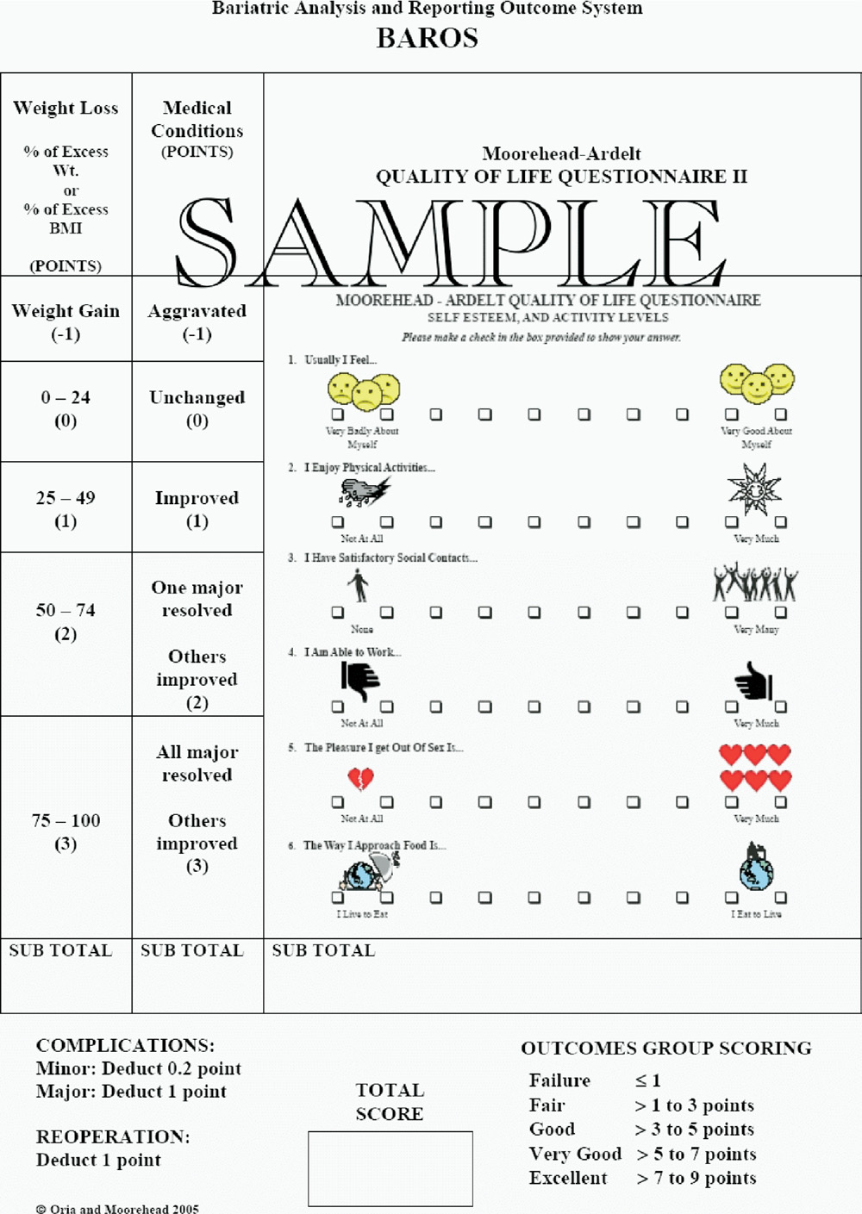
eFigure 2 Bariatric Analysis and Reporting Outcome System

eFigure 3 Percentage Excess Weight Loss (%EWL) and BMI for All Patients After Laparoscopic Sleeve Gastrectomy (LSG)

eFigure 4 Comparison of the prognostic performance between patients early and in the past three years of the study

eFigure 5 Changes in comorbidities by group

