Methods:
Mutational analysis and Next Generation Sequencing
NGS panel testing was performed on peripheral blood or bone marrow specimens (OncoHeme, Mayo Clinic). The NGS panel included 47 genes: ANKRD26, ASXL1, BCOR, BCORL1, BRAF, CALR, CBL, CEBPA, CSF3R, DDX41, DNMT3A, ELANE, ETNK1, ETV6, EZH2, FLT3, GATA1, GATA2, IDH1, IDH2, JAK2, KDM6A, KIT, KRAS, MPL, NF1, NPM1, NRAS, PHF6, PTPN11, RAD21, RUNX1, SETBP1, SH2B3, SF3B1, SRP72, SMC3, SRSF2, STAG2, STAT3, TERT, TET2, TP53, U2AF1, UBA1, WT1 and ZRSR2.[1] DNA was target-enriched with a custom hybridization-capture reagent (SureSelectXT, Agilent, Santa Clara, CA) and sequenced on the MiSeq or HiSeq platforms (Illumina, San Diego, CA) at the Mayo Clinic Clinical Genome Sequencing Laboratory. Sequencing data was processed through a custom bioinformatics pipeline Mayo NGS Workbench, using CLC Bio Genomics Server v6.0 (Qiagen, Redwood City, CA) for alignment and variant calling. The aligned BAM files were further processed through an in-house developed breakpointSearch tool for large insertion/deletion detection. BAM files of all variant calls were manually reviewed in the genome browser Alamut® Visual (Interactive Biosoftware, Rouen, France) for confirmation. The limit of detection of the NGS assay is 5% with a minimum 250X depth of coverage. More than 95% of tested regions had >1000X depth of coverage in the clinical assay. Genetic variants were curated and annotated in the Mayo Clinic Molecular Hematopathology Laboratory following the American College of Medical Genetics and Genomics (ACMG) five-tier system.[2] If a patient had more than one pathogenic/likely pathogenic mutation, we included the one with the highest variant allele frequency (VAF).

Statistical Analysis
Continuous variables were compared using Wilcoxon-Mann-Whitney or Kruskal-Wallis test. Categorical variables were compared using Fisher’s exact or Chi-square test (χ2). Basic linear regression was used to compare categorical independent variables according to dependent numerical variables.
BM blasts were considered 1% for patients with reported BM blasts percentage as “not increased”. Given that ZRSR2 is an X-linked gene, gender corrected ZRSR2m VAF was calculated by dividing VAF in males by 2. Everviz chart editor was used to form the dependency wheel chart and RStudio was used to form the Fishplot.

Abbreviations: Pre-ZF1, Pre-Zinc Finger 1; UHM, U2AF homology motif; Post-ZF2, the Post-Zinc Finger 2; ZF1, Zinc fingers 1; ZF2, Zinc fingers 2; RS, arginine/serine rich.

Results:
Patient Characteristics:
Other concurrent diagnoses included VEXAS syndrome, plasmacytoid dendritic cell neoplasm (PDCN), monoclonal gammopathy of unknown significance (MGUS), Marginal zone lymphoma, B-cell non-Hodgkin lymphoma, and lymphoplasmacytic lymphoma.

References:
1. Malcovati, L., et al., Driver somatic mutations identify distinct disease entities within myeloid neoplasms with myelodysplasia. Blood, 2014. 124(9): p. 1513-21.
2. Richards, S., et al., Standards and guidelines for the interpretation of sequence variants: a joint consensus recommendation of the American College of Medical Genetics and Genomics and the Association for Molecular Pathology. Genet Med, 2015. 17(5): p. 405-24.

Supplemental table 1: CBC variables of ZRSR2m patients at NGS
Variable | Median (Q1, Q3)
Hgb | 9.6 (8.4, 11.4)
RDW | 16 (14.6, 18.3)
MCV | 104.2 (97.78, 111.22)
PLT | 134 (83.75, 213.75)
WBCs | 4.35 (2.78, 8.14)
ANC | 2.14 (0.89, 4.98)
Neutrophils % | 0.49 (0.3, 0.63)
ALC | 1.04 (0.76, 1.52)
AMC | 0.61 (0.31, 1.09)
Monocyte % | 0.14 (0.07, 0.21)
BM Blasts % | 2.00 (1.00, 5.00)
Ringed sideroblasts % | 0 (0, 0)

Supplemental table 2: Cytogenetic abnormalities of ZRSR2m patients at NGS
Cytogenetic abnormality | Frequency
+8 | 16
-Y | 11
del (20) | 7
+1 | 3
+4 | 3
mar | 3
-5 | 3
-7 | 3
-13 | 3
del (7) | 3
del (13) | 3
+13 | 2
+20 | 2
add (5) | 2
-12 | 2
-17 | 2
t (1;3) | 1
t (1;10) | 1
t (1;18) | 1
t (2:3) | 1
t (3;12) | 1
t (3;21) | 1
t (5;17) | 1
t (6;14) | 1
t (6:17) | 1
t (6;22) | 1
t (12;18) | 1
t (13;19) | 1
+5 | 1
+9 | 1
+11 | 1
+15 | 1
+18 | 1
+21 | 1
trp (1) | 1
add (1) | 1
add (2) | 1
add (3) | 1
add (7) | 1
add (8) | 1
add (13) | 1
add (15) | 1
add (17) | 1
-X | 1
-9 | 1
-10 | 1
-15 | 1
-16 | 1
-18 | 1
del (1) | 1
del (5) | 1
del (9) | 1
del (11) | 1
del14q | 1
del (16) | 1
del (17) | 1
der (1;7) | 1
der (1;13) | 1
der (1;21) | 1
der (3;17) | 1
der (5) | 1
der (18) | 1

Supplemental table 3: ZRSR2 mutation types and domains for ZRSR2m patients
Mutation type | Total | AML | CCUS | MDS | MDS/MPN | MPN
Nonsense | 69 (42%) | 6 | 16 | 21 | 11 | 15
Frameshift | 56 (34%) | 8 | 14 | 19 | 6 | 8
Splice site | 39 (24%) | 1 | 9 | 13 | 6 | 10
Mutation domain
Post-ZF2 | 12.8049 | 1 (6.7%) | 7 (17.9%) | 7 (13.2%) | 2 (8.7%) | 4 (12.1%)
Pre-ZF1 | 48.7805 | 9 (60.0%) | 23 (59.0%) | 25 (47.2%) | 10 (43.5%) | 12 (36.4%)
RS | 1.2195 | 1 (6.7%) | 0 (0.0%) | 1 (1.9%) | 0 (0.0%) | 0 (0.0%)
UHM | 27.439 | 3 (20.0%) | 4 (10.3%) | 17 (32.1%) | 9 (39.1%) | 12 (36.4%)
ZF1 | 4.2683 | 1 (6.7%) | 4 (10.3%) | 0 (0.0%) | 1 (4.3%) | 1 (3.0%)
ZF2 | 5.4878 | 0 (0.0%) | 1 (2.6%) | 3 (5.7%) | 1 (4.3%) | 4 (12.1%)

Supplemental table 4: AML progression among ZRSR2m MDS patients according to MDS subtype
 | 5q (N=1) | biTP53 (N=2) | F (N=3) | IB1 (N=2) | IB2 (N=6) | LB (N=37) | SF3B1 (N=2) | p value
AML progression | 0 | 1 (50.0%) | 2 (66.7%) | 0 | 3 (50.0%) | 3 (8.1%) | 0 | 0.024

Supplemental table 5: Co-mutations among ZRSR2m patients according to MN diagnoses
Gene | Frequency (%) | AML (% of AML cases) | CCUS (%) | MDS (%) | MDS/MPN (%) | MPN (%)
TET2* | 84 (21.2) | 9 (60) | 25 (64) | 25 (47) | 16 (70) | 9 (27)
ASXL1 | 52 (31.7) | 5 (33) | 8 (20) | 18 (34) | 7 (30) | 14 (42)
JAK2 | 31 (18.9) | 1 (7) | 0 | 0 | 7 (30) | 23 (70)
RUNX1 | 23 (14) | 5 (33) | 1 (3) | 12 (23) | 3 (13) | 2 (6)
EZH2 | 14 (8.5) | 2 (13) | 0 | 8 (15) | 3 (13) | 1 (3)
U2AF1 | 9 (5.5) | 3 (6) | 1 (3) | 3 (6) | 1 (4) | 1 (3)
SRSF2 | 8 (4.9) | 1 (7) | 1 (3) | 5 (9) | 1 (4) | 0
TP53 | 8 (4.9) | 3 | 1 | 4 | 0 | 0
CBL | 8 (4.3) | 1 | 0 | 3 | 4 | 0
SF3B1 | 7 (4.3) | 0 | 2 (5) | 2 (4) | 1 (4) | 2 (6)
PHF6 | 7 (4.3) | 2 | 0 | 0 | 1 | 4
CALR | 7 (4.2) | 0 | 0 | 0 | 0 | 7 (21)
NRAS | 6 (3.6) | 2 | 0 | 1 | 2 | 1
IDH2 | 5 (3) | 2 | 1 | 1 | 1 | 0
BCOR | 5 (3) | 1 | 0 | 4 | 0 | 0
IDH1 | 4 (2.4) | 1 | 1 | 2 | 0 | 0
GATA2 | 4 (2.4) | 0 | 1 | 2 | 1 | 0
KRAS | 4 (2.4) | 2 | 0 | 0 | 2 | 0
ETNK1 | 4 (2.4) | 0 | 0 | 0 | 2 | 2
WT1 | 3 (1.8) | 1 | 0 | 0 | 0 | 2
KDM6A | 3 (1.8) | 1 | 1 | 0 | 1 | 0
KIT | 3 (1.8) | 1 | 0 | 0 | 1 | 1
DNMT3A | 2 (1.2) | 1 | 0 | 0 | 0 | 1
PTPN11 | 2 (1.2) | 0 | 0 | 0 | 2 | 0
MPL | 2 (1.2) | 0 | 0 | 0 | 0 | 2
DDX41 | 2 (1.2) | 0 | 0 | 2 | 0 | 0
SH2B3 | 2 (1.2) | 0 | 0 | 1 | 0 | 1
ETV6 | 1 (0.6) | 0 | 0 | 1 | 0 | 0
FLT3 | 1 (0.6) | 1 | 0 | 0 | 0 | 0
CSF3R | 1 (0.6) | 0 | 0 | 1 | 0 | 0
BRAF | 1 (0.6) | 0 | 0 | 1 | 0 | 0
STAG2 | 1 (0.6) | 0 | 0 | 1 | 0 | 0
NPM1 | 1 (0.6) | 1 | 0 | 0 | 0 | 0
SETBP1 | 1 (0.6) | 0 | 0 | 1 | 0 | 0
PPM1D | 1 (0.6) | 0 | 1 | 0 | 0 | 0
UBA1 | 1 (0.6) | 0 | 1 | 0 | 0 | 0
*Multiple TET2 mutations were found in 35 patients (41.7% of ZRSR2m patients with TET2)

Supplemental table 6: ZRSR2 mutation characteristics and frequency among ZRSR2m patients
Nucleotide change | Amino acid change | Frequency
Total c.827 | p.? | 14
c.376C>T; | p.Arg126* | 9
c.203+1G>A; | p.? | 8
c.827+1G>A; | p.? | 7
c.883C>T; | p.Arg295* | 5
c.312+1G>A; | p.? | 4
c.868C>T; | p.Arg290* | 4
c.1019G>A; | p.Trp340* | 3
c.106C>T; | p.Arg36* | 3
c.1212del; | p.Lys405Argfs*? | 3
c.294del; | p.Lys98Asnfs*10 | 3
c.920G>A; | p.Trp307* | 3
c.1020G>A; | p.Trp340* | 2
c.1122C>A; | p.Tyr374* | 2
c.247C>T; | p.Gln83* | 2
c.294dup; | p.Arg99Thrfs*46 | 2
c.307C>T; | p.Gln103* | 2
c.459G>A; | p.Trp153* | 2
c.50del; | p.Lys17Serfs*6 | 2
c.558-1G>A; | p.? | 2
c.676G>T; | p.Glu226* | 2
c.827+1G>C; | p.? | 2
c.827+2dup; | p.? | 2
c.83dup; | p.Lys29Glufs*26 | 2
c.1039del; | p.Tyr347Thrfs*? | 1
c.1061del; | p.Gly354Alafs*? | 1
c.1075A>T; | p.Lys359* | 1
c.1082_1084delinsA; | p.Ser361* | 1
c.1084G>T; | p.Glu362* | 1
c.1094dup; | p.Arg366Glufs*19 | 1
c.1116_1123del; | p.Asp372Glufs*10 | 1
c.1119C>A; | p.Tyr373* | 1
c.1141A>T; | p.Arg381* | 1
c.1148del; | p.Pro383Leufs*? | 1
c.119C>G; | p.Ser40* | 1
c.121G>T; | p.? | 1
c.124_146del; | p.Leu42Glyfs*5 | 1
c.130C>T; | p.Gln44* | 1
c.1368_1369dup; | p.Ser457Lysfs*? | 1
c.145G>T; | p.Glu49* | 1
c.155_156del; | p.Phe52Tyrfs*2 | 1
c.169C>T; | p.Gln57* | 1
c.200del; | p.Glu67Glyfs*11 | 1
c.216dup; | p.Glu73* | 1
c.827+1G>A; | p.? | 1
c.231_238delinsT; | p.Glu79Argfs*8 | 1
c.234del; | p.Glu79Serfs*10 | 1
c.246del; | p.Gln83Lysfs*6 | 1
c.266del; | p.Lys89Argfs*19 | 1
c.27del; | p.Glu11Argfs*12 | 1
c.27dup; | p.Pro10Serfs*45 | 1
c.310G>T; | p.Glu104* | 1
c.312+1del; | p.? | 1
c.313del; | p.Arg105Glufs*3 | 1
c.328C>T; | p.Gln110* | 1
c.334G>T; | p.Glu112* | 1
c.337G>T; | p.Glu113* | 1
c.343C>T; | p.Gln115* | 1
c.348del; | p.Glu118Argfs*47 | 1
c.349A>T; | p.Lys117* | 1
c.356_359del; | p.Arg119Lysfs*45 | 1
c.358_359del; | p.Glu120Argfs*24 | 1
c.361G>T; | p.Glu121* | 1
c.886_887del; | p.Gln296Alafs*4 | 1
c.396del; | p.Glu133Argfs*32 | 1
c.398_399del; | p.Glu133Glyfs*11 | 1
c.399+1G>A; | p.? | 1
c.423_424dup; | p.Gln142Leufs*24 | 1
c.439-1G>C; | p.? | 1
c.446del; | p.Asn149Metfs*16 | 1
c.458G>A; | p.Trp153* | 1
c.505C>T; | p.Arg169* | 1
c.528del; | p.Ser176Argfs*62 | 1
c.536del; | p.Gly179Glufs*59 | 1
c.556del; | p.Arg186Aspfs*52 | 1
c.558-1_558dup; | p.Cys187Aspfs*52 | 1
c.58del; | p.Ala20Profs*3 | 1
c.593_595delinsT; | p.Pro198Leufs*5 | 1
c.593dup; | p.Thr199Tyrfs*5 | 1
c.637C>T; | p.Gln213* | 1
c.700C>T; | p.Gln234* | 1
c.71_72delinsT; | p.Lys24Metfs*14 | 1
c.721G>T; | p.Glu241* | 1
c.754A>T; | p.Lys252* | 1
c.771+1G>A; | p.? | 1
c.772-1G>A; | p.? | 1
c.772-2A>C; | p.? | 1
c.772dup; | p.Val258Glyfs*31 | 1
c.787G>T; | p.Glu263* | 1
c.792_793dup; | p.His265Leufs*3 | 1
c.79C>T; | p.Arg27* | 1
c.811dup; | p.Tyr271Leufs*18 | 1
c.817del; | p.Gln273Serfs*32 | 1
c.823C>T; | p.Gln275* | 1
c.828-1G>C; | p.? | 1
c.841C>T; | p.Gln281* | 1
c.853dup; | p.Ser285Phefs*4 | 1
c.873G>A; | p.Trp291* | 1
c.876T>A; | p.Tyr292* | 1
c.87del; | p.Lys29Asnfs*9 | 1
c.880G>T; | p.Gly294* | 1
c.937+1G>T; | p.? | 1
c.937G>A; | p.Gly313Ser | 1
c.938-3_946del; | p.? | 1
c.97del; | p.Glu33Asnfs*5 | 1
c.97G>T; | p.Glu33* | 1
c.980dup; | p.Asn327Lysfs*12 | 1
c.983_984insA; | p.Phe328Leufs*11 | 1
c.984dup; | p.Leu329Serfs*10 | 1
c.996_999dup; | p.Asn334Glnfs*6 | 1
c.99del; | p.Glu33Aspfs*5 | 1

Supplemental table 7: Diagnoses of patients who were diagnosed prior to NGS.
 | Value
Diagnosed Prior to NGS (%) | 78 (47.6)
AML (%) | 5 (6.4)
MDS (%) | 26 (33.3)
5q | 2 (8)
SF3B1 | 2 (8)
LB | 16 (64)
IB1 | 3 (12)
IB2 | 2 (1.2)
MDS/MPN (%) | 10 (12.8)
CMML | 8 (80)
Unclassifiable | 2 (20)
MPN (%) | 27 (34.6)
CCUS (%) | 10 (12.8)

Supplemental table 8: IPSS-M and IPSS-R scores and groups among ZRSR2m patients according to MN diagnoses
IPSS-M score | CCUS | MDS | MDS/MPN | MPN | Total
- Median (Q1, Q3) | -1.160 (-1.425, -0.812) | -0.300 (-1.140, 0.800) | -0.670 (-1.040, -0.100) | -0.980 (-1.690, -0.340) | 0.81 (-1.36, -0.12)
IPSS-M Group
Very low | 9 (23.7%) | 6 (11.3%) | 3 (13.0%) | 11 (33.3%) | 29 (19.7%)
Low | 27 (71.1%) | 16 (30.2%) | 10 (43.5%) | 12 (36.4%) | 65 (44.2%)
Moderate low | 2 (5.3%) | 13 (24.5%) | 5 (21.7%) | 4 (12.1%) | 24 (16.3%)
Moderate high | 0 (0.0%) | 2 (3.8%) | 2 (8.7%) | 3 (9.1%) | 7 (4.8%)
High | 0 (0.0%) | 12 (22.6%) | 1 (4.3%) | 1 (3.0%) | 14 (9.5%)
Very high | 0 (0.0%) | 4 (7.5%) | 2 (8.7%) | 2 (6.1%) | 8 (5.4%)
IPSS-R Score
Median (Q1, Q3) | 2.000 (1.500, 2.500) | 3.000 (2.000, 4.500) | 3.000 (1.500, 4.250) | 3.000 (1.000, 3.500) | 2.50 (1.75, 3.50)
IPSS-R Group
Very low | 15 (39.5%) | 7 (13.2%) | 6 (26.1%) | 10 (30.3%) | 38 (25.9%)
Low | 21 (55.3%) | 24 (45.3%) | 7 (30.4%) | 13 (39.4%) | 65 (44.2%)
Intermediate | 2 (5.3%) | 9 (17.0%) | 6 (26.1%) | 4 (12.1%) | 21 (14.3%)
High | 0 (0.0%) | 7 (13.2%) | 2 (8.7%) | 6 (18.2%) | 15 (10.2%)
Very high | 0 (0.0%) | 6 (11.3%) | 2 (8.7%) | 0 (0.0%) | 8 (5.4%)

Supplemental table 9: Treatment lines and response/relapse rates for ZRSR2m MDS and AML patients
Received at least 1 line of treatment, n (%) |  | 108 (65.9)
HMA |  | 37 (22.3)
HSCT |  | 21 (12.8)
ESA |  | 21 (12.8)
Hydroxyurea |  | 15 (9)
Venetoclax + HMA |  | 15 (9)
JAK2 inhibitor |  | 16 (9.6)
Study therapy |  | 10 (6)
Hormonal |  | 7 (4.2)
Decitabine + Cedazuridine |  | 7 (4.2)
3 + 7 (Cytarabine + Anthracycline) |  | 7 (4.2)
Lenalidomide |  | 4 (2.4)
Antimetabolite |  | 3 (1.8)
Luspatercept |  | 3 (1.8)
Peg-alfa |  | 2 (1.2)
Alkylating agent |  | 2 (1.2)
IDAC + Venetoclax |  | 2 (1.2)
TK inhibitors |  | 2 (1.2)
Purine analogue |  | 2 (1.2)
TPO-mimetic |  | 2 (1.2)
G-CSF |  | 2 (1.2)
Kinase inhibitor |  | 1 (0.6)
CVAD + Rituximab |  | 1 (0.6)
FLAG-IDA + Venetoclax |  | 1 (0.6)
CLAG-m |  | 1 (0.6)
CLAG |  | 1 (0.6)
IDH inhibitors |  | 1 (0.6)
Response to treatment, n (%) |  | 22 (38.6)
AML Response |  | 8 (50)
CR |  | 6 (75)
CRi |  | 2 (25)
Relapsed |  | 1(25)
Time to response from NGS, m (median) |  | 1
MDS Response |  | 14 (34.1)
CR |  | 3 (21.4)
CR equivalent |  | 1 (7.1)
CRL |  | 3 (21.4)
HI |  | 7 (50.0)
Relapsed |  | 2 (100)
Time to response from NGS, m (median) |  | 4.5
Abbreviations: HMA, hypomethylating therapy; HSCT, hematopoietic stem cell transplantation; ESA, erythropoietin stimulating agent; Peg-alfa, peginterferon alfa-2b; TK inhibitor, tyrosine kinase inhibitor; TPO-mimetic, thrombopoietin mimetic; G-CSF, Granulocyte colony-stimulating factor; CVAD; cyclophosphamide, vincristine sulfate, doxorubicin hydrochloride (Adriamycin), and dexamethasone; FLAG-IDA, fludarabine, cytarabine, Idarubicin and filgrastim; CLAG-M, Cladribine + Cytarabine + G-CSF + Mitoxantrone; IDH, isocitrate dehydrogenase; CR, complete remission; CRi, complete remission with incomplete hematologic recovery; CRL, CR with limited count recovery; HI, hematologic improvement.

Supplemental table 10: Response/relapse rates for ZRSR2m MDS and AML patients according to treatment
 | HMA (n=24) | HMA + Venetoclax (n=9)
Response to therapy | 7 (29.2%) | 5 (55.6%)
AML patients (n=7) | (n=4) | (n=3)
CR | 1 (25.0%) | 1 (33.3%)
CRi | 0 | 1 (33.3%)
MDS patients (n=26) | (n=20) | (n=6)
CR | 0 | 2 (33.3%) *
CR equivalent | 0 | 1 (16.7%)
CRL | 2 (10.0%) | 0
HI | 3 (15.0%) | 0
*1 patient relapsed

Supplemental Figure 1: Bar chart of IPSS-M groups in ZRSR2m MDS patients.
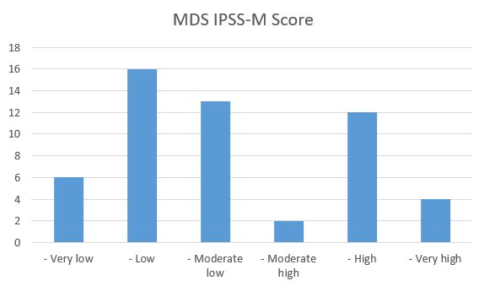

Supplemental Figure 2: Bar chart of IPSS-M groups in ZRSR2m MDS, MDS/MPN overlap, MPN and CCUS patients.
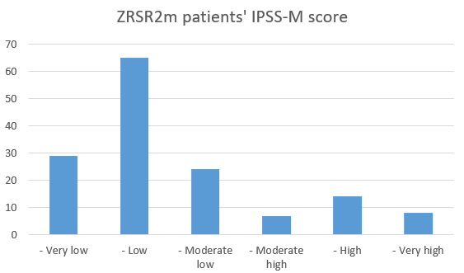

Supplemental Figure 3: Density plot of IPSS-M score in ZRSR2m MDS, MDS/MPN overlap, MPN and CCUS patients.

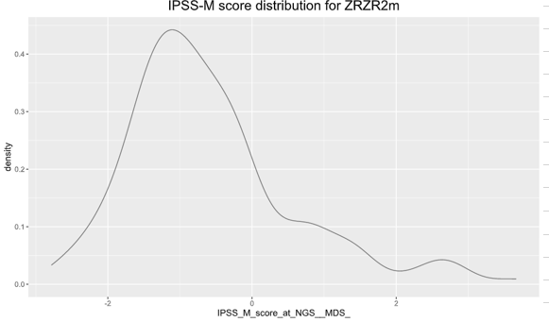

Supplemental Figure 4: Gender corrected VAF for ZRSR2m MN patients according to myeloid neoplasm diagnoses.
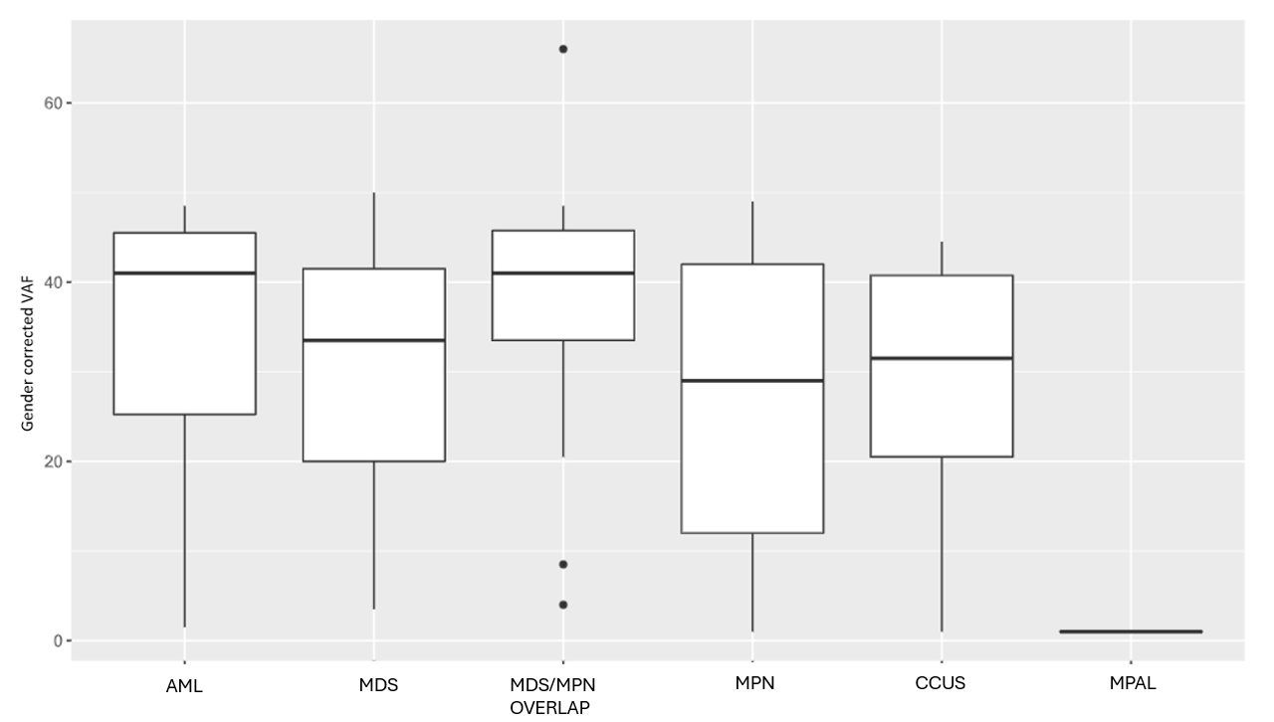

Supplemental Figure 5: Gender corrected VAF for ZRSR2m MDS patients according to MDS subtype.
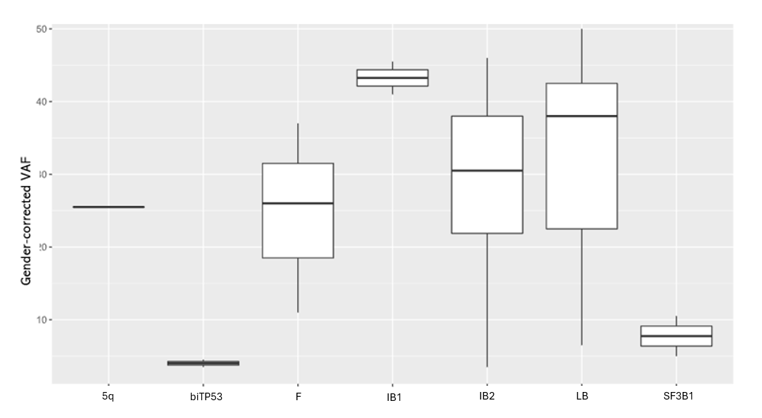

Supplemental Figure 6: Median number of co-mutations among ZRSR2m patients at time of NGS according to MN diagnoses.
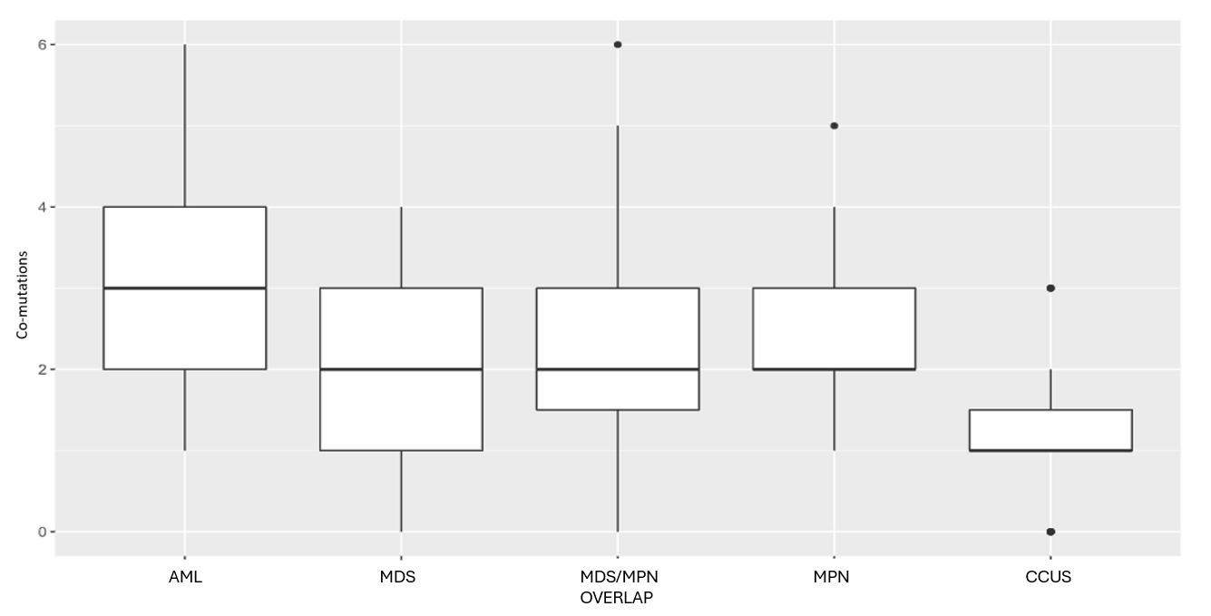

Supplemental Figure 7: Frequency of gene pathways co-mutations in 164 ZRSR2m MN patients at time of NGS.
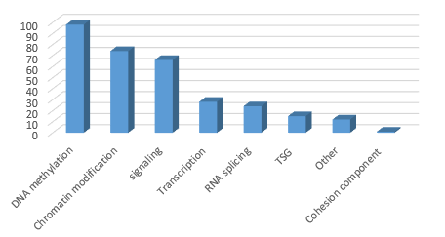

Supplemental Figure 8: Frequency of different medications used as therapy for 164 ZRSR2m MN patients.
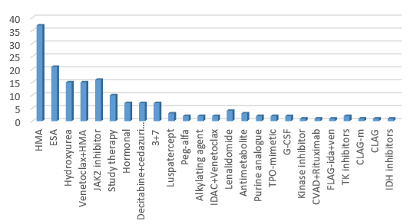

Supplemental Figure 9: Pie charts showing (A) MDS and (B) AML responses to therapy in ZRSR2m patients.
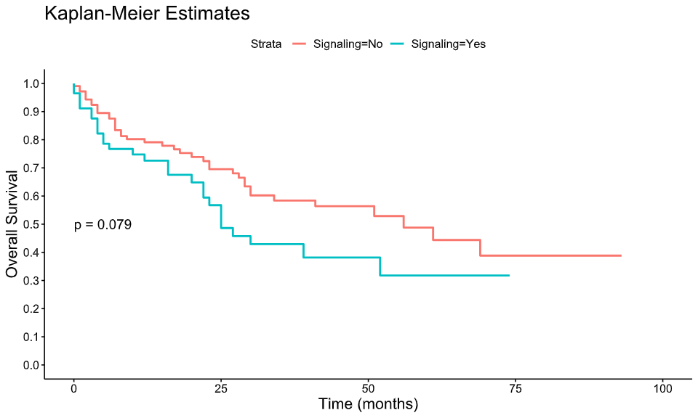
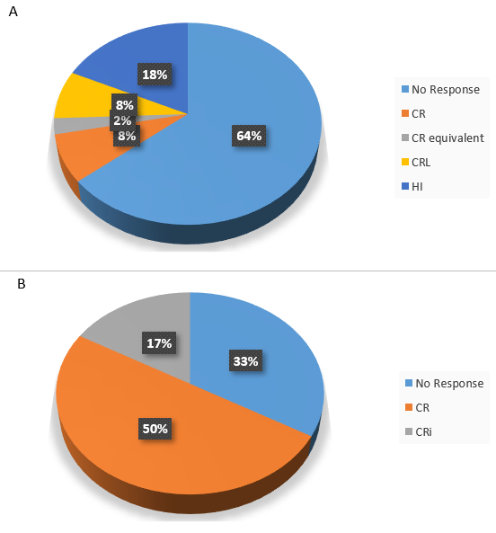

Supplemental Figure 10: Overall survival according to the presence or absence of spliceosome family co-mutation in ZRSR2m MN patients.
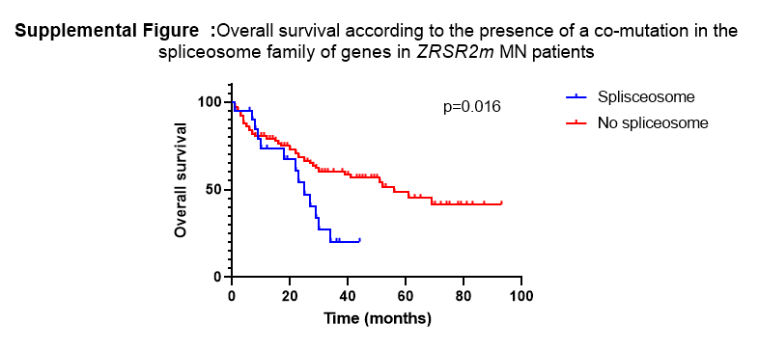

Supplemental Figure 11: Overall survival according to the presence or absence of peripheral circulating blasts ≥5% in ZRSR2m MN patients.
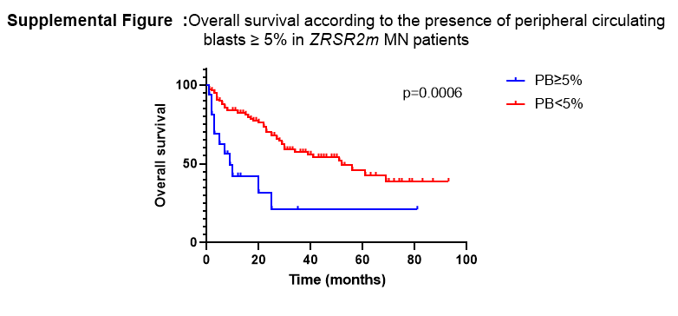

Supplemental Figure 12: Overall survival according to cytogenetic status in ZRSR2m MN patients.
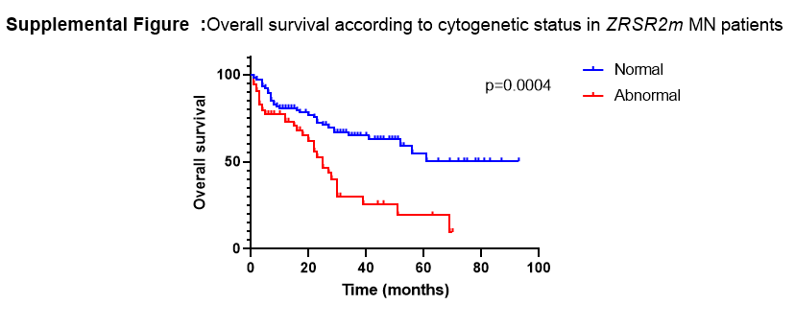

Supplemental Figure 13: Overall survival according to the presence or absence of a TSG family co-mutation in ZRSR2m MN patients.
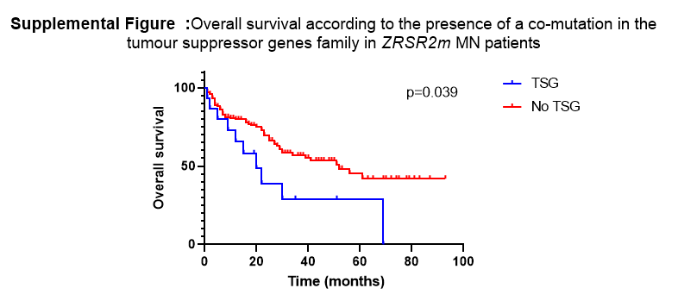

Supplemental Figure 14: Overall survival according to IPSS-M groups in ZRSR2 MDS patients.
