Supplementary information
Month | Coordinates | Nº specimens | Habitat
May | 36.297045, -5.867136 | 2 | Olive grove
May | 37.543276, -7.046505 | 2 | Scrubs
June | 37.635514, -6.627346 | 15 | Riparian vegetation
June | 37.344600, -6.639984 | 110 | Scrubs
June | 37.767019, -7.028623 | 37 | Woodland
July | 37.3165432, -7.3548337 | 6 | Scrubs
July | 37.52843, -7.272591 | 1 | Scrubs
July | 37.548127, -6.051914 | 2 | Urban trees
July | 37.519279, -5.859416 | 1 | Eucalyptus forest
July | 37.3664662, -4.9868029 | 23 | Eucalyptus forest
August | 37.5230120, -6.5379540 | 230 | Holm oak
August | 37.914752, -7.194055 | 18 | Scrubs
August | 37.160235, -6.807134 | 1 | Mixed pine forest
October | 36.308543, -5.724029 | 1 | Mediterranean forest
Table 1. Details of C. grandifovea sp. nov. collections with BG traps baited with carbon dioxide in Andalusia (southern Spain) in 2023.

Table 2. Morphometric parameters of C. grandifovea sp. nov. and C. pseudolangeroni measured in microns from 10 individuals of each species. SD = Standard Deviation. Length and width measures are expressed in microns.
Parameters | C. pseudolangeroni | C. grandifovea sp. nov
Distribution of sensilla coeloconica | 3-6, 11-14 | 3-14
Nº of sensilla coeloconica per flagellomere | (3-4),1,1,1,1,1,1, (1-2) | (3-4),(0-1),1,(0-1),1,1,1,(1-2)
Wing length ± SD | 875.9 ± 50.41 | 1087.3 ± 77.10
Wing width ± SD | 424.6 ± 13.1 | 502.1 ± 34.79
Length of spermathecae ± SD | 39.2 ± 7.59 x 42.1± 4.34 | 66.5 ± 2.12 x 55.0 ± 4.32
Width of spermathecae ± SD | 34.0 ± 4.54 x 37.3 ± 5.48 | 53.0 ± 7.1 x 45.6 ± 6.66
Nº of mandibular teeth, mean (min-max) | 14.2 (14-15) | 11.75 (9-14)
Nº of maxillary teeth, mean (min-max) | 15.6 (15-16) | 15.5 (15-17)
Length palpus (1-5 segments) ± SD | 210.8 ± 20.10 | 238.8 ± 20.86
Length palpus (3rd segment) ± SD | 63.8 ± 7.25 | 69.5 ± 7.10
Width palpus (3rd segment) ± SD | 32.8 ± 3.25 | 45.3 ± 3.80
Area of the sensory pit, mean ± SD | NA | 605.2 ± 68.31

Table 3. Estimation of the evolutionary distance between different Culicoides species for the COI gene. Standard error estimate(s) are shown above the diagonal and were obtained by a bootstrap procedure (1000 replicates). This analysis involved 21 nucleotide sequences. All ambiguous positions were removed for each sequence pair (pairwise deletion option). There was a total of 766 positions in the final dataset. Evolutionary analyses were conducted in MEGA11.
Culicoides species | 1 | 2 | 3 | 4 | 5 | 6 | 7 | 8 | 9 | 10 | 11 | 12 | 13 | 14 | 15 | 16 | 17 | 18 | 19 | 20 | 21
1_C4_C. grandifovea sp. nov. Spain |  | 0.00224 | 0.00239 | 0.00237 | 0.00163 | 0.00163 | 0.01317 | 0.01300 | 0.02365 | 0.01711 | 0.02496 | 0.02020 | 0.01930 | 0.01968 | 0.01930 | 0.02016 | 0.01930 | 0.01826 | 0.01821 | 0.02037 | 0.02233
2_C5_ C. grandifovea sp. nov. Spain | 0.00321 |  | 0.00224 | 0.00227 | 0.00154 | 0.00218 | 0.01308 | 0.01292 | 0.02362 | 0.01693 | 0.02434 | 0.01952 | 0.01864 | 0.01892 | 0.01855 | 0.01970 | 0.01864 | 0.01811 | 0.01774 | 0.01993 | 0.02143
3_C12_ C. grandifovea sp. nov. Spain | 0.00324 | 0.00315 |  | 0.00000 | 0.00162 | 0.00161 | 0.01322 | 0.01326 | 0.02379 | 0.01680 | 0.02455 | 0.01986 | 0.01907 | 0.01955 | 0.01915 | 0.01962 | 0.01929 | 0.01853 | 0.01825 | 0.01976 | 0.02157
4_C13_ C. grandifovea sp. nov. Spain | 0.00323 | 0.00319 | 0.00000 |  | 0.00163 | 0.00163 | 0.01322 | 0.01320 | 0.02360 | 0.01728 | 0.02488 | 0.02042 | 0.01963 | 0.01995 | 0.01963 | 0.02037 | 0.01963 | 0.01844 | 0.01816 | 0.02038 | 0.02236
5_C14_C C. grandifovea sp. nov. Spain | 0.00160 | 0.00156 | 0.00159 | 0.00159 |  | 0.00000 | 0.01308 | 0.01291 | 0.02347 | 0.01691 | 0.02469 | 0.01983 | 0.01896 | 0.01928 | 0.01896 | 0.01992 | 0.01896 | 0.01818 | 0.01793 | 0.02011 | 0.02182
6_C15_ C. grandifovea sp. nov. Spain | 0.00160 | 0.00307 | 0.00158 | 0.00159 | 0.00000 |  | 0.01308 | 0.01290 | 0.02350 | 0.01687 | 0.02452 | 0.01949 | 0.01867 | 0.01881 | 0.01859 | 0.01974 | 0.01867 | 0.01811 | 0.01774 | 0.01996 | 0.02146
7_C7_C. kurensis Spain | 0.09551 | 0.09478 | 0.09658 | 0.09658 | 0.09478 | 0.09478 |  | 0.00160 | 0.02248 | 0.01717 | 0.02415 | 0.01852 | 0.01727 | 0.01762 | 0.01727 | 0.01762 | 0.01727 | 0.01839 | 0.01822 | 0.01964 | 0.02183
8_C8_ C. kurensis Spain | 0.09420 | 0.09390 | 0.09658 | 0.09609 | 0.09317 | 0.09383 | 0.00162 |  | 0.02210 | 0.01697 | 0.02447 | 0.01840 | 0.01705 | 0.01744 | 0.01697 | 0.01786 | 0.01705 | 0.01775 | 0.01736 | 0.01971 | 0.02148
9_JQ620127_C. nubeculosus Sweden | 0.18048 | 0.18444 | 0.18080 | 0.17940 | 0.17911 | 0.18123 | 0.17245 | 0.17031 |  | 0.02323 | 0.02459 | 0.02546 | 0.02498 | 0.02493 | 0.02487 | 0.02649 | 0.02498 | 0.02535 | 0.02512 | 0.02802 | 0.02918
10_LC759005_C. cataneii Spain | 0.16025 | 0.16381 | 0.15994 | 0.16533 | 0.16164 | 0.16221 | 0.15777 | 0.15888 | 0.18429 |  | 0.02573 | 0.02090 | 0.02018 | 0.02062 | 0.02006 | 0.02069 | 0.02036 | 0.02001 | 0.01952 | 0.02083 | 0.02297
11_C9_C. indistinctus Spain | 0.16571 | 0.16421 | 0.16991 | 0.16897 | 0.16480 | 0.16421 | 0.16044 | 0.15461 | 0.21348 | 0.19260 |  | 0.02688 | 0.02611 | 0.02614 | 0.02593 | 0.02690 | 0.02611 | 0.02656 | 0.02625 | 0.02869 | 0.02946
12_C10_ C. indistinctus Spain | 0.16814 | 0.16372 | 0.17043 | 0.16951 | 0.16546 | 0.16372 | 0.16377 | 0.15518 | 0.21129 | 0.19090 | 0.00000 |  | 0.00636 | 0.00693 | 0.00635 | 0.00576 | 0.00641 | 0.02136 | 0.02099 | 0.02003 | 0.02139
13_C1_C. pseudolangeroni Spain | 0.18870 | 0.18272 | 0.18696 | 0.19172 | 0.18531 | 0.18304 | 0.17130 | 0.16937 | 0.21293 | 0.19664 | 0.20098 | 0.20036 |  | 0.00219 | 0.00000 | 0.00000 | 0.00000 | 0.02029 | 0.02001 | 0.01898 | 0.02068
14_C3_ C. pseudolangeroni Spain | 0.18870 | 0.18177 | 0.18762 | 0.19172 | 0.18531 | 0.18208 | 0.17130 | 0.16847 | 0.21129 | 0.19560 | 0.20098 | 0.19927 | 0.00000 |  | 0.00218 | 0.00233 | 0.00220 | 0.02062 | 0.02023 | 0.01921 | 0.02129
15_C17_ C. pseudolangeroni Spain | 0.18870 | 0.18272 | 0.18897 | 0.19172 | 0.18531 | 0.18304 | 0.17130 | 0.16937 | 0.21293 | 0.19804 | 0.20098 | 0.20036 | 0.00000 | 0.00000 |  | 0.00000 | 0.00000 | 0.02029 | 0.01992 | 0.01898 | 0.02088
16_C2_ C. pseudolangeroni Spain | 0.19294 | 0.18708 | 0.19244 | 0.19596 | 0.18943 | 0.18547 | 0.17543 | 0.17414 | 0.21323 | 0.20187 | 0.20546 | 0.20358 | 0.00308 | 0.00307 | 0.00309 |  | 0.00000 | 0.02129 | 0.02094 | 0.01927 | 0.02155
17_C16_ C. pseudolangeroni Spain | 0.19167 | 0.18731 | 0.18729 | 0.19336 | 0.18908 | 0.18766 | 0.17065 | 0.17312 | 0.21959 | 0.19544 | 0.20689 | 0.20644 | 0.00000 | 0.00000 | 0.00000 | 0.00327 |  | 0.02029 | 0.02001 | 0.01899 | 0.02104
18_HQ824417_C. pulicaris Switzerland | 0.19386 | 0.19435 | 0.18800 | 0.19272 | 0.19227 | 0.19132 | 0.18372 | 0.19310 | 0.20509 | 0.21146 | 0.23208 | 0.22952 | 0.22806 | 0.22617 | 0.22806 | 0.22826 | 0.22976 |  | 0.00000 | 0.02163 | 0.02398
19_KJ729987_C. langeroni Tunisia | 0.20579 | 0.20139 | 0.20141 | 0.20660 | 0.20187 | 0.19967 | 0.19008 | 0.19045 | 0.22487 | 0.20945 | 0.21893 | 0.21877 | 0.02501 | 0.02497 | 0.02524 | 0.02979 | 0.01981 | 0.24059 |  | 0.02186 | 0.02389
20_KJ162981_C. imicola France | 0.20113 | 0.19870 | 0.19732 | 0.20376 | 0.20049 | 0.19906 | 0.19171 | 0.19376 | 0.25647 | 0.22429 | 0.22375 | 0.23350 | 0.19330 | 0.19330 | 0.19268 | 0.19609 | 0.19172 | 0.25425 | 0.20976 |  | 0.00673
21_KJ729973_ C. imicola Tunisia | 0.23822 | 0.23394 | 0.23265 | 0.24105 | 0.23540 | 0.23247 | 0.22885 | 0.22807 | 0.27690 | 0.25859 | 0.26095 | 0.26795 | 0.22263 | 0.22501 | 0.22582 | 0.22943 | 0.22745 | 0.27344 | 0.23668 | 0.02703

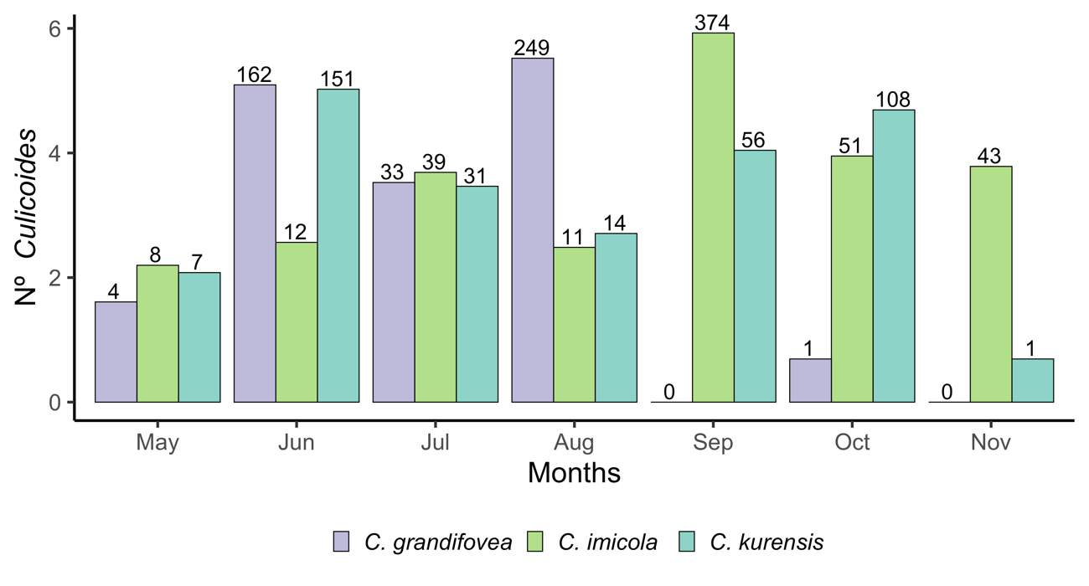
Figure 1. Number of individuals per trap night for the three most abundant Culicoides species collected at 476 sampling sites between April and November 2023 with carbon dioxide baited traps. The number above the bar represents the total number of collected individuals.

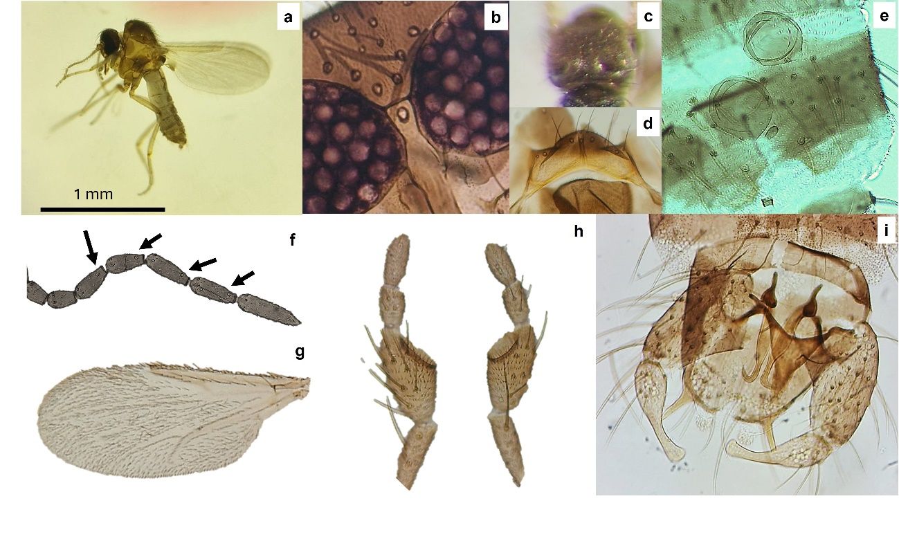Additional file 1: Figure S2. Habitus of C. pseudolangeroni. a General aspect. b Interocular space. c Scutum. d Scutellum. e Spermathecae. f Antennal sensilla coeloconica distribution. g Wing patterns. h Maxillary palpus. i Male genitalia.

