Supplementary Information
Unveiling the Impact of Electron Accumulation on the Performance of Quantum-Dot Light-Emitting Diodes Using Electrically Pumped Transient Absorption Spectroscopy

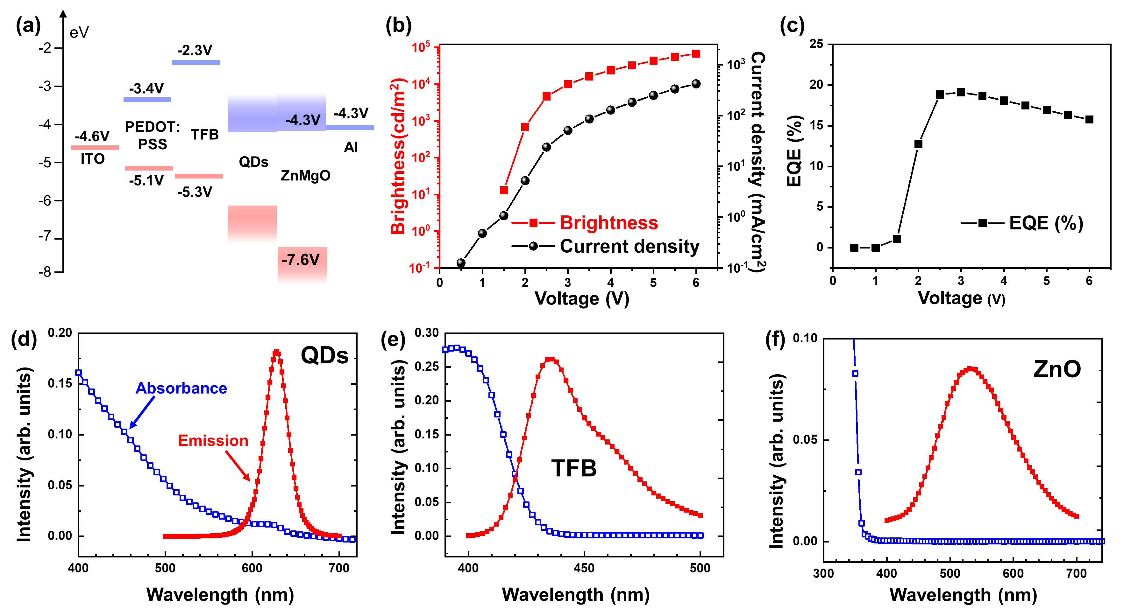
Figure S1: (a) Structure and energy diagram of red QLEDs studied in the main text; (b) The brightness and current of the QLED as functions of voltage; (c) The EQE of the QLED as a function of voltage; (d) – (f) Absorption (hollow) and photoluminescence (solid) spectra of the solutions of QDs (solvent: octane), TFB (solvent: chlorobenzene) and ZnO nanoparticles (solvent: ethanol) that are used in QLED fabrication.
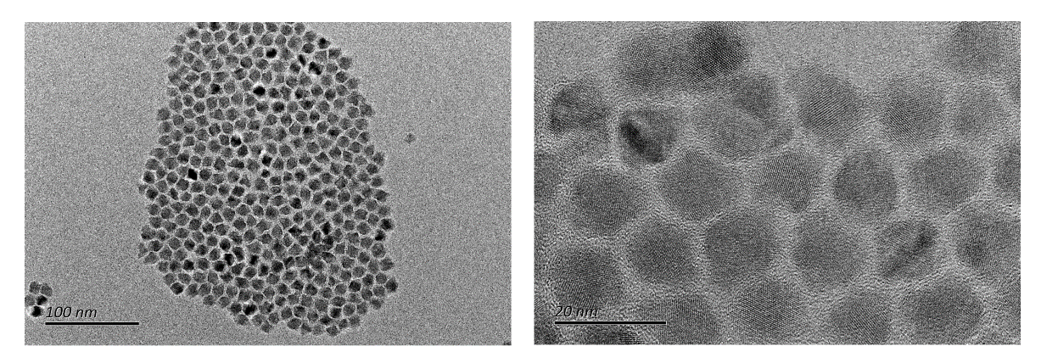
Figure S2: TEM images of red QDs used in QLED fabrication.
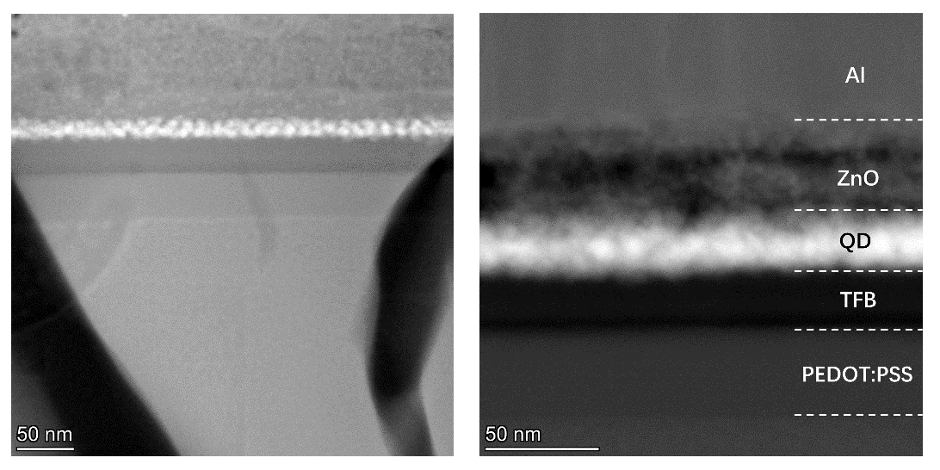
Figure S3: Cross-sectional TEM images of a QLED used in this work.
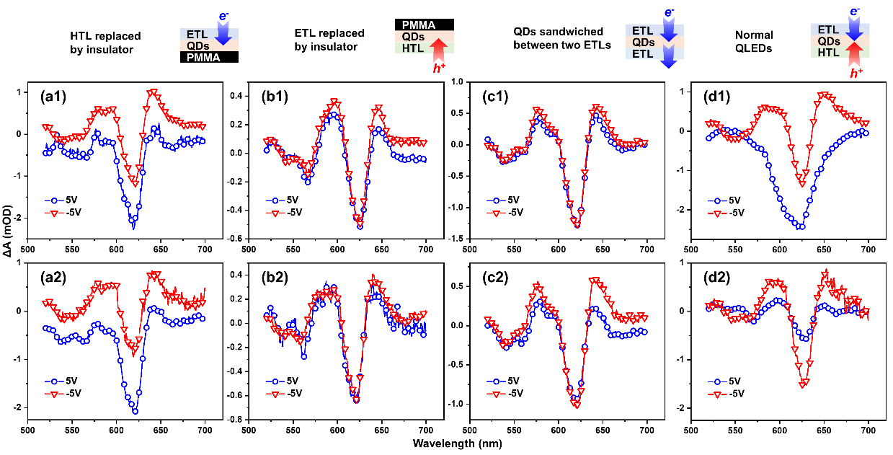
Figure S4: In order to verify that the E-TA bleach signal originates from electrons, E-TA spectra of half-devices under 5 V forward (denoted as 5 V) and backward (denoted as -5 V) pump voltage biases are displayed in this figure, with two samples displayed for each case. The figure shows four different device structures. (a1) and (a2): Devices with PMMA/QDs/ZnO structure (with insulator polymer PMMA replacing HIL/HTL). Under forward biases, both Stark and bleach signals are observed, indicating the contribution of electrons to the bleach signal. (b1) and (b2): Devices with PEDOT:PSS/TFB/QDs/PMMA structure (with ETL replaced by PMMA). At 5 V, there is no bleach signal, suggesting that either the holes do not exhibit a bleach signal or the injection of holes is insufficient. (c1) and (c2): Devices with ZnO/QDs/ZnO structure, where an emissive QD layer is sandwiched between two ETLs. In these devices, electrons flow through without accumulating in the QD layer. (d1) and (d2): Two normal QLEDs that exhibit different bleach signal intensities.
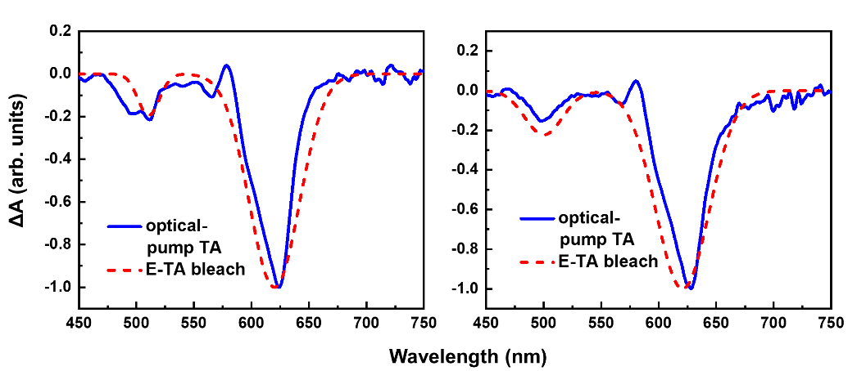
Figure S5: Comparison of the bleach signal shape between E-TA and optically pumped TA spectra on the same QLED. The figure presents two different QLEDs, shown in the left and right panels, respectively.

The main discussion of this manuscript features a red QLED that is displayed in Figure 2, 3(a) of the main text. Figures S6-S15 provide additional information on the same device. Figure S6 shows the time evolution of its E-TA spectra, while Figure S7 presents the voltage dependence of E-TA and EL spectra. The decomposition of E-TA spectra into a bleach and a Stark component is illustrated in Figure S8, and Figure S10 displays the voltage dependence of the dynamical time constants, with the method of their determination shown in Figure S11 and their numerical values tabulated in Table S1. Transient current under different pump voltage biases is shown in Figure S12, and the shape of the Stark effect is explained in Figure S13. Figure S15 includes its voltage dependence of N_{e} and Stark signal intensity.
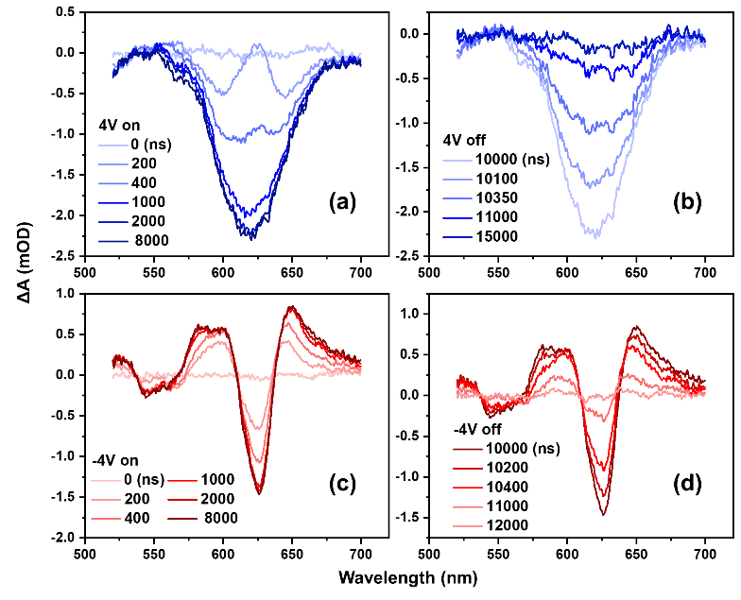
Figure S6: The time-evolution of E-TA spectra under a pump voltage bias applied between 0 ns and 10000 ns. (a) E-TA spectra after switching on forward bias (4 V); (b) spectra after cutting off the forward bias; (c) E-TA spectra after switching on the backward bias (-4 V); (d) spectra after cutting off the backward bias.
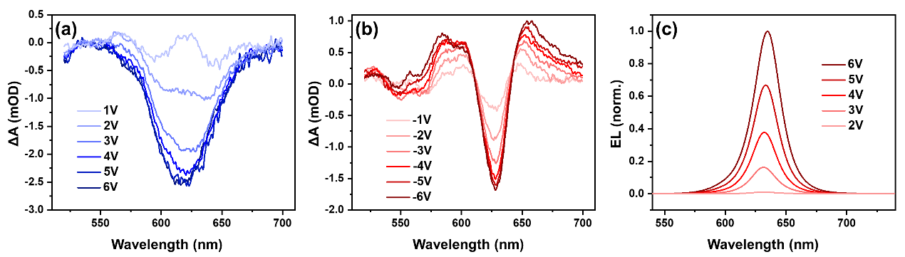Figure S7: E-TA and EL spectra under different pump voltages. (a) Equilibrated E-TA spectra of the red QLED under different forward biases; (b) Equilibrated E-TA spectra under different backward biases. (c) EL spectra of the QLED under different voltages.
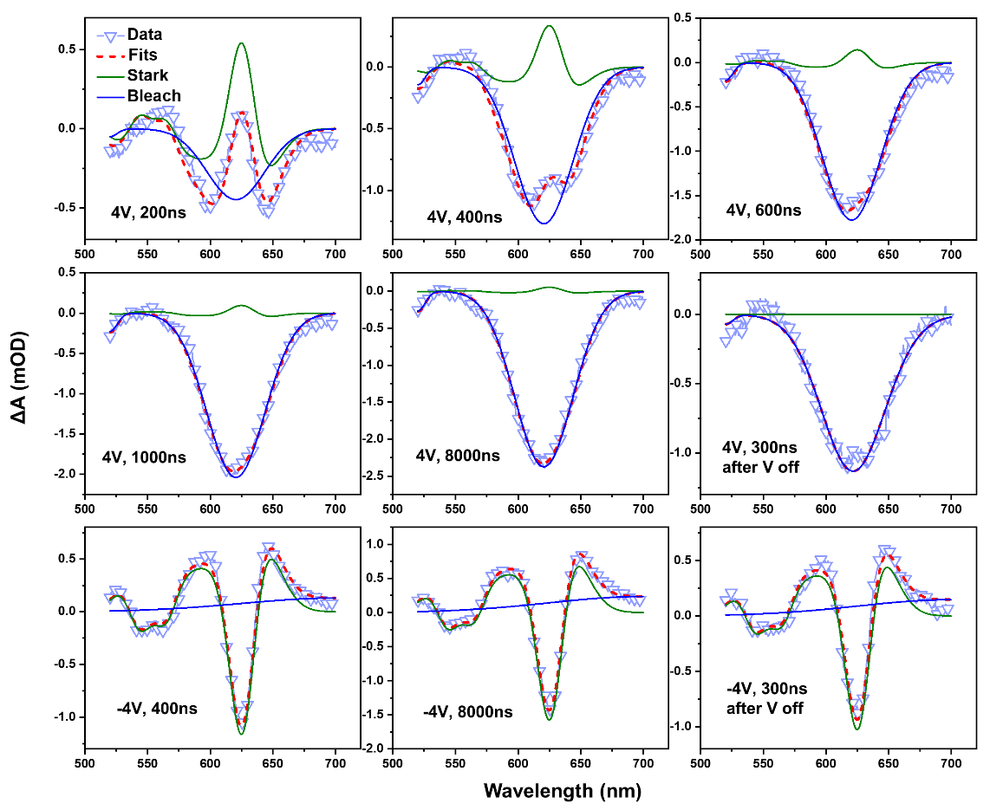
Figure S8: Decomposition of E-TA spectra into two components: a Stark effect and a bleach component. The bandshapes of both components are constant, but their magnitudes vary with delay times. The Stark-effect bandshape is consistent for both forward and backward biases. When a backward bias is applied, a small, broad positive bleach peak is observed, likely due to the withdrawal of stray electrons from the conduction band. Spectra at several selected delay times are displayed.
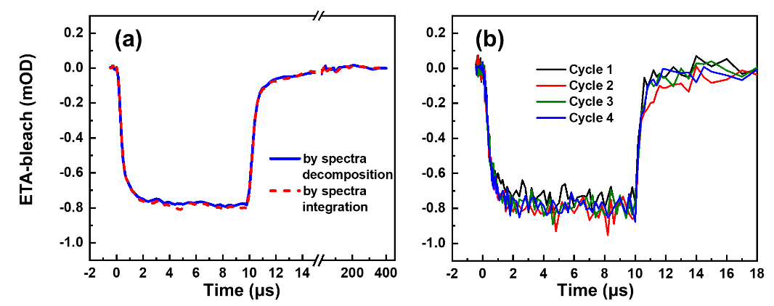
Figure S9: (a) Comparison of the bleach kinetics obtained by two different methods from E-TA technology: spectral decomposition (as shown in Figure S8) and integration of the spectrum over wavelength. The bleach kinetics obtained by both methods overlap since integrating the Stark-effect bandshape over wavelength should result in zero; (b) The bleach intensity as a function of time measured in various scan cycles, indicating that the device is operating in a stable condition.
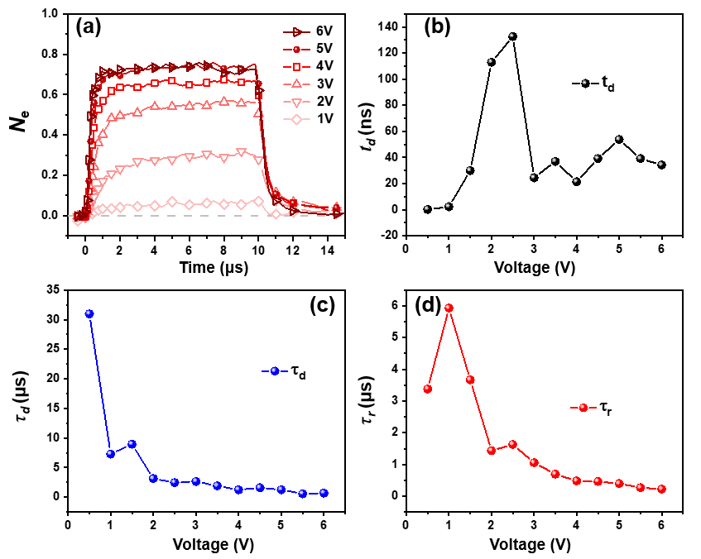
Figure S10: (a) N_{e}(t) values of the red QLED as a function of time at different pump voltage biases. (b) – (d) $τ_{r}$, $τ_{d}$, or $t_{d}$ of E-TA bleach signal obtained at different pump voltages.
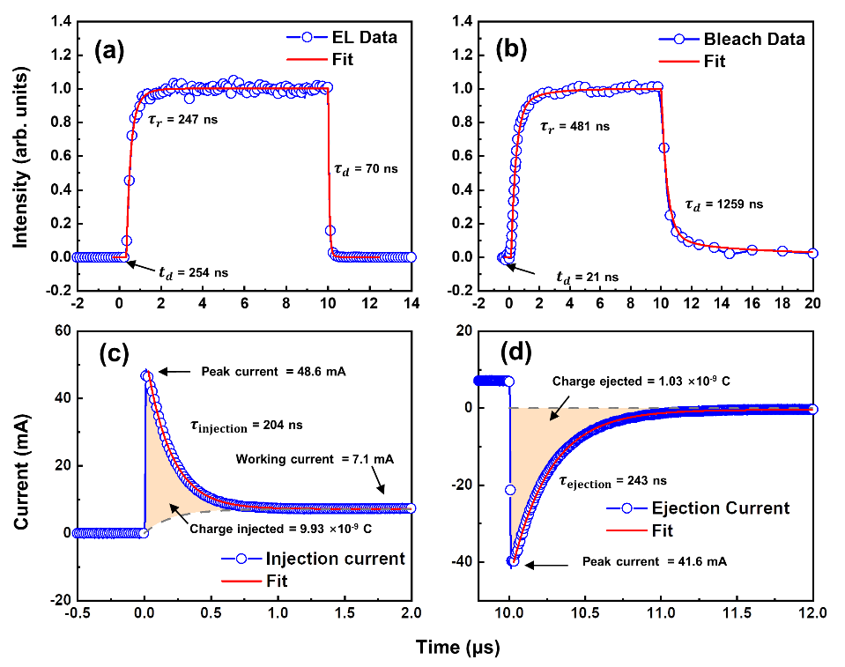
Figure S11: Calculation of time constants. (a) and (b) Fits of the TREL and E-TA bleach signal. For TREL and bleach signal, signal raise after turning on the pump voltage (0 < T_{d} < 10 μs) is fitted with a bi-exponential function (increased form), $S\left(t\right)=\sum_{i}{A_{i} \left(1-e^{{-\left(t-t_{0}\right)}/{τ_{i}}}\right)}$. $τ_{r}$ is computed by averaging the time constants: $τ_{r} =\sum_{i}{A_{i}}τ_{i}$. $t_{d}$ is determined as the time at which the signal first rises above the level of noise. Signal decay after cutting off the pump voltages (T_{d} > 10 μs) is fitted with a multi-exponential function with 4 or 5 lifetime components ($S\left(t\right)=\sum_{i}{A_{i} \left(e^{{-\left(t-t_{0}\right)}/{τ_{i}}}\right)}$), and $τ_{d}$ is calculated by averaging all time constants: $τ_{d} =\sum_{i}{A_{i}}τ_{i}$. (c) and (d) Fit of the kinetics of transient current when pump voltage is turned on and off, respectively. Injection ($τ_{injection}$) and ejection ($τ_{ejection})$ time constants of transient current are obtained by fitting transient current with single exponential decay from the highest and lowest point, respectively. The current decay curve can be well-described by a single exponential function, indicating an RC circuit-like behavior. This is because the injection of carriers into the inner layers occurs much more slowly than the charging of the electrodes, causing carriers to initially accumulate on the electrodes before redistributing into the inner layers. Therefore, during the early stages of injection, the QLED can be approximated as a capacitor. The transient current measurements also reveal a longer discharging time (~243 ns) than charging time (~203 ns), which suggests that carriers are being extracted from the inner layers when ejected. The quantity of injected or ejected charge can be calculated by integrating the area shaded in orange.
Signal type | Interpretation | Time constants
TREL | $${∝J}_{h}(t)∙{ N}_{e}(t)$$ | $t_{d}$ = 254$±$10 ns |  | $τ_{r}$ = 247 ns | $τ_{d}$ = 70 ns
E-TA Bleach | $${∝ N}_{e}(t)$$ | $t_{d}$ = 21$±$10 ns |  | $τ_{r}$ = 481 ns | $τ_{d}$ = 1259 ns
Transient current |  | $τ_{injection}$= 204$±2$ ns; $τ_{ejection}$= 243$±2$ ns
E-TA Stark | Electric field | Flat-band condition at 210$±$10 ns
$J_{h}(t)$: Hole injection current into QD; |  |  | $N_{e}(t)$: Number of electrons per QD;
Table S1: Summary of charge injection time constants for the QLED in Figure S11.
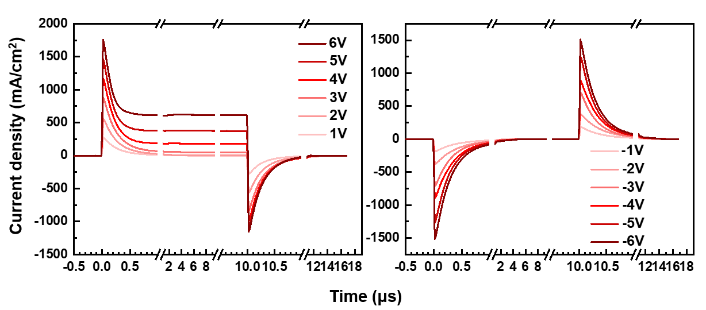
Figure S12: Transient current flows through the QLED when different forward (left panel) and backward (right panel) voltage pulses are applied. The current measured at QLED cathode is always equal to that measured at QLED anode, so the whole device is always neutral in charge. Positive and negative spikes at 0 and 10 µs indicate the charging and discharging current, while a plateau between 3 and 10 µs indicates the working current. These observations suggest that the QLED functions as a capacitor and a diode, respectively. The magnitude of the charging current exhibits a linear relationship with the voltage, and the direction of the charging current is opposite when a negative voltage bias is applied, while its magnitude remains similar. The working current exhibits a turn-on voltage and increases more rapidly with increasing voltage. At negative biases, no working current is detected.
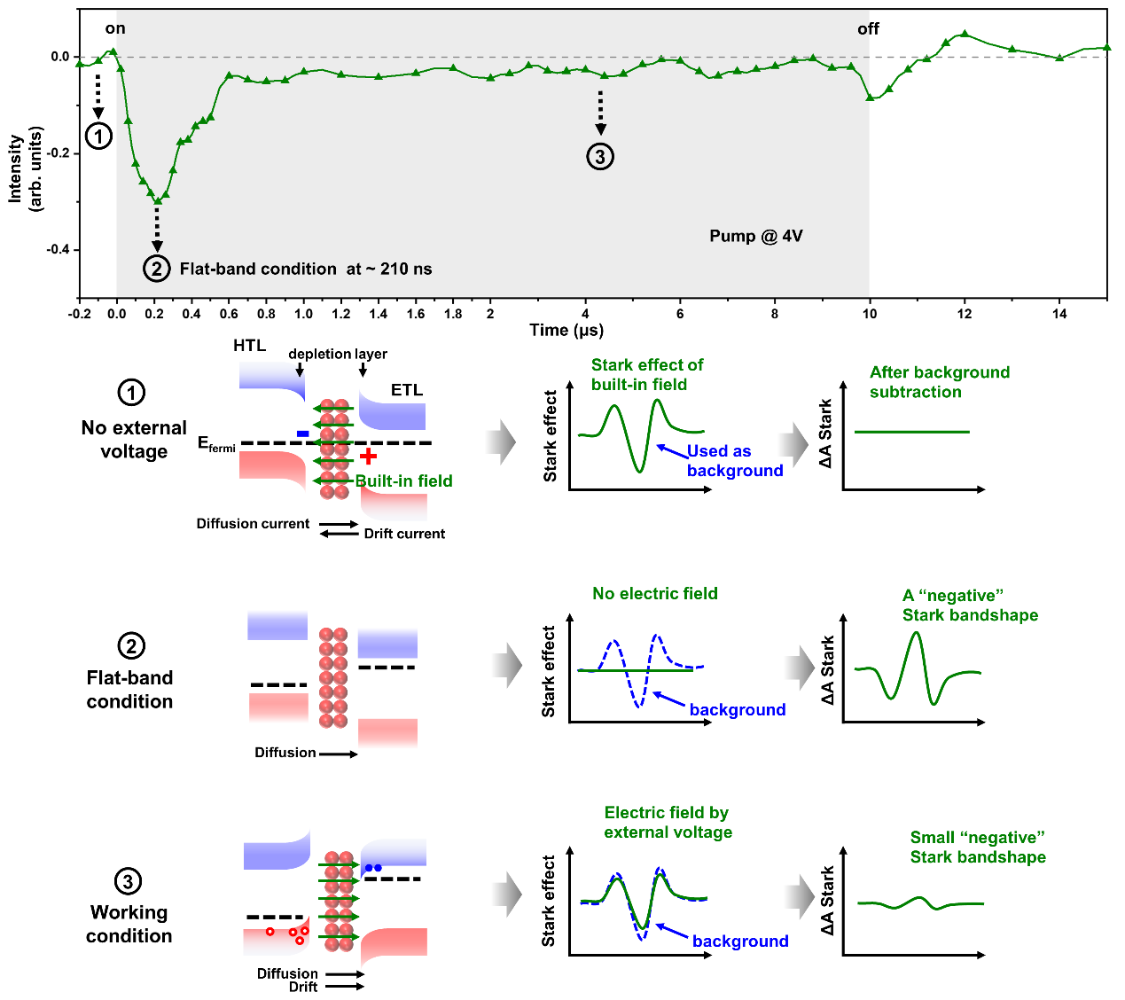
Figure S13: Explanation of the Stark effect peak shape and kinetics. The kinetics of the Stark effect is shown in the top graph, which replicates Figure 3 from the main text. A 4V pump voltage is applied at 0 ns and turned off at 10000 ns. When a forward pump voltage is applied, a Stark effect is observed at early times or low voltages with a shape opposite to that obtained at negative biases. To explain this, we selected three specific time points:
(1) Before the voltage is applied: With no external voltage, the holes in the HTL and electrons in the ETL will be drained, causing the HTL to be negatively charged and the ETL to be positively charged. This creates a built-in field, resulting in a Stark effect. As this built-in field is subtracted as background, the change in absorbance (ΔA) is 0.
(2) Flat-band condition: After time zero, the external voltage starts to cancel out the built-in field, leading to a decrease in the total electric field in the QD layer. At the flat-band condition, the net electric field in the QD layer is 0, and the green curve reaches the bottom. The subtraction of the background signal results in a "negative" Stark effect bandshape.
(3) Working condition: As the external voltage continues to increase, the direction of the electric field is flipped. The Stark effect signal begins to rise again because its intensity is proportional to the square of the electric field amplitude, regardless of the electric field direction. In this device, the Stark intensity never reaches 0, indicating that the magnitude of the electric field in the QDs is always smaller than the built-in field.
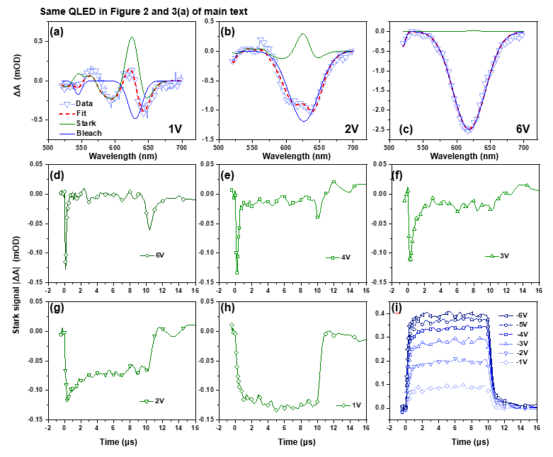
Figure S14: Stark signal kinetics at different voltages for the red QLED discussed in the main text. Panels (a)-(c) show the decomposition of E-TA spectra into Stark signal and bleach signal at 1V, 2V, and 6V pump voltages, respectively. Panels (d)-(i) display the Stark kinetics at different pump voltages, including negative pump voltage. For pump voltages greater than 1V, the signal initially decreases before increasing, indicating a flip in the direction of the electric field. The absorbance of the Stark signal is calculated by averaging |ΔA| of the Stark effect shape between 520 nm and 700 nm, with a three-lobed shape identical to the one measured under backward biases defined as "positive".

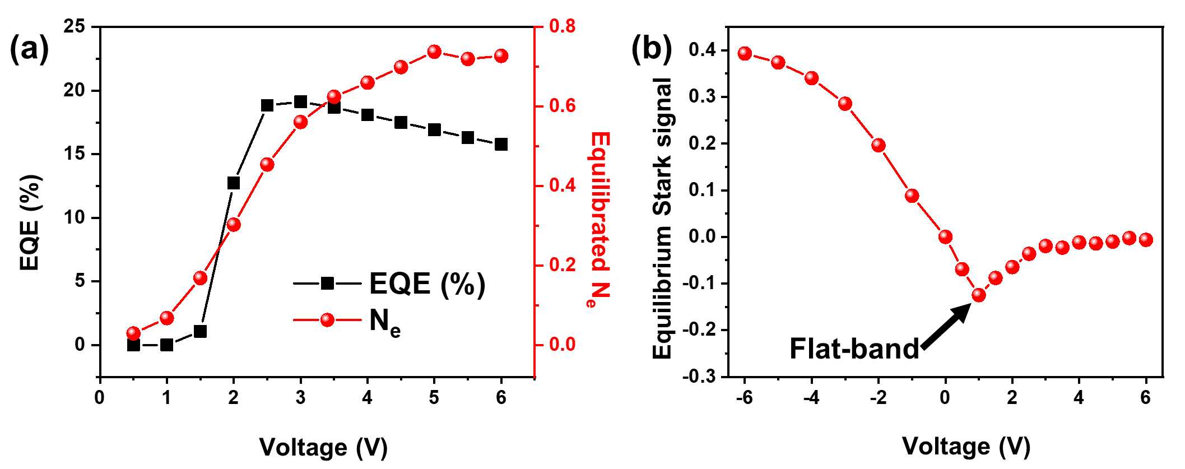
Figure S15. (a) N_{e} in the QLED as functions of voltage. EQE is also provided for comparison. (b) The equilibrium Stark effect signal intensity as a function of voltage, from which the flat-band voltage can be obtained.

We conduct E-TA measurements on the QLED at various driving voltages. Figure S15 (a) shows N_{e} as functions of voltage. At lower voltages, both N_{e} and EQE increase with voltage, but at higher voltages, EQE begins to decrease (roll-off) while N_{e} continues to increase. Figure S15 (b) illustrates the equilibrium Stark effect signal intensity at various voltages. This correlation allows us to determine the flat-band voltage of the device, which corresponds to the lowest point of the Stark signal. At this point, the electric field in the QLED is zero. When the external voltage is lower than the flat-band voltage, the direction of the electric field in the QDs is parallel to the built-in field. When the applied voltage is greater than the flat-band voltage, the electric field is parallel to the applied voltage and opposite to the built-in field. Figure S15 (b) highlights the capability of the E-TA technique to measure flat-band voltage, which is another valuable function of the technology.

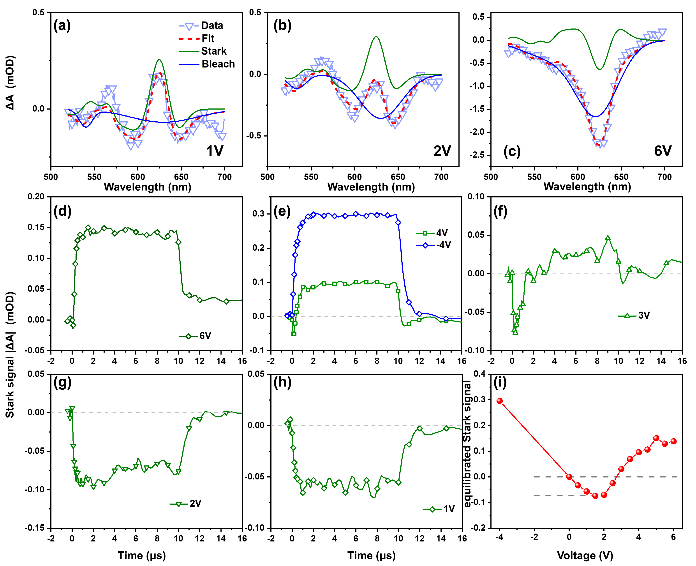
Figure S16: Stark effect in another red QLED. Not all red QLEDs exhibit an equilibrated Stark effect smaller than zero at high voltages, as illustrated by this counterexample, which shows the Stark effect of another red QLED. Panels (a) – (c) depict the decomposition of E-TA spectra into Stark and bleach contributions at 1V, 2V, and 6V, respectively. Panels (d) – (h) display the kinetics of the Stark effect signal at different voltages. (i) Equilibrium Stark effect signal as a function of voltage in this QLED.
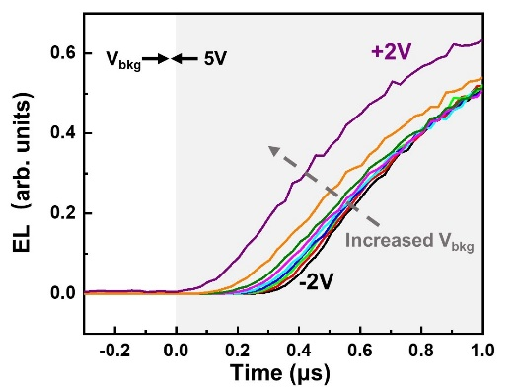
Figure S17: Explaining the initial delay time t_{d} observed in TREL. A fixed 5V working voltage is applied between 0µs and 10µs, while different background voltages are applied when the working voltage is off. The normalized TREL at +5V working voltage and different background voltages (before 0µs) are shown. A smaller t_{d} is observed at higher background voltages, and t_{d} vanishes at 2V background voltage. These results indicate that the initial delay time td in TREL originates from the hole accumulation time in the HTL.

Mechanism of Electron Injection
E-TA technology enables us to explore the mechanism of electron injection. To focus solely on electron injection dynamics and exclude the influence of recombination, this study is conducted on a half-device where the HTL is replaced with an insulator, effectively blocking hole injection. E-TA experiments were conducted on this customized device at various driving voltages, and the results are presented in Figure S18. In the left and right panels of the figure, we model electron injection/ejection with the current described by spatial charge limited current (SCLC) and Ohmic current, respectively. The fits using SCLC are superior, indicating that the J-V behavior is closer to SCLC compared to Ohmic current.
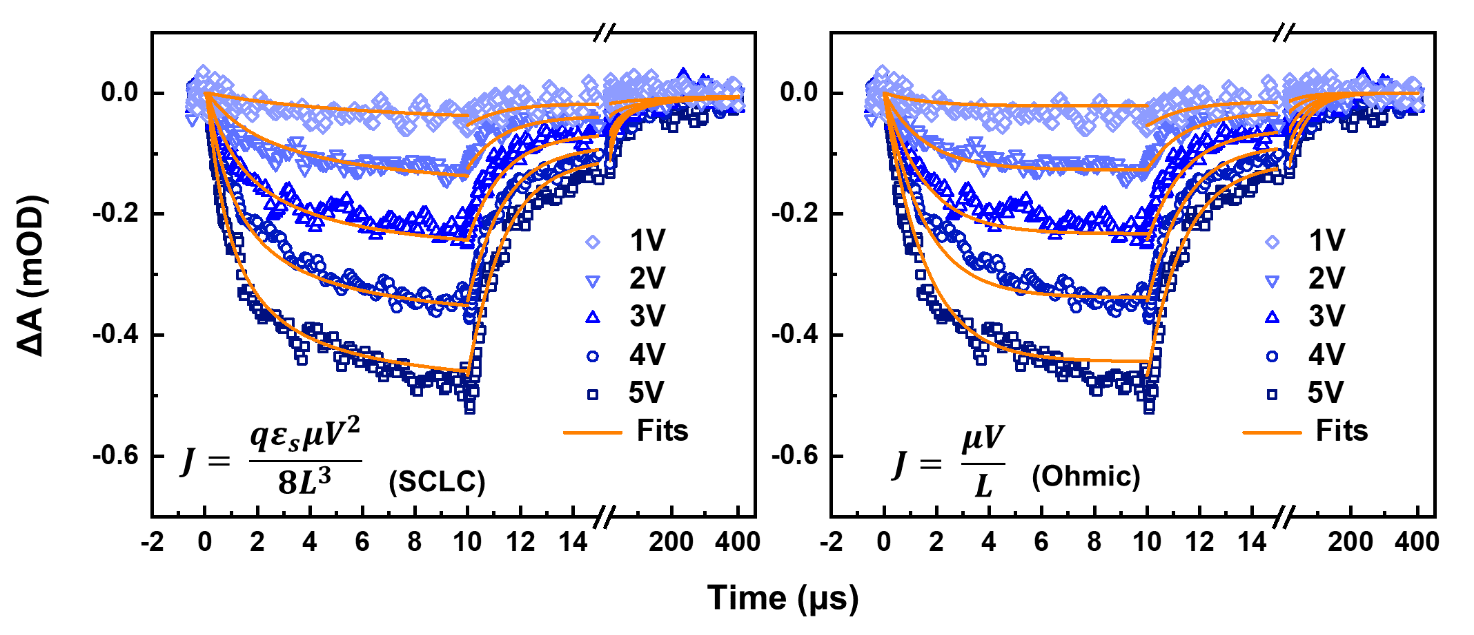
Figure S18: Elucidating the mechanism of electron injection and ejection through the modeling of bleach signal kinetics. The model is applied to a half-device where the HIL is replaced with an insulator polymer (polymethyl methacrylate, PMMA), resulting in no hole injection. The left and right panels describe the bleach signal intensity as a function of time, with electron injection/ejection modeled using the current-voltage (J-V) curve described by spatial charge limited current (SCLC) and Ohmic current, respectively.

- Electron injection model
The intensity of the E-TA bleach signal in a QLED is directly proportional to $N_{e}$. In the absence of recombination, $N_{e}(t)$ as a function of time is solely determined by the electron injection current, $J_{e}(t)$:
$$\begin{aligned}\frac{dN_{e}(t)}{dt}*n_{QD} =J_{e}\left(t\right) \#\left( AUTONUM \backslash * Arabic \right)\end{aligned}$$
where $n_{QD}$ is the number of QDs in the emissive layer. In this model, the $J_{e}\left(t\right)-V$ property is either described by spatial charge limited current (SCLC) or Ohmic current:
$$\begin{aligned}J_{e}(t)=β{\left(V- V_{fb}\right)}^{2} or J_{e}(t)=β(V- V_{fb}), \#\left( AUTONUM \backslash * Arabic \right)\end{aligned}$$
For Ohmic current, $β$is conductivity. For SCLC, $β = qε_{s}μ/8L^{3}$, where $ε_{s}$ is the dielectric constant of the material, $μ$ is electron mobility, L is the length of ETL. A flat-band voltage $V_{fb}$ is added to the equation. In this model, we set $β$ as a flexible parameter. According to Poisson’s equation, the total voltage-drop between QDs and cathode, $V_{ETL}$, is related to $N_{e}$ by:
$$\begin{aligned}V_{ETL}(t)=V_{total}(t)-α{ N}_{e}(t)\#\left( AUTONUM \backslash * Arabic \right)\end{aligned}$$
where $α$ is constant that is determined by the thickness and dielectric constant of ETL. $V_{total}(t)$ is the voltage drop between QLED anode and cathode, it is related to the applied external voltage $V_{0}$ by:
$$\begin{aligned}V_{total}(t)=V_{0} \left(1-e^{-t/τ}\right)\#\left( AUTONUM \backslash * Arabic \right)\end{aligned}$$
where $τ$ is time that $V_{0}$ relocated from power source to QLED electrodes, which is the injection time constant measured with transient current. The E-TA bleach signal measured at 1V ~ 5V fits simultaneously using the above equations with the three floating variables, $α$, $β$, and $V_{fb}$.
The kinetics of the bleach signal are modeled and compared with experimental results, as shown in Figure S18. The electron injection current $J_{e}\left(t\right)$ is described using either spatial charge limited current (SCLC, light panel) or Ohmic current (right panel). The SCLC model provided a better fit to the experimental data, suggesting that the electron injection process is more accurately described by SCLC. The value of $V_{fb}$ obtained from both methods was approximately 0.4 V.
- Electron Ejection Model
After the external voltage is turned off, the flow of electrons out of the QD layer begins. Poisson's equation describes that the voltage between the QD layer and the cathode as a function of density of electrons stored in the QD layer:
$$\begin{aligned}V_{ETL}(t)=αN_{e}(t)\#\left( AUTONUM \backslash * Arabic \right)\end{aligned}$$
Due to the extremely slow decay of $N_{e}(t)$, we assume that some of the electrons are in shallow traps in the QD layer:
$$\begin{aligned}{ N}_{e}(t) = { N}_{et}(t)+{ N}_{eu}(t)\#\left( AUTONUM \backslash * Arabic \right)\end{aligned}$$
Where ${ N}_{et}$(t) and $N_{eu}$(t) denote the trapped and un-trapped electrons, respectively. The initial ratio of trapped to the total electrons is $δ$:
$$\begin{aligned}{ N}_{et}(0) =δ{ N}_{e}(0)\#\left( AUTONUM \backslash * Arabic \right)\end{aligned}$$
We assume that only un-trapped electrons can flow out, and the electron de-trapping rate constant is k:
$$\begin{aligned}\frac{d{ N}_{eu}(t)}{dt} = -J(t)+k{ N}_{et}(t)\#\left( AUTONUM \backslash * Arabic \right)\end{aligned}$$
$$\begin{aligned}\frac{d{ N}_{et}(t)}{dt} = -k{ N}_{et}(t)\#\left( AUTONUM \backslash * Arabic \right)\end{aligned}$$
Therefore, we need two additional parameters, $δ$ and k, to fit the curve decay. $J(t)$ is also described using Ohmic current or SCLC. The fits are shown in Figure S18. For SCLC, $δ$ = 0.35, k = 8.50$×$10⁻⁴ ns⁻¹, which correlated to a time constant of ~1120 ns for the electron de-trapping process.

Calculation of N_{e}
We compute N_{e} according to Beer–Lambert law from E-TA bleach signal intensity:
$$\begin{aligned}ΔA(ETA)=log_{10}\frac{I_{0}}{I}=\frac{1}{2.303}ln\frac{I_{0}}{I}=\frac{σnd}{2.303}= \frac{2σN_{e}σ_{QD}}{2.303}\#\left( AUTONUM \backslash * Arabic \right)\end{aligned}$$
$ΔA$ is the intensity of E-TA bleach signal. $σ$ is the absorption cross section of the QDs in cm², n is the electron concentration per cm³，d is the optical path length in cm. Since the probe beam penetrates through the QD layer twice, $nd=2N_{e}σ_{QD}$. The area density of quantum dots ($σ$_{QD} = 0.0115 nm⁻²) is estimated by the TEM images shown in Figure S2 and S3.
The absorption cross section, $σ$, is measured using an optical pumped transient absorption method. The transient absorption is pumped by optical laser pulses at two different wavelengths of 600 nm and 500 nm at the reflection geometry. At long waiting times, the optical TA spectrum is similar to the bleach bandshape of E-TA. Therefore, we believe that $σ$ obtained from optical TA can be used to estimate the electron density in E-TA. The experiment is performed on multiple QLEDs to ensure consistency, and results from 2 devices are shown here. The dependence of $ΔA$ on pump power can be described as
$$\begin{aligned}ΔA\left(F_{ph}\right) = a\left(1-exp\left(-{2F}_{ph}σ\right)\right)\#\left( AUTONUM \backslash * Arabic \right)\end{aligned}$$
$F_{ph}$ is the photon flux of the pump beam in probe area (in photons/cm²). Note that in Equation (11) a factor of 2 is before $F_{ph}$, because the pump beam penetrates through the QD layer twice in reflection geometry. In Figure S19, bleach intensity $ΔA$ is plotted against $F_{ph}$, and the data is fit to Equation (11) to obtain $σ$. To obtain the N_{e} value from E-TA spectra, we first compute the absorption cross section at the excitation wavelength and then convert it to the value at 620 nm, which is the absorbance maximum of the TA bleach peak. This conversion is based on the steady-state absorption spectra of the QDs (see Figure S1). Finally, we use Equation (10) to calculate the N_{e} value.
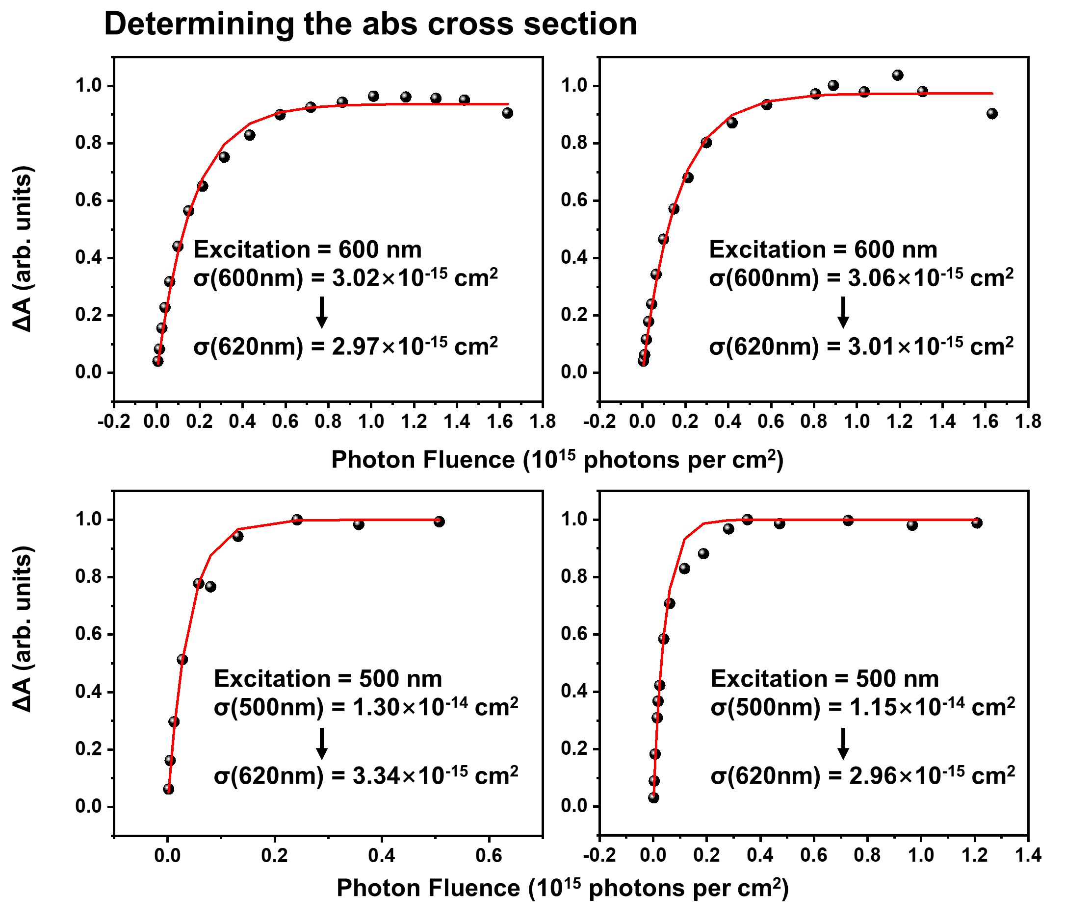
Figure S19: The dependence of the optical pumped TA absorbance on the photon flux and the absorption cross section determined at the excitation wavelength. We then converted this value to the absorbance at 620 nm, which corresponds to the maximum of the E-TA bleach peak.

$F_{ph}$ is determined using the following way: the pump and probe light beams are described using a Gaussian type equation:
$$\begin{aligned}I\left(r\right)=I_{0}\exp\left(\frac{-2r^{2}}{ω_{0}^{2}}\right)\#\left( AUTONUM \backslash * Arabic \right)\end{aligned}$$
r is the distance to the beam center, $ω_{0}$ is set to be the radius of pump and probe beam ($R_{pump}$ and $R_{probe}$, where the beam intensity drops to 1/e² of the peak value). $ω_{0}$ is measured this way: a razor blade partially cuts the beam, and the intensity I(x) of the rest part is measured in a function of the position of blade x, and fit to the following equation:
$$\begin{aligned}I\left(x\right)=\int_{x}^{∞}{Aexp\left(\frac{-2{\left(y-y_{0}\right)}^{2}}{ω_{0}^{2}}\right)}dy\#\left( AUTONUM \backslash * Arabic \right)\end{aligned}$$
The pump power within the radius of probe is calculated by
$$\begin{aligned}P=2π\int_{0}^{R_{probe}}{I_{pump}\left(r\right)rdr}=P_{0}\left[1-\exp\left(\frac{-2R_{probe}^{2}}{R_{pump}^{2}}\right)\right]\#\left( AUTONUM \backslash * Arabic \right)\end{aligned}$$
$P_{0}$ is the total power of pump light. Flux is computed using the following equation:
$$\begin{aligned}F_{ph}=\frac{P}{REP⋅E_{ph}⋅πR_{probe}^{2}}\#\left( AUTONUM \backslash * Arabic \right)\end{aligned}$$
REP is the pump laser repetition rate (500 Hz), and the energy of each photon $E_{ph}$ is given by $E_{ph}=hc/λ$, where λ is the pump wavelength, c is the speed of light (2.998 × 10⁸ m/s), and h is the Planck constant (6.626 × 10⁻³⁴ m² kg s⁻¹).
We calculated the $N_{e}$ values for both green and blue devices using the same method.
Verification of $N_{e}$ value by saturating the QD layer with electrons
Since the correctness of N_{e} value is critical in our work, we verify it by saturating the QD layer with electrons. To achieve this, we fabricated an ETL-only device in which the HTL was replaced with a thick PMMA layer to prevent the passage of either electrons or holes. We then applied a high external voltage to this device to saturate the QD layer with electrons. According to the spectroelectrochemistry results obtained from QD films, at this point, the N_{e} value should be either 1 or 2. ^{[1-2]} The voltage required in this experiment was much higher than that used in spectroelectrochemistry results. This is because in spectroelectrochemistry experiments, the electric double layer formed next to the QDs creates an extremely strong electric field that facilitates the injection of electrons, whereas achieving a similar electric field in solid devices requires very high voltages. In this experiment, an $N_{e}$ value close to 1 is consistently observed, which serves as a strong indication of the accuracy of our $N_{e}$ determination. With continued voltage increases, it is possible that the electrical static repulsion can be overcome, leading to another platform at $N_{e}$=2. However, that is not observed, probably due to the excessively high voltage required.
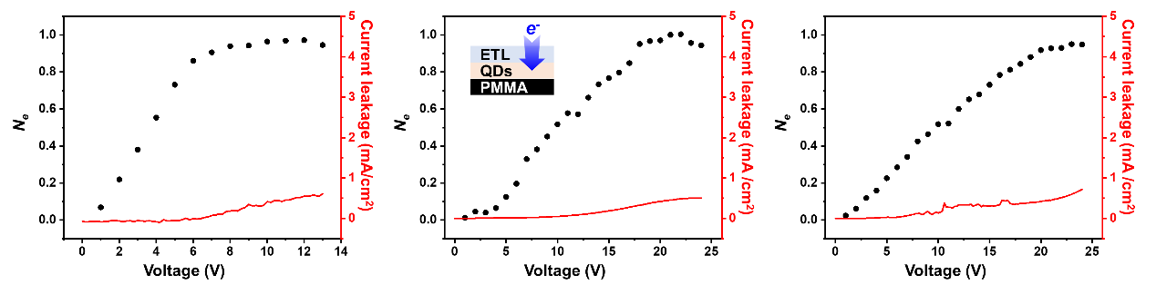
Figure S20: Saturate the QD layer with electrons. We fabricated devices consisting only ETL with a thick polymethyl methacrylate (PMMA) layer in place of the HTL, blocking the passage of both electrons and holes through it. E-TA experiments are performed on these devices to obtain the $N_{e}$ value when the QD layer is saturated by electrons. Three distinct devices with the same structure are measured. The relationships between $N_{e}$ and pump voltage in these devices are displayed in the corresponding panels. The electron injection rates vary among the devices, as evidenced by their different $N_{e}$-voltage relationships. However, as the voltage increases, $N_{e}$ converges at ~1 for all three devices, which serves as a strong indication of the accuracy of our $N_{e}$ determination. The graph also shows the current density flow through the devices, which remains small even at high voltages, indicating that the plateauing of the $N_{e}$-voltage curve is not attributed to current leakage.
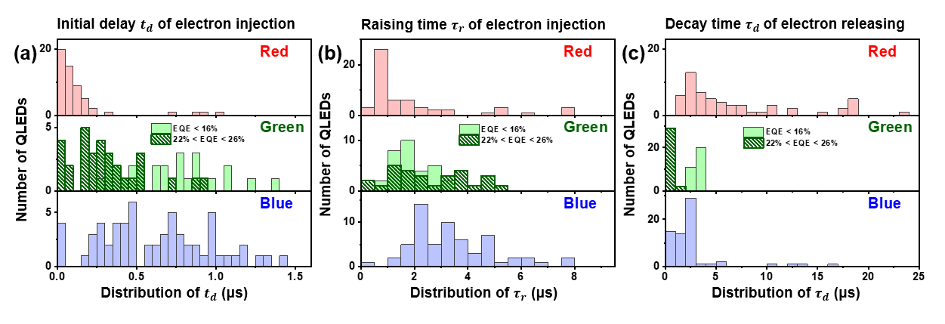
Figure S21: The statistical distribution of initial delay time ($t_{d}$) and the average rising time constant ($τ_{r}$) after voltage is applied, as well as the decay time constant ($τ_{d}$) after voltage is turned off. The dataset consists of 57 red QLEDs, 67 blue QLEDs, 31 highly efficient green QLEDs and 31 less efficient green QLEDs. Less efficient green QLEDs share the same device and QD structure as the red and blue QLEDs. Highly efficient QLEDs utilizing higher quality QDs with a high quantum yield of 95%, as compared to 55% for the less efficient green QLEDs. The highly efficient QLEDs also have improved HTL to facilitate hole injection while reducing electron leakage (See methods for details). Red, green, and blue QLEDs are pumped at 4V, 3V, and 6V, respectively.

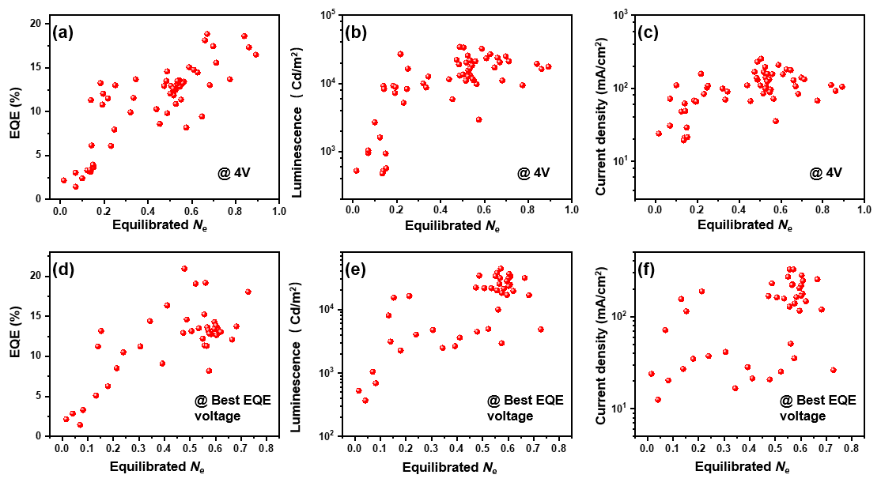
Figure S22: Correlation between device EQE, luminescence, current, and equilibrated N_{e} on red QLEDs, with measurements taken either at a fixed voltage of 4 V (panels (a)-(c)), or at the voltage corresponding to the peak EQE (panels (d)-(f)).

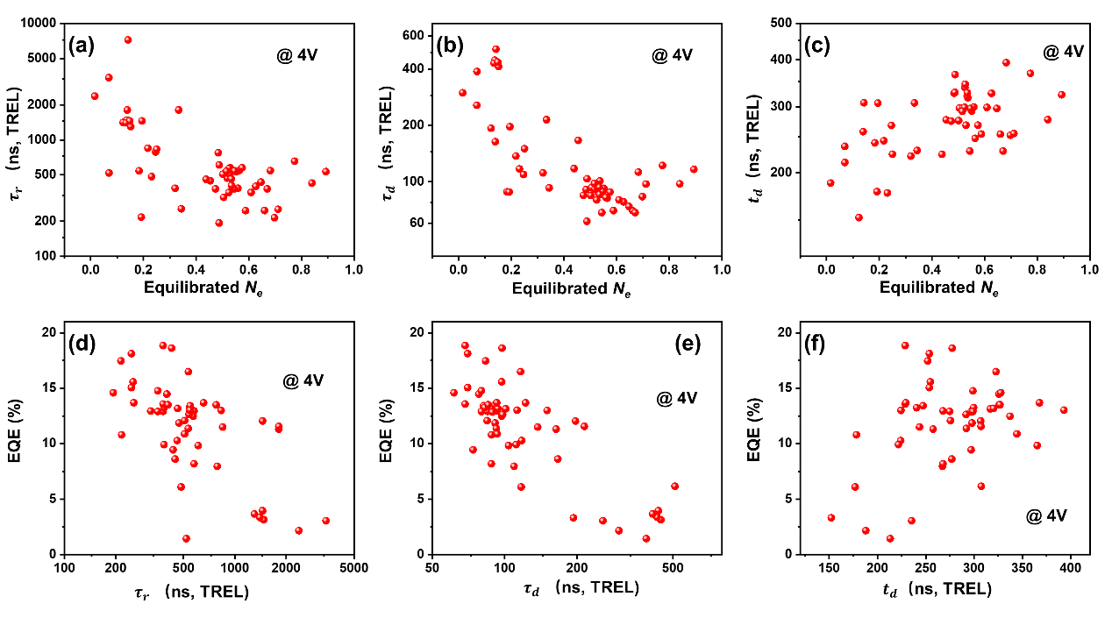
Figure S23: Correlation between equilibrated $N_{e}$ and TREL kinetics in red QLEDs. (a)-(c) Correlation between $N_{e}$ and raise edge $τ_{r}$, decay time $τ_{d}$ and initial delay $t_{d}$ of TREL, respectively; (d)-(f) Correlation between $τ_{r}$, $τ_{d}$, or $t_{d}$ of TREL and device EQE, respectively. $τ_{d}$ could be understood as the hole lifetime in the emissive layer in the presence of electrons. Negative correlations between either $N_{e}$ or EQE and $τ_{d}$ support a Langevin recombination mechanism.

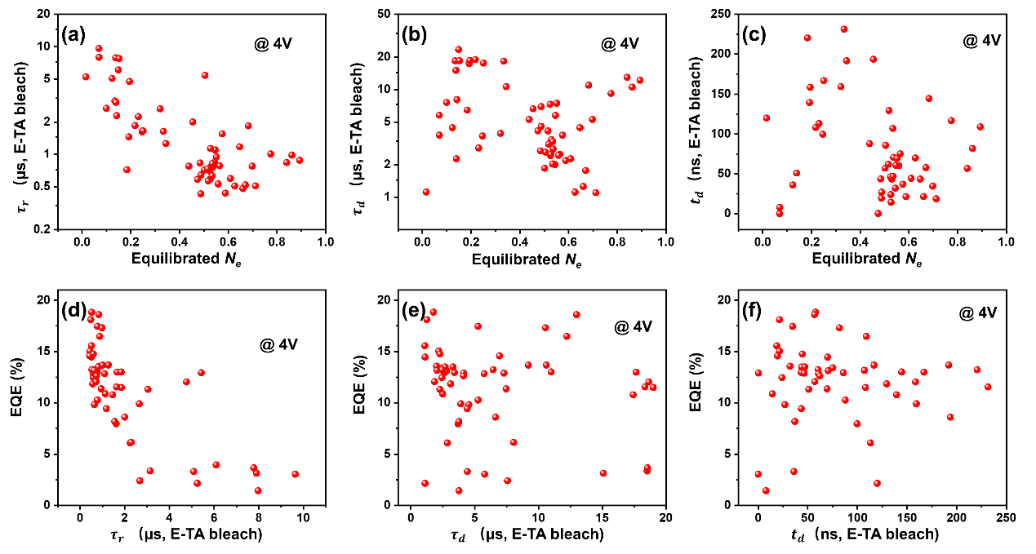
Figure S24: Correlation between equilibrated $N_{e}$ and E-TA bleach kinetics. (a)-(c) Correlation between equilibrium $N_{e}$ and raise edge $τ_{r}$, decay time $τ_{d}$ and initial delay $t_{d}$ of E-TA bleach signal, respectively; (d)-(f) Correlation between $τ_{r}$, $τ_{d}$, or $t_{d}$ of E-TA bleach signal and device EQE, respectively.
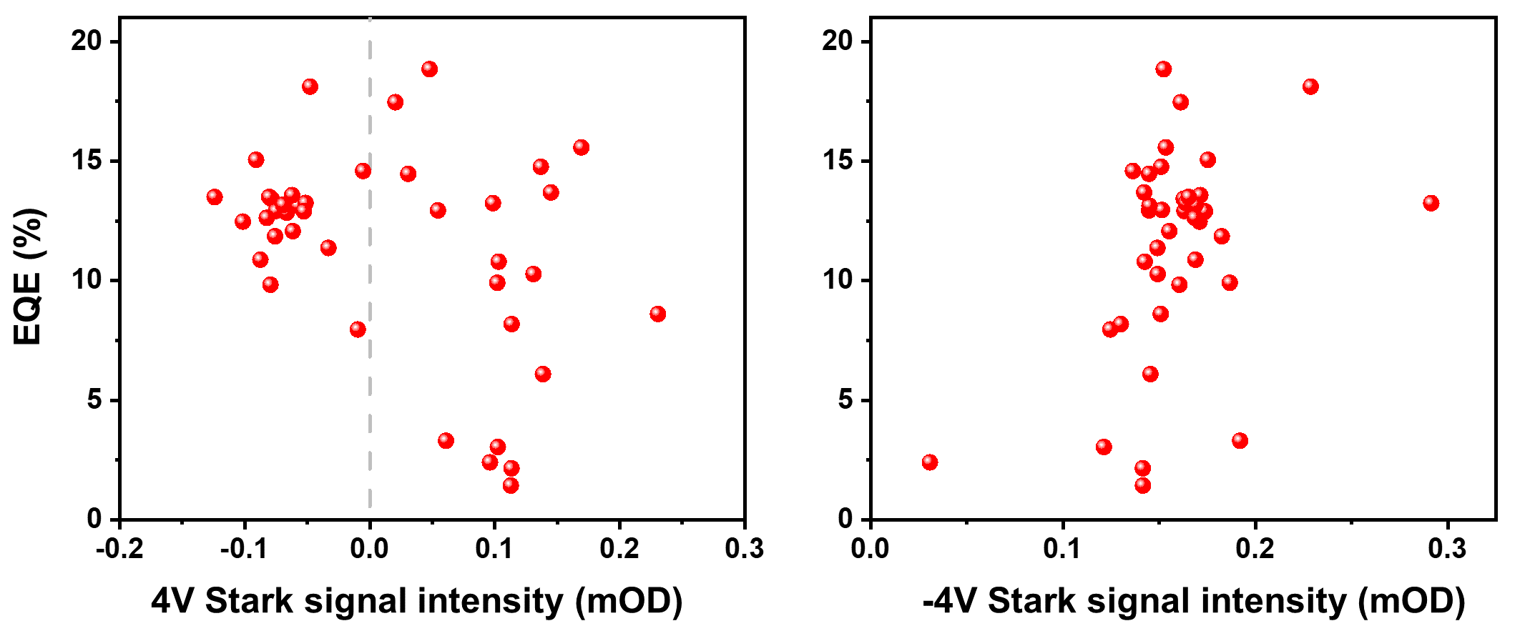
Figure S25: Correlation between EQE and Stark effect intensity under 4V and -4V pump voltage bias, respectively. The intensity of Stark effect signal is an averaged |ΔA| value over 520 nm to 700 nm, where a three-lobed shape identical to the one measured under backward biases is defined as “positive”.

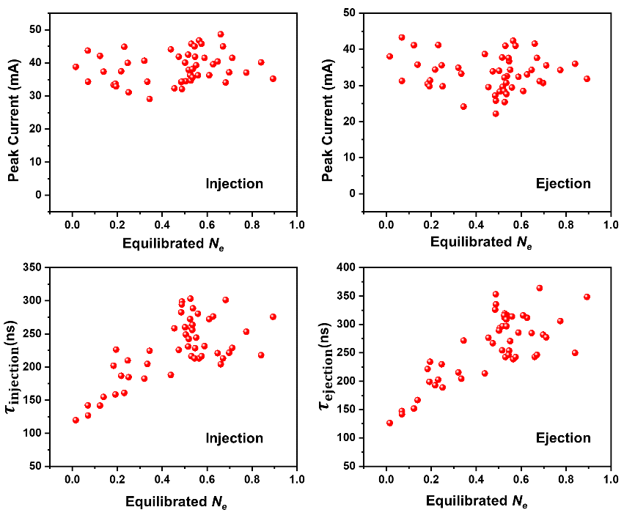
Figure S26: Correlation between equilibrated $N_{e}$ and transient current parameters. Equilibrated $N_{e}$ is plotted against peak current and time constants of injection and ejection, respectively.
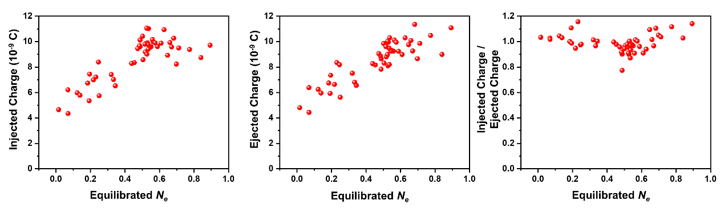
Figure S27: Correlation between equilibrium $N_{e}$ and total stored charge. Injected and ejected charges are computed from the transient current.

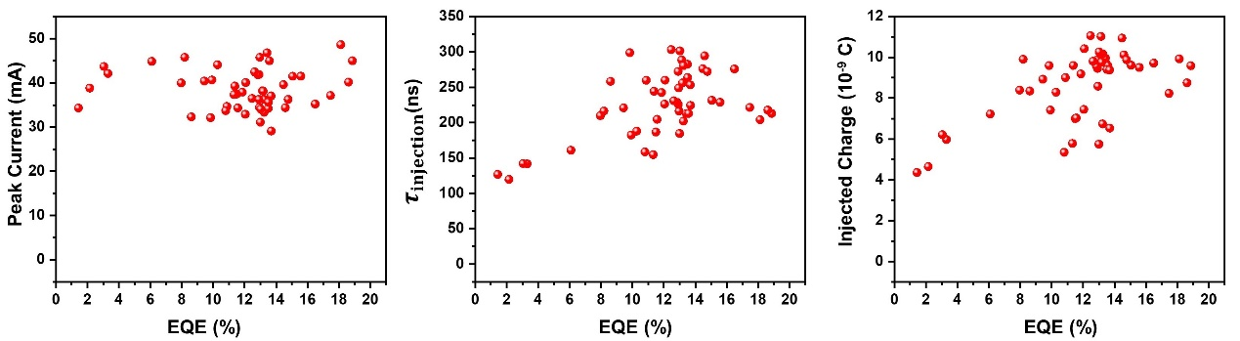
Figure S28: Correlation between EQE and transient current parameters. Correlation between peak current, injection time constant, total injected charge and device EQE are plotted.

Effect of a PMMA block layer between ETL and QD layer
Inserting an insulating layer of polymethyl methacrylate (PMMA) between the ETL and QD layer is a widely used strategy to enhance the EQE of QLEDs. ^{[3]} In this study, we investigated the impact of PMMA on the device performance of red QLEDs. Specifically, we fabricated 17 QLEDs with a ~6 nm PMMA layer between the ETL and QD layer and characterized their performance using E-TA.
The statistical distribution of device performance, plotted as a function of equilibrated $N_{e}$, is presented in Figure S29. Our results demonstrate that QLEDs with PMMA exhibit a significantly higher EQE than those without PMMA, especially for devices with lower $N_{e}$ values, while maintaining the same level of electron injection. Furthermore, the QDs in QLEDs with a PMMA layer exhibit longer photoluminescence (PL) lifetimes and higher PL intensities than those without PMMA (Figure S30). These findings support the hypothesis by other research groups that the PMMA layer reduces interfacial recombination between holes in the QD layer and electrons in the ETL, thereby inhibiting the quenching of QD excitons by metal-oxide-based ETLs. ^{[3-6]}

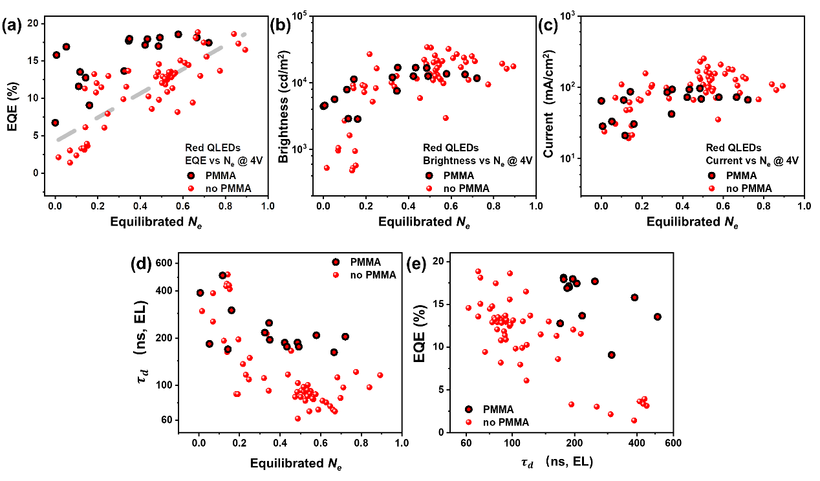
Figure S29: (a)–(c) depict the correlation between electron density ($N_{e}$) and the EQE, device brightness, and current of the red QLEDs, respectively. (d) and (e) show the correlation between $N_{e}$, EQE, and the decay time ($τ_{d}$) of the TREL emission in the QLEDs. $τ_{d}$ of TREL represents the hole lifetime in the working device. The red dots in the figures represent the regular QLEDs, while the red dots with black edges denote the QLEDs with an additional ~6 nm PMMA layer between the ETL and QDs. The QDs used for the two kinds of QLEDs are the same.

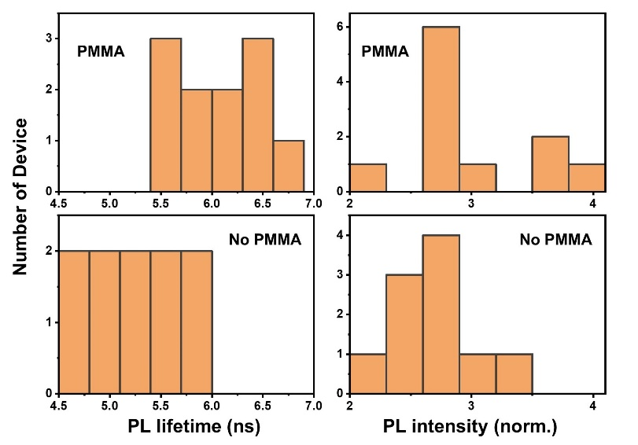
Figure S30: Comparison of the photoluminescence (PL) lifetime and intensity of regular QLEDs and QLEDs with ~6 nm PMMA layer between ETL and QDs.

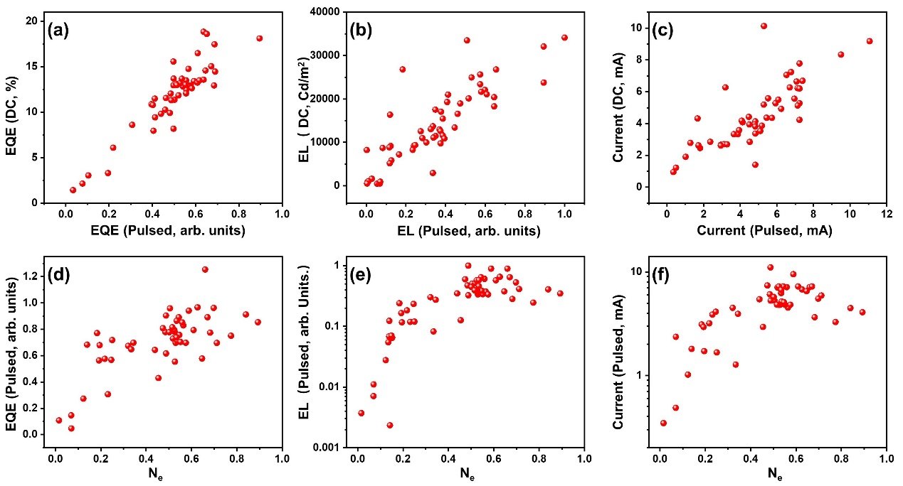
Figure S31: Comparison of red QLED performance under DC voltage and pulsed voltage. In this work, the E-TA experiments are performed under pulsed voltage, while device EQE is measured at DC voltage. Meanwhile, device performance under pulsed voltage is also displayed. (a)-(c) Comparison of the QLED performance under DC voltage (y-axis) and voltage pulses (x-axis). The device performance under pulsed and DC voltages are well correlated. (d)-(e) Correlation between N_{e} and device efficiency (left), luminescence (middle), and current (right) under voltage pulses. The correlation between N_{e} and device performance is still the same if device performance is measured under pulsed voltage.

Correlation between N_{e} and the performance of green and blue QLEDs.
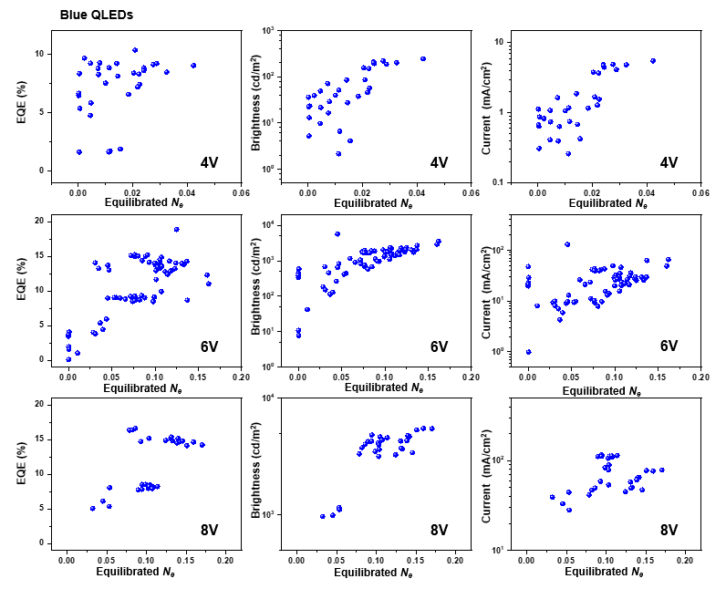
Figure S32: The correlation between N_{e} and EQE (left panels), brightness (middle panels), and electric current density (right panels) on blue QLEDs at different voltages.
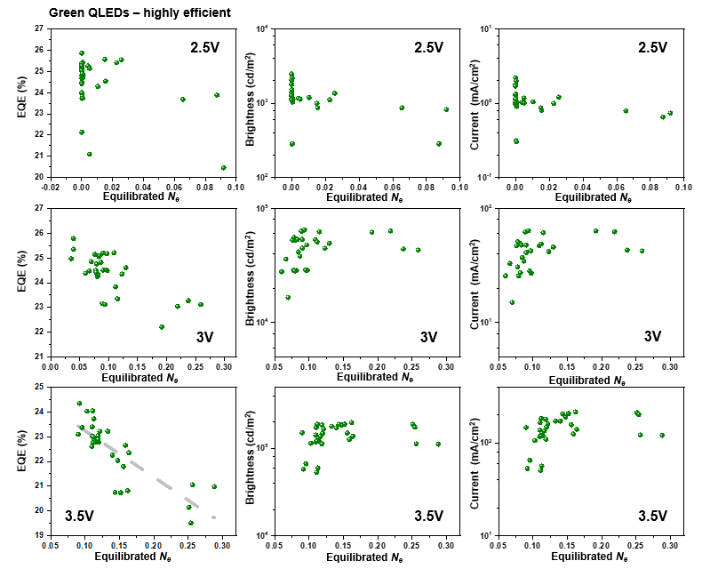
Figure S33: The correlation between N_{e} and EQE (left panels), brightness (middle panels), and electric current density (right panels) on highly efficient green QLEDs.
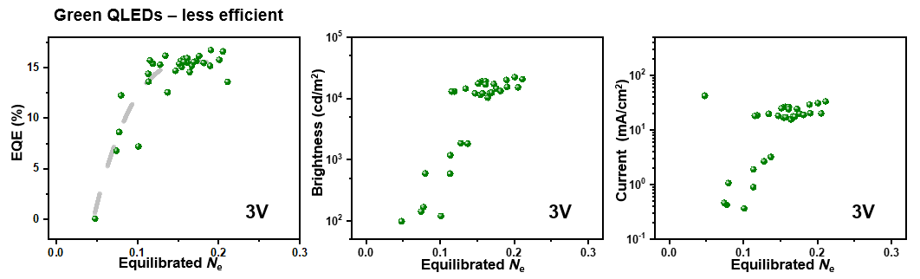
Figure S34: The correlation between N_{e} and EQE (left panels), brightness (middle panels), and electric current density (right panels) on less efficient green QLEDs.

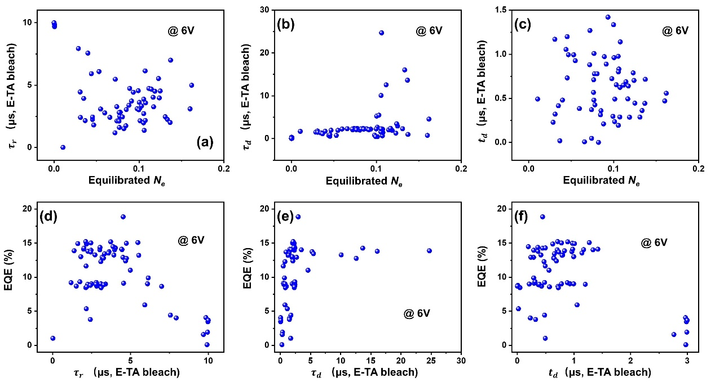
Figure S35: Correlation between equilibrated $N_{e}$ and E-TA bleach kinetics of blue QLEDs. (a)-(c) Correlation between equilibrium $N_{e}$ and raise edge $τ_{r}$, decay time $τ_{d}$ and initial delay $t_{d}$ of E-TA bleach signal, respectively; (d)-(f) Correlation between $τ_{r}$, $τ_{d}$, or $t_{d}$ of E-TA bleach signal and device EQE, respectively.

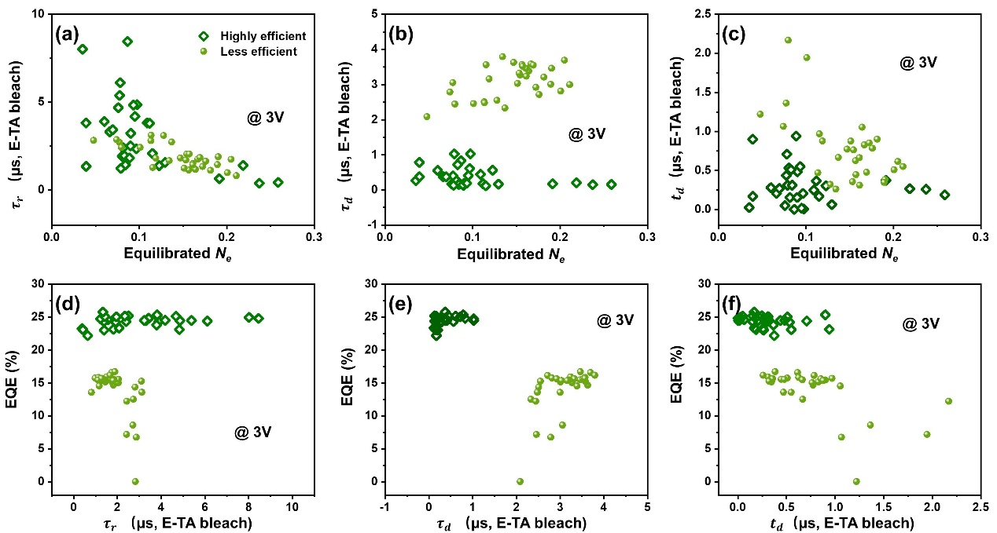
Figure S36: Correlation between equilibrated $N_{e}$ and E-TA bleach kinetics of green QLEDs. (a)-(c) Correlation between equilibrium $N_{e}$ and raise edge $τ_{r}$, decay time $τ_{d}$ and initial delay $t_{d}$ of E-TA bleach signal, respectively; (d)-(f) Correlation between $τ_{r}$, $τ_{d}$, or $t_{d}$ of E-TA bleach signal and device EQE, respectively.

Correlation between N_{e} and electron leakage.
Electron leakage from the QD layer into the HTL is a significant cause of efficiency loss in green and blue QLEDs. In this study, we investigated the relationship between N_{e} and electron leakage by analyzing the emission of the HTL. Figure S37 shows the quantification of HTL emission for less efficient green QLEDs, and its correlation with N_{e}. The results indicate that an increase in accumulated electrons in the QD layer leads to a corresponding increase in electron leakage, which is expected. Quantifying HTL emission in red QLEDs and highly-efficient green QLEDs was challenging due to their small HTL emissions. Blue QLEDs are also difficult to be analyzed due to the overlap of HTL emission with QD emission.
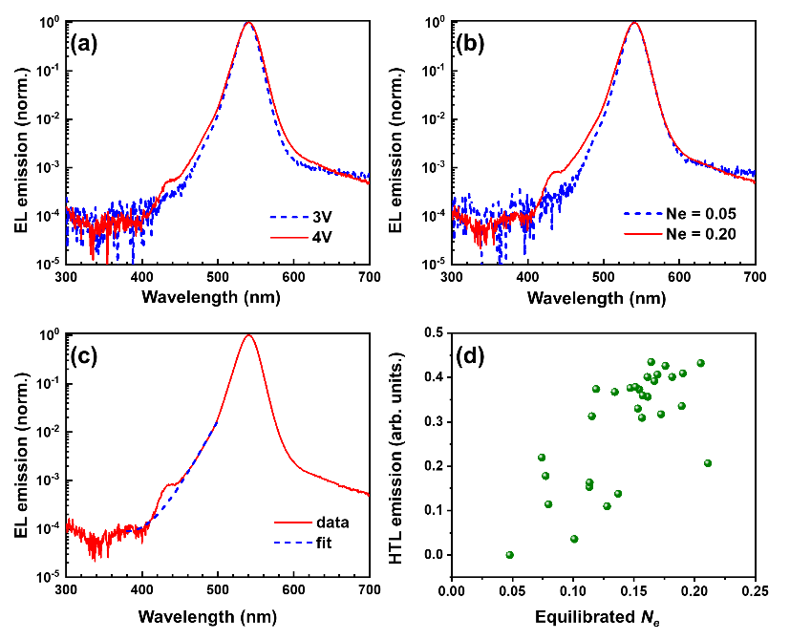
Figure S37: The correlation between electron leakage and N_{e} for green QLEDs. (a) Normalized EL emission spectra of a QLED at 4V and 3V, where the HTL emission is observed at 4V. (b) Normalized EL emission spectra of two QLEDs with different N_{e} values, revealing that the device with a higher N_{e} displays more HTL emission. (c) Quantification of the HTL emission by calculating the bandgap emission, which is defined by the difference between the red curve and the blue dashed curve. (d) The correlation between equilibrated N_{e} and HTL emission.

EL and E-TA spectra and dynamics of green and blue QLEDs
In Figure 4 of the main text, the equilibrated Stark signal intensity is presented for blue and green QLED devices. In Figures S38-S40, we have included the E-TA spectra and kinetics of a representative device for each color variant.
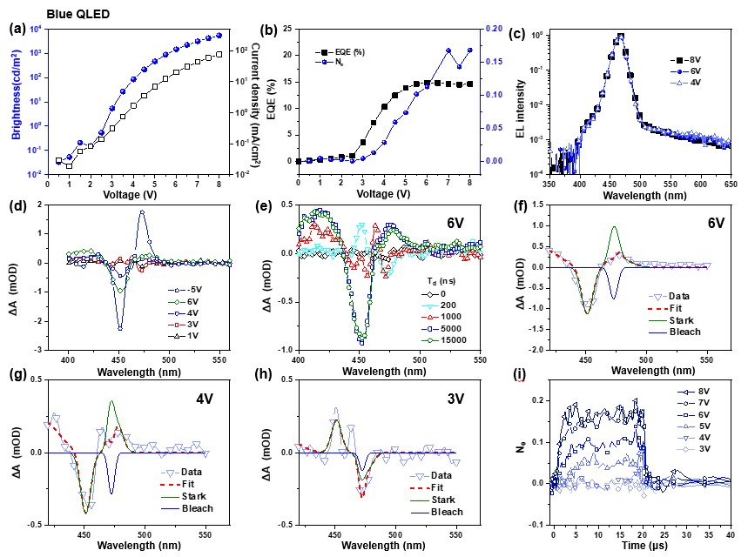
Figure S38: EL and E-TA Spectra and dynamics of a representative blue QLED. (a) Brightness and current density under DC conditions; (b) N_{e} and EQE as a function of voltage; (c) Normalized EL spectra at different voltages; (d) equilibrated E-TA spectra at different voltages; (e) E-TA spectra at 6V pump voltage and different delay times (T_{d}); (f) – (h) Decomposition of E-TA spectra into bleach and Stark contribution, respectively; (i) N_{e} as a function of time under different pump voltages.
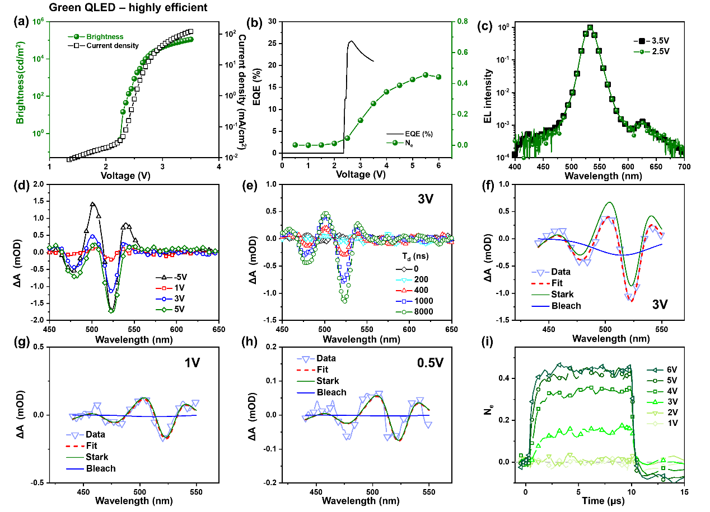
Figure S39: EL and E-TA Spectra and dynamics of a representative high-efficiency green QLED (a) Brightness and current density under DC conditions; (b) N_{e} and EQE as a function of voltage; (c) Normalized EL spectra at different voltages; (d) equilibrated E-TA spectra at different voltages; (e) E-TA spectra at 3 V pump voltage and different delay times (T_{d}); (f) – (h) Decomposition of E-TA spectra into bleach and Stark contribution, respectively; (i) N_{e} as a function of time under different pump voltages.

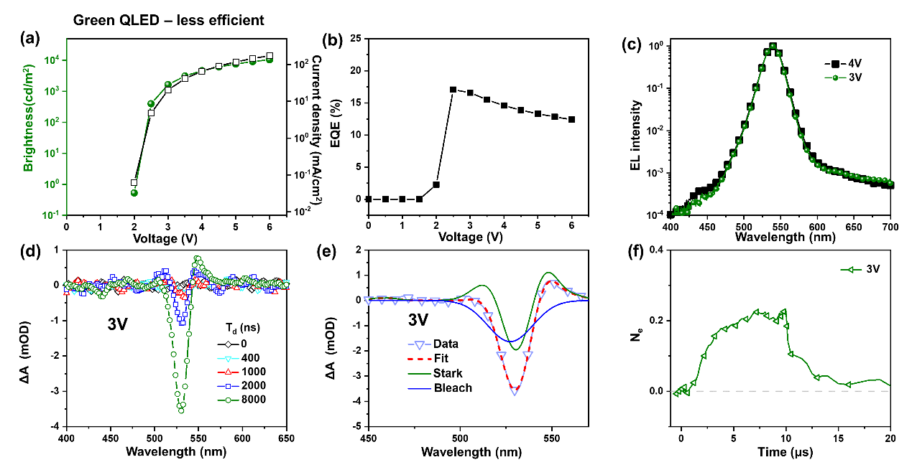
Figure S40: EL and E-TA Spectra and dynamics of a representative less-efficient green QLED. (a) Brightness and current density under DC conditions; (b) EQE as a function of voltage; (c) Normalized EL spectra at different voltages; (d) E-TA spectra at 3 V pump voltage and different delay times (T_{d}); (e) Decomposition of E-TA spectra into bleach and Stark contribution, respectively; (f) N_{e} as a function of time at 3V pump voltage.
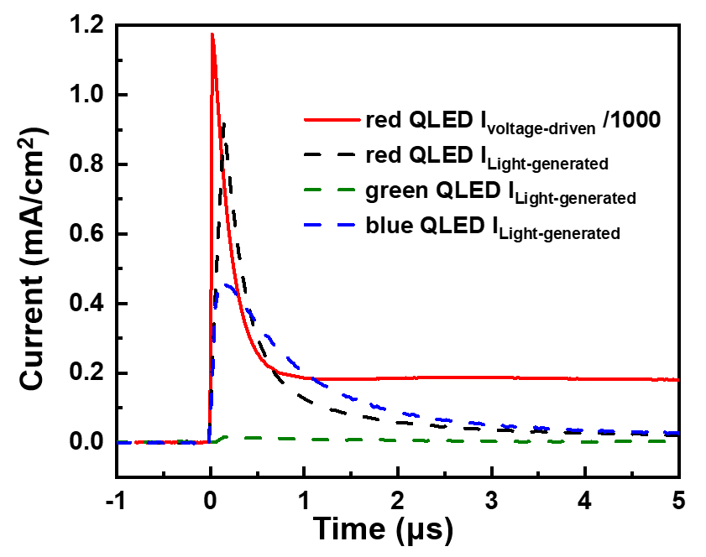
Figure S41: The magnitude of light induced current. We measured the current induced by the white probe laser light and compared it to the transient current driven by a 4 V voltage. The magnitude of the voltage-driven current was divided by 1000 for comparison. The probe light was turned off when measuring the voltage-driven current.

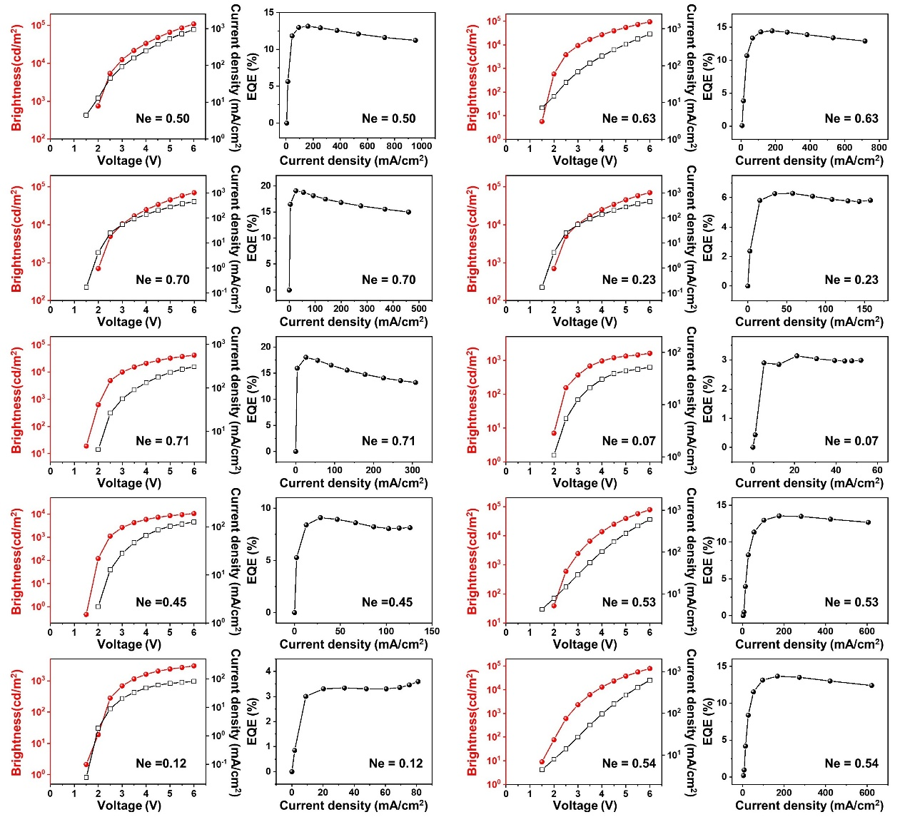
Figure S42: J-L-V curves and EQE-J curves of 57 red QLEDs are present in Figures S42-S47. The N_{e} values for each device at a voltage of 4V are indicated.
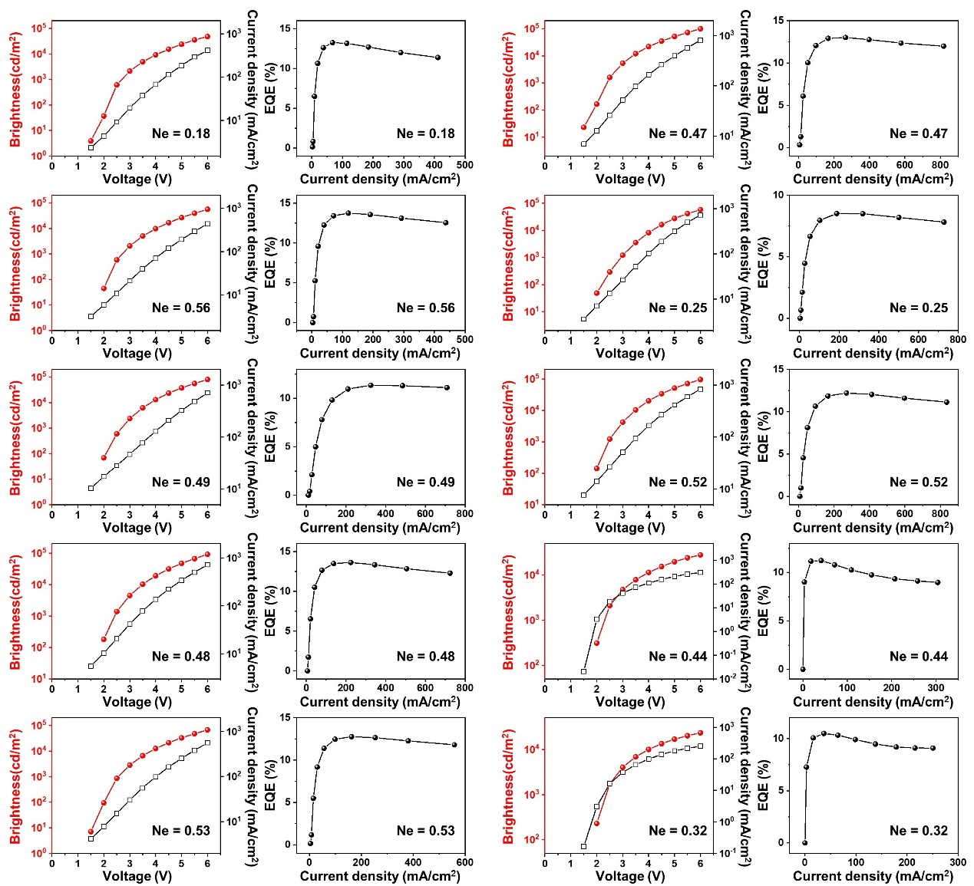
Figure S43: J-L-V curves and EQE-J curves of red QLEDs. The N_{e} values for each device at a voltage of 4V are indicated.
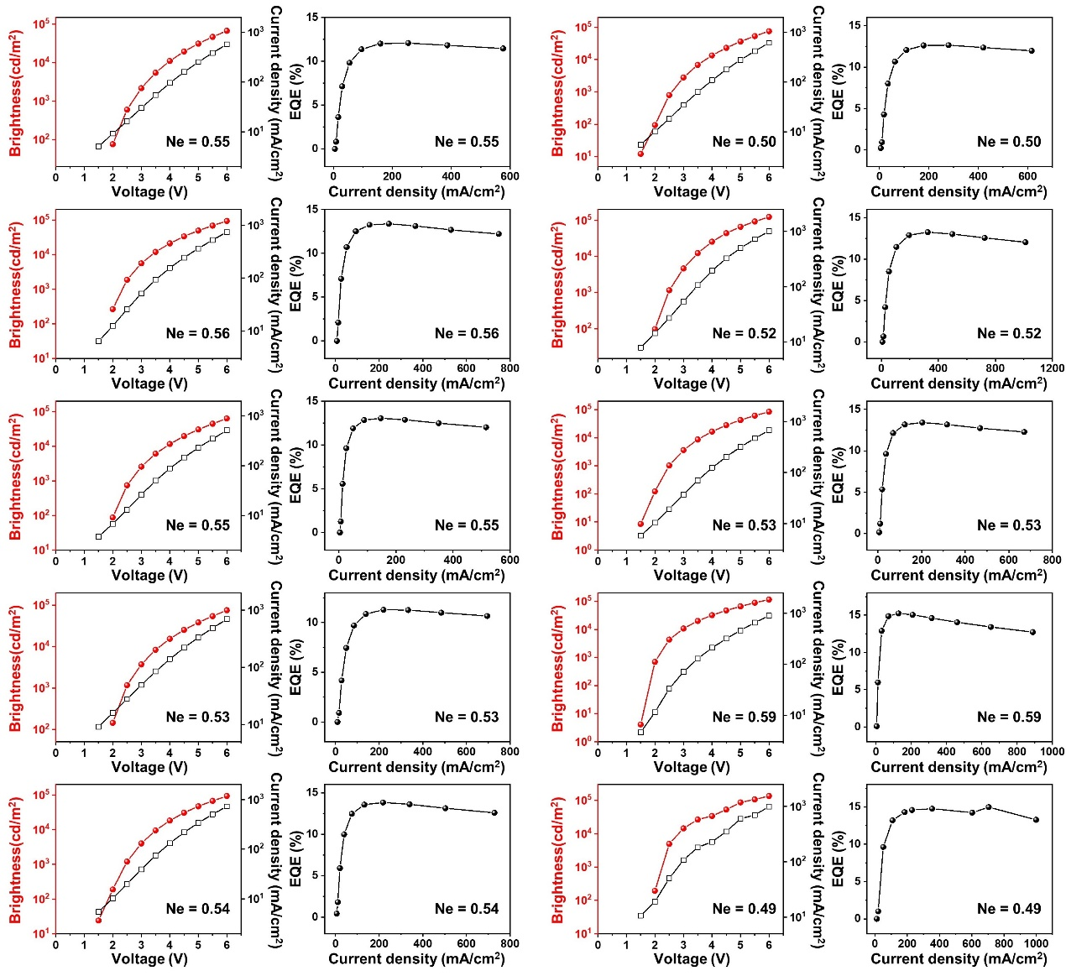
Figure S44: J-L-V curves and EQE-J curves of red QLEDs. The N_{e} values for each device at a voltage of 4V are indicated.
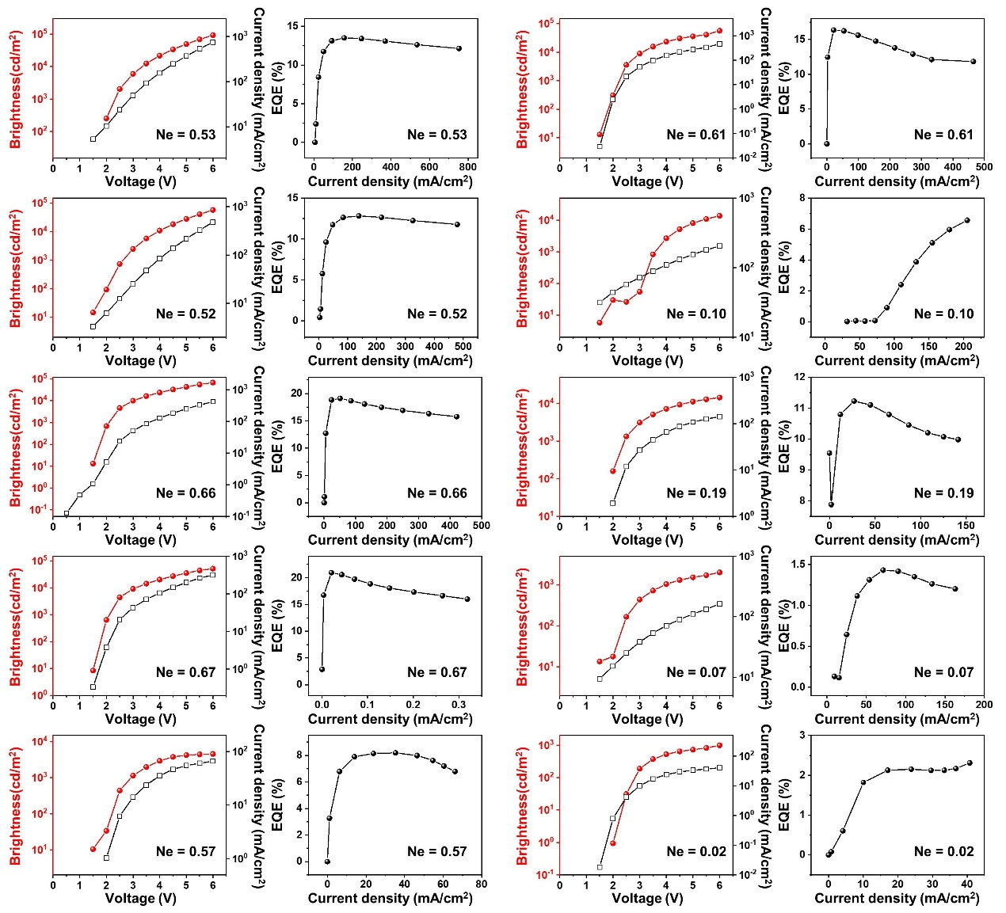
Figure S45: J-L-V curves and EQE-J curves of red QLEDs. The N_{e} values for each device at a voltage of 4V are indicated.
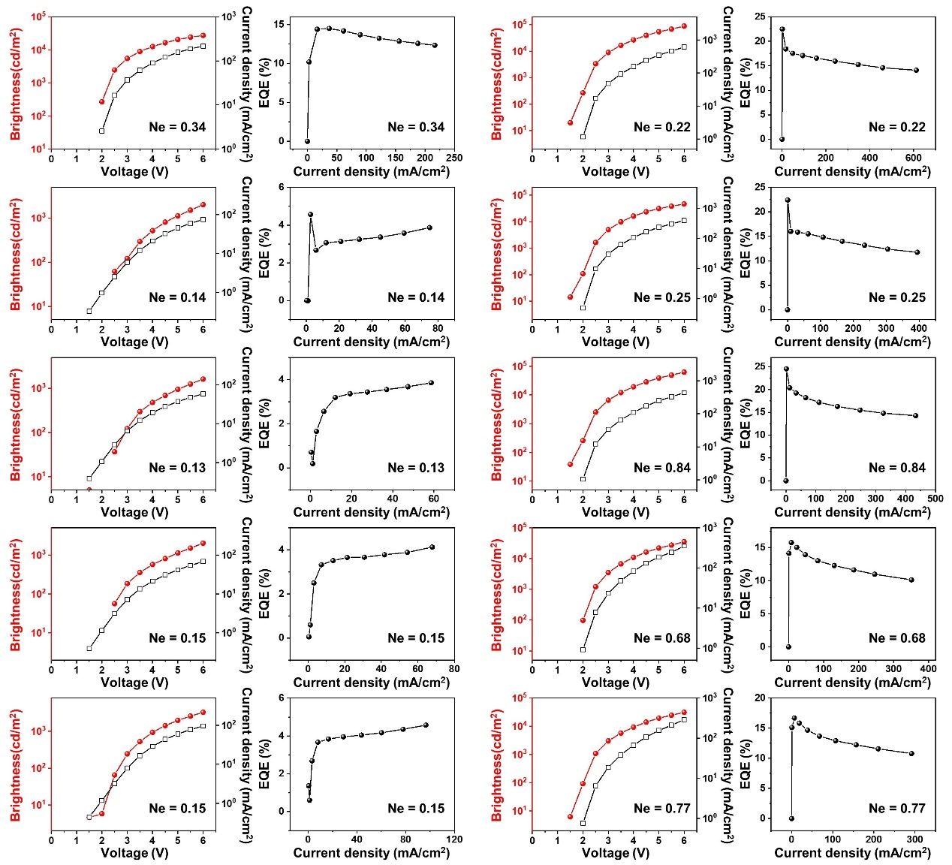
Figure S46: J-L-V curves and EQE-J curves of red QLEDs. The N_{e} values for each device at a voltage of 4V are indicated.
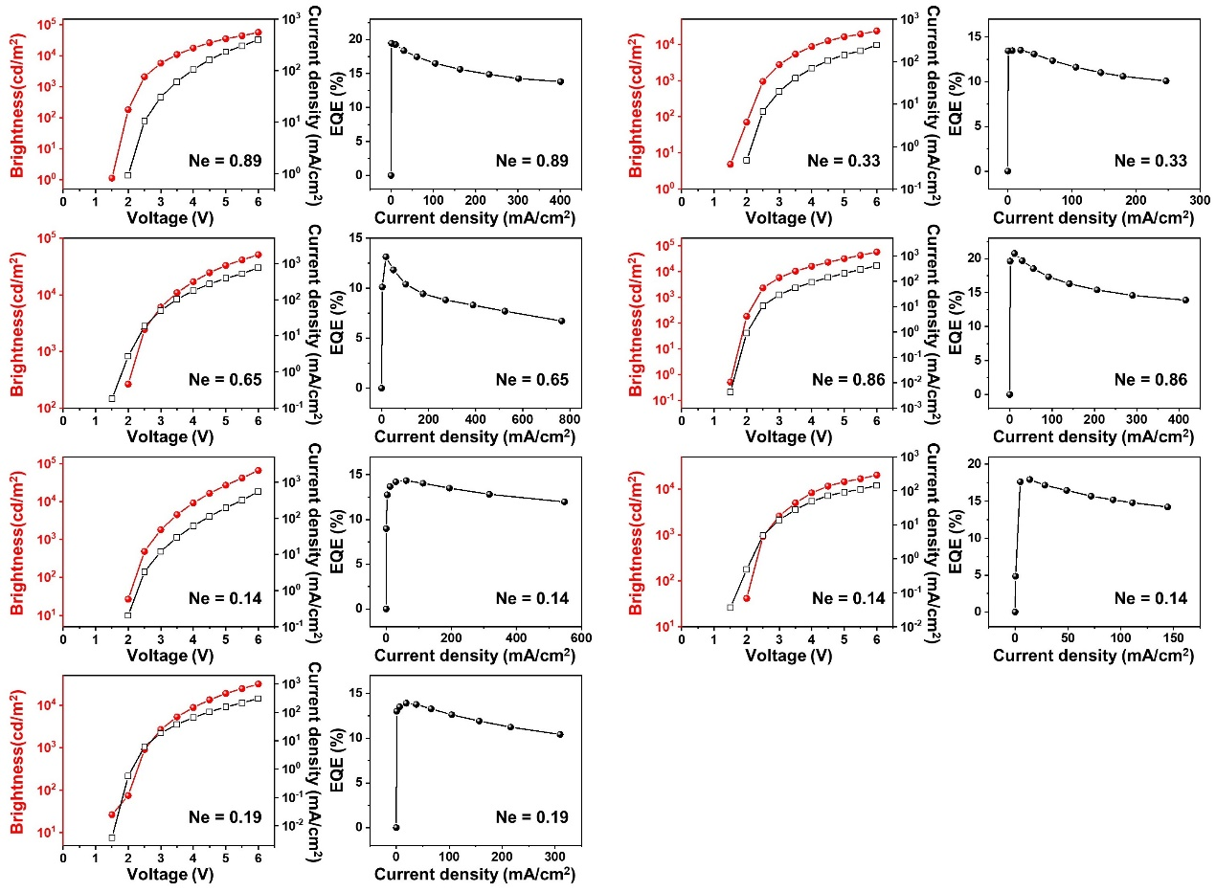
Figure S47: J-L-V curves and EQE-J curves of red QLEDs. The N_{e} values for each device at a voltage of 4V are indicated.
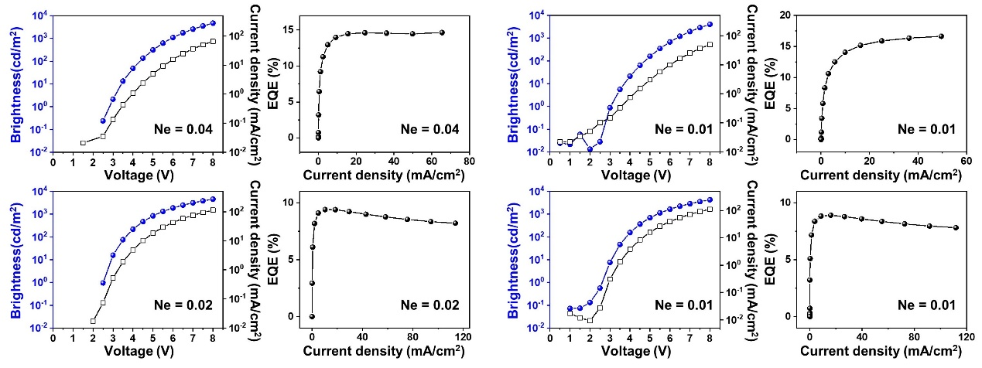
Figure S48: J-L-V curves and EQE-J curves of blue QLEDs. The N_{e} values for each device at a voltage of 6V are indicated.
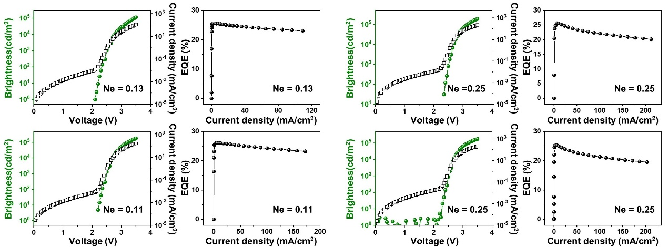
Figure S49: J-L-V curves and EQE-J curves of highly efficient green QLEDs. The N_{e} values for each device at a voltage of 3V are indicated.

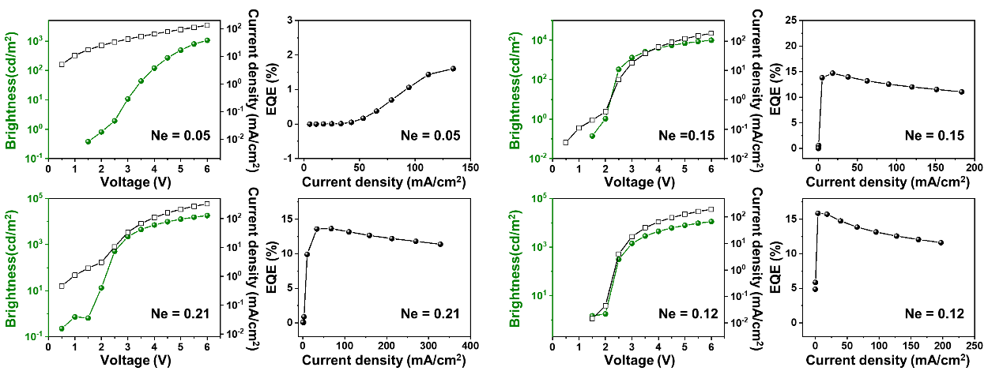
Figure S50: J-L-V curves and EQE-J curves of less efficient green QLEDs. The N_{e} values for each device at a voltage of 3V are indicated.
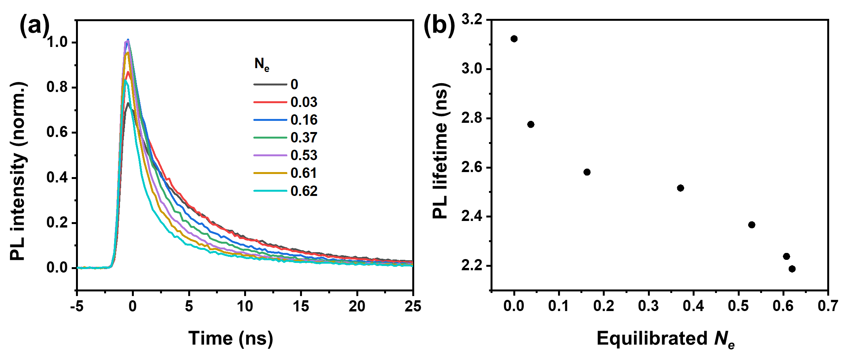
Figure S51: PL decay (a) and lifetime (b) of the QLED as a function of N_{e}, excited by 400 nm laser pulses. When a quantum dot is occupied by an electron, exciting it again will generate a negative trion, leading to Auger recombination. Consequently, higher N_{e} results in lower photoluminescence lifetime and intensity.

References
[1] Wang, C.; Shim, M.; Guyot-Sionnest, P., Electrochromic Nanocrystal Quantum Dots. Science 291, 2390-2392 (2001).
[2] Geuchies, J. J., et al., Quantitative Electrochemical Control over Optical Gain in Quantum-Dot Solids. ACS Nano 15, 377-386 (2021).
[3] Dai, X., et al., Solution-processed, high-performance light-emitting diodes based on quantum dots. Nature 515, 96-99 (2014).
[4] Fu, Y., et al., Highly Efficient and Fully Solution-Processed Inverted Light-Emitting Diodes with Charge Control Interlayers. ACS Applied Materials & Interfaces 10, 17295-17300 (2018).
[5] Wood, V., et al., Selection of Metal Oxide Charge Transport Layers for Colloidal Quantum Dot LEDs. ACS Nano 3, 3581-3586 (2009).
[6] Kim, H. H., et al., Inverted Quantum Dot Light Emitting Diodes using Polyethylenimine ethoxylated modified ZnO. Scientific Reports 5, 8968 (2015).

