Sea urchin-like Ni₃(HITP)₂ as the substrate of molecular imprinted polymer: the voltammetric mechanism for sensitive detection of dopamine
Xia Zhang ^{a,b,}*, Jishan Su ª, Lili Sun ª, Yingying Ben ª, Yizhan Sun ª, Yajun Wei ^{c}, Yuandong Xu ^{a,}*
ª School of Chemistry and Chemical Engineering, Henan University of Technology, Zhengzhou 450001, China
^{b} Institute for Superconducting and Electronic Materials, Australian Institute for Innovative Materials, University of Wollongong, Wollongong, NSW 2522, Australia
^{c} School of Chemical Engineering, Northwest Minzu University, Lanzhou 730030, China
Corresponding author: ydx11@126.com (Yuandong Xu); xiaz@uow.edu.au (Xia Zhang)

Figure S1 The experimental and fitting result of Nyquist plots.

Figure S2 The experimental and fitting result of Nyquist plots.
Figure S3 The experimental and fitting result of Nyquist plots.

Figure S4 The experimental and fitting result of Nyquist plots.

Figure S5 The experimental and fitting result of Nyquist plots.

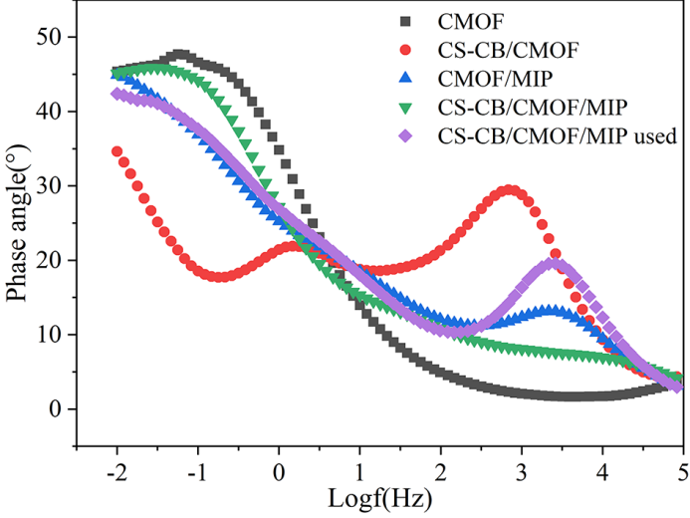
Figure S6 The Bode phase plots of all the electrodes.

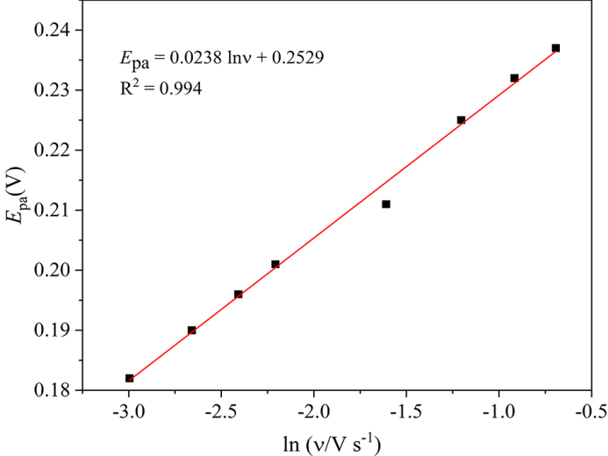
Figure S7 The linear fitting of peak potential (E_{pa}) vs. scan rate (υ).

