Supplementary Figure 1. Confirmation of deletion of lon, rfaL, pagL and arnT genes.
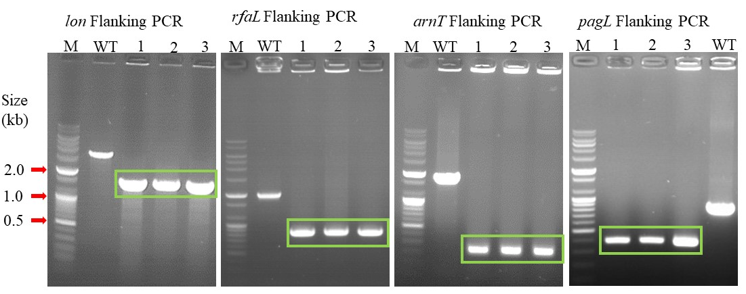

Supplementary Table 1. Measurement of body temperature (⁰C) at post-immunization
Stage | 1⁰ immunization |  | 2⁰ immunization |  |  | Challenge
Group/Age | W4 | W5 | W6 | W7 | W8 | W9 | W10 | W11
Naive | 40.7 ± 0.3 | 41.0 ± 0.2 | 40.9 ± 0.3 | 40.8 ± 0.5 | 40.5 ± 0.4 | 40.5 ± 0.4 | 40.2 ± 0.4 | 40.8 ± 0.5
PBS | 40.5 ± 0.4 | 40.9 ± 0.4 | 40.8 ± 0.3 | 41.1 ±0.2 | 40.6 ±0.3 | 42.1 ±0.2 | 42.3 ± 0.3
SG9R | 41.3 ± 0.3 | 41.2 ± 0.4 | 41.4 ± 0.4 | 41.5 ± 0.3 | 41.3 ± 0.2 | 41.5 ± 0.2 | 41.1 ± 0.4 | 40.9 ± 0.4
JOL3015 | 41.0 ± 0.3 | 40.8 ± 0.4 | 41.2 ± 0.2 | 40.9 ± 0.2 | 40.8 ± 0.2 | 41.3 ± 0.5 | 41.1 ± 0.3 | 41.0 ± 0.2
JOL3016 | 41.2 ± 0.2 | 41.0 ± 0.3 | 41.5 ± 0.3 | 40.8 ± 0.4 | 40.6 ± 0.3 | 41.1 ± 0.2 | 40.9 ± 0.3 | 40.9 ± 0.2

Note: W4; 4 Weeks Old, W5; 5 Weeks Old, W6; 6 Weeks Old, W7; 7 Weeks Old, W8, 8 Weeks Old, W9; 9 Weeks Old, W10; 10 Weeks Old, and W11; 11 Weeks Old

