Supplementary Materials for

Phase II Study of The Combination of Venetoclax, Azacitidine and Flumatinib in Newly Diagnosed Adult Patients with Philadelphia Chromosome-Positive Acute Lymphoblastic Leukemia
Mengyun. Li†,1 2 Qingya. Cui†, 1 2 Huiying. Qiu*,1 2 Lingling. Liu,1 2 Jianxin. Fu, 1 2 Zheng. Li,1 2 Sifan. Chen, 1 2 Yan. Yu,1 2 Jiannong. Cen,1 2 Hongjie. Sheng,1 2 Jinlan. Pan,1 2 Mingqing. Zhu,1 2 Xiaming. Zhu,1 2 Ying. Wang,1 2 Suning. Chen,1 2 Depei. Wu*,1 2 and Xiaowen. Tang*1 2
Correspondence to: Xiaowen Tang (xwtang1020@163.com) or Depei Wu (drwudepei@163.com)

This PDF file includes:

Figures. S1 to S2

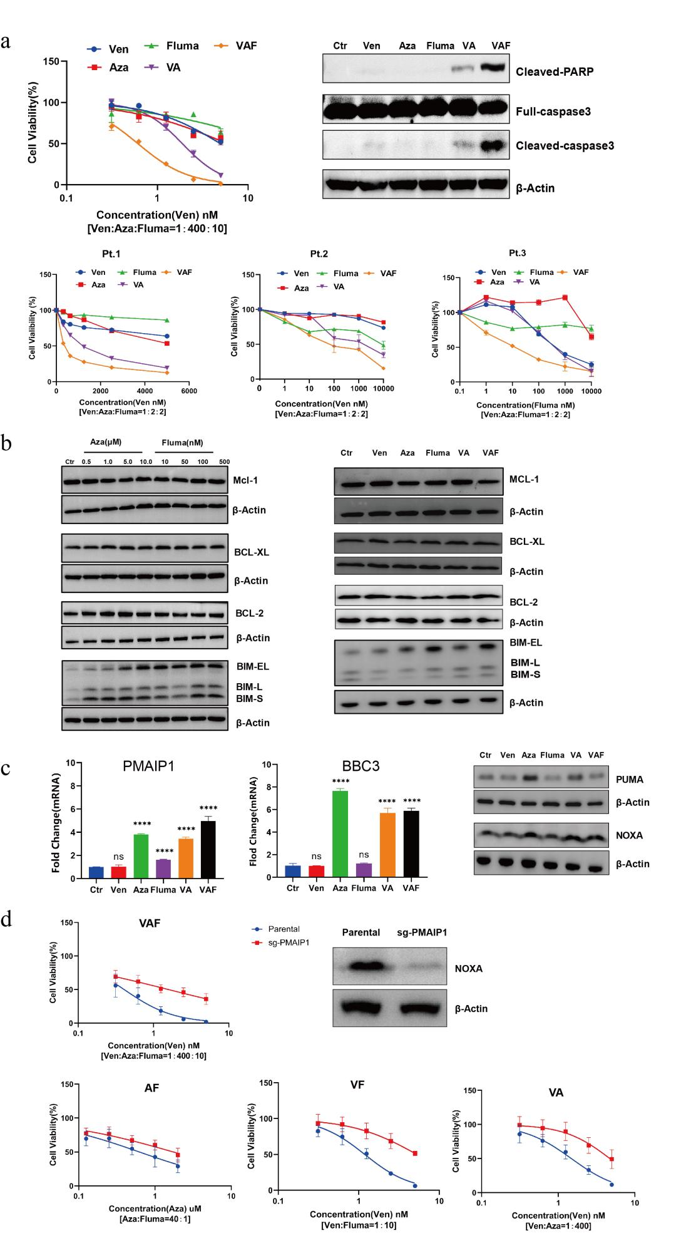

Figure. S1.
Venetoclax, azacitidine and flumatinib exerted high synergism in Ph+ALL cell line and samples from patients. (a)The cell viability of Ph+ALL cell line and primary human specimens treated with venetoclax, azacitidine, and flumatinib alone or in combination for 24 h or 48h. And changes in apoptosis-related proteins detected by western blot. (b) Protein expression of MCL-1, BCL-2, BCL-XL, and BIM in SUP-B15 cells treated with venetoclax, azacitidine, and flumatinib alone or in combination. B-ACTIN levels are given as loading control. (c) The expression of PMAIP1 (NOXA) and BBC3 (PUMA) at the mRNA and protein level in SUP-B15 cells after treatment with venetoclax, azacitidine and flumatinib alone or in combination. (d) PMAIP1 was crucial for azacitidine/flumatinib-specific combination effect with venetoclax in Ph+ALL.
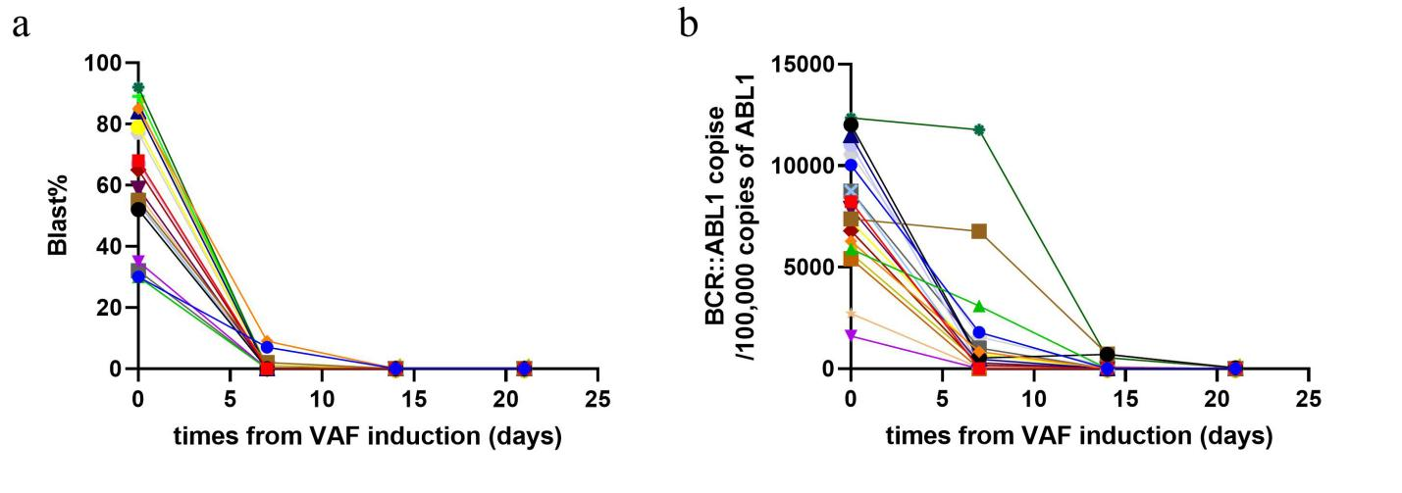Figure. S2.Venetoclax, azacitidine and flumatinib induced a rapid reduction of leukemic cells (a) and BCR::ABL1 transcripts (b).

