Supplementary Material
Supplementary Figure 1. Rarefaction curves based on OUT level.
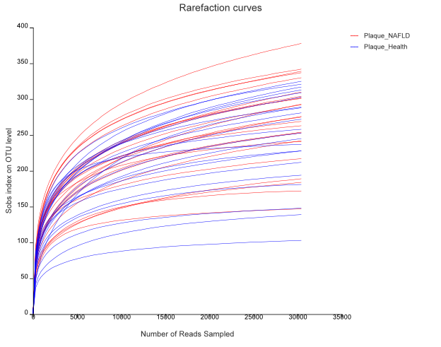
Supplementary Figure 2. Community heatmap at genus level.

