Supplementary files
Bacillus-derived cycle lipopeptides modulate microbiome structure and enzymatic activity of soil and increase productivity of Solanum tuberosum
Alexey S. Vasilchenko¹*, Diana S. Dilbaryan¹, Darya V. Poshvina¹, Eugene O. Burlakov ^{2,3}, Olga V. Domanskaya¹, Alexander V. Iashnikov¹, Irina V. Palamarchuk⁴, Anastasia V. Teslya^{1,5}
¹Laboratory of Antimicrobial Resistance, Institute of Environmental and Agricultural Biology (X-BIO), Tyumen State University, Tyumen
² International Integrated Research Laboratory for Climate Change, Land Use and Biodiversity, Institute of Environmental and Agricultural Biology (X-BIO), Tyumen State University, Tyumen, Russian Federation.
³ Research Institute of Mathematics, Physics and Computer Science, Derzhavin Tambov State University, Tambov, Russian Federation
⁴ School of Natural Science, Tyumen State University, Tyumen
⁵ Laboratory of Biochemistry and Ecology of Microorganisms, All-Russian Institute of Plant Protection, 196608 Pushkin, Russia
* Corresponding author. E-mail: avasilchenko@gmail.com (ASV).

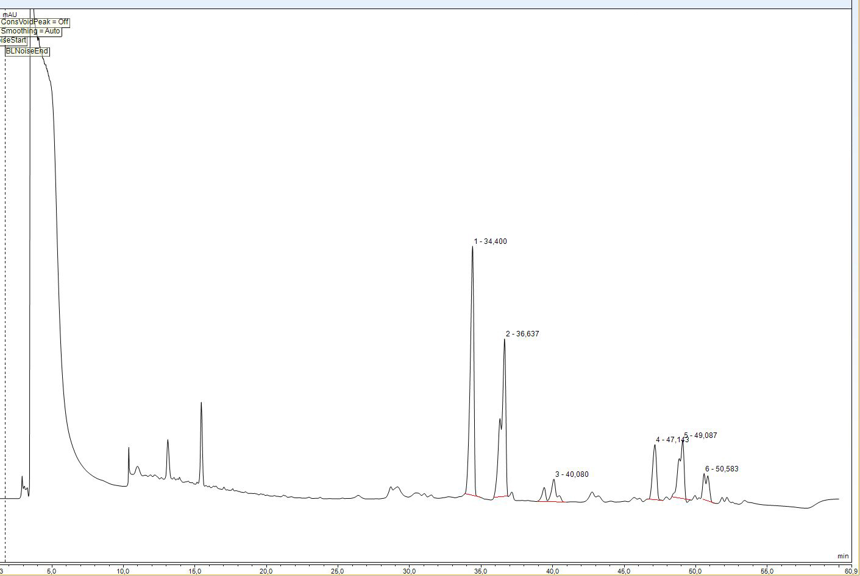
Figure S1. RT-HPLC profile of CLPs-contained preparation derived from Bacillus metabolites.

Table S1. The characteristics of CLPs-contained preparation
№ | Retention time, min | m/z ¹ | Square of pik, % ² | Compound ³
1 | 34.4 | 1021.6900 | 36.15 ±0.50 | C₁₄ Bacillomycin L
2 | 36.64 | 1035.55404 | 30.81±2.23 | C₁₅ Bacillomycin L
3 | 40.08 | 1435.9588 | 5.58± 0.76 | C₁₄ Fengycin A
4 | 47.14 | 1063.5788 | 2.84±0.08 | C₁₇ Bacillomycin L
5 | 49.08 | 1477.8361  1491.8393 | 11.56±1.34 | Fengycin B [C₁₄ & C₁₅]
6 | 50.58 | 1447  1507 | 4.96 ±0.36 | Fengycin A [C₁₅ & C₁₉]

¹The m/z value of individual collected lipopeptides were determined using HPLC-ESI-MS.
² The pik squares were derived from HPLС data.
³ The chemical nature of individual compound was resolved by comparing of m/z value with published data (de Faria et al., 2011; Li et al. 2016; DeFilippi et al. 2018; Dunlap et al., 2019; Ait Kaki et al., 2020).

Table S2. Quantitative assessment of antifungal activity of CLPs-contained preparation is expressed as the minimum inhibitory concentration (MIC)
Tested strains |  | MIC, µg/mL
Fungal species | Fusarium sporotrichioides MFG 11039 | 60
Fungal species | Fusarium poae MFG 11046 | 60
Fungal species | Fusarium culmorum MFG 102.100 | 60
Fungal species | Fusarium solani F-890 | >100
Fungal species | Aspergillus niger INA 00760 | 30
Fungal species | Aspergillus ochraceus INA 01223 | 60
Fungal species | Aspergillus fumigatus UTMN | >100
Fungal species | Aspergillus fumigatus KPB F-37 | >100
Fungal species | Penicíllium citreonigrum | 60
Fungal species | Penicíllium janczewskii INA 01223 | 60
Fungal species | Metarhizium robertsii | 15
Fungal species | Beauveria bassiana | 30
Fungal species | Beauveria sp. | 30
Fungal species | Trichoderma viride 471 | 60

Table S3. Statistics of relationships between microorganisms and the activity of soil enzymes calculated on the basis of correlation expressed by the Spearman coefficient (R_{s} > 0.6, p<0.05).
EEAs | Bacteria, number of edges | Fungi, number of edges
NAG | 18 | 15
BG | 9 | 6
Xylo | 9 | 10
CBH | 10 | 10
AP | 12 | 5
LAP | 3 | 9
In total | 61 | 55

Table 4. Results of linear mixed-effect (LME) modeling of relationships between bacteria and the activity of soil enzymes
Enzymes | Fixed effects |  |  | Random effects |  | LME model statistics
Enzymes | Regression coefficients, 95%-confidence intervals |  | Intercept, 95%-confidence interval | Intercepts, 95%-confidence intervals
Enzymes | Hyphomicrobium | Methylocapsa | Intercept, 95%-confidence interval | CLP | Experiment duration | t-stat | p-value
NAG | 4.8497,  [1.9922, 7.7072] | – | 1374.5,  [1055.5, 1693.6] | – | 1273.5,  [417.84, 1631.6] | 3.4765 | 0.002
BG | – | -1.0821,  [-1.8306, -0.33364] | 3592.6,  [1933.7, 5251.5] | 907.83,  [363.52, 2267.1] | 831.27, [278.47, 2481.4] | -2.9615 | 0.006
Xylo | 4.8668,  [1.9152, 7.8185] | – | 1015.4,  [527.81, 1503] | – | 248.92, [60.232, 1028.7] | 3.3776 | 0.002
CBH | 2.332,  [0.36815, 4.2958] | -0.50242,  [-0.88597, -0.11886] | 2134.3,  [9.2943, 4259.3] | – | 1457.5, [543.99, 3905.2] | 2.8275 | 0.010
AP | – | -3.2778,  [-5.8446, -0.71107] | 10601,  [7249, 13952] | 2393.8,  [913.95, 6269.9] | 810.82, [99.311, 6619.9] | -2.6159 | 0.014
LAP | -74.493,  [-128.55, -20.436] | 14.164,  [4.3189, 24.009] | 20155,  [14076, 26235] | – | – | - 2.0608 | 0.040

References
Ait Kaki A, Smargiasso N, Ongena M, Kara Ali M, Moula N, De Pauw E, Kacem Chaouche N. Characterization of New Fengycin Cyclic Lipopeptide Variants Produced by Bacillus amyloliquefaciens (ET) Originating from a Salt Lake of Eastern Algeria. Curr Microbiol. 2020 Mar;77(3):443-451. doi: 10.1007/s00284-019-01855-w.
Andreia Fonseca de Faria, Diego Stéfani, Boniek Gontijo Vaz, Ísis Serrano Silva, Jerusa Simone Garcia, Marcos N Eberlin, Matthew James Grossman, Oswaldo Luiz Alves, Lucia Regina Durrant, Purification and structural characterization of fengycin homologues produced by Bacillus subtilis LSFM-05 grown on raw glycerol, Journal of Industrial Microbiology and Biotechnology, Volume 38, Issue 7, 1 July 2011, Pages 863–871, https://doi.org/10.1007/s10295-011-0980-1
Dunlap CA, Bowman MJ and Rooney AP (2019) Iturinic Lipopeptide Diversity in the Bacillus subtilis Species Group – Important Antifungals for Plant Disease Biocontrol Applications. Front. Microbiol. 10:1794. doi: 10.3389/fmicb.2019.01794
DeFilippi, S., Groulx, E., Megalla, M. et al. Fungal Competitors Affect Production of Antimicrobial Lipopeptides in Bacillus subtilis Strain B9–5. J Chem Ecol 44, 374–383 (2018). https://doi.org/10.1007/s10886-018-0938-0
Li X, Zhang Y, Wei Z, Guan Z, Cai Y, Liao X. Antifungal Activity of Isolated Bacillus amyloliquefaciens SYBC H47 for the Biocontrol of Peach Gummosis. PLoS One. 2016 Sep 1;11(9):e0162125. doi: 10.1371/journal.pone.0162125

