Support material
A novel photothermal energy storage phase change material with high stability and enthalpy
Shenghua Xiong ^{a,b}, Yanlong Shi ^{a,b} Changhui Liu ^{a,b}, Gang Li^{a,b*}, and Yunyun Yang ^{a,b*}
ª: College of Civil Aviation Safety Engineering, Civil Aviation Flight University of China, Guanghan 618307, China
^{b}: Civil Aircraft Fire Science and Safety Engineering Key Laboratory of Sichuan Province, Civil Aviation Flight University of China, Guanghan 618307, China
*: Corresponding authors: yunyun1990@cafuc.edu.cn, ligang@cafuc.edu.cn

Table S1. The related TGA and DTG data of CNT-SA, CNT-BN-SA-1 and CNT-BN-SA-2.
Samples | T_{5%}(℃)ª | T_{50%}(℃)^{b} | T_{P}(℃)^{c} | P_{L}(%/min)^{d}
CNT-SA | 200.5 | 248.0 | 255.5 | -18.2
CNT-BN-SA-1 | 205.5 | 258.0 | 258.0 | -14.1
CNT-BN-SA-2 | 193.1 | 245.6 | 250.1 | -18.8
a: The testing temperature when the mass-loss of sample reaches 5wt.%
b: The testing temperature when the mass-loss of sample reaches 50wt.%
c: The testing temperature of mass-loss peak
d: The mass-loss rate of the mass-loss peak
Table S2. The phase-change properties of CNT-SA, CNT-BN-SA-1, CNT-BN-SA-2, and CNT-SA-1k, CNT-BN-SA-1-1k, CNT-BN-SA-2-1k
Samples | T_{c}(℃)ª | T_{m}(℃)^{b} | △Hc (J/g)^{c} |  | △Hm (J/g)^{d}
SA | 52.23 | 51.5 |  | 189.4 | 178.9
CNT-SA | 51.96 | 50.81 |  | 141.2 | 135.0
CNT-BN-SA-1 | 52.66 | 51.83 |  | 150.4 | 143.5
CNT-BN-SA-2 | 52.67 | 51.2 |  | 139.5 | 131.6
CNT-SA-1k | 51.9 | 50.79 |  | 136.4 | 132.6
CNT-BN-SA-1-1k | 52.86 | 51.53 |  | 147.5 | 147.3
CNT-BN-SA-2-1k | 52.75 | 51.00 |  | 146.7 | 138.3
a: The crystalline temperature during cooling
b: The melting temperature during heating
c: The crystalline enthalpy during cooling
d: The melting enthalpy during heating
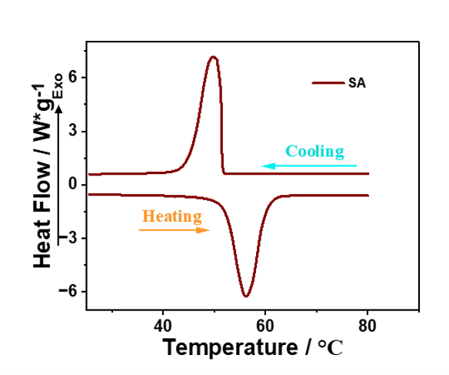
Figure S1. The DSC curves of SA.

