List of Figures
Fig. 1 Location map of sites of Godavari river basin
Fig 2. Trends in Pan Evaporation in Annual time scale over the Godavari basin
Fig. 3. Trends in mean relative humidity in Annual time scale over the Godavari basin
Fig 4a- Spatial variations of $E_{pan}$ (mm) over Godavari river basin at annual and seasonal scale
Fig 4b- Spatial variations of $T_{avg}$ trends magnitude (℃/decade) over Godavari river basin at annual and seasonal scale
Fig 4c- Spatial variations of wind speed trends magnitude (m/sec/decade) over Godavari river basin at annual and seasonal scale
Fig-5 Change point year with trend-line before and after the change year at annual time scale
Fig-6 Change point year with trend-line before and after the change year at seasonal time scale

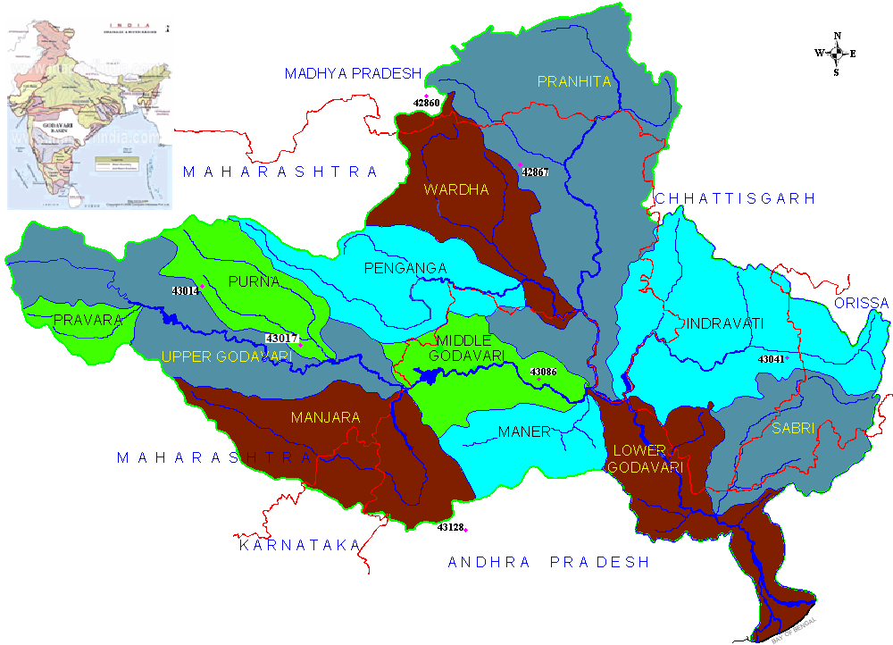
Fig. 1 Location map of sites of Godavari river basin

