Supplementary Information

Radiological evaluation of different retroperitoneal lymph node measurements in stage 1 testicular cancer patients: influence on clinical stage and therapy

Angelina Strauch^{1*}, Kai Nestler^{2*}, Justine Schoch¹, Laura Kubitscheck², Stephan Waldeck², Hans Schmelz¹, Tim Nestler^{1,3}

¹ Department of Urology, Federal Armed Forces Hospital Koblenz, Koblenz, Germany
² Institute of Diagnostic and Interventional Radiology, Federal Armed Forces Hospital Koblenz, Koblenz, Germany
³ Department of Urology, University Hospital of Cologne, Cologne, Germany
* These authors contributed equally.
Corresponding author:
Tim Nestler, M.D., FEBU
Department of Urology
Federal Armed Forces Hospital Koblenz
Ruebenacherstrasse 170
56072 Koblenz, Germany

Telephone: +49 261 281 31803
E-mail: tim-nestler@web.de
cc: timnestler@bundeswehr.org
ORCID-ID: 0000‐0001‐6033‐6364

Figures:

cSI GCT patients at our institution from 2000 to 2021 (n = 225)
Patients with adjuvant therapy after ablatio testis (n = 67)

No imaging available (n = 1)
Possible patient cohort (n = 158)
Included patients (n = 154)
No follow-up ≥24 months available
(n = 3)

Figure 1: The flowchart summarizes patient accrual according to STARD recommendations.
cS = clinical stage, GCT = testicular germ cell tumor

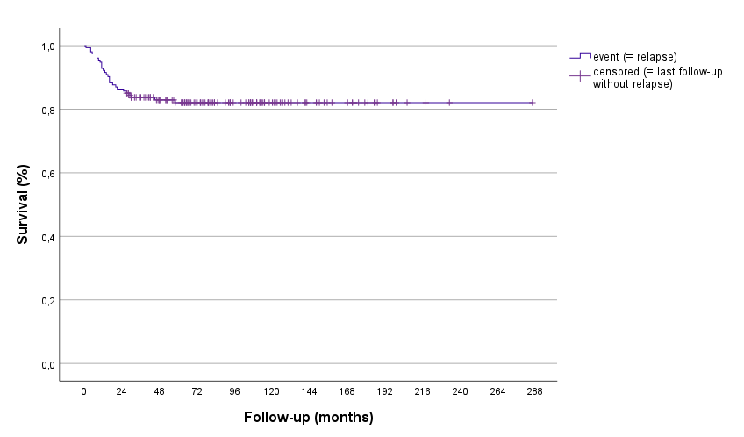
Figure 2: Kaplan-Meier survival curve of the entire study cohort (n=154) with a minimum follow-up of 27 months and a maximum of 286 months.

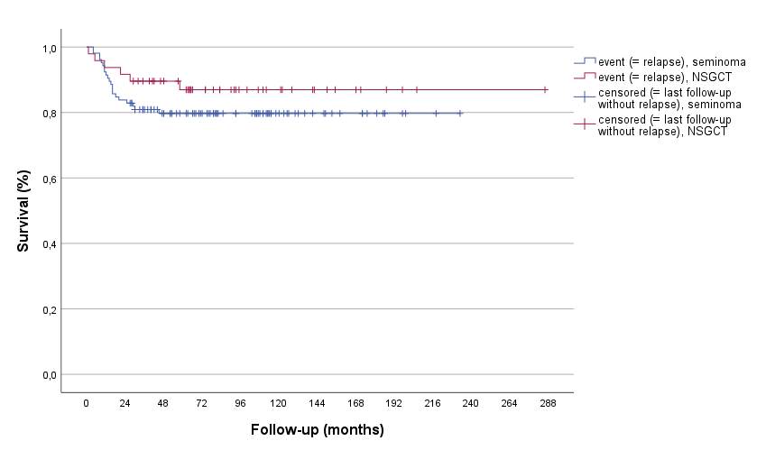
Figure 3: Kaplan-Meier survival curve of the study cohort separated by seminoma (n=106) (blue line) and NSGCT (n=48) (red line) patients.
NSGCT = non-seminomatous germ cell tumor
Tables:
Table 1: Clinical parameters of the study cohort (n=154). Estimates were given as median (quartile 1, quartile 3) or frequency (percentage).
clinical parameters
number of patients, n (%) | 154 (100)
patient age at diagnosis (years)
median (quartile 1, quartile 3) | 35 (28, 43)
tumor histology, n (%)
seminoma | 106 (69)
non-seminoma | 48 (31)
embryonal cell carcinoma | 33 (69)
teratoma | 26 (54)
choriocarcinoma | 10 (20)
yolk sac tumor | 16 (33)
seminoma | 13 (27)
pT-stage, n (%)
1 | 112 (73)
2 | 31 (20)
3 | 3 (2)
4 | 0
unknown | 8 (5)
testicular tumor size (mm)
median (quartile 1, quartile 3) | 30 (18, 43)
infiltration of rete testis, n (%)  unknown | 32 (21)  18 (12)
lymphovascular invasion, n (%)  pL  pV  unknown | 29 (19)  21 (14)  22 (14)  16 (10)
tumor marker nadir
median (quartile 1, quartile 3)
AFP (norm <5.8 IU/ml) | 2.5 (1.9, 3.4)
ß-hCG (norm <5 mIU/ml) | 0.6 (0.3, 1.4)
LDH (norm <250 U/l) | 173 (152, 201)
follow-up (months)
median (quartile 1, quartile 3) | 83 (59, 120)
relapse, n (%) | 27 (18)
deaths | 0

AFP = alpha fetoprotein, ß-hCG = human choriongonadotropin, LDH = lactate dehydrogenase

Tab. 2 Treatment recommendations for the study cohort (n=154) depending on the different lymph node measurements/guidelines, p<0.001. The colors stand for the toxicity of the therapies: green – surveillance, yellow – surveillance or 1 cycle of Carboplatin AUC 7/BEP, red – 3 cycles of BEP or 30/36Gy radiotherapy. Estimates were given as frequency (percentage).
cS and histology |  | axSAD | sagSAD | corSAD | axLAD | sagLAD | corLAD | max | therapy
cSI | seminoma  + RF | 28 (18) | 20 (13) | 24 (16) | 13 (8) | 5 (3) | 4 (3) | 4 (3) | surveillance/  1x Carboplatin
cSI | NSGCT+RF | 6 (4) | 5 (3) | 5 (3) | 4 (3) | 3 (2) | 3 (2) | 3 (2) | surveillance/  1x BEP
cSI | without RF | 120 (78) | 107 (69) | 112 (73) | 77 (50) | 38 (25) | 38 (25) | 29 (19) | surveillance
cSIIA | seminoma | 0 | 18 (12) | 8 (5) | 43 (28) | 55 (36) | 55 (36) | 61 (40) | 3x BEP/30Gy
cSIIA | NSGCT | 0 | 4 (3) | 5 (3) | 16 (10) | 19 (12) | 20 (13) | 18 (12) | 3x BEP
cSIIB | seminoma | 0 | 0 | 0 | 0 | 18 (12) | 20 (13) | 21 (14) | 3x BEP/36Gy
cSIIB | NSGCT | 0 | 0 | 0 | 1 (1) | 16 (10) | 14 (9) | 18 (12) | 3x BEP
guidelines |  | RECIST 1.1 |  |  | DGU  SWENOTECA |  |  | others
cS = clinical stage, axSAD = axial SAD, sagSAD = sagittal SAD, corSAD = coronal SAD, axLAD = axial LAD, sagLAD = sagittal LAD, corLAD = coronal LAD, max = maximum LAD in any plane, NSGCT = non-seminomatous germ cell tumor, RF = risk factor, BEP = Bleomycin/Etoposide/Cisplatin, RECIST 1.1 = Response Evaluation Criteria In Solid Tumors 1.1, DGU = S3 guideline of the German Society of Urology, SWENOTECA = Swedish and Norwegian Testicular Cancer Group, others = other guidelines (EAU = European Association of Urology, onkopedia = Guidelines of the Medical Societies in Hematology and Medical Oncology of the German speaking countries, AJCC = American Joint Committee on Cancer, ESMO = European Society for Medical Oncology)

