Supplementary Information
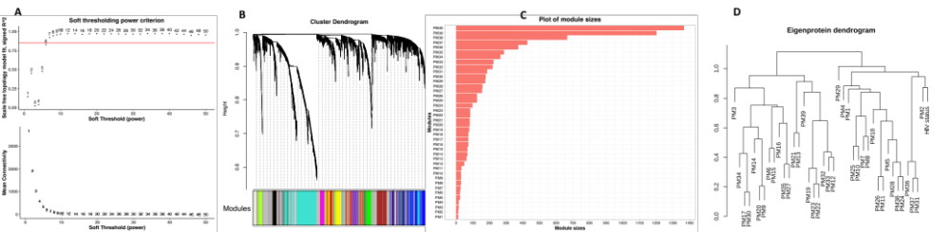

Supplementary Figure 1. Plasma proteome correlation network construction and structure. A. Scale-free topology criterion with r-squared of 0.85. A soft thresholding power of 9 was chosen based on r-squared of 0.85 (red line in the top panel) and minimum mean connectivity (bottom panel). B. Hierarchical clustering dendrogram of plasma proteome. Forty protein modules (annotated as PM1 through PM40) including the unassigned module (PM40) were generated from the 7335 plasma proteins. Each branch of the dendrogram represents a single protein, and the coloured bar below designates its corresponding protein module. The dendrogram height is the distance between proteins. We constructed a signed correlation network of proteins using biweight mid-correlation as it resulted into a network with fewer proteins in the unassigned module compared to using Pearson correlation which resulted to more unclassified proteins. (C) Bar plot showing module sizes, the smallest module has 11 proteins (PM1) while the largest module contains 1203 proteins (PM39). (D) Hierarchical clustering dendrogram of the eigenproteins showing relationships between HIV and modules.

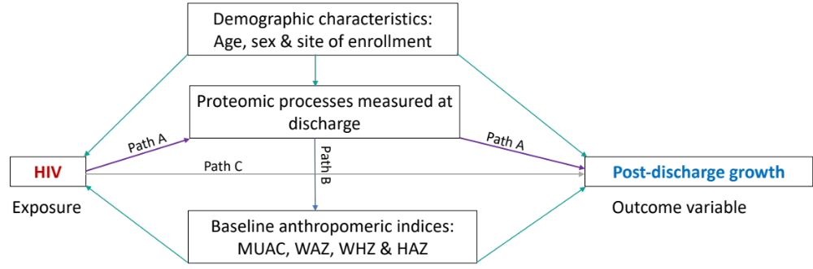
Supplementary Figure 2. Hypothesised path model linking HIV to post-discharge growth. The proposed pathway framework outlines link between HIV and post-discharge growth in children. The model incorporates site as a potential influencing factor, recognizing variations in HIV prevalence among different locations. Age, which may impact the child's viral load, is also integrated into the model. The hypothesised path model suggests that HIV indirectly affects post-discharge growth through modulation of certain biological processes measured at discharge in human blood plasma, as denoted by the purple-coloured arrow (path A). This framework serves as a guide for analysing the intricate biological relationship between HIV and post-discharge growth in children.

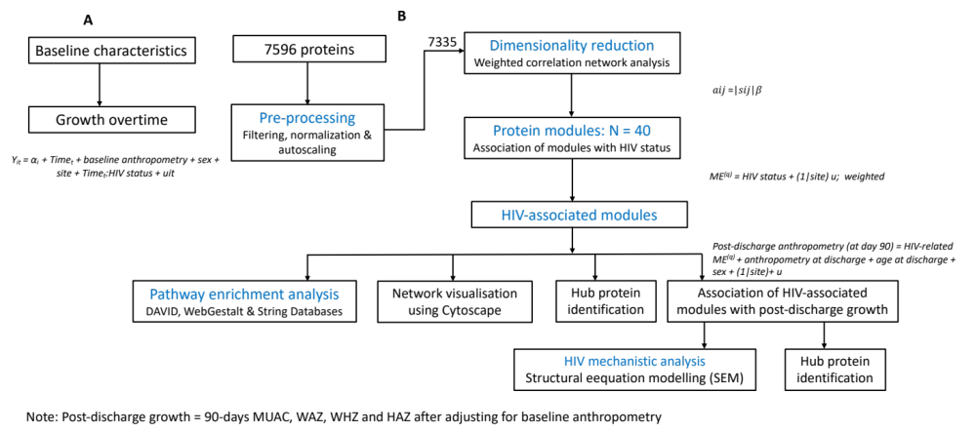
Supplementary Figure 3. A general analysis workflow of the present study: The figure demonstrates the analyses steps including the profiling of baseline characteristics of the partcipants, evaluation of the growth overtime by HIV status, construction of the plasma proteome network, identification of its individual protein modules and their association with HIV status, association of HIV-related protein modules with 90-day post-discharge growth, identification of hub proteins within individual modules, network visualization and enrichment analysis to identify over-represented biological process. Lastly, identification of potential directed paths through which HIV influences post-discharge growth using structural equation modelling (SEM).

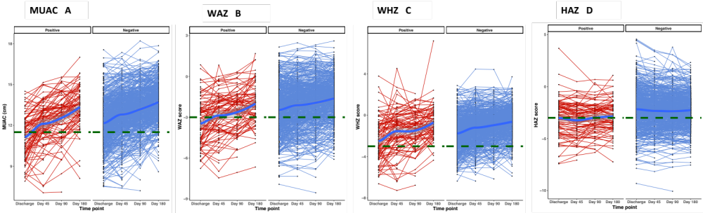

Supplementary Figure 4. Six months growth trajectories for every child by HIV status. A-D. Line graphs illustrating growth trajectories for each child by MUAC, WAZ, WHZ and HAZ respectively. The graphs are fitted with a LOESS function represented by a thick blue line, indicating the overall growth rates by HIV status. Red and blue colours denote children with and without HIV, respectively. Horizontal dotted green lines indicate the cutoffs for severe wasting, stunting and underweight. Abbrevaitions: MUAC, mid-upper arm circumference, WAZ, weight-for-age z score; WHZ, weight-for-height z score and HAZ, height-for-age z score.

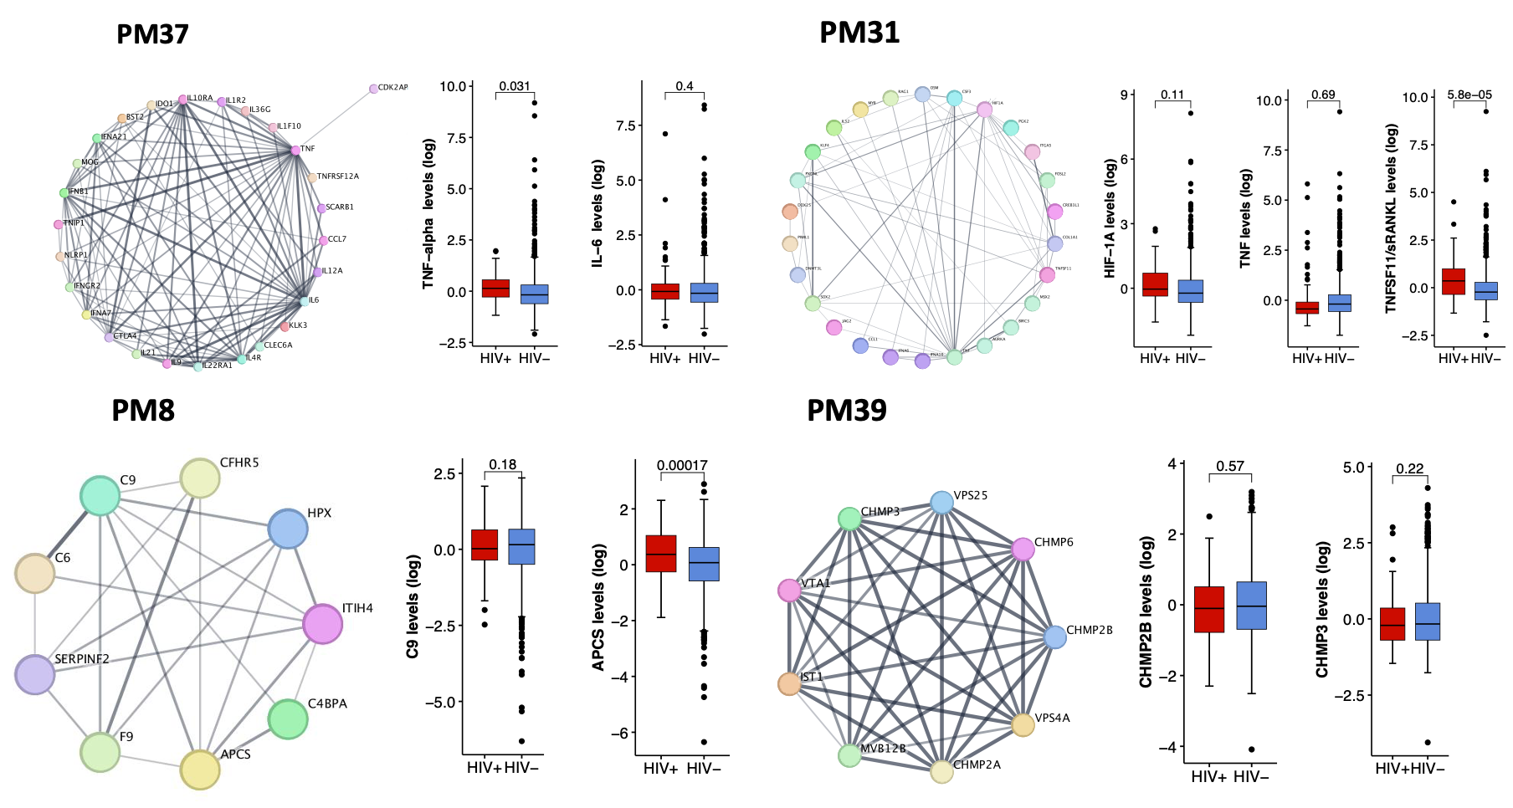
Supplementary Figure 5. Core proteins within modules positively associated with HIV status. Protein connectivity within modules positively association with HIV. Nodes represent the proteins making up the network. The lines represent edges connecting proteins with dark colored edges indicating highly correlated proteins in the network. Box plots show the potential core proteins within the network and their expression levels stratified by HIV status where p-value <0.05 indicate signficant difference in the expression levels of the core proteins between the two groups. Abbrevaition: PM, protein module

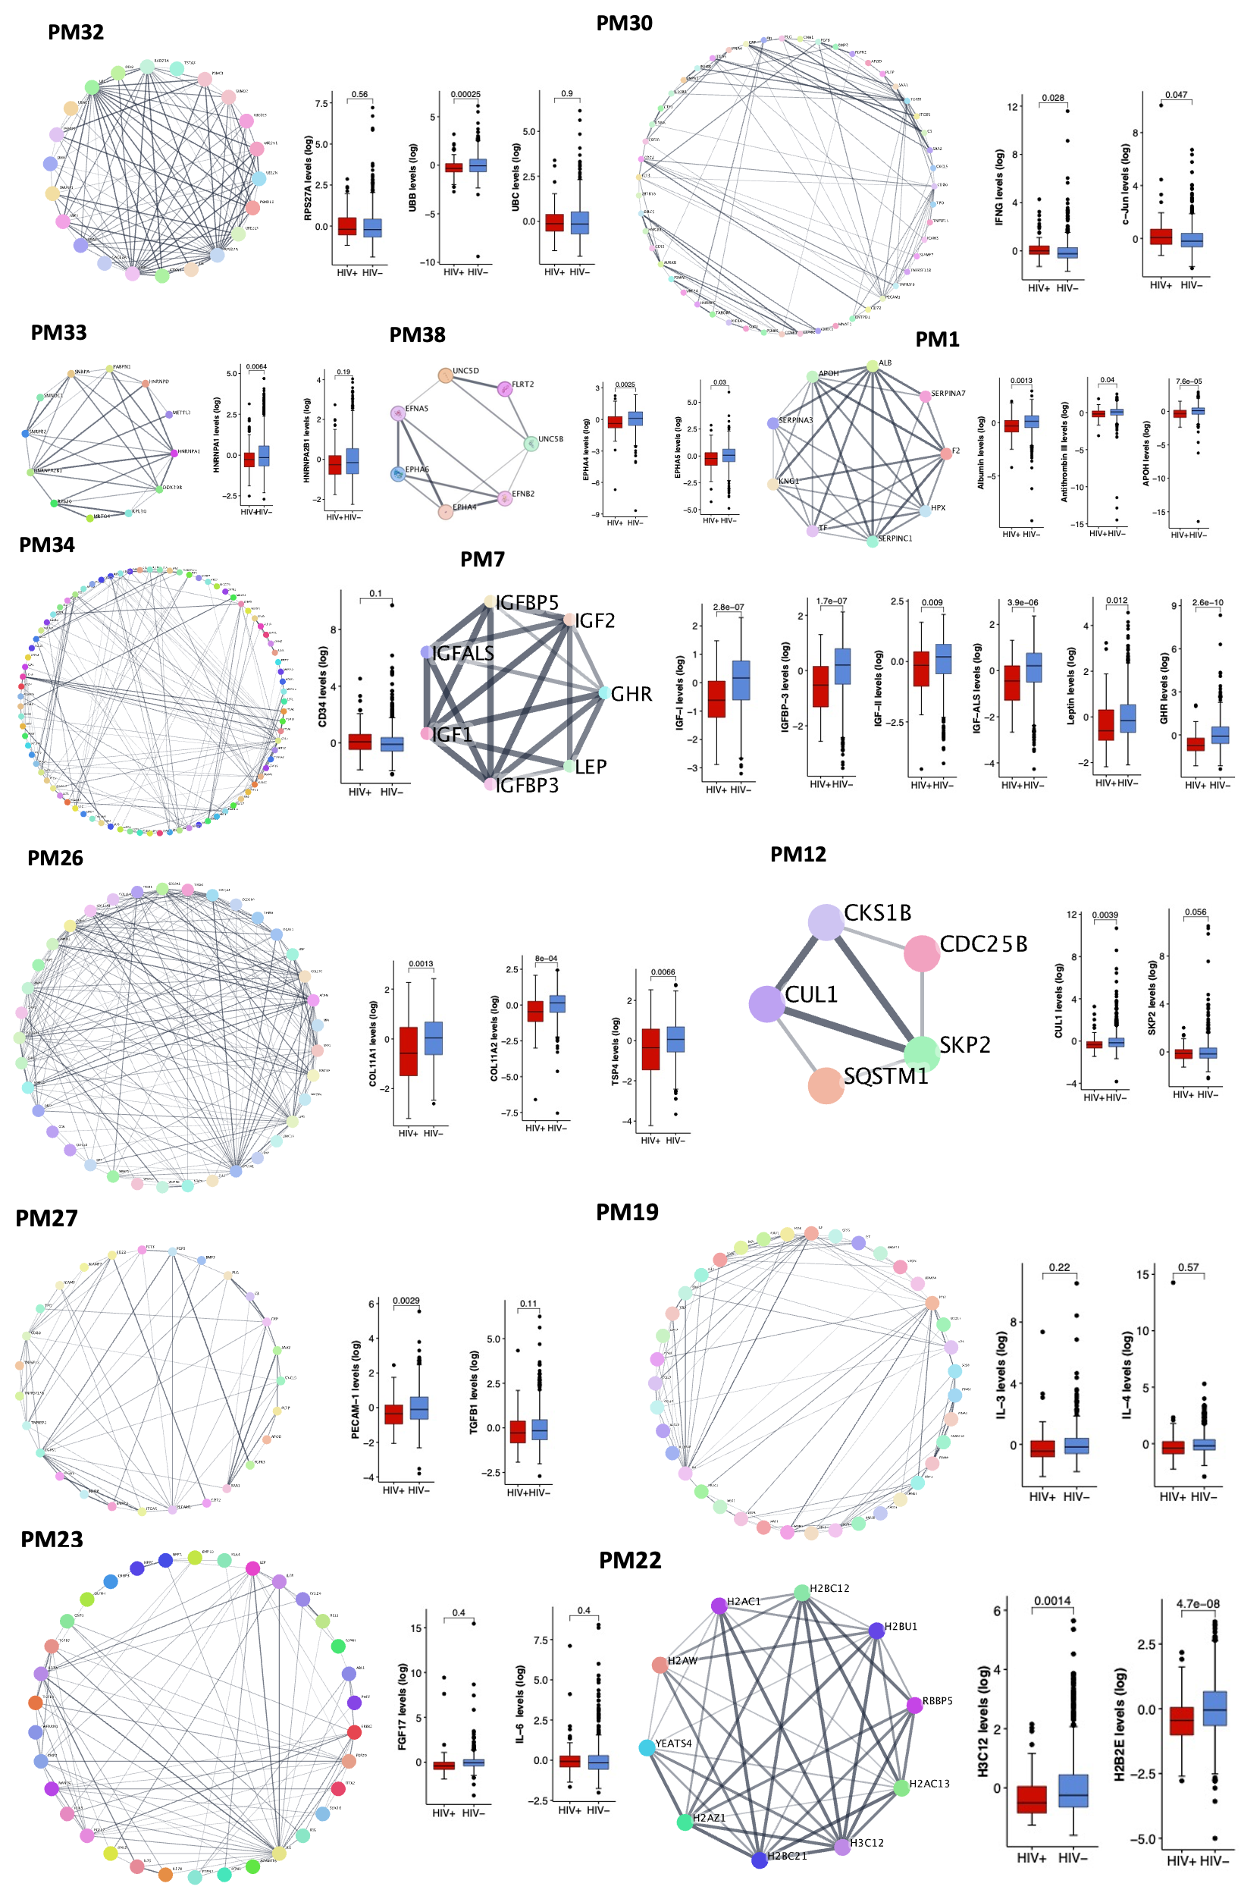
Supplementary Figure 6. Core proteins within modules negatively associated with HIV status. Protein connectivity within modules negatively association with HIV status. Nodes represent the proteins making up the network. The lines represent edges connecting proteins with dark colored edges indicating highly correlated proteins in the network. Box plots show the potential core proteins within the network and their expression levels stratified by HIV status where p-value <0.05 indicate signficant difference in the expression levels of the core proteins between the two groups.

Supplementary Table 1. Functional annotation of modules associated with HIV
Modules | Size | Biological pathways | P-value (Bonf adj) | Databases
Modules positively associated with HIV
PM37 | 428 | Response to odorant  Branching morphogenesis of a nerve  Regulation of type 2 immune response | ns  ns  0.04 | DAVID  WebGestalt  STRING
PM31 | 185 | Negative regulation of natural killer cell chemotaxis  Exploration behaviour  Signaling receptor regulator activity | ns  ns  ns | DAVID  WebGestalt  STRING
PM5 | 22 | Type B pancreatic cell development  Glandular epithelial cell development | ns  ns | DAVID WebGestalt
PM16 | 72 | Cellular potassium ion homeostasis  Negative regulation of necroptotic process | ns  ns | DAVID  WebGestalt
PM6 | 23 | Very-low density lipoprotein particle assembly  Lipoprotein particle binding | ns  ns | WebGestalt  STRING
PM8 | 30 | Complement activation  Complement activation  Cytolysis | 0.01  0.001  0.02 | DAVID  WebGestalt  STRING
PM39 | 1203 | Translational initiation  Establishment of localization in cell  Peptide transport*  Regulation of Golgi inheritance | 0.0000  0.0001  0.0001 | DAVID  WebGestalt  DAVID  STRING
PM2 | 12
Modules negatively associated with HIV
PM17 | 73 | Cysteine biosynthetic process from serine  Regulation of high voltage-gated calcium channel activity | ns  ns | DAVID  WebGestalt
PM38 | 665 | Synaptic membrane adhesion  Axonogenesis  Positive regulation of cardiac neural crest migration invasion | 0.000  0.000  0.01 | DAVID  WebGestalt  STRING
PM14 | 66 | Regulation of heparan sulfate proteoglycan biosynthetic process  Glial cell fate commitment | ns  ns | DAVID  WebGestalt
PM32 | 218 | Purine nucleotide biosynthesis process  5-phosphoribose 1-diphosphate biosynthetic process | 0.000  0.000 | DAVID/STRING  WebGestalt
PM30 | 176 | Innate immune response  Positive regulation of immune effector process | 0.04  0.0003 | WebGestalt  STRING
PM10 | 30 | Sulfation | ns | WebGestalt
PM25 | 124 | Carbohydrate phosphorylation | ns | WebGestalt
PM33 | 224 | Ribosomal small subunit biogenesis  mRNA processing  Cellular response to sodium arsenite | 0.000  0.000  0.009 | DAVID  WebGestalt  STRING
PM34 | 266 | Notch receptor processing  Défense response to other organism | ns  0.02 | WebGestalt  STRING
PM1 | 11 | Regulation of blood coagulation  Blood coagulation  Negative regulation of fibrinolysis | 0.004  0.000  0.013 | DAVID  WebGestalt  STRING
PM12 | 48 | Immature T cell proliferation in thymus  Mitotic cell cycle phase transition | ns  0.040 | DAVID  WebGestalt
PM18 | 74 | Regulation of activin receptor signalling pathway  Synapse organization  Proximal/distal axis specification  Regulation of activin receptor signalling pathway | ns  ns  0.04  0.04 | DAVID  WebGestalt  STRING  STRING
PM27 | 155 | Positive regulation of mitotic sister chromatid separation  Chondrocyte proliferation  Positive regulation of peptidyl-tyrosine phosphorylation | ns  ns  0.03 | DAVID  WebGestalt  STRING
PM3 | 15 | Negative regulation of proteolysis  Blood coagulation, intrinsic pathway | ns  ns | DAVID  WebGestalt
PM7 | 25 | Insulin-like growth factor receptor signalling pathway  Positive regulation of insulin-like growth factor receptor signalling pathway | 0.02  0.01 | DAVID/STRING  WebGestalt
PM19 | 79 | Negative regulation of DNA damage checkpoint  Hindlimb morphogenesis  Chondroblast differentiation and Hindlimb morphogenesis | ns  0.02  0.03 | DAVID  WebGestalt  STRINNG
PM26 | 125 | Collagen fibril organization  Bone morphogenesis  Bone trabecular formation | 0.000  0.000  0.007 | DAVID  WebGestalt  STRING
PM22 | 83 | Telomere organization  Chromatin assembly  Leukocyte mediated cytotoxicity | 0.001  0.007  0.02 | DAVID  WebGestalt  STRING
PM23 | 84 | Uterine wall breakdown  Regulation of signalling receptor activity  Positive regulation of T-helper 2 cell cytokine production | ns  0.001  0.01 | DAVID  WebGestalt  STRING
Superclusters
SC1-PM17,30,34 | 513 | Inflammatory response | 0.03 | DAVID
SC2-PM19,22,23 | 319 | Positive regulation of T-helper 2 cell cytokine production  Regulation of signalling receptor activity | 0.0001  0.0001 | DAVID  WebGestalt
SC3-PM12,32,33 | 489 | Ribosomal small subunit biosynthesis  mRNA metabolic process | 0.0001  0.0001 | DAVID  WebGestalt
SC4-PM25,10 | 154 | Response to interleukin-4 | ns | DAVID
SC5-PM7,8 | 55 | Complement activation  Regulation of humoral immune response | 0.0001  0.0001 | DAVID  WebGestalt
SC6-PM31,37 | 613 | Humoral immune response* | 0.02 | DAVID
*Homo sapiens served as the reference background for calculating fold enrichment for pathway enrichment analysis;
ns = not significantly enriched biological pathway

Supplementary Table 2. Candidate hub proteins within modules significantly associated with HIV status
Modules | Hub protein | Description | UniProt/STRING functional annotation | HIV literature on these hub proteins from PubMed
Modules positively associated with HIV
PM5 | TRAPPC3 | Trafficking protein particle complex subunit 3 (TRAPPC3) | As a component of TRAPP complex, TRAPPC3 could be involved in vesicular transport from endoplasmic reticulum to Golgi.  Vesicle tethering§ | TRAPPC1 a component of TRAPP complex is required for HIV infection¹. Lower expression of HIV-permissive host genes including TRAPPC1 were associated with deceased susceptibility to HIV-1 infection in female sex workers².
PM6 | SC5A8 | Sodium-coupled monocarboxylate transporter 1 | Acts as a sodium ion-coupled solute transporter of short-chain fatty acids, monocarboxylates drugs and ketone bodies.  Positive regulation of acute inflammatory response to non-antigenic stimulus§ | Transport of ions including lactate across the cell membrane is aided by monocarboxylates transporters (MCTs) whose direction is determined by the concentration of monocarboxylates ions and protons. Similarly, sodium coupled transport is also performed by SC5A8. The levels of concentration of these transporters is affected by inflammation. Solute carrier transporters such GLUT1 have been implicated in HIV infection. GLUT1, a primary glucose transporter in lymphocytes is increased in CD4+ and CD8+ T cells in HIV infection³.
PM8 | CFHR5 | Complement factor H-related protein 5 | Involved in complement regulation.  Opsonization§ | In adults living with HIV on ART, CFHR5 was significantly enriched compared to their seronegative counterparts. CFHR5 exhibited borderline association with prevalence of non-AIDS related comorbidities⁴.
PM16 | FGF-8B | Fibroblast growth factor 8  isoform B | FGF8b is one of the four isoforms of FGF. It is involved in embryonic development, cell proliferation and migration. Required for normal development of the gonadotropin-releasing hormone neural system.  Prostate epithelial cord elongation§
PM31 | SEM4F | Semaphorin-4F | A probable cell surface receptor that regulates oligodendroglial precursor cell migration. Can also regulate differentiation of oligodendroglial precursor cells.  Olfactory nerve formation§
PM37 | DNS2B | Deoxyribonuclease-2-beta | Preferentially hydrolyses double stranded DNA under acidic conditions. Plays a role in the clearance of nucleic acids generated through apoptosis, hence preventing autoinflammation.  DNA catabolic process, endonucleolytic§
PM39 | SH3G2 | Endophilin-A1 | Implicated in the synaptic vesicle endocytosis. Required for BDNF-dependent dendrite outgrowth.  Synaptic vesicle uncoating§ | SH3 domain mediates the binding of Tat protein with human proteins including Grb2. The binding of Tat to Grb2 impairs activation of MAPK/Raf pathway. This interaction also affects viral function by inhibiting the Tat-mediated transactivation of HIV-1 long terminal repeats and viral replication in infected primary microglia⁵.
Modules negatively associated with HIV
PM1 | Transferrin | Serotransferrin | Binds and transport iron in the body. Elevated transferrin used as a marker of iron deficiency  Cellular response to iron ion§ | HIV has been associated with low transferrin levels⁶.
PM3 | KNG2 | Kininogen, HMW, Two Chain | Play a role in coagulation.  Positive regulation of fibrinolysis§ | HIV⁺ patients with and without pruritic papular eruption (skin rashes) had higher plasma levels of total kininogen (high molecular weight and low molecular weight kininogen) than their HIV⁻ controls. HMWK levels were diminished in HIV⁺ group although without significance when compared to their counterparts⁷.
PM7 | IGFBP-3 | Insulin-like growth factor-binding  protein 3 | Binds and regulate the actions of IGF-I. IGFBP-3 is the main transporter of IGFs in the bloodstream.  Positive regulation of insulin-like growth factor receptor signalling pathway§ | Infection with HIV is often associated with a decrease in the concentrations of IGF-I, IGF-II, IGFBP-3 and increase of IGFBP-1 and -2. IGFBP-3 protease activity in the serum is increased during conditions such as protein deprivation and chronic illness e.g., HIV infection^{8,9}.
PM10 | CCD43 | Coiled-coil domain-containing protein 43 | Protein involved in acetylation§
PM12 | MOB3B | MOB kinase activator 3B | Regulates large tumor suppressor kinase 1 (LATS1) expression in the Hippo pathway which plays a crucial role in organ size control and tumor suppression by promoting apoptosis and inhibiting proliferation.  Inner cell mass cellular morphogenesis§
PM14 | DPH5 | Diphthine methyl ester synthase | Involved in post translational methylation. DPH5 gene is involved in diphthamide biosynthesis.  Protein histidyl modification to diphthamide§ | Diphthamide is a cellular target in viral infection. It ensures maintenance of reading frame and its deficiency is linked to increased -1 programmed ribosomal frameshifting propagating viral infection. DPH7 one of the diphthamide synthase enzyme has been associated with targeted vif protein degradation thus promoting frameshifting necessary for HIV infection¹⁰.
PM17 | MBL2 | Vesicular integral-membrane protein VIP36 | Plays a role as an intracellular lectin in the early secretory pathway. Involved in transport and sorting of glycoproteins carrying high mannose-type glycans.  COPI coating of Golgi vesicle§
PM18 | CA7 | Carbonic anhydrase 7 | Involved in catalytic reversible hydration of carbon dioxide.  Positive regulation of cellular pH reduction§
PM19 | SOD | Superoxide dismutase | An antioxidant enzyme that protects the cell from reactive oxygen species (ROS) toxicity.  Positive regulation of oxidative stress-induced intrinsic apoptotic signalling pathway§ | SOD controls ROS and oxidative stress¹¹. HIV infection and the Tat protein can induce ROS production and alter redox regulation¹². In prepubertal children with and without HIV similar SOD levels were observed ¹³. In adults living with HIV, SOD levels were elevated in physically active group compared to the inactive one¹⁴.
PM22 | H2B2E | Histone H2B type 2-E | Is a core component of nucleosome. Nucleosomes wrap and compact DNA into chromatin, limiting its accessibility to the cellular machineries which depend on DNA as a template.  Protein localization to chromosome, centromeric region§
PM23 | Enterokinase | Enteropeptidase | Responsible for initiating activation of pancreatic proteolytic proenzymes. It catalyses the conversion of trypsinogen to trypsin which in turn activates other proenzymes such as proelastases, procarboxypeptidases and chymotrypsinogen. | An in vitro study investigating the effects of HAART drugs and excipient on the activity of digestive enzymes reported no association between HAART drug formulations and inhibition of trypsin or enterokinase activity¹⁵.
PM25 | CQ10A | Coenzyme Q-binding protein COQIO homolog A, mitochondrial | Required for coenzyme Q functioning in the mitochondrial respiratory chain.  Ubiquinone biosynthesis process§ | A clinical trial assessing the effect of COQ10 supplementation on incidences of opportunistic infections and levels of CD4⁺ T-cell counts among HIV-infected adults reported no improvement in these measurements¹⁶.
PM26 | COL11A2 | Collagen alpha-2(XI) chain | Involved in fibrillogenesis by controlling lateral  growth of collagen II fibrils. Type XI collagen is mainly found in cartilage.  Negative regulation of endodermal cell differentiation§
PM27 | FR1OP | FGFR1 oncogene partner | Is a centrosomal protein involved in anchoring microtubules to the centromeres.  Microtubule anchoring§
PM30 | OPT | Opticin | Inhibits angiogenesis in the vitreous humour of the eye thereby repressing neovascularization. May be involved in collagen fibre organization through regulation of other members of the small leucine-rich repeat proteoglycan superfamily  Collagen catabolic process§
PM32 | FGF-16 | Fibroblasts growth factor 16 | Plays a role in the regulation of embryo development, cell proliferation. Required for normal cardiomyocyte proliferation and heart development.  Positive regulation of endothelial cell chemotaxis to fibroblast growth factor§ | In a cell line study model that investigated the interactions of neurotrophins and HIV induced macrophage activation, reported altered growth factor secretion where FGF16 levels were decreased in cells exposed to HIV¹⁷.
PM33 | STMN4 | Stathmin-4 | Exhibits microtubule-destabilizing activity. Prevents assembly and promotes disassembly of microtubules.  COPII vesicle coating§ | Stathmin-1 a protein also involved in the regulation of the microtubule filament by destabilizing microtubules has been associated with the maintenance of HIV-1 latency¹⁸.
PM34 | SATB1 | DNA binding protein SATB1 | Transcriptional repressor controlling nuclear and viral expression in a phosphorylated and acetylated dependent manner.  Facultative heterochromatin formation§ | STAB1 was found to be positively associated with markers of immune activation among HIV⁺ individuals on ART in South Africa¹⁹.
PM38 | EPHA4 | Ephrin type-A receptor 4 | Involved in development of nervous system.  Positive regulation of aspartic-type endopeptidase activity involved in amyloid precursor protein catabolic process§ | Lower levels of EPHA4 transcripts were associated with HIV-related neurocognitive disorders among HIV⁺ adults on ART compared to the HIV⁻ group²⁰.
§ Biological process functional annotation (Gene Ontology) from STRING database

Supplementary Table 3. Top hub proteins with high effect sizes and intramodular connectivity within modules associated with HIV
Modules | Target | Description | Within-module Connectivity | Effect size
PM1 | a1-Antichymotrypsin | Alpha-1-antichymotrypsin | 1 | 0.085
PM1 | Transferrin | Serotransferrin | 0.885 | 0.126
PM1 | Prothrombin | Prothrombin | 0.723 | 0.069
PM1 | Kininogen, HMW | Kininogen-1 | 0.649 | 0.083
PM3 | TPGS2 | Tubulin polyglutamylase complex subunit 2 | 1 | 0.152
PM3 | HSP 70 | Heat shock 70 protein 1A | 0.994 | 0.141
PM3 | KNG2 | Kininogen, HMW, Two Chain | 0.892 | 0.16
PM3 | CGAT2 | Chondroitin sulfate N acetylgalactosaminyltransferase 2 | 0.6 | 0.135
PM3 | IL-1b | Interleukin-1 beta | 0.558 | 0.123
PM5 | ERP29 | Endoplasmic reticulum resident protein 29 | 1 | 0.056
PM5 | HNF4A | Hepatocyte nuclear factor 4-alpha | 0.871 | 0.082
PM5 | a1-Microglobulin | Alpha-1-microglobulin | 0.813 | 0.083
PM5 | TPPC3 | Trafficking protein particle complex subunit 3 | 0.786 | 0.115
PM5 | SUMF1 | Sulfatase-modifying factor 1 | 0.673 | 0.156
PM5 | DLL1 | Delta-like protein 1 | 0.588 | 0.064
PM7 | IGF-I | Insulin-like growth factor I | 1 | 0.17
PM7 | IGFBP-3 | Insulin-like growth factor-binding protein 3 | 0.956 | 0.175
PM7 | IGFALS | IGF binding protein complex acid labile subunit | 0.756 | 0.173
PM8 | CFHR5 | Complement factor H related 5 | 0.973 | 0.101
PM8 | CAD15:CD | Cadherin-15:Cytoplasmic domain | 0.899 | 0.117
PM8 | PXDC1 | Plexin domain-containing protein 1 | 0.715 | 0.08
PM8 | VCX1 | Variable charge X-linked protein 1 | 0.632 | 0.067
PM8 | GON1 | Progonadoliberin-1 | 0.622 | 0.104
PM12 | MOB3B | MOB kinase activator 3B | 0.998 | 0.203
PM12 | ITM2A | Integral membrane protein 2A | 0.99 | 0.107
PM12 | HDAC8 | Histone deacetylase 8 | 0.977 | 0.098
PM12 | PDCL2 | Phosducin-like protein 2 | 0.848 | 0.151
PM12 | RGS1 | Regulator of G-protein signaling 1 | 0.755 | 0.166
PM12 | EGLN2 | Egl nine homolog 2 | 0.716 | 0.081
PM12 | BR serine/threonine kinase 2 | Serine/threonine-protein kinase BRSK2 | 0.698 | 0.09
PM12 | Megalin | Low-density lipoprotein receptor-related protein 2 | 0.668 | 0.09
PM12 | CUL1 | Cullin-1 | 0.654 | 0.105
PM14 | DPH5 | Diphthine methyl ester synthase | 1 | 0.095
PM14 | IFT22 | Intraflagellar transport protein 22 homolog | 0.729 | 0.052
PM14 | FUT9 | Alpha-(1,3)-fucosyltransferase 9 | 0.655 | 0.06
PM14 | ZCC18 | Zinc finger CCHC domain-containing protein 18 | 0.618 | 0.115
PM16 | FGF8B | Fibroblast growth factor 8 isoform B | 1 | 0.118
PM16 | OLR1 | Oxidized low-density lipoprotein receptor 1 | 0.928 | 0.1
PM16 | Collagen alpha-3(VI):isoform 3 | Collagen alpha-3(VI) chain:isoform 3 | 0.922 | 0.108
PM16 | NNAT | Neuronatin | 0.919 | 0.109
PM16 | ARL14 | ADP-ribosylation factor-like protein 14 | 0.862 | 0.119
PM16 | CPTP | Ceramide-1-phosphate transfer protein | 0.857 | 0.104
PM16 | Semaphorin 3E | Semaphorin 3E | 0.817 | 0.126
PM16 | Beta-casein | Beta-casein | 0.723 | 0.088
PM16 | 5NT1A | Cytosolic 5'-nucleotidase 1A | 0.723 | 0.129
PM16 | MAGE-4 | Melanoma-associated antigen 4 | 0.718 | 0.101
PM16 | MAP3K3 | Mitogen-activated protein kinase kinase kinase 3 | 0.71 | 0.097
PM17 | MBL2 | Mannose binding lectin 2 | 1 | 0
PM17 | CHKB | Choline/ethanolamine kinase | 0.987 | 0.017
PM17 | OLFL3 | Olfactomedin-like protein 3 | 0.933 | 0.026
PM17 | PCDGK | Protocadherin gamma-C3 | 0.777 | 0.002
PM17 | SIG12:Ig-like C2-type 2 | Sialic acid-binding Ig-like lectin 12:Ig-like C2-type 2 domain, Isoform short | 0.719 | 0.025
PM18 | LRRT3 | Leucine rich repeat transmembrane neuronal protein 3 | 0.934 | 0.108
PM18 | CA7 | Carbonic anhydrase 7 | 0.896 | 0.156
PM18 | IL-20 Ra | Interleukin-20 receptor subunit alpha | 0.85 | 0.068
PM18 | MRP6 | Multidrug resistance-associated protein 8 | 0.85 | 0.068
PM18 | GPC2 | Glypican-2 | 0.742 | 0.066
PM19 | SOD | Superoxide dismutase [Cu-Zn] | 1 | 0.12
PM19 | Azurocidin | Azurocidin | 0.777 | 0.102
PM19 | MFRP | Membrane frizzled-related protein | 0.768 | 0.089
PM19 | Activin AB | Inhibin beta A chain:Inhibin beta B chain heterodimer | 0.753 | 0.108
PM19 | Bone proteoglycan II | Decorin | 0.727 | 0.156
PM19 | TBK1 | Serine/threonine-protein kinase | 0.712 | 0.167
PM19 | TSLP | Thymic stromal lymphopoietin | 0.706 | 0.12
PM19 | RSPO2 | R-spondin-2 | 0.689 | 0.204
PM19 | IL-11 | Interleukin-11 | 0.637 | 0.151
PM19 | MED-1 | Mediator of RNA polymerase II transcription subunit 1 | 0.629 | 0.098
PM19 | CD47 | Leukocyte surface antigen CD47 | 0.628 | 0.128
PM19 | FST | Follistatin | 0.62 | 0.092
PM22 | GFRa-3 | GDNF family receptor alpha-3 | 1 | 0.144
PM22 | CELF2 | CUGBP Elav-like family member 2 | 0.997 | 0.128
PM22 | H2B1K | Histone H2B type 1-K | 0.993 | 0.152
PM22 | H2B3B | Histone H2B type 3-B | 0.955 | 0.122
PM22 | H2B2E | Histone H2B type 2-E | 0.913 | 0.168
PM22 | H2A3 | Histone H2A type 3 | 0.904 | 0.154
PM22 | IL22RA1 | Interleukin-22 receptor subunit alpha-1 | 0.899 | 0.145
PM22 | H2A1A | Histone H2A type 1-A | 0.832 | 0.118
PM22 | H2B2E | Histone H2B type 2-E | 0.826 | 0.129
PM22 | Histone H2A type 1 | Histone H2A type 1 | 0.759 | 0.162
PM23 | IFNL2 | Interferon lambda-2 | 1 | 0.11
PM23 | Enterokinase | Enteropeptidase | 0.955 | 0.114
PM23 | CHST6 | Carbohydrate sulfotransferase 6 | 0.917 | 0.114
PM23 | WFKN1 | WAP, kazal, immunoglobulin, kunitz and NTR domain-containing protein 1 | 0.917 | 0.114
PM23 | PESC | Pescadillo homolog | 0.84 | 0.111
PM23 | ABL1 | Tyrosine-protein kinase ABL1 | 0.824 | 0.083
PM23 | PLK-1 | Serine/threonine-protein kinase PLK1 | 0.745 | 0.079
PM23 | NANOG | Homeobox protein NANOG | 0.735 | 0.089
PM23 | ANP | Atrial natriuretic factor | 0.723 | 0.116
PM23 | Lymphotactin | Lymphotactin | 0.72 | 0.094
PM26 | COL11A2 | Collagen alpha-2(XI) chain | 1 | 0.14
PM26 | CO9A1 | Collagen alpha-1(IX) chain | 0.979 | 0.113
PM26 | TSP4 | Thrombospondin-4 | 0.927 | 0.117
PM26 | TSP3 | Thrombospondin-3 | 0.857 | 0.115
PM26 | CILP2 | Cartilage intermediate layer protein 2 | 0.841 | 0.125
PM26 | LRC15 | Leucine-rich repeat-containing protein 15 | 0.804 | 0.116
PM26 | CO1A1:C-term propeptide | Collagen alpha-1(I) chain:C-term propeptide | 0.781 | 0.101
PM26 | HPLN1 | Hyaluronan and proteoglycan link protein 1 | 0.733 | 0.086
PM26 | CNTN3 | Contactin-3 | 0.715 | 0.108
PM26 | DERM | Dermatopontin | 0.705 | 0.121
PM27 | MSP R | Macrophage-stimulating protein receptor | 1 | 0.079
PM27 | ENTP3 | Ectonucleoside triphosphate diphosphohydrolase 3 | 0.998 | 0.061
PM27 | TMM46 | Protein shisa-2 homolog | 0.938 | 0.073
PM27 | TMCC3:region 2 | Transmembrane and coiled-coil domains protein 3: region 2 | 0.935 | 0.065
PM27 | PECAM-1 | Platelet endothelial cell adhesion molecule | 0.86 | 0.132
PM27 | AURKB | Aurora kinase B | 0.857 | 0.102
PM27 | CAMK1D | Calcium/calmodulin-dependent protein kinase type 1D | 0.852 | 0.075
PM27 | CD22 | B-cell receptor CD22 | 0.82 | 0.12
PM27 | TMA | Thyroid peroxidase | 0.804 | 0.076
PM27 | KI16B | Kinesin-like protein KIF16B | 0.788 | 0.113
PM27 | CCNB2 | G2/mitotic-specific cyclin-B2 | 0.786 | 0.066
PM27 | FR1OP | FGFR1 oncogene partner | 0.78 | 0.157
PM31 | SEM4F | Semaphorin-4F | 0.798 | 0.001
PM31 | XLRS1 | Retinoschisin | 0.779 | 0.008
PM31 | cAMP-regulated phosphoprotein 21 | cAMP-regulated phosphoprotein 21 | 0.778 | 0.024
PM31 | KLRF1 | Killer cell lectin-like receptor subfamily F member 1 | 0.727 | 0.011
PM31 | IFNA6 | Interferon alpha-6 | 0.715 | 0.001
PM31 | TM11D | Transmembrane protease serine 11D | 0.683 | 0.01
PM31 | SESQ2 | Sesquipedalian-2 | 0.682 | 0.005
PM31 | FA24B | Protein FAM24B | 0.676 | 0.004
PM31 | YMEL1 | ATP-dependent zinc metalloprotease YME1L1 | 0.668 | 0.006
PM31 | UROL1 | Uromodulin-like 1 | 0.662 | 0.003
PM36 | GNT2C | N-acetyllactosaminide beta-1,6-N-acetylglucosaminyl-transferase, isoform C | 1 | 0.003
PM36 | KELL | Kell blood group glycoprotein | 0.987 | 0.004
PM36 | LIMP II | Lysosome membrane protein 2 | 0.947 | 0.03
PM36 | KLHL3 | Kelch-like protein 3 | 0.938 | 0.031
PM36 | DPP10 | Inactive dipeptidyl peptidase 10 | 0.912 | 0.022
PM36 | SIM13 | Small integral membrane protein 13 | 0.888 | 0.009
PM36 | PRDX4 | Peroxiredoxin-4 | 0.861 | 0.002
PM36 | TUTLB | Protein turtle homolog B | 0.838 | 0.035
PM36 | OBP2A | Odorant-binding protein 2a | 0.824 | 0.004
PM36 | FABP6 | Gastrotropin | 0.803 | 0.002
PM36 | GALT3 | Polypeptide N-acetylgalactosaminyltransferase 3 | 0.801 | 0.032
PM37 | SPEF1 | Sperm flagellar protein 1 | 1 | 0.108
PM37 | NGRN | Neugrin | 0.995 | 0.102
PM37 | SORC3 | VPS10 domain-containing receptor SorCS3 | 0.979 | 0.094
PM37 | DNS2B | Deoxyribonuclease-2-beta | 0.957 | 0.134
PM37 | ISL1 | Insulin gene enhancer protein ISL-1 | 0.948 | 0.113
PM37 | VAPB | Vesicle-associated membrane protein- associated protein B/C | 0.944 | 0.13
PM37 | HCCR-1 | LETM1 domain-containing protein 1 | 0.916 | 0.108
PM37 | COPA1 | Collagen alpha-1(XXV) chain | 0.906 | 0.114
PM37 | PLD5 | Inactive phospholipase D5 | 0.905 | 0.117
PM37 | SNX1 | Sorting nexin-1 | 0.896 | 0.1
PM37 | IDD | Integral membrane protein DGCR2/IDD | 0.893 | 0.093
PM37 | MOT4 | Monocarboxylate transporter 4 | 0.891 | 0.134
PM38 | EPHA4 | Ephrin type-A receptor 4 | 1 | 0.127
PM38 | ISLR2 | Immunoglobulin superfamily containing leucine-rich repeat protein 2 | 0.863 | 0.095
PM38 | ROBO2 | Roundabout homolog 2 | 0.836 | 0.106
PM38 | UNC5B | Netrin receptor UNC5B | 0.826 | 0.098
PM38 | ISLR2 | Immunoglobulin superfamily containing leucine-rich repeat protein 2 | 0.803 | 0.084
PM38 | ROR1 | Inactive tyrosine-protein kinase transmembrane receptor ROR1 | 0.801 | 0.117
PM38 | T132D | Transmembrane protein 132D | 0.797 | 0.097
PM38 | LRRT2 | Leucine rich repeat transmembrane neuronal protein 2 | 0.792 | 0.08
PM38 | FLRT2 | Leucine-rich repeat transmembrane protein FLRT2 | 0.785 | 0.126
PM38 | EPHA4 | Ephrin type-A receptor 4 | 0.775 | 0.122

Supplementary Table 4. Characteristics of the participants with plasma proteome data at discharge, who were included in the HIV mechanistic analysis
Characteristics at discharge | HIV– (n=179) |  | HIV⁺ (n=38) |  | Total (n=217)
Demographic
Sex – Males N (%) | 102 (57%) |  | 20 (53%) |  | 122 (56%)
Age, months – Median (IQR) | 13.9 (8.9 – 17.8) |  | 14.9 (7.3 – 19.3) |  | 13.9 (8.9 – 17.9)
Site
Banfora | 35 (20%) |  | 2 (5.3%) |  | 37 (17%)
Blantyre | 15 (8.4%) |  | 5 (13%) |  | 20 (9.2%)
Kampala | 63 (35%) |  | 9 (24%) |  | 72 (33%)
Kilifi | 20 (11%) |  | 8 (21%) |  | 28 (13%)
Migori | 28 (16%) |  | 12 (32%) |  | 40 (18%)
Nairobi | 18 (10%) |  | 2 (5.3%) |  | 20 (9.2%)
Anthropometry – Median (IQR)
MUAC (cm) | 10.80 (10.15 – 11.30) |  | 10.20 (9.58 – 11.06) |  | 10.65 (10.00 – 11.30)
WAZ score | -3.96 (-4.67 to -3.18) |  | -4.52 (-4.98 to -3.44) |  | -4.01 (-4.79 to -3.19)
WHZ score | -2.95 (-3.84 to -2.20) |  | -3.17 (-4.24 to -2.52) |  | -3.01 (-3.91 to -2.22)
HAZ score | -3.35 (-4.39 to -2.39) |  | -3.63 (-4.59 to -2.10) |  | -3.39 (-4.46 to -2.34)
Oedema – Yes | 15 (8.4%) |  | 2 (5.3%) |  | 17 (7.8%)
Clinical illness at admission – N (%)
Diarrhoea | 79 (44%) |  | 22 (58%) |  | 101 (47%)
Pneumonia | 84 (47%) |  | 15 (39%) |  | 99 (46%)
Malaria Positive (RDT) | 28 (16%) |  | 4 (11%) |  | 32 (15%)
Sepsis | 5 (2.8%) |  | 2 (5.3%) |  | 7 (3.2%)
LRTI | 44 (25%) |  | 11 (29%) |  | 55 (25%)
On Co-trimoxazole prophylaxis and Antiretroviral treatment at admission – N (%)
Co-trimoxazole prophylaxis |  | 2 (1.1%) |  | 15 (39%) |  | 17 (7.8%)
Antiretroviral treatment |  | – |  | 9 (24%) |  | –
Data are median (IQR) or count, n (%). RDT – rapid diagnostic test; TB – tuberculosis; MUAC – mid-upper arm circumference; WAZ – weight-for-age; WHZ – weight-for-height; HAZ – height-for-age; and IQR – interquartile range.

Supplementary Table 5. Modules and candidate hub proteins within modules significantly associated with 90-day post discharge growth
MUAC
Modules | Target | Protein | UniProt functional annotation | Growth literature on these hub proteins - PubMed
PM12 | ITM2A | Integral membrane protein 2A | In mouse models, postulated to be involved in osteo- and chondrogenic differentiation.  Hematopoietic cell lineage§ | In mouse model, ITM2A was found to be expressed in differentiated muscles, hair the follicles in skin and in diaphragm. In these tissues, ITM2A expression also increased during embryonic development. Additionally, ITM2A was expressed at the onset of chondrocytic differentiation in growth plates²¹. An in vitro study demonstrated that overexpression of IMT2A enhanced myogenic differentiation²².
PM26 | CO9A1 | Collagen alpha-1(IX) chain | Structural component of hyaline and vitreous of the eye.  Extracellular matrix organization§ | Collagen IX is a stabilizing component of the cartilage fibrils. A mouse model study demonstrated that absence of collagen IX seriously compromised growth cartilage structure and differentiation in mice. Specifically, changes in growth plate morphology were prominent in late proliferative, pre-hypertrophic and hypertrophic zones. Also, in the epiphyseal regions of long bones, new-borns to the mice lacking collagen IX had reduced cell numbers, irregular distribution of glycosaminoglycan in the ECM and disturbed columnar arrangement of chondrocytes which made to long bones to be shorter and broader in new-borns²³.
PM31 | ARPP21 | cAMP-regulated phosphoprotein 21 | Involved in the integration of key neurotransmitter inputs into medium spiny neurons through its regulation of calmodulin-dependent kinase-1 and protein phosphatae-2B.  Negative regulation of protein dephosphorylation§
PM37 | NGRN | Neugrin | Plays vital role in mitochondrial ribosome biogenesis.  Mitochondrial ribosome assembly§
WAZ
PM7 | IGF-I | Insulin-like growth factor 1 | Involved in growth and development.  Regulation of insulin-like growth factor receptor signalling pathway§ | IGF-1 has been mainly associated with postnatal growth. In mutant animal models where IGF-1 action was impaired, most animals died shortly after birth and those that survived had growth defects^{24,25}. In human, poor nutritional status is associated with reduced levels of IGF-1 in blood among undernourished children^{26,27}.
PM26 | CILP2 | Cartilage intermediate layer protein 2 | May play a role in cartilage scaffolding.  Glycosaminoglycan binding§ | In adults, serum levels of CLIP2 in overweight and obese individuals was higher than that in individuals with normal BMI values²⁸.
PM31 | SMDC1 | SAYSvFN domain-containing protein 1
PM37 | ISL1 | Insulin gene enhancer protein ISL-1 | DNA binding transcriptional activator. Regulates the expression of insulin, glucagon, somatostatin, and pancreatic polypeptides in postanal islet tissue.  Medial motor column neuron differentiation§ | In murine study models, reduced expression of ISL-1 inhibited proliferation, migration and tube formation in vascular endothelial cells²⁹.
WHZ
PM7 | IGF-I | Insulin-like growth factor 1 | Involved in growth and development.  Regulation of insulin-like growth factor receptor signalling pathway§ | IGF-1 levels are responsive to both acute and chronic malnutrition^{26,27}.
PM26 | TSP3 | Thrombospondin-3 | In a mouse model it is an adhesive protein that mediates cell-to-cell and cell-to-matrix interactions. Can bind fibrinogen, fibronectin, laminin and type V collagen.  Positive regulation of extracellular exosome assembly§ | TSP3 expression has been detected in the developing skeleton and in adult bone, particularly in the early proliferative zone of the growth plate of long bones, where it is expressed by chondrocytes³⁰. TSP3 knockout mice exhibited growth plate abnormalities³¹.
PM31 | BRD2 | Bromodomain-containing protein 2 | Involved in chromatin remodelling and nucleosome assembly. Binds hyperacetylated chromatin thus regulating transcription of CCND1 gene.  Positive regulation of histone H3-K36 trimethylation§ | In cell line model study, bromodomain and extra-terminal protein (BET) inhibitors impeded chondrogenesis, a biological process through which bones are formed. BRD2 is one of the protein members that constitute BET. Mechanistically BET inhibitors influenced the depletion of RNA polymerase II from the col2al promoter. Type II collagen, col2al is important for chondrocyte maintenance and proliferation³².
PM33 | STMN4 | Stathmin-4 | Exhibits microtubule-destabilizing activity.  COPII vesicle coating§
PM37 | ISL1 | Insulin gene enhancer protein ISL-1 | DNA binding transcriptional activator. Regulates the expression of insulin, glucagon, somatostatin, and pancreatic polypeptides in postanal islet tissue.  Medial motor column neuron differentiation§ | In murine study models, reduced expression of ISL-1 inhibited proliferation, migration and tube formation in vascular endothelial cells²⁹.
HAZ
PM3 | TPGS2 | Tubulin polyglutamylase complex subunit 2 | Involved in post-translational addition of glutamate residues to C-terminal tubulin tails.  Protein polyglutamylation§
PM12 | MOB3B | MOB kinase activator 3B | Regulates large tumor suppressor kinase 1 (LATS1) expression in the Hippo pathway which plays a crucial role in organ size control and tumor suppression by promoting apoptosis and inhibiting proliferation.  Inner cell mass cellular morphogenesis§
PM18 | LRRT3 | Leucine-rich repeat transmembrane neuronal protein 3 | May be involved in development and maintenance of nervous system.  Neuroligin clustering involved in postsynaptic membrane assembly§  Regulation of activin receptor signalling pathway§
§ Biological process functional annotation (Gene Ontology) from STRING database

References
1 Brass, A. L. et al. Identification of host proteins required for HIV infection through a functional genomic screen. Science 319, 921-926 (2008). https://doi.org:10.1126/science.1152725
2 Abdulhaqq, S. A. et al. HIV-1-negative female sex workers sustain high cervical IFNɛ, low immune activation, and low expression of HIV-1-required host genes. Mucosal Immunol 9, 1027-1038 (2016). https://doi.org:10.1038/mi.2015.116
3 Song, W., Li, D., Tao, L., Luo, Q. & Chen, L. Solute carrier transporters: the metabolic gatekeepers of immune cells. Acta Pharm Sin B 10, 61-78 (2020). https://doi.org:10.1016/j.apsb.2019.12.006
4 Vujkovic-Cvijin, I. et al. The Complement Pathway Is Activated in People With Human Immunodeficiency Virus and Is Associated With Non-AIDS Comorbidities. J Infect Dis 224, 1405-1409 (2021). https://doi.org:10.1093/infdis/jiab096
5 Rom, S. et al. HIV-1 Tat binds to SH3 domains: cellular and viral outcome of Tat/Grb2 interaction. Biochim Biophys Acta 1813, 1836-1844 (2011). https://doi.org:10.1016/j.bbamcr.2011.06.012
6 Garrido-Rodríguez, V. et al. Dysregulation of iron metabolism modulators in virologically suppressed HIV-infected patients. Front Immunol 13, 977316 (2022). https://doi.org:10.3389/fimmu.2022.977316
7 Reis, M. L., Maeda, S., Rosatelli, J. B., Donadi, E. A. & Roselino, A. M. Kininogens and kallikrein in pruritic papular eruption. Immunopharmacology 45, 115-120 (1999). https://doi.org:10.1016/s0162-3109(99)00063-6
8 Congote, L. F. Monitoring insulin-like growth factors in HIV infection and AIDS. Clin Chim Acta 361, 30-53 (2005). https://doi.org:10.1016/j.cccn.2005.05.001
9 Kessler, M. et al. Growth patterns in pubertal HIV-infected adolescents and their correlation with cytokines, IGF-1, IGFBP-1, and IGFBP-3. J Pediatr Endocrinol Metab 26, 639-644 (2013). https://doi.org:10.1515/jpem-2011-0464
10 Schaffrath, R. & Brinkmann, U. Diphthamide - a conserved modification of eEF2 with clinical relevance. Trends Mol Med (2023). https://doi.org:10.1016/j.molmed.2023.11.008
11 Wang, Y., Branicky, R., Noë, A. & Hekimi, S. Superoxide dismutases: Dual roles in controlling ROS damage and regulating ROS signaling. J Cell Biol 217, 1915-1928 (2018). https://doi.org:10.1083/jcb.201708007
12 Aukrust, P. et al. Disturbed glutathione metabolism and decreased antioxidant levels in human immunodeficiency virus-infected patients during highly active antiretroviral therapy--potential immunomodulatory effects of antioxidants. J Infect Dis 188, 232-238 (2003). https://doi.org:10.1086/376459
13 Pugliese, C. et al. Assessment of antioxidants status and superoxide dismutase activity in HIV-infected children. Braz J Infect Dis 18, 481-486 (2014). https://doi.org:10.1016/j.bjid.2014.02.003
14 Lopes, G. O. et al. Increased vascular function and superoxide dismutase activity in physically active vs inactive adults living with HIV. Scand J Med Sci Sports 29, 25-33 (2019). https://doi.org:10.1111/sms.13312
15 Wignot, T. M., Stewart, R. P., Schray, K. J., Das, S. & Sipos, T. In vitro studies of the effects of HAART drugs and excipients on activity of digestive enzymes. Pharm Res 21, 420-427 (2004). https://doi.org:10.1023/B:PHAM.0000019294.03188.cf
16 Yousefi, F. & Roozbeh, F. The effect of coenzyme Q10 in comparison with placebo on CD4 in HIV-infected patients. Clinical Epidemiology and Global Health 7, 306-308 (2019). https://doi.org:https://doi.org/10.1016/j.cegh.2018.10.001
17 Williams, K. S., Killebrew, D. A., Clary, G. P. & Meeker, R. B. Opposing Effects of NGF and proNGF on HIV Induced Macrophage Activation. J Neuroimmune Pharmacol 11, 98-120 (2016). https://doi.org:10.1007/s11481-015-9631-z
18 Deletsu, S. D. et al. Identification and characterization of Stathmin 1 as a host factor involved in HIV-1 latency. Biochem Biophys Res Commun 567, 106-111 (2021). https://doi.org:10.1016/j.bbrc.2021.06.017
19 Teer, E., Joseph, D. E., Dominick, L., Glashoff, R. H. & Essop, M. F. Expansion of GARP-Expressing CD4(+)CD25(-)FoxP3(+) T Cells and SATB1 Association with Activation and Coagulation in Immune Compromised HIV-1-Infected Individuals in South Africa. Virol Sin 36, 1133-1143 (2021). https://doi.org:10.1007/s12250-021-00386-8
20 Yuferov, V. et al. Expression of ephrin receptors and ligands in postmortem brains of HIV-infected subjects with and without cognitive impairment. J Neuroimmune Pharmacol 8, 333-344 (2013). https://doi.org:10.1007/s11481-012-9429-1
21 Tuckermann, J. P., Pittois, K., Partridge, N. C., Merregaert, J. & Angel, P. Collagenase-3 (MMP-13) and integral membrane protein 2a (Itm2a) are marker genes of chondrogenic/osteoblastic cells in bone formation: sequential temporal, and spatial expression of Itm2a, alkaline phosphatase, MMP-13, and osteocalcin in the mouse. J Bone Miner Res 15, 1257-1265 (2000). https://doi.org:10.1359/jbmr.2000.15.7.1257
22 Van den Plas, D. & Merregaert, J. Constitutive overexpression of the integral membrane protein Itm2A enhances myogenic differentiation of C2C12 cells. Cell Biol Int 28, 199-207 (2004). https://doi.org:10.1016/j.cellbi.2003.11.019
23 Dreier, R., Opolka, A., Grifka, J., Bruckner, P. & Grässel, S. Collagen IX-deficiency seriously compromises growth cartilage development in mice. Matrix Biol 27, 319-329 (2008). https://doi.org:10.1016/j.matbio.2008.01.006
24 Wang, Y. et al. IGF-1R signaling in chondrocytes modulates growth plate development by interacting with the PTHrP/Ihh pathway. J Bone Miner Res 26, 1437-1446 (2011). https://doi.org:10.1002/jbmr.359
25 Wu, S., Yang, W. & De Luca, F. Insulin-Like Growth Factor-Independent Effects of Growth Hormone on Growth Plate Chondrogenesis and Longitudinal Bone Growth. Endocrinology 156, 2541-2551 (2015). https://doi.org:10.1210/en.2014-1983
26 Hawkes, C. P. & Grimberg, A. Insulin-Like Growth Factor-I is a Marker for the Nutritional State. Pediatr Endocrinol Rev 13, 499-511 (2015).
27 Lee, S. E. et al. The Plasma Proteome Is Associated with Anthropometric Status of Undernourished Nepalese School-Aged Children. J Nutr 147, 304-313 (2017). https://doi.org:10.3945/jn.116.243014
28 Li, Q., Pu, D., Xia, X., Liu, H. & Li, L. Serum Concentrations of Cartilage Intermediate Layer Protein 2 Were Higher in Overweight and Obese Subjects. Biomed Res Int 2022, 6290064 (2022). https://doi.org:10.1155/2022/6290064
29 Xiong, S. Q. et al. Role of endogenous insulin gene enhancer protein ISL-1 in angiogenesis. Mol Vis 22, 1375-1386 (2016).
30 Iruela-Arispe, M. L., Liska, D. J., Sage, E. H. & Bornstein, P. Differential expression of thrombospondin 1, 2, and 3 during murine development. Dev Dyn 197, 40-56 (1993). https://doi.org:10.1002/aja.1001970105
31 Hankenson, K. D., Hormuzdi, S. G., Meganck, J. A. & Bornstein, P. Mice with a Disruption of the Thrombospondin 3 Gene Differ in Geometric and Biomechanical Properties of Bone and Have Accelerated Development of the Femoral Head. Molecular and Cellular Biology 25, 5599-5606 (2005). https://doi.org:10.1128/MCB.25.13.5599-5606.2005
32 Niu, N., Shao, R., Yan, G. & Zou, W. Bromodomain and Extra-terminal (BET) Protein Inhibitors Suppress Chondrocyte Differentiation and Restrain Bone Growth. J Biol Chem 291, 26647-26657 (2016). https://doi.org:10.1074/jbc.M116.749697

