Paper 1: Supplementary Figures
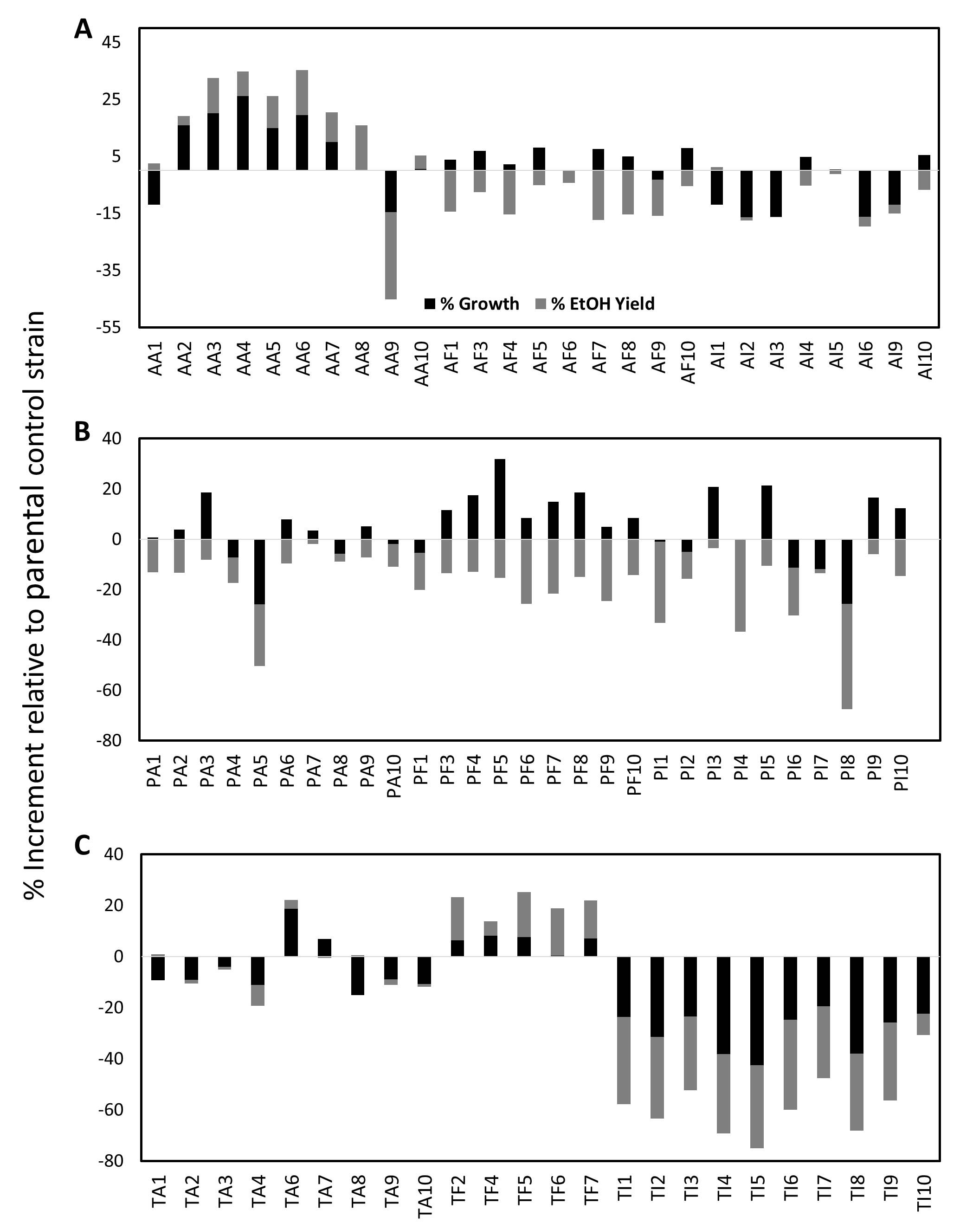
Figure S1: The % increment in growth and ethanol yield relative to parental strain for the 1st round transformants for the (A) ARI1-derivatives, (B) PAD1-derivatives and (C) TAL1-derivatives in fermentations in 2% SC-X supplemented with 65% v/v sugarcane hydrolysate at 120 h.
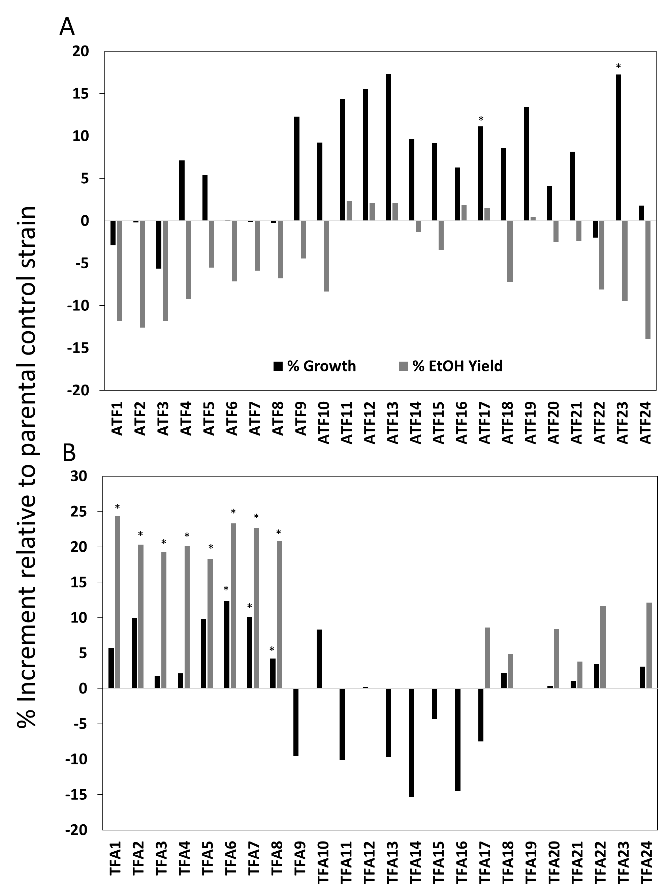

Figure S2: The % increment in growth and ethanol yield relative to parental strain for the 2nd round transformants for the (A) AA6 (ARI1+ADH6) + TF (TAL1 + FDH1) transformants, and (B) TF2 (TAL1 + FDH1) + AA transformants in fermentations in 2% SC-X supplemented with 65% v/v sugarcane hydrolysate at 120 h. The asterisks indicates significant differences at p < 0.05.

