[Site to insert local logo]



Patient Information
Booklet

We would like to invite you to take part in our research study. This booklet explains what the SOLARIO study is all about, why it is being done and what it involves for those patients who participate. Please take time to read this information and discuss it with others if you wish. If there is anything that is not clear, or if you would like more information, please ask us.



What is the purpose of this study?
Using antibiotics wisely, only when and where they are really needed, is important to prevent superbugs emerging. At the moment, bone and joint infections are usually treated by a combination of surgery and antibiotics. Traditionally, we have relied on several weeks of antibiotics as tablets or injections (systemic antibiotics), but these can sometimes cause problems. It is now possible to give antibiotics into the bone or joint at the time of surgery (local antibiotics). This allows much higher levels of the antibiotic to be delivered, for days or weeks, directly to the infection. Therefore, we wish to investigate whether local antibiotics with a shorter course of systemic antibiotics can treat bone and joint infections as effectively as local antibiotics with a prolonged course of systemic antibiotics (usual treatment). If so, we may be able to reduce antibiotic side effects, help to prevent antibiotic resistant germs emerging and reduce overall treatment costs.

What are bone and joint infections?
These infections happen when a germ gets into a bone or a joint and then multiplies. Sometimes this happens with a germ that is carried by the blood stream but it can also occur when a broken bone is fixed with metal work, such as a plate and screws or an internal rod. It may also happen when a joint is replaced with an artificial one, such as a new hip or knee. Germs can also infect bones and joints through open wounds, such as foot ulcers in people with diabetes. Bone and joint infections can be difficult to treat. Many different specialist doctors, nurses and therapists may be needed. Treatment normally involves at least one operation followed by antibiotics.

Why have I been invited to take part in this study?
You have been invited to take part in this study because you have an infection in one of your bones or joints. Your doctors have advised that surgery and antibiotics are needed to treat your infection successfully and local antibiotics in the bone or joint have been recommended for you. You may have already had your operation at the time of reading this booklet, in which case you have local antibiotics in your bone or joint already. We plan to include 500 patients in total. All of the patients in this study will have local antibiotics put in their bone or joint at the time of surgery.

What will happen if I participate?
If you choose to take part in this study, you will be asked to sign a consent form after reading this booklet. After your surgery you will be randomly allocated into one of two groups.

One group of patients will be treated with local antibiotics and a long course of systemic antibiotics which is the usual treatment: this is the ‘long group’. The other group will be treated with local antibiotics and a short course of systemic antibiotics: this is the ‘short group’ whose treatment differs from the current usual treatment. In both groups, local antibiotics will continue working inside your bone or joint for days to weeks. Neither you nor your doctors will be able to choose which group you are in. A computer will decide randomly so you will have an equal chance of being put into either group. Whichever group you are in, you will remain under the care of the medical team that has been treating you.

You will be involved in the study for one year but you will not need to attend any extra clinics or provide any kind of samples specifically for the study. We will collect some of the information we need from your hospital records. You will normally be seen by your medical team at around 6 weeks, between three and six months and one year after your operation. When you come to the clinic for these check-ups, we will ask you a few questions about how you have been getting on since your operation, whether you have needed extra antibiotics for any reason since we last saw you, and if you have needed to go into hospital for any reason. If you cannot attend these clinic appointments, or if they are not when the study needs them to be, we may contact you, or your GP, by phone, e-mail or letter to ask these questions. We will ask you to complete a quality of life questionnaire at baseline and 1 year.
In all respects other than duration of systemic antibiotic treatment, participants in this trial will be treated equally.

Do I have to take part?
No. Participation in this study is entirely voluntary. If you decide not to take part, your medical care will not be affected in any way.

What else do I need to consider?
Taking part in this study will not affect any other medical conditions you may have or any other medication that you are taking. Everyone taking part will have up to 7 days of systemic antibiotics so that there is sufficient time for laboratory tests to be available. If we find that the germ causing your infection is resistant to the local antibiotic in your bone or joint, you will not be able to take part in the study and your doctor will continue your treatment with systemic antibiotics in the usual way. Regardless of which group you are in, if your infection doesn’t go away or if it comes back, your doctor will continue to provide the most appropriate treatment for you.

Are there any possible disadvantages or risks if I take part?
We do not know for sure if patients in one group will do better or worse than patients in the other group; this is what the study will try to find out. On the one hand, until the results of this trial are known, we cannot be certain whether those in the short group will be at a higher risk of treatment failure than those in the long group. On the other hand, patients in the long group are more likely to have side effects than patients in the short group. If you choose not to be in the study, you are likely to be at a similar risk of side effects as the participants in the long group.

Here is a diagram showing the steps of the study:

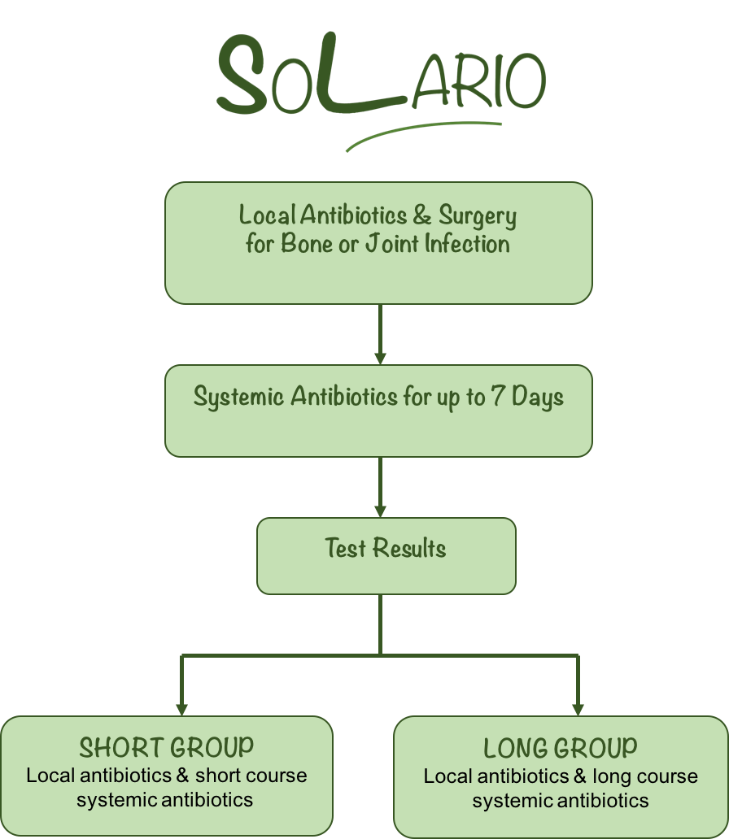

Are there any benefits if I take part?
There are no known benefits of taking part but the study aims to investigate whether or not patients in the short group are able to leave hospital earlier and/or have fewer side effects than the patients in the long group. Some studies suggest that people who are exposed to fewer antibiotics have a lower risk of developing antibiotic-resistant infections in the future.
Will you tell my GP?
Yes. We will send a letter to your GP to tell them that you are involved in this study. We may contact your GP to ask questions about how you have been getting on since your operation if you are not able to attend your clinic appointments.

If I take part, will it be confidential?
Yes. All your information will be encrypted and stored securely on NHS or University computers in accordance with relevant data protection laws.

No one outside of your medical care team, the research team and the regulatory agencies governing the research need to know that you are taking part. Responsible members of the Oxford University Hospitals NHS Foundation Trust may be given access to data for monitoring and/or audit of the study to ensure that the research is complying with applicable regulations. The information that we collect and store will be anonymised. Your data will be identified by a unique study number, your NHS number and your date of birth, instead of your name. Personal data, such as your contact details, will be stored in a study file in accordance with the General Data Protection Regulation.

What will happen to my data?
We will be using information from you and your medical records in order to undertake this study. Research is a task that we perform in the public interest. Oxford University Hospitals NHS Foundation Trust, as sponsor, is the data controller. This means that we, as Oxford University Hospitals NHS Foundation Trust researchers, are responsible for looking after your information and using it properly. We will use the minimum personally-identifiable information possible. We will keep identifiable information about you for at least 3 years after the study has finished. We will store the anonymised research data and any research documents with personal information, such as consent forms, securely at the Oxford University Hospitals NHS Foundation Trust for 10 years after the end of the study as part of the research record.
The [local NHS Trust or local study team (site to complete)] will use your name, NHS number, home address, and contact details to contact you about the research study to make sure that relevant information about the study is recorded and to oversee the quality of the study. They will keep identifiable information about you from this study for 6 months after the study has finished unless you give specific consent for us to contact you about other related studies in the future. Research documents such as consent forms will be archived securely at [site to complete] for 10 years from the end of the study.
Anonymised research data will be shared with others outside the EU. These countries might not offer the same level of protection of privacy as that demanded by law in the UK. These data will not include any personal identifiable information other than your study number.

Your rights to access, change, or move your personal information may be limited, as we need to manage your information in specific ways in order for the research to be reliable and accurate. Further information about your rights with respect to your personal data is available at https://www.ouh.nhs.uk/privacy/default.aspx

You can find out more about how we use your information by contacting the Chief Investigator, Dr Matthew Scarborough on 07872436461.

Are there any expenses or payments?
There are no payments for taking part in this study. You will not need any extra trips to hospital that would incur expenses from being involved.

What happens if I change my mind and I don't want to carry on?
If you change your mind during the study, you can withdraw at any time without having to give a reason. We will use the information we have collected up until that point unless you tell us not to. After you withdraw, you and your doctors will decide how best to continue with your treatment independently of the study. If, for any reason, you are unable to express your opinion during the trial, we will not seek to collect further trial-specific information from you.

What will happen to the results of this study?
The results of this study will be published in medical journals and presented at scientific meetings. Patients who participate will not be identified in any of the publications or presentations.

What if there is a problem?
Oxford University Hospitals NHS Foundation Trust will provide indemnity for this study in the UK. If you are harmed due to someone’s negligence, then you may have grounds for legal action but you may have to pay for it. NHS bodies are legally liable for the negligent acts and omissions of their employees. If you are harmed whilst taking part in a clinical trial as a result of negligence on the part of a member of the study team this liability cover would apply. Non-negligent harm is not covered by the NHS indemnity scheme. The Oxford University Hospitals NHS Foundation Trust, therefore, cannot agree in advance to pay compensation in these circumstances. In exceptional circumstances an ex-gratia payment may be offered.
If you wish to complain about any aspect of the way in which you have been approached or treated during the course of this study, you should contact the Principal Investigator [Site to add local contact details]. Anyone who has cause for concern regarding the care they receive as an NHS patient can also contact the Patient Advisory Liaison Service (PALS) [Site to add local contact details]. PALS is a confidential NHS service that provides support for complaints and queries; it cannot provide specific information about this research study.

Who is organising and funding this study?
This study is sponsored by Oxford University Hospitals NHS Foundation Trust and is funded by the European Bone and Joint Infection Society. It is being organised by the Oxford Bone Infection Unit.

Who has reviewed this study?
This study has been reviewed and approved by the South Central – Oxford C Research Ethics Committee and the Health Research Authority. Hospital consultants and doctors and patient representatives have helped to design this study. Here are some links to general information about taking part in research that you may find helpful:
www.ukctg.nihr.ac.uk/clinical-trials/why-take-part-in-a-clinical-trial
www.nhs.uk/Conditions/Clinical-trials/Pages/Introduction.aspx

Do I need to participate in future research?
No. If you consent to further contact regarding related studies in the future, your hospital’s trial team will store your contact details separately on a secure, password-protected computer. Agreeing to be contacted does not mean that you will be obliged to take part in future research.

If you would like further information, please contact either your local research nurse or the trial clinician:

Local Research Nurse  [Site to insert  local contact details] | Trial Clinician  Dr Maria Dudareva  Oxford Bone Infection Unit  Nuffield Orthopaedic Centre  Windmill Road, Oxford, OX3 7LD  maria.dudareva@ouh.nhs.uk



