Supplementary material
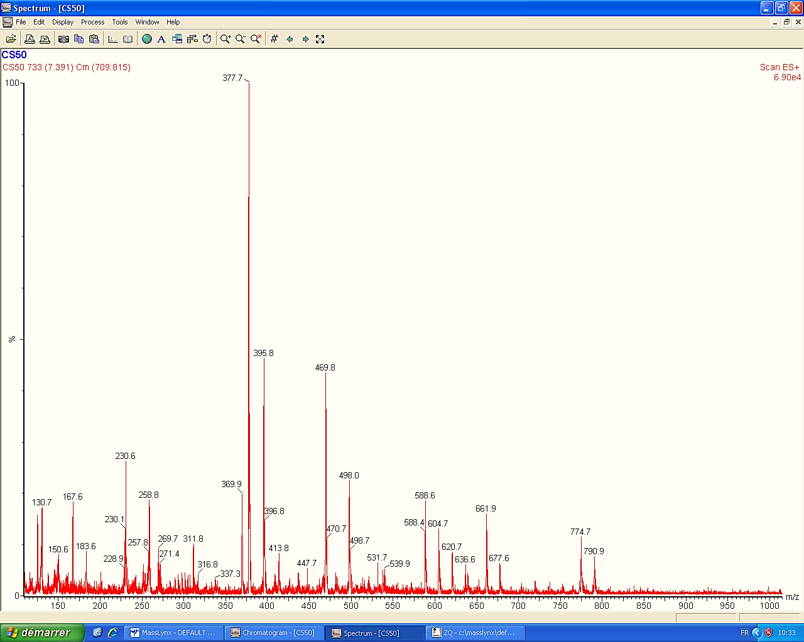
ESI-MS (+) mode spectrum of Ergosterol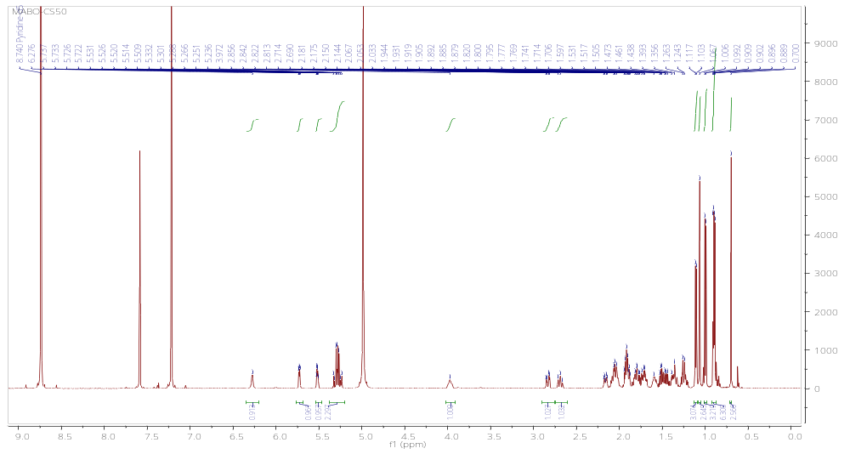
¹H-NMR spectrum of Ergosterol
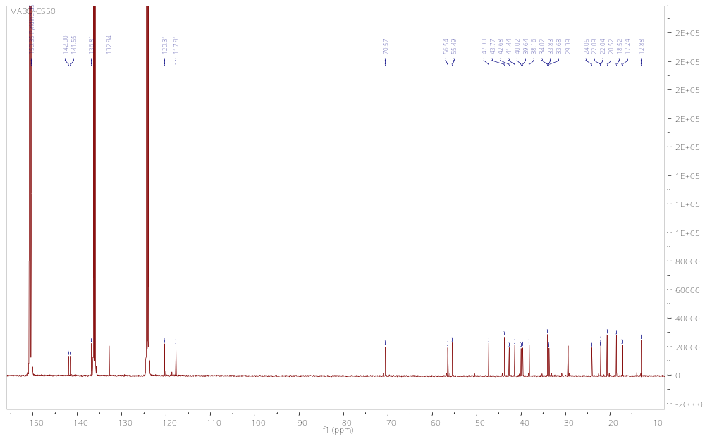
¹³C-NMR spectrum of Ergosterol
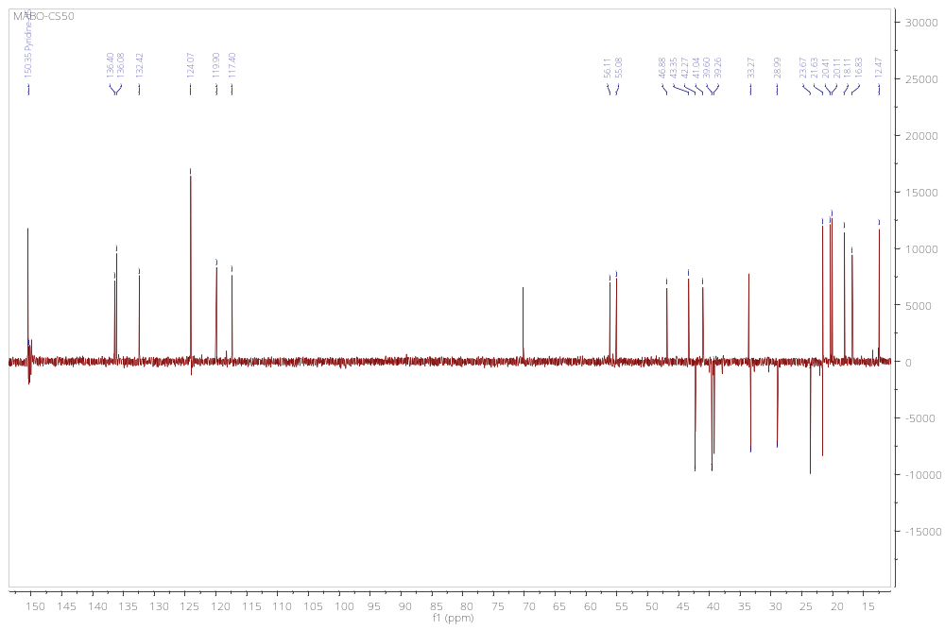
DEPT 135 NMR spectrum of Ergosterol
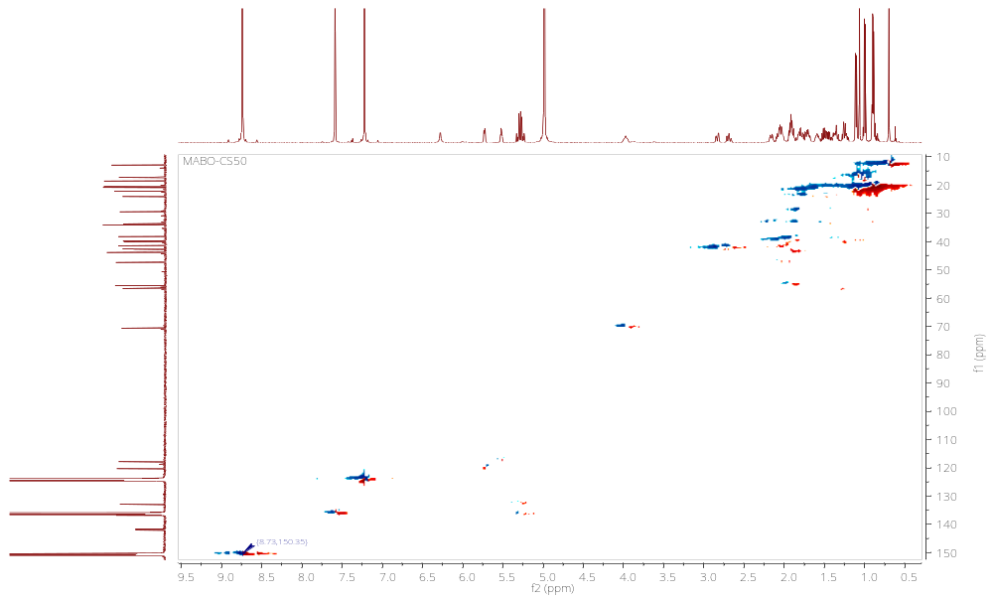
HSQC spectrum of Ergosterol

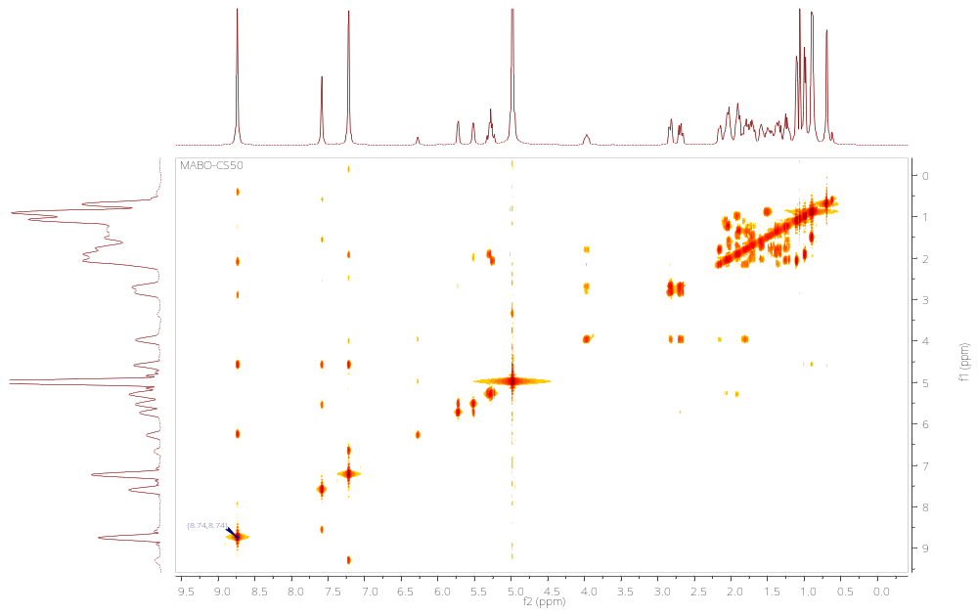COSY spectrum of Ergosterol

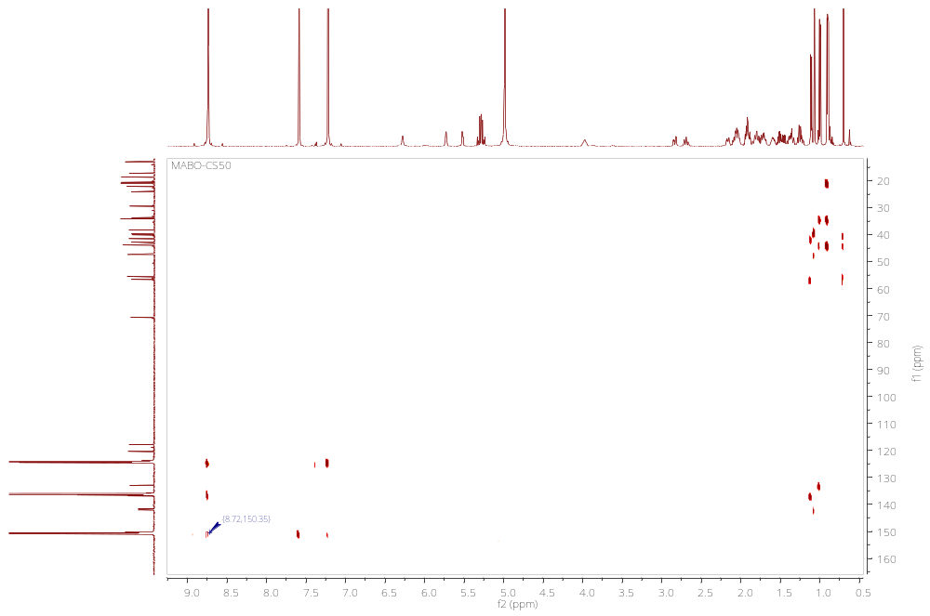
HMBC spectrum of Ergosterol
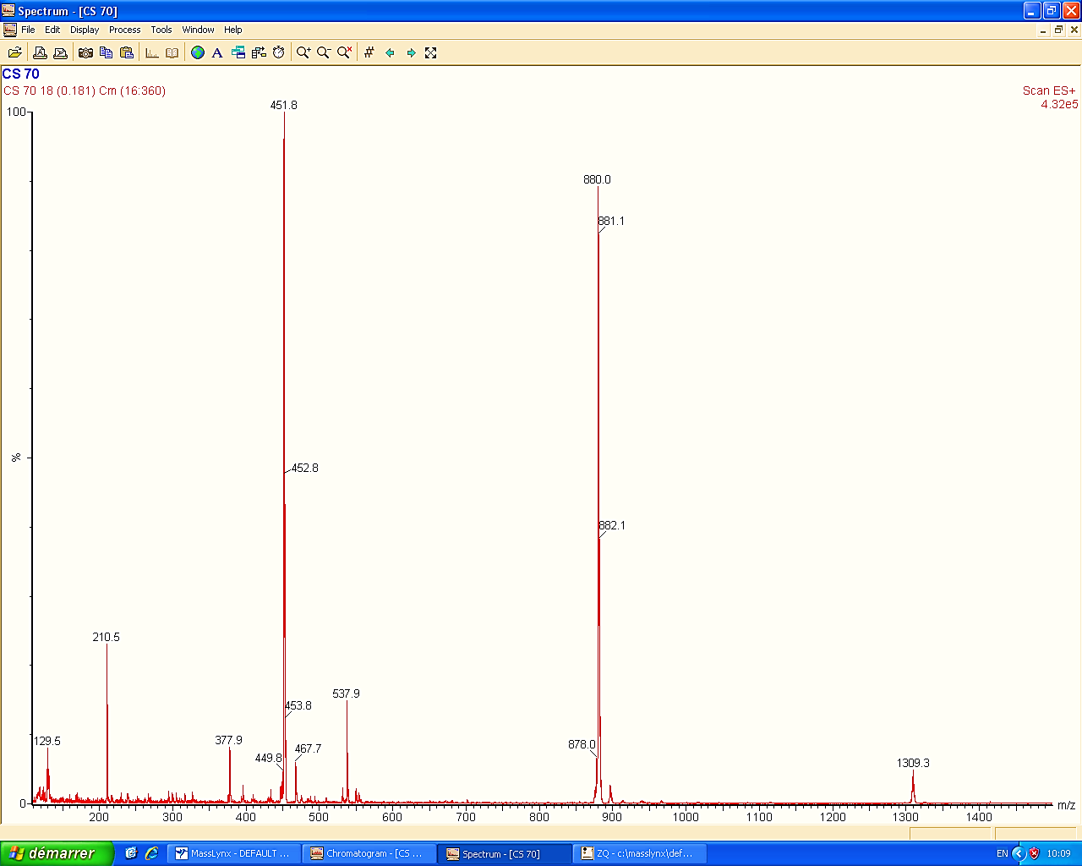
ESI-MS (+) mode spectrum of Ergosterol endoperoxide also known as ergosterol peroxide
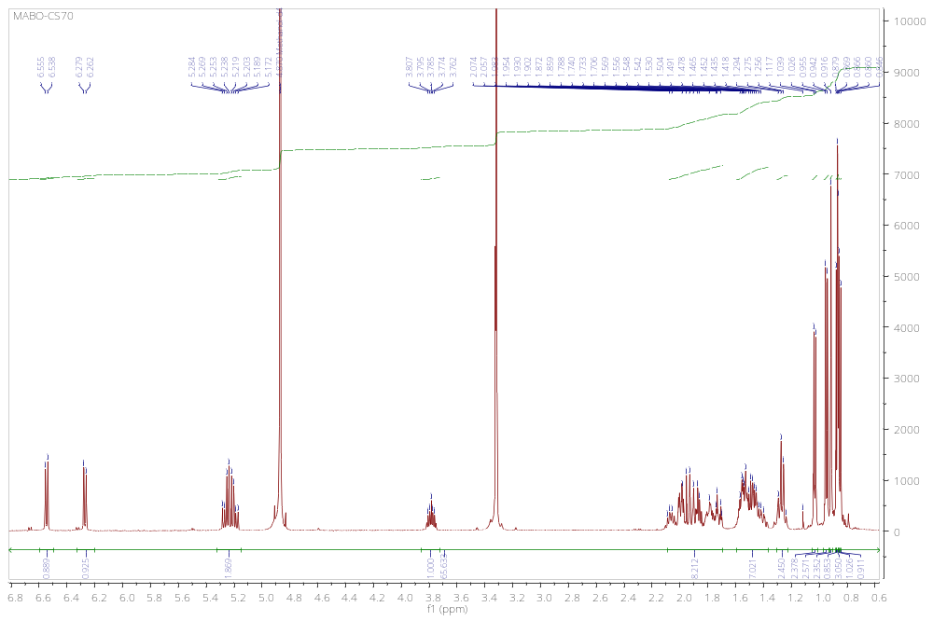
¹H-NMR of Ergosterol endoperoxide
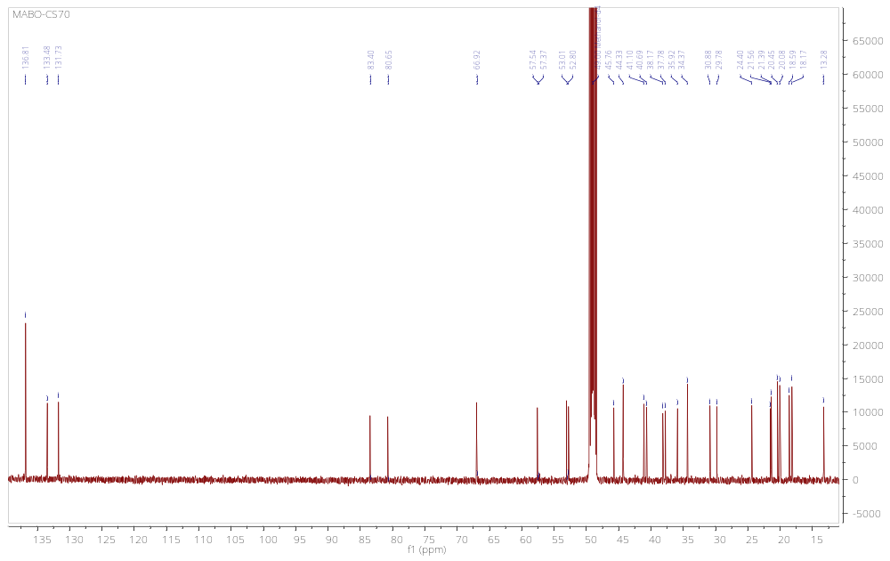¹³C-NMR of Ergosterol endoperoxide
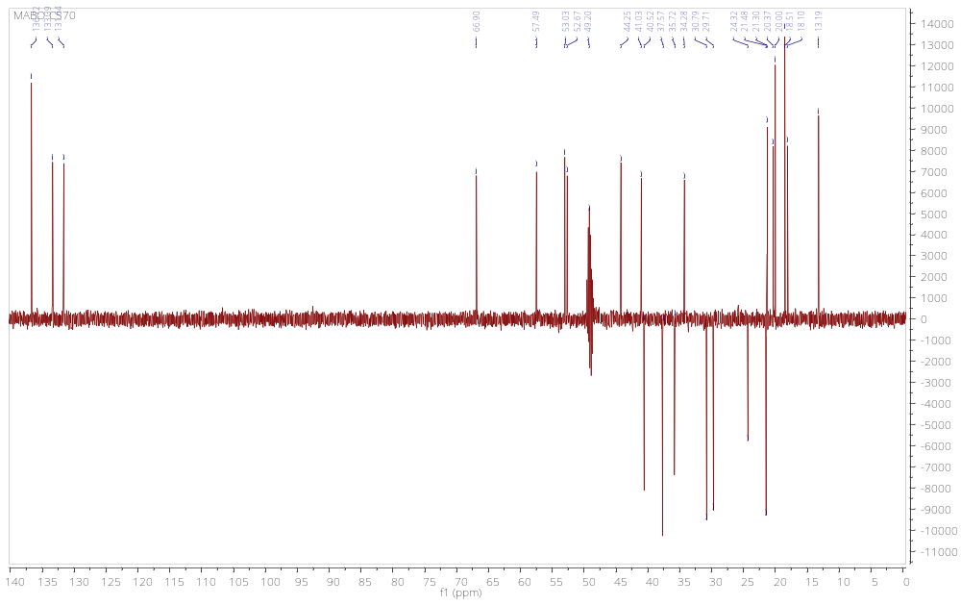
DEPT 135 spectrum of Ergosterol endoperoxide
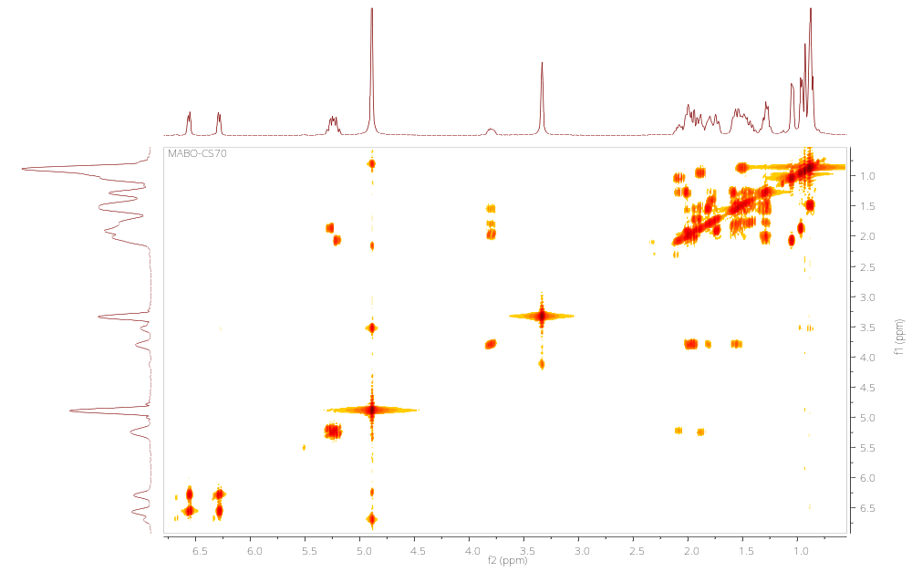
COSY spectrum of Ergosterol endoperoxide

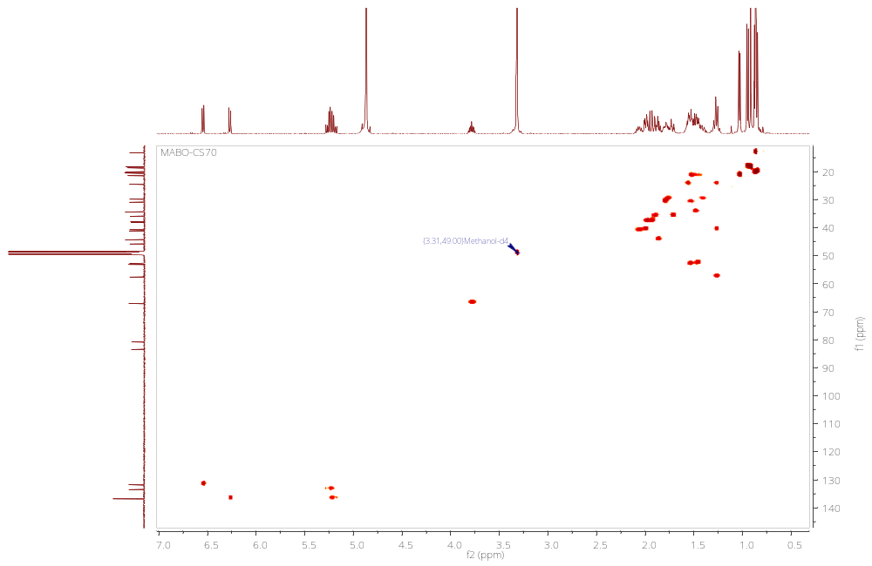
HSQC spectrum of Ergosterol endoperoxide
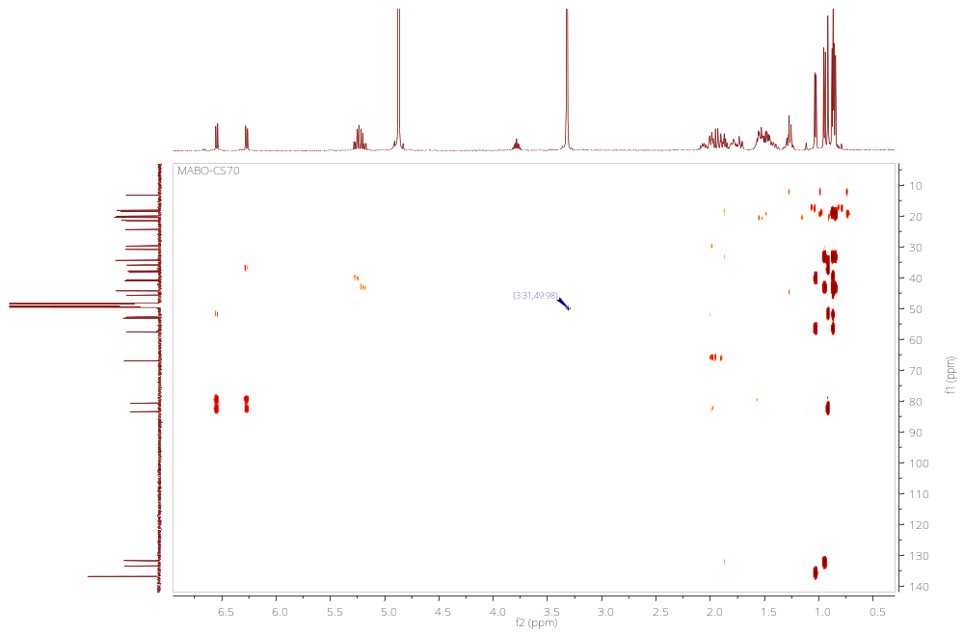
HMBC spectrum of Ergosterol endoperoxide
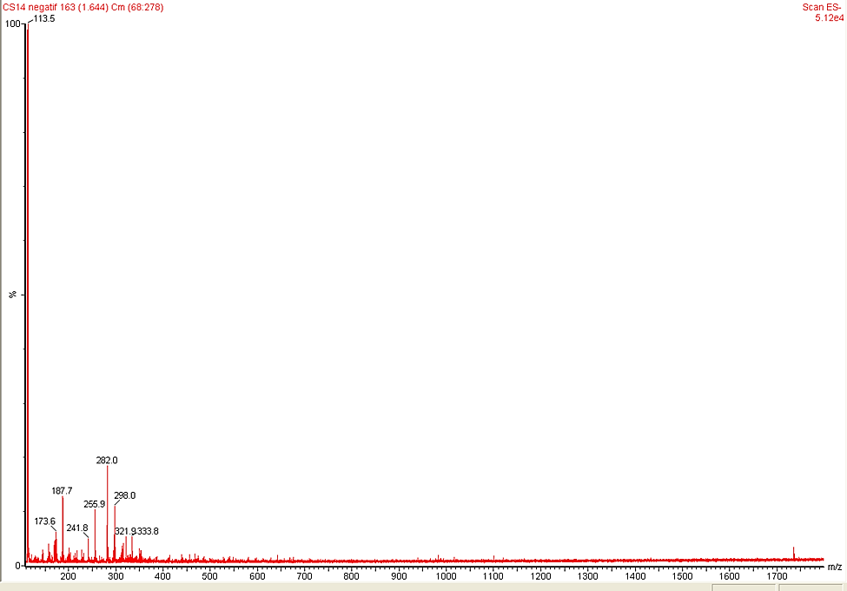 ESI-MS (-) mode spectrum of Petroselinic acid
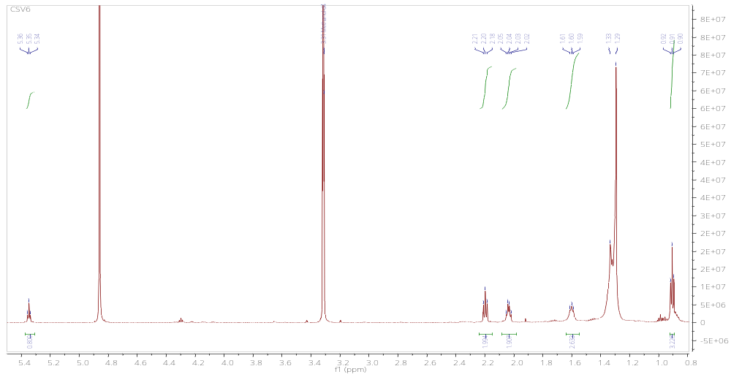
¹H-NMR spectrum of Petroselinic acid
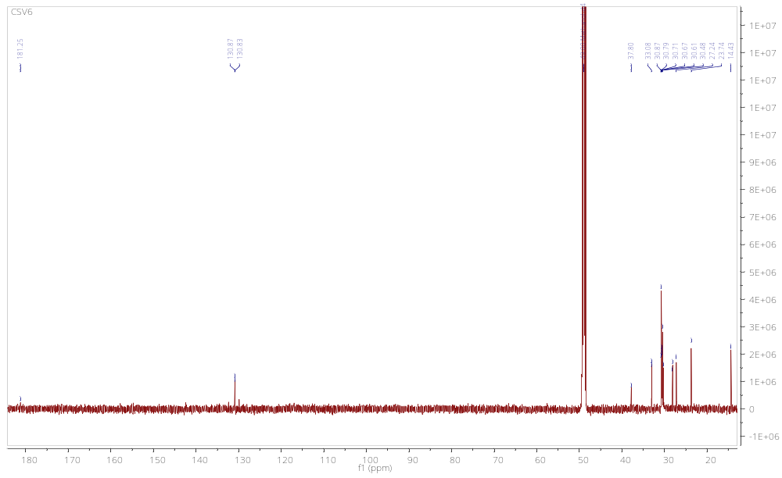
¹³C-NMR spectrum of Petroselinic acid:
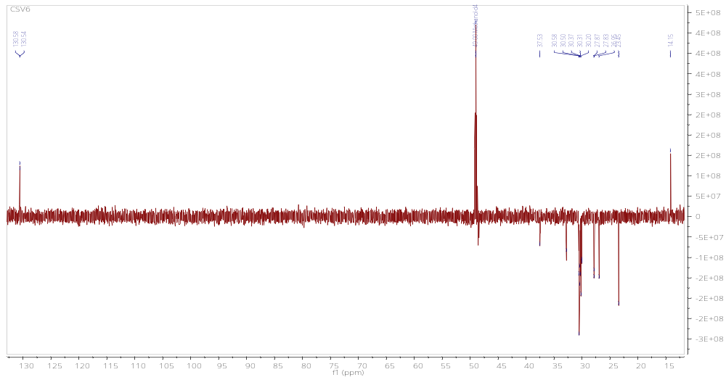
HSQC spectrum of Petroselinic acid

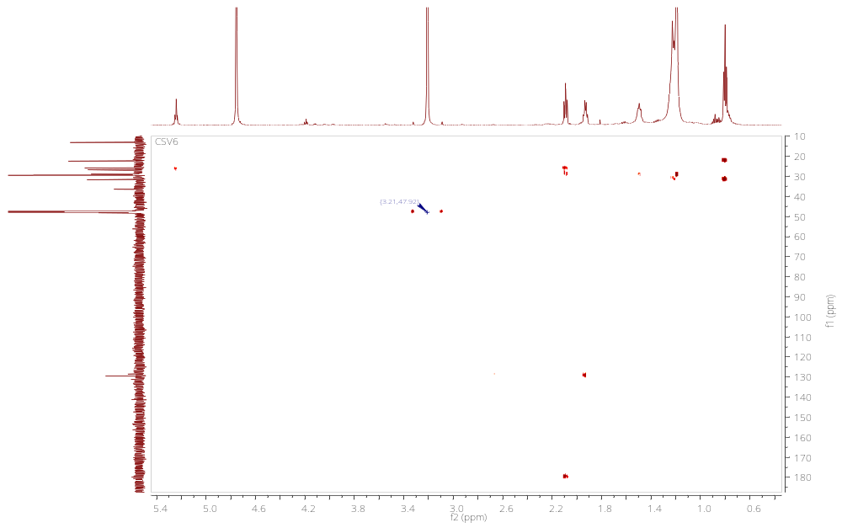
HMBC spectrum of Petroselinic acid

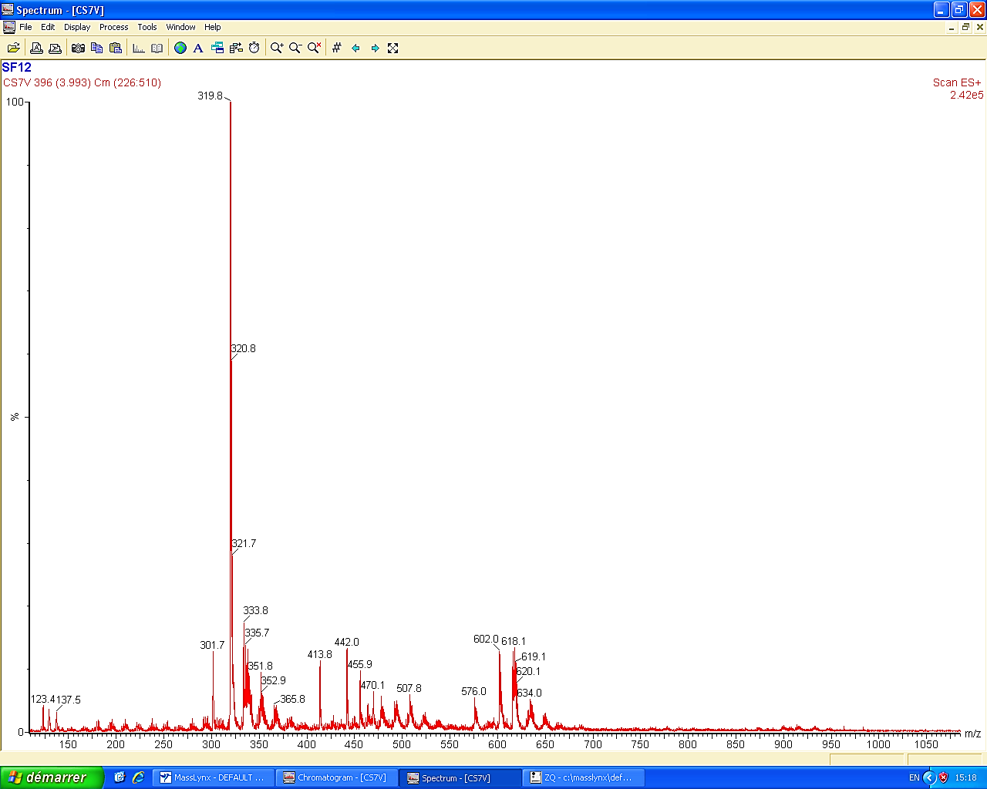
ESI-MS (+) mode spectrum of Elaidic acid
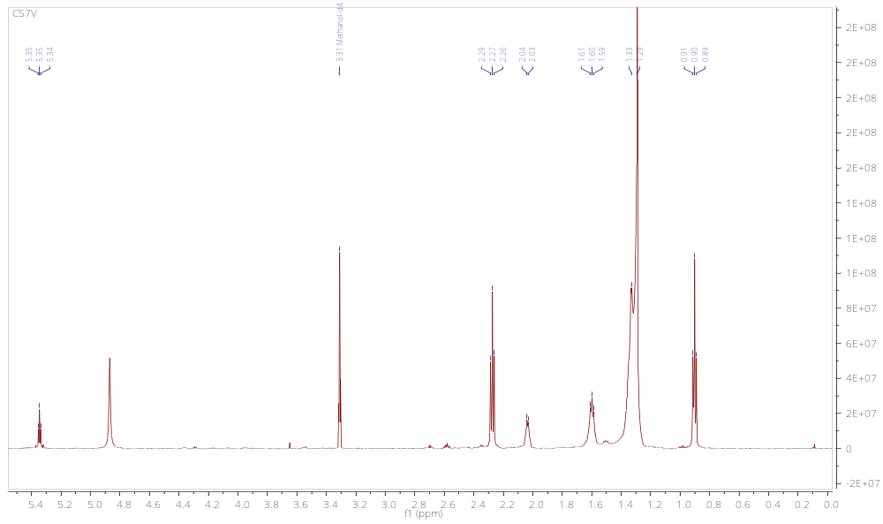
¹H-NMR spectrum of Elaidic acid
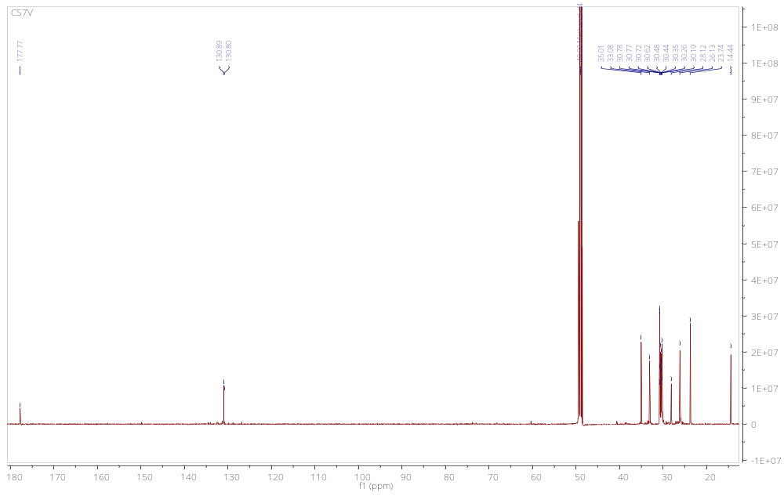
¹³C-NMR spectrum of Elaidic acid

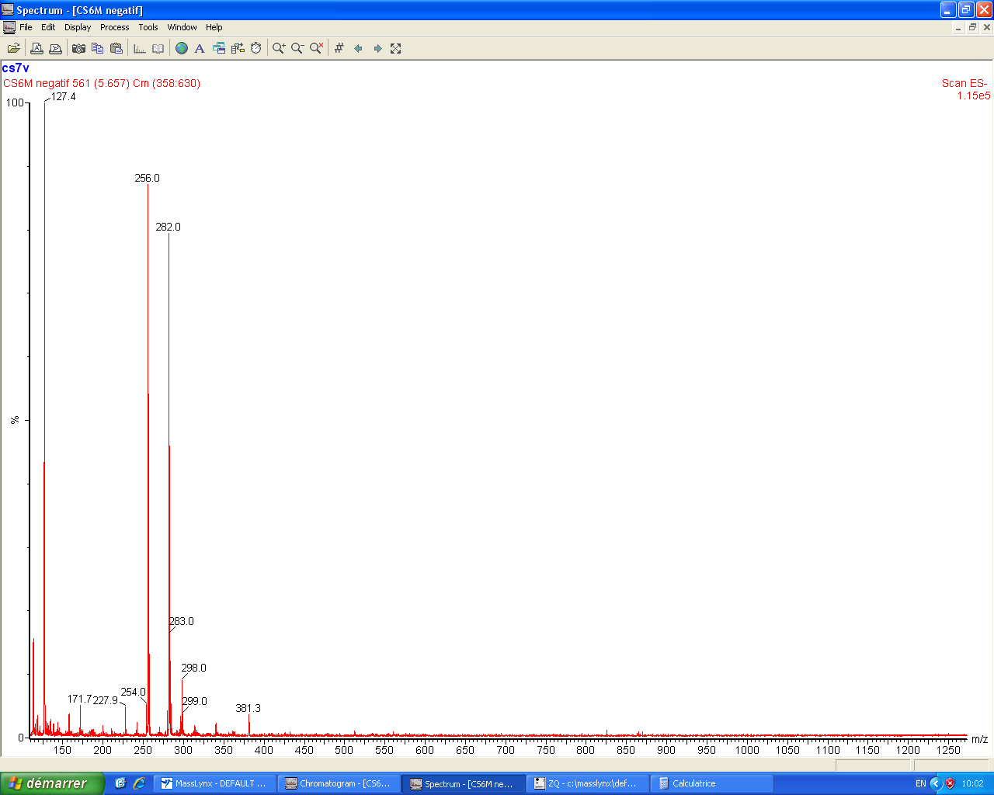
ESI-MS (-) mode spectrum of Oleic acid
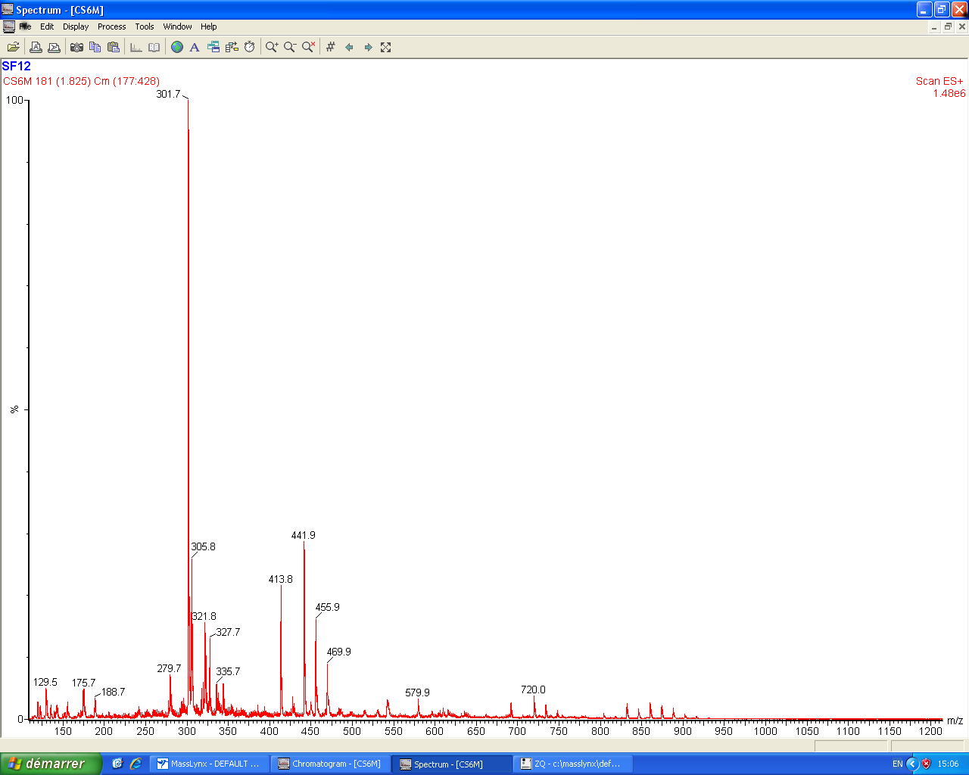
ESI-MS (+) mode spectrum of Oleic acid
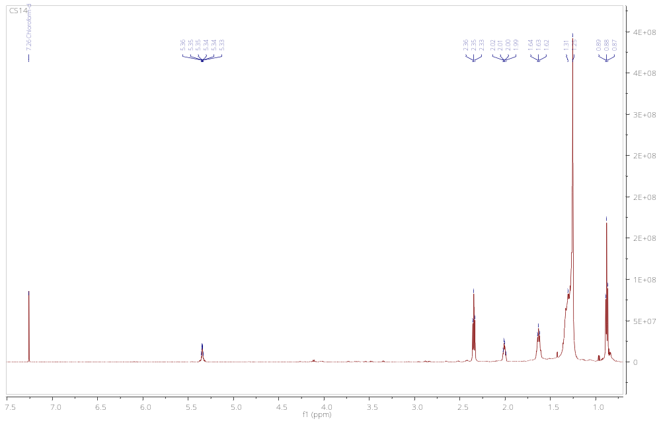
¹H-NMR spectrum of Oleic acid

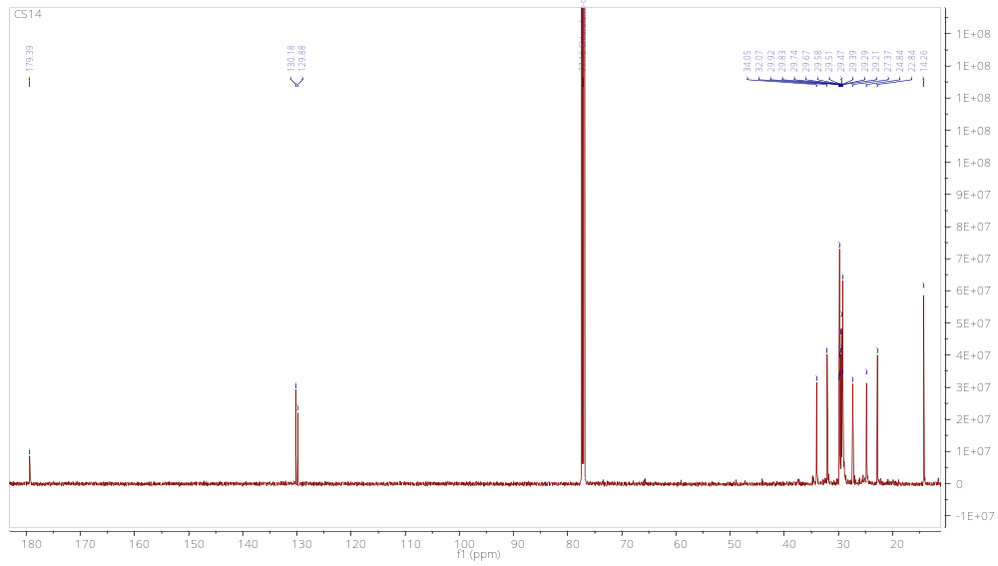 ¹³C-NMR spectrum of Oleic acid
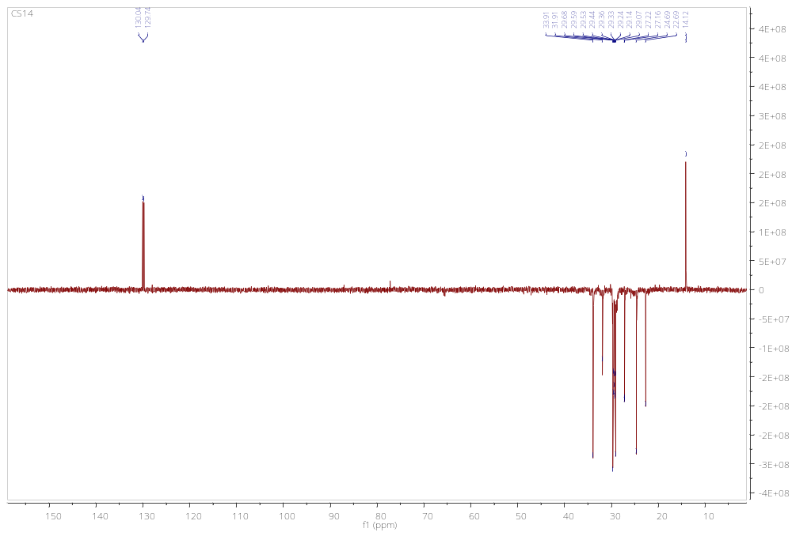
DEPT 135 spectrum of Oleic acid:
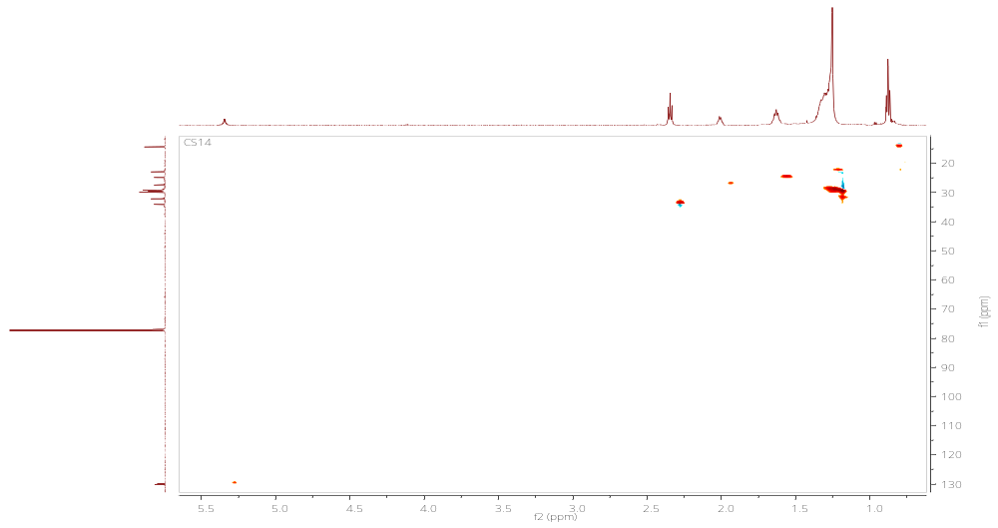
HSQC spectrum of Oleic acid:
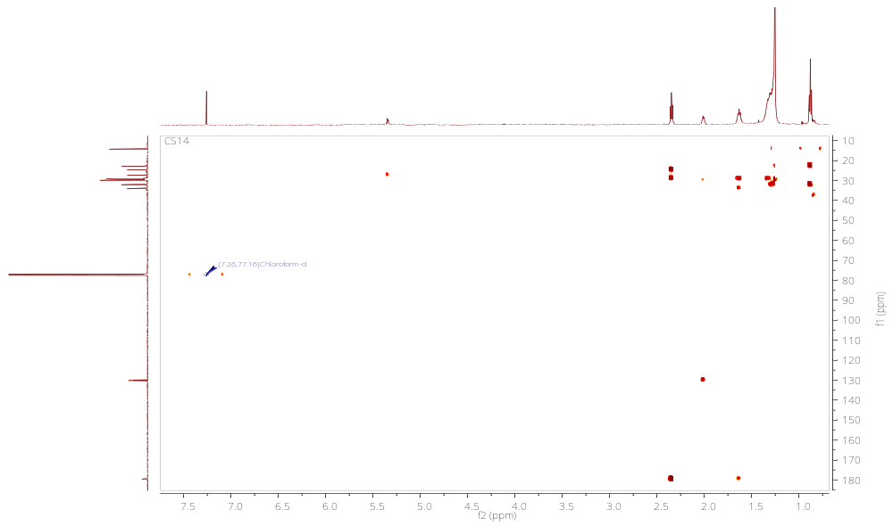
HMBC spectrum of Oleic acid
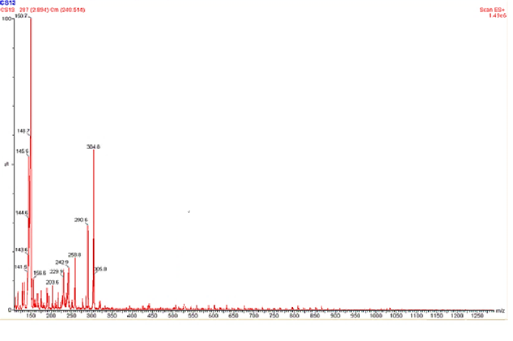
ESI-MS (+) mode spectrum of Adenosine
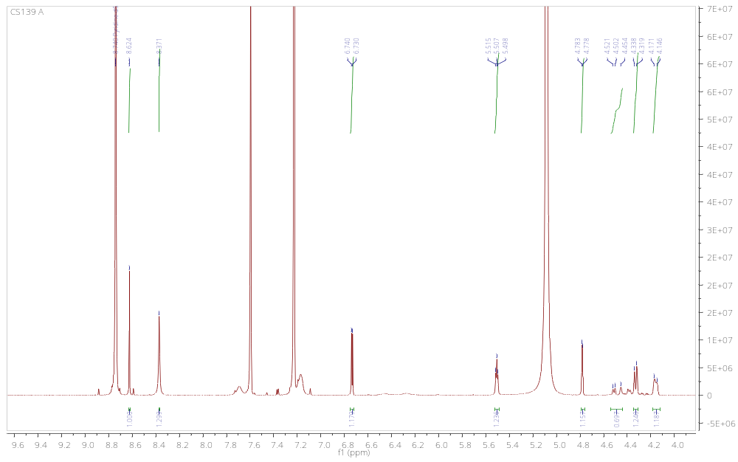
¹H-NMR spectrum of Adenosine
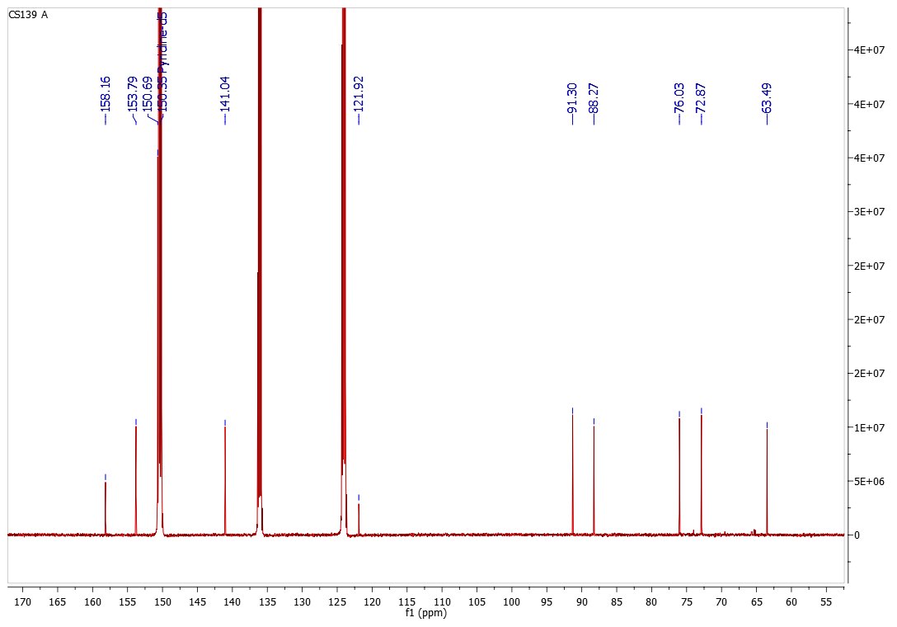
¹³C-NMR spectrum of Adenosine
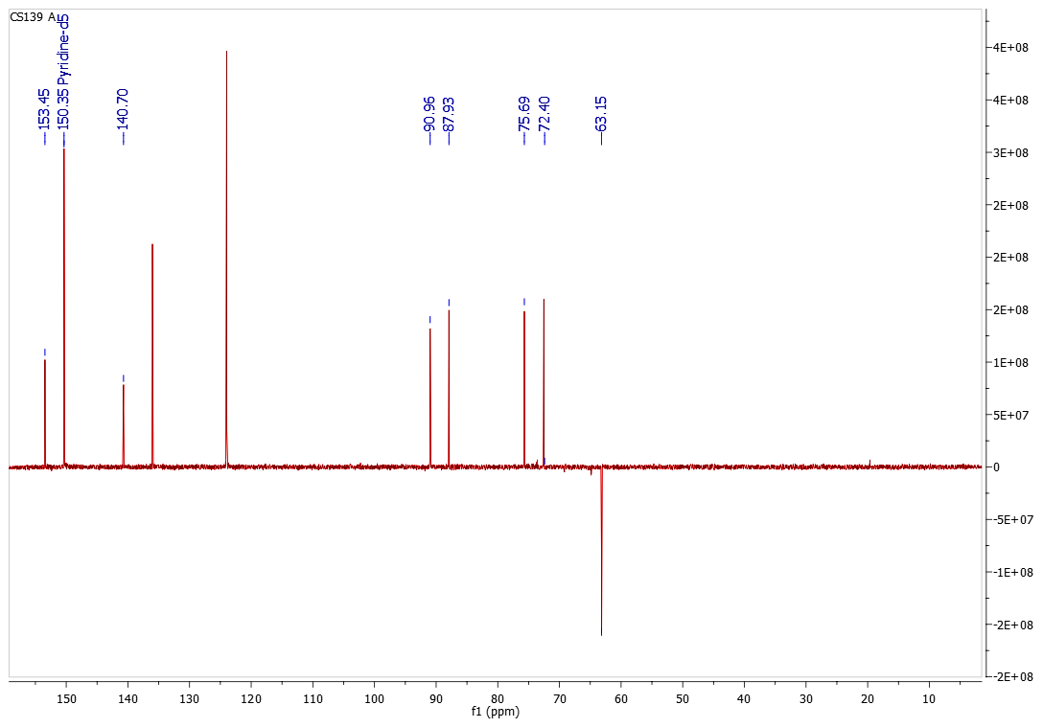
DEPT 135 spectrum of adenosine
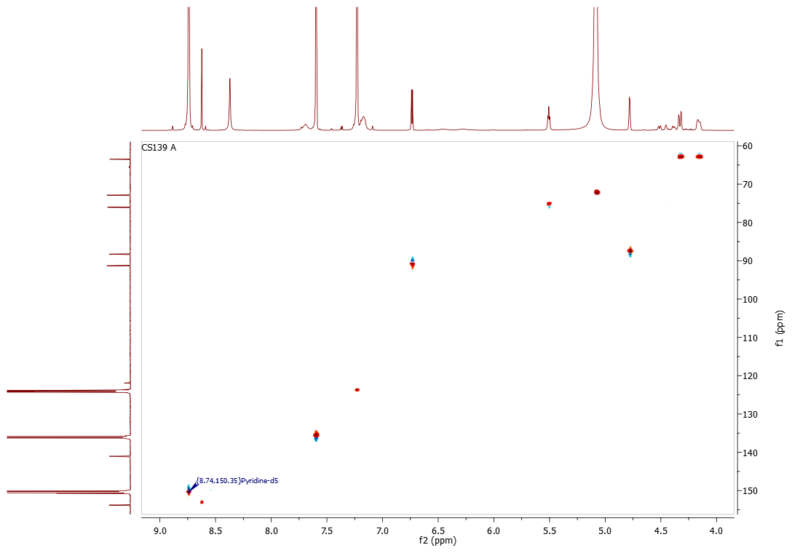
HSQC spectrum of adenosine
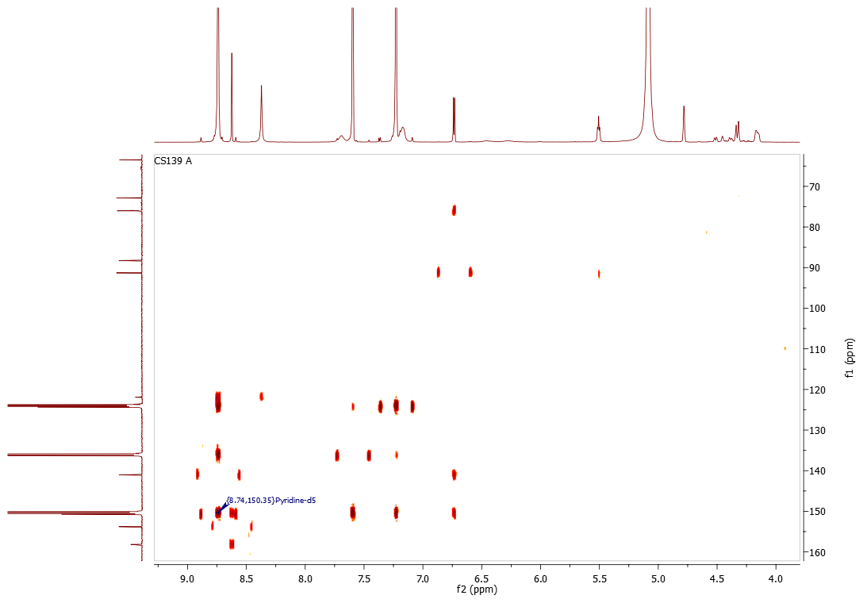
HMBC spectrum of adenosine
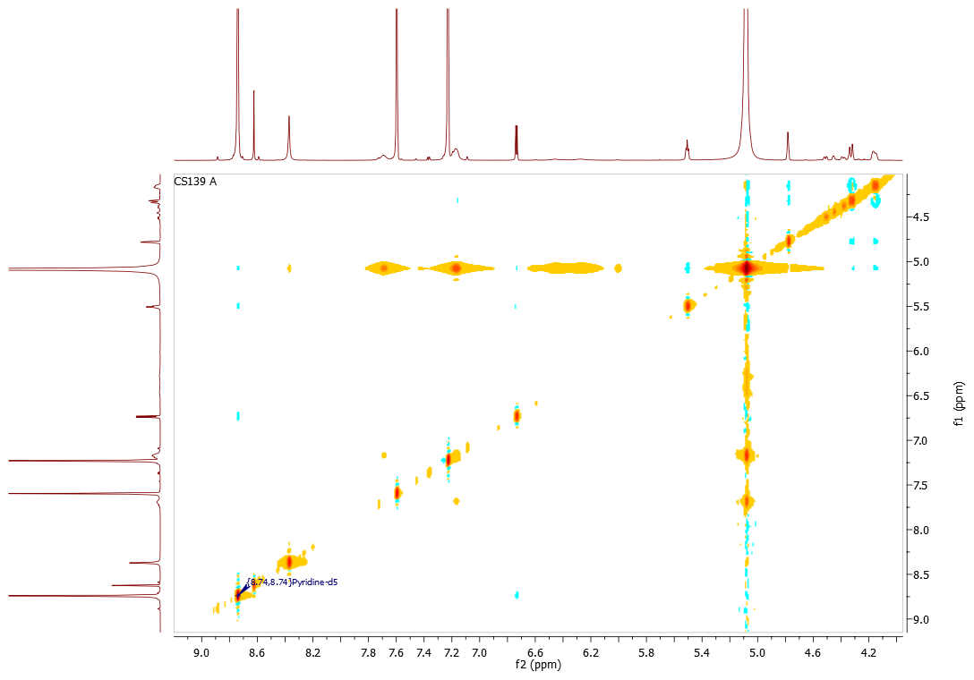
NOESY spectrum of adenosine

