Supplementary Appendix

Table S1. Association Between 1-year Overall Survival Rate and mPAP in Univariable Analysis

Variables | 1-yr overall survival
Variables | % | (95% CI) | p-value
All patients | 71.17 | (57.39 - 81.19)
mPAP
<20 mmHg | 88.69 | (67.56 - 96.39) | 0.003
≥20 mmHg | 55.23 | (36.13 - 70.74)
mPAP
<25 mmHg | 81.96 | (65.27 - 91.14) | 0.003
≥25 mmHg | 47.65 | (24.09 - 67.97)
mPAP
<30 mmHg | 69.84 | (55.63 - 80.28) | 0.340
≥30 mmHg | 100.00 | NR
P-value corresponds to Log-rank test.
* Significant at p-value < 0.05

Table S2. Correlation Between Post-treatment Mean Pulmonary Arterial Pressure (mPAP) and Cancer Dyspnea Score (CDS)

Variables | r | 95%CI | p-value
mPAP vs CDS | 0.218 | (-0.141 - 0.527) | 0.230
Abbreviations: r, Pearson correlation coefficient; CI, confident interval; CDS, Cancer Dyspnea Score; PASP, Pulmonary arterial systolic pressure.
* Significant at p-value < 0.05

r = 0.218 (95% Cl: -0.141 to 0.527, P = 0.230)

Table S3. Correlations Between Pre- and Post-treatment Echocardiographic Parameters and Cancer Dyspnea Score

Outcome | Pretreatment | Posttreatment | Mean difference  (95%CI) |  | t | df | p-value
Echocardiographic Parameters
LVEF (%) | 61.98 ± 11.31 | 61.32 ± 8.72 | -0.67 | (-3.61, 2.28) | -0.461 | 31 | 0.648
PASP/RVSP (mmHg) | 31.00 ± 8.90 | 28.34 ± 6.82 | -2.66 | (-5.33, 0.02) | -2.022 | 31 | 0.052
mPAP (mmHg) | 20.96 ± 5.46 | 19.31 ± 4.16 | -1.65 | (-3.29, -0.01) | -2.048 | 31 | 0.049
TRVmax (cm/s) | 248.77 ± 74.46 | 231.43 ± 80.36 | -17.34 | (-49.88, 15.2) | -1.090 | 29 | 0.285
RAP (mmHg) | 4.56 ± 2.35 | 4.25 ± 2.20 | -0.31 | (-1.43, 0.80) | -0.571 | 31 | 0.572
Cancer Dyspnea Score (n = 45) | 12.28 ± 9.06 | 6.72 ± 2.37 | -5.56 | (-7.86, -3.26) | -4.872 | 42 | <0.001
Abbreviations: PASP, pulmonary arterial systolic pressure; LVEF, left ventricular ejection fraction; mPAP, mean pulmonary arterial pressure
p-value corresponds to paired samples t-test or Wilcoxon signed-rank test.
* Significant at p-value < 0.05

Table S4. Correlations Between Changes in Mean Pulmonary Arterial Pressure and Treatment Response and Improvement in Cancer Dyspnea Score

Variables | All patients  (n = 32) |  | Change of mPAP |  |  |  | p-value
Variables |  |  | <2 mmHg  (n = 18) |  | ≥2 mmHg  (n = 14) |  | p-value
Treatment responses
Partial response (PR) | 23 | (71.9) | 12 | (66.7) | 11 | (78.6) | 0.315
Stable disease (SD) | 8 | (25) | 6 | (33.3) | 2 | (14.3)
Progressive disease (PD) | 1 | (3.1) | 0 | (0.0) | 1 | (7.1)
Changes in Cancer Dyspnea Score
<5 | 20 | (62.5) | 13 | (72.2) | 7 | (50.0) | 0.277
≥5 | 12 | (37.5) | 5 | (27.8) | 7 | (50.0)
Data are presented as number (%).
P-value corresponds to Fisher’s exact test.

Figure S1. Kaplan-Meier Curve of 1-year Overall Survival Among Participants
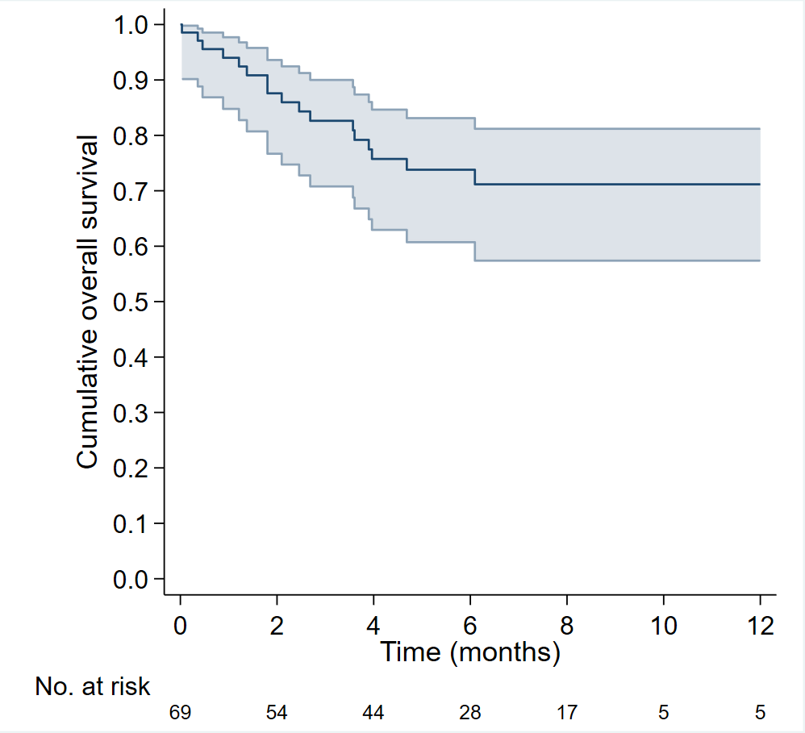

Figure S2. Kaplan-Meier Curve for Overall Survival Differences Between Patients with Pre-treatment mPAP Above and Below 20 mmHg.

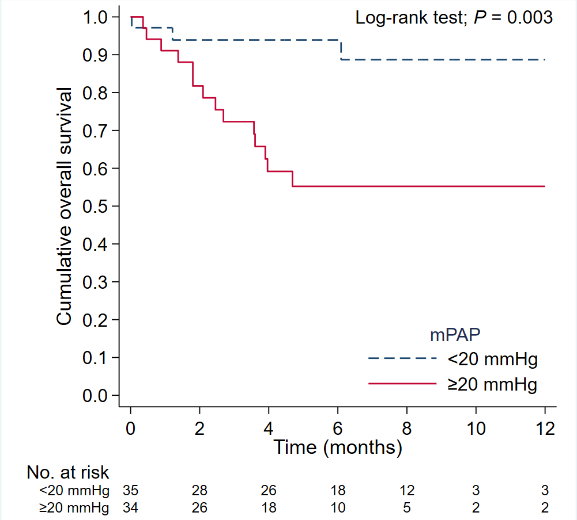

Figure S3. Kaplan-Meier Curve for Overall Survival Differences Between Patients with Pre-treatment mPAP Above and Below 25 mmHg.

