SUPPLEMENTARY INFORMATION
Medaka liver developed Human NAFLD-NASH transcriptional signatures in response to ancestral bisphenol A exposure
Sourav Chakraborty, Santosh Anand, Ramji Kumar Bhandari*
Division of Biological Sciences, University of Missouri, Columbia, MO 65211, U.S.A.

*Corresponding Author: Ramji K. Bhandari (Email: bhandarir@missouri.edu). ORCiD: 0000-0001-5608-7254

Figure S1. Volcano plot exhibited distribution of differentially expressed genes in (A) male and (B) female liver of BPA lineage.
A
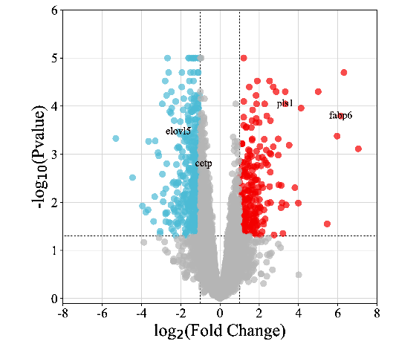
B
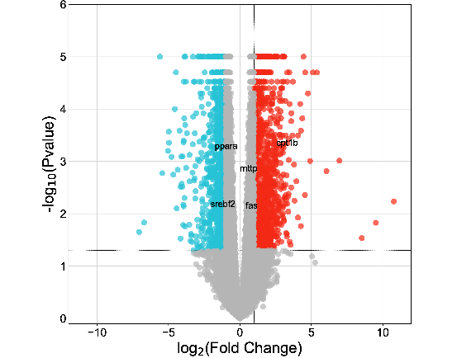

Figure S2. Transcription factors network in the liver of (A) male and (B) female in BPA lineage

B
A
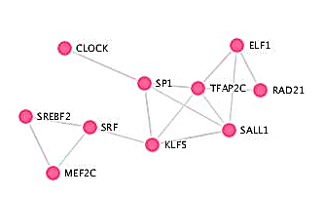
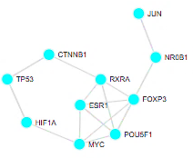

Figure S3: ESR mediated downstream gene activation.
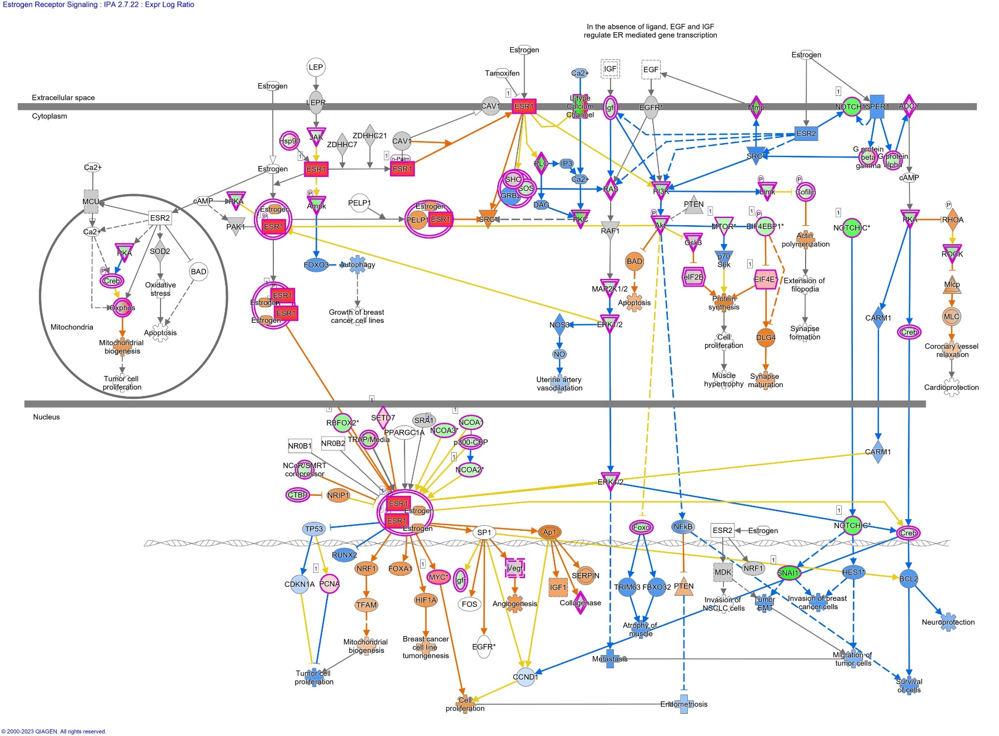

Figure S4: pathway enrichment by cell cycle genes

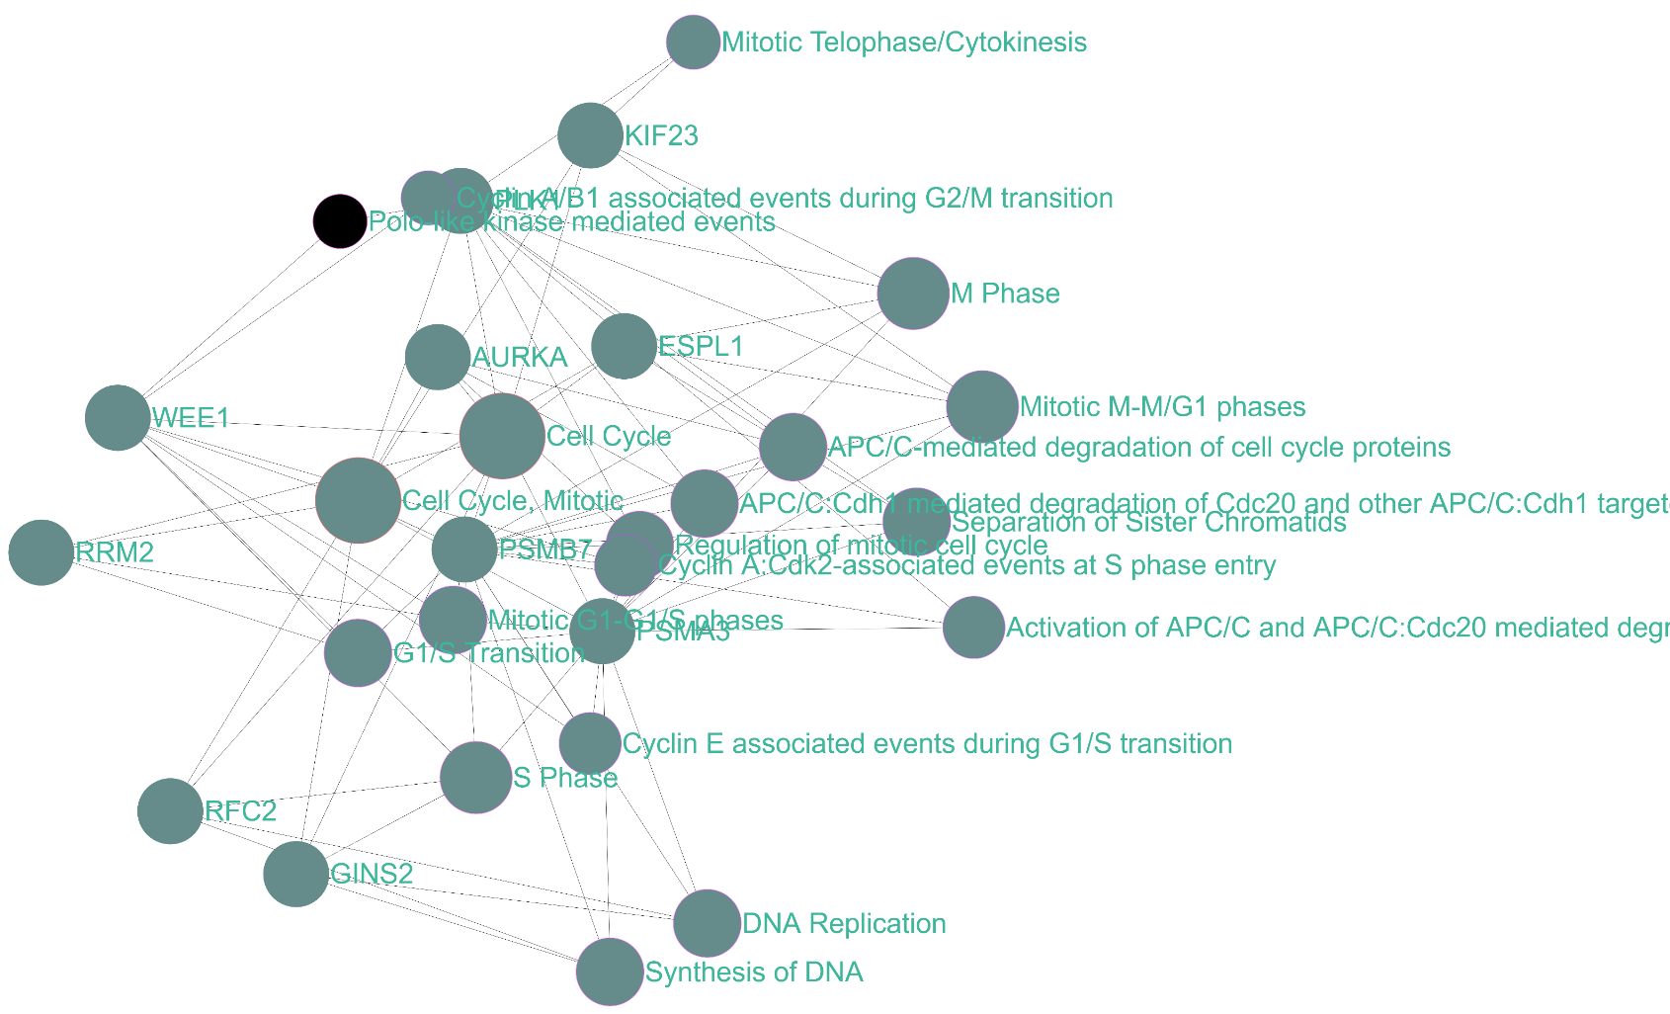
A

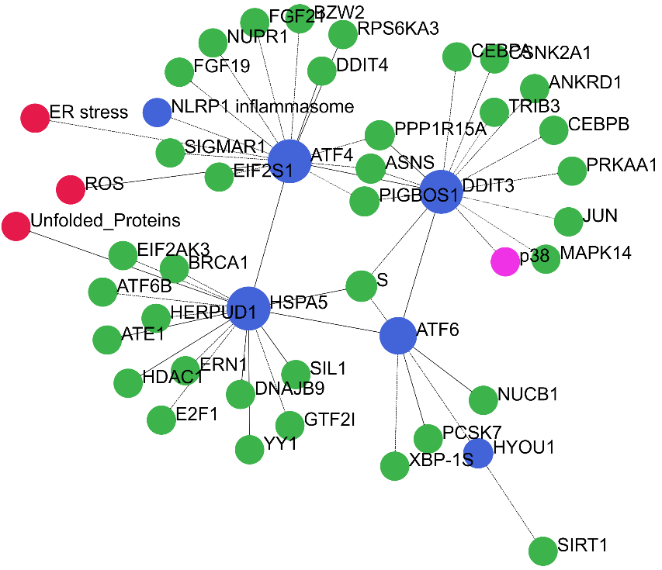
B.

Figure S5. Aberrant regulation of genes linked to electron transport chain in mitochondria

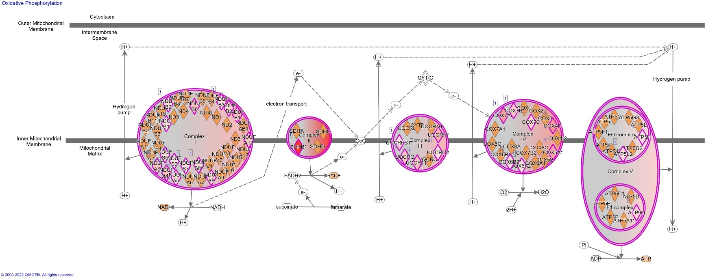
A

Figure S6. Genes linked to protein complex in mitochondrial membrane determined by KEGG
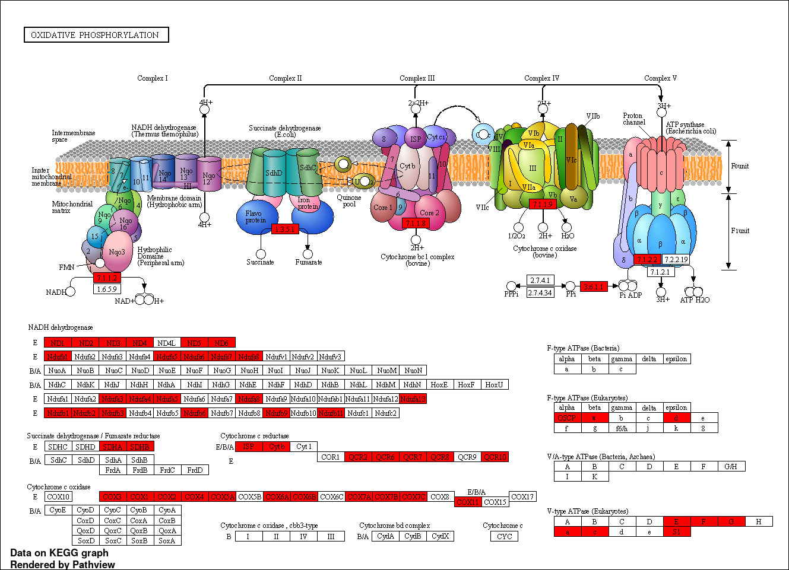

Figure S7. KEGG pathway analysis in male and female
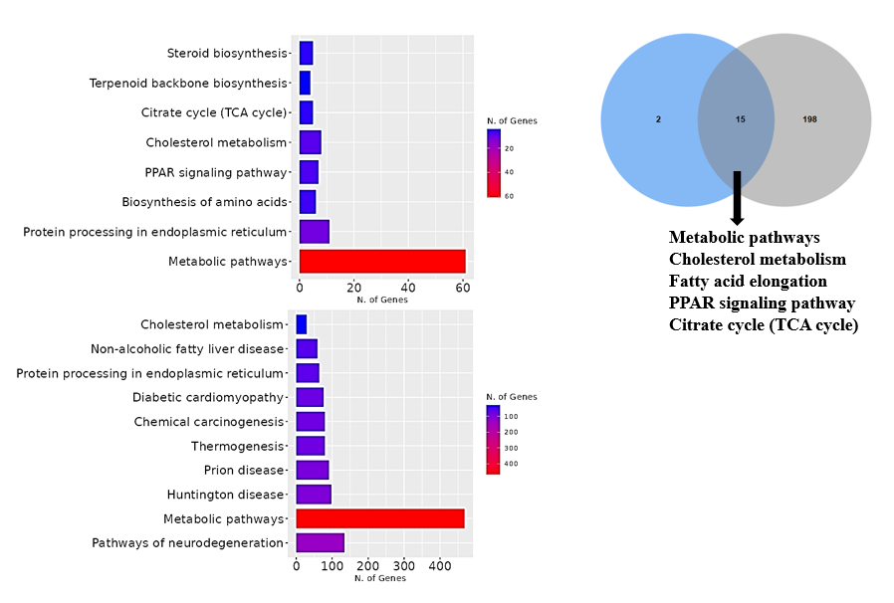
C
B
A

Figure S8: Up and down regulated genes mediated pathways in liver of BPA lineage female

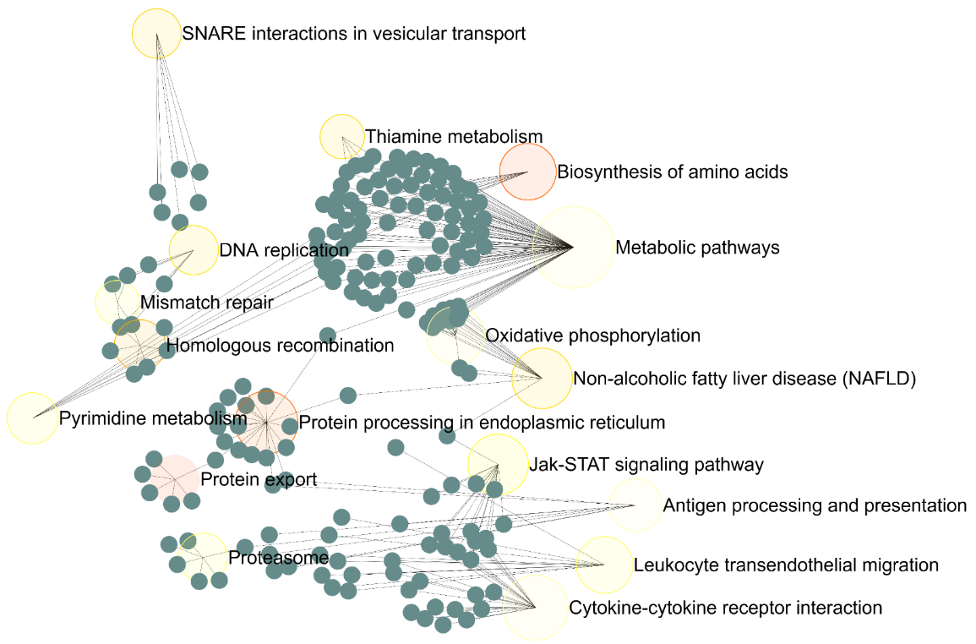

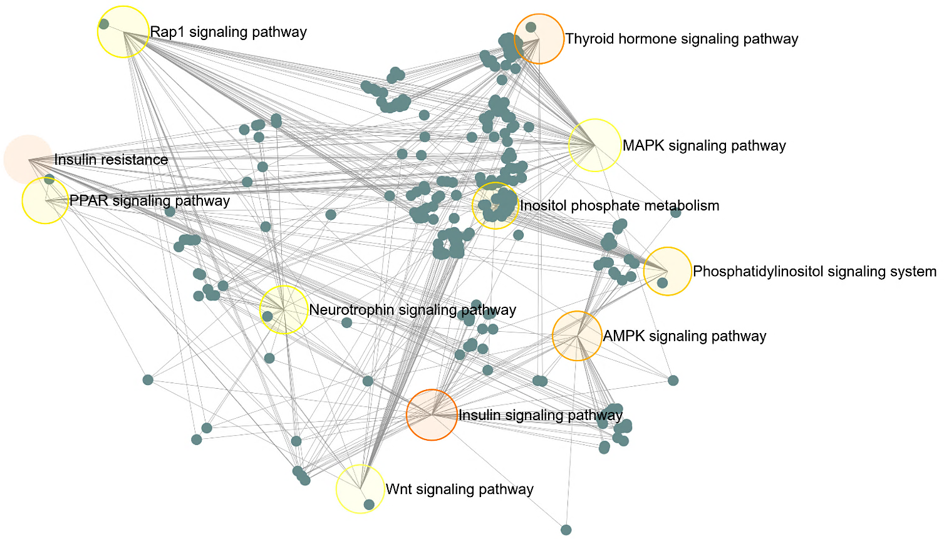

Figure S9: Gene ontology for male liver of BPA lineage
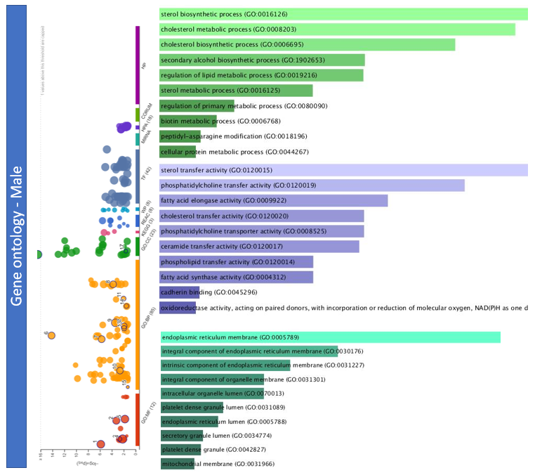

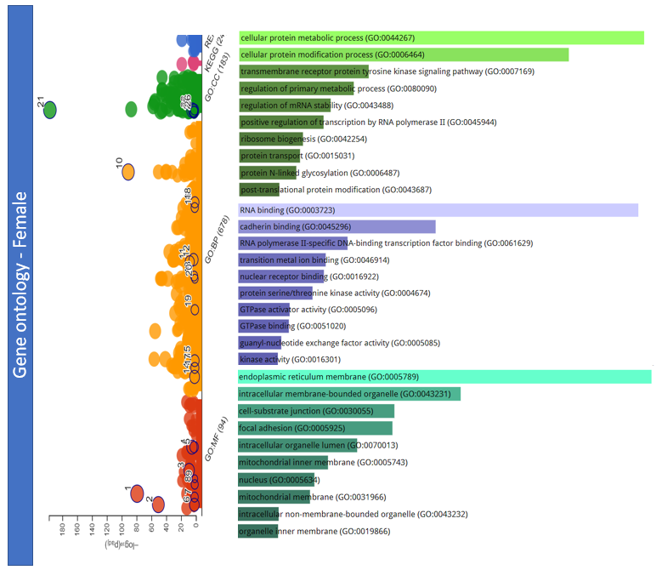
Figure S10: Gene ontology for female liver of BPA linegae

Figure S11: Disease specific pathway by IPA.

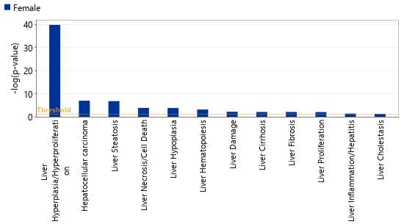

Figure S12: IPA analysis in liver of male and female

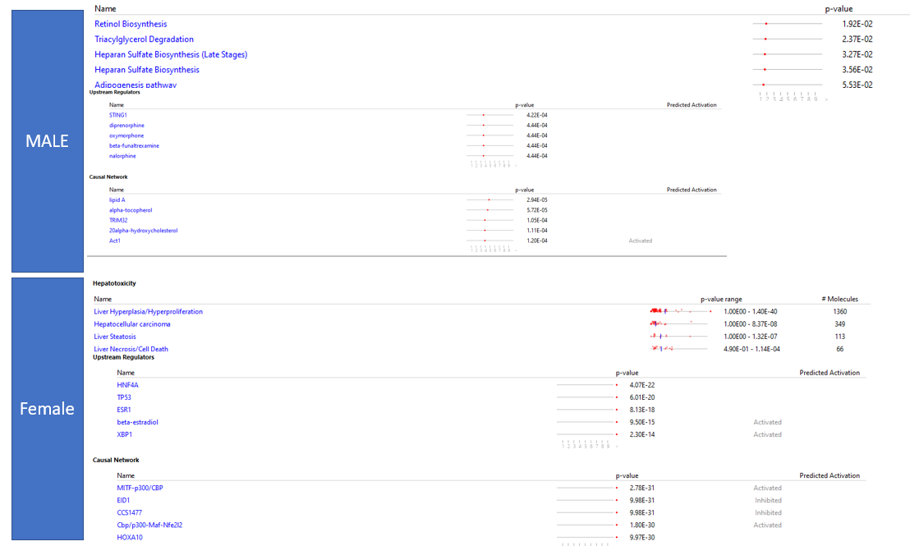

Figure S13: Upstream regulator in the female liver of medaka associated with human NAFLD genes
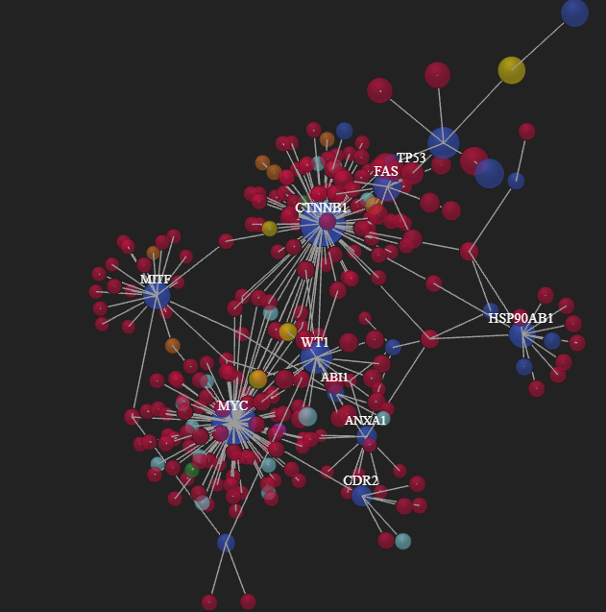

Figure S14: Upstream regulator in NASH specific genes

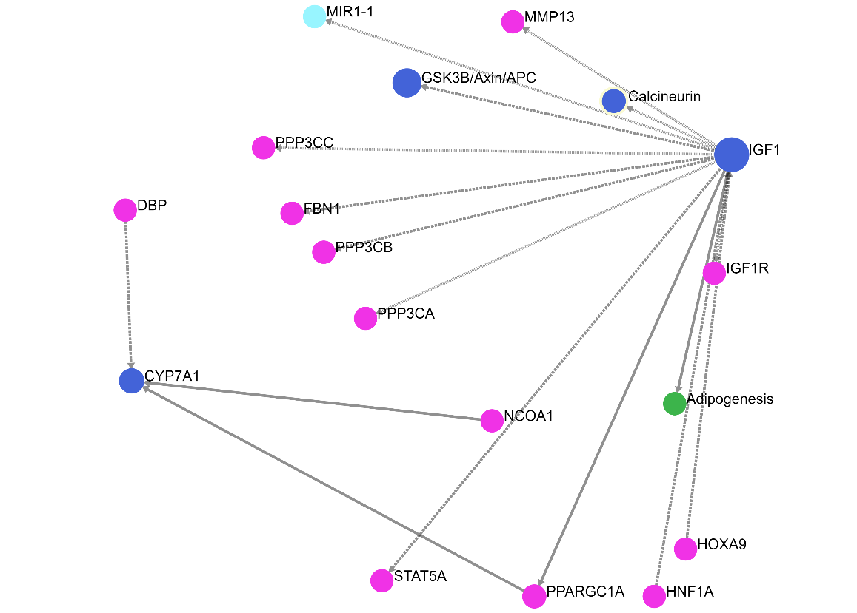

Figure S15: NASH specific gene network

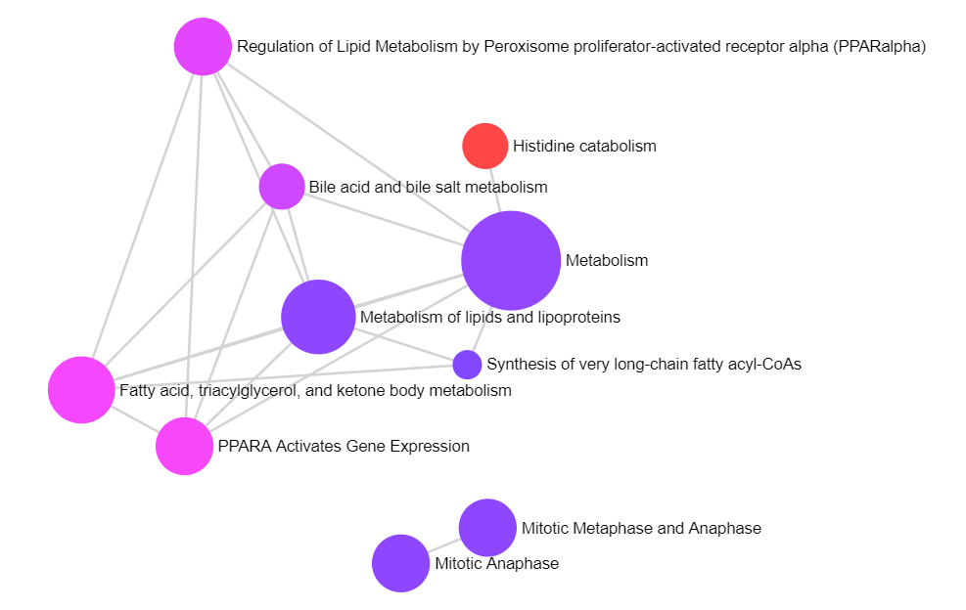

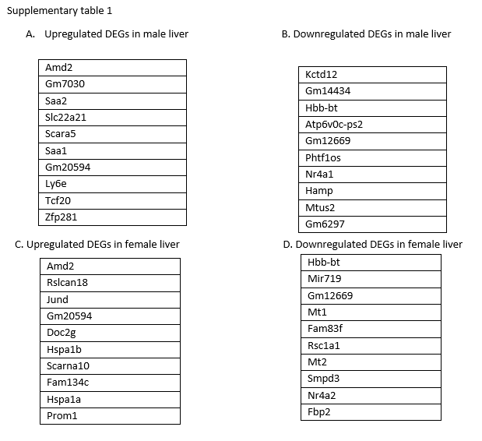
Supplementary Table 2: Transcription factors in the liver of BPA lineage male determined by IPA
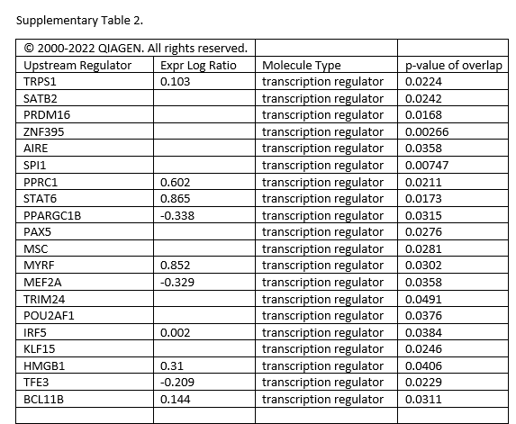

Supplementary Table 3: Cancerous gene in the liver of BPA lineage female determined by IPA

Genes in dataset | Prediction (based on measurement direction) | Expr Log Ratio | Findings
BEND7 | Affected | 9.178 | Affects (1)
TENT5A | Affected | 8.403 | Affects (0)
FBXO2 | Affected | 8.281 | Affects (1)
APCS | Affected | 7.41 | Affects (1)
TMEM235 | Affected | 7.282 | Affects (1)
GABRA6 | Affected | 7.233 | Affects (2)
FAM20C | Affected | 6.997 | Affects (2)
CACNA2D4 | Affected | 6.712 | Affects (2)
ESR1 | Affected | 6.517 | Affects (63)
PYCR2 | Affected | 6.379 | Affects (2)
SLC6A2 | Affected | 5.809 | Affects (1)
DACH1 | Affected | 5.471 | Affects (0)
SOX8 | Affected | 5.376 | Affects (1)
OPRL1 | Affected | 5.212 | Affects (1)
IL10 | Affected | 5.129 | Affects (2)
MYOF | Affected | 5.042 | Affects (2)
FBXW12 | Affected | 4.793 | Affects (1)
PKD1L1 | Affected | 4.721 | Affects (1)
CRELD2 | Affected | 4.672 | Affects (2)
VAV3 | Affected | 4.583 | Affects (4)
GABRB2 | Affected | 4.55 | Affects (3)
SLC7A10 | Affected | 4.404 | Affects (1)
ENDOD1 | Affected | 4.314 | Affects (1)
SLC48A1 | Affected | 4.309 | Affects (1)
GLIS1 | Affected | 4.197 | Affects (1)
ZNF804B | Affected | 4.094 | Affects (2)
GLUL | Affected | 4.025 | Affects (3)
RTN1 | Affected | 3.975 | Affects (1)
MAPK15 | Affected | 3.759 | Affects (1)
GORASP1 | Affected | 3.708 | Affects (1)
SH3GLB1 | Affected | 3.636 | Affects (1)
ANKRD34C | Affected | 3.621 | Affects (2)
GALNT13 | Affected | 3.55 | Affects (1)
NID1 | Affected | 3.506 | Affects (1)
TMEM41A | Affected | 3.494 | Affects (1)
HCN4 | Affected | 3.466 | Affects (1)
CHTF8 | Affected | 3.396 | Affects (1)
GRIA4 | Affected | 3.381 | Affects (3)
VILL | Affected | 3.376 | Affects (1)
SLC7A1 | Affected | 3.363 | Affects (1)
FRMD1 | Affected | 3.348 | Affects (1)
HDAC9 | Affected | 3.331 | Affects (1)
P2RY12 | Affected | 3.312 | Affects (2)
CPT1B | Affected | 3.292 | Affects (1)
LRRTM4 | Affected | 3.291 | Affects (0)
USP54 | Affected | 3.288 | Affects (4)
ATP2B2 | Affected | 3.269 | Affects (2)
mir-142 | Affected | 3.268 | Affects (2)
ERI2 | Affected | 3.226 | Affects (1)
KCNQ5 | Affected | 3.151 | Affects (1)

Supplementary Table 4: (A) Mutual up regulated and (B) Mutual downregulated genes in the liver of BPA lineage male and female.
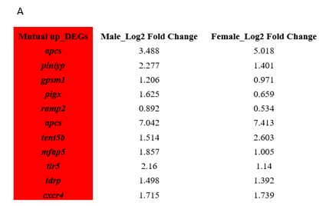
B
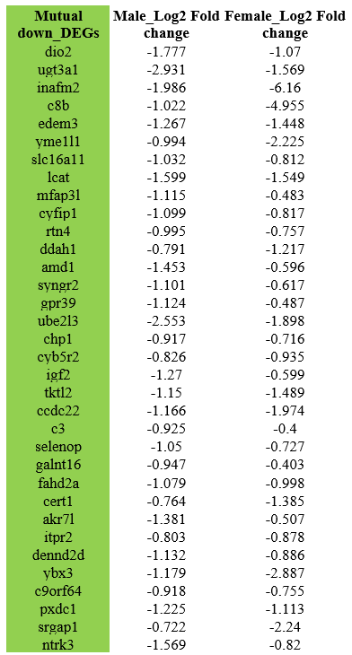

Supplementary Table 5: Total pathways in male liver of BPA lineage.

Enrichment FDR | Genes | Pathway Genes | Fold Enrichment | Pathway
1.47E-09 | 61 | 1527 | 2.587061678 | Metabolic pathways
0.000101996 | 8 | 50 | 10.36181818 | Cholesterol metabolism
0.000816214 | 5 | 20 | 16.19034091 | Steroid biosynthesis
0.003755451 | 11 | 169 | 4.215236686 | Protein processing in endoplasmic reticulum
0.003965145 | 5 | 30 | 10.79356061 | Citrate cycle (TCA cycle)
0.005937474 | 7 | 75 | 6.044393939 | PPAR signaling pathway
0.010498138 | 4 | 22 | 11.77479339 | Terpenoid backbone biosynthesis
0.029908806 | 6 | 75 | 5.180909091 | Biosynthesis of amino acids
0.051738403 | 7 | 115 | 3.941996047 | Carbon metabolism
0.121155786 | 3 | 27 | 7.195707071 | Fatty acid elongation
0.121155786 | 4 | 50 | 5.180909091 | Cysteine and methionine metabolism
0.121155786 | 4 | 48 | 5.396780303 | Valine, leucine and isoleucine degradation
0.121155786 | 4 | 51 | 5.079322638 | Arginine and proline metabolism
0.121155786 | 4 | 49 | 5.286641929 | Amino sugar and nucleotide sugar metabolism
0.121155786 | 3 | 27 | 7.195707071 | Biosynthesis of unsaturated fatty acids
0.166820106 | 3 | 31 | 6.267228739 | Circadian rhythm
0.192823471 | 6 | 128 | 3.03568892 | Lysosome

Supplementary Table 6: Total pathways in female liver of BPA lineage

Enrichment FDR | Genes | Pathway Genes | Fold Enrichment | Pathway
1.74E-44 | 468 | 1527 | 1.871074805 | Metabolic pathways
5.63E-11 | 76 | 203 | 2.285608745 | Diabetic cardiomyopathy
1.25E-10 | 80 | 223 | 2.190127804 | Chemical carcinogenesis
2.67E-10 | 91 | 272 | 2.042475346 | Prion disease
5.80E-10 | 98 | 306 | 1.955190075 | Huntington disease
6.44E-10 | 80 | 232 | 2.105165949 | Thermogenesis
6.45E-10 | 64 | 169 | 2.311945563 | Protein processing in endoplasmic reticulum
1.19E-09 | 29 | 50 | 3.540889127 | Cholesterol metabolism
1.61E-09 | 134 | 475 | 1.722247343 | Pathways of neurodegeneration
2.20E-09 | 59 | 155 | 2.323831574 | Non-alcoholic fatty liver disease
2.33E-09 | 113 | 383 | 1.801208568 | Alzheimer disease
1.08E-08 | 52 | 134 | 2.369097203 | Oxidative phosphorylation
1.46E-08 | 84 | 266 | 1.927888817 | Parkinson disease
1.62E-07 | 48 | 128 | 2.28936797 | Lysosome
1.87E-07 | 46 | 121 | 2.320901964 | Thyroid hormone signaling pathway
2.93E-07 | 44 | 115 | 2.335818914 | Carbon metabolism
3.22E-07 | 33 | 75 | 2.686191751 | Biosynthesis of amino acids
1.04E-06 | 41 | 108 | 2.317631772 | Insulin resistance
1.87E-06 | 47 | 134 | 2.141299395 | Ribosome
2.02E-06 | 52 | 155 | 2.048122743 | Biosynthesis of cofactors
2.92E-06 | 43 | 120 | 2.187618282 | AMPK signaling pathway
9.34E-06 | 46 | 137 | 2.04984772 | Insulin signaling pathway
9.55E-06 | 96 | 363 | 1.614540497 | Amyotrophic lateral sclerosis
4.04E-05 | 61 | 210 | 1.773351697 | Rap1 signaling pathway
4.20E-05 | 40 | 119 | 2.052094539 | Growth hormone synthesis, secretion, and action
4.24E-05 | 70 | 252 | 1.695828126 | Endocytosis
4.28E-05 | 59 | 202 | 1.783138089 | Proteoglycans in cancer
4.56E-05 | 22 | 50 | 2.686191751 | N-Glycan biosynthesis
4.56E-05 | 48 | 154 | 1.9028513 | MTOR signaling pathway
4.92E-05 | 54 | 181 | 1.821375623 | Axon guidance
8.33E-05 | 34 | 98 | 2.118054721 | Glycerophospholipid metabolism
0.000102067 | 125 | 530 | 1.439854069 | Pathways in cancer
0.000116321 | 44 | 142 | 1.891684332 | Spinocerebellar ataxia
0.000146551 | 36 | 109 | 2.016324084 | HIF-1 signaling pathway
0.000167152 | 31 | 89 | 2.126454144 | Longevity regulating pathway
0.000269154 | 42 | 138 | 1.858037773 | Fluid shear stress and atherosclerosis
0.000413503 | 18 | 42 | 2.616420537 | Tryptophan metabolism
0.000430568 | 37 | 119 | 1.898187449 | Sphingolipid signaling pathway
0.000430568 | 34 | 106 | 1.958201534 | Parathyroid hormone synthesis, secretion, and action
0.000430568 | 60 | 224 | 1.635262836 | Human cytomegalovirus infection
0.000505909 | 34 | 107 | 1.939900585 | Glucagon signaling pathway
0.000659045 | 15 | 33 | 2.774991479 | Fructose and mannose metabolism
0.000659045 | 27 | 79 | 2.08651258 | EGFR tyrosine kinase inhibitor resistance
0.000659045 | 15 | 33 | 2.774991479 | SNARE interactions in vesicular transport
0.000660744 | 26 | 75 | 2.116393501 | PPAR signaling pathway
0.000865085 | 24 | 68 | 2.154699266 | Renal cell carcinoma
0.001035273 | 45 | 161 | 1.70636122 | Hepatitis B
0.001035273 | 45 | 161 | 1.70636122 | MicroRNAs in cancer
0.001108203 | 14 | 31 | 2.757088308 | Circadian rhythm
0.001183256 | 27 | 82 | 2.010176754 | Peroxisome
0.001278501 | 24 | 70 | 2.09313643 | Prolactin signaling pathway
0.001278501 | 24 | 70 | 2.09313643 | Central carbon metabolism in cancer
0.001488009 | 40 | 141 | 1.731909575 | Ubiquitin mediated proteolysis
0.001492917 | 38 | 132 | 1.757494603 | Spliceosome
0.001517736 | 24 | 71 | 2.063655635 | Adherens junction
0.001579437 | 11 | 22 | 3.052490627 | Histidine metabolism
0.001579437 | 30 | 97 | 1.888138532 | Phosphatidylinositol signaling system
0.001579437 | 30 | 97 | 1.888138532 | Prostate cancer
0.002233207 | 15 | 37 | 2.4749924 | Alanine, aspartate and glutamate metabolism
0.002233207 | 24 | 73 | 2.007117124 | Inositol phosphate metabolism
0.002415975 | 11 | 23 | 2.919773643 | Protein export
0.002511665 | 19 | 53 | 2.188578185 | Endocrine and other factor-regulated calcium reabsorption
0.003117871 | 16 | 42 | 2.325707144 | Fat digestion and absorption
0.003117871 | 20 | 58 | 2.105165949 | Endometrial cancer
0.003211026 | 13 | 31 | 2.560153429 | Beta-Alanine metabolism
0.003211026 | 39 | 143 | 1.664994887 | Signaling pathways regulating pluripotency of stem cells
0.003211026 | 26 | 84 | 1.889637055 | Complement and coagulation cascades
0.003211026 | 29 | 97 | 1.825200581 | Circadian entrainment
0.003211026 | 38 | 138 | 1.681081794 | Estrogen signaling pathway
0.003211026 | 53 | 210 | 1.540780983 | Human immunodeficiency virus 1 infection
0.003266772 | 40 | 148 | 1.649994933 | Retrograde endocannabinoid signaling
0.003582882 | 29 | 98 | 1.806576085 | Aldosterone synthesis and secretion
0.003701028 | 18 | 51 | 2.154699266 | Arginine and proline metabolism
0.003821183 | 57 | 232 | 1.499930739 | Coronavirus disease
0.004017236 | 36 | 131 | 1.677704772 | FoxO signaling pathway
0.004628807 | 60 | 249 | 1.47107982 | Salmonella infection
0.004749844 | 37 | 137 | 1.648790557 | Yersinia infection
0.004936464 | 32 | 114 | 1.713678948 | Leukocyte transendothelial migration
0.005165544 | 33 | 119 | 1.692977995 | Neurotrophin signaling pathway
0.005279714 | 37 | 138 | 1.6368428 | Apelin signaling pathway
0.005680846 | 17 | 49 | 2.118054721 | Amino sugar and nucleotide sugar metabolism
0.005680846 | 17 | 49 | 2.118054721 | Sphingolipid metabolism
0.006277434 | 27 | 93 | 1.772413912 | GnRH signaling pathway
0.006695952 | 28 | 98 | 1.744280358 | Choline metabolism in cancer
0.006762455 | 12 | 30 | 2.441992501 | Pentose phosphate pathway
0.006895741 | 17 | 50 | 2.075693626 | Cysteine and methionine metabolism
0.008901206 | 20 | 64 | 1.907806642 | GnRH secretion
0.008901206 | 28 | 100 | 1.709394751 | AGE-RAGE signaling pathway in diabetic complications
0.009297411 | 14 | 39 | 2.191531732 | Various types of N-glycan biosynthesis
0.009396656 | 33 | 124 | 1.624712753 | Platelet activation
0.009780725 | 25 | 87 | 1.754304958 | Cardiac muscle contraction
0.010445836 | 20 | 65 | 1.87845577 | Cortisol synthesis and secretion
0.010836526 | 51 | 214 | 1.454925439 | Lipid and atherosclerosis
0.010935594 | 8 | 17 | 2.872932355 | Primary bile acid biosynthesis
0.011308022 | 14 | 40 | 2.136743439 | Glycine, serine and threonine metabolism
0.011308022 | 23 | 79 | 1.777399605 | RNA degradation
0.011497836 | 33 | 126 | 1.598923662 | Purine metabolism
0.011873737 | 24 | 84 | 1.744280358 | ErbB signaling pathway
0.012026525 | 36 | 141 | 1.558718618 | Alcoholic liver disease
0.013035495 | 34 | 132 | 1.572495171 | Dopaminergic synapse
0.013511164 | 73 | 331 | 1.346415805 | Human papillomavirus infection
0.014073437 | 13 | 37 | 2.144993413 | Biosynthesis of nucleotide sugars
0.014073437 | 13 | 37 | 2.144993413 | Aldosterone-regulated sodium reabsorption
0.014808168 | 19 | 63 | 1.841184822 | Lysine degradation
0.014808168 | 21 | 72 | 1.780619532 | Non-small cell lung cancer
0.015269243 | 24 | 86 | 1.703715699 | Colorectal cancer
0.018137752 | 11 | 30 | 2.238493126 | Glyoxylate and dicarboxylate metabolism
0.018137752 | 38 | 155 | 1.496705081 | Cushing syndrome
0.018235199 | 25 | 92 | 1.658962297 | Salivary secretion
0.01857486 | 20 | 69 | 1.769559784 | Amphetamine addiction
0.019319217 | 40 | 166 | 1.47107982 | CGMP-PKG signaling pathway
0.019319217 | 35 | 141 | 1.515420878 | Autophagy
0.019319217 | 40 | 166 | 1.47107982 | Wnt signaling pathway
0.019449079 | 50 | 217 | 1.406677708 | Regulation of actin cytoskeleton
0.022354998 | 29 | 113 | 1.5667651 | Cholinergic synapse
0.022354998 | 21 | 75 | 1.709394751 | Glioma
0.022380343 | 10 | 27 | 2.261104168 | Biosynthesis of unsaturated fatty acids
0.022544321 | 50 | 219 | 1.393831336 | CAMP signaling pathway
0.02535231 | 32 | 129 | 1.514413954 | Relaxin signaling pathway
0.025368462 | 21 | 76 | 1.686902715 | Gastric acid secretion
0.02634723 | 19 | 67 | 1.731263341 | Acute myeloid leukemia
0.026554548 | 15 | 49 | 1.868871812 | Ether lipid metabolism
0.0271977 | 11 | 32 | 2.098587306 | Propanoate metabolism
0.0271977 | 8 | 20 | 2.441992501 | One carbon pool by folate
0.0271977 | 33 | 135 | 1.492328751 | Apoptosis
0.028550764 | 26 | 101 | 1.571579333 | Melanogenesis
0.029971687 | 13 | 41 | 1.935725763 | Ferroptosis
0.030826139 | 15 | 50 | 1.831494376 | Vibrio cholerae infection
0.031442002 | 12 | 37 | 1.97999392 | Thyroid cancer
0.031442002 | 39 | 167 | 1.425714185 | Hepatocellular carcinoma
0.032965934 | 14 | 46 | 1.858037773 | Proteasome
0.033876747 | 7 | 17 | 2.51381581 | Phenylalanine metabolism
0.034658382 | 17 | 60 | 1.729744688 | Glycerolipid metabolism
0.034658382 | 17 | 60 | 1.729744688 | Long-term depression
0.036495661 | 39 | 169 | 1.408841828 | Tight junction
0.037890347 | 16 | 56 | 1.744280358 | Hedgehog signaling pathway
0.03879097 | 28 | 114 | 1.49946908 | Glutamatergic synapse
0.038814603 | 20 | 75 | 1.627995001 | Thyroid hormone synthesis
0.039873981 | 43 | 191 | 1.374419863 | Chemokine signaling pathway
0.041177967 | 13 | 43 | 1.845692007 | Fatty acid degradation
0.0413319 | 10 | 30 | 2.034993751 | Citrate cycle (TCA cycle)
0.0413319 | 24 | 95 | 1.542311053 | Endocrine resistance
0.041450477 | 44 | 197 | 1.363549112 | Pathogenic Escherichia coli infection
0.042414691 | 16 | 57 | 1.713678948 | Fatty acid metabolism
0.042775664 | 36 | 156 | 1.408841828 | Cellular senescence
0.043219181 | 8 | 22 | 2.219993183 | Arginine biosynthesis
0.043219181 | 14 | 48 | 1.780619532 | Valine, leucine and isoleucine degradation
0.043626303 | 22 | 86 | 1.56173939 | Insulin secretion
0.044645579 | 25 | 101 | 1.511133974 | Pancreatic secretion
0.044737178 | 18 | 67 | 1.640144217 | Glycolysis / Gluconeogenesis
0.047066719 | 20 | 77 | 1.585709416 | Bacterial invasion of epithelial cells
0.04879683 | 24 | 97 | 1.510510826 | Fc gamma R-mediated phagocytosis
0.04879683 | 27 | 112 | 1.471736552 | Serotonergic synapse
0.048996221 | 44 | 200 | 1.343095876 | Focal adhesion
0.048996221 | 14 | 49 | 1.744280358 | Cocaine addiction
0.049078186 | 5 | 11 | 2.774991479 | Ubiquinone and other terpenoid-quinone biosynthesis
0.049136714 | 34 | 148 | 1.402495693 | Phospholipase D signaling pathway
0.049199513 | 18 | 68 | 1.616024449 | Fc epsilon RI signaling pathway
0.051155261 | 20 | 78 | 1.565379809 | Synaptic vesicle cycle
0.051641789 | 8 | 23 | 2.12347174 | Mannose type O-glycan biosynthesis
0.051641789 | 16 | 59 | 1.655588137 | VEGF signaling pathway
0.051641789 | 22 | 88 | 1.526245313 | Gap junction
0.051641789 | 25 | 103 | 1.481791566 | T cell receptor signaling pathway
0.051702384 | 11 | 36 | 1.865410939 | Tyrosine metabolism
0.055891363 | 12 | 41 | 1.786823781 | Homologous recombination
0.055891363 | 61 | 294 | 1.266679784 | MAPK signaling pathway
0.055891363 | 12 | 41 | 1.786823781 | Bladder cancer
0.059642189 | 13 | 46 | 1.725320789 | Nucleotide excision repair
0.060073097 | 34 | 151 | 1.37463154 | Phagosome
0.063682458 | 8 | 24 | 2.034993751 | Vitamin digestion and absorption
0.06370004 | 42 | 194 | 1.321696972 | Kaposi sarcoma-associated herpesvirus infection
0.074032137 | 15 | 57 | 1.606574014 | Glutathione metabolism
0.075877336 | 17 | 67 | 1.549025094 | Long-term potentiation
0.075877336 | 34 | 154 | 1.347853004 | Oxytocin signaling pathway
0.079939056 | 51 | 246 | 1.265666845 | Shigellosis
0.083131098 | 23 | 98 | 1.432801723 | Inflammatory mediator regulation of TRP channels
0.085130034 | 18 | 73 | 1.505337843 | P53 signaling pathway
0.092815981 | 10 | 35 | 1.744280358 | Starch and sucrose metabolism
0.092815981 | 15 | 59 | 1.552113878 | Notch signaling pathway
0.092815981 | 34 | 157 | 1.322097851 | Hippo signaling pathway
0.092815981 | 21 | 89 | 1.440501195 | PD-L1 expression and PD-1 checkpoint pathway in cancer
0.093204884 | 8 | 26 | 1.87845577 | Folate biosynthesis
0.093204884 | 17 | 69 | 1.504125816 | Adipocytokine signaling pathway
0.095696233 | 32 | 147 | 1.328975511 | Breast cancer
0.105545878 | 34 | 159 | 1.305467689 | Necroptosis
0.111679253 | 25 | 112 | 1.36271903 | TNF signaling pathway
0.111699399 | 8 | 27 | 1.808883334 | Fatty acid elongation
0.112058142 | 12 | 46 | 1.592603805 | Type II diabetes mellitus
0.112058142 | 18 | 76 | 1.445916613 | Pancreatic cancer
0.112058142 | 18 | 76 | 1.445916613 | Chronic myeloid leukemia
0.112792321 | 14 | 56 | 1.526245313 | Pyrimidine metabolism
0.112792321 | 14 | 56 | 1.526245313 | Regulation of lipolysis in adipocytes
0.115157618 | 69 | 354 | 1.189953973 | PI3K-Akt signaling pathway
0.115157618 | 32 | 150 | 1.302396001 | Adrenergic signaling in cardiomyocytes
0.121581149 | 18 | 77 | 1.427138475 | Ribosome biogenesis in eukaryotes
0.123476432 | 45 | 222 | 1.2374962 | Human T-cell leukemia virus 1 infection
0.126002109 | 21 | 93 | 1.378544154 | TGF-beta signaling pathway
0.126360203 | 33 | 157 | 1.28321262 | Hepatitis C
0.127323771 | 20 | 88 | 1.387495739 | ECM-receptor interaction
0.128718092 | 6 | 19 | 1.927888817 | Glycosaminoglycan degradation
0.128718092 | 6 | 19 | 1.927888817 | 2-Oxocarboxylic acid metabolism
0.132388001 | 17 | 73 | 1.421707963 | Platinum drug resistance
0.136357609 | 11 | 43 | 1.56173939 | Porphyrin and chlorophyll metabolism
0.14246323 | 22 | 100 | 1.343095876 | Progesterone-mediated oocyte maturation
0.151255489 | 9 | 34 | 1.616024449 | RNA polymerase
0.15368259 | 22 | 101 | 1.329797897 | Chagas disease
0.166840636 | 27 | 129 | 1.277786774 | Oocyte meiosis
0.170897354 | 47 | 240 | 1.195558829 | Calcium signaling pathway
0.186364225 | 6 | 21 | 1.744280358 | Pantothenate and CoA biosynthesis
0.192569433 | 7 | 26 | 1.643648799 | Glycosylphosphatidylinositol (GPI)-anchor biosynthesis
0.192569433 | 16 | 72 | 1.356662501 | Melanoma
0.194111678 | 30 | 148 | 1.2374962 | Gastric cancer
0.194115288 | 9 | 36 | 1.526245313 | DNA replication

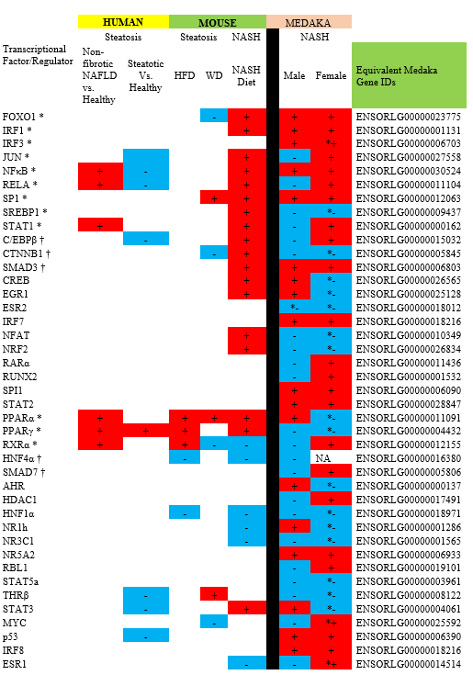
Supplementary Table 7

 | Steatosis |  | Steatosis |  |  | NASH |  |  |  | NASH
Transcriptional Factor/Regulator | Non-fibrotic NAFLD vs. Healthy | Steatotic Vs. Healthy | HFD |  | WD |  | NASH Diet |  |  | Male | Female | Equivalent Medaka Gene IDs
FOXO1 * |  |  |  | - |  | + |  |  |  | + | + | ENSORLG00000023775
IRF1 * |  |  |  |  |  | + |  |  |  | + | + | ENSORLG00000001131
IRF3 * |  |  |  |  |  |  |  |  |  | + | *+ | ENSORLG00000006703
JUN * |  |  |  |  |  | + |  |  |  | - | + | ENSORLG00000027558
NFκB * | + | - |  |  |  | + |  |  |  | + | + | ENSORLG00000030524
RELA * | + | - |  |  |  | + |  |  |  | - | + | ENSORLG00000011104
SP1 * |  |  |  | + |  | + |  |  |  | + | + | ENSORLG00000012063
SREBP1 * |  |  |  |  |  | + |  |  |  | - | *- | ENSORLG00000009437
STAT1 * | + |  |  |  |  | + |  |  |  | - | + | ENSORLG00000000162
C/EBPβ † |  | - |  |  |  | + |  |  |  | - | + | ENSORLG00000015032
CTNNB1 † |  |  |  | - |  | + |  |  |  | - | *- | ENSORLG00000005845
SMAD3 † |  |  |  |  |  | + |  |  |  | + | + | ENSORLG00000006803
CREB |  |  |  |  |  | + |  |  |  | + | *- | ENSORLG00000026565
EGR1 |  |  |  |  |  | + |  |  |  | + | *- | ENSORLG00000025128
ESR2 |  |  |  |  |  |  |  |  |  | *- | *- | ENSORLG00000018012
IRF7 |  |  |  |  |  |  |  |  |  | + | + | ENSORLG00000018216
NFAT |  |  |  |  |  | + |  |  |  | - | *- | ENSORLG00000010349
NRF2 |  |  |  |  |  | + |  |  |  | - | *- | ENSORLG00000026834
RARα |  |  |  |  |  |  |  |  |  | - | + | ENSORLG00000011436
RUNX2 |  |  |  |  |  |  |  |  |  | - | + | ENSORLG00000001532
SPI1 |  |  |  |  |  |  |  |  |  | + | + | ENSORLG00000006090
STAT2 |  |  |  |  |  |  |  |  |  | + | + | ENSORLG00000028847
PPARα * | + |  | + | + |  | + |  |  |  | + | *- | ENSORLG00000011091
PPARγ * | + | + | + |  |  | + |  |  |  | - | *- | ENSORLG00000004432
RXRα * | + |  | + | - |  | - |  |  |  | - | + | ENSORLG00000012155
HNF4α † |  |  | - |  |  | - |  |  |  | - | NA | ENSORLG00000016380
SMAD7 † |  |  |  |  |  |  |  |  |  | - | + | ENSORLG00000005806
AHR |  |  |  |  |  |  |  |  |  | + | *- | ENSORLG00000000137
HDAC1 |  |  |  |  |  |  |  |  |  | - | + | ENSORLG00000017491
HNF1α |  |  | - |  |  | - |  |  |  | - | *- | ENSORLG00000018971
NR1h |  |  |  |  |  | - |  |  |  | + | *- | ENSORLG00000001286
NR3C1 |  |  |  |  |  | - |  |  |  | - | *- | ENSORLG00000001565
NR5A2 |  |  |  |  |  |  |  |  |  | + | + | ENSORLG00000006933
RBL1 |  |  |  |  |  |  |  |  |  | - | + | ENSORLG00000019101
STAT5a |  |  |  |  |  |  |  |  |  | - | *- | ENSORLG00000003961
THRβ |  | - |  | + |  |  |  |  |  | - | *- | ENSORLG00000008122
STAT3 |  | - |  |  |  | + |  |  |  | + | *- | ENSORLG00000004061
MYC |  |  |  | - |  |  |  |  |  | - | *+ | ENSORLG00000025592
p53 |  | - |  |  |  |  |  |  |  | + | + | ENSORLG00000006390
IRF8 |  |  |  |  |  |  |  |  |  | + | + | ENSORLG00000018216
ESR1 |  |  |  |  |  | - |  |  |  | - | *+ | ENSORLG00000014514

Supplementary table 8: Comparison of NAFLD genes’ expression in Human and medaka

 | HUMAN |  |  |  | MEDAKA
Symbol | NAFLD |  | NASH |  | Male |  | Female
 | logFC | FDR | logFC | FDR | logFC | FDR | logFC | FDR
ABCB11 | -0.57 | 0.0001 | -0.62 | 0 | -0.995 | 0.32395 | -2.751 | 0
ACKR2 | -0.44 | 0.0071 | -0.61 | 0 | 0.148 | 0.95812 | NA | NA
ACSL4 | 0.76 | 0.1063 | 1.04 | 0.0078 | 0.493 | 0.45947 | 0.629 | 0.01723
ADAM20 | 0.41 | 0.1301 | 0.61 | 0.013 | -0.632 | 0.13335 | NA | NA
ADCY10P1 | 0.6 | 0.0117 | 0.44 | 0.0509 | 0.358 | 0.65866 | -0.676 | 0.0066
ADSSL1 | 0.52 | 0.012 | 0.65 | 0.0002 | 0.056 | 0.97586 | NA | NA
ADTRP | -0.5 | 0.0885 | -0.62 | 0.0153 | NA | NA | NA | NA
AEBP1 | 0.28 | 0.2288 | 0.7 | 0.0008 | 0.457 | 0.89692 | NA | NA
ALDH6A1 | -0.57 | 0.0006 | -0.6 | 0 | 0.134 | 0.87928 | -0.941 | 0
ALPK2 | 0.8 | 0.003 | 0.75 | 0.0038 | 0.994 | 0.21061 | 2.372 | 0
ALPL | -0.55 | 0.0003 | -0.59 | 0 | 0.322 | 0.80719 | -0.661 | 0.08069
AMDHD1 | -0.46 | 0.0037 | -0.66 | 0 | -0.27 | 0.70422 | -1.479 | 0
AMICA1 | 0.33 | 0.096 | 0.61 | 0.0007 | NA | NA | NA | NA
ANKRD36 | 0.52 | 0.0667 | 0.79 | 0.0017 | -0.372 | 0.89205 | 2.916 | 0
APOF | -0.54 | 0.0015 | -0.88 | 0 | -0.612 | 0.4083 | -3.28 | 0
ARRDC4 | 0.45 | 0.0259 | 0.66 | 0.0002 | -0.081 | 0.96816 | -1.15 | 0.00018
ATF3 | 0.26 | 0.4393 | 0.69 | 0.0455 | -0.99 | 0.03497 | 0.761 | 0.00076
ATHL1 | 1.03 | 0.0001 | 0.61 | 0.0252 | NA | NA | NA | NA
B3GAT1 | -0.58 | 0.0272 | -0.71 | 0.0043 | 0.914 | 0.63159 | NA | NA
BAMBI | -0.59 | 0.005 | -0.2 | 0.3546 | -0.083 | 0.95739 | -1.054 | 0.00004
BHLHA15 | -0.67 | 0.0027 | -0.65 | 0.0019 | -1.184 | 0.07234 | 1.142 | 0.00041
CACNA1H | 0.64 | 0.0846 | 0.73 | 0.032 | -0.658 | 0.85642 | -0.923 | 0.03464
CAMK1D | 0.5 | 0.0002 | 0.66 | 0 | 0.037 | 0.98977 | NA | NA
CAPN12 | 0.67 | 0.0346 | 0.55 | 0.1064 | 0.266 | 0.83312 | -0.669 | 0.04243
CCDC82 | 0.69 | 0.0001 | 0.48 | 0.0013 | 0.58 | 0.55154 | -1.403 | 0.00006
CD83 | 0.43 | 0.0237 | 0.72 | 0.0006 | 0.19 | 0.88276 | NA | NA
CDC45 | 0.42 | 0.0363 | 0.68 | 0.0013 | -0.414 | 0.46711 | -0.75 | 0.00056
CDC6 | 0.53 | 0.072 | 0.75 | 0.0145 | 0.724 | 0.86655 | NA | NA
CDHR2 | 0.59 | 0.0436 | 0.63 | 0.0238 | -1.313 | 0.18116 | -1.689 | 0.0001
CENPK | 0.22 | 0.2511 | 0.6 | 0.0022 | -0.33 | 0.9286 | 1.923 | 0.00306
CENPU | 0.2 | 0.4019 | 0.59 | 0.0118 | -1.834 | 0.13406 | NA | NA
CFHR4 | -0.36 | 0.1163 | -0.71 | 0 | NA | NA | NA | NA
CFHR5 | -0.34 | 0.0586 | -0.59 | 0.0003 | NA | NA | NA | NA
CH25H | 0.43 | 0.2424 | 0.77 | 0.0346 | NA | NA | NA | NA
CHRNA4 | 0.57 | 0.0888 | 0.63 | 0.0301 | 0.098 | 0.96771 | -2.665 | 0
CMYA5 | -0.58 | 0.0023 | -0.66 | 0.0001 | NA | NA | NA | NA
CNGA1 | -0.36 | 0.1014 | -0.65 | 0.0019 | -0.465 | 0.76269 | 0.661 | 0.03113
COL1A1 | 0.36 | 0.1572 | 0.79 | 0.0004 | 0.195 | 0.93476 | NA | NA
COL1A2 | 0.36 | 0.1055 | 0.64 | 0.0013 | 0.314 | 0.82455 | NA | NA
COX7B | -0.54 | 0.0116 | -0.81 | 0.0001 | 0.094 | 0.94188 | 1.387 | 0
CXCL13 | -1.17 | 0.0283 | -1.12 | 0.0393 | 0.261 | 0.97895 | -4.664 | 0.00823
CXCR4 | 0.63 | 0.0274 | 0.83 | 0.0086 | 1.715 | 0.08241 | 1.739 | 0.00029
CYP1A1 | -1.09 | 0.0236 | -1.61 | 0.0001 | -0.233 | 0.90929 | -2.627 | 0
CYP2C19 | -0.52 | 0.1586 | -0.9 | 0.0042 | 1.159 | 0.49415 | 3.104 | 0
CYP7A1 | 1.73 | 0.0054 | 1.24 | 0.0547 | -1.906 | 0.13935 | -1.65 | 0.01862
CYTIP | 0.51 | 0.0667 | 0.86 | 0.0014 | NA | NA | NA | NA
DOK6 | 0.57 | 0.0334 | 0.64 | 0.0029 | 0.552 | 0.79813 | NA | NA
DPYSL2 | 0.51 | 0.0006 | 0.61 | 0 | 0.231 | 0.95485 | 0.802 | 0.07337
DTL | 0.49 | 0.0929 | 0.95 | 0.0018 | -0.084 | 0.96047 | NA | NA
DUSP8 | 0.26 | 0.1151 | 0.62 | 0.0001 | -0.118 | 0.96115 | NA | NA
ENO3 | 0.98 | 0.0192 | 1.24 | 0.0006 | -1.68 | 0.6169 | -4.477 | 0.00016
EPHA3 | 0.57 | 0.0187 | 0.8 | 0.0005 | -0.827 | 0.67108 | NA | NA
ERV3-1 | 0.59 | 0.0074 | 0.54 | 0.0076 | NA | NA | NA | NA
FABP4 | 0.5 | 0.1453 | 1.72 | 0 | -0.356 | 0.7874 | -0.795 | 0.03824
FABP5 | 0.26 | 0.2499 | 0.75 | 0.0003 | 0.504 | 0.78124 | 8.988 | 0
FAM111B | 0.26 | 0.5272 | 0.86 | 0.0222 | -0.35 | 0.83064 | 0.706 | 0.08972
FAM171A1 | -0.57 | 0.0021 | -0.53 | 0.0017 | -0.129 | 0.94553 | -1.831 | 0
FASN | 0.5 | 0.1567 | 0.66 | 0.0417 | 0.82 | 0.7318 | NA | NA
FAT1 | 0.35 | 0.2497 | 0.86 | 0.0007 | 0.047 | 0.97505 | -0.648 | 0.00236
FGF21 | 0.8 | 0.0128 | 0.67 | 0.038 | -0.368 | 0.7886 | -1.343 | 0.00015
FGL1 | -0.56 | 0.0035 | -0.69 | 0.0001 | 1.154 | 0.34464 | NA | NA
FLJ36840 | 0.45 | 0.2067 | 0.68 | 0.0281 | NA | NA | NA | NA
FMO1 | 0.35 | 0.2828 | 1.14 | 0.0003 | NA | NA | NA | NA
FNDC5 | 1.21 | 0.0047 | 1.33 | 0.0012 | -0.036 | 0.98424 | -0.559 | 0.05443
FPR3 | 0.45 | 0.1282 | 0.62 | 0.0283 | NA | NA | NA | NA
GALNT18 | 0.4 | 0.0023 | 0.6 | 0 | -1.809 | 0.02733 | -2.24 | 0
GAS6-AS1 | 0.42 | 0.1743 | 0.78 | 0.0024 | -0.998 | 0.22356 | -1.941 | 0
GEM | 0.33 | 0.3453 | 0.73 | 0.0216 | 0.919 | 0.76761 | 7.148 | 0
GINS1 | 0.33 | 0.115 | 0.6 | 0.005 | -0.212 | 0.94553 | 2.546 | 0
GINS2 | 0.52 | 0.1152 | 0.94 | 0.0027 | 0.71 | 0.37664 | 1.163 | 0.00037
GNMT | -0.55 | 0.0979 | -0.84 | 0.0071 | 0.492 | 0.51098 | NA | NA
GOLGA8A | 0.63 | 0.0424 | 0.56 | 0.0553 | -0.043 | 0.98008 | -0.493 | 0.06312
GOLM1 | 0.67 | 0.0336 | 0.75 | 0.01 | 0.12 | 0.93476 | NA | NA
GPNMB | 0.38 | 0.3226 | 0.76 | 0.0215 | 2.468 | 0.39678 | 2.138 | 0.09681
GPR183 | 0.34 | 0.103 | 0.64 | 0.0076 | 0.163 | 0.88487 | 0.727 | 0.00216
GPR52 | 0.39 | 0.1469 | 0.6 | 0.0119 | -1.31 | 0.01169 | -1.489 | 0
GPR88 | -0.55 | 0.0239 | -0.88 | 0 | -1.176 | 0.04003 | NA | NA
GRID1 | 1.29 | 0 | 1.16 | 0 | -1.209 | 0.08706 | NA | NA
GRM8 | 0.59 | 0.0028 | 0.74 | 0.0001 | NA | NA | NA | NA
H2AFY2 | 0.61 | 0.0007 | 0.75 | 0 | 0.212 | 0.88487 | 0.702 | 0.04376
HAL | -0.41 | 0.1173 | -0.62 | 0.0163 | -0.222 | 0.84896 | -1.649 | 0
HBEGF | 0.42 | 0.2531 | 0.89 | 0.0227 | 0.723 | 0.4921 | NA | NA
HMCN1 | 0.43 | 0.0319 | 0.75 | 0 | -0.795 | 0.57014 | -1.382 | 0.00026
HMGCS1 | 0.2 | 0.5243 | 0.63 | 0.0172 | -3.153 | 0.04026 | NA | NA
HSD17B11 | -0.61 | 0 | -0.62 | 0 | -0.324 | 0.7318 | -0.966 | 0.0004
HSD17B7 | 0.48 | 0.0375 | 0.62 | 0.0049 | -2.583 | 0.00002 | NA | NA
HSD17B7P2 | 0.57 | 0.0376 | 0.59 | 0.028 | -2.583 | 0.00002 | NA | NA
HYDIN | 1.08 | 0.0021 | 0.94 | 0.0023 | NA | NA | NA | NA
IDO2 | 0.39 | 0.4904 | 0.86 | 0.0334 | -0.011 | 0.9972 | -1.468 | 0
IGF1 | -0.84 | 0.0005 | -1.01 | 0 | -0.961 | 0.35546 | -3.709 | 0
IGFBP2 | -1.34 | 0 | -1.75 | 0 | -0.682 | 0.11792 | 0.465 | 0.05896
IGHV3-48 | 0.42 | 0.3705 | 0.89 | 0.0264 | NA | NA | NA | NA
IGSF9 | 0.65 | 0.0008 | 0.56 | 0.0023 | 1.222 | 0.33737 | NA | NA
INHBE | 0.59 | 0.0281 | 0.74 | 0.0037 | 0.392 | 0.86089 | -1.319 | 0.01812
IP6K3 | 0.77 | 0.0116 | 0.86 | 0.0025 | -0.674 | 0.61671 | -1.111 | 0.02115
ISM1 | 0.57 | 0.0386 | 0.95 | 0.0002 | NA | NA | NA | NA
ITGAX | 0.42 | 0.0294 | 0.82 | 0.0001 | 1.269 | 0.24287 | NA | NA
ITGBL1 | 0.29 | 0.2832 | 0.68 | 0.0116 | -0.133 | 0.89205 | -0.388 | 0.0789
KAT2A | 0.66 | 0.0029 | 0.37 | 0.1152 | 0.164 | 0.95087 | NA | NA
KCNJ3 | 0.45 | 0.1161 | 0.62 | 0.02 | -0.75 | 0.81165 | -2.962 | 0.00466
KNTC1 | 0.38 | 0.0414 | 0.64 | 0.0003 | -0.759 | 0.54662 | -0.892 | 0.03868
LCP1 | 0.44 | 0.0958 | 0.65 | 0.0086 | 0.774 | 0.73752 | NA | NA
LINC00174 | 0.75 | 0.0034 | 0.54 | 0.0345 | NA | NA | NA | NA
LINC00885 | 1.05 | 0 | 1.04 | 0 | NA | NA | NA | NA
LINC00893 | 0.66 | 0.0161 | 0.61 | 0.014 | NA | NA | NA | NA
LOC100131131 | 0.53 | 0.1268 | 0.74 | 0.0226 | NA | NA | NA | NA
LOC100131541 | 0.42 | 0.1104 | 0.63 | 0.0159 | NA | NA | NA | NA
LOC100131756 | 1.04 | 0.0168 | 0.93 | 0.0274 | NA | NA | NA | NA
LOC642947 | 0.54 | 0.0278 | 0.75 | 0.0007 | NA | NA | NA | NA
LPA | -0.55 | 0.059 | -0.63 | 0.0129 | NA | NA | NA | NA
LPL | 0.39 | 0.0363 | 0.88 | 0 | -0.49 | 0.77563 | NA | NA
LRG1 | -0.49 | 0.0291 | -0.65 | 0.0011 | -0.036 | 0.98562 | -0.521 | 0.07064
LRRC31 | 0.57 | 0.0006 | 0.67 | 0.0001 | 0.609 | 0.67433 | 1.025 | 0.00267
LYZ | 0.3 | 0.4354 | 0.64 | 0.0488 | 0.147 | 0.92571 | -1.088 | 0.00057
MAMDC4 | 0.73 | 0.0048 | 0.74 | 0.0052 | -0.58 | 0.44609 | -0.499 | 0.06276
MCM2 | 0.31 | 0.1934 | 0.71 | 0.0012 | -0.254 | 0.96816 | NA | NA
MCM5 | 0.43 | 0.0753 | 0.73 | 0.0012 | -0.282 | 0.96952 | NA | NA
MCM6 | 0.22 | 0.3567 | 0.7 | 0.002 | -0.537 | 0.8766 | NA | NA
ME1 | 0.6 | 0.0105 | 0.85 | 0.0002 | -0.446 | 0.66016 | -0.884 | 0.00318
MEP1B | 1.01 | 0.0033 | 1.15 | 0.0004 | -0.562 | 0.61508 | NA | NA
MIR107 | 0.7 | 0.0565 | 0.59 | 0.0762 | NA | NA | NA | NA
MIR99A | 0.31 | 0.3097 | 0.59 | 0.044 | NA | NA | NA | NA
MMP19 | 0.19 | 0.4486 | 0.62 | 0.0221 | -0.089 | 0.98298 | -1.445 | 0.01841
MMP9 | 0.24 | 0.4614 | 1.13 | 0.0001 | 0.019 | 0.99939 | NA | NA
NAMPT | -0.62 | 0.009 | -0.49 | 0.0359 | 0.174 | 0.90231 | -1.014 | 0.00033
NCAM2 | 1.28 | 0.0011 | 1.3 | 0.0004 | -0.221 | 0.92107 | -0.941 | 0.03091
NCF2 | 0.29 | 0.2368 | 0.6 | 0.0112 | 1.122 | 0.58306 | NA | NA
NPNT | 0.61 | 0.0029 | 0.72 | 0.0005 | -1.727 | 0.05531 | -2.927 | 0
NR0B2 | -0.1 | 0.7932 | -0.59 | 0.0309 | NA | NA | NA | NA
OCR1 | 0.53 | 0.155 | 0.65 | 0.034 | 0.534 | 0.63424 | -0.652 | 0.07432
OLFM2 | 0.94 | 0.0144 | 0.77 | 0.0374 | 0.705 | 0.52513 | NA | NA
OXT | 0.85 | 0.0028 | 0.69 | 0.0081 | NA | NA | NA | NA
P4HA1 | -1.21 | 0.0005 | -1.54 | 0 | -0.719 | 0.58694 | NA | NA
PCDH20 | -0.63 | 0.0396 | -0.76 | 0.0082 | 0.655 | 0.51921 | 0.707 | 0.07899
PCDH20 | -0.63 | 0.0396 | -0.76 | 0.0082 | 0.655 | 0.51921 | 0.707 | 0.07899
PCSK5 | 0.51 | 0.0021 | 0.6 | 0.0001 | 0.077 | 0.95485 | -1.23 | 0
PDE11A | 0.39 | 0.0728 | 0.74 | 0.0004 | -0.427 | 0.80369 | 0.961 | 0.03709
PEG10 | 1.24 | 0.0066 | 1.64 | 0.0006 | 1.462 | 0.43037 | 1.504 | 0.03275
PLA2G7 | 0.4 | 0.2586 | 0.78 | 0.0122 | -0.457 | 0.4133 | -0.579 | 0.01105
PLAUR | 0.45 | 0.1358 | 0.72 | 0.0278 | NA | NA | NA | NA
PLIN1 | 0.66 | 0.0278 | 1.04 | 0 | -0.278 | 0.83746 | 1.002 | 0.00271
PLXNC1 | 0.22 | 0.356 | 0.61 | 0.0033 | 1.312 | 0.5974 | NA | NA
PPM1K | -0.57 | 0.0433 | -0.6 | 0.0248 | 0.057 | 0.97333 | -0.879 | 0.00053
PRAMEF10 | 0.88 | 0.0059 | 1.26 | 0 | -0.355 | 0.89159 | -0.972 | 0.06545
PRDM1 | 0.47 | 0.0526 | 0.81 | 0.0012 | -0.126 | 0.93728 | -0.774 | 0.00387
PRKAA2 | 0.5 | 0.0654 | 0.81 | 0.0016 | 0.471 | 0.39629 | -1.63 | 0
PRKCE | 0.86 | 0 | 1.08 | 0 | 0.587 | 0.64094 | NA | NA
PROL1 | 0.65 | 0.007 | 0.5 | 0.0154 | NA | NA | NA | NA
PTGER4 | 0.44 | 0.016 | 0.62 | 0.0006 | 1.174 | 0.59378 | 1.652 | 0.01839
RAMP1 | -0.54 | 0.0041 | -0.64 | 0 | 0.892 | 0.0308 | 0.534 | 0.0235
RAPGEFL1 | 0.57 | 0.0105 | 0.61 | 0.0033 | -0.995 | 0.17718 | -0.608 | 0.02088
RGS1 | 0.92 | 0.0133 | 0.99 | 0.0102 | -0.203 | 0.88392 | 2.011 | 0
RGS2 | 0.6 | 0.0745 | 0.92 | 0.0227 | -0.203 | 0.88392 | 2.011 | 0
SCUBE1 | 0.51 | 0.1745 | 0.91 | 0.0026 | -0.259 | 0.91629 | NA | NA
SGCB | 0.68 | 0.001 | 0.84 | 0 | -1.175 | 0.44609 | NA | NA
SHBG | -0.8 | 0.0022 | -1.16 | 0 | -0.25 | 0.86903 | -1.137 | 0.00143
SLC16A4 | -0.66 | 0.0246 | -0.53 | 0.0492 | -1.404 | 0.38815 | -1.077 | 0.05858
SLC16A7 | -0.89 | 0.0001 | -0.54 | 0.021 | 0.409 | 0.49726 | -1.647 | 0
SLC29A4 | 0.64 | 0.0731 | 0.76 | 0.0245 | -0.726 | 0.31639 | NA | NA
SLC51A | -0.61 | 0.0035 | -0.61 | 0.002 | 0.073 | 0.96695 | -1.778 | 0
SNAI2 | -0.49 | 0.0467 | -0.63 | 0.0067 | 0.4 | 0.74168 | NA | NA
SND1-IT1 | 0.48 | 0.1091 | 0.64 | 0.0154 | -0.048 | 0.97543 | NA | NA
SNORA14A | -0.15 | 0.7978 | -0.67 | 0.0345 | NA | NA | NA | NA
SNORA16B | 0.64 | 0.0116 | 0.52 | 0.0395 | NA | NA | NA | NA
SNORA23 | 0.12 | 0.8896 | -0.9 | 0.047 | NA | NA | NA | NA
SNORA28 | -0.19 | 0.6436 | -0.59 | 0.033 | NA | NA | NA | NA
SNORD115-32 | -0.33 | 0.2065 | -0.61 | 0.0102 | NA | NA | NA | NA
SNORD116-1 | -0.37 | 0.1277 | -0.59 | 0.0094 | NA | NA | NA | NA
SNORD116-23 | -0.25 | 0.37 | -0.63 | 0.0112 | NA | NA | NA | NA
SNORD116-24 | -0.21 | 0.5169 | -0.73 | 0.0079 | NA | NA | NA | NA
SNORD116-6 | -0.39 | 0.2216 | -0.93 | 0.0001 | NA | NA | NA | NA
SNORD56B | 0.37 | 0.2512 | 0.62 | 0.0393 | NA | NA | NA | NA
SNORD82 | 0.15 | 0.7724 | -0.67 | 0.0362 | -0.819 | 0.7316 | 2.844 | 0
SPP1 | 0.37 | 0.4589 | 1.44 | 0.0002 | 0.742 | 0.2856 | 1.189 | 0
SQLE | 0.67 | 0.0632 | 1.05 | 0.001 | -2.933 | 0 | NA | NA
SRD5A2 | 0.93 | 0.0014 | 0.69 | 0.0139 | -0.56 | 0.54036 | NA | NA
STAB2 | 0.59 | 0.001 | 0.52 | 0.0036 | -0.337 | 0.89245 | NA | NA
STMN2 | 0.38 | 0.1413 | 0.64 | 0.0009 | 0.484 | 0.72379 | NA | NA
STXBP1 | 0.47 | 0.0026 | 0.61 | 0 | -0.643 | 0.7095 | -1.445 | 0.00449
SULF2 | 0.42 | 0.0937 | 0.65 | 0.0016 | -0.507 | 0.27611 | -1.626 | 0
SUMO4 | 0.4 | 0.0824 | 0.65 | 0.0008 | -0.573 | 0.51921 | 0.853 | 0.00651
TAS2R31 | 0.25 | 0.5206 | 0.61 | 0.0472 | NA | NA | NA | NA
THSD7A | 0.46 | 0.0026 | 0.78 | 0 | -0.441 | 0.85897 | -1.186 | 0.03197
THY1 | 0.29 | 0.3029 | 0.71 | 0.0035 | NA | NA | NA | NA
TMEM154 | 1.21 | 0.0028 | 1.78 | 0 | -0.975 | 0.35665 | NA | NA
TMEM45B | 0.92 | 0.0067 | 0.65 | 0.0525 | -0.473 | 0.75252 | -1.406 | 0.00061
TMEM63A | 0.6 | 0 | 0.61 | 0 | 0.532 | 0.46343 | NA | NA
TMPRSS9 | 0.68 | 0.0067 | 0.36 | 0.1971 | -0.337 | 0.40108 | -0.819 | 0
TP53I3 | 0.53 | 0.0049 | 0.67 | 0 | 0.14 | 0.95485 | NA | NA
TRHDE | 0.83 | 0.0044 | 1.12 | 0 | NA | NA | NA | NA
TRPS1 | 0.21 | 0.2754 | 0.59 | 0.0007 | NA | NA | NA | NA
TYMS | 0.14 | 0.7436 | 0.65 | 0.0429 | -0.306 | 0.7874 | -1.014 | 0.00116
UGT2A3 | 0.6 | 0.0023 | 0.7 | 0.0004 | -1.994 | 0.00015 | -1.366 | 0.00003
VAMP1 | 0.75 | 0.0008 | 0.64 | 0.0005 | -0.54 | 0.63493 | NA | NA
VCAN | 0.35 | 0.3236 | 0.81 | 0.0097 | -0.805 | 0.43723 | -1.889 | 0
WNT11 | 0.47 | 0.0692 | 0.62 | 0.0105 | 0.33 | 0.9286 | NA | NA
ZDHHC2 | 0.52 | 0.0029 | 0.64 | 0.0001 | -0.741 | 0.33999 | NA | NA
ZNF385D | 0.83 | 0.0023 | 0.64 | 0.0094 | 0.167 | 0.91372 | -0.786 | 0.00903

Supplementary table 9: Comparison of genes associated various biochemical process in human
and medaka

Human |  |  |  | Medaka
Gene Symbol | Gene Name | P Value | LFAT Correlation | Male | Female
Glycolysis/gluconeogenesis
GCK | Glucokinase (hexokinase 4, maturity onset diabetes of the young 2) | 0.001 | *+ |  | NA
PGM3 | Phosphoglucomutase 3 | 0.033 | *+ |  | NA
PPP1R2 | Protein phosphatase 1, regulatory (inhibitor) subunit 2 | 0.021 | *+ |  | NA
PDHA1 | Pyruvate dehydrogenase (lipoamide) alpha 1 | 0.029 | *+ |  | NA
DLD | Dihydrolipoamide dehydrogenase | 0.047 | *+ |  | NA
GPI | Glucose phosphate isomerase | 0.015 | *+ |  | *−
PHKA2 | Phosphorylase kinase, alpha 2 (liver) | 0.029 | *− |  | NA
GPD2 | Glycerol-3-phosphate dehydrogenase 2 (mitochondrial) | 0.038 | *− |  | *−
PYGM | Phosphorylase, glycogen | 0.029 | *− |  | NA
PPP1R1A | Protein phosphatase 1, regulatory (inhibitor) subunit 1A | 0.013 | *− | *− / | *− /
Lipid metabolism
FABP4 | Fatty acid binding protein 4, adipocyte | 0.035 | *+ | *+ / | NA
PLIN | Perilipin | 0.027 | *+ | / | *+ /
VLDLR | Very low density lipoprotein receptor | 0.008 | *+ |  | NA
ACADM | Acyl-coenzyme A dehydrogenase, C-4 to C-12 straight chain | 0.048 | *+ | *− | NA
ALDH1B1 | Aldehyde dehydrogenase 1 family, member B1 | 0.022 | *+ |  | *−
LIPC | Lipase, hepatic | 0.016 | *+ |  | *−
BCAT1 | Branched chain aminotransferase 1, cytosolic | 0.031 | *+ | / | NA
ELOVL2 | Elongation of very long chain fatty acids (FEN1/Elo2, SUR4/Elo3, yeast)-like 2 | 0.028 | *+ | / | *− /
CD36 | CD36 molecule (thrombospondin receptor) | 0.022 | *+ | / | *− /
APOA5 | Apolipoprotein A-V | 0.012 | *− | / | *+ /
APOC4 | Apolipoprotein C-IV | 0.0008 | *− | / | *− /
LIPE | Lipase, hormone-sensitive | 0.032 | *− |  | *−
Mitochondrion
PDHA1 | Pyruvate dehydrogenase (lipoamide) alpha 1 | 0.029 | *+ |  | NA
Ceramide signaling
MAP2K4 | Mitogen-activated protein kinase kinase 4 | 0.047 | *+ |  | NA
Ceramide metabolism
UGCG | UDP-glucose ceramide glucosyltransferase | 0.024 | *+ |  | *+
Insulin pathway
ACACB | Acetyl-coenzyme A carboxylase beta | 0.01 | *+ |  | *−
PTPRF | Protein tyrosine phosphatase, receptor type, F | 0.014 | *− | *− | *−
SOCS1 | Suppressor of cytokine signaling 1 | 0.004 | *− | / | NA
PHKA2 | Phosphorylase kinase, alpha 2 (liver) | 0.029 | *− |  | NA
Inflammatory response
CCL2 | Chemokine (C-C motif) ligand 2 | 0.017 | *+ | *+ / | *+ /
CMKOR1 | Chemokine orphan receptor 1 | 0.006 | *+ | / | *+ /
FAS | Fas (TNF receptor superfamily, member 6) | 0.007 | *+ |  | *+
TNFRSF17 | Tumor necrosis factor receptor superfamily, member 17 | 0.003 | *+ | / | NA
CCL4 | Chemokine (C-C motif) ligand 4 | 0.01 | *+ | / | NA
IFNA7 | Interferon, alpha 7 | 0.024 | *+ | / | NA
TGFB1 | Transforming growth factor, beta 1 (Camurati-Engelmann disease) | 0.016 | *+ |  | NA
Cell adhesion
ADAMTS1 | Adam metallopeptidase with thrombospondin type 1 motif, 1 | 0.01 | *+ |  | NA
COL15A1 | Collagen, type xv, alpha 1 | 0.017 | *+ | / | NA
FLRT2 | Fibronectin leucine rich transmembrane protein 2 | 0.027 | *+ |  | NA
CTHRC1 | Collagen triple helix repeat containing 1 | 0.012 | *+ | NA | NA
ACTG1 | Actin, gamma 1 | 0.024 | *+ |  | *+
CTNNB1 | Catenin (cadherin-associated protein), beta 1, 88 kDa | 0.004 | *+ |  | *−
ITGA9 | Integrin, alpha 9 | 0.005 | *+ | *− | *−
LAMA4 | Laminin, alpha 4 | 0.031 | *+ |  | NA
COL7A1 | Collagen, type vii, alpha 1 (epidermolysis bullosa, dystrophic, dominant, and recessive) | 0.022 | *+ | / | NA
MMP7 | Matrix metallopeptidase 7 (matrilysin, uterine) | 0.013 | *+ | / | NA
LAMA1 | Laminin, alpha 1 | 0.039 | *− | / | *− /
MMP15 | Matrix metallopeptidase 15 (membrane-inserted) | 0.033 | *− |  | *−
Coagulation
F13A1 | Coagulation factor XIII, A1 polypeptide | 0.038 | *+ |  | *+
Cytokines |  |  | Control Vs NAFLD/NASH Values
EGF |  | 0.01 | *− |  | NA
INFγ |  | 0.001 | *− | / | NA
IL-1α |  | 0.17 | *− | NA | NA
IL-1β |  | 0.015 | *+ | NA | NA
IL-2 |  | 0.07 | *− | NA | NA
IL-4 |  | 0.108 | *− | NA | NA
IL-6 |  | 0.001 | *+ | / | *− /
IL-8 |  | 0.001 | *+ | NA | NA
IL-10 |  | 0.006 | *+ | / | *+ /
MCP-1 |  | 0.183 | *+ | NA | NA
TNFα |  | 0.001 | *+ | NA | *+ /
VEGF |  | 0.85 | *+ | / | NA

