Supplementary Materials

Impact of Coronary Artery Calcium on Progression of Diastolic Dysfunction: A Cohort Study

Ki Hong Choi; Danbee Kang; Seung Hun Lee, Darae Kim, Sung Won Cho, Soo-Hee Choi, Taek Kyu Park; Joo Myung Lee; Young Bin Song; Joo-Yong Hahn; Seung-Hyuk Choi; Hyeon-Cheol Gwon; Soo Jin Cho; Jeong Hoon Yang.

Table of Contents
(1) Supplementary Table
(2) Supplementary Figure and Figure Legend
(1) Supplementary Table
Supplementary Table 1. Diastolic parameters measured by echocardiography in the study participants according to the presence of CAC (N = 15,193)
 | CAC=0 | 0< CAC <100 | CAC ≥100 | P for trends
 | (N = 7,995) | (N = 4,661) | (N = 2,537) | P for trends
E (cm/s) (N=15,137) |  |  |  | 0.361
Mean (SD) | 60.9 (13.8) | 59.4 (13.6) | 59.3 (13.9)
Difference (95% CI)* | Reference | -0.59 (-1.10, -0.11) | -0.08 (-0.76, 0.59)
A (cm/s) (N=15,063) |  |  |  | < 0.001
Mean (SD) | 61.4 (14.7) | 66.1 (15.5) | 71.7 (16.6)
Difference (95% CI)* | Reference | 1.62 (1.10, 2.13) | 3.87 (3.18, 4.56)
e′ (cm/s) (N=15,137) |  |  |  | < 0.001
Mean (SD) | 8.9 (2.6) | 8.1 (2.6) | 7.5 (2.2)
Difference (95% CI)* | Reference | -0.33 (-0.42, -0.23) | -0.59 (-0.71, -0.46)
E/e' (N=15,137) |  |  |  | < 0.001
Mean (SD) | 7.1 (2.1) | 7.6 (2.2) | 8.3 (2.6)
Difference (95% CI)* | Reference | 0.19 (0.11, 0.27) | 0.54 (0.43, 0.64)
LAVI (N=15,147) |  |  |  | < 0.001
Mean (SD) | 28.3 (8.9) | 29.5 (8.4) | 31.8 (13.1)
Difference (95% CI)* | Reference | 0.55 (0.2, 0.91) | 2.05 (1.57, 2.52)
LV mass (g) (N=15,155) |  |  |  | < 0.001
Mean (SD) | 81.9 (18.4) | 86.7 (66.3) | 89.3 (41.1)
Difference (95% CI)* | Reference | 2.70 (1.09, 4.30) | 3.41 (1.27, 5.55)
TR velocity (N=11,912) |  |  |  | 0.001
Mean (SD) | 2.4 (0.6) | 2.4 (0.6) | 2.5 (0.7)
Difference (95% CI)* | Reference | 0.01 (-0.02, 0.04) | 0.07 (0.03, 0.1)
*Adjusted for age, sex, BMI, smoking status (never, ever, or missing), drinking status, diabetes, hypertension, hyperlipemia, atrial fibrillation, history of cancer, aspirin use, and statin use at baseline.
Abbreviation: CAC, coronary artery calcium; CI, confidence interval; LAVI, left atrial volume index; SD, standard deviation; TR, tricuspid regurgitation.
(2) Supplementary Figure and Figure Legend
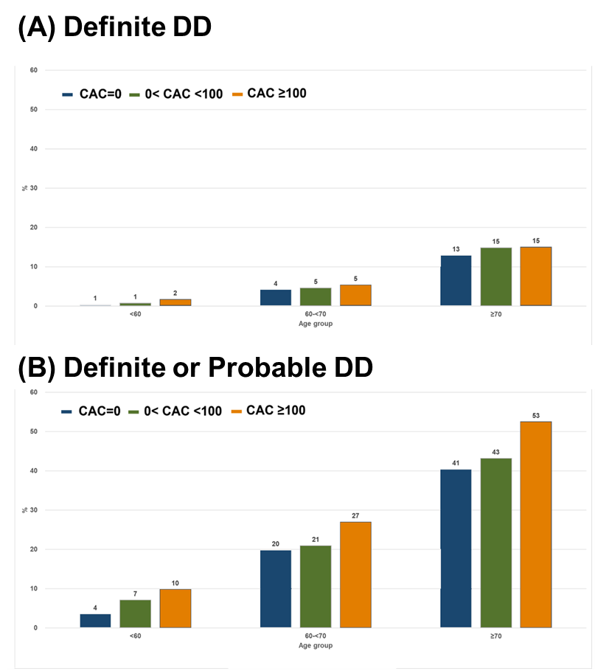
Supplementary Figure 2. Prevalence of definite DD (A) and definite or probable DD (B) according to age by CAC group
Abbreviation: CAC: coronary artery calcium; DD, diastolic dysfunction.

