Title：Impact of COVID-19 Restrictions Liberalization on Air Quality: A Case Study of Chongqing, Southwest China
Haozheng Wangª, Liuyi Zhang^{a*}, Yuanjun Chen^{c}, Guangming Shi^{b*}, Chentao Huangª, Fumo Yang^{a,b}，Weihao Liª
ª Chongqing Key Laboratory of Water Environment Evolution and Pollution Prevention and Control in Three Gorges Reservoir Area, Chongqing Three Gorges University, Chongqing 404000, China
^{b} College of Carbon Neutrality Future Technology, Sichuan University, Chengdu 610065, China
^{c} Wanzhou Meteorological Bureau of Chongqing, Wanzhou 404000, China
*Correspondence: zhangliuyi@sanxiau.edu.cn; shigm@scu.edu.cn
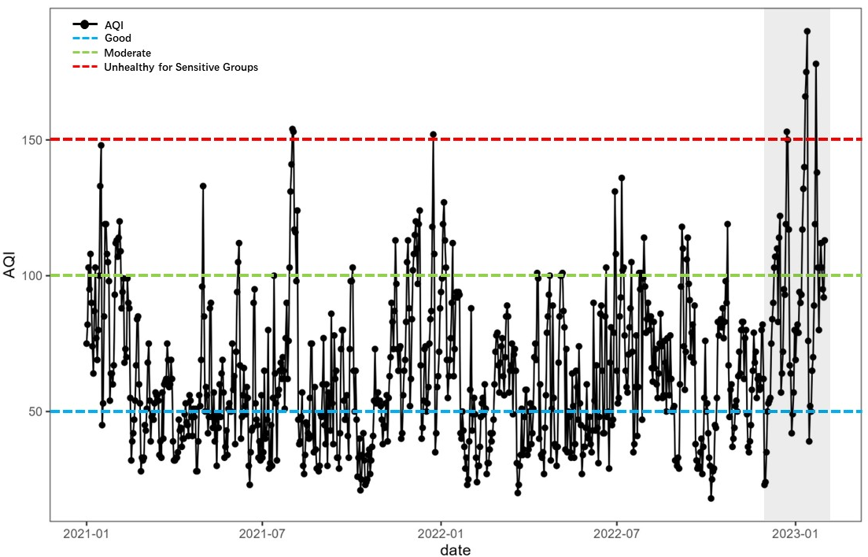
Fig.S1. Changes in AQI and three different air quality levels in Chongqing from January 2021 to January 2023 ( the shadow part is after the opening of the epidemic )
Based on the AQI data of 761 days from January 1st, 2021, to January 31st, 2023 in Chongqing, the daily variation of AQI was plotted (Fig. S1). The result show that 1.1%, 10.2% and 88.7% of the days were heavily, moderately and non-polluting, respectively, with a total of 8 days of heavy pollution, compared to 4 days of heavy pollution in the post-liberalization free period (January 2023), which may be related to the full liberalization of the restrictive policies. The shadow part represents the research period ( after the restrictive measures were lifted ). The average AQI before the liberalization was 62.0, and the average value rose to 82.5 after the liberalization. It can be seen that the release was significantly higher than the restriction period. Table S1 compares the average value of AQI in different periods. P1, P2, P3 and AQI showed an upward trend. P2 was 32.6 % higher than P1 because people began to travel and industry began to resume production after the lockdown was lifted. P3 was 65.6 % higher than P1 mainly due to the complete release of the restrictive measures, the infected people gradually recovered and returned to normal living conditions. At this time, it was also the Spring Festival. The frequent flow of people and the superposition of fireworks and firecrackers caused a significant increase in AQI of P3 compared with P1. During the P1 period, the air quality of Chongqing was in two states of excellent or good, and pollution-free weather appeared. However, with the sudden liberalization of the restrictive policies, the air quality in the P2 period was significantly worse than that in the P1 period, and some moderate pollution occurred, and the proportion of air quality pollution days was 32 %. The proportion of pollution days in P3 period reached 45 %. During this period, although there are some seasonal factors, such as winter meteorological conditions and temperature inversion to prevent the spread of pollutants, resulting in high pollutant levels (Marangon et al., 2021 , Tan et al., 2023). Compared with the AQI increase of only 4.2 % ( Table S1 ) from November 2021 to January 2022 ( P1’-P3’ ), the P1-P3 period increased by 65.6 %, indicating that the impact of the restrictive policies on air quality is significant. Therefore, we need to specifically analyze the changes of air pollutants in different periods, and provide reference for the prevention and control of air pollution in similar scenarios in the future.

Research period | AQI Monthly average
P1  P2  P3  P1'  P2'  P3' | 62.0  82.2  102.7  68.4  81.9  71.3
Table S1 Monthly mean values of AQI for the study period (P1-P3) and the same period in 2021 and 2022 (P1'-P3')
Table S2 Detailed information of air quality monitoring stations
Code | Station Name | Latitude | Longitude | Area
1414A | Jinyun Mountain | 106.378975 | 29.827246 | Bei Bei
1416A | Tian Sheng | 106.423963 | 29.826471 | Bei Bei
1417A | Liang Lu | 106.626 | 29.72283 | Yu Bei
1418A | Hu Xi | 106.296 | 29.59837 | Shaping Ba
1419A | Nan Ping | 106.5732 | 29.53111 | Nan An
1420A | Tangjia Tuo | 106.6496 | 29.62212 | Jiang Bei
1421A | Cha Yuan | 106.634 | 29.48923 | Nan An
1422A | Baishi Yi | 106.3641 | 29.48232 | Jiulong Po
1425A | Kong Gang | 106.6167 | 29.71243 | Yu Bei
1426A | Xinshan Cun | 106.468 | 29.48927 | Dadu Kou
1427A | Li Jia | 106.562 | 29.64529 | Yu Bei
1428A | Cai Jia | 106.452 | 29.70917 | Bei Bei
1429A | Yuxin Street | 106.513 | 29.38906 | Ba Nan
3014A | Xietai Zi | 106.4959 | 29.53675 | Jiulong Po
3015A | Longjing Wan | 106.4057 | 29.57307 | Shaping Ba
3016A | Longzhou Wan | 106.5506 | 29.4157 | Ba Nan
3133A | Shangqing Si | 106.549 | 29.56631 | Yu Zhong
3346A | An Kang | 108.3852 | 31.16442 | Kai Zhou
3347A | Beishan Road | 105.8971 | 29.35758 | Yong Chuan
3348A | Chunyang Street | 105.8393 | 30.1949 | Tong Nan
3349A | Renmin East Road | 107.7985 | 30.67573 | Liang ping
3350A | Tanzi Kou | 106.648 | 29.02468 | Qi Jiang
3351A | Tang Xiang | 105.717 | 29.70539 | Da Zu
3352A | Taoyuan West Road | 107.0732 | 29.8617 | Chang Shou
3353A | Yingbin Road | 107.3519 | 29.7269 | Fu Ling
3354A | Zhou Bai | 108.8149 | 29.50802 | Qian Jiang
3355A | Zhoujia Ba | 108.3679 | 30.84261 | Wan Zhou
3356A | Baian Ba | 108.4328 | 30.75776 | Wan Zhou
3482A | Furong Middle Road | 107.7543 | 29.32756 | Wu Long
3483A | Xi Shan | 108.7662 | 29.53706 | Qian Jiang
3484A | Administrative Centre | 106.2628 | 29.32003 | Jiang Jin
3485A | Gaosi Road | 107.0949 | 29.16005 | Nan Chuan
3599A | Shuyuan Road | 106.2655 | 29.98608 | He Chuan
3600A | Hu Feng | 106.2339 | 29.55595 | Bi Shan
3601A | Longmen Street | 106.0502 | 29.83427 | Tong Liang
3610A | Chang Yuan | 105.5933 | 29.41052 | Rong Chang

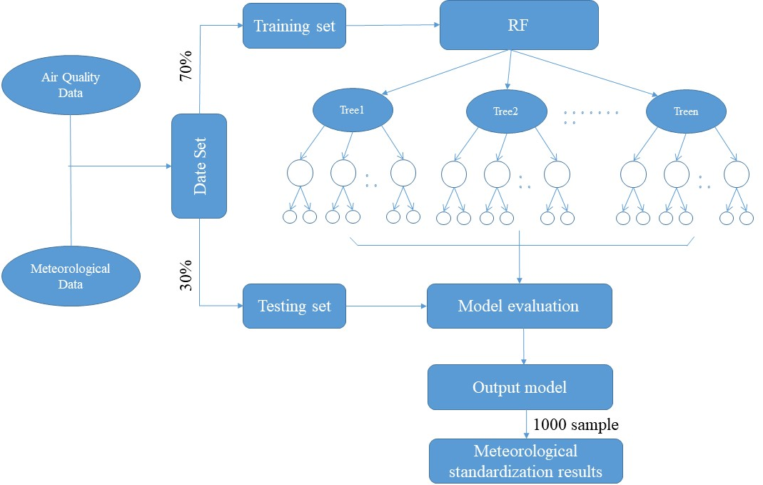
Fig. S2. Meteorological normalization flow chart
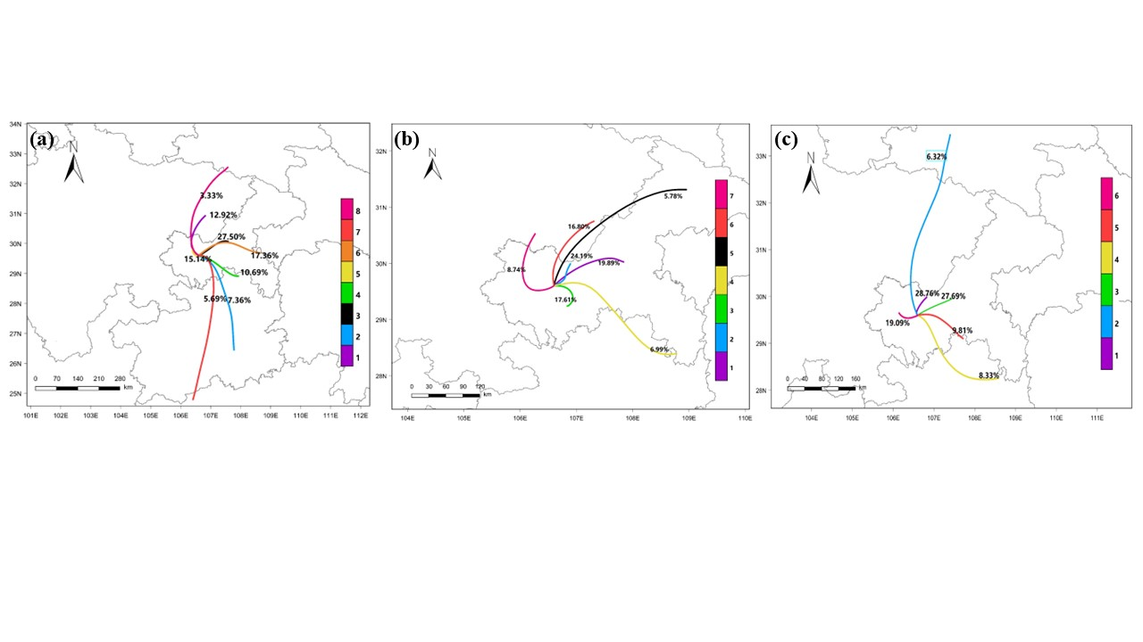
Fig. S3. Clustering results of air mass trajectories in Chongqing during different periods (a, b, and c represent P1, P2, and P3, respectively)
Table S3 The changes of air pollutant concentration in different regions during the lockdown period(Lockdown) and the normalized restriction of lockdown release(Post-Lockdown)
Area | Lockdown | Post-Lockdown | Change in different stages（%） | Reference
Jiangsu, China  Wuhan, China  Southwest coast of India  (Three Area) | PM_{2.5}:42.39μg/m³  PM₁₀:62.64μg/m³  NO₂:28.73μg/m³  CO:0.70mg/m³  PM₁₀:50.46μg/m³  NO₂:21.34μg/m³  PM_{2.5}:6.1μg/m³  PM_{2.5}:20.9μg/m³  PM_{2.5}:11.3μg/m³  PM₁₀:19.7μg/m³  PM₁₀:51.2μg/m³  PM₁₀:30.8μg/m³  NO₂:14.3μg/m³  NO₂:15.4μg/m3  NO₂:7.8μg/m³  O₃:18.4μg/m³  O₃:14.5μg/m³  O₃:7.3 | PM_{2.5}:41.50μg/m³  PM₁₀:77.17μg/m³  NO₂:33.50μg/m³  CO:0.71 mg/m³  PM₁₀:53.42μg/m³  NO₂:33.19μg/m³  PM_{2.5}:6.8μg/m³  PM_{2.5}:28.9μg/m³  PM_{2.5}:12.7μg/m³  PM₁₀:26.8μg/m³  PM₁₀:65.7μg/m³  PM₁₀:31.2μg/m³  NO₂:17.8μg/m³  NO₂:22.5μg/m³  NO₂:7.4μg/m³  O₃:14.5μg/m³  O₃:13.2μg/m³  O₃:7.6μg/m³ | PM_{2.5}:-2.1%  PM₁₀:+23.2%  NO₂:+16.6%  CO:+1.4%  PM₁₀:+5.9%  NO₂:+55.5%  PM_{2.5}:+11.5%~+38.3%  PM₁₀:+1.3%~+36.0%  NO₂:-5.1%~+46.1%  O₃:-21.2%~+4.1% | (Bhatti et al., 2022)  (Sulaymon et al., 2021)  (Thomas et al., 2023)

References：
Bhatti U A, Zeeshan Z, Nizamani M M, et al. 2022. Assessing the change of ambient air quality patterns in Jiangsu Province of China pre-to post-COVID-19. Chemosphere [J], 288: 132569. https://doi.org/10.1016/j.chemosphere.2021.132569
Marangon D, Traversi D, D'Agostino A M, et al. 2021. The North-western Italy air quality monitoring network: Improving experience of PM2.5 assessment with mutagenicity assay. Environ Res [J], 195: 110699. https://doi.org/10.1016/j.envres.2020.110699
Sulaymon I D, Zhang Y, Hopke P K, et al. 2021. COVID-19 pandemic in Wuhan: Ambient air quality and the relationships between criteria air pollutants and meteorological variables before, during, and after lockdown. Atmos Res [J], 250: 105362. https://doi.org/10.1016/j.atmosres.2020.105362
Tan S, Xie D, Ni C, et al. 2023. Spatiotemporal characteristics of air pollution in Chengdu-Chongqing urban agglomeration (CCUA) in Southwest, China: 2015-2021. J Environ Manage [J], 325: 116503. https://doi.org/10.1016/j.jenvman.2022.116503
Thomas G, Thomas J, Devika R S, et al. 2023. Impact of COVID-19 Lockdown on Ambient Air Quality in the Southwest Coastal Urban Regions of India. Aerosol Science and Engineering [J]. https://doi.org/10.1007/s41810-023-00180-x

