Supplementary Information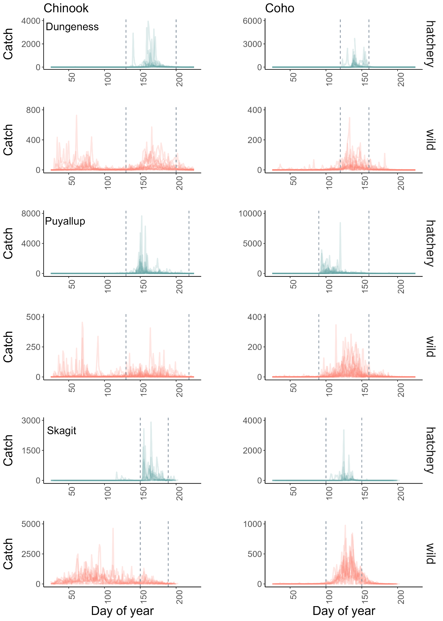
Figure S1 - Daily catches for hatchery and wild sub-yearling Chinook salmon, hatchery and wild yearling coho salmon in the Dungeness (years 2005-2020), Puyallup (years 2004-2021), and Skagit rivers (years 2010-2022). Raw data without interpolation from every year available is overlaid. The vertical dashed lines bracket the period when both hatchery and wild salmon were caught in the trap, which was the portion of data we used for the analysis.

River | Species | Origin | Total number caught | Max number caught
Dungeness | Chinook | hatchery | 62146 | 3274
Dungeness | Chinook | wild | 42836 | 355
Dungeness | Coho | hatchery | 58857 | 1983
Dungeness | Coho | wild | 15414 | 348
Puyallup | Chinook | hatchery | 153030 | 7429
Puyallup | Chinook | wild | 15360 | 342
Puyallup | Coho | hatchery | 155593 | 8436
Puyallup | Coho | wild | 27759 | 291
Skagit | Chinook | hatchery | 51332 | 2912
Skagit | Chinook | wild | 47285 | 982
Skagit | Coho | hatchery | 29207 | 3364
Skagit | Coho | wild | 83347 | 976
Table S1 - Total and maximum number of fish caught in the trap during the days and years used in our analysis.

Unmarked hatchery salmon
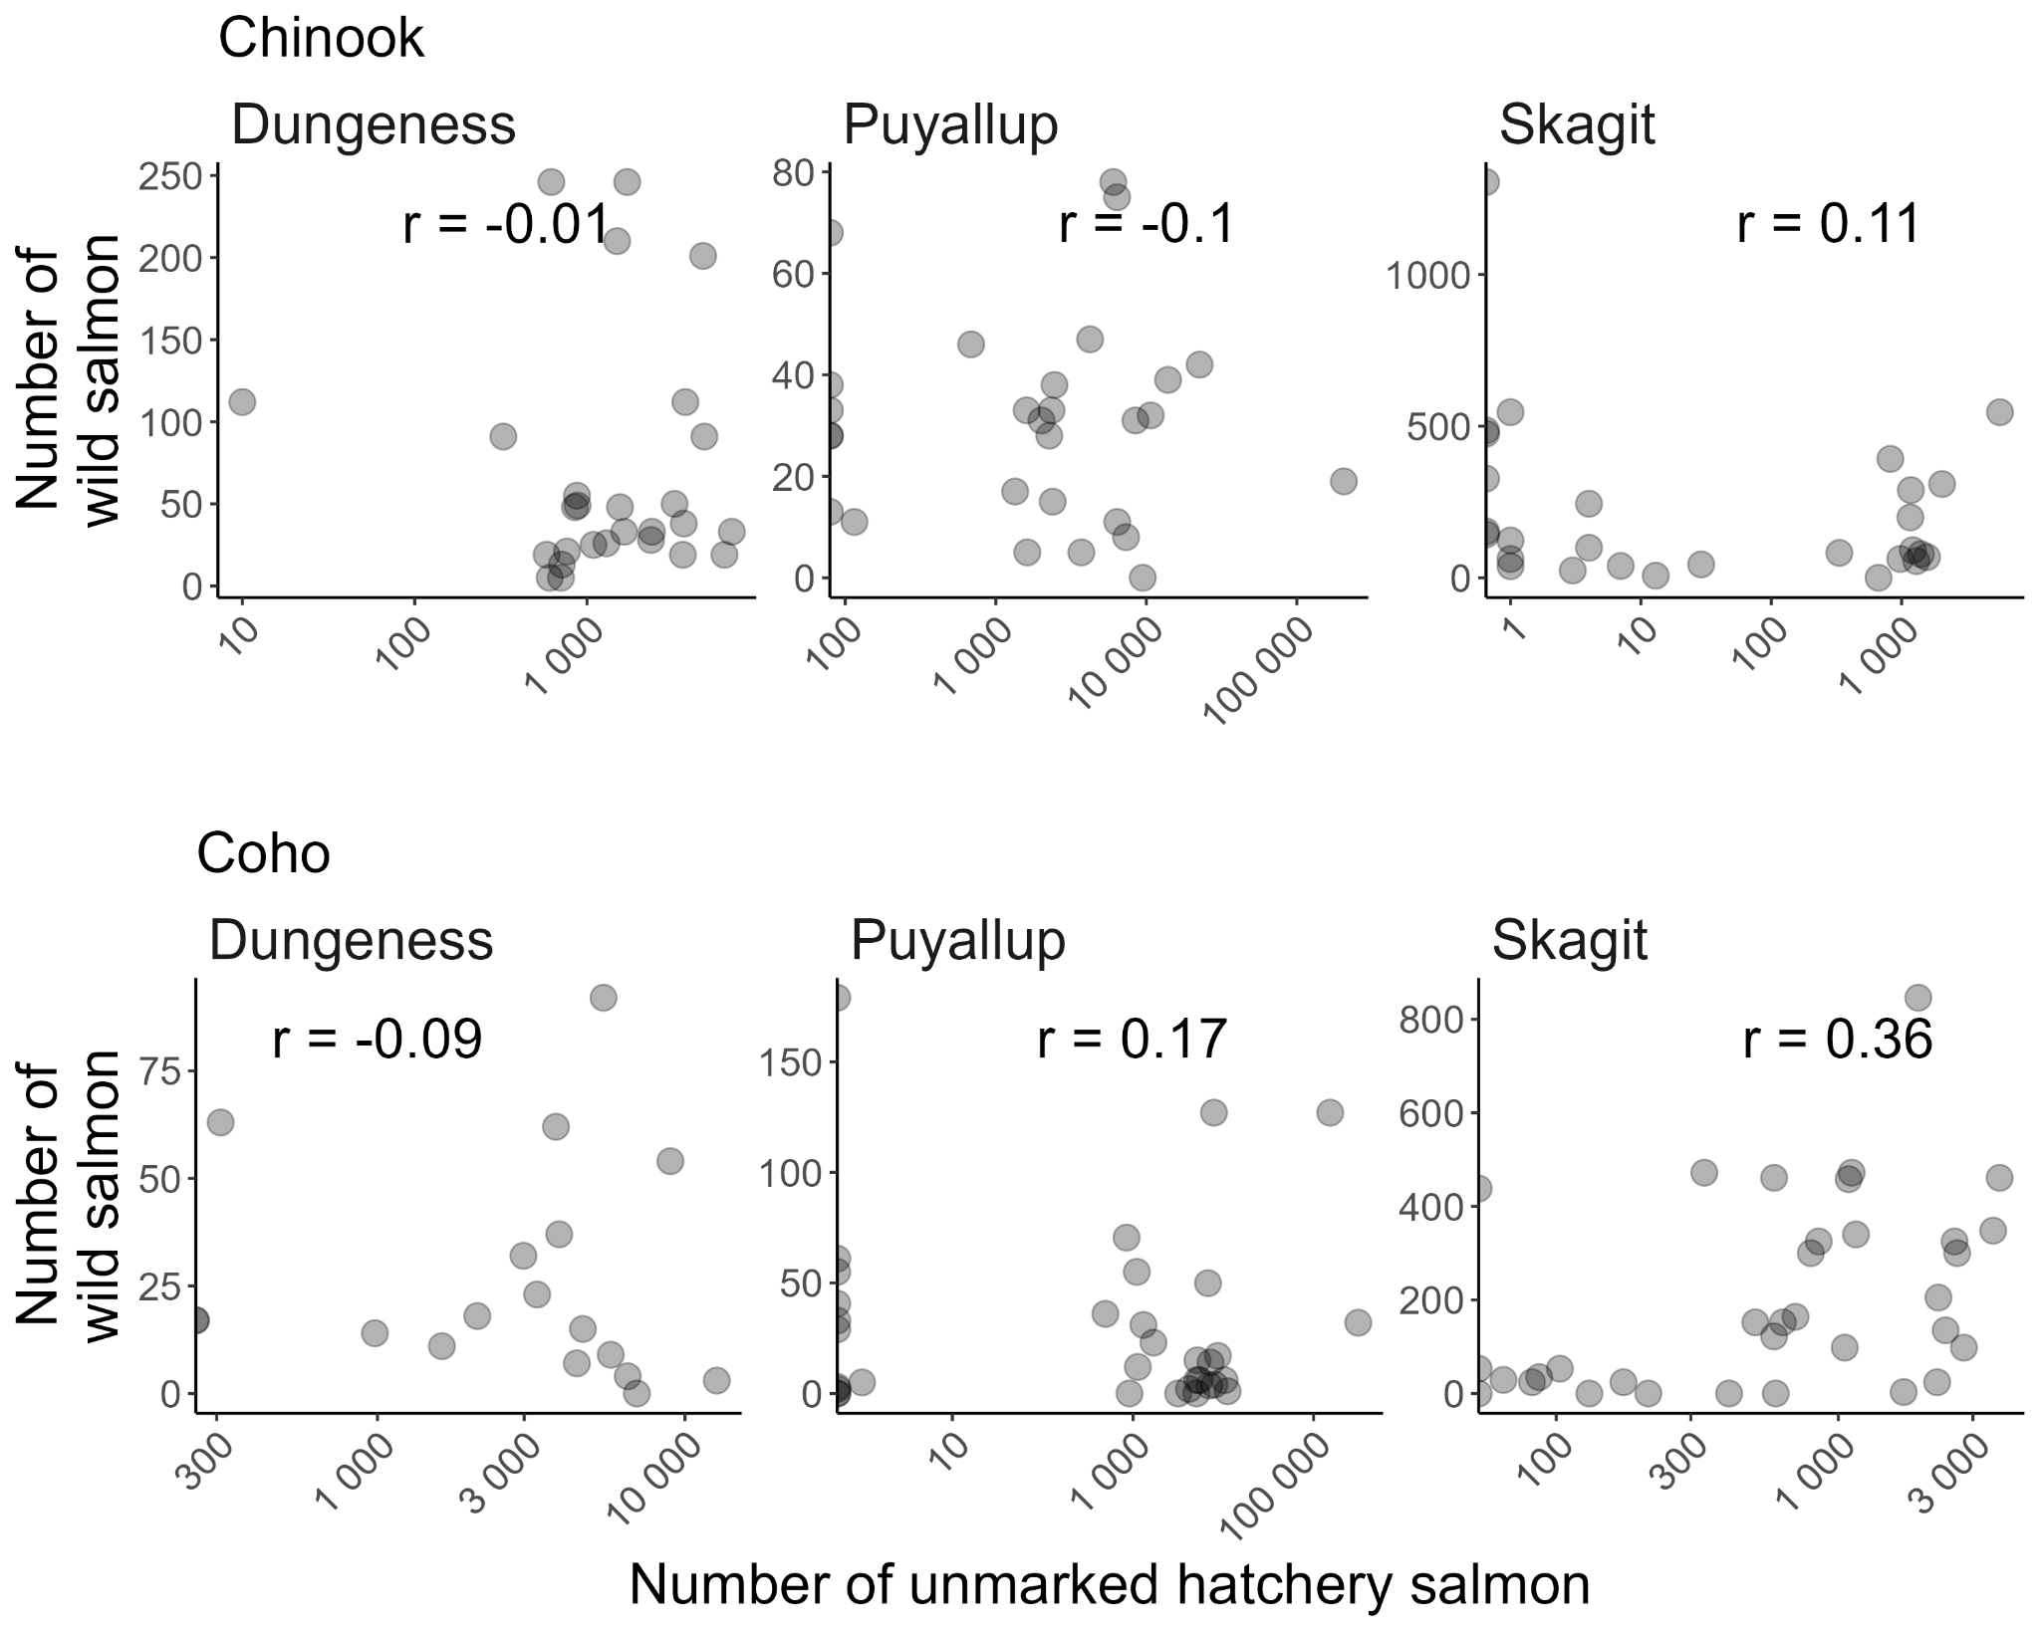
Figure S1 - Correlation between unmarked hatchery salmon and wild salmon for Chinook and coho salmon in the Dungeness, Puyallup, and Skagit rivers. Each data point represents a day with the maximum number of hatchery salmon caught in the trap within ten days of a hatchery release. Note log scale on the x-axis.

Proportion of day vs. night migrants
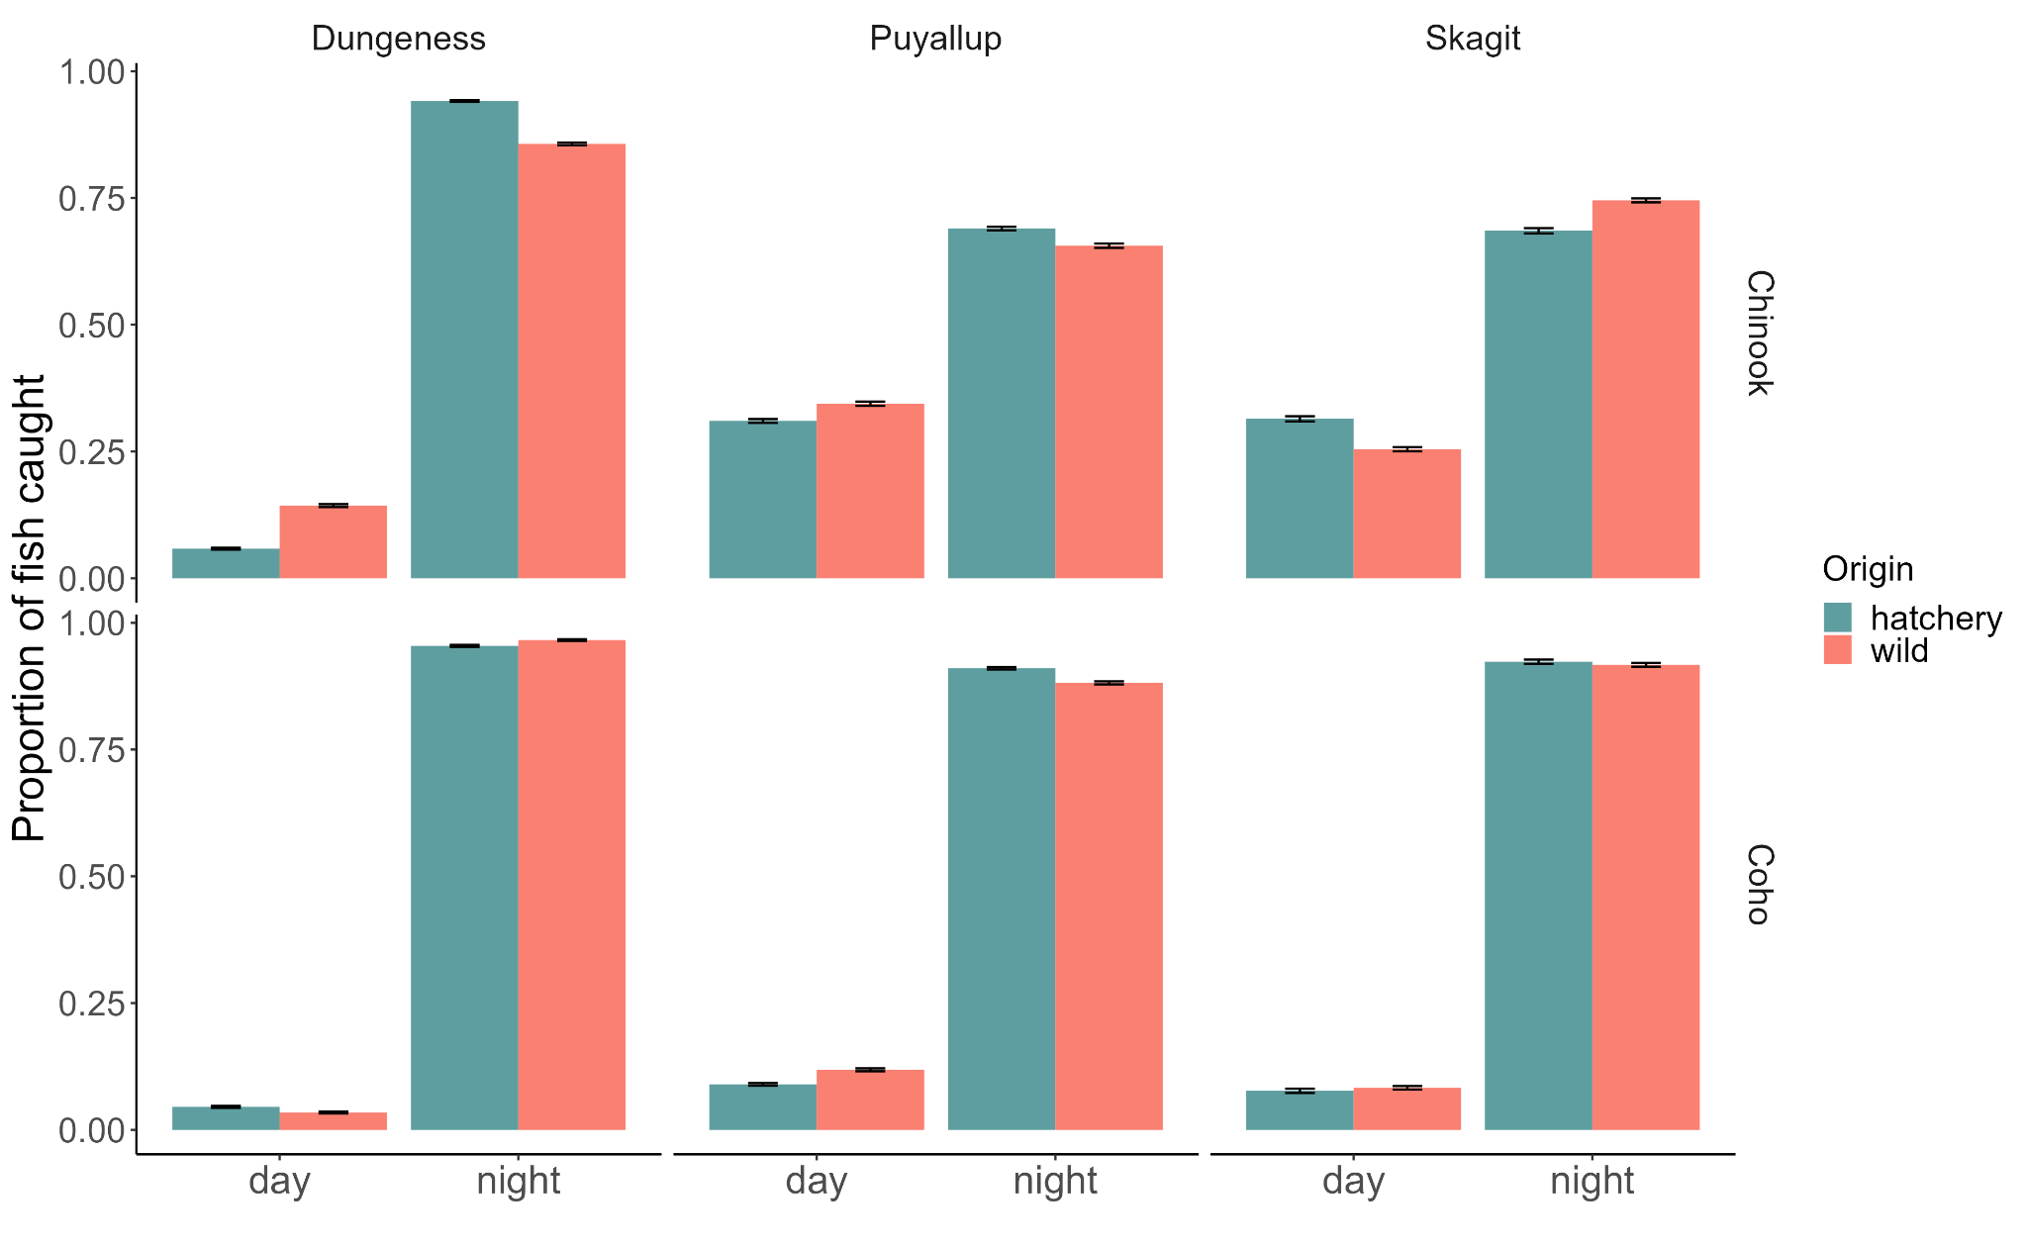
Figure S2 - Average proportion of Chinook salmon and coho salmon caught in the trap at night vs. day in all three rivers.

Dungeness River
The Dungeness River is a 45-km river in the northwest part of Washington State. It originates in the Olympic Mountains and drains into the Strait of Juan de Fuca. The Dungeness River is fed through melting snowpack from the Olympic Mountains and by rain. The lowest flows are in August-September whereas the highest temperature is around 15° C in July-August. The Dungeness River supports seven species of salmonids - Chinook, coho, chum and pink salmon, steelhead, cutthroat and bull trout. There are multiple hatcheries that release Chinook and coho salmon and steelhead into the river at various stages. The Dungeness River hatchery, Gray Wolf, Hurd Creek, and Upper Dungeness Hatchery are the main hatcheries on the Dungeness River. A rotary screw trap is used to monitor juvenile salmon that migrate from their natal site to the ocean. The trap, operated by the Washington Department of Fish and Wildlife (WDFW), is located about 1.6 km upstream of the Strait of Juan De Fuca (48.1441, -123.1283).

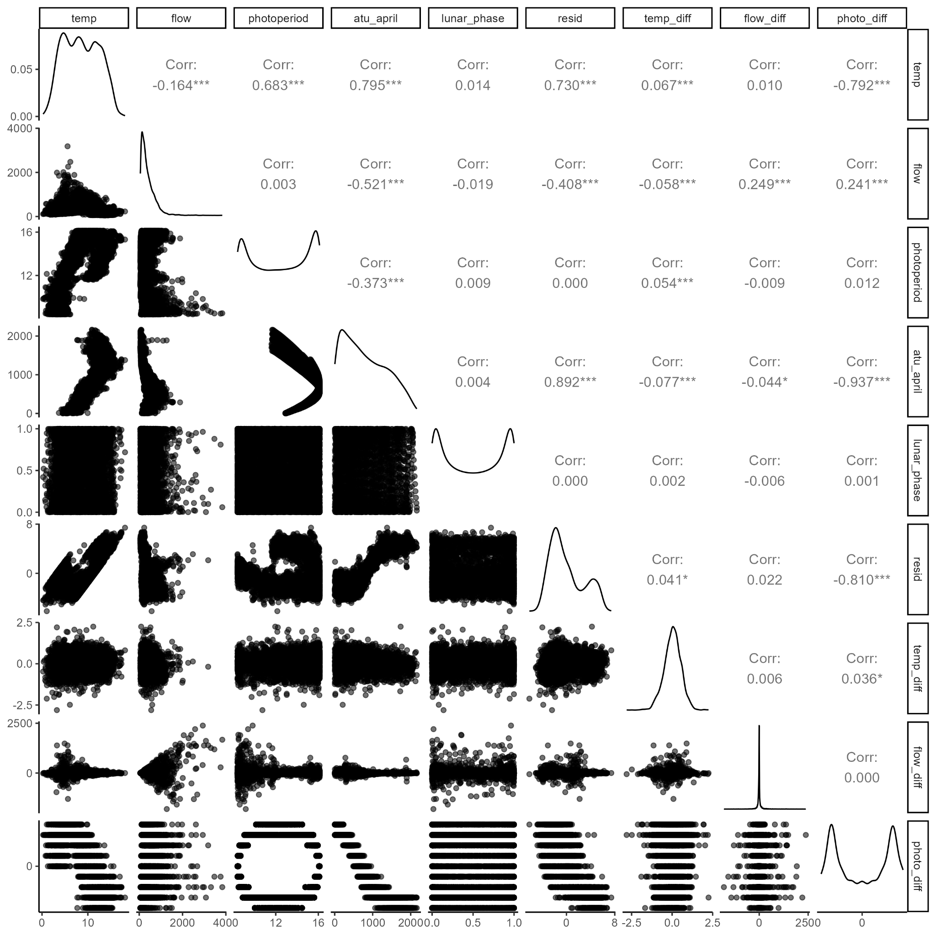
Figure S3 - Correlation between all the environmental covariates in the Dungeness River.

Chinook |  | Coho
Covariate | $$ΔAICc$$ | Covariate | $$ΔAICc$$
Photoperiod difference | 0 | Photoperiod | 0
Flow | 3.73 | ATU | 3.03
ATU | 5.50 | Flow | 27.9
Temperature | 8.37 | Temperature | 30.01
Residuals | 12.56 | Photoperiod difference | 43.12
Photoperiod | 25.09 | Residuals | 44.16
Table S2 - Model selection for Chinook salmon and coho salmon in the Dungeness with each of the correlated covariates.

Photoperiod | Photoperiod difference | Temperature difference | flow | Flow difference | Lunar phase | Hatchery | $ΔAICc$ | rel.LL | weights | Cumulative weights
0 | 1 | 1 | 0 | 1 | 0 | 1 | 0 | 1 | 0.24 | 0.24
0 | 1 | 1 | 0 | 1 | 1 | 1 | 0.42 | 0.81 | 0.2 | 0.44
1 | 1 | 1 | 0 | 1 | 0 | 1 | 0.82 | 0.66 | 0.16 | 0.6
1 | 1 | 1 | 0 | 1 | 1 | 1 | 1.21 | 0.55 | 0.13 | 0.73
0 | 1 | 1 | 1 | 1 | 0 | 1 | 2.09 | 0.35 | 0.09 | 0.82
0 | 1 | 1 | 1 | 1 | 1 | 1 | 2.51 | 0.28 | 0.07 | 0.89
1 | 1 | 1 | 1 | 1 | 0 | 1 | 2.9 | 0.23 | 0.06 | 0.94
1 | 1 | 1 | 1 | 1 | 1 | 1 | 3.29 | 0.19 | 0.05 | 0.99
1 | 0 | 1 | 1 | 1 | 0 | 1 | 9.98 | 0.01 | 0 | 0.99
1 | 0 | 1 | 1 | 1 | 1 | 1 | 10.27 | 0.01 | 0 | 0.99
1 | 0 | 1 | 0 | 1 | 0 | 1 | 10.72 | 0 | 0 | 1
0 | 1 | 1 | 0 | 1 | 0 | 0 | 11.06 | 0 | 0 | 1
1 | 0 | 1 | 0 | 1 | 1 | 1 | 11.09 | 0 | 0 | 1
1 | 1 | 1 | 0 | 1 | 0 | 0 | 12.15 | 0 | 0 | 1
0 | 1 | 1 | 0 | 1 | 1 | 0 | 12.44 | 0 | 0 | 1
0 | 1 | 1 | 1 | 1 | 0 | 0 | 12.81 | 0 | 0 | 1
1 | 1 | 1 | 0 | 1 | 1 | 0 | 13.44 | 0 | 0 | 1
1 | 1 | 1 | 1 | 1 | 0 | 0 | 14.08 | 0 | 0 | 1
0 | 1 | 1 | 1 | 1 | 1 | 0 | 14.15 | 0 | 0 | 1
1 | 1 | 1 | 1 | 1 | 1 | 0 | 15.36 | 0 | 0 | 1
0 | 0 | 1 | 1 | 1 | 0 | 1 | 18.57 | 0 | 0 | 1
0 | 0 | 1 | 1 | 1 | 1 | 1 | 18.91 | 0 | 0 | 1
0 | 0 | 1 | 0 | 1 | 0 | 1 | 21.12 | 0 | 0 | 1
0 | 0 | 1 | 0 | 1 | 1 | 1 | 21.56 | 0 | 0 | 1
1 | 1 | 1 | 0 | 0 | 0 | 1 | 28.41 | 0 | 0 | 1
0 | 1 | 1 | 0 | 0 | 0 | 1 | 28.46 | 0 | 0 | 1
1 | 1 | 1 | 0 | 0 | 1 | 1 | 29.34 | 0 | 0 | 1
0 | 1 | 1 | 0 | 0 | 1 | 1 | 29.43 | 0 | 0 | 1
1 | 1 | 1 | 1 | 0 | 0 | 1 | 29.62 | 0 | 0 | 1
0 | 1 | 1 | 1 | 0 | 0 | 1 | 30 | 0 | 0 | 1
0 | 0 | 1 | 1 | 1 | 0 | 0 | 30.21 | 0 | 0 | 1
1 | 0 | 1 | 1 | 1 | 0 | 0 | 30.47 | 0 | 0 | 1
1 | 1 | 1 | 1 | 0 | 1 | 1 | 30.5 | 0 | 0 | 1
0 | 1 | 1 | 1 | 0 | 1 | 1 | 30.95 | 0 | 0 | 1
0 | 0 | 1 | 1 | 1 | 1 | 0 | 31.51 | 0 | 0 | 1
1 | 0 | 1 | 1 | 1 | 1 | 0 | 31.87 | 0 | 0 | 1
1 | 0 | 1 | 1 | 0 | 0 | 1 | 36.38 | 0 | 0 | 1
0 | 1 | 1 | 0 | 0 | 0 | 0 | 36.56 | 0 | 0 | 1
1 | 0 | 1 | 0 | 1 | 0 | 0 | 36.78 | 0 | 0 | 1
0 | 0 | 1 | 0 | 1 | 0 | 0 | 37.01 | 0 | 0 | 1
0 | 1 | 1 | 1 | 0 | 0 | 0 | 37.1 | 0 | 0 | 1
1 | 0 | 1 | 1 | 0 | 1 | 1 | 37.16 | 0 | 0 | 1
0 | 1 | 1 | 0 | 0 | 1 | 0 | 38.19 | 0 | 0 | 1
1 | 0 | 1 | 0 | 1 | 1 | 0 | 38.36 | 0 | 0 | 1
1 | 1 | 1 | 0 | 0 | 0 | 0 | 38.41 | 0 | 0 | 1
0 | 0 | 1 | 0 | 1 | 1 | 0 | 38.5 | 0 | 0 | 1
0 | 1 | 1 | 1 | 0 | 1 | 0 | 38.67 | 0 | 0 | 1
1 | 1 | 1 | 1 | 0 | 0 | 0 | 39.12 | 0 | 0 | 1
1 | 1 | 1 | 0 | 0 | 1 | 0 | 40.01 | 0 | 0 | 1
1 | 1 | 1 | 1 | 0 | 1 | 0 | 40.67 | 0 | 0 | 1
1 | 0 | 1 | 0 | 0 | 0 | 1 | 41.06 | 0 | 0 | 1
1 | 0 | 1 | 0 | 0 | 1 | 1 | 41.95 | 0 | 0 | 1
0 | 0 | 1 | 1 | 0 | 0 | 1 | 48.28 | 0 | 0 | 1
0 | 0 | 1 | 1 | 0 | 1 | 1 | 49.14 | 0 | 0 | 1
1 | 0 | 1 | 1 | 0 | 0 | 0 | 54.45 | 0 | 0 | 1
1 | 0 | 1 | 1 | 0 | 1 | 0 | 56.08 | 0 | 0 | 1
0 | 0 | 1 | 0 | 0 | 0 | 1 | 56.22 | 0 | 0 | 1
0 | 0 | 1 | 1 | 0 | 0 | 0 | 56.3 | 0 | 0 | 1
0 | 0 | 1 | 0 | 0 | 1 | 1 | 57.22 | 0 | 0 | 1
0 | 0 | 1 | 1 | 0 | 1 | 0 | 57.83 | 0 | 0 | 1
1 | 0 | 1 | 0 | 0 | 0 | 0 | 66.16 | 0 | 0 | 1
1 | 0 | 1 | 0 | 0 | 1 | 0 | 67.98 | 0 | 0 | 1
0 | 0 | 1 | 0 | 0 | 0 | 0 | 69.13 | 0 | 0 | 1
0 | 0 | 1 | 0 | 0 | 1 | 0 | 70.86 | 0 | 0 | 1
1 | 1 | 0 | 1 | 1 | 0 | 1 | 84.74 | 0 | 0 | 1
1 | 1 | 0 | 1 | 1 | 1 | 1 | 84.84 | 0 | 0 | 1
1 | 0 | 0 | 1 | 1 | 0 | 1 | 85.38 | 0 | 0 | 1
1 | 0 | 0 | 1 | 1 | 1 | 1 | 85.44 | 0 | 0 | 1
0 | 1 | 0 | 1 | 1 | 0 | 1 | 86.63 | 0 | 0 | 1
0 | 1 | 0 | 1 | 1 | 1 | 1 | 86.81 | 0 | 0 | 1
1 | 1 | 0 | 0 | 1 | 0 | 1 | 88.31 | 0 | 0 | 1
1 | 1 | 0 | 0 | 1 | 1 | 1 | 88.51 | 0 | 0 | 1
0 | 1 | 0 | 0 | 1 | 0 | 1 | 89.17 | 0 | 0 | 1
0 | 1 | 0 | 0 | 1 | 1 | 1 | 89.43 | 0 | 0 | 1
0 | 1 | 0 | 1 | 1 | 0 | 0 | 89.87 | 0 | 0 | 1
0 | 1 | 0 | 1 | 1 | 1 | 0 | 90.77 | 0 | 0 | 1
1 | 1 | 0 | 1 | 1 | 0 | 0 | 91.8 | 0 | 0 | 1
1 | 1 | 0 | 1 | 1 | 1 | 0 | 92.74 | 0 | 0 | 1
0 | 1 | 0 | 0 | 1 | 0 | 0 | 94.37 | 0 | 0 | 1
0 | 0 | 0 | 1 | 1 | 0 | 1 | 94.75 | 0 | 0 | 1
0 | 0 | 0 | 1 | 1 | 1 | 1 | 94.85 | 0 | 0 | 1
1 | 0 | 0 | 0 | 1 | 0 | 1 | 95.25 | 0 | 0 | 1
0 | 1 | 0 | 0 | 1 | 1 | 0 | 95.42 | 0 | 0 | 1
1 | 0 | 0 | 0 | 1 | 1 | 1 | 95.42 | 0 | 0 | 1
1 | 1 | 0 | 0 | 1 | 0 | 0 | 96.45 | 0 | 0 | 1
1 | 1 | 0 | 0 | 1 | 1 | 0 | 97.49 | 0 | 0 | 1
1 | 0 | 0 | 1 | 1 | 0 | 0 | 97.63 | 0 | 0 | 1
1 | 0 | 0 | 1 | 1 | 1 | 0 | 98.69 | 0 | 0 | 1
0 | 0 | 0 | 1 | 1 | 0 | 0 | 99.15 | 0 | 0 | 1
0 | 0 | 0 | 1 | 1 | 1 | 0 | 100.04 | 0 | 0 | 1
1 | 1 | 0 | 1 | 0 | 0 | 1 | 102.95 | 0 | 0 | 1
1 | 1 | 0 | 1 | 0 | 1 | 1 | 103.51 | 0 | 0 | 1
1 | 0 | 0 | 1 | 0 | 0 | 1 | 103.92 | 0 | 0 | 1
1 | 0 | 0 | 1 | 0 | 1 | 1 | 104.42 | 0 | 0 | 1
0 | 1 | 0 | 1 | 0 | 0 | 1 | 106.24 | 0 | 0 | 1
0 | 1 | 0 | 1 | 0 | 1 | 1 | 106.9 | 0 | 0 | 1
0 | 1 | 0 | 1 | 0 | 0 | 0 | 107.79 | 0 | 0 | 1
0 | 0 | 0 | 0 | 1 | 0 | 1 | 108.41 | 0 | 0 | 1
0 | 0 | 0 | 0 | 1 | 1 | 1 | 108.67 | 0 | 0 | 1
0 | 1 | 0 | 1 | 0 | 1 | 0 | 108.97 | 0 | 0 | 1
1 | 1 | 0 | 1 | 0 | 0 | 0 | 109.1 | 0 | 0 | 1
1 | 1 | 0 | 0 | 0 | 0 | 1 | 109.97 | 0 | 0 | 1
1 | 1 | 0 | 1 | 0 | 1 | 0 | 110.35 | 0 | 0 | 1
1 | 1 | 0 | 0 | 0 | 1 | 1 | 110.67 | 0 | 0 | 1
0 | 1 | 0 | 0 | 0 | 0 | 1 | 111.78 | 0 | 0 | 1
0 | 1 | 0 | 0 | 0 | 1 | 1 | 112.56 | 0 | 0 | 1
1 | 0 | 0 | 1 | 0 | 0 | 0 | 115.15 | 0 | 0 | 1
0 | 1 | 0 | 0 | 0 | 0 | 0 | 115.34 | 0 | 0 | 1
1 | 0 | 0 | 0 | 1 | 0 | 0 | 115.67 | 0 | 0 | 1
0 | 0 | 0 | 1 | 0 | 0 | 1 | 116.42 | 0 | 0 | 1
1 | 0 | 0 | 1 | 0 | 1 | 0 | 116.48 | 0 | 0 | 1
0 | 1 | 0 | 0 | 0 | 1 | 0 | 116.68 | 0 | 0 | 1
0 | 0 | 0 | 1 | 0 | 1 | 1 | 117.01 | 0 | 0 | 1
1 | 0 | 0 | 0 | 1 | 1 | 0 | 117.03 | 0 | 0 | 1
1 | 1 | 0 | 0 | 0 | 0 | 0 | 117.28 | 0 | 0 | 1
0 | 0 | 0 | 0 | 1 | 0 | 0 | 118.35 | 0 | 0 | 1
1 | 1 | 0 | 0 | 0 | 1 | 0 | 118.65 | 0 | 0 | 1
0 | 0 | 0 | 1 | 0 | 0 | 0 | 119.06 | 0 | 0 | 1
0 | 0 | 0 | 0 | 1 | 1 | 0 | 119.57 | 0 | 0 | 1
1 | 0 | 0 | 0 | 0 | 0 | 1 | 119.96 | 0 | 0 | 1
0 | 0 | 0 | 1 | 0 | 1 | 0 | 120.22 | 0 | 0 | 1
1 | 0 | 0 | 0 | 0 | 1 | 1 | 120.63 | 0 | 0 | 1
0 | 0 | 0 | 0 | 0 | 0 | 1 | 138.12 | 0 | 0 | 1
0 | 0 | 0 | 0 | 0 | 1 | 1 | 138.93 | 0 | 0 | 1
1 | 0 | 0 | 0 | 0 | 0 | 0 | 140.43 | 0 | 0 | 1
1 | 0 | 0 | 0 | 0 | 1 | 0 | 142.07 | 0 | 0 | 1
0 | 0 | 0 | 0 | 0 | 0 | 0 | 146.49 | 0 | 0 | 1
0 | 0 | 0 | 0 | 0 | 1 | 0 | 147.99 | 0 | 0 | 1
Table S3 - Model selection with all combinations of uncorrelated covariates for Chinook yearlings in the Dungeness River.

Chinook |  | Coho
Variable | Relative Importance | Variable | Relative Importance
Temperature difference | 1 | Photoperiod | 1
Flow difference | 1 | Flow difference | 1
Photoperiod difference | 1 | Flow | 0.9
Hatchery | 1 | Temperature difference | 0.5
Lunar Phase | 0.4 | Hatchery | 0.4
Photoperiod | 0.4 | Photoperiod difference | 0.3
Flow | 0.3 | Lunar phase | 0.3
Table S4 - Relative variable importance for all variables used in the model selection process for sub-yearling Chinook salmon and yearling coho salmon in the Dungeness River.

Photoperiod | Photo difference | Temperature difference | Flow | Flow difference | Lunar phase | Hatchery | $$ΔAICc$$ | rel.LL | weights | Cumulative weights
1 | 0 | 1 | 1 | 1 | 0 | 0 | 0 | 1 | 0.17 | 0.17
1 | 0 | 0 | 1 | 1 | 0 | 0 | 0.52 | 0.77 | 0.13 | 0.31
1 | 0 | 1 | 1 | 1 | 0 | 1 | 1.01 | 0.6 | 0.11 | 0.41
1 | 0 | 0 | 1 | 1 | 0 | 1 | 1.16 | 0.56 | 0.1 | 0.51
1 | 0 | 1 | 1 | 1 | 1 | 0 | 2 | 0.37 | 0.06 | 0.58
1 | 1 | 1 | 1 | 1 | 0 | 0 | 2.14 | 0.34 | 0.06 | 0.64
1 | 1 | 0 | 1 | 1 | 0 | 0 | 2.5 | 0.29 | 0.05 | 0.69
1 | 0 | 0 | 1 | 1 | 1 | 0 | 2.53 | 0.28 | 0.05 | 0.74
1 | 0 | 1 | 1 | 1 | 1 | 1 | 3.02 | 0.22 | 0.04 | 0.77
1 | 1 | 1 | 1 | 1 | 0 | 1 | 3.15 | 0.21 | 0.04 | 0.81
1 | 0 | 0 | 1 | 1 | 1 | 1 | 3.17 | 0.21 | 0.04 | 0.85
1 | 1 | 0 | 1 | 1 | 0 | 1 | 3.27 | 0.19 | 0.03 | 0.88
1 | 1 | 1 | 1 | 1 | 1 | 0 | 4.14 | 0.13 | 0.02 | 0.9
1 | 1 | 0 | 1 | 1 | 1 | 0 | 4.53 | 0.1 | 0.02 | 0.92
1 | 1 | 1 | 1 | 1 | 1 | 1 | 5.14 | 0.08 | 0.01 | 0.93
1 | 1 | 0 | 1 | 1 | 1 | 1 | 5.3 | 0.07 | 0.01 | 0.95
1 | 0 | 0 | 0 | 1 | 0 | 1 | 5.68 | 0.06 | 0.01 | 0.96
1 | 0 | 0 | 0 | 1 | 0 | 0 | 5.99 | 0.05 | 0.01 | 0.97
1 | 0 | 1 | 0 | 1 | 0 | 1 | 7.47 | 0.02 | 0 | 0.97
1 | 0 | 1 | 0 | 1 | 0 | 0 | 7.51 | 0.02 | 0 | 0.97
1 | 0 | 0 | 0 | 1 | 1 | 1 | 7.76 | 0.02 | 0 | 0.98
1 | 1 | 0 | 0 | 1 | 0 | 0 | 7.79 | 0.02 | 0 | 0.98
1 | 1 | 0 | 0 | 1 | 0 | 1 | 7.82 | 0.02 | 0 | 0.98
1 | 0 | 0 | 0 | 1 | 1 | 0 | 8.08 | 0.02 | 0 | 0.99
1 | 1 | 1 | 0 | 1 | 0 | 0 | 9.51 | 0.01 | 0 | 0.99
1 | 1 | 1 | 0 | 1 | 0 | 1 | 9.55 | 0.01 | 0 | 0.99
1 | 0 | 1 | 0 | 1 | 1 | 1 | 9.56 | 0.01 | 0 | 0.99
1 | 0 | 1 | 0 | 1 | 1 | 0 | 9.6 | 0.01 | 0 | 0.99
1 | 1 | 0 | 0 | 1 | 1 | 0 | 9.89 | 0.01 | 0 | 0.99
1 | 1 | 0 | 0 | 1 | 1 | 1 | 9.91 | 0.01 | 0 | 1
1 | 1 | 1 | 0 | 1 | 1 | 0 | 11.61 | 0 | 0 | 1
1 | 1 | 1 | 0 | 1 | 1 | 1 | 11.64 | 0 | 0 | 1
1 | 0 | 0 | 1 | 0 | 0 | 0 | 12.18 | 0 | 0 | 1
1 | 0 | 0 | 1 | 0 | 0 | 1 | 12.66 | 0 | 0 | 1
1 | 0 | 1 | 1 | 0 | 0 | 0 | 13.3 | 0 | 0 | 1
1 | 0 | 0 | 0 | 0 | 0 | 0 | 13.85 | 0 | 0 | 1
1 | 0 | 0 | 1 | 0 | 1 | 0 | 13.88 | 0 | 0 | 1
1 | 0 | 1 | 1 | 0 | 0 | 1 | 13.9 | 0 | 0 | 1
1 | 0 | 0 | 0 | 0 | 0 | 1 | 14.03 | 0 | 0 | 1
1 | 1 | 0 | 1 | 0 | 0 | 0 | 14.05 | 0 | 0 | 1
1 | 1 | 0 | 1 | 0 | 0 | 1 | 14.25 | 0 | 0 | 1
1 | 0 | 0 | 1 | 0 | 1 | 1 | 14.36 | 0 | 0 | 1
1 | 1 | 1 | 1 | 0 | 0 | 0 | 14.59 | 0 | 0 | 1
1 | 1 | 1 | 1 | 0 | 0 | 1 | 14.98 | 0 | 0 | 1
1 | 0 | 1 | 1 | 0 | 1 | 0 | 14.99 | 0 | 0 | 1
1 | 1 | 0 | 0 | 0 | 0 | 1 | 15.42 | 0 | 0 | 1
1 | 0 | 1 | 1 | 0 | 1 | 1 | 15.59 | 0 | 0 | 1
1 | 0 | 0 | 0 | 0 | 1 | 0 | 15.7 | 0 | 0 | 1
1 | 1 | 0 | 1 | 0 | 1 | 0 | 15.73 | 0 | 0 | 1
1 | 0 | 1 | 0 | 0 | 0 | 0 | 15.73 | 0 | 0 | 1
1 | 0 | 0 | 0 | 0 | 1 | 1 | 15.88 | 0 | 0 | 1
1 | 1 | 0 | 1 | 0 | 1 | 1 | 15.9 | 0 | 0 | 1
1 | 1 | 0 | 0 | 0 | 0 | 0 | 15.91 | 0 | 0 | 1
1 | 0 | 1 | 0 | 0 | 0 | 1 | 16.06 | 0 | 0 | 1
1 | 1 | 1 | 1 | 0 | 1 | 0 | 16.21 | 0 | 0 | 1
1 | 1 | 1 | 1 | 0 | 1 | 1 | 16.58 | 0 | 0 | 1
1 | 1 | 1 | 0 | 0 | 0 | 1 | 17.21 | 0 | 0 | 1
1 | 1 | 0 | 0 | 0 | 1 | 1 | 17.21 | 0 | 0 | 1
1 | 0 | 1 | 0 | 0 | 1 | 0 | 17.59 | 0 | 0 | 1
1 | 1 | 1 | 0 | 0 | 0 | 0 | 17.69 | 0 | 0 | 1
1 | 1 | 0 | 0 | 0 | 1 | 0 | 17.76 | 0 | 0 | 1
1 | 0 | 1 | 0 | 0 | 1 | 1 | 17.91 | 0 | 0 | 1
0 | 0 | 1 | 1 | 1 | 0 | 0 | 18.28 | 0 | 0 | 1
1 | 1 | 1 | 0 | 0 | 1 | 1 | 18.99 | 0 | 0 | 1
1 | 1 | 1 | 0 | 0 | 1 | 0 | 19.53 | 0 | 0 | 1
0 | 0 | 1 | 1 | 1 | 0 | 1 | 19.76 | 0 | 0 | 1
0 | 1 | 1 | 1 | 1 | 0 | 0 | 20.05 | 0 | 0 | 1
0 | 0 | 0 | 1 | 1 | 0 | 0 | 20.36 | 0 | 0 | 1
0 | 0 | 1 | 1 | 1 | 1 | 0 | 20.39 | 0 | 0 | 1
0 | 1 | 1 | 1 | 1 | 0 | 1 | 21.07 | 0 | 0 | 1
0 | 0 | 0 | 1 | 1 | 0 | 1 | 21.37 | 0 | 0 | 1
0 | 0 | 1 | 1 | 1 | 1 | 1 | 21.88 | 0 | 0 | 1
0 | 1 | 1 | 1 | 1 | 1 | 0 | 22.16 | 0 | 0 | 1
0 | 0 | 0 | 1 | 1 | 1 | 0 | 22.48 | 0 | 0 | 1
0 | 1 | 0 | 1 | 1 | 0 | 0 | 22.5 | 0 | 0 | 1
0 | 1 | 1 | 1 | 1 | 1 | 1 | 23.17 | 0 | 0 | 1
0 | 1 | 0 | 1 | 1 | 0 | 1 | 23.28 | 0 | 0 | 1
0 | 0 | 0 | 1 | 1 | 1 | 1 | 23.5 | 0 | 0 | 1
0 | 1 | 0 | 1 | 1 | 1 | 0 | 24.63 | 0 | 0 | 1
0 | 1 | 0 | 1 | 1 | 1 | 1 | 25.4 | 0 | 0 | 1
0 | 0 | 0 | 0 | 1 | 0 | 1 | 39.86 | 0 | 0 | 1
0 | 1 | 1 | 1 | 0 | 0 | 1 | 40.2 | 0 | 0 | 1
0 | 1 | 0 | 0 | 1 | 0 | 1 | 40.26 | 0 | 0 | 1
0 | 1 | 1 | 1 | 0 | 0 | 0 | 40.79 | 0 | 0 | 1
0 | 0 | 0 | 0 | 1 | 0 | 0 | 41.33 | 0 | 0 | 1
0 | 0 | 1 | 1 | 0 | 0 | 0 | 41.44 | 0 | 0 | 1
0 | 1 | 0 | 1 | 0 | 0 | 1 | 41.57 | 0 | 0 | 1
0 | 0 | 0 | 1 | 0 | 0 | 0 | 41.75 | 0 | 0 | 1
0 | 0 | 1 | 0 | 1 | 0 | 1 | 41.83 | 0 | 0 | 1
0 | 1 | 1 | 0 | 1 | 0 | 1 | 41.83 | 0 | 0 | 1
0 | 1 | 1 | 1 | 0 | 1 | 1 | 41.96 | 0 | 0 | 1
0 | 0 | 0 | 0 | 1 | 1 | 1 | 42 | 0 | 0 | 1
0 | 1 | 0 | 0 | 1 | 1 | 1 | 42.42 | 0 | 0 | 1
0 | 1 | 0 | 1 | 0 | 0 | 0 | 42.46 | 0 | 0 | 1
0 | 0 | 1 | 1 | 0 | 0 | 1 | 42.53 | 0 | 0 | 1
0 | 0 | 0 | 1 | 0 | 0 | 1 | 42.55 | 0 | 0 | 1
0 | 1 | 1 | 1 | 0 | 1 | 0 | 42.61 | 0 | 0 | 1
0 | 0 | 1 | 0 | 1 | 0 | 0 | 43.13 | 0 | 0 | 1
0 | 0 | 1 | 1 | 0 | 1 | 0 | 43.33 | 0 | 0 | 1
0 | 1 | 0 | 1 | 0 | 1 | 1 | 43.4 | 0 | 0 | 1
0 | 0 | 0 | 0 | 1 | 1 | 0 | 43.46 | 0 | 0 | 1
0 | 1 | 0 | 0 | 1 | 0 | 0 | 43.46 | 0 | 0 | 1
0 | 0 | 0 | 1 | 0 | 1 | 0 | 43.67 | 0 | 0 | 1
0 | 0 | 1 | 0 | 1 | 1 | 1 | 43.98 | 0 | 0 | 1
0 | 1 | 1 | 0 | 1 | 1 | 1 | 43.99 | 0 | 0 | 1
0 | 1 | 0 | 1 | 0 | 1 | 0 | 44.35 | 0 | 0 | 1
0 | 0 | 1 | 1 | 0 | 1 | 1 | 44.43 | 0 | 0 | 1
0 | 0 | 0 | 1 | 0 | 1 | 1 | 44.47 | 0 | 0 | 1
0 | 1 | 1 | 0 | 1 | 0 | 0 | 45.22 | 0 | 0 | 1
0 | 0 | 1 | 0 | 1 | 1 | 0 | 45.27 | 0 | 0 | 1
0 | 1 | 0 | 0 | 1 | 1 | 0 | 45.6 | 0 | 0 | 1
0 | 1 | 1 | 0 | 1 | 1 | 0 | 47.36 | 0 | 0 | 1
0 | 1 | 0 | 0 | 0 | 0 | 1 | 52.19 | 0 | 0 | 1
0 | 1 | 1 | 0 | 0 | 0 | 1 | 53.68 | 0 | 0 | 1
0 | 1 | 0 | 0 | 0 | 1 | 1 | 54.21 | 0 | 0 | 1
0 | 0 | 0 | 0 | 0 | 0 | 1 | 55.07 | 0 | 0 | 1
0 | 1 | 1 | 0 | 0 | 1 | 1 | 55.69 | 0 | 0 | 1
0 | 0 | 0 | 0 | 0 | 0 | 0 | 55.91 | 0 | 0 | 1
0 | 1 | 0 | 0 | 0 | 0 | 0 | 56.96 | 0 | 0 | 1
0 | 0 | 1 | 0 | 0 | 0 | 1 | 57.14 | 0 | 0 | 1
0 | 0 | 0 | 0 | 0 | 1 | 1 | 57.16 | 0 | 0 | 1
0 | 0 | 1 | 0 | 0 | 0 | 0 | 57.84 | 0 | 0 | 1
0 | 0 | 0 | 0 | 0 | 1 | 0 | 58.01 | 0 | 0 | 1
0 | 1 | 1 | 0 | 0 | 0 | 0 | 58.61 | 0 | 0 | 1
0 | 1 | 0 | 0 | 0 | 1 | 0 | 59.06 | 0 | 0 | 1
0 | 0 | 1 | 0 | 0 | 1 | 1 | 59.23 | 0 | 0 | 1
0 | 0 | 1 | 0 | 0 | 1 | 0 | 59.95 | 0 | 0 | 1
0 | 1 | 1 | 0 | 0 | 1 | 0 | 60.7 | 0 | 0 | 1

Table S5 - Model selection with all combinations of uncorrelated covariates for coho salmon in the Dungeness River.

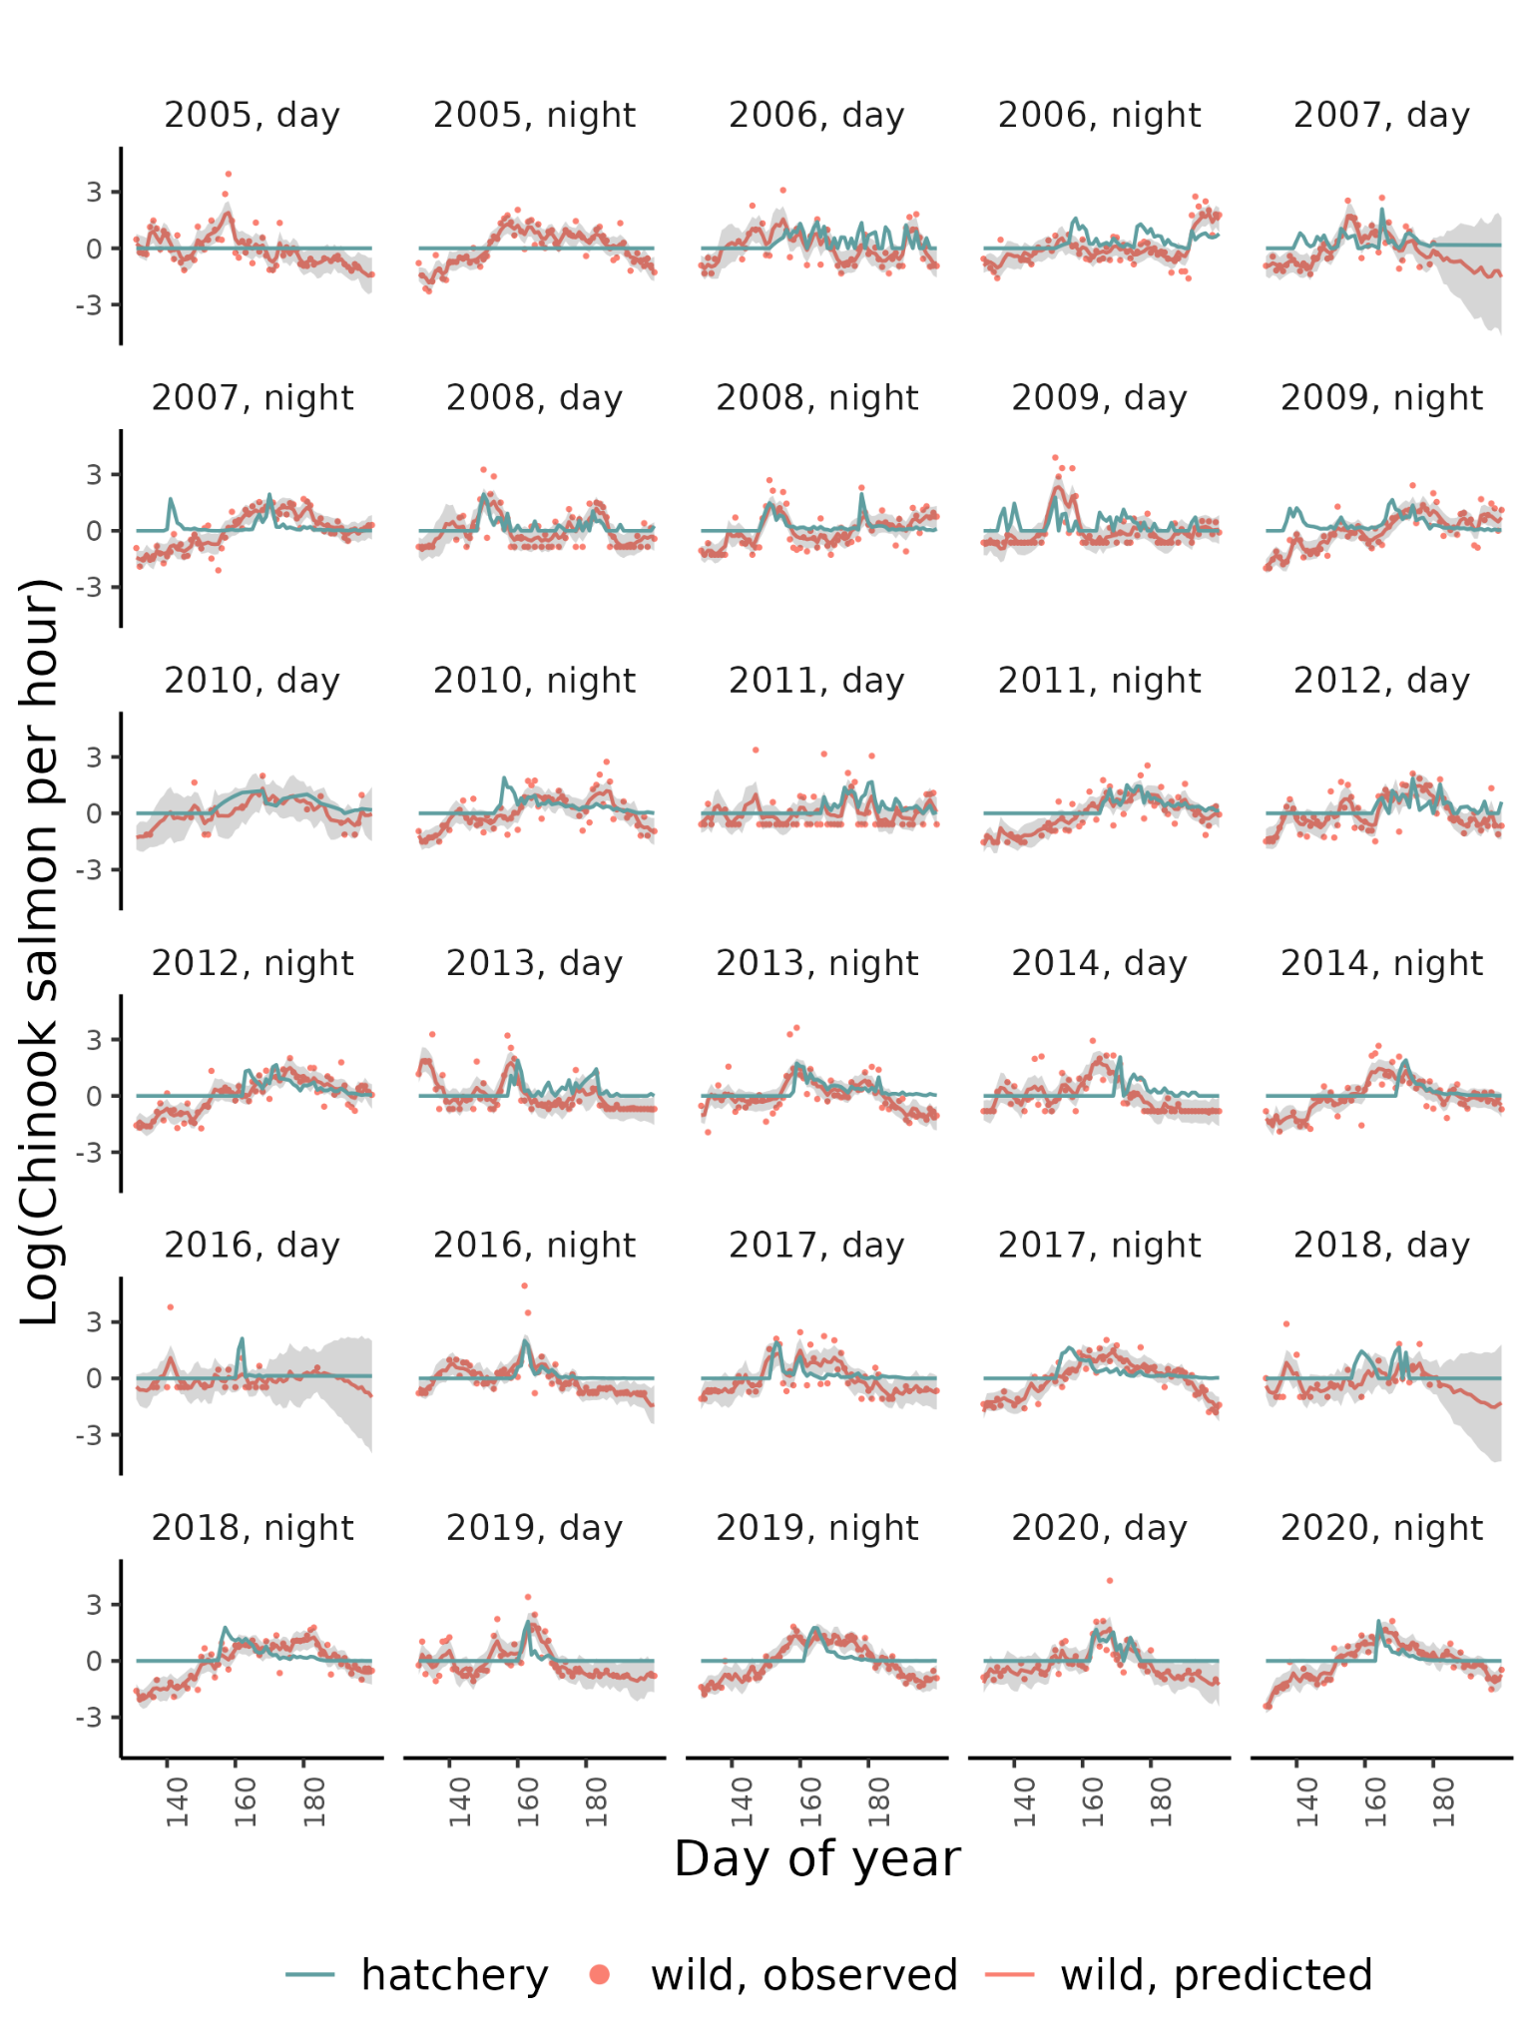
Figure S4 - Model estimates and observations of wild Chinook salmon and observations of hatchery Chinook salmon in the Dungeness River.
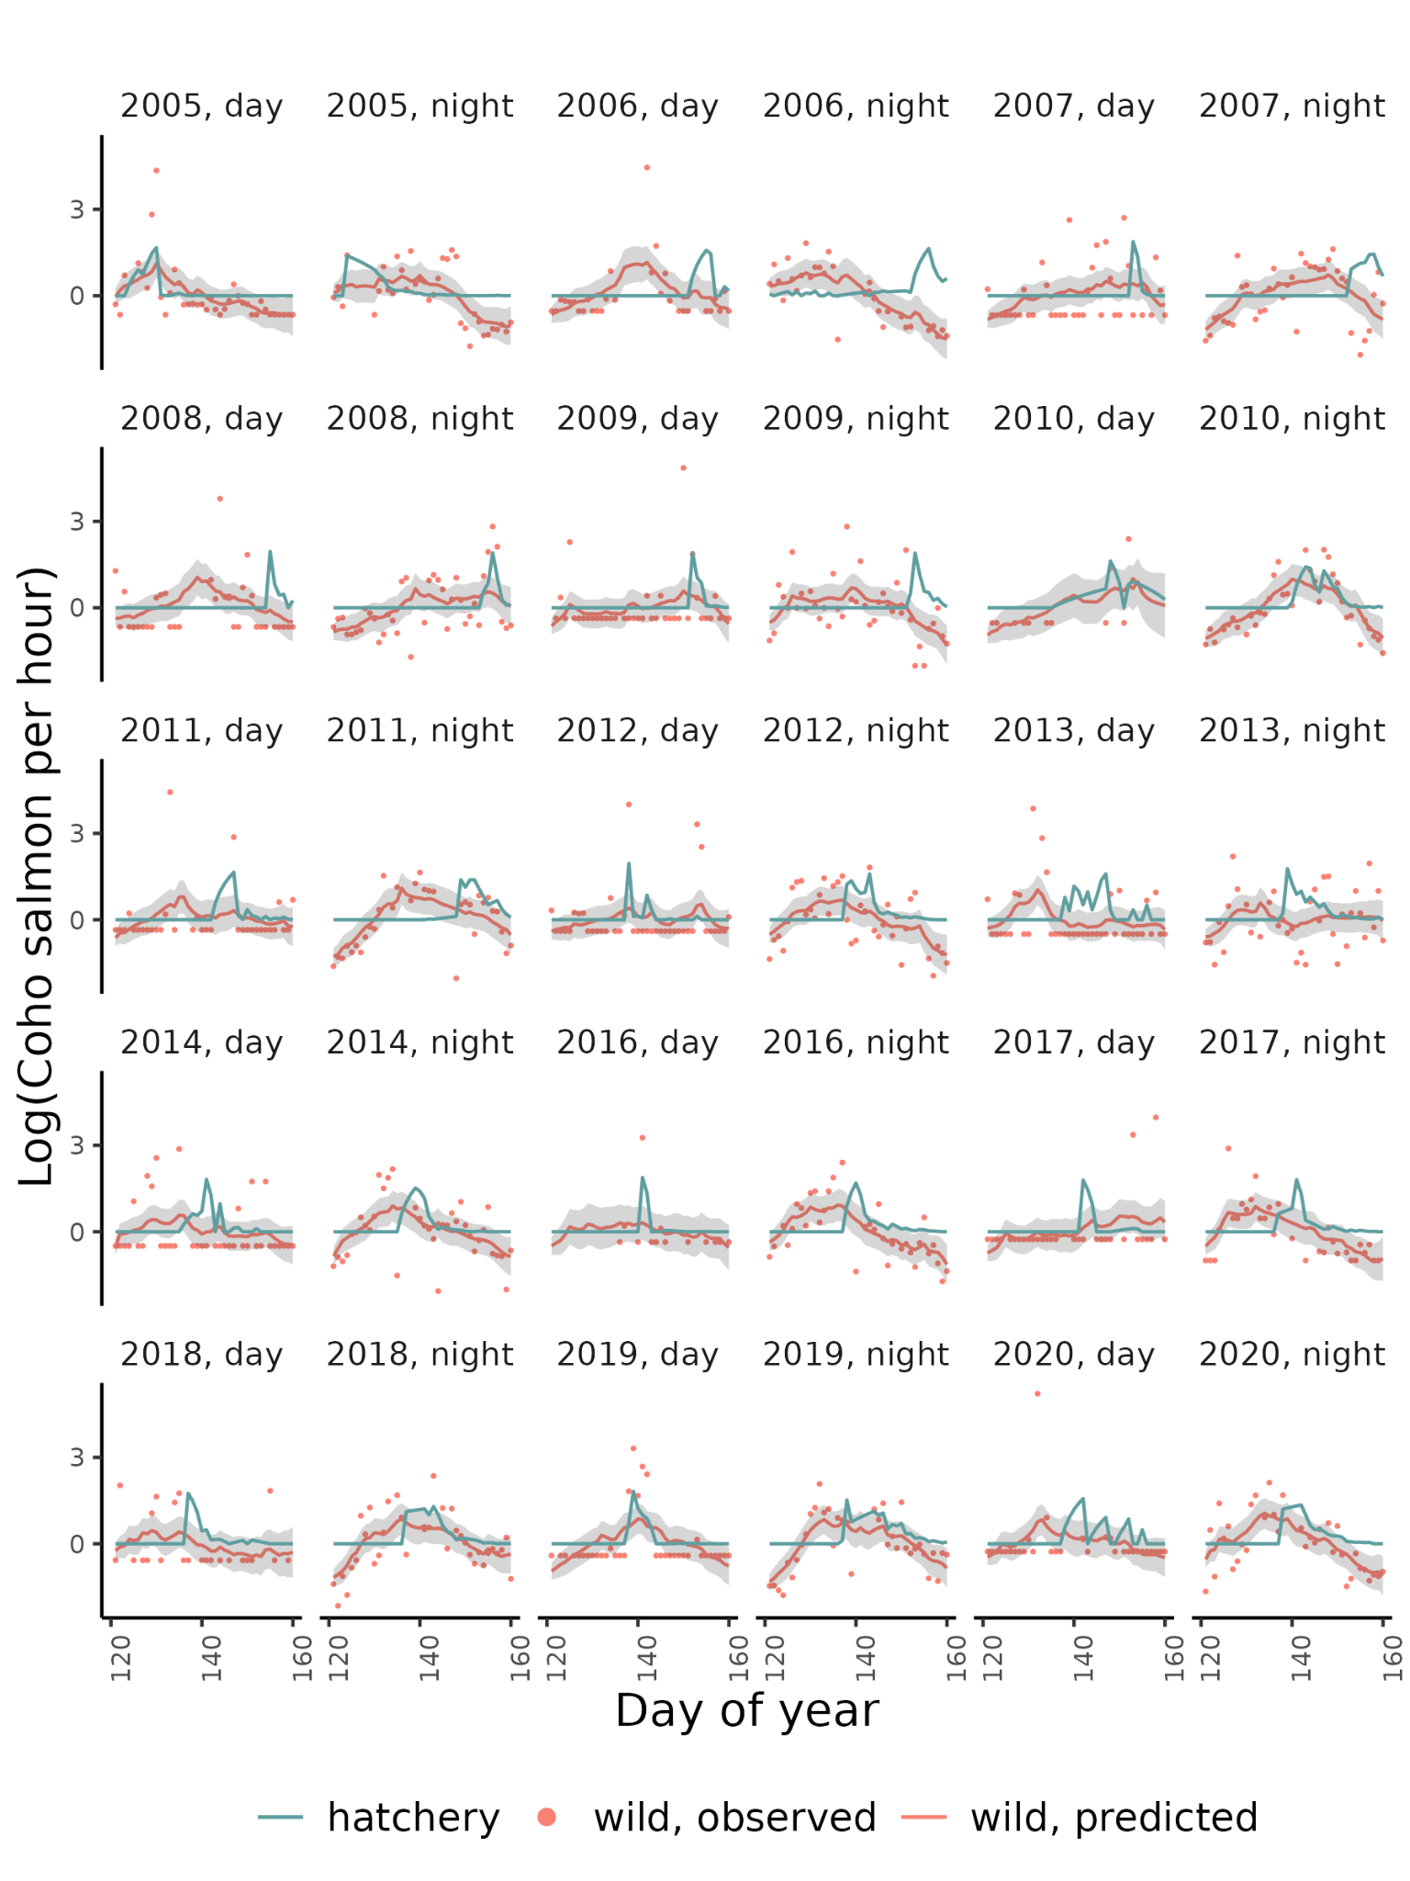
Figure S5 - Model estimates and observations of wild coho salmon and observations of hatchery coho salmon in the Dungeness River

Puyallup River
The Puyallup River is a 72-km river that originates in the glaciers on Mount Rainier and drains into Puget Sound. In the summer, the river is fed by melting glaciers which increases the turbidity. River flow and sediment budget is largely natural, except a diversion dam located in the upper Puyallup which diverts and returns a portion of the river for hydropower. The highest water temperatures are around July-August and the lowest flows are in September-October. The Puyallup River supports Chinook, coho, pink, and chum salmon, and steelhead, cutthroat and bull trout. The Puyallup River trap, operated by the Puyallup Tribe of Indians, is located just upstream of the confluence of the White River and Puyallup River (47.1971, -122.2523). The trap catches hatchery salmon from the Voights Creek hatchery, and Rushingwater, Cowskull, and Wilkeson Creek acclimation ponds and Lake Kapowsin net pen.

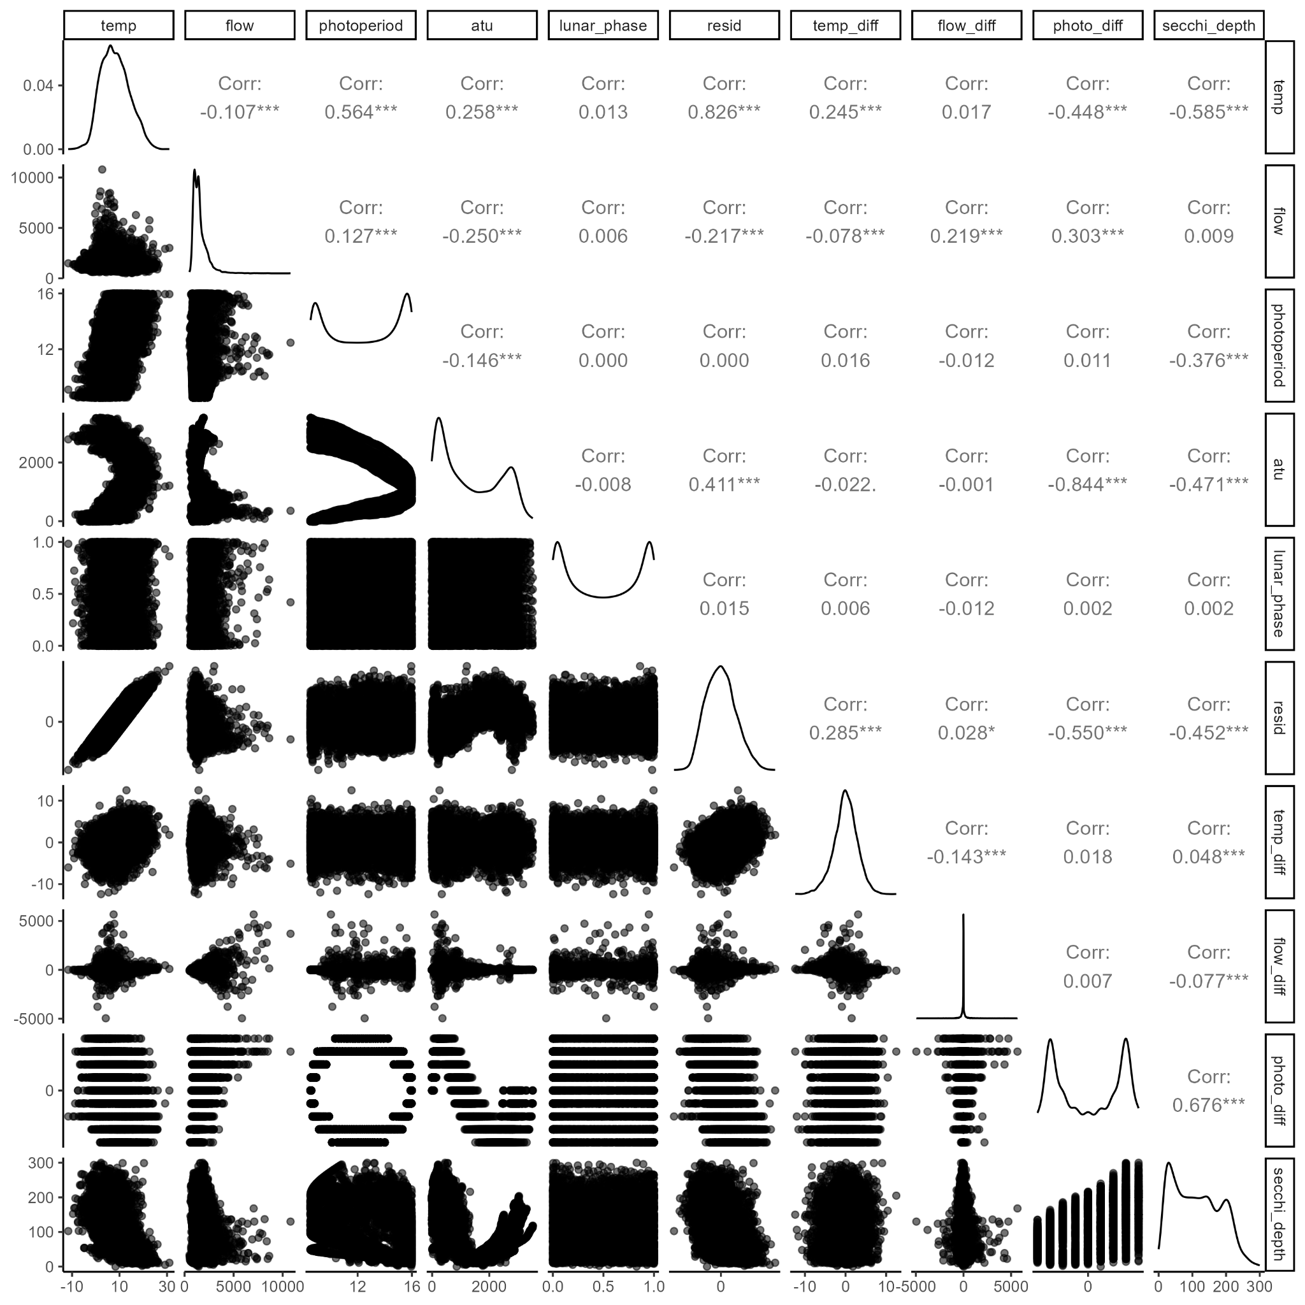
Figure S6 - Correlation between all the environmental variables in the Puyallup River.

Chinook |  | Coho
Covariate | $$ΔAICc$$ | Covariate | $$ΔAICc$$
Photoperiod difference | 0 | ATU | 0
ATU | 1.26 | Photoperiod | 12.51
Residuals | 6.76 | Photoperiod difference | 25.58
Temperature | 8.33 | Secchi depth | 31.18
Secchi depth | 10.36 | Temperature | 36.51
Photoperiod | 12.22 | Residuals | 36.55
Table S6 - Model selection for Chinook and coho salmon in the Puyallup River with each of the correlated covariate.

Photoperiod difference | Temperature | Temperature difference | Flow | Lunar phase | Flow difference | Hatchery | $$ΔAICc$$ | Relative Likelihood | Weights | Cumulative weights
1 | 1 | 0 | 1 | 1 | 1 | 1 | 0 | 1 | 0.5 | 0.5
1 | 1 | 1 | 1 | 1 | 1 | 1 | 1.43 | 0.49 | 0.24 | 0.74
1 | 1 | 0 | 1 | 0 | 1 | 1 | 2.17 | 0.34 | 0.17 | 0.91
1 | 1 | 1 | 1 | 0 | 1 | 1 | 3.68 | 0.16 | 0.08 | 0.99
1 | 1 | 0 | 1 | 1 | 1 | 0 | 9.66 | 0.01 | 0 | 1
1 | 1 | 0 | 1 | 0 | 1 | 0 | 11.22 | 0 | 0 | 1
1 | 1 | 1 | 1 | 1 | 1 | 0 | 11.3 | 0 | 0 | 1
1 | 1 | 1 | 1 | 0 | 1 | 0 | 12.92 | 0 | 0 | 1
1 | 1 | 0 | 0 | 1 | 1 | 1 | 18.82 | 0 | 0 | 1
1 | 1 | 0 | 0 | 0 | 1 | 1 | 19.31 | 0 | 0 | 1
1 | 1 | 1 | 0 | 1 | 1 | 1 | 20.9 | 0 | 0 | 1
1 | 1 | 1 | 0 | 0 | 1 | 1 | 21.39 | 0 | 0 | 1
1 | 1 | 0 | 0 | 1 | 1 | 0 | 23.1 | 0 | 0 | 1
1 | 1 | 0 | 0 | 0 | 1 | 0 | 23.38 | 0 | 0 | 1
1 | 1 | 1 | 0 | 1 | 1 | 0 | 25.18 | 0 | 0 | 1
1 | 1 | 1 | 0 | 0 | 1 | 0 | 25.47 | 0 | 0 | 1
1 | 0 | 0 | 1 | 1 | 1 | 1 | 48.35 | 0 | 0 | 1
1 | 0 | 0 | 1 | 0 | 1 | 1 | 48.4 | 0 | 0 | 1
0 | 1 | 0 | 0 | 0 | 1 | 1 | 48.51 | 0 | 0 | 1
0 | 1 | 0 | 0 | 1 | 1 | 1 | 48.99 | 0 | 0 | 1
0 | 1 | 0 | 1 | 0 | 1 | 1 | 49.18 | 0 | 0 | 1
0 | 1 | 0 | 1 | 1 | 1 | 1 | 49.46 | 0 | 0 | 1
1 | 0 | 1 | 1 | 1 | 1 | 1 | 50.26 | 0 | 0 | 1
1 | 0 | 1 | 1 | 0 | 1 | 1 | 50.28 | 0 | 0 | 1
0 | 1 | 1 | 0 | 0 | 1 | 1 | 50.51 | 0 | 0 | 1
0 | 1 | 1 | 0 | 1 | 1 | 1 | 51.01 | 0 | 0 | 1
0 | 1 | 1 | 1 | 0 | 1 | 1 | 51.23 | 0 | 0 | 1
0 | 1 | 1 | 1 | 1 | 1 | 1 | 51.53 | 0 | 0 | 1
1 | 0 | 0 | 1 | 0 | 1 | 0 | 52.22 | 0 | 0 | 1
1 | 0 | 0 | 1 | 1 | 1 | 0 | 52.35 | 0 | 0 | 1
1 | 0 | 1 | 1 | 0 | 1 | 0 | 54.04 | 0 | 0 | 1
1 | 0 | 1 | 1 | 1 | 1 | 0 | 54.2 | 0 | 0 | 1
0 | 0 | 0 | 1 | 0 | 1 | 1 | 55.08 | 0 | 0 | 1
1 | 0 | 0 | 0 | 0 | 1 | 1 | 55.25 | 0 | 0 | 1
0 | 0 | 0 | 1 | 1 | 1 | 1 | 55.47 | 0 | 0 | 1
1 | 0 | 0 | 0 | 1 | 1 | 1 | 55.89 | 0 | 0 | 1
0 | 0 | 0 | 0 | 0 | 1 | 1 | 56.15 | 0 | 0 | 1
1 | 0 | 0 | 0 | 0 | 1 | 0 | 56.5 | 0 | 0 | 1
1 | 0 | 1 | 0 | 0 | 1 | 1 | 56.73 | 0 | 0 | 1
0 | 0 | 0 | 0 | 1 | 1 | 1 | 56.85 | 0 | 0 | 1
0 | 0 | 1 | 1 | 0 | 1 | 1 | 56.88 | 0 | 0 | 1
1 | 0 | 0 | 0 | 1 | 1 | 0 | 57.18 | 0 | 0 | 1
0 | 0 | 1 | 1 | 1 | 1 | 1 | 57.31 | 0 | 0 | 1
1 | 0 | 1 | 0 | 1 | 1 | 1 | 57.4 | 0 | 0 | 1
0 | 0 | 1 | 0 | 0 | 1 | 1 | 57.72 | 0 | 0 | 1
1 | 0 | 1 | 0 | 0 | 1 | 0 | 57.97 | 0 | 0 | 1
0 | 0 | 1 | 0 | 1 | 1 | 1 | 58.44 | 0 | 0 | 1
1 | 0 | 1 | 0 | 1 | 1 | 0 | 58.66 | 0 | 0 | 1
0 | 1 | 0 | 0 | 0 | 1 | 0 | 60.82 | 0 | 0 | 1
0 | 1 | 0 | 0 | 1 | 1 | 0 | 61.57 | 0 | 0 | 1
0 | 0 | 0 | 0 | 0 | 1 | 0 | 62.42 | 0 | 0 | 1
0 | 1 | 1 | 0 | 0 | 1 | 0 | 62.77 | 0 | 0 | 1
0 | 1 | 0 | 1 | 0 | 1 | 0 | 62.9 | 0 | 0 | 1
0 | 0 | 0 | 0 | 1 | 1 | 0 | 63.24 | 0 | 0 | 1
0 | 1 | 1 | 0 | 1 | 1 | 0 | 63.54 | 0 | 0 | 1
0 | 1 | 0 | 1 | 1 | 1 | 0 | 63.64 | 0 | 0 | 1
0 | 0 | 1 | 0 | 0 | 1 | 0 | 64.07 | 0 | 0 | 1
0 | 0 | 0 | 1 | 0 | 1 | 0 | 64.17 | 0 | 0 | 1
0 | 1 | 1 | 1 | 0 | 1 | 0 | 64.86 | 0 | 0 | 1
0 | 0 | 0 | 1 | 1 | 1 | 0 | 64.91 | 0 | 0 | 1
0 | 0 | 1 | 0 | 1 | 1 | 0 | 64.91 | 0 | 0 | 1
0 | 1 | 1 | 1 | 1 | 1 | 0 | 65.62 | 0 | 0 | 1
0 | 0 | 1 | 1 | 0 | 1 | 0 | 65.91 | 0 | 0 | 1
0 | 0 | 1 | 1 | 1 | 1 | 0 | 66.68 | 0 | 0 | 1
1 | 1 | 0 | 1 | 1 | 0 | 1 | 287.11 | 0 | 0 | 1
1 | 1 | 1 | 1 | 1 | 0 | 1 | 288.19 | 0 | 0 | 1
1 | 1 | 0 | 1 | 1 | 0 | 0 | 290.91 | 0 | 0 | 1
1 | 1 | 1 | 1 | 1 | 0 | 0 | 292.59 | 0 | 0 | 1
1 | 1 | 0 | 1 | 0 | 0 | 1 | 293.06 | 0 | 0 | 1
1 | 1 | 1 | 1 | 0 | 0 | 1 | 294.14 | 0 | 0 | 1
1 | 1 | 0 | 1 | 0 | 0 | 0 | 296.39 | 0 | 0 | 1
1 | 1 | 1 | 1 | 0 | 0 | 0 | 298.06 | 0 | 0 | 1
1 | 1 | 0 | 0 | 1 | 0 | 1 | 298.26 | 0 | 0 | 1
1 | 1 | 0 | 0 | 1 | 0 | 0 | 298.61 | 0 | 0 | 1
1 | 1 | 1 | 0 | 1 | 0 | 1 | 300.13 | 0 | 0 | 1
1 | 1 | 1 | 0 | 1 | 0 | 0 | 300.65 | 0 | 0 | 1
1 | 1 | 0 | 0 | 0 | 0 | 1 | 302.13 | 0 | 0 | 1
1 | 1 | 0 | 0 | 0 | 0 | 0 | 302.46 | 0 | 0 | 1
1 | 1 | 1 | 0 | 0 | 0 | 1 | 303.97 | 0 | 0 | 1
1 | 1 | 1 | 0 | 0 | 0 | 0 | 304.47 | 0 | 0 | 1
0 | 1 | 0 | 0 | 1 | 0 | 1 | 357.78 | 0 | 0 | 1
0 | 1 | 1 | 0 | 1 | 0 | 1 | 359.25 | 0 | 0 | 1
0 | 1 | 0 | 0 | 0 | 0 | 1 | 359.29 | 0 | 0 | 1
0 | 1 | 0 | 1 | 1 | 0 | 1 | 359.41 | 0 | 0 | 1
0 | 1 | 0 | 1 | 0 | 0 | 1 | 360.73 | 0 | 0 | 1
0 | 1 | 1 | 0 | 0 | 0 | 1 | 360.74 | 0 | 0 | 1
0 | 1 | 1 | 1 | 1 | 0 | 1 | 361.02 | 0 | 0 | 1
0 | 1 | 1 | 1 | 0 | 0 | 1 | 362.34 | 0 | 0 | 1
1 | 0 | 0 | 0 | 1 | 0 | 0 | 362.92 | 0 | 0 | 1
1 | 0 | 0 | 1 | 1 | 0 | 0 | 363.41 | 0 | 0 | 1
1 | 0 | 1 | 0 | 1 | 0 | 0 | 364.39 | 0 | 0 | 1
1 | 0 | 0 | 0 | 0 | 0 | 0 | 364.84 | 0 | 0 | 1
1 | 0 | 1 | 1 | 1 | 0 | 0 | 365.04 | 0 | 0 | 1
1 | 0 | 0 | 1 | 1 | 0 | 1 | 365.2 | 0 | 0 | 1
1 | 0 | 0 | 0 | 1 | 0 | 1 | 365.42 | 0 | 0 | 1
1 | 0 | 0 | 1 | 0 | 0 | 0 | 365.79 | 0 | 0 | 1
1 | 0 | 1 | 0 | 0 | 0 | 0 | 366.36 | 0 | 0 | 1
1 | 0 | 1 | 1 | 1 | 0 | 1 | 367.12 | 0 | 0 | 1
1 | 0 | 1 | 0 | 1 | 0 | 1 | 367.16 | 0 | 0 | 1
1 | 0 | 0 | 0 | 0 | 0 | 1 | 367.2 | 0 | 0 | 1
1 | 0 | 1 | 1 | 0 | 0 | 0 | 367.44 | 0 | 0 | 1
1 | 0 | 0 | 1 | 0 | 0 | 1 | 367.54 | 0 | 0 | 1
1 | 0 | 1 | 0 | 0 | 0 | 1 | 368.98 | 0 | 0 | 1
1 | 0 | 1 | 1 | 0 | 0 | 1 | 369.47 | 0 | 0 | 1
0 | 1 | 0 | 1 | 1 | 0 | 0 | 370.25 | 0 | 0 | 1
0 | 1 | 0 | 1 | 0 | 0 | 0 | 371.16 | 0 | 0 | 1
0 | 1 | 0 | 0 | 1 | 0 | 0 | 371.8 | 0 | 0 | 1
0 | 0 | 0 | 0 | 1 | 0 | 1 | 372.01 | 0 | 0 | 1
0 | 1 | 1 | 1 | 1 | 0 | 0 | 372.27 | 0 | 0 | 1
0 | 1 | 0 | 0 | 0 | 0 | 0 | 373.16 | 0 | 0 | 1
0 | 1 | 1 | 1 | 0 | 0 | 0 | 373.18 | 0 | 0 | 1
0 | 0 | 0 | 0 | 0 | 0 | 1 | 373.4 | 0 | 0 | 1
0 | 1 | 1 | 0 | 1 | 0 | 0 | 373.62 | 0 | 0 | 1
0 | 0 | 1 | 0 | 1 | 0 | 1 | 374.08 | 0 | 0 | 1
0 | 0 | 0 | 1 | 1 | 0 | 1 | 374.09 | 0 | 0 | 1
0 | 1 | 1 | 0 | 0 | 0 | 0 | 374.96 | 0 | 0 | 1
0 | 0 | 0 | 1 | 0 | 0 | 1 | 375.45 | 0 | 0 | 1
0 | 0 | 1 | 0 | 0 | 0 | 1 | 375.48 | 0 | 0 | 1
0 | 0 | 1 | 1 | 1 | 0 | 1 | 376.17 | 0 | 0 | 1
0 | 0 | 0 | 0 | 1 | 0 | 0 | 376.96 | 0 | 0 | 1
0 | 0 | 1 | 1 | 0 | 0 | 1 | 377.53 | 0 | 0 | 1
0 | 0 | 0 | 1 | 1 | 0 | 0 | 377.65 | 0 | 0 | 1
0 | 0 | 0 | 0 | 0 | 0 | 0 | 378.35 | 0 | 0 | 1
0 | 0 | 0 | 0 | 0 | 0 | 0 | 378.35 | 0 | 0 | 1
0 | 0 | 0 | 1 | 0 | 0 | 0 | 378.75 | 0 | 0 | 1
0 | 0 | 1 | 0 | 1 | 0 | 0 | 379.02 | 0 | 0 | 1
0 | 0 | 1 | 1 | 1 | 0 | 0 | 379.59 | 0 | 0 | 1
0 | 0 | 1 | 0 | 0 | 0 | 0 | 380.41 | 0 | 0 | 1
0 | 0 | 1 | 1 | 0 | 0 | 0 | 380.7 | 0 | 0 | 1

Table S7 - Model selection with all combinations of uncorrelated covariates for Chinook salmon in the Puyallup River.

Photoperiod difference | Temperature | Temperature difference | Flow | Lunar phase | Flow difference | Hatchery | $$ΔAICc$$ | Relative Likelihood | Weights | Cumulative weights
1 | 1 | 0 | 1 | 1 | 1 | 1 | 0 | 1 | 0.5 | 0.5
1 | 1 | 1 | 1 | 1 | 1 | 1 | 1.43 | 0.49 | 0.24 | 0.74
1 | 1 | 0 | 1 | 0 | 1 | 1 | 2.17 | 0.34 | 0.17 | 0.91
1 | 1 | 1 | 1 | 0 | 1 | 1 | 3.68 | 0.16 | 0.08 | 0.99
1 | 1 | 0 | 1 | 1 | 1 | 0 | 9.66 | 0.01 | 0 | 1
1 | 1 | 0 | 1 | 0 | 1 | 0 | 11.22 | 0 | 0 | 1
1 | 1 | 1 | 1 | 1 | 1 | 0 | 11.3 | 0 | 0 | 1
1 | 1 | 1 | 1 | 0 | 1 | 0 | 12.92 | 0 | 0 | 1
1 | 1 | 0 | 0 | 1 | 1 | 1 | 18.82 | 0 | 0 | 1
1 | 1 | 0 | 0 | 0 | 1 | 1 | 19.31 | 0 | 0 | 1
1 | 1 | 1 | 0 | 1 | 1 | 1 | 20.9 | 0 | 0 | 1
1 | 1 | 1 | 0 | 0 | 1 | 1 | 21.39 | 0 | 0 | 1
1 | 1 | 0 | 0 | 1 | 1 | 0 | 23.1 | 0 | 0 | 1
1 | 1 | 0 | 0 | 0 | 1 | 0 | 23.38 | 0 | 0 | 1
1 | 1 | 1 | 0 | 1 | 1 | 0 | 25.18 | 0 | 0 | 1
1 | 1 | 1 | 0 | 0 | 1 | 0 | 25.47 | 0 | 0 | 1
1 | 0 | 0 | 1 | 1 | 1 | 1 | 48.35 | 0 | 0 | 1
1 | 0 | 0 | 1 | 0 | 1 | 1 | 48.4 | 0 | 0 | 1
0 | 1 | 0 | 0 | 0 | 1 | 1 | 48.51 | 0 | 0 | 1
0 | 1 | 0 | 0 | 1 | 1 | 1 | 48.99 | 0 | 0 | 1
0 | 1 | 0 | 1 | 0 | 1 | 1 | 49.18 | 0 | 0 | 1
0 | 1 | 0 | 1 | 1 | 1 | 1 | 49.46 | 0 | 0 | 1
1 | 0 | 1 | 1 | 1 | 1 | 1 | 50.26 | 0 | 0 | 1
1 | 0 | 1 | 1 | 0 | 1 | 1 | 50.28 | 0 | 0 | 1
0 | 1 | 1 | 0 | 0 | 1 | 1 | 50.51 | 0 | 0 | 1
0 | 1 | 1 | 0 | 1 | 1 | 1 | 51.01 | 0 | 0 | 1
0 | 1 | 1 | 1 | 0 | 1 | 1 | 51.23 | 0 | 0 | 1
0 | 1 | 1 | 1 | 1 | 1 | 1 | 51.53 | 0 | 0 | 1
1 | 0 | 0 | 1 | 0 | 1 | 0 | 52.22 | 0 | 0 | 1
1 | 0 | 0 | 1 | 1 | 1 | 0 | 52.35 | 0 | 0 | 1
1 | 0 | 1 | 1 | 0 | 1 | 0 | 54.04 | 0 | 0 | 1
1 | 0 | 1 | 1 | 1 | 1 | 0 | 54.2 | 0 | 0 | 1
0 | 0 | 0 | 1 | 0 | 1 | 1 | 55.08 | 0 | 0 | 1
1 | 0 | 0 | 0 | 0 | 1 | 1 | 55.25 | 0 | 0 | 1
0 | 0 | 0 | 1 | 1 | 1 | 1 | 55.47 | 0 | 0 | 1
1 | 0 | 0 | 0 | 1 | 1 | 1 | 55.89 | 0 | 0 | 1
0 | 0 | 0 | 0 | 0 | 1 | 1 | 56.15 | 0 | 0 | 1
1 | 0 | 0 | 0 | 0 | 1 | 0 | 56.5 | 0 | 0 | 1
1 | 0 | 1 | 0 | 0 | 1 | 1 | 56.73 | 0 | 0 | 1
0 | 0 | 0 | 0 | 1 | 1 | 1 | 56.85 | 0 | 0 | 1
0 | 0 | 1 | 1 | 0 | 1 | 1 | 56.88 | 0 | 0 | 1
1 | 0 | 0 | 0 | 1 | 1 | 0 | 57.18 | 0 | 0 | 1
0 | 0 | 1 | 1 | 1 | 1 | 1 | 57.31 | 0 | 0 | 1
1 | 0 | 1 | 0 | 1 | 1 | 1 | 57.4 | 0 | 0 | 1
0 | 0 | 1 | 0 | 0 | 1 | 1 | 57.72 | 0 | 0 | 1
1 | 0 | 1 | 0 | 0 | 1 | 0 | 57.97 | 0 | 0 | 1
0 | 0 | 1 | 0 | 1 | 1 | 1 | 58.44 | 0 | 0 | 1
1 | 0 | 1 | 0 | 1 | 1 | 0 | 58.66 | 0 | 0 | 1
0 | 1 | 0 | 0 | 0 | 1 | 0 | 60.82 | 0 | 0 | 1
0 | 1 | 0 | 0 | 1 | 1 | 0 | 61.57 | 0 | 0 | 1
0 | 0 | 0 | 0 | 0 | 1 | 0 | 62.42 | 0 | 0 | 1
0 | 1 | 1 | 0 | 0 | 1 | 0 | 62.77 | 0 | 0 | 1
0 | 1 | 0 | 1 | 0 | 1 | 0 | 62.9 | 0 | 0 | 1
0 | 0 | 0 | 0 | 1 | 1 | 0 | 63.24 | 0 | 0 | 1
0 | 1 | 1 | 0 | 1 | 1 | 0 | 63.54 | 0 | 0 | 1
0 | 1 | 0 | 1 | 1 | 1 | 0 | 63.64 | 0 | 0 | 1
0 | 0 | 1 | 0 | 0 | 1 | 0 | 64.07 | 0 | 0 | 1
0 | 0 | 0 | 1 | 0 | 1 | 0 | 64.17 | 0 | 0 | 1
0 | 1 | 1 | 1 | 0 | 1 | 0 | 64.86 | 0 | 0 | 1
0 | 0 | 0 | 1 | 1 | 1 | 0 | 64.91 | 0 | 0 | 1
0 | 0 | 1 | 0 | 1 | 1 | 0 | 64.91 | 0 | 0 | 1
0 | 1 | 1 | 1 | 1 | 1 | 0 | 65.62 | 0 | 0 | 1
0 | 0 | 1 | 1 | 0 | 1 | 0 | 65.91 | 0 | 0 | 1
0 | 0 | 1 | 1 | 1 | 1 | 0 | 66.68 | 0 | 0 | 1
1 | 1 | 0 | 1 | 1 | 0 | 1 | 287.11 | 0 | 0 | 1
1 | 1 | 1 | 1 | 1 | 0 | 1 | 288.19 | 0 | 0 | 1
1 | 1 | 0 | 1 | 1 | 0 | 0 | 290.91 | 0 | 0 | 1
1 | 1 | 1 | 1 | 1 | 0 | 0 | 292.59 | 0 | 0 | 1
1 | 1 | 0 | 1 | 0 | 0 | 1 | 293.06 | 0 | 0 | 1
1 | 1 | 1 | 1 | 0 | 0 | 1 | 294.14 | 0 | 0 | 1
1 | 1 | 0 | 1 | 0 | 0 | 0 | 296.39 | 0 | 0 | 1
1 | 1 | 1 | 1 | 0 | 0 | 0 | 298.06 | 0 | 0 | 1
1 | 1 | 0 | 0 | 1 | 0 | 1 | 298.26 | 0 | 0 | 1
1 | 1 | 0 | 0 | 1 | 0 | 0 | 298.61 | 0 | 0 | 1
1 | 1 | 1 | 0 | 1 | 0 | 1 | 300.13 | 0 | 0 | 1
1 | 1 | 1 | 0 | 1 | 0 | 0 | 300.65 | 0 | 0 | 1
1 | 1 | 0 | 0 | 0 | 0 | 1 | 302.13 | 0 | 0 | 1
1 | 1 | 0 | 0 | 0 | 0 | 0 | 302.46 | 0 | 0 | 1
1 | 1 | 1 | 0 | 0 | 0 | 1 | 303.97 | 0 | 0 | 1
1 | 1 | 1 | 0 | 0 | 0 | 0 | 304.47 | 0 | 0 | 1
0 | 1 | 0 | 0 | 1 | 0 | 1 | 357.78 | 0 | 0 | 1
0 | 1 | 1 | 0 | 1 | 0 | 1 | 359.25 | 0 | 0 | 1
0 | 1 | 0 | 0 | 0 | 0 | 1 | 359.29 | 0 | 0 | 1
0 | 1 | 0 | 1 | 1 | 0 | 1 | 359.41 | 0 | 0 | 1
0 | 1 | 0 | 1 | 0 | 0 | 1 | 360.73 | 0 | 0 | 1
0 | 1 | 1 | 0 | 0 | 0 | 1 | 360.74 | 0 | 0 | 1
0 | 1 | 1 | 1 | 1 | 0 | 1 | 361.02 | 0 | 0 | 1
0 | 1 | 1 | 1 | 0 | 0 | 1 | 362.34 | 0 | 0 | 1
1 | 0 | 0 | 0 | 1 | 0 | 0 | 362.92 | 0 | 0 | 1
1 | 0 | 0 | 1 | 1 | 0 | 0 | 363.41 | 0 | 0 | 1
1 | 0 | 1 | 0 | 1 | 0 | 0 | 364.39 | 0 | 0 | 1
1 | 0 | 0 | 0 | 0 | 0 | 0 | 364.84 | 0 | 0 | 1
1 | 0 | 1 | 1 | 1 | 0 | 0 | 365.04 | 0 | 0 | 1
1 | 0 | 0 | 1 | 1 | 0 | 1 | 365.2 | 0 | 0 | 1
1 | 0 | 0 | 0 | 1 | 0 | 1 | 365.42 | 0 | 0 | 1
1 | 0 | 0 | 1 | 0 | 0 | 0 | 365.79 | 0 | 0 | 1
1 | 0 | 1 | 0 | 0 | 0 | 0 | 366.36 | 0 | 0 | 1
1 | 0 | 1 | 1 | 1 | 0 | 1 | 367.12 | 0 | 0 | 1
1 | 0 | 1 | 0 | 1 | 0 | 1 | 367.16 | 0 | 0 | 1
1 | 0 | 0 | 0 | 0 | 0 | 1 | 367.2 | 0 | 0 | 1
1 | 0 | 1 | 1 | 0 | 0 | 0 | 367.44 | 0 | 0 | 1
1 | 0 | 0 | 1 | 0 | 0 | 1 | 367.54 | 0 | 0 | 1
1 | 0 | 1 | 0 | 0 | 0 | 1 | 368.98 | 0 | 0 | 1
1 | 0 | 1 | 1 | 0 | 0 | 1 | 369.47 | 0 | 0 | 1
0 | 1 | 0 | 1 | 1 | 0 | 0 | 370.25 | 0 | 0 | 1
0 | 1 | 0 | 1 | 0 | 0 | 0 | 371.16 | 0 | 0 | 1
0 | 1 | 0 | 0 | 1 | 0 | 0 | 371.8 | 0 | 0 | 1
0 | 0 | 0 | 0 | 1 | 0 | 1 | 372.01 | 0 | 0 | 1
0 | 1 | 1 | 1 | 1 | 0 | 0 | 372.27 | 0 | 0 | 1
0 | 1 | 0 | 0 | 0 | 0 | 0 | 373.16 | 0 | 0 | 1
0 | 1 | 1 | 1 | 0 | 0 | 0 | 373.18 | 0 | 0 | 1
0 | 0 | 0 | 0 | 0 | 0 | 1 | 373.4 | 0 | 0 | 1
0 | 1 | 1 | 0 | 1 | 0 | 0 | 373.62 | 0 | 0 | 1
0 | 0 | 1 | 0 | 1 | 0 | 1 | 374.08 | 0 | 0 | 1
0 | 0 | 0 | 1 | 1 | 0 | 1 | 374.09 | 0 | 0 | 1
0 | 1 | 1 | 0 | 0 | 0 | 0 | 374.96 | 0 | 0 | 1
0 | 0 | 0 | 1 | 0 | 0 | 1 | 375.45 | 0 | 0 | 1
0 | 0 | 1 | 0 | 0 | 0 | 1 | 375.48 | 0 | 0 | 1
0 | 0 | 1 | 1 | 1 | 0 | 1 | 376.17 | 0 | 0 | 1
0 | 0 | 0 | 0 | 1 | 0 | 0 | 376.96 | 0 | 0 | 1
0 | 0 | 1 | 1 | 0 | 0 | 1 | 377.53 | 0 | 0 | 1
0 | 0 | 0 | 1 | 1 | 0 | 0 | 377.65 | 0 | 0 | 1
0 | 0 | 0 | 0 | 0 | 0 | 0 | 378.35 | 0 | 0 | 1
0 | 0 | 0 | 0 | 0 | 0 | 0 | 378.35 | 0 | 0 | 1
0 | 0 | 0 | 1 | 0 | 0 | 0 | 378.75 | 0 | 0 | 1
0 | 0 | 1 | 0 | 1 | 0 | 0 | 379.02 | 0 | 0 | 1
0 | 0 | 1 | 1 | 1 | 0 | 0 | 379.59 | 0 | 0 | 1
0 | 0 | 1 | 0 | 0 | 0 | 0 | 380.41 | 0 | 0 | 1
0 | 0 | 1 | 1 | 0 | 0 | 0 | 380.7 | 0 | 0 | 1
Table S8 - Model selection with all combinations of uncorrelated covariates for coho salmon in the Puyallup River.

Chinook |  | Coho
Variable | Relative Importance | Variable | Relative Importance
Flow difference | 1 | Flow difference | 1
Temperature | 1 | Flow | 1
Flow | 1 | Hatchery | 1
Hatchery | 1 | ATU | 1
Photoperiod difference | 1 | Photoperiod | 0.9
Lunar Phase | 0.4 | Lunar phase | 0.5
Temperature difference | 0.3 | Temperature difference | 0.3
Table S9 - Relative variable importance for all variables used in the model selection process for Chinook and coho salmon in the Puyallup River.

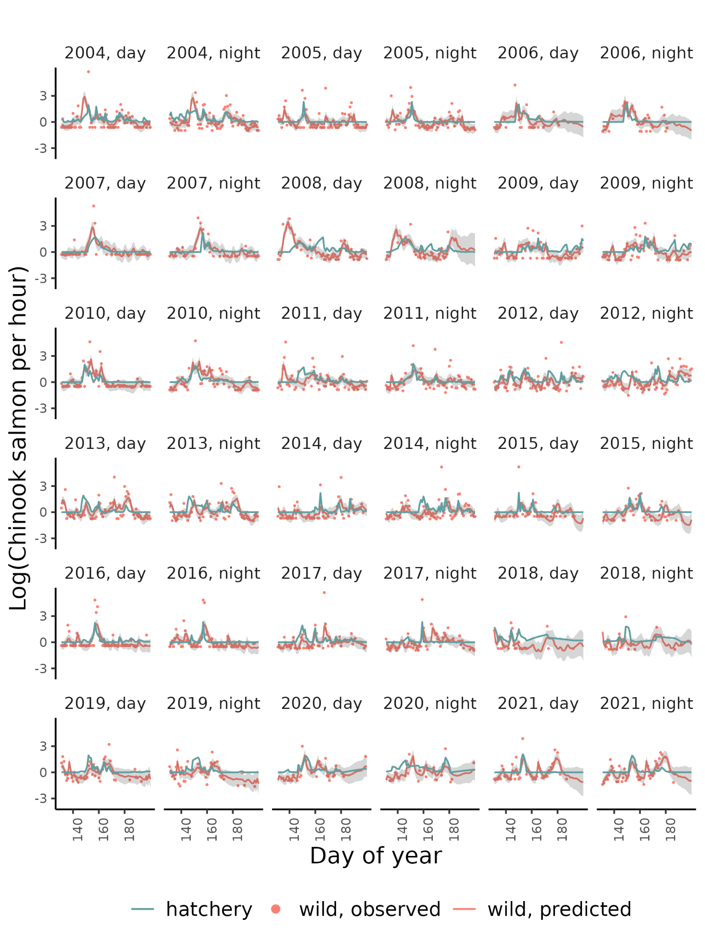
Figure S7 - Model estimates and observations of wild Chinook salmon and observations of hatchery Chinook salmon in the Puyallup River.

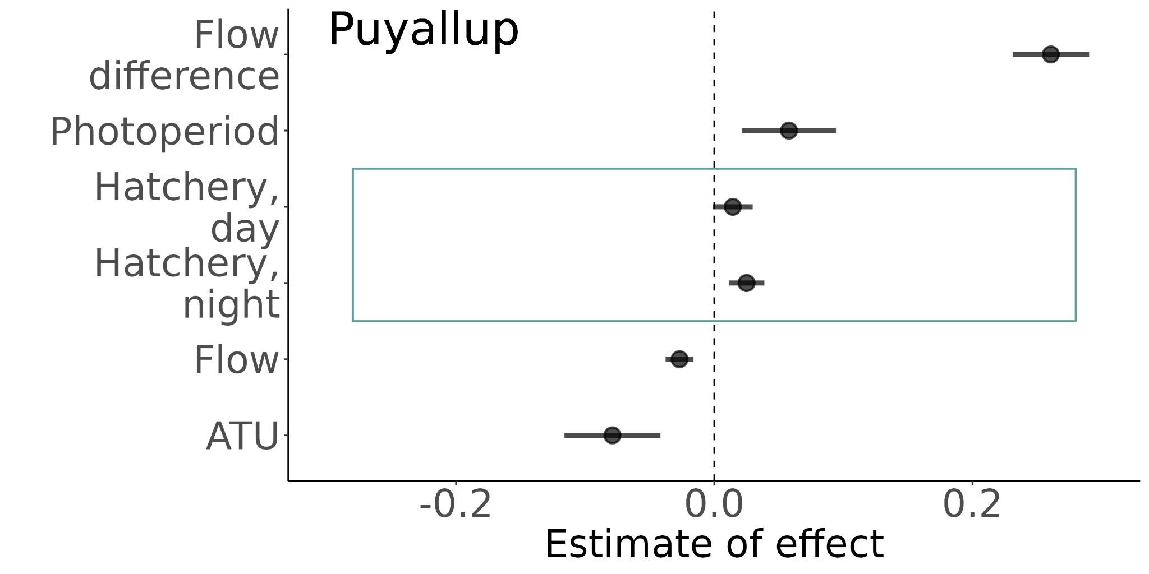
Figure S8 - Estimates of the effect of different covariates in the best MARSS model for coho salmon in the Puyallup River without 2009 and 2021 data (years with high proportions of unmarked hatchery fish). Blue boxes indicate social variables associated with the pied piper hypothesis.
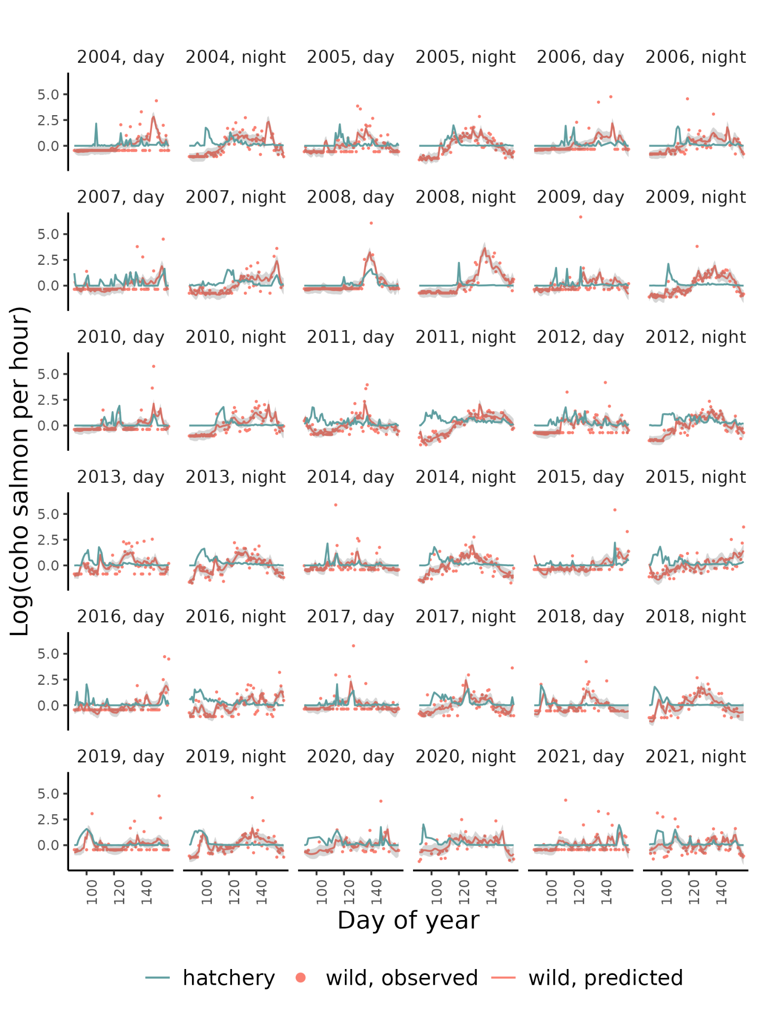
Figure S9 - Model estimates and observations of wild coho salmon and observations of hatchery coho salmon in the Puyallup River.

Skagit River
The Skagit River is a 240-km river that originates in the Canadian Cascades and drains into the Puget Sound. Several dams regulate the flow of the river. The Skagit River supports all five species of Pacific Salmon as well as Steelhead and Cutthroat. WDFW operates a screw trap and a scoop trap on the mainstem of the Skagit River (48.4451, -122.3251), 27 km upstream of the river mouth. The traps catch hatchery salmon released from Countyline Ponds, Baker Lake Hatchery, and Marblemount Hatchery.

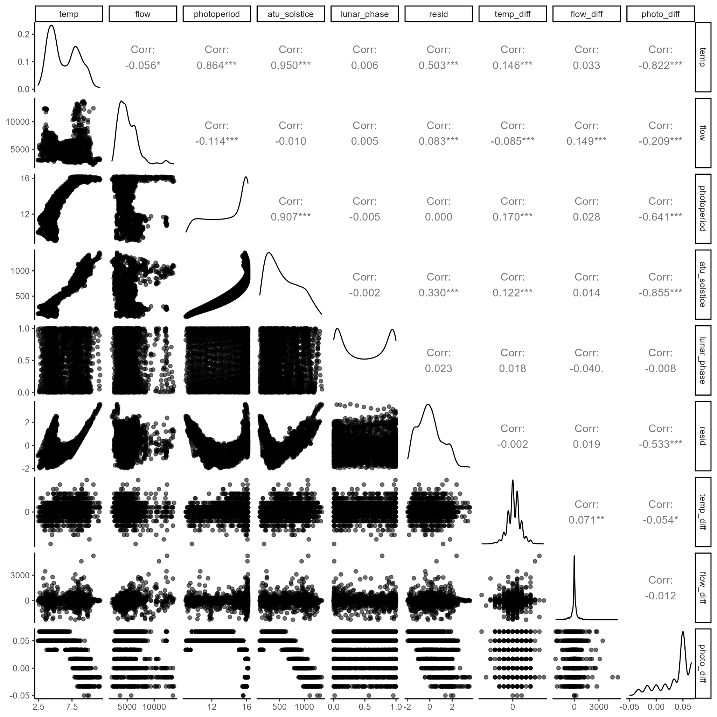
Figure S10 - Correlation between all the environmental covariates in the Skagit River.

Chinook |  | Coho
Covariate | $$ΔAICc$$ | Covariate | $$ΔAICc$$
Residuals | 0 | ATU | 0
Photoperiod | 4.37 | Photoperiod | 6.61
Temperature | 6.76 | Residuals | 7.33
ATU | 8.03 | Temperature | 7.46
Photo difference | 11.54 | Photo difference | 24.75
Table S10 - Model selection for Chinook salmon and coho salmon in the Skagit River with each of the correlated covariates.

Chinook |  | Coho
Variable | Relative Importance | Variable | Relative Importance
Temperature difference | 1 | ATU | 1
Residuals | 0.9 | Hatchery | 1
Photoperiod | 0.8 | Flow | 0.9
Hatchery | 0.4 | Lunar phase | 0.5
Flow difference | 0.3 | Temperature difference | 0.4
Lunar phase | 0.3 | Flow difference | 0.3
Flow | 0.3
Table S11 - Relative variable importance for all variables used in the model selection process for Chinook salmon and coho salmon in the Skagit.

Residuals | Photoperiod | Flow | Lunar  phase | Temperature  difference | Flow difference | Hatchery | $$ΔAICc$$ | Relative Likelihood | Weights | Cumulative weights
1 | 1 | 0 | 0 | 1 | 0 | 0 | 0 | 1 | 0.1 | 0.1
1 | 1 | 0 | 0 | 1 | 0 | 1 | 0.31 | 0.86 | 0.09 | 0.19
1 | 1 | 0 | 0 | 1 | 1 | 0 | 1.33 | 0.51 | 0.05 | 0.24
1 | 1 | 0 | 0 | 1 | 0 | 0 | 1.58 | 0.45 | 0.05 | 0.28
1 | 1 | 0 | 1 | 1 | 0 | 0 | 1.69 | 0.43 | 0.04 | 0.33
1 | 1 | 0 | 0 | 1 | 1 | 1 | 1.89 | 0.39 | 0.04 | 0.36
1 | 1 | 0 | 1 | 1 | 0 | 1 | 2.12 | 0.35 | 0.03 | 0.4
1 | 1 | 1 | 0 | 1 | 0 | 0 | 2.17 | 0.34 | 0.03 | 0.43
1 | 1 | 1 | 0 | 1 | 0 | 1 | 2.46 | 0.29 | 0.03 | 0.46
1 | 0 | 0 | 0 | 1 | 0 | 0 | 2.69 | 0.26 | 0.03 | 0.49
0 | 1 | 0 | 0 | 1 | 0 | 1 | 2.83 | 0.24 | 0.02 | 0.51
1 | 1 | 0 | 0 | 1 | 1 | 0 | 3.06 | 0.22 | 0.02 | 0.53
1 | 1 | 0 | 1 | 1 | 1 | 0 | 3.21 | 0.2 | 0.02 | 0.55
1 | 1 | 0 | 1 | 1 | 0 | 0 | 3.24 | 0.2 | 0.02 | 0.57
0 | 1 | 0 | 0 | 1 | 0 | 0 | 3.28 | 0.19 | 0.02 | 0.59
1 | 1 | 0 | 0 | 1 | 0 | 1 | 3.33 | 0.19 | 0.02 | 0.61
1 | 1 | 1 | 0 | 1 | 0 | 0 | 3.45 | 0.18 | 0.02 | 0.63
1 | 1 | 1 | 0 | 1 | 1 | 0 | 3.49 | 0.17 | 0.02 | 0.65
1 | 0 | 0 | 0 | 1 | 0 | 1 | 3.64 | 0.16 | 0.02 | 0.66
1 | 1 | 0 | 1 | 1 | 1 | 1 | 3.84 | 0.15 | 0.01 | 0.68
1 | 1 | 1 | 1 | 1 | 0 | 0 | 3.86 | 0.15 | 0.01 | 0.69
1 | 1 | 1 | 0 | 1 | 1 | 1 | 4.01 | 0.13 | 0.01 | 0.71
1 | 1 | 1 | 1 | 1 | 0 | 1 | 4.27 | 0.12 | 0.01 | 0.72
1 | 0 | 0 | 0 | 1 | 1 | 0 | 4.3 | 0.12 | 0.01 | 0.73
1 | 0 | 0 | 1 | 1 | 0 | 0 | 4.3 | 0.12 | 0.01 | 0.74
0 | 1 | 0 | 0 | 1 | 1 | 1 | 4.45 | 0.11 | 0.01 | 0.75
0 | 1 | 1 | 0 | 1 | 0 | 1 | 4.52 | 0.1 | 0.01 | 0.76
0 | 1 | 0 | 0 | 1 | 1 | 0 | 4.63 | 0.1 | 0.01 | 0.77
1 | 0 | 1 | 0 | 1 | 0 | 0 | 4.8 | 0.09 | 0.01 | 0.78
0 | 1 | 0 | 1 | 1 | 0 | 1 | 4.84 | 0.09 | 0.01 | 0.79
1 | 1 | 0 | 1 | 1 | 1 | 0 | 4.89 | 0.09 | 0.01 | 0.8
1 | 1 | 0 | 0 | 1 | 1 | 1 | 4.94 | 0.08 | 0.01 | 0.81
1 | 1 | 1 | 0 | 1 | 1 | 0 | 5.02 | 0.08 | 0.01 | 0.82
1 | 1 | 0 | 1 | 1 | 0 | 1 | 5.04 | 0.08 | 0.01 | 0.82
0 | 1 | 1 | 0 | 1 | 0 | 0 | 5.06 | 0.08 | 0.01 | 0.83
1 | 0 | 0 | 0 | 1 | 0 | 0 | 5.12 | 0.08 | 0.01 | 0.84
1 | 1 | 1 | 1 | 1 | 0 | 0 | 5.17 | 0.08 | 0.01 | 0.85
1 | 1 | 1 | 0 | 1 | 0 | 1 | 5.2 | 0.07 | 0.01 | 0.85
0 | 1 | 0 | 1 | 1 | 0 | 0 | 5.2 | 0.07 | 0.01 | 0.86
1 | 0 | 0 | 1 | 1 | 0 | 1 | 5.36 | 0.07 | 0.01 | 0.87
1 | 1 | 1 | 1 | 1 | 1 | 0 | 5.36 | 0.07 | 0.01 | 0.87
1 | 0 | 0 | 0 | 1 | 1 | 1 | 5.42 | 0.07 | 0.01 | 0.88
1 | 0 | 1 | 0 | 1 | 0 | 1 | 5.7 | 0.06 | 0.01 | 0.89
1 | 1 | 1 | 1 | 1 | 1 | 1 | 5.96 | 0.05 | 0.01 | 0.89
0 | 1 | 1 | 0 | 1 | 1 | 1 | 6 | 0.05 | 0 | 0.9
1 | 0 | 0 | 1 | 1 | 1 | 0 | 6.08 | 0.05 | 0 | 0.9
0 | 1 | 1 | 0 | 1 | 1 | 0 | 6.26 | 0.04 | 0 | 0.91
1 | 0 | 1 | 0 | 1 | 1 | 0 | 6.36 | 0.04 | 0 | 0.91
1 | 0 | 1 | 1 | 1 | 0 | 0 | 6.39 | 0.04 | 0 | 0.91
0 | 1 | 1 | 1 | 1 | 0 | 1 | 6.48 | 0.04 | 0 | 0.92
0 | 1 | 0 | 1 | 1 | 1 | 1 | 6.54 | 0.04 | 0 | 0.92
1 | 0 | 0 | 1 | 1 | 0 | 0 | 6.68 | 0.04 | 0 | 0.93
0 | 1 | 0 | 1 | 1 | 1 | 0 | 6.68 | 0.04 | 0 | 0.93
1 | 1 | 0 | 1 | 1 | 1 | 1 | 6.8 | 0.03 | 0 | 0.93
0 | 0 | 0 | 0 | 1 | 0 | 0 | 6.84 | 0.03 | 0 | 0.94
1 | 0 | 0 | 0 | 1 | 1 | 0 | 6.89 | 0.03 | 0 | 0.94
1 | 1 | 1 | 1 | 1 | 1 | 0 | 6.89 | 0.03 | 0 | 0.94
1 | 1 | 1 | 0 | 1 | 1 | 1 | 6.89 | 0.03 | 0 | 0.95
0 | 1 | 1 | 1 | 1 | 0 | 0 | 6.92 | 0.03 | 0 | 0.95
1 | 1 | 1 | 1 | 1 | 0 | 1 | 6.97 | 0.03 | 0 | 0.95
0 | 0 | 0 | 0 | 1 | 0 | 1 | 7.1 | 0.03 | 0 | 0.95
1 | 0 | 1 | 0 | 1 | 0 | 0 | 7.12 | 0.03 | 0 | 0.96
1 | 0 | 0 | 0 | 1 | 0 | 1 | 7.16 | 0.03 | 0 | 0.96
1 | 0 | 0 | 1 | 1 | 1 | 1 | 7.27 | 0.03 | 0 | 0.96
1 | 0 | 1 | 1 | 1 | 0 | 1 | 7.4 | 0.02 | 0 | 0.97
1 | 0 | 1 | 0 | 1 | 1 | 1 | 7.43 | 0.02 | 0 | 0.97
0 | 1 | 1 | 1 | 1 | 1 | 1 | 8.06 | 0.02 | 0 | 0.97
1 | 0 | 1 | 1 | 1 | 1 | 0 | 8.12 | 0.02 | 0 | 0.97
0 | 0 | 1 | 0 | 1 | 0 | 0 | 8.24 | 0.02 | 0 | 0.97
0 | 1 | 1 | 1 | 1 | 1 | 0 | 8.27 | 0.02 | 0 | 0.97
0 | 0 | 1 | 0 | 1 | 0 | 1 | 8.38 | 0.02 | 0 | 0.98
0 | 0 | 0 | 0 | 1 | 1 | 0 | 8.5 | 0.01 | 0 | 0.98
1 | 0 | 0 | 1 | 1 | 1 | 0 | 8.59 | 0.01 | 0 | 0.98
0 | 0 | 0 | 1 | 1 | 0 | 0 | 8.72 | 0.01 | 0 | 0.98
1 | 0 | 1 | 1 | 1 | 0 | 0 | 8.73 | 0.01 | 0 | 0.98
1 | 0 | 0 | 1 | 1 | 0 | 1 | 8.76 | 0.01 | 0 | 0.98
1 | 1 | 1 | 1 | 1 | 1 | 1 | 8.79 | 0.01 | 0 | 0.98
0 | 0 | 0 | 0 | 1 | 1 | 1 | 8.94 | 0.01 | 0 | 0.99
1 | 0 | 1 | 0 | 1 | 1 | 0 | 8.95 | 0.01 | 0 | 0.99
1 | 0 | 0 | 0 | 1 | 1 | 1 | 8.99 | 0.01 | 0 | 0.99
0 | 0 | 0 | 1 | 1 | 0 | 1 | 9.07 | 0.01 | 0 | 0.99
1 | 0 | 1 | 0 | 1 | 0 | 1 | 9.17 | 0.01 | 0 | 0.99
1 | 0 | 1 | 1 | 1 | 1 | 1 | 9.25 | 0.01 | 0 | 0.99
0 | 1 | 0 | 0 | 1 | 0 | 0 | 9.48 | 0.01 | 0 | 0.99
0 | 0 | 1 | 0 | 1 | 1 | 0 | 9.71 | 0.01 | 0 | 0.99
0 | 0 | 1 | 1 | 1 | 0 | 0 | 10.03 | 0.01 | 0 | 0.99
0 | 0 | 1 | 0 | 1 | 1 | 1 | 10.05 | 0.01 | 0 | 0.99
0 | 0 | 1 | 1 | 1 | 0 | 1 | 10.26 | 0.01 | 0 | 0.99
0 | 0 | 0 | 1 | 1 | 1 | 0 | 10.49 | 0.01 | 0 | 0.99
1 | 0 | 1 | 1 | 1 | 1 | 0 | 10.68 | 0 | 0 | 0.99
1 | 0 | 0 | 1 | 1 | 1 | 1 | 10.71 | 0 | 0 | 1
1 | 0 | 1 | 1 | 1 | 0 | 1 | 10.82 | 0 | 0 | 1
0 | 0 | 0 | 1 | 1 | 1 | 1 | 10.98 | 0 | 0 | 1
1 | 0 | 1 | 0 | 1 | 1 | 1 | 11.05 | 0 | 0 | 1
0 | 1 | 0 | 0 | 1 | 1 | 0 | 11.09 | 0 | 0 | 1
0 | 1 | 0 | 0 | 1 | 0 | 1 | 11.15 | 0 | 0 | 1
0 | 1 | 0 | 1 | 1 | 0 | 0 | 11.44 | 0 | 0 | 1
0 | 0 | 1 | 1 | 1 | 1 | 0 | 11.63 | 0 | 0 | 1
0 | 1 | 1 | 0 | 1 | 0 | 0 | 11.64 | 0 | 0 | 1
0 | 0 | 1 | 1 | 1 | 1 | 1 | 12.04 | 0 | 0 | 1
1 | 0 | 1 | 1 | 1 | 1 | 1 | 12.81 | 0 | 0 | 1
0 | 1 | 0 | 0 | 1 | 1 | 1 | 12.88 | 0 | 0 | 1
0 | 1 | 0 | 1 | 1 | 1 | 0 | 13.14 | 0 | 0 | 1
0 | 1 | 0 | 1 | 1 | 0 | 1 | 13.15 | 0 | 0 | 1
0 | 1 | 1 | 0 | 1 | 1 | 0 | 13.24 | 0 | 0 | 1
0 | 1 | 1 | 0 | 1 | 0 | 1 | 13.31 | 0 | 0 | 1
0 | 1 | 1 | 1 | 1 | 0 | 0 | 13.6 | 0 | 0 | 1
0 | 1 | 0 | 1 | 1 | 1 | 1 | 14.96 | 0 | 0 | 1
0 | 1 | 1 | 0 | 1 | 1 | 1 | 15.05 | 0 | 0 | 1
0 | 1 | 1 | 1 | 1 | 1 | 0 | 15.3 | 0 | 0 | 1
0 | 1 | 1 | 1 | 1 | 0 | 1 | 15.32 | 0 | 0 | 1
0 | 0 | 0 | 0 | 1 | 1 | 0 | 16.73 | 0 | 0 | 1
0 | 0 | 0 | 1 | 1 | 0 | 0 | 16.73 | 0 | 0 | 1
0 | 0 | 0 | 0 | 1 | 0 | 1 | 16.79 | 0 | 0 | 1
0 | 0 | 1 | 0 | 1 | 0 | 0 | 16.92 | 0 | 0 | 1
0 | 1 | 1 | 1 | 1 | 1 | 1 | 17.13 | 0 | 0 | 1
0 | 0 | 0 | 1 | 1 | 1 | 0 | 18.72 | 0 | 0 | 1
0 | 0 | 0 | 1 | 1 | 0 | 1 | 18.74 | 0 | 0 | 1
0 | 0 | 0 | 0 | 1 | 1 | 1 | 18.76 | 0 | 0 | 1
0 | 0 | 1 | 0 | 1 | 1 | 0 | 18.81 | 0 | 0 | 1
0 | 0 | 1 | 1 | 1 | 0 | 0 | 18.82 | 0 | 0 | 1
0 | 0 | 1 | 0 | 1 | 0 | 1 | 18.91 | 0 | 0 | 1
0 | 0 | 0 | 1 | 1 | 1 | 1 | 20.77 | 0 | 0 | 1
0 | 0 | 1 | 1 | 1 | 1 | 0 | 20.79 | 0 | 0 | 1
0 | 0 | 1 | 1 | 1 | 0 | 1 | 20.84 | 0 | 0 | 1
0 | 0 | 1 | 0 | 1 | 1 | 1 | 20.85 | 0 | 0 | 1
0 | 0 | 1 | 1 | 1 | 1 | 1 | 22.85 | 0 | 0 | 1
Table S12 - Model selection with all combinations of uncorrelated covariates for Chinook salmon in the Skagit River.

ATU | Flow | Lunar phase | Temperature difference | Flow difference | Hatchery | $$ΔAICc$$ | Relative Likelihood | Weights | Cumulative weights
1 | 1 | 1 | 0 | 0 | 1 | 0 | 1 | 0.16 | 0.16
1 | 1 | 0 | 0 | 0 | 1 | 0.1 | 0.95 | 0.15 | 0.31
1 | 0 | 1 | 0 | 0 | 1 | 1.32 | 0.52 | 0.08 | 0.39
1 | 0 | 0 | 0 | 0 | 1 | 1.41 | 0.49 | 0.08 | 0.47
1 | 1 | 1 | 1 | 0 | 1 | 1.41 | 0.49 | 0.08 | 0.55
1 | 1 | 1 | 0 | 1 | 1 | 1.78 | 0.41 | 0.07 | 0.62
1 | 1 | 0 | 1 | 0 | 1 | 1.79 | 0.41 | 0.07 | 0.69
1 | 1 | 0 | 0 | 1 | 1 | 1.9 | 0.39 | 0.06 | 0.75
1 | 0 | 1 | 0 | 1 | 1 | 2.65 | 0.27 | 0.04 | 0.79
1 | 0 | 1 | 1 | 0 | 1 | 2.76 | 0.25 | 0.04 | 0.83
1 | 0 | 0 | 0 | 1 | 1 | 2.79 | 0.25 | 0.04 | 0.87
1 | 0 | 0 | 1 | 0 | 1 | 3.13 | 0.21 | 0.03 | 0.9
1 | 1 | 1 | 1 | 1 | 1 | 3.18 | 0.2 | 0.03 | 0.93
1 | 1 | 0 | 1 | 1 | 1 | 3.59 | 0.17 | 0.03 | 0.96
1 | 0 | 1 | 1 | 1 | 1 | 4.07 | 0.13 | 0.02 | 0.98
1 | 0 | 0 | 1 | 1 | 1 | 4.49 | 0.11 | 0.02 | 1
1 | 1 | 0 | 0 | 0 | 0 | 44.84 | 0 | 0 | 1
1 | 1 | 0 | 1 | 0 | 0 | 45.61 | 0 | 0 | 1
1 | 1 | 0 | 0 | 1 | 0 | 46.65 | 0 | 0 | 1
1 | 1 | 1 | 0 | 0 | 0 | 46.66 | 0 | 0 | 1
1 | 1 | 0 | 1 | 1 | 0 | 47.42 | 0 | 0 | 1
1 | 1 | 1 | 1 | 0 | 0 | 47.53 | 0 | 0 | 1
1 | 1 | 1 | 0 | 1 | 0 | 48.46 | 0 | 0 | 1
1 | 0 | 0 | 0 | 0 | 0 | 48.87 | 0 | 0 | 1
1 | 1 | 1 | 1 | 1 | 0 | 49.33 | 0 | 0 | 1
1 | 0 | 0 | 1 | 0 | 0 | 49.49 | 0 | 0 | 1
1 | 0 | 0 | 0 | 1 | 0 | 50.05 | 0 | 0 | 1
1 | 0 | 0 | 1 | 1 | 0 | 50.67 | 0 | 0 | 1
1 | 0 | 1 | 0 | 0 | 0 | 50.72 | 0 | 0 | 1
1 | 0 | 1 | 1 | 0 | 0 | 51.43 | 0 | 0 | 1
1 | 0 | 1 | 0 | 1 | 0 | 51.88 | 0 | 0 | 1
1 | 0 | 1 | 1 | 1 | 0 | 52.6 | 0 | 0 | 1
0 | 0 | 0 | 0 | 0 | 1 | 55.78 | 0 | 0 | 1
0 | 0 | 1 | 0 | 0 | 1 | 56.07 | 0 | 0 | 1
0 | 0 | 0 | 0 | 1 | 1 | 56.49 | 0 | 0 | 1
0 | 1 | 0 | 0 | 0 | 1 | 56.52 | 0 | 0 | 1
0 | 0 | 1 | 0 | 1 | 1 | 56.75 | 0 | 0 | 1
0 | 1 | 1 | 0 | 0 | 1 | 56.81 | 0 | 0 | 1
0 | 0 | 0 | 1 | 0 | 1 | 57.34 | 0 | 0 | 1
0 | 0 | 1 | 1 | 0 | 1 | 57.37 | 0 | 0 | 1
0 | 1 | 0 | 0 | 1 | 1 | 57.68 | 0 | 0 | 1
0 | 1 | 1 | 0 | 1 | 1 | 57.94 | 0 | 0 | 1
0 | 0 | 1 | 1 | 1 | 1 | 58 | 0 | 0 | 1
0 | 0 | 0 | 1 | 1 | 1 | 58.02 | 0 | 0 | 1
0 | 1 | 0 | 1 | 0 | 1 | 58.05 | 0 | 0 | 1
0 | 1 | 1 | 1 | 0 | 1 | 58.06 | 0 | 0 | 1
0 | 1 | 1 | 1 | 1 | 1 | 59.17 | 0 | 0 | 1
0 | 1 | 0 | 1 | 1 | 1 | 59.19 | 0 | 0 | 1
0 | 1 | 0 | 0 | 0 | 0 | 88.98 | 0 | 0 | 1
0 | 1 | 0 | 0 | 1 | 0 | 90.39 | 0 | 0 | 1
0 | 1 | 1 | 0 | 0 | 0 | 90.69 | 0 | 0 | 1
0 | 1 | 0 | 1 | 0 | 0 | 90.7 | 0 | 0 | 1
0 | 0 | 0 | 0 | 1 | 0 | 90.86 | 0 | 0 | 1
0 | 0 | 0 | 1 | 0 | 0 | 91.72 | 0 | 0 | 1
0 | 0 | 1 | 0 | 0 | 0 | 91.85 | 0 | 0 | 1
0 | 1 | 1 | 0 | 1 | 0 | 92.09 | 0 | 0 | 1
0 | 1 | 0 | 1 | 1 | 0 | 92.1 | 0 | 0 | 1
0 | 1 | 1 | 1 | 0 | 0 | 92.47 | 0 | 0 | 1
0 | 0 | 0 | 1 | 1 | 0 | 92.48 | 0 | 0 | 1
0 | 0 | 1 | 0 | 1 | 0 | 92.58 | 0 | 0 | 1
0 | 0 | 1 | 1 | 0 | 0 | 93.53 | 0 | 0 | 1
0 | 1 | 1 | 1 | 1 | 0 | 93.87 | 0 | 0 | 1
0 | 0 | 1 | 1 | 1 | 0 | 94.27 | 0 | 0 | 1
Table S13 - Model selection with all combinations of uncorrelated covariates for coho salmon in the Skagit River.

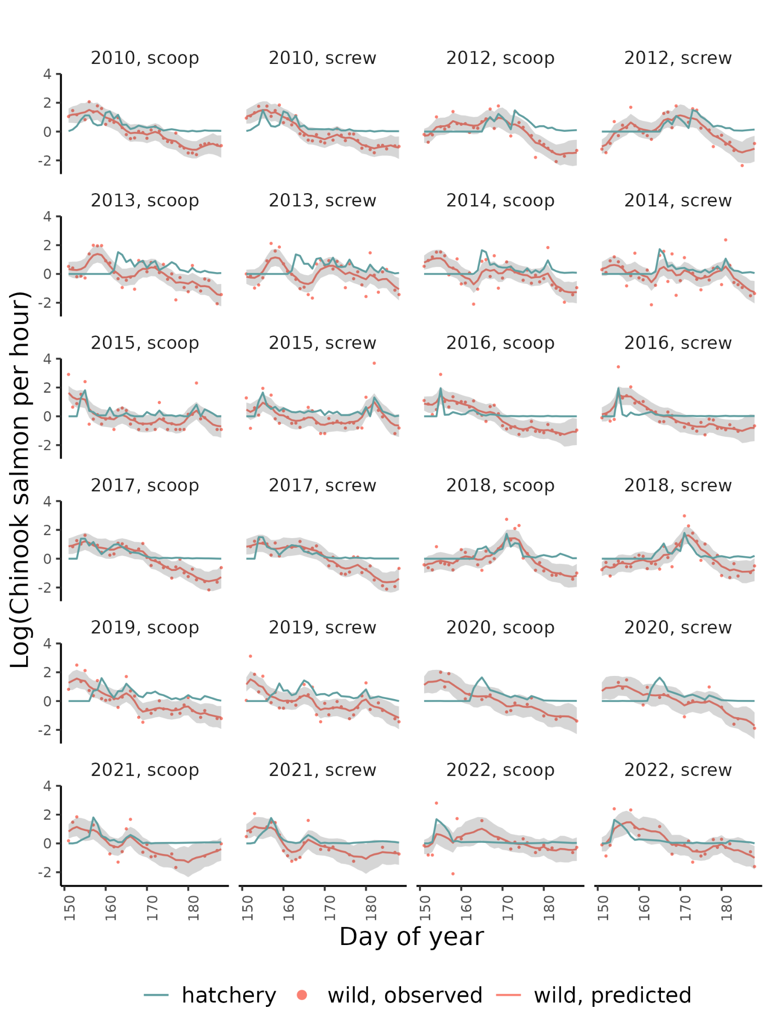Figure S11 - Model estimates and observations of wild Chinook salmon and observations of hatchery Chinook salmon in the Skagit River.
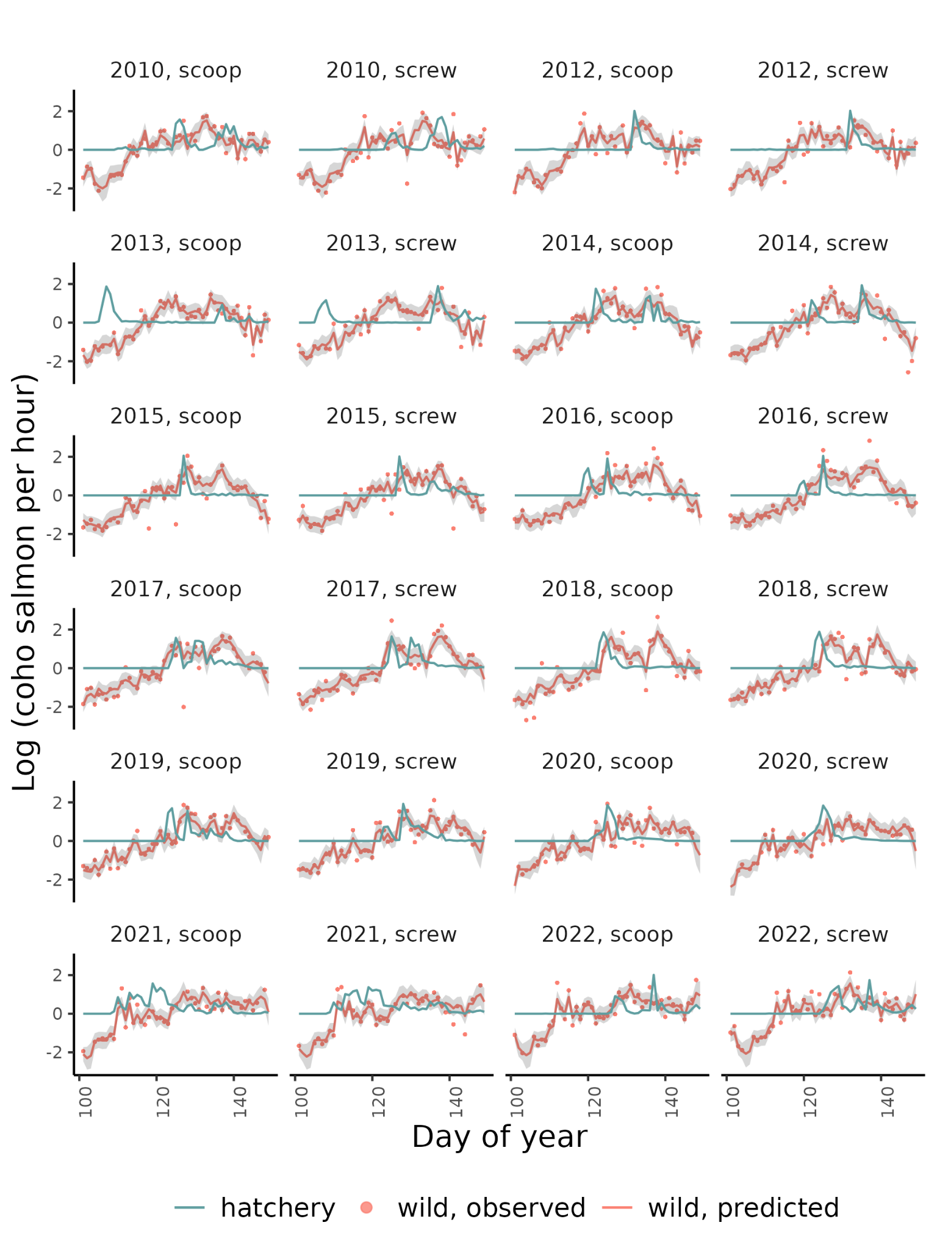
Figure S12 - Model estimates and observations of wild coho salmon and observations of hatchery coho salmon in the Skagit River.

Species | River | Average releases | Average total released | Hatcheries
Chinook | Dungeness | 2 | 147731 | GRAY WOLF R ACCL PD, DUNGENESS HATCHERY, UPR DUNGENESS ACC PD, HURD CR HATCHERY
Chinook | Puyallup | 2 | 1279570 | VOIGHTS CR HATCHERY , GREENWATER ACCLIMATION PD, COWSKULL ACCLIM POND, PUYALLUP TRIBAL HATCHERY
Chinook | Skagit | 2 | 848206 | MARBLEMOUNT HATCHERY
Coho | Dungeness | 1 | 548141 | DUNGENESS HATCHERY
Coho | Puyallup | 2 | 844170 | VOIGHTS CR HATCHERY , GREENWATER ACCLIMATION PD, COWSKULL ACCLIM POND, PUYALLUP TRIBAL HATCHERY
Coho | Skagit | 3 | 421403 | MARBLEMOUNT HATCHERY, BAKER LK HATCHERY

Table S14 - Average number of hatchery salmon released, hatchery location names, and average number of hatchery releases for each river-species combination as reported in RMIS.

