Supplementary Materials
Heresy in ENSO teleconnections:
Atmospheric Rivers as disruptors of canonical seasonal precipitation anomalies in the Southwestern US
Rosa Luna Niño¹, Alexander Gershunov¹, F. Martin Ralph¹, Alexander Weyant¹, Kristen Guirguis¹ Michael J. DeFlorio¹, Daniel R. Cayan¹, A. Park Williams²
¹Center for Western Weather and Water Extremes, Scripps Institution of Oceanography, University of California, San Diego; CA, USA
²Department of Geography, University of California, Los Angeles; CA, USA
Corresponding author: Rosa Luna Niño (rlunanino@ucsd.edu)

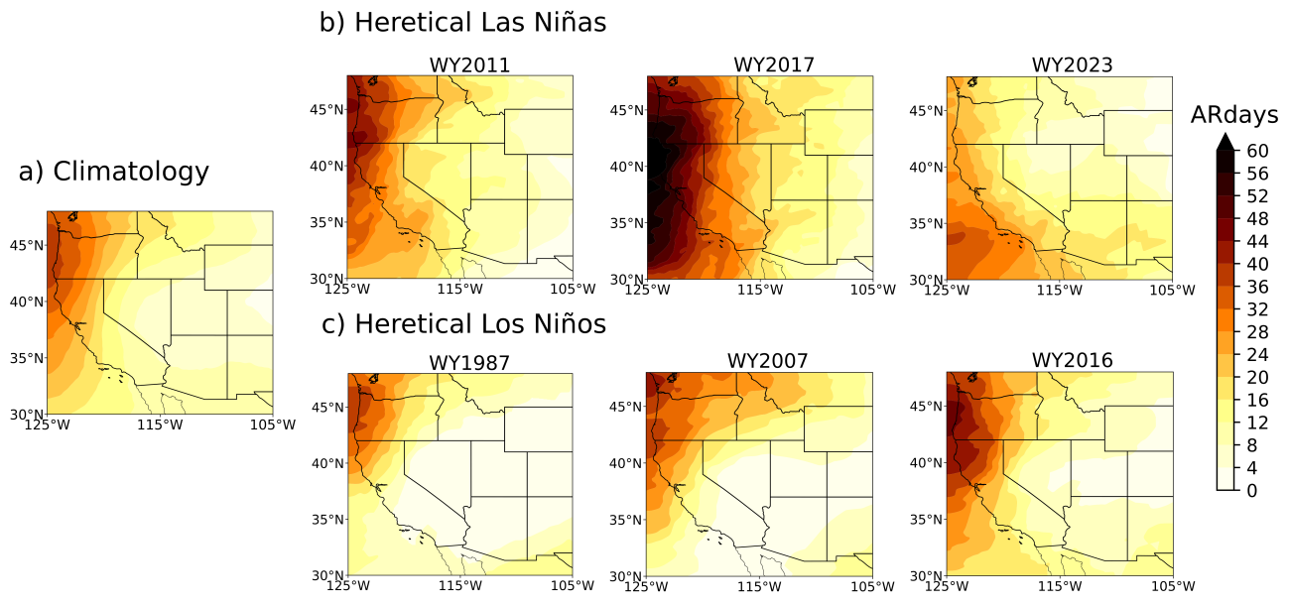
Figure S1. a) Climatology of AR days during the WY (mean from WYs 1982-2023), AR days during b) heretical La Niña, and c) heretical El Niño WYs
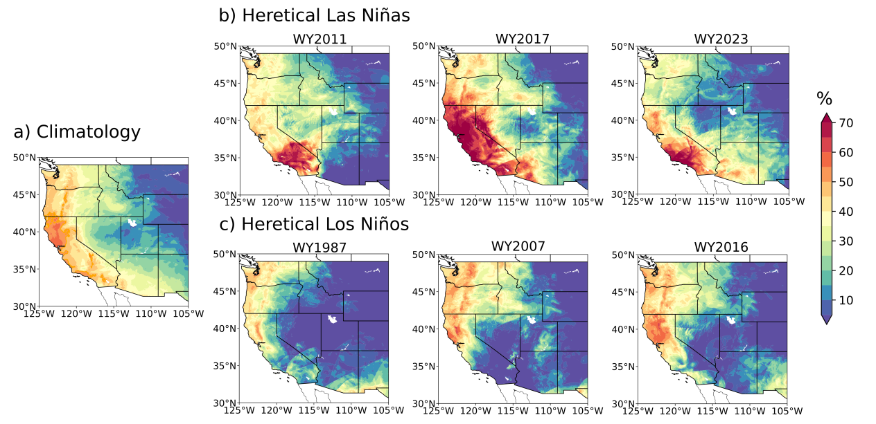
Figure S2. Similar to Figure S1 but for AR precipitation contribution (%) to the total WY precipitation

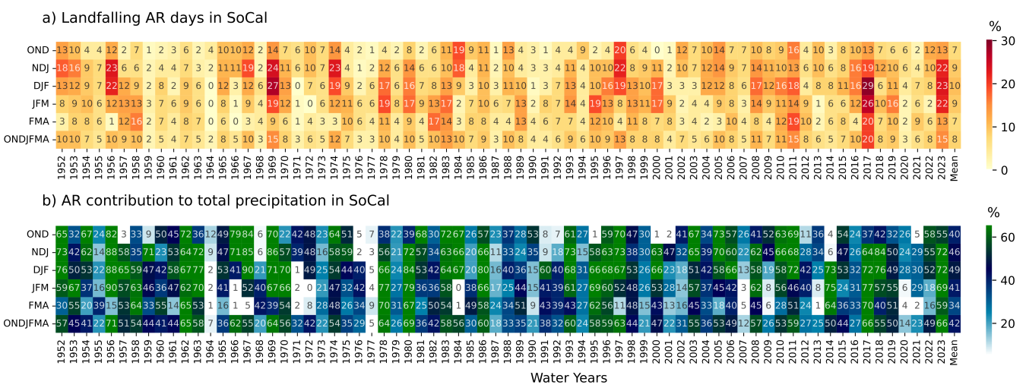
Figure S3. Time series of landfalling AR days and AR precipitation contribution (%) in SoCal

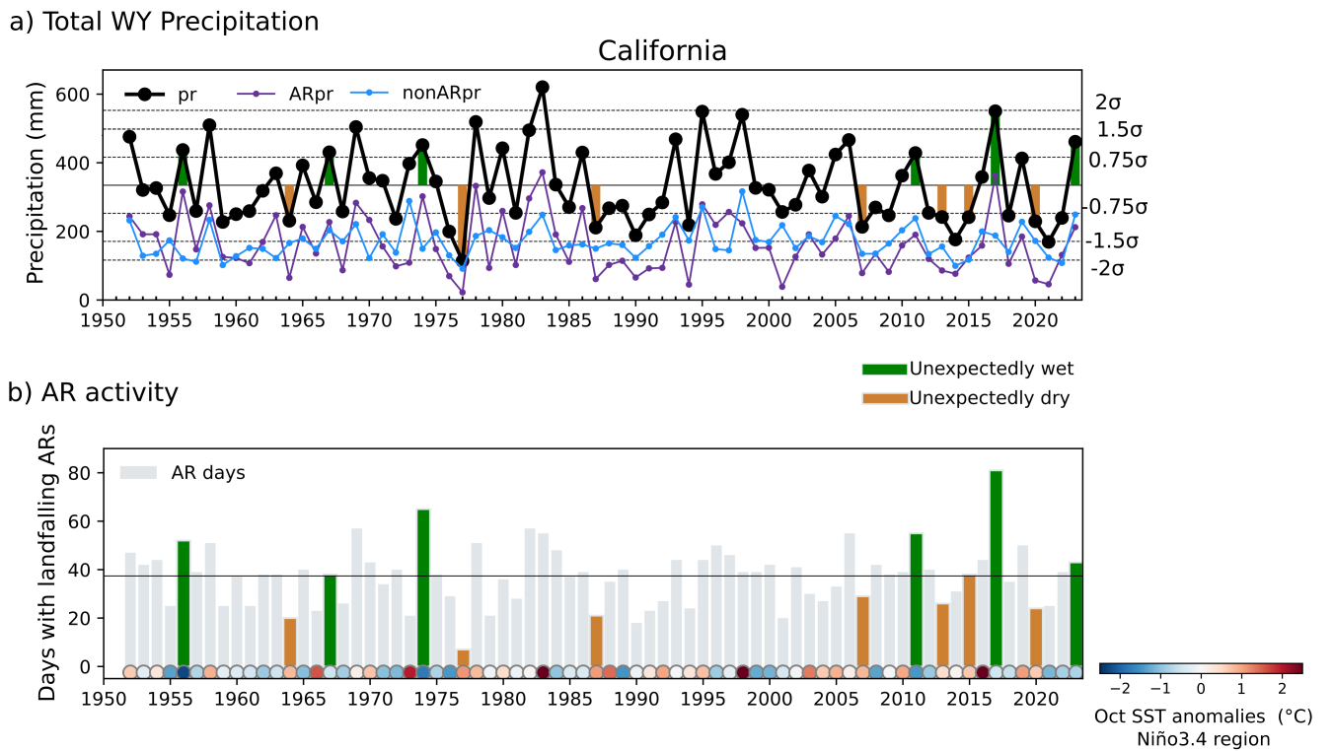
Figure S4. a) Total precipitation (October-April; mm) and b) Number of days of landfalling ARs in California. Solid horizontal lines in a) and b) indicate mean annual precipitation and average landfalling AR days, respectively; dashed lines in a) show thresholds based on the standard deviation ($σ$). Circles in b) show the October SST anomalies in the Niño3.4 region as indicator of the ENSO conditions at the beginning of the WYs. Green and brown colors highlight unexpected wet and dry water years, respectively, based on ENSO: unexpectedly wet for La Niña and unexpectedly dry for El Niño.

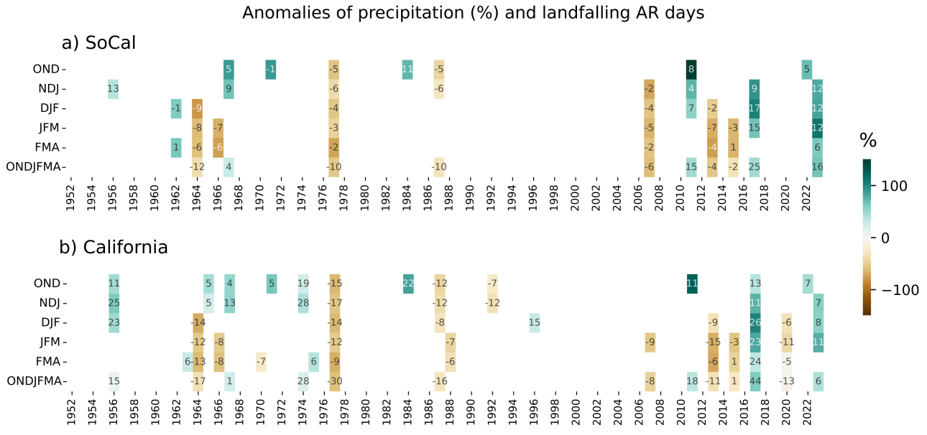
Figure S5. Unexpectedly wet and dry seasons in a) Southern California (SoCal, red box in Figure 1) and b) California. The shaded colors and numbers indicate the anomalies of precipitation (%) and landfalling AR days, respectively.

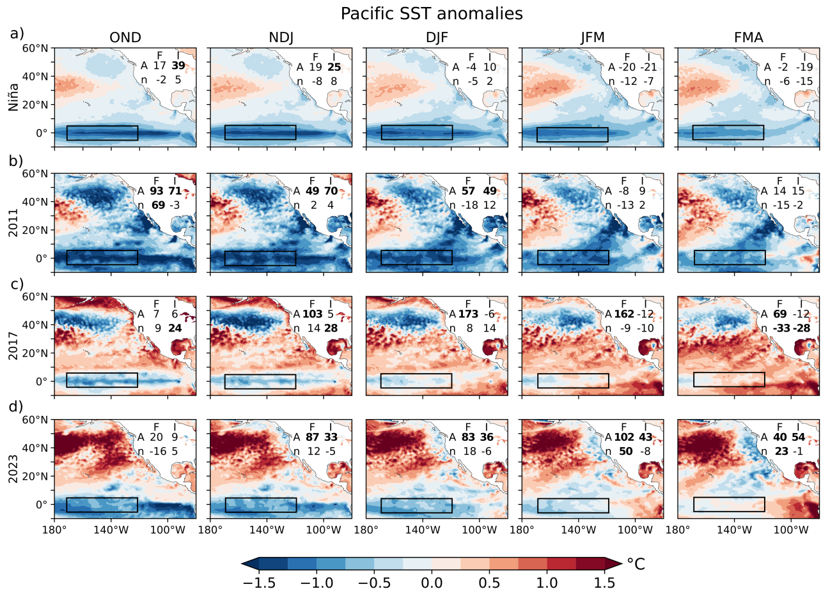
Figure S6. Pacific SST anomalies (°C) during a) La Niña years (based on ONI index) and heretical La Niña WYs b) 2011, c) 2017, and d) 2023. The numbers indicate anomalies in frequency and intensity (%) for AR precipitation and non-AR precipitation in SoCal. Numbers in bold indicate significant anomalies at the 95% confidence level. Black box shows the Niño3.4 region.
Las Niñas WY2011 and WY2023 (Figure S6b, S6d) were accompanied by the negative PDO phase (https://www.ncei.noaa.gov/access/monitoring/pdo/), but the below normal SST along the West Coast of North America did not clearly materialize until late winter and early spring during WY2023. A quite different SST field occurred in WY2017 (Figure S6c), with a persistent warm tropical ocean and a positive PDO pattern.

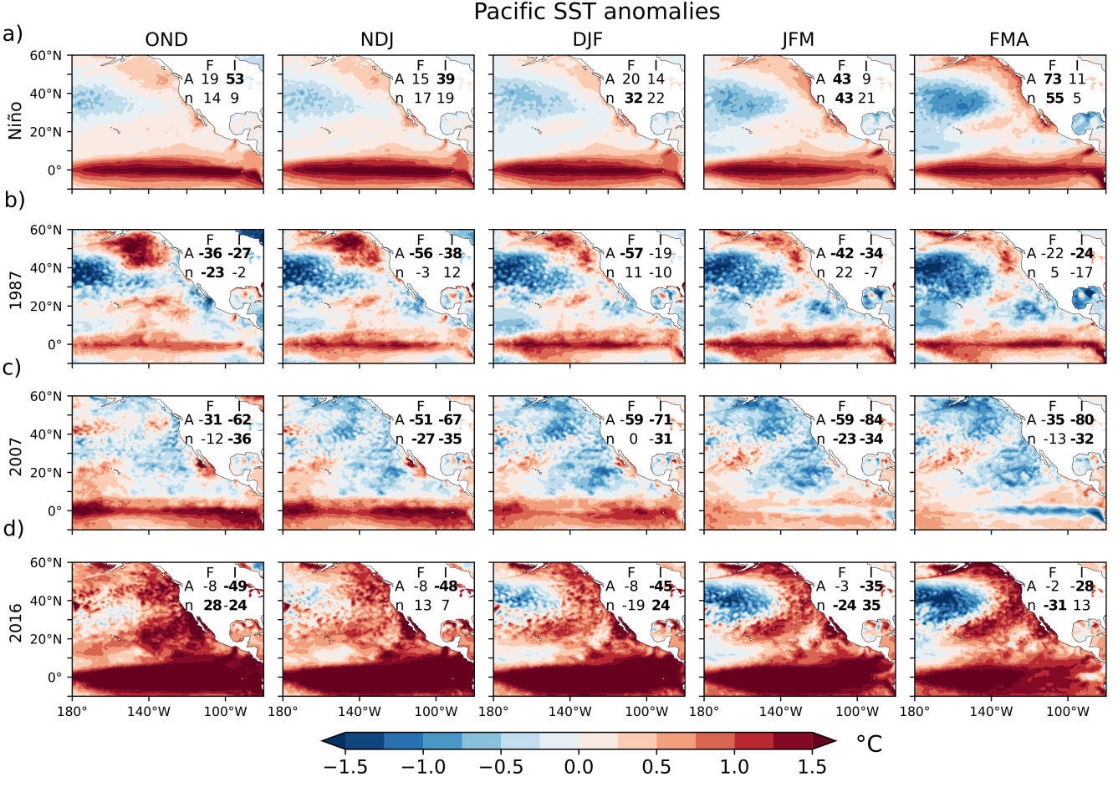
Figure S7. Pacific SST anomalies (°C) during a) El Niño years (based on ONI index) and heretical El Niño WYs b) 1987, c) 2007, and d) 2016. The numbers indicate anomalies in frequency and intensity (%) for AR precipitation and non-AR precipitation in SoCal. Numbers in bold indicate significant anomalies at the 95% confidence level. Black box shows the Niño3.4 region.

The heretical El Nino WY1987 SST anomalies looked similar to that of canonical El Niño but differed mainly over the northeastern tropical Pacific Ocean and the Gulf of California especially during late winter and early spring (Figure S7b). In contrast, WY2007 showed an SST pattern very different from the canonical El Niño, the anomalies were negative along the Coastal Pacific and offshore (Figure S7c). On the other hand, SST anomalies in 2016 looked like an enhanced version of the mean SST El Niño pattern (Figure S7d); the warm tropical Pacific could have provided the atmosphere with potentially large amounts of water vapor, which could have served as fuel for atmospheric rivers, resulting in intense and frequent precipitation. However, the water vapor transport toward the US West Coast wasn't favored (Figure S9d), and even when there was no an outstanding negative precipitation anomaly in SoCal, WY2016 is considered a heretical year due to the scarced observed precipitation compared to the expected given the strong Pacific SST anomalies.

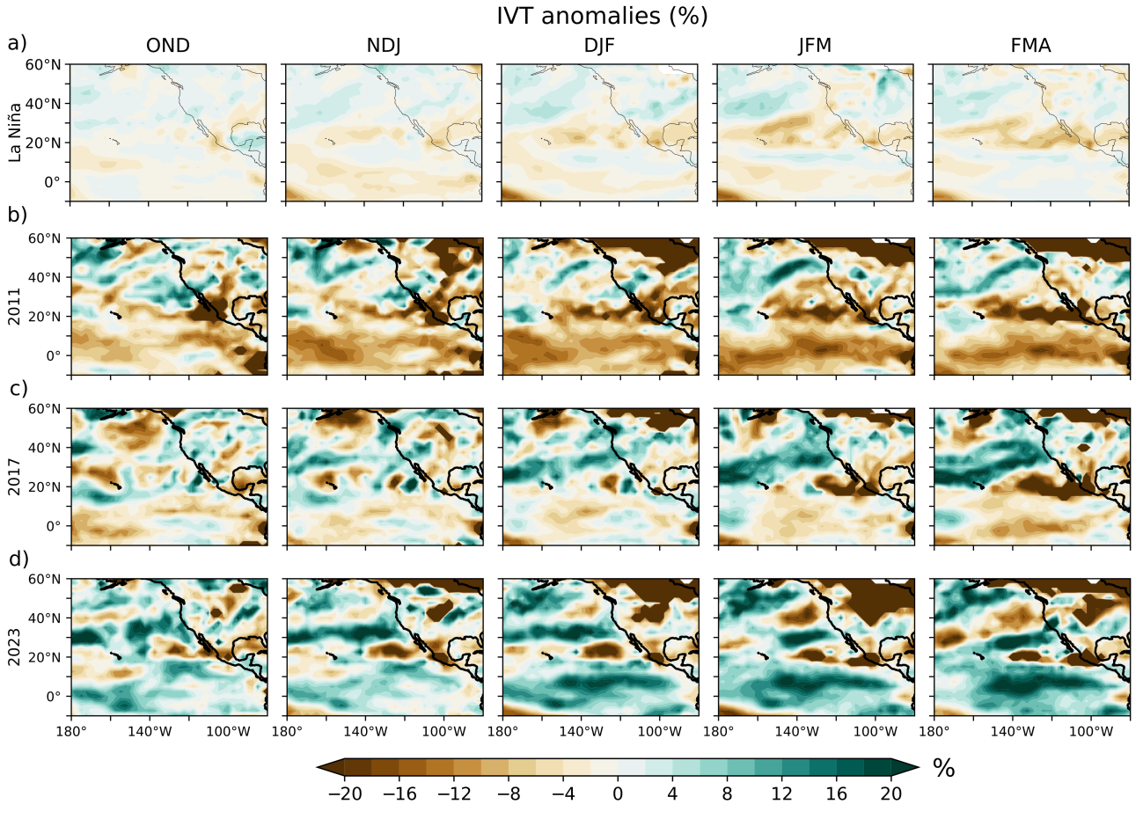
Figure S8. IVT anomalies (%) during a) La Niña years (based on ONI index) and heretical La Niña WYs b) 2011, c) 2017, d) 2023.

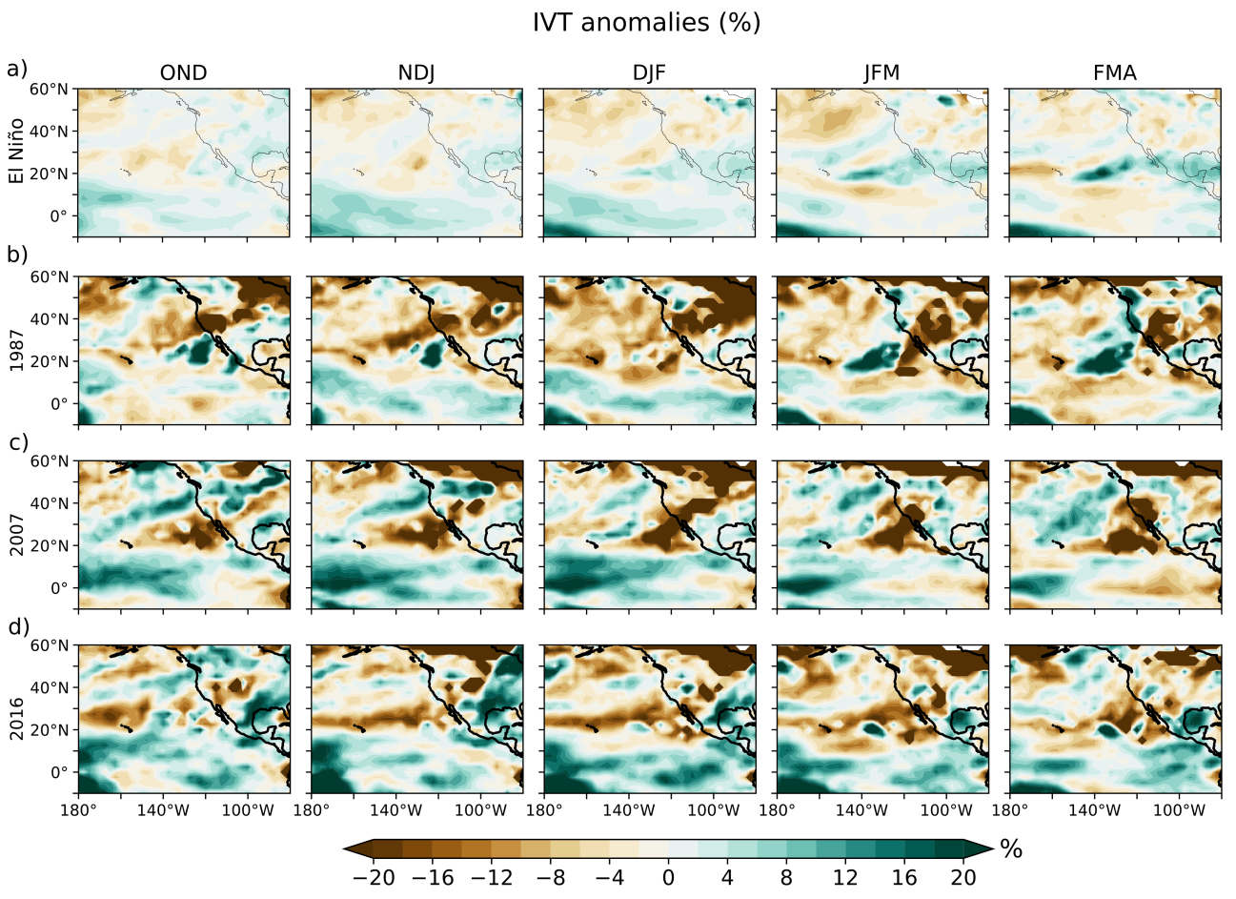
Figure S9. IVT anomalies (%) during a) El Niño years (based on ONI index) and heretical El Niño WYs b) 1987, c) 2007, d) 2016.

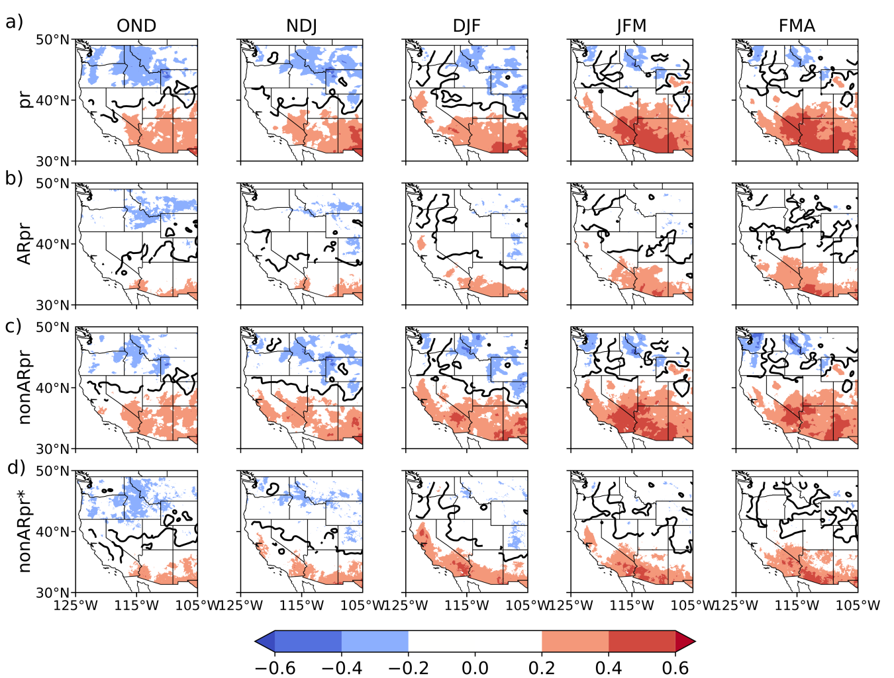
Figure S10. Spearman correlation between ONI index and seasonal a) total precipitation, b) AR precipitation, and c) non-AR precipitation during the WYs 1952-2023. d) shows the correlation for non-AR precipitation using the same sample size as AR precipitation (total non-ARpr using the n-heaviest days, where n is the frequency of AR precipitation). Shaded colors indicate significant correlations at 95% confidence level. Black contour limits areas of positive and negative correlation.
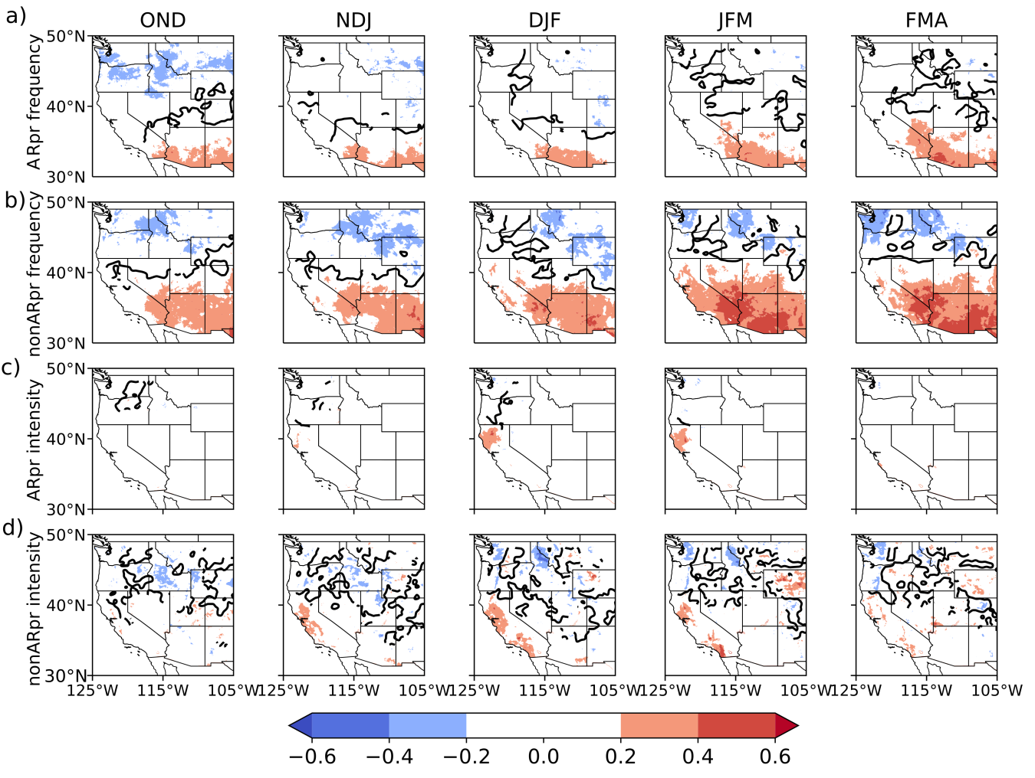
Figure S11. Spearman correlation between ONI index and a) non-AR precipitation frequency, b) non-AR precipitation intensity, c) AR precipitation frequency, d) AR precipitation intensity during the WYs 1952-2023. Shaded colors indicate significant correlations at 95% confidence level. Black contour limits areas of positive and negative correlation.

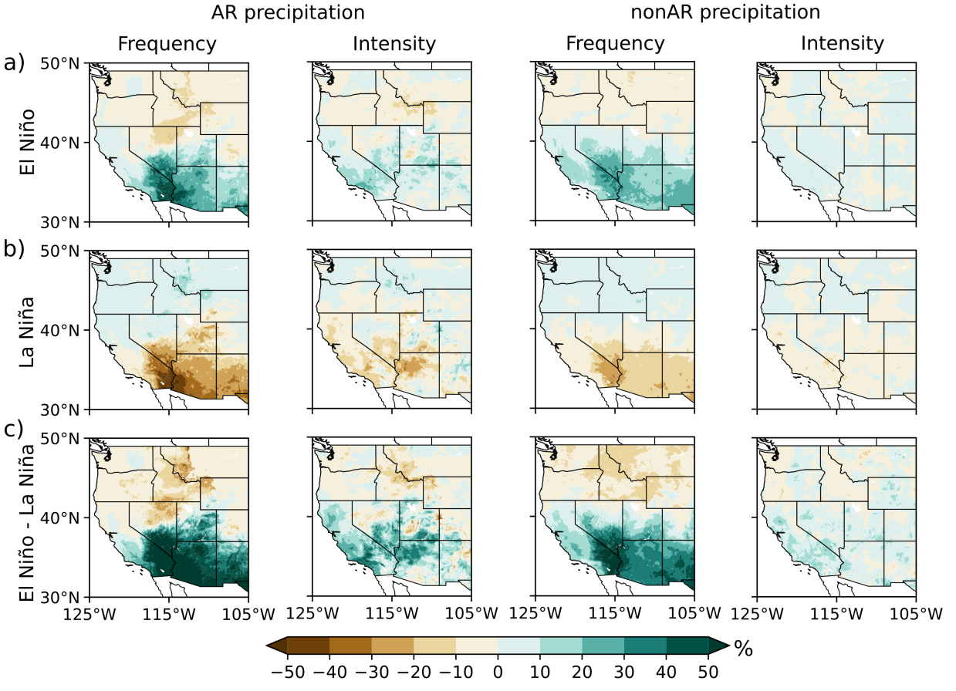
Figure S12. Anomalies (%) of AR and nonAR precipitation frequency and intensity during a) El Niño, b) La Niña, and c) El Niño – La Niña WYs (ONDJFMA).

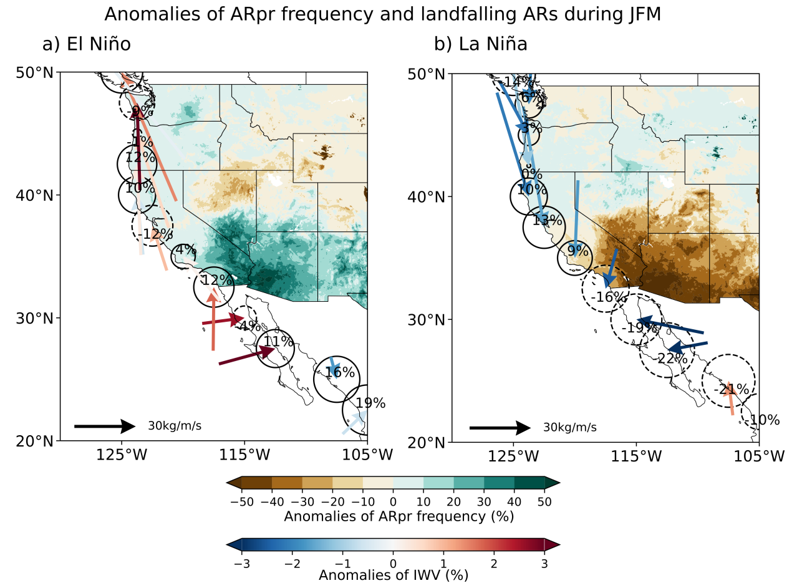
Figure S13. Composites of landfalling ARs during El Niño and La Niña years (late winter JFM) from 1952-2023. The shaded colors represent the anomalies in ARpr frequency (%), the size and number within the circles indicate the anomalies of landfalling ARdays (%), the direction and magnitude of vectors show the IVT anomalies, and the colors represents IWV anomalies (%).

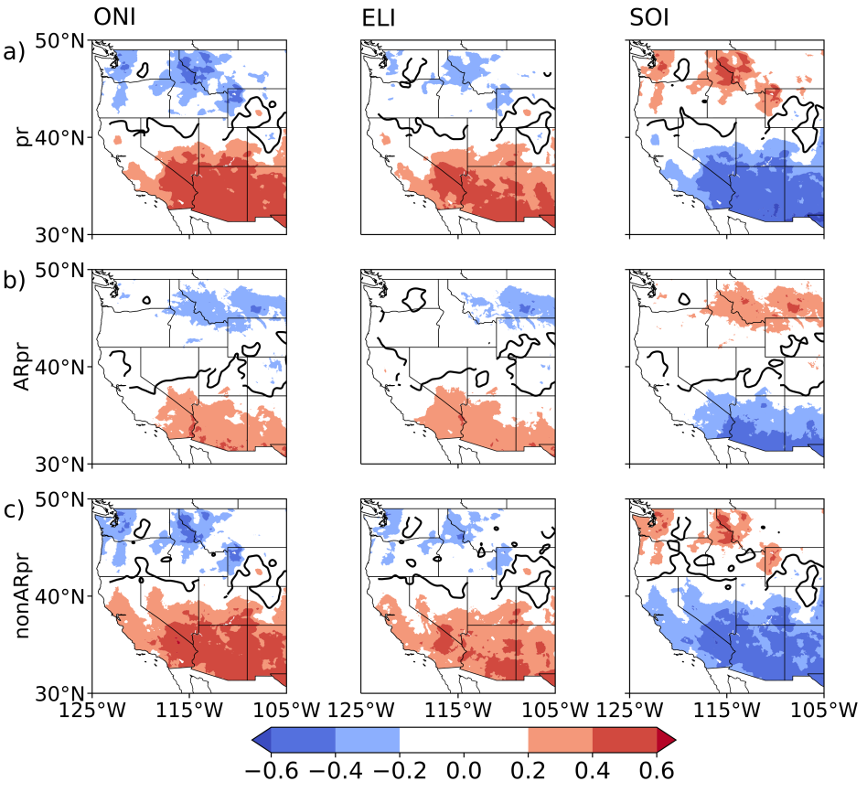
Figure S14. Spearman correlation between independent ENSO indexes and seasonal a) total precipitation, b) AR precipitation, and c) non-AR precipitation during the WYs 1952-2023 (ONDJFMA). Shaded colors indicate significant correlations at 95% confidence level. Black contour limits areas of positive and negative correlation. The opposite correlations obtained with SOI compared with ONI and ELI are because negative (positive) SOI values are associated with El Niño (La Niña) events.

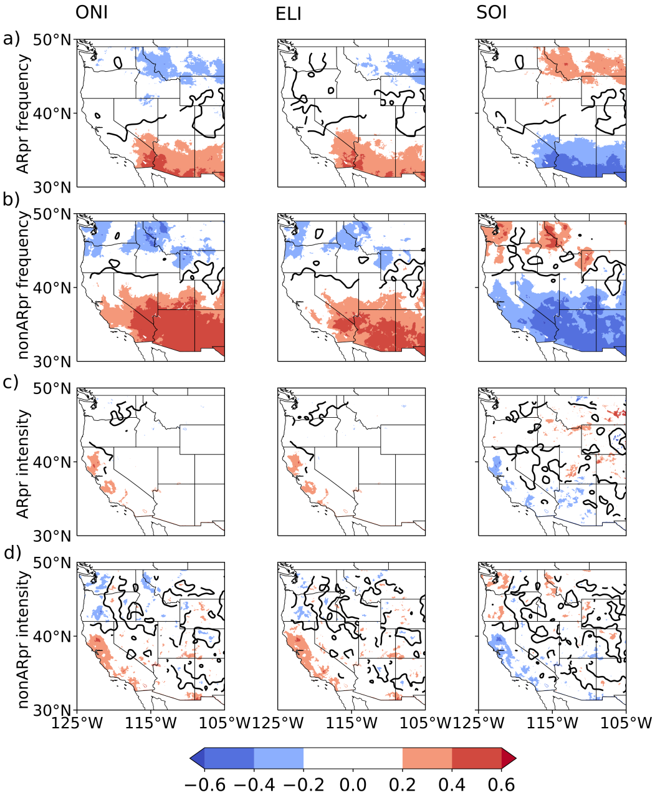
Figure S15. Spearman correlation between independent ENSO indexes and seasonal a) AR precipitation frequency, b) non AR precipitation frequency, c) AR precipitation intensity, and nonAR precipitation intensity during the WYs 1952-2023 (ONDJFMA). Shaded colors indicate significant correlations at 95% confidence level. Black contour limits areas of positive and negative correlation. The opposite correlations obtained with SOI compared with ONI and ELI are because negative (positive) SOI values are associated with El Niño (La Niña) events.

Table S1. List of heretical WYs identified based on different thresholds.
$$σ=0.5$$ | La Niña: 1962, 1967, 2011, 2017, 2023  El Niño: 1964, 1970, 1977, 1987, 2004, 2007, 2013, 2015
$$σ=0.75$$ | La Niña: 1967, 2011, 2017, 2023  El Niño: 1964, 1977, 1987,2007, 2013, 2015
$$σ=1$$ | La Niña: 2017, 2023  El Niño: 1977, 2007, 2013

Table S2. Mean and standard deviation of the total precipitation (pr), AR precipitation (ARpr), nonAR precipitation (nonARpr) and nonARpr* using the same sample size than ARpr during the WY (October-April) in SoCal.
 | Mean (mm) | Standard deviation (mm)
pr | 309.6 | 139.4
ARpr | 143.6 | 103.8
nonARpr | 166.0 | 61.3
nonARpr* | 60.1 | 21.1

