Supplementary Information
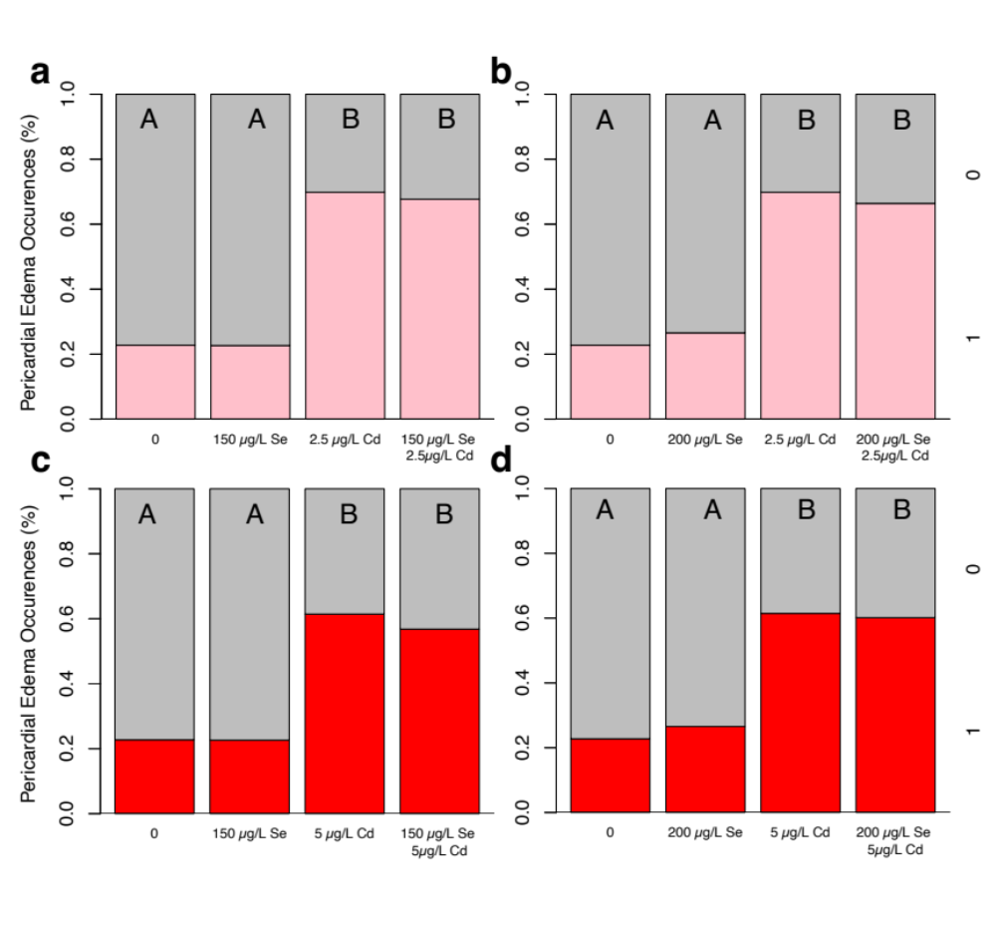
Fig S1. Fish exposed to various concentrations of Se and Cd. a) The presence of pericardial edemas in fish exposed to 2.5 µg/L of Cd, 150 µg/L of Se and a pre-treatment of 150 µg/L of Se prior to a 2.5 µg/L Cd exposure. Fish exposed to 150 µg/L of Se prior to Cd (n = 130) and those exposed to 2.5 µg/L of Cd (n = 169) show similar incidences of pericardial edemas. Se deficient fish (n = 167) and those exposed to 150 µg/L of Cd (n = 130) show similar incidences of pericardial edemas. This led to a significant difference across treatment groups, H (3, n = 594) = 127.45, p < 0.0001. b) Fish exposed to 200 µg/L of Se prior to 2.5 µg/L of Cd (n = 128) and those exposed to 2.5 µg/L of Cd (n = 169) show similar incidences of pericardial edemas. Se deficient fish (n = 167) and those exposed to 200 µg/L of Cd (n = 128) show similar incidences of pericardial edemas, H (3, n = 592) = 115.46, p < 0.0001. c) Fish exposed to 150 µg/L of Se prior to 5 µg/L of Cd (n = 132) and those exposed to 5 µg/L of Cd (n = 166) show similar incidences of pericardial edemas. Control fish (n = 167) and those exposed to 150 µg/L of Se (n = 128) show similar incidences of pericardial edemas (H(3, n = 593) = 82.89, p < 0.0001). d) Fish exposed to 200 µg/L of Se prior to Cd (n = 256) and those exposed to 5 µg/L of Cd (n = 166) show similar incidences of pericardial edemas. Control fish (n = 167) and those exposed to 200 µg/L of Se (n =128) show similar incidences of pericardial edemas. This led to a significant difference across treatments, H(3, n = 589) = 80.46, p < 0.0001.

