Supplemantary Information

Additional Methods & Results, Green Crab vs. Sea Otter Manuscript

Estimates of sea otter consumption of green crabs
We estimated green crab consumption rates by sea otters by using a data set of observational data on sea otter foraging behavior, collected during United States Geological Survey (USGS) annual surveys. These data were collected between 1999 and 2017 in Elkhorn Slough as a part of several sea otter population studies and have been previously published elsewhere (Hughes et al. 2013, Espinosa 2018, Tinker et al. 2018, Mayer et al. 2019, Haslam et al. 2019, Grimes et al. 2020). Briefly, shore-based observers with high powered (80x) telescopes recorded data from multiple sequential feeding dives made by randomly selected focal sea otters. Data recorded include durations of dives and subsequent surface intervals, whether or not prey were captured and, for successful prey captures, the taxonomic identity of the prey (if observable), size of items (linear dimension) and handling duration (Tinker et al. 2008, 2012). A total of 26,429 sea otter feeding dives were recorded in Elkhorn Slough over the past two decades, resulting in 16,117 captures, or 12,559 prey that were identifiable to some taxonomic level. Of identifiable prey captures, 23.5% were crabs of some type, and 7.8% of crab prey that were identifiable to species were green crabs (N = 52). If we apply this proportion to un-identifiable crab prey, we estimate an additional 177 green crab captures for a total of 229, corresponding to 1.82% of identifiable prey. Assuming that identifiable prey were representative of un-identifiable prey, and thus that 1.82% of the total number of prey captures (16,117) were green crab, this yields a total of 294 green crabs. Dividing this number by the summed duration of all recorded feeding dives (36,128 minutes) gives a consumption rate of 0.00813 green crabs per minute of feeding time.
To translate this estimated consumption rate to the population level, we note that the mean abundance of sea otters in Elkhorn Slough since 2013 is approximately 80 (Eby et al. 2017, Hatfield et al. 2018), and these otters spend approximately 35% of their activity budgets feeding (Tinker et al. 2018). This corresponds to 40,320 minutes of feeding time per day or 14,716,800 minutes per year. Multiplying these durations by the estimated consumption rate (0.00813) results in an estimated 328 consumed green crabs per day or 119,710 consumed green crabs per year.

Sea otter consumption of green crabs the field and in captivity
In the field, co-author Hughes observed an individual sea otter consume about 30 green crabs, over the course of an hour, in 2014 at Kirby Park. The observer was on shore processing crabs from crab traps, while the otter was foraging very close by.
To further document whether sea otters readily consume green crabs, we conducted a pilot experiment at the University of California Santa Cruz (July 2015) testing sea otter foraging on green crab using the captive sea otter Selka (CDFW Permit # MA 186914-2). Two green crabs were tethered to the experimental array with one green crab tethered outside a plastic jar and one inside a plastic jar (Figure S1 Video). The design aimed to test if: 1) a sea otter that had never encountered a green crab would consume it from a tether, and 2) a sea otter could remove a tethered green crab inside the jar. The purpose of the latter was to develop and test a design that would allow for sea otter consumption, but not consumption by sharks and rays. We intended to conduct a field experiment with tethered green crabs with and without jars to quantify sea otter consumption rates, but after this pilot experiment was conducted, green crab abundance remained too low in Elkhorn Slough to conduct the field experiment.

Spatial Patterns
Estuarine gradient and tidal restriction
Elkhorn Slough is a shallow estuary, at the center of Monterey Bay in central California. The estuary extends about 12 km inland from Monterey Bay. By the end of the wet season (Feb-Apr), salinity in the main channel in the upper estuary can temporarily (for a few hours) be as low as 10-15 ppt during heavy run-off and as high as upper 30s ppt during the dry season with strong evaporation in late summer and early fall (Aug-Oct). Salinities in the lower estuary are rarely below 25 ppt even during the wet season, and most of the year salinity is just under 35 ppt. These conditions create an estuarine gradient from lowest range of salinity fluctuations near the mouth of the estuary, intermediate salinity range in the middle estuary, and highest range in the upper estuary (ESNERR long-term monitoring data, managed by CDMO). Residence time is highest in the upper estuary, intermediate in the middle estuary, and lowest in the lower estuary (Nidzieko 2009). Although salinities are variable among seasons, sites at varying distances from the mouth, and sites with or without tidal restriction, have salinities well within the range of suitable habitat for green crabs.
About 50% of the wetlands in Elkhorn Slough are behind water control structures (Van Dyke & Wasson 2005, Ritter et al. 2008). Tidally restricted sites have a narrower tidal range, a higher residence time, and more indicators of eutrophication than sites with full tidal flow (Hughes et al. 2011). The predominant vegetation in the estuary is seagrass (Zostera marina) subtidally, and pickleweed (Salicornia pacifica) above mean high water level. Both species are important to sea otters, seagrass for prey and pickleweed for resting spots, have declined over the past centuries, and are actively being restored.
To examine relationships between sea otter density and green crab CPUE from the mouth to the head of Elkhorn Slough estuary, we divided the estuary into three sections, lower-, middle-, and upper estuary based on water residence time, salinity, and distance from the mouth of the estuary. To examine the relationships between tidal restriction on otter density and green crab CPUE we sampled three sites with restricted tidal flow (APM (upper estuary), NMM, WS (middle estuary) and six sites with full tidal flow (VB, SM, HI (lower), KP, NMF (middle), HL (upper)).
Crab Trapping
To characterize both small and large crabs in the estuary we used three different trap types: 1) Modified minnow traps which are conically shaped plastic traps (42 x 22.5 x 15.5 cm, 2.5 and 5 cm diameter openings) 2) Fukui fish traps (20 x 45 x 60 cm) and 3) shrimp pots (61 x 61 x 23 cm, 22 x 22 mm mesh and circular opening of 38 mm diameter). All traps were tethered to a PVC stake, baited with raw anchovy or sardine, deployed at least 10 m apart on muddy or sandy substrate, and retrieved approximately 24 hours after deployment. To ensure consistency of trapping crabs in the same habitat range with respect to tidal height, traps were deployed at Mean Lower Low Water (MLLW) for all surveys.
All captured crabs were identified to species, counted and carapace width measured to the nearest 1 mm with calipers or a ruler. To estimate relative abundance of crabs we calculated Catch Per Unit Effort (CPUE) as the total number of crabs caught at a site on a trap day, divided by the total number of traps at that site on that day. Initial calculation of CPUE was separated for the three different trap types but combined for the analyses, due to similar trap type uses among bays and estuaries, days and sites. We used the combined, averaged minnow trap and Fukui trap data for all green crab CPUE calculations. We compared shrimp pot catches to Fukui trap catches when traps were simultaneously deployed at Elkhorn Slough in 2017, to ensure that catches between those two trap types were comparable. We calculated green crab maximum CPUE by using the maximum number of green crabs in one trap, at a given site, on a given day. We then calculated the average maximum number of green crab CPUE by averaging all maximum daily site numbers over one year.
Otter surveys
USGS conducts annual spring surveys of sea otter abundance at Elkhorn Slough. Two shore-based observers using binoculars and spotting scopes count all sea otters in a geographically specific area from pre-determined stations, with approximately 15-30 min per station, and completing an exhaustive count of the entire Slough over the course of about 4 hours (Tinker & Hatfield 2018, Hatfield et al 2018, Appendix 1). The resulting survey data consist of the geolocation of each observed otter (or group of otters) at the time of the survey. To account for the mobile nature of sea otters, we used kernel density smoothing to convert these point counts to a continuous density layer that can be interpolated at each crab trapping site (see “Sea otter effects on green crab population dynamics” section, below, for details).
The ecotourist company Elkhorn Slough Safari (ESS) conducts a count of total otters observed from the mouth of the slough to approximately Parsons Slough entrance (Figure 1). Otters are counted every time ESS runs a tour boat, which is almost daily, year-round and sometimes multiple times per day (Eby et al. 2022). On each trip, a designated volunteer or staff member records each unique sea otter using a click counter. These data are robust and show the same long-term temporal trends as the USGS surveys (Eby et al. 2022).

Temporal relationships
To explore relative sea otter abundance and relative green crab abundance over time at Elkhorn Slough, we used otter abundance data collected by ESS from 1994-2021 and crab data collected by Elkhorn Slough Reserve at nine sites from 2001-2021 (Table A1, Table A2).
Table S1. Site locations, tidal regime, and sampling years.
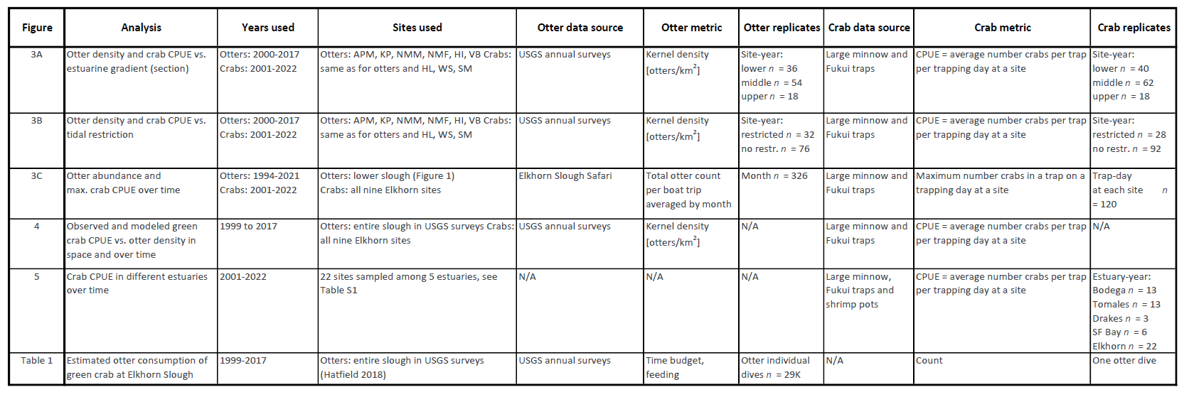
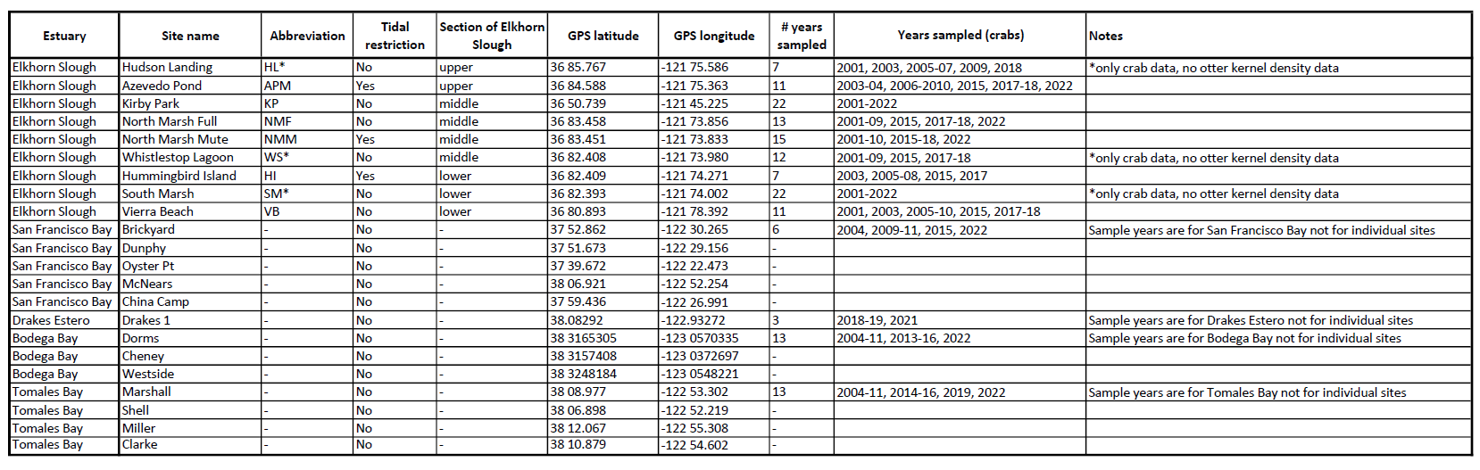
Table S2. Data sources for temporal analysis.
To characterize relative otter abundance, we averaged ESS daily counts within each year, to yield an annual relative otter abundance. Relative green crab abundance was reported as the maximum number of green crabs (Max CPUE) in one trap on a trap day, and averaged over all sites for the year, using trap day as a replicate. (Figure 3C).

Sea otter effects on green crab population dynamics
We developed a simple model of green crab population dynamics in Elkhorn Slough, to assess the degree to which the growing sea otter population affected green crab dynamics. Our process model estimated the spatiotemporal dynamics of sea otters and green crabs and was fit using Bayesian MCMC methods to data from annual population surveys (for sea otters) and trapping catch per unit effort (CPUE) for crabs. Specifically, we estimated the density of sea otters (D, units = otters⋅km⁻¹) and crabs (C, units = CPUE) at each of 6 sites (i = 1, 2… N_{s}) and over 18 one-year time steps (t = 1, 2…N_{t}) between 1999 and 2017, allowing for a potential effect of sea otters on the site-specific dynamics of crab populations. We estimated the density of sea otters at site i and year t as a stochastic, autoregressive (AR[1]) latent variable:
$D_{i,t}=\exp{(}μ_{i,t}), μ_{i,t}∼normal\left(ρ⋅μ_{i,t-1}, σ_{d}\right)$
where ρ is a parameter that determines the degree of temporal autocorrelation in log-transformed sea otter density across years, and σ_{d} is a variance parameter that determines the magnitude of temporal variation in log sea otter density. Because equation is recursive for values of t > 1, we treated log density at year 1 of the time series (μ_{i,1}) as a free parameter. For green crabs we assumed that population dynamics at each site was both stochastic and density dependent in the absence of predation or other extrinsic limiting factors. We therefor modeled crab dynamics using a stochastic logistic growth function:
$C_{i,t}=C_{i,t-1}⋅\exp\left(r⋅\left[1-\frac{C_{i,t-1}}{K_{i}}\right]+ε_{i,t}-α⋅D_{i,t}\right)$
where parameters r (maximum intrinsic growth rate), K_{i} (site-specific equilibrium densities) and C_{i,1} (crab CPUE in year 1 at each site) are estimated parameters and the ε_{i,t} term is a random effect accounting for environmental stochasticity. Noting that large spikes in crab abundance tended to be spatially correlated, we treated ε_{i,t} as a hierarchical parameter: specifically, we estimated mean stochastic effects for year t (${\overline{ε}}_{t}$) as a random normal variable with mean of 0 and SD of σ_{c} , and then estimated site-specific effects (ε_{i,t}) as random normal variables with mean of ${\overline{ε}}_{t}$ and SD of σ_{s} (σ_{c} and σ_{s} were estimated parameters). The final term in equation represents the potential negative effect of sea otter predation on crab growth rates, with the magnitude of this effect determined by local sea otter density (D_{i,t}) and the estimated interaction parameter α.
We used two data sets for model fitting: 1) mean annual observed CPUE at each site (Cobs_{i,t}), and 2) geospatial data on sea otter distribution and abundance in Elkhorn Slough, recorded as part of an annual range-wide sea otter census (Hatfield et al. 2018). For the latter data set, each record consisted of the location of one or more sea otters; however, because sea otters are mobile predators and the raw survey observations represent just a snapshot in time, these point locations do not capture the “true” distribution of otters as integrated over a year. We therefore used kernel density smoothing to convert point observations into a continuous surface of sea otter density within the Slough. To account for the linear nature of Elkhorn Slough estuary, and the fact that sea otter distribution within the Slough has essentially spread as a linear wave front moving inland from the ocean, we created a 1-dimensional “Distance from ocean” axis, defined as 1m increments along an imaginary line running down the middle of the estuary (Figure S2). We spatially joined each otter observation to the closest 1m increment along this axis, and then fit a 1-dimensional kernel density smoother to the resulting data set, stratified by year, to obtain the mean annual sea otter density within the Slough as a non-linear function of distance from the ocean. By accounting for the width of the Slough we converted values from linear densities to area-based densities (otters⋅km⁻¹). We then interpolated the density surface at the location of each crab trapping site, thus generating “observed” density values by site and year (Dobs_{i,t}).
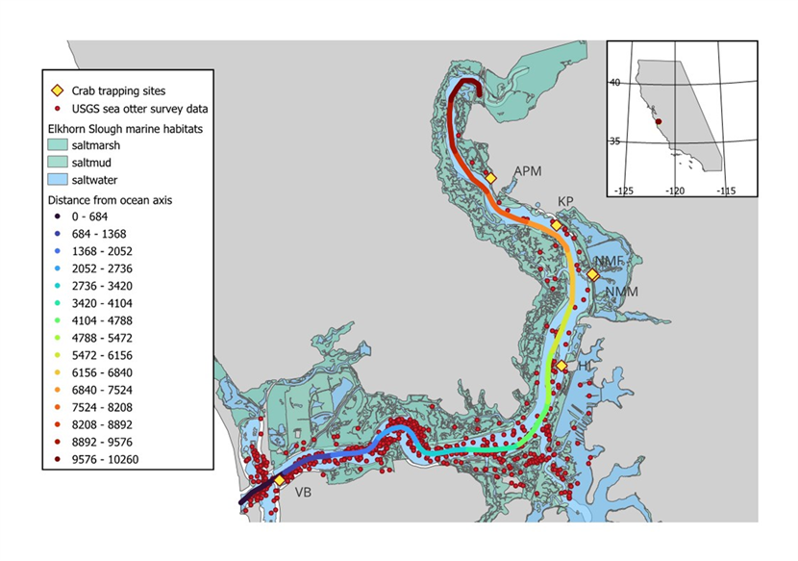
Fig. S2. Map of Elkhorn Slough showing the observed distribution of sea otters during annual surveys and the locations of crab trapping sites. Also shown is a “distance from ocean” axis running down the midline of the Slough channel, which was used for estimating local sea otter densities as a 1-dimensional kernel density function.
We probabilistically related the observed data (Cobs_{i,t}, Dobs_{i,t}) to the estimated latent variables (C_{i,t}, D_{i,t}), in order to estimate the parameters of the process model. We assumed that observed sea otter densities were log-normally distributed with median value corresponding to the log of true density:
$Dobs_{i,t}\sim lognormal\left(μ_{i,t}, σ_{o}\right)$
where estimated variance parameter σ_{o} determines the magnitude of observation error. For green crabs, we noted that the observed CPUE data (Cobs_{i,t}) contained an excessive number of 0 values, and thus were not well fit by a simple probability distribution. We therefore used a hurdle model (Baetschmann and Winkelmann 2017) to account for excess 0s. A hurdle model is applied by dividing the likelihood of each observed data point into two parts:
$\operatorname{Pr}\left(Cobs_{i,t}=y\right)=\left\{\begin{matrix}f_{1}\left(C_{i,t},θ,ζ\right) & for y=0 \\ \left[1-f_{1}\left(C_{i,t},θ,ζ\right)\right]⋅f_{2}\left(y,C_{i,t},ϕ\right) & for y>0\end{matrix}\right.$
where:
$f_{1}\left(C_{i,t},θ,ζ\right)={logit}^{-1}\left(θ-ζ⋅\log{(}C_{i,t})\right)$
$f_{2}\left(y,C_{i,t},ϕ\right)=gamma.pdf\left(y|C_{i,t}⋅ϕ, ϕ\right)$
As shown in equation , the probability of observing y = 0 is given by function f₁ (equation ), a logit-transformed linear function of estimated density (C_{i,t}) with intercept θ and slope ζ (note that for positive values of ζ, increasing values of C_{i,t} are associated with lower probabilities of observing a 0). The probability of observing y > 0 is given by the product of (1 – f₁) and function f₂ (equation ), corresponding to the probability density at y of a gamma distribution with mean of C_{i,t} and inverse scale parameter φ (another estimated parameter). In terms of model fitting, for each observation where y = 0 we incremented the total log probability of the model by the value of a Bernoulli log probability mass function (lpmf) with parameter p = f₁, evaluated at 1, while for each observation where y > 0, we incremented the total log probability by the sum of 1) the Bernoulli lpmf with parameter p = f₁, evaluated at 0, and 2) the gamma log probability density function (lpdf) with shape parameter a = C_{i,t} ⋅φ and inverse scale parameter b = φ, evaluated at y.
We coded and solved the above-described model using Bayesian MCMC methods, implemented using programming language R (R.Core.Team 2022) and MCMC analytical software STAN (Carpenter et al. 2017). We set vague and effectively uninformative priors for all parameters (i.e. distributions that reflected fundamental biological constraints but with no information specific to the study system): we used half-Cauchy(0, 1) priors for standard errors and other parameters logically constrained to be positive (σ_{d} , σ_{c}, σ_{s}, σ_{o}, φ, r, K_{i} and C_{i,1}), unbounded Cauchy(0, 1) priors for α and ζ (Gelman et al. 2008), Normal(0, 5) priors for θ and μ_{i,1}, and a Beta(1, 1) prior for temporal autocorrelation parameter ρ. The STAN Code for the model is provided in Appendix 1. We saved 10000 posterior samples from 10 parallel chains (after a burn-in of 2500 samples), and to evaluate model convergence we graphically examined trace plots to ensure well-mixed chains and ensured that r-hat statistics for all parameters were < 1.05 (Vehtari et al. 2021). To evaluate model goodness of fit we conducted posterior predictive checking (PPC), using the parameterized model to generate new “out-of-sample” observations for sea otter density and crab CPUE, and we graphically compared the distributions of these out-of-sample observations to the original data distributions (Gelman et al. 1996, 2000). We report means and 95% credible intervals (CI₉₅) of parameter posterior distributions, and we consider the effect of otters on crab growth rates to be significant if the CI₉₅ for parameter α does not overlap 0. We also calculate and present the posterior predictions of crab dynamics at each site under two different scenarios: 1) a base scenario of actual dynamics, with observed sea otter population growth and range spread (i.e., the fitted estimates of C_{i,t}); and 2) an alternative scenario generated by re-solving equation for all sites and years with parameter α forced to 0 (i.e., with no sea otter effects), but all other parameter values and random effects drawn from their estimated joint posterior distribution. Comparing these two scenarios provided a means of evaluating the magnitude of sea otter effects on crab population dynamics.

Results
The model converged well (r-hat < 1.05) and produced high effective sample sizes for all parameters (Table A3).
Table S3. Model parameters. Summary statistics for estimated parameters in a model of sea otter and green crab population dynamics for Elkhorn Slough. Statistics reported for the posterior distributions of each parameter include: arithmetic mean, Monte Carlo standard error (mcse), standard deviation (sd), select quantiles, effective population size (N_eff), and the Gelman-Rubin convergence diagnostic (r-hat).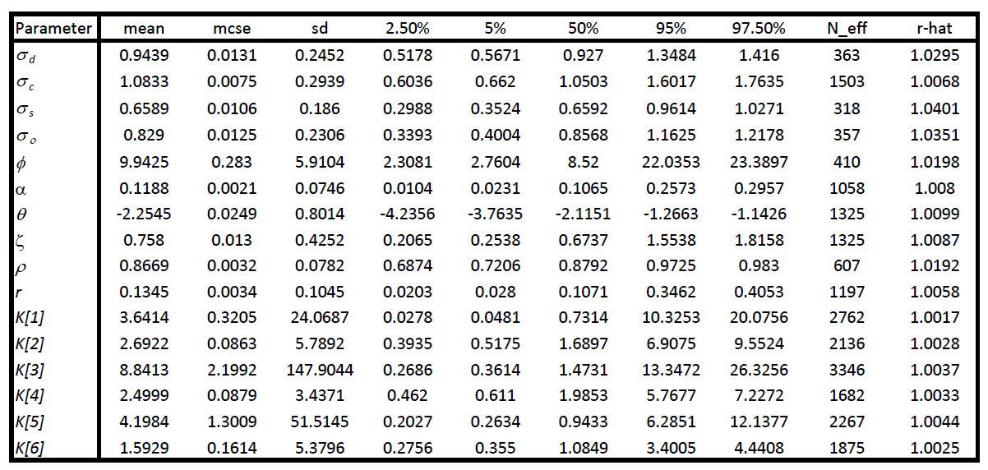
Visual posterior predictive checking indicated good agreement between the distributions of observed and out of sample predictions (Figure S3). There was a significant and negative effect of sea otters on crab population growth rates (α = 0.11, CI₉₅ = 0.01 – 0.30; Table S3, Figure S4A), leading to negative expected growth rates for crab populations, even at low densities (10% of equilibrium abundance), when otter densities were >2.5 (Figure S4B). In Elkhorn Slough, the realized effects of sea otters on crab populations varied considerably by site, due to differences in absolute sea otter densities. At sites where sea otter densities were relatively high throughout the time series (e.g., sites VB or HI), the population trajectories for green crabs experiencing sea otter effects were substantially lower than they would have been without otters (Figure 4A, 4B). At other sites with lower sea otter densities (e.g., sites NMF or NMM), the differences between expected trends with vs. without otter effects were less dramatic (Figure 4C, 4D). However, even at these latter sites, effects on crab abundance began to emerge in the last few years of the time series, as otter densities increased at these more inland sites.
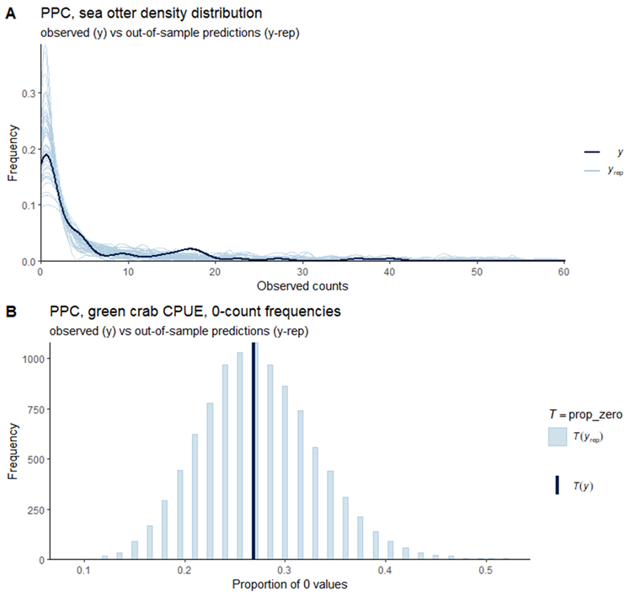
Fig. S3. Posterior predictive check plots comparing observed data distributions to out-of-sample “new” observations generated by the model.

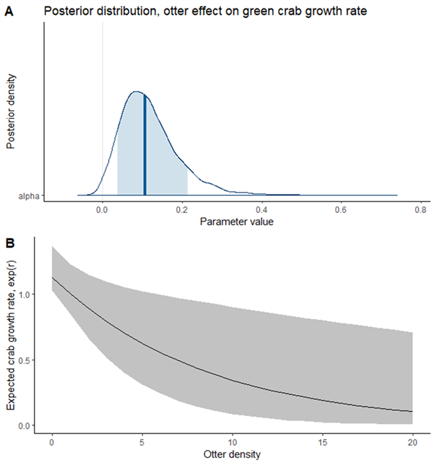
Fig. S4. Effects of sea otter density on local crab population dynamics. A) posterior distribution for model parameter α, whic h measures the strength of the effect of sea otter density on the instantaneous growth rate of the green crab distribution. A positive value indicates a negative effect on crab growth rates. B) a ribbon plot showing the relationship between sea otter density and the mean expected growth rate for green crabs. The solid line indicates the mean predicted relationship, while the grey shaded band shows the 95% CI for the estimated relationship.

Cross-estuary comparison of invasion trends
To compare green crab relative abundance among bays and estuaries we followed the commonly used, standard trapping protocols described above in the section: Spatial patterns, crab trapping, at all sites. We sampled nine sites annually at Elkhorn Slough, five sites in San Francisco Bay, one site in Drakes Estero, three sites in Bodega Bay and four sites in Tomales Bay (Table A1). We used trapping data from 2001 to 2022. Not all sites were sampled in all years, but all sites were sampled in at least three years during this period. A full site list is provided in Table A2. We included data from modified minnow traps and Fukui traps at all estuaries except for at Drakes Estero, where we only used shrimp pots and only trapped at one site due to logistical constraints. We calculated green crab CPUE as the number of green crabs per trap, per day, across all sites within an estuary to characterize green crab CPUE over time. An arbitrary low value (0.05) was added to all CPUE data which were then natural log transformed. A summary of which data were used for which analyses is provided in Table A2.

Literature Cited
Baetschmann, G., and R. Winkelmann. 2017. A dynamic hurdle model for zero-inflated count data. Communications in Statistics - Theory and Methods 46:7174–7187.
Carpenter, B., A. Gelman, M. D. Hoffman, D. Lee, B. Goodrich, M. Betancourt, M. Brubaker, J. Guo, P. Li, and A. Riddell. 2017. Stan: A Probabilistic Programming Language. Journal of statistical software 76:32.
Eby, R., R. Scoles, B. B. Hughes, and K. Wasson. 2017. Serendipity in a salt marsh: detecting frequent sea otter haul outs in a marsh ecosystem. Ecology 98.
Espinosa, S. M. 2018. Predictors of sea otter salt marsh use in Elkhorn Slough, California. Masters thesis. UC Santa Cruz, Santa Cruz, CA.
Gelman, A., Y. Goegebeur, F. Tuerlinckx, and I. Van Mechelen. 2000. Diagnostic checks for discrete data regression models using posterior predictive simulations. Journal of the Royal Statistical Society: Series C (Applied Statistics) 49:247–268.
Gelman, A., A. Jakulin, M. G. Pittau, and Y.-S. Su. 2008. A weakly informative default prior distribution for logistic and other regression models. The Annals of Applied Statistics 2:1360–1383.
Gelman, A., X.-L. Meng, and H. Stern. 1996. Posterior predictive assessment of model fitness via realized discrepancies. Statistica sinica:733–760.
Grimes, T. M., M. T. Tinker, B. B. Hughes, K. E. Boyer, L. Needles, K. Beheshti, and R. L. Lewison. 2020. Characterizing the impact of recovering sea otters on commercially important crabs in California estuaries. Marine Ecology Progress Series 655:123–137.
Haslam, M., J. Fujii, S. Espinosa, K. Mayer, K. Ralls, M. T. Tinker, and N. Uomini. 2019. Wild sea otter mussel pounding leaves archaeological traces. Scientific Reports 9:4417.
Hatfield, B. B., J. L. Yee, M. C. Kenner, J. A. Tomoleoni, and M. T. Tinker. 2018. Annual California sea otter census—2018 spring census summary. U.S. Geological Survey data release, U.S. Geological Survey data release, https://doi.org/10.5066/P98012HE.
Hughes, B. B., R. Eby, E. Van Dyke, M. T. Tinker, C. I. Marks, K. S. Johnson, and K. Wasson. 2013. Recovery of a top predator mediates negative eutrophic effects on seagrass. Proceedings of the National Academy of Sciences of the United States of America 110:15313–15318.
Mayer, K. A., M. T. Tinker, T. E. Nicholson, M. J. Murray, A. B. Johnson, M. M. Staedler, J. A. Fujii, and K. S. Van Houtan. 2019. Surrogate rearing a keystone species to enhance population and ecosystem restoration. Oryx:1–11.
R.Core.Team. 2022. R: A language and environment for statistical computing. R Foundation for Statistical Computing, Vienna, Austria.
Tinker, M. T., G. Bentall, and J. A. Estes. 2008. Food limitation leads to behavioral diversification and dietary specialization in sea otters. Proceedings of the National Academy of Sciences of the United States of America 105:560–565.
Tinker, M. T., S. M. Espinosa, M. M. Staedler, J. A. Tomoleoni, J. A. Fujii, R. Eby, R. Scoles, M. C. Kenner, B. B. Hatfield, C. Fuentes, J. K. Lindsey, T. Nicholson, M. J. Murray, M. A. Young, K. A. Mayer, E. Dodd, S. Fork, and K. Wasson. 2018. The Population Status and Ecology of Sea Otters in Elkhorn Slough, California. Page 109. Final Report for California Coastal Conservancy and U.S. Fish and Wildlife Service.
Tinker, M. T., P. R. Guimarães, M. Novak, F. M. D. Marquitti, J. L. Bodkin, M. Staedler, G. Bentall, and J. A. Estes. 2012. Structure and mechanism of diet specialisation: testing models of individual variation in resource use with sea otters. Ecology letters 15:475--483.
Vehtari, A., A. Gelman, D. Simpson, B. Carpenter, and P.-C. Bürkner. 2021. Rank-normalization, folding, and localization: an improved R for assessing convergence of MCMC (with discussion). Bayesian analysis 16:667–718.

Appendix 1
// This Stan program defines a model to estimate trends in otter density
// and green crab catch per unit effort (CPUE) at sites in Elkhorn Slough,
// and their potential relationship
//
// The data used to fit the model
data {
int<lower=1> Nyrs ; // Number years of data
int<lower=1> Nsites ; // Number of sites to evaluate
int<lower=1> N_Ot ; // Number sea otter density observations
int<lower=1> N_Cr ; // Number crab CPUE observations
vector[Nsites] Ott1pri ; // Priors for initial sea otter densities
vector[N_Ot] Dobs ; // Observed densities of otters by site, year
array[N_Ot] int StOt ; // index of site IDs for otter obs
array[N_Ot] int YrOt ; // index of year IDs for otter obs
vector[N_Cr] CPUE ; // Observed crab CPUE by site, year
array[N_Cr] int StCr ; // index of site IDs for crab obs
array[N_Cr] int YrCr ; // index of year IDs for crab obs
vector[21] Ottdens ; // range of otter densities for visualizing alpha effect
}
// The parameters accepted by the model.
parameters {
real<lower=0> sig_d; // stochasticity in annual otter density
real<lower=0> sig_c; // stochasticity in green crab growth rates
real<lower=0> sig_s; // stochasticity in green crab growth rates
real<lower=0> sig_ob; // observer error in sea otter density
real<lower=0,upper=25> phi;// inverse-scale param, CPUE measurements (gamma dist.)
real<lower=0,upper=1> rho ;// temporal auto-correlation in sea otter abundance
real<lower=0> rmax ; // max growth rate for crab population
vector<lower=0>[Nsites] K ;// site-specific mean equilibrium crab densities
vector<lower=0>[Nsites] C0;// initial crab densities, by site
real alpha ; // effect of local otter density on crab growth rates
real theta; // base prob of obtaining "0" CPUE measurement
real zeta ; // crab density effect, prob of obtaining "0" CPUE measurement
array[Nsites] vector[Nyrs] mu ; // true log otter density by site/year
vector[Nyrs-1] eps_mn ; // environmental stochasticity, mean annual effects
array[Nsites] vector[Nyrs-1] eps;// environmental stochasticity, crab growth by site
}
// Transformations of parameters
transformed parameters {
real sig_o = sig_ob + 0.25 ; // restricts obs error to "feasible" range (>0.25)
array[Nsites] vector[Nyrs] C; // Latent variable: true crab density (CPUE units)
array[Nsites] vector[Nyrs] D; // Latent variable: true otter density
for(i in 1:Nsites){
D[i] = exp(mu[i]) ;
C[i][1] = C0[i] ;
for(t in 2:Nyrs){
real lambda ;
lambda = exp(rmax * (1 - C[i][t-1] / K[i]) - alpha * D[i][t] + eps[i][t-1]) ;
C[i][t] = C[i][t-1] * lambda ;
}
}
}
// The model to be estimated.
model {
// Otter density observations
for(i in 1:N_Ot){
target += lognormal_lpdf(Dobs[i] | mu[StOt[i]][YrOt[i]], sig_o) ;
}
// CPUE observations
for(i in 1:N_Cr){
// Gamma hurdle model used to handle zero inflation of continuous data
if (CPUE[i] == 0) {
target += bernoulli_lpmf(1 | inv_logit(theta - zeta * log(C[StCr[i]][YrCr[i]]) )) ; //
} else {
target += bernoulli_lpmf(0 | inv_logit(theta - zeta * log(C[StCr[i]][YrCr[i]]) )) + //
gamma_lpdf(CPUE[i] | C[StCr[i]][YrCr[i]] * phi, phi) ;
}
}
// Estimate otter density by site/year
for(i in 1:Nsites){
// initialize log otter density in year 1
mu[i][1] ~ normal(0,5) ;
// AR(1) model for estimating smoothed log otter density by site, year
mu[i][2:Nyrs] ~ normal(rho * mu[i][1:(Nyrs - 1)], sig_d) ;
}
// Priors for model parameters
eps_mn ~ normal(0, sig_c) ;
for(i in 1:Nsites){
eps[i] ~ normal(eps_mn, sig_s) ;
}
sig_d ~ cauchy(0, 1) ;
sig_c ~ cauchy(0, 1) ;
sig_s ~ cauchy(0, 1) ;
sig_ob ~ cauchy(0, 1) ;
phi ~ cauchy(0, 1) ;
rmax ~ cauchy(0, 1) ;
K ~ cauchy(0, 1) ;
C0 ~ cauchy(0, 1) ;
theta ~ normal(0, 5) ;
zeta ~ cauchy(0, 0.1) ;
alpha ~ cauchy(0, 0.1) ;
rho ~ beta(1,1) ;
}
//
generated quantities {
vector[21] r_ott ;
vector[N_Ot] y_new_D ;
vector[N_Cr] y_new_C ;
array[Nsites] vector[Nyrs] C_Nott ; // expected crab density if no otters
r_ott = rmax * (1 - 0.1) - alpha * Ottdens ;
for(i in 1:Nsites){
C_Nott[i][1] = C0[i] ;
for(t in 2:Nyrs){
real lambda ;
lambda = exp(rmax * (1 - C_Nott[i][t-1] / K[i]) + eps[i][t-1]) ;
C_Nott[i][t] = C_Nott[i][t-1] * lambda ;
}
}
for(i in 1:N_Ot){
y_new_D[i] = lognormal_rng(mu[StOt[i]][YrOt[i]], sig_o) ;
}
for(i in 1:N_Cr){
int tmp ;
tmp = bernoulli_rng(inv_logit(theta - zeta * log(C[StCr[i]][YrCr[i]])) ) ;
if (tmp == 1) {
y_new_C[i] = 0 ;
}else{
y_new_C[i] = gamma_rng(C[StCr[i]][YrCr[i]] * phi, phi) ;
}
}
}
//

