SUPPLEMENTARY FIGURES
Supplementary Figure 1: Summary of the three bulk transcriptomics cohorts used.
A. Distribution of responders (R) vs. non-responders (NR) across the three cohorts. R and NR indicate the patients who achieved pCR following neoadjuvant treatment and those who did not, respectively.
B. Distribution of breast cancer subtypes across the three cohorts. ER+ / HER2- and TN stand for ER-positive, HER2-negative tumor subtype and triple negative tumor subtype, respectively.
C. Fractions of chemotherapy regimens used for neoadjuvant treatment across the three cohorts. E = Epirubicin, C = Cyclophosphamide, F = 5-Flurouracil, T = Docetaxel (Taxotere), P = Paclitaxel (Taxol), Cb = Carboplatin.
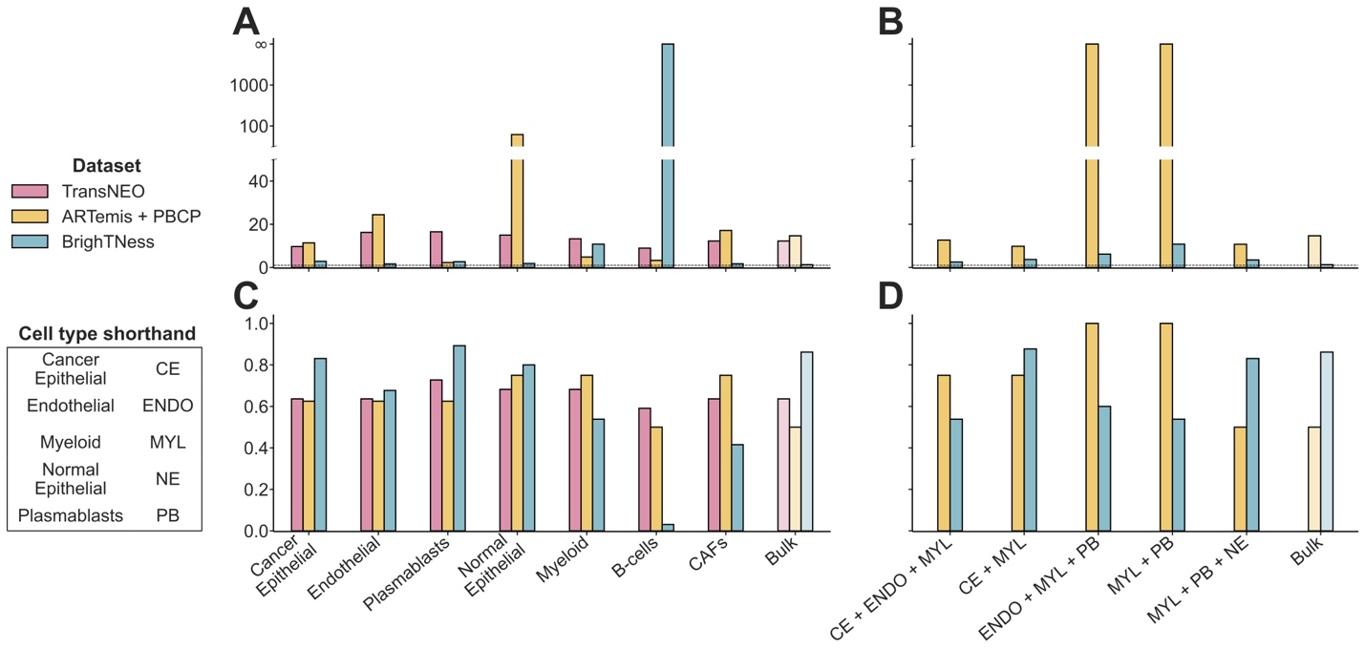
Supplementary Figure 2: The prominent cell types and ensembles mediating chemotherapy response in breast cancer tumor microenvironment.
A-B. Odds ratios for the prominent cell types (A) and multi-cell-type ensembles (B) as compared to the bulk across three cohorts. Cell types are ranked by their area under the receiver operating characteristics curve (AUC) values in cross-validation in a descending order (see Figure 2B). Ensembles are ranked by their AUC values in external validation in a descending order (see Figure 3A-D).
C-D. Sensitivities for the prominent cell types (C) and multi-cell-type ensembles (D) as compared to the bulk across the three cohorts. Cell types are ranked by their AUC values in cross-validation in a descending order (see Figure 2B). Cell ensembles are ranked by their AUC values in external validation in a descending order (see Figure 3A-D).

Supplementary Figure 3: The prominent cell types and ensembles mediating chemotherapy response in breast cancer tumor microenvironment in a subtype-specific manner.
A-B. Comparison of model performances in cross-validation with TransNEO for the ER-positive, HER2-negative (ER+ / HER2-; A) and triple negative (TN; B) subtypes across nine cell-type-specific, bulk, and Sammut et al. predictors. AUC and AP stand for the area under the receiver operating characteristics curve and average precision (equivalent to the area under precision-recall curve), respectively. Cell types are ranked by their AUC values in a descending order.
C-D. Comparison of model performances in external validation with ARTemis + PBCP for the ER+ / HER2- (C) and TN (D) subtypes across nine cell-type-specific, bulk, and Sammut et al. predictors. Cell types are ranked by their AUC values in a descending order.
E-F. Comparison of model performances in external validation with ARTemis + PBCP for the ER+ / HER2- (E) and TN (F) subtypes across five most prominent two-cell-ensembles, five most prominent three-cell-ensembles, bulk, and Sammut et al. predictors. Ensembles are ranked by their AUC values in a descending order.

Supplementary Figure 4: The CD4⁺ / CD8⁺ T-cells enrichment and cell abundance – clinical response association analyses reaffirm the poor chemotherapy response stratification by T-cells at the current resolution.
A-B. GSVA enrichment scores (A) and predictive performance (B) of CD4⁺ T-cells for chemotherapy response stratification across TransNEO (n = 94), ARTemis + PBCP (n = 55), and BrighTNess (n = 106) cohorts. R and NR stand for responders and non-responders, respectively. The differences between the prediction scores were computed by using a one-tailed Wilcoxon rank-sum test. AUC and AP stand for the area under the receiver operating characteristics curve and average precision (equivalent to the area under precision-recall curve), respectively.
C-D. GSVA enrichment scores (C) and predictive performance (D) of CD8⁺ T-cells for chemotherapy response stratification across the three cohorts.
E-G. Predictive performance of abundances of the nine cell types for TransNEO (E), ARTemis + PBCP (F), and BrighTNess (G) cohorts. Cell types are ranked by their AUC values for TransNEO in a descending order.

Supplementary Figure 5: The prominent immune cell types and ensembles mediating response to the most prevalent immunogenic chemotherapy regimen in each breast cancer cohort.
A. Comparison of model performances in cross-validation with TransNEO for the T-FEC regimen (n = 61) across nine cell-type-specific and bulk predictors. AUC and AP stand for the area under the receiver operating characteristics curve and average precision (equivalent to the area under precision-recall curve), respectively. Cell types are ranked by their AUC values in a descending order. Here, T = docetaxel/taxotere, F = 5-flurouracil, E = epirubicin, and C = cyclophosphamide.
B-C. Comparison of model performances in external validation with ARTemis + PBCP for the T-FEC regimen (n = 40) across the top cell-type-specific models (B) and top multi-cell-type ensembles (C). Cell types and ensembles are ranked by their AUC values in a descending order.
D-E. Comparison of model performances in external validation with BrighTNess for paclitaxel + carboplatin regimen (n = 106) across the top cell-type-specific models (D) and top multi-cell-type ensembles (E). Cell types and ensembles are ranked by their AUC values in a descending order.

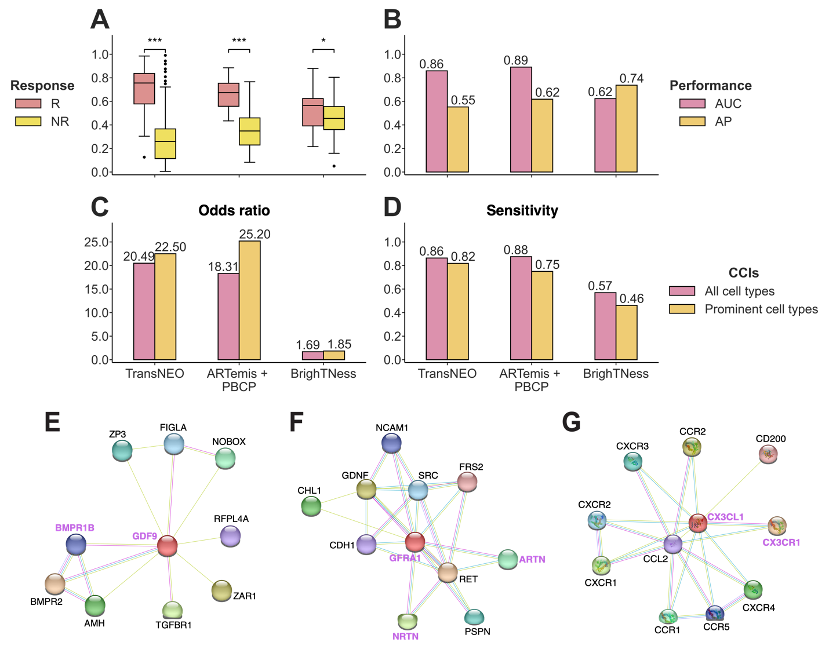
Supplementary Figure 6: The cell-cell interactions (CCIs) encompassing prominent cell types capture the performance of CCIs using all nine cell types in mediating chemotherapy response and are validated in single-cell (SC) breast cancer tumor microenvironment.
A-B. Prediction scores (A) and model performance (B) for DECODEMi using all available CCIs in cross-validation with TransNEO (n = 94) and in external validation with ARTemis + PBCP (n = 55) and BrighTNess (n = 106). R and NR stand for responders and non-responders, respectively. The differences between the prediction scores were computed by using a one-tailed Wilcoxon rank-sum test. AUC and AP stand for the area under the receiver operating characteristics curve and average precision (equivalent to the area under precision-recall curve), respectively.
C-D. Odds ratios (C) and sensitivities (D) for DECODEMi using different sets of CCIs in cross-validation with TransNEO (n = 94) and in external validation with ARTemis + PBCP (n = 55) and BrighTNess (n = 106).
E-G. Protein-protein interaction networks obtained from STRING [48] displaying the known interaction networks for three prominent CCIs i.e., GDF9 – BMPR1B (E), NRTN – GFRA1 and ARTN – GFRA1 (F), and CX3CL1 – CX3CR1 (G).

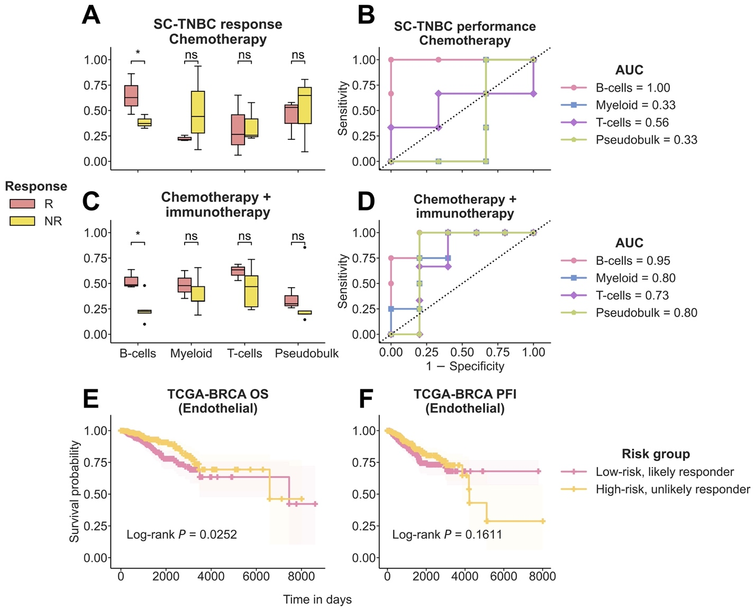
Supplementary Figure 7: The generalizability of DECODEM to single-cell (SC) transcriptomics and TCGA patient survival stratification.
A-B. Prediction scores (A) and the area under the receiver operating characteristics curve (AUC) values (B) for all available cell types in external validation with SC expression of TNBC patients (SC-TNBC) treated with chemotherapy (n = 6) from Zhang et al. [48]. Pseudobulk is shown as a baseline and computed as the mean expression across all available cells per patient after filtering for low-variance genes (threshold = 0.8). R and NR stand for responders and non-responders, respectively. The differences between the prediction scores were computed by using a one-tailed Wilcoxon rank-sum test.
C-D. Prediction scores (C) and the AUC values (D) for four cell types in external validation with SC expression of TNBC patients (SC-TNBC) treated with chemotherapy and immunotherapy (n = 9) from Zhang et al. [48].
E-F. Kaplan-Meier curves depicting the overall survival (OS; E) and progression-free interval (PFI; F) of the 705 BC patients from TCGA (TCGA-BRCA). Patients were stratified into low-risk, likely responder (n = 353) and high-risk, unlikely responder (n = 352) groups by their median DECODEM score computed using the expression of endothelial cells, whereby the low-risk and high-risk groups comprised individuals with scores above and below the median, respectively. The differences between the two curves were computed by using a Log-rank test.

