Supplementary Materials

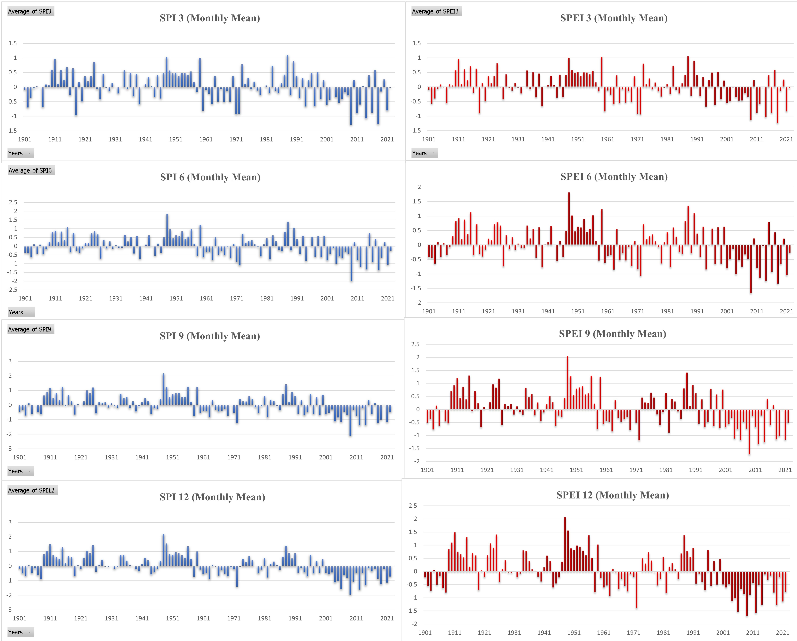
Fig. S1: Variation of SPI and SPEI for all the time scales in Himalaya Region
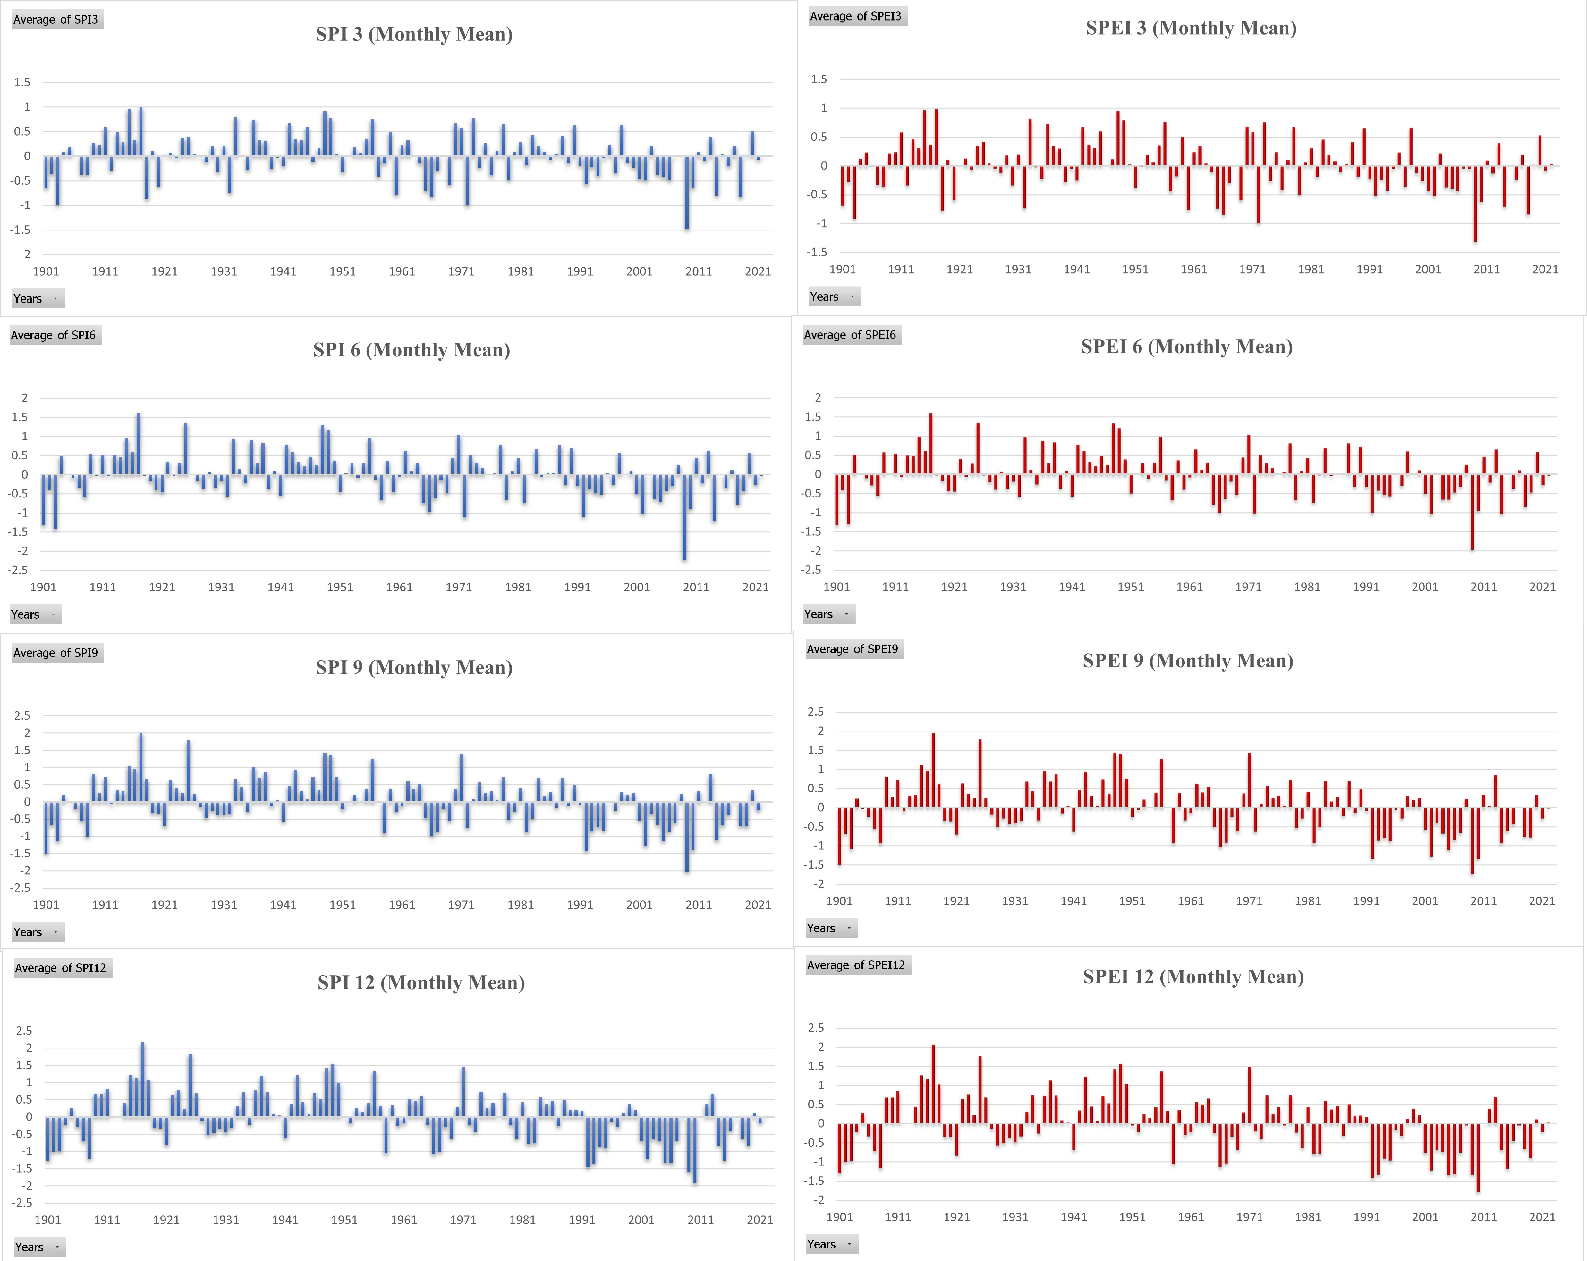
Fig. S2: Variation of SPI and SPEI for all the time scales in Northern Plain Region
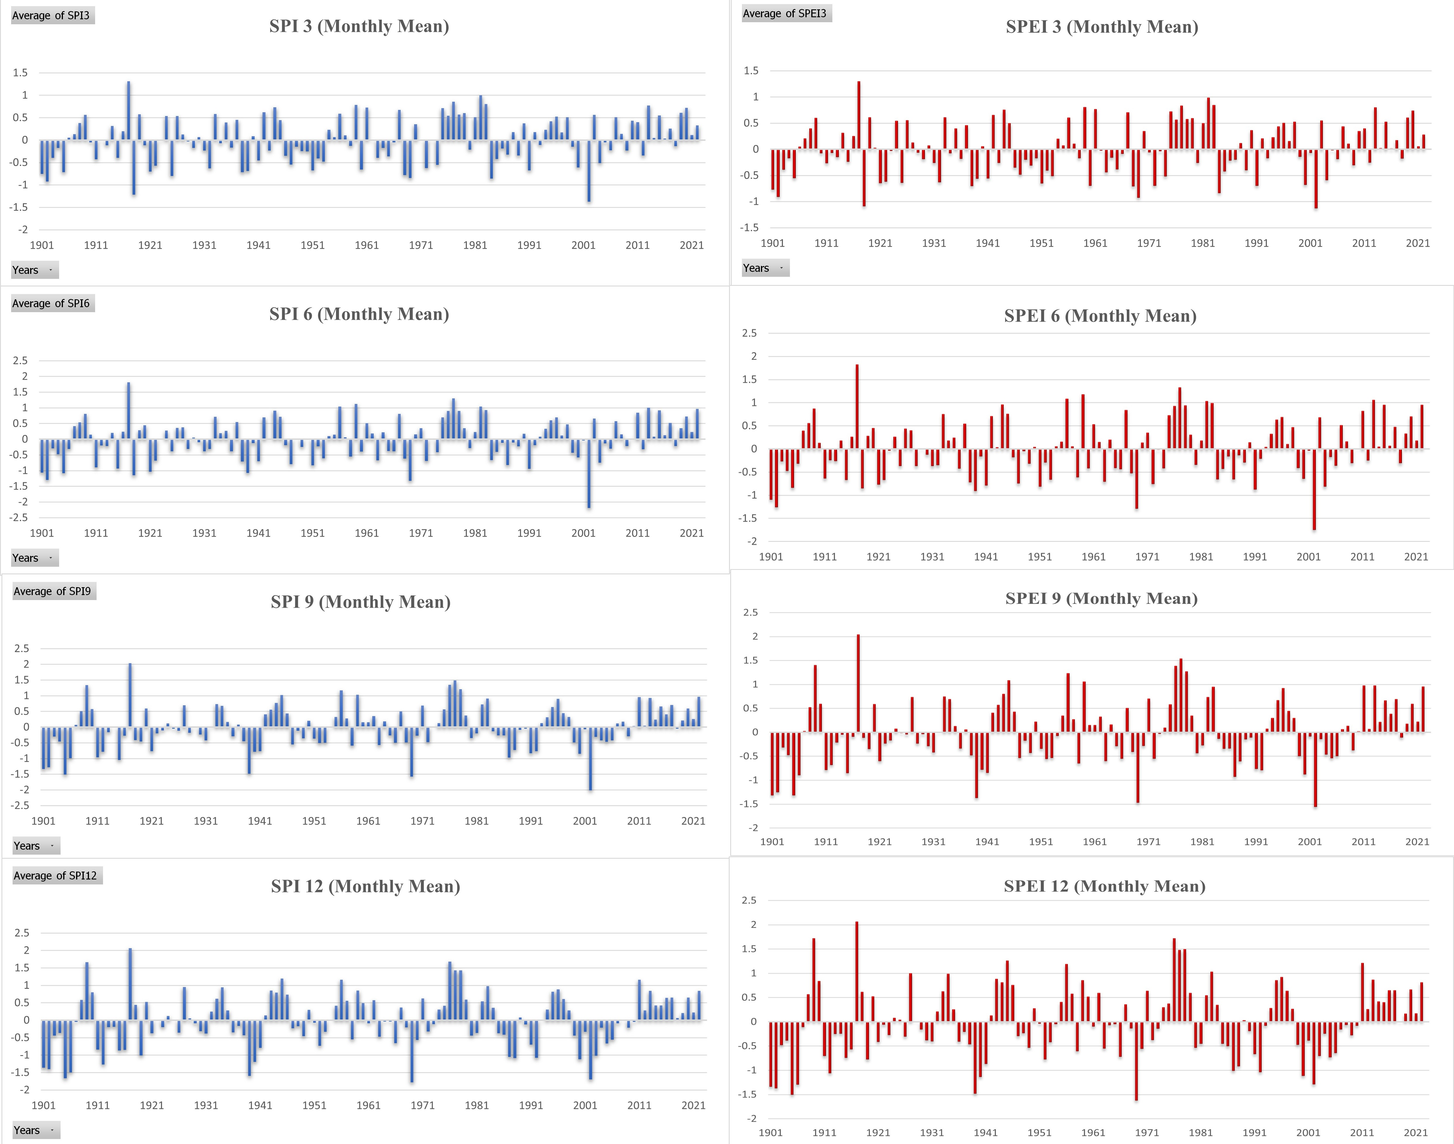
Fig. S3: Variation of SPI and SPEI for all the time scales in Great Indian Desert Region
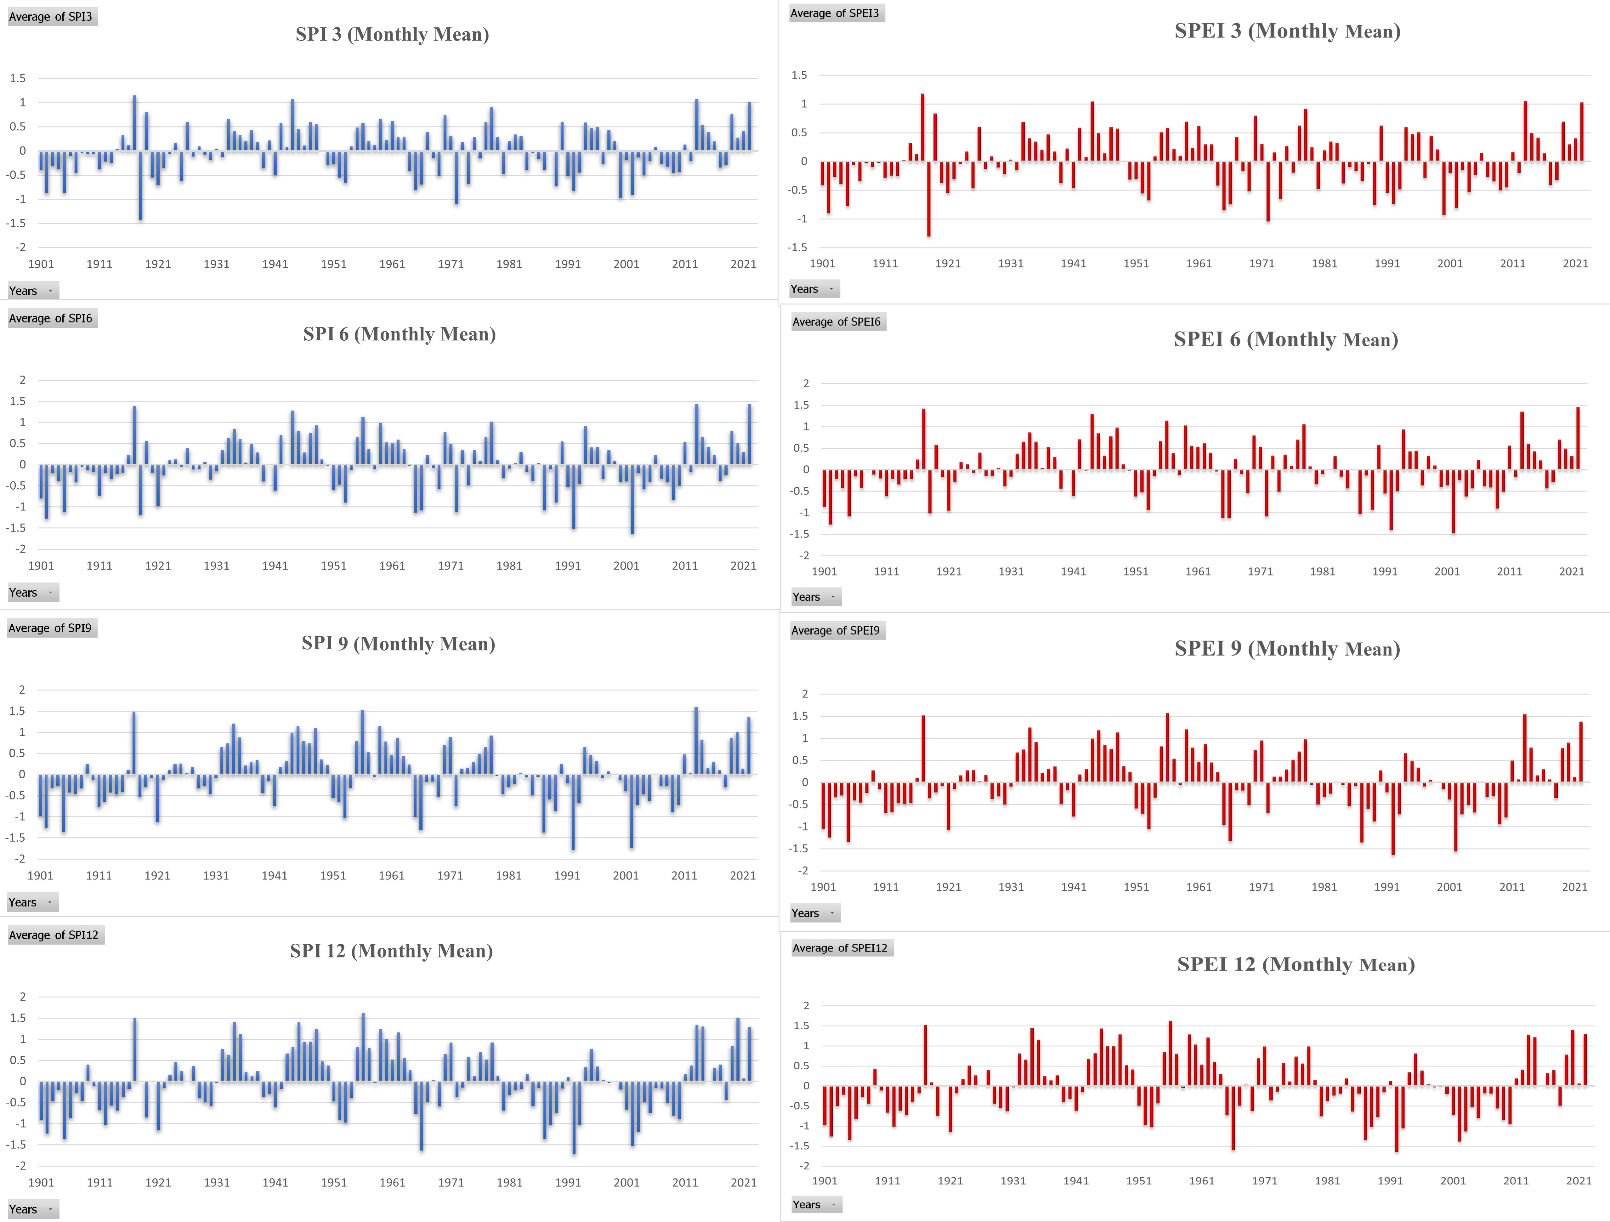
Fig. S4: Variation of SPI and SPEI for all the time scales in Central Highland Region
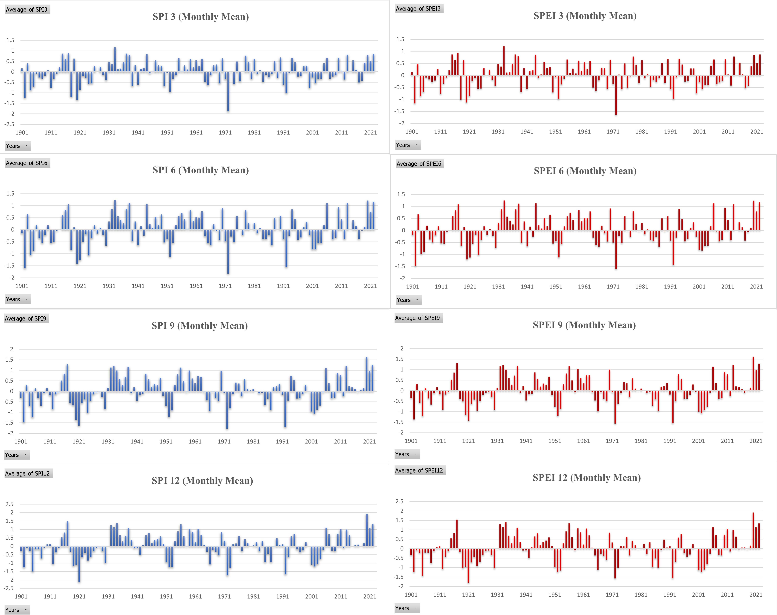
Fig. S5: Variation of SPI and SPEI for all the time scales in Northern Deccan Region

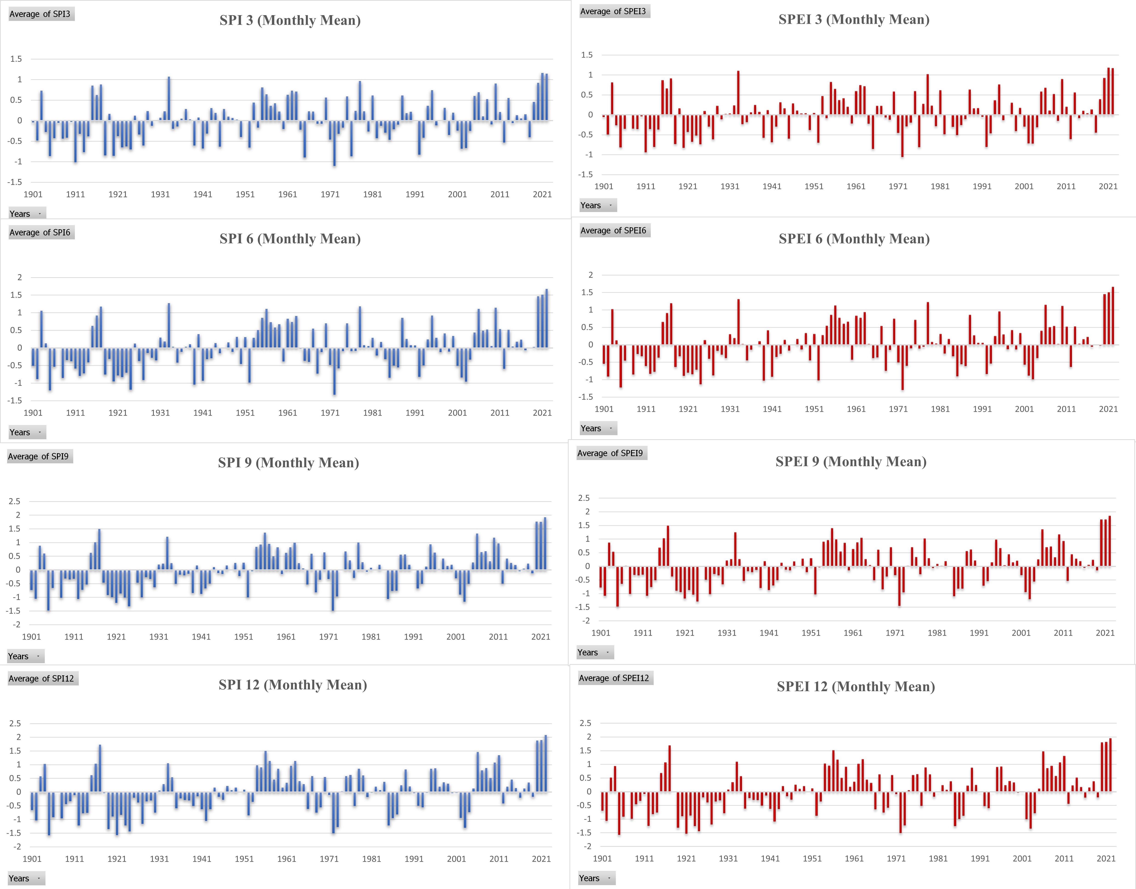
Fig. S6: Variation of SPI and SPEI for all the time scales in Southern Deccan Region
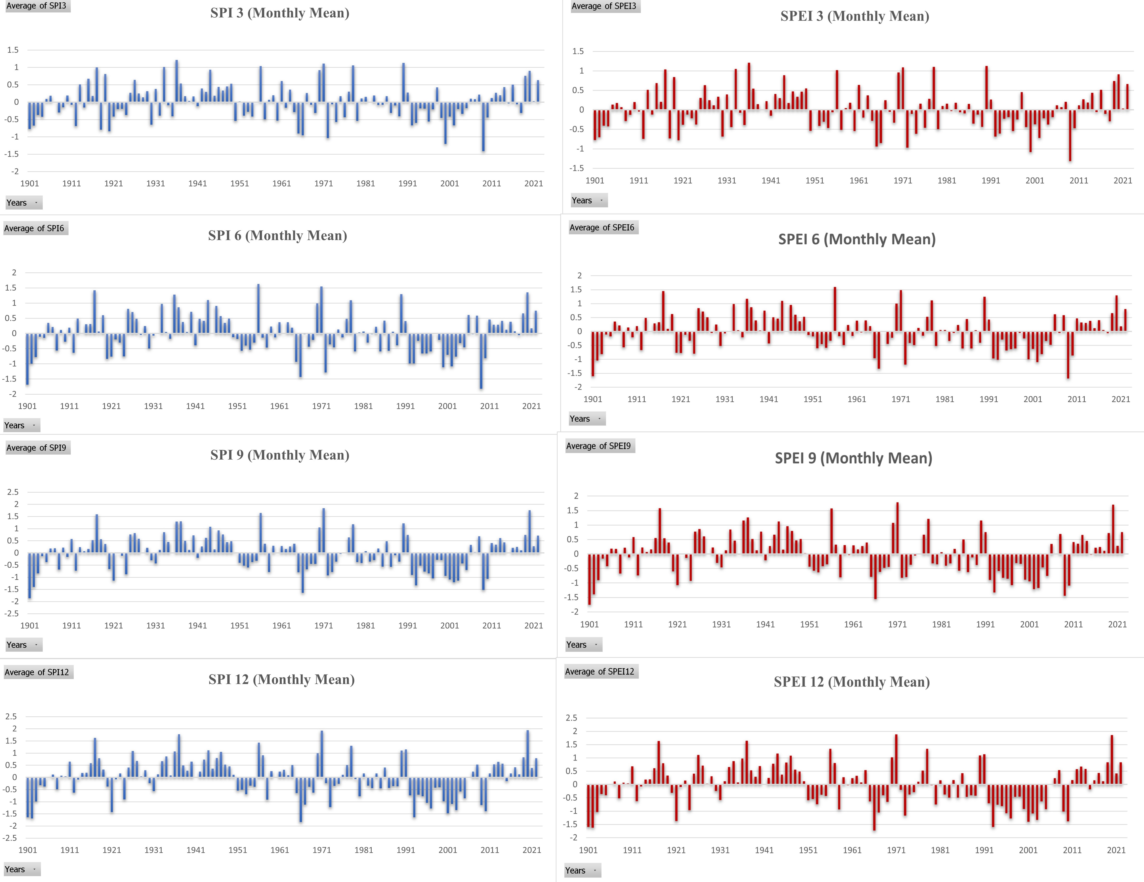
Fig. S7: Variation of SPI and SPEI for all the time scales in Eastern Deccan Region
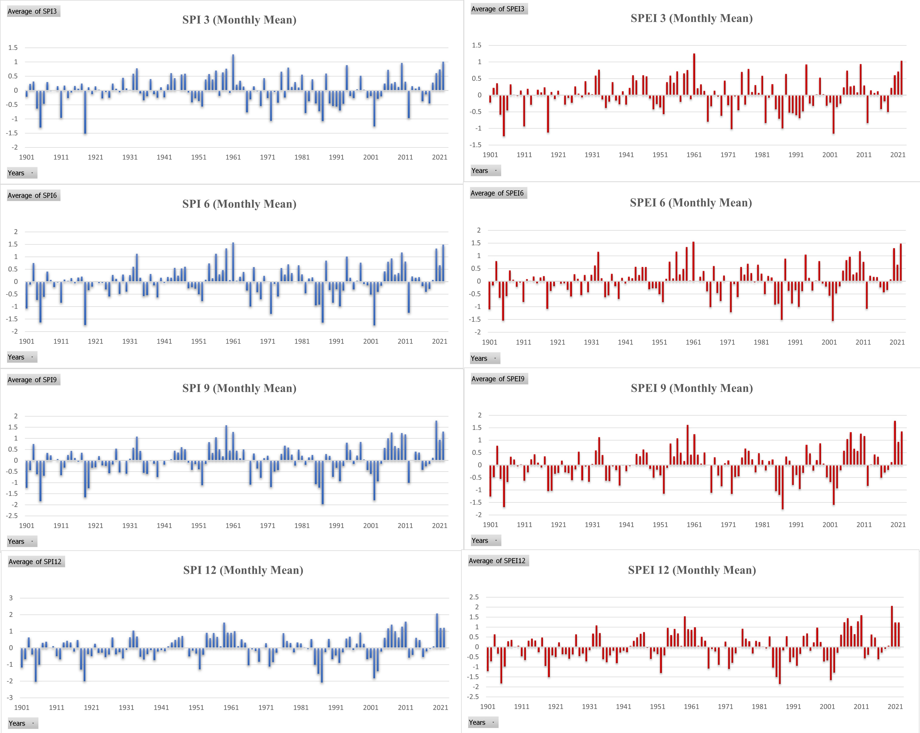
Fig. S8: Variation of SPI and SPEI for all the time scales in Western Coastal Plain Region
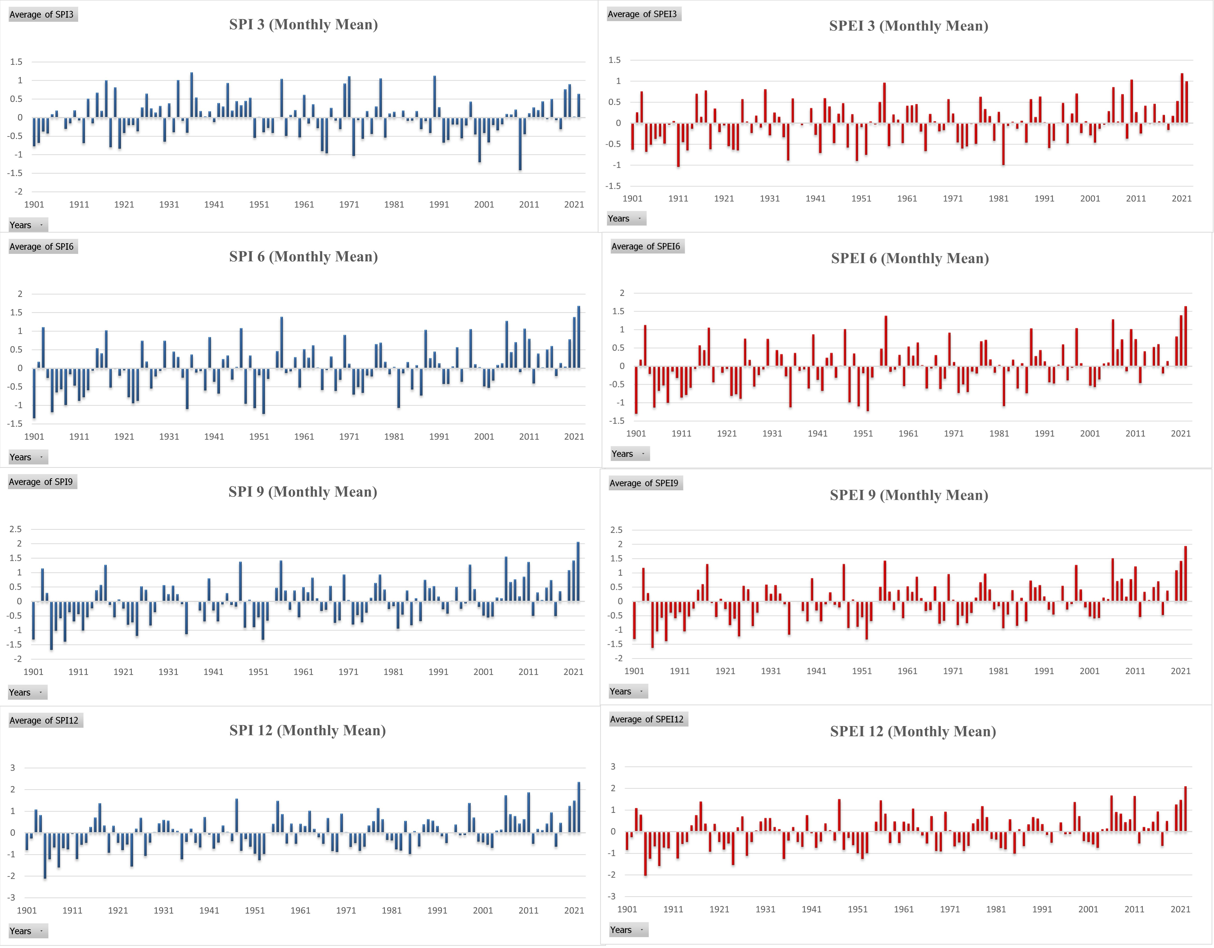
Fig. S9: Variation of SPI and SPEI for all the time scales in Eastern Coastal Plain Region

