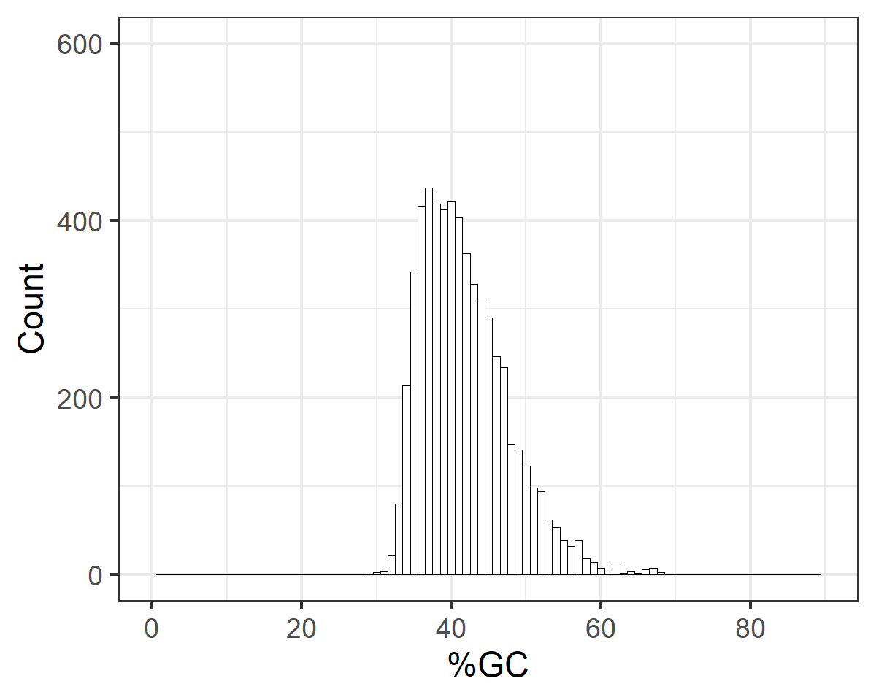
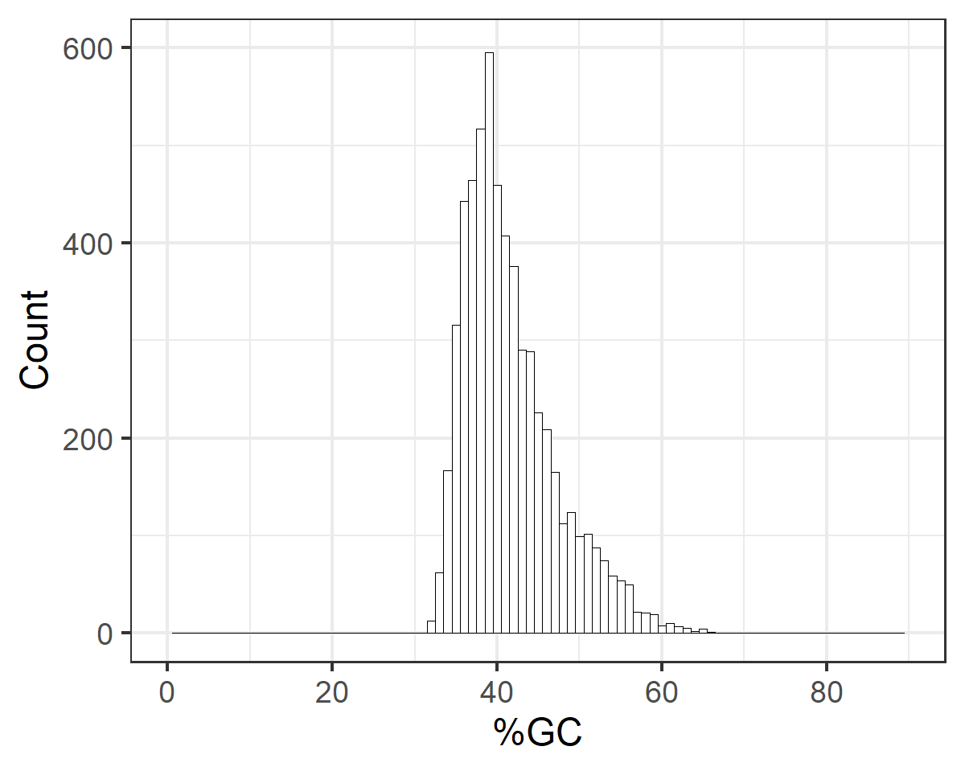
b
a

Figure S1. Percent of GC pairs for all duplications (a) and percent of GC pairs in Set 1 representing randomized duplications (b).
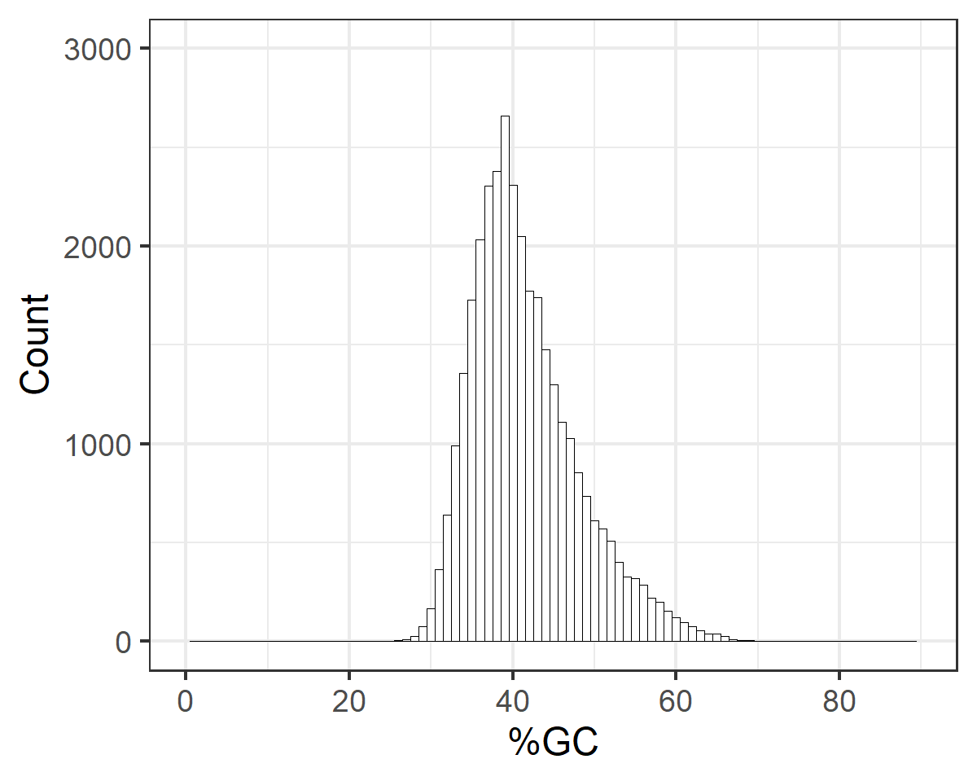
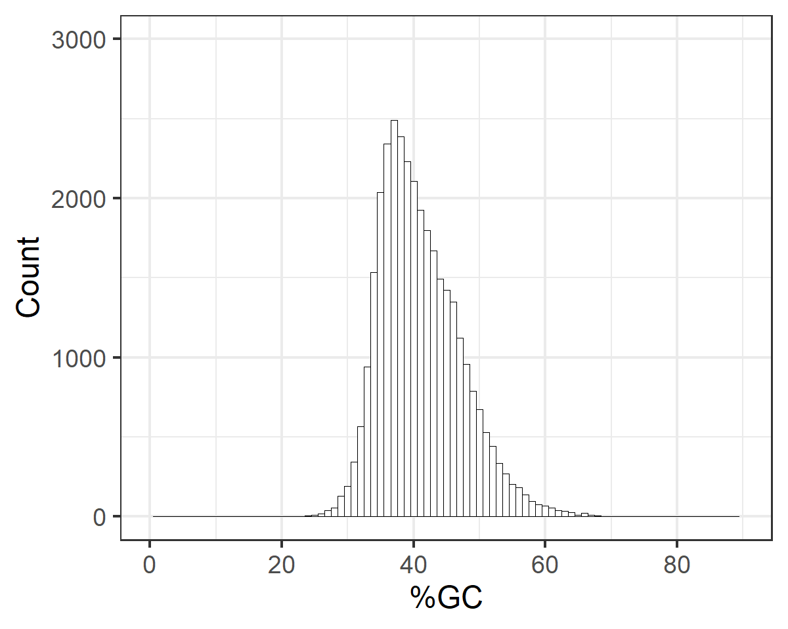
a
b
a

Figure S2. Percent of GC pairs for all deletions (a) and percent of GC pairs in Set 2 representing randomized deletions (b).

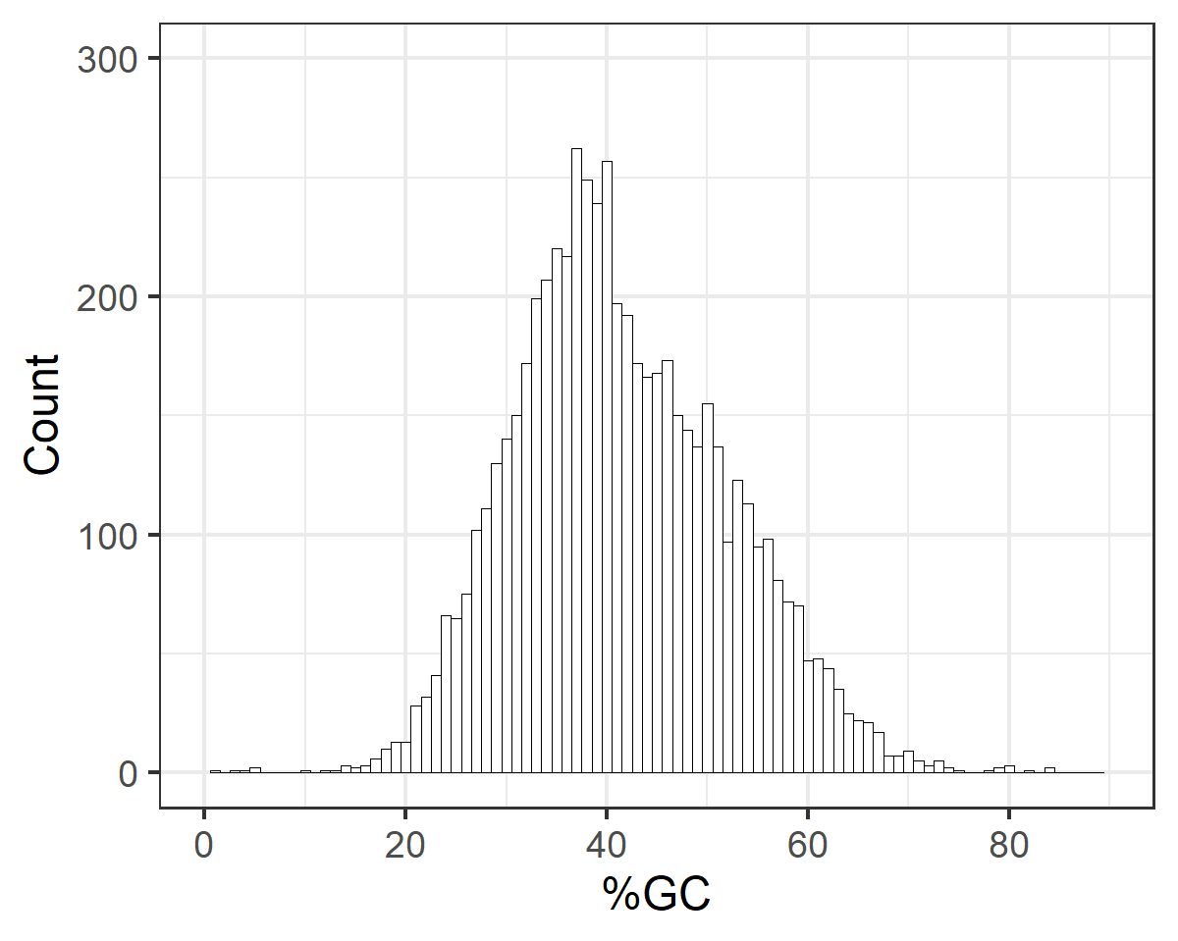
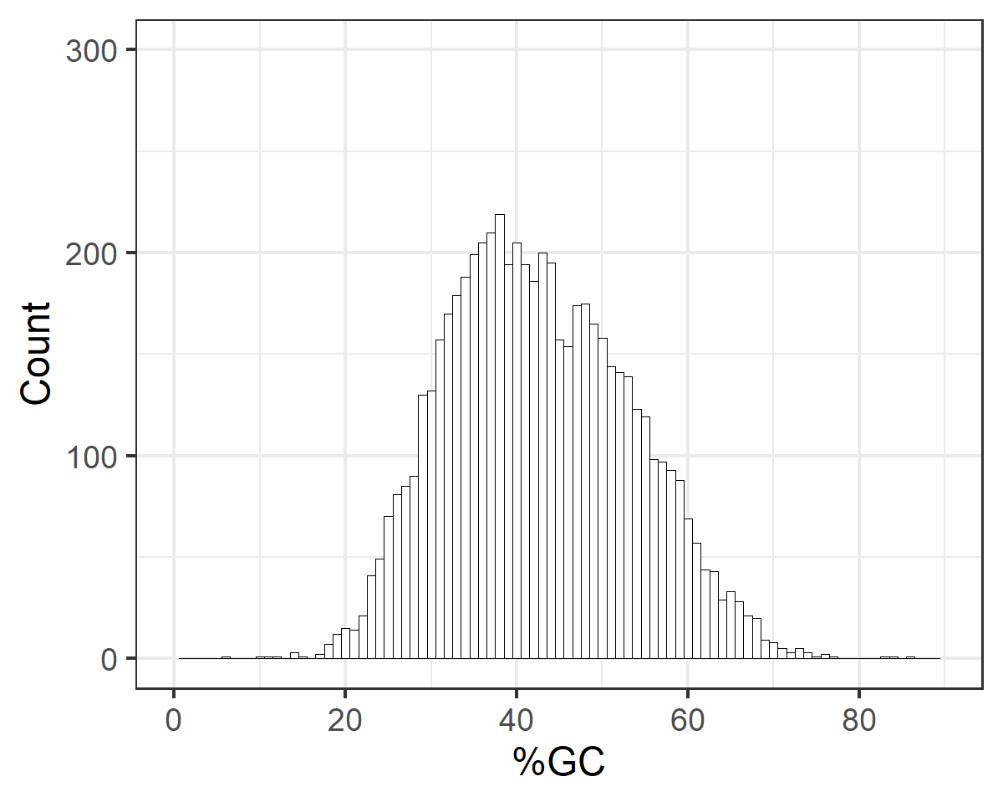
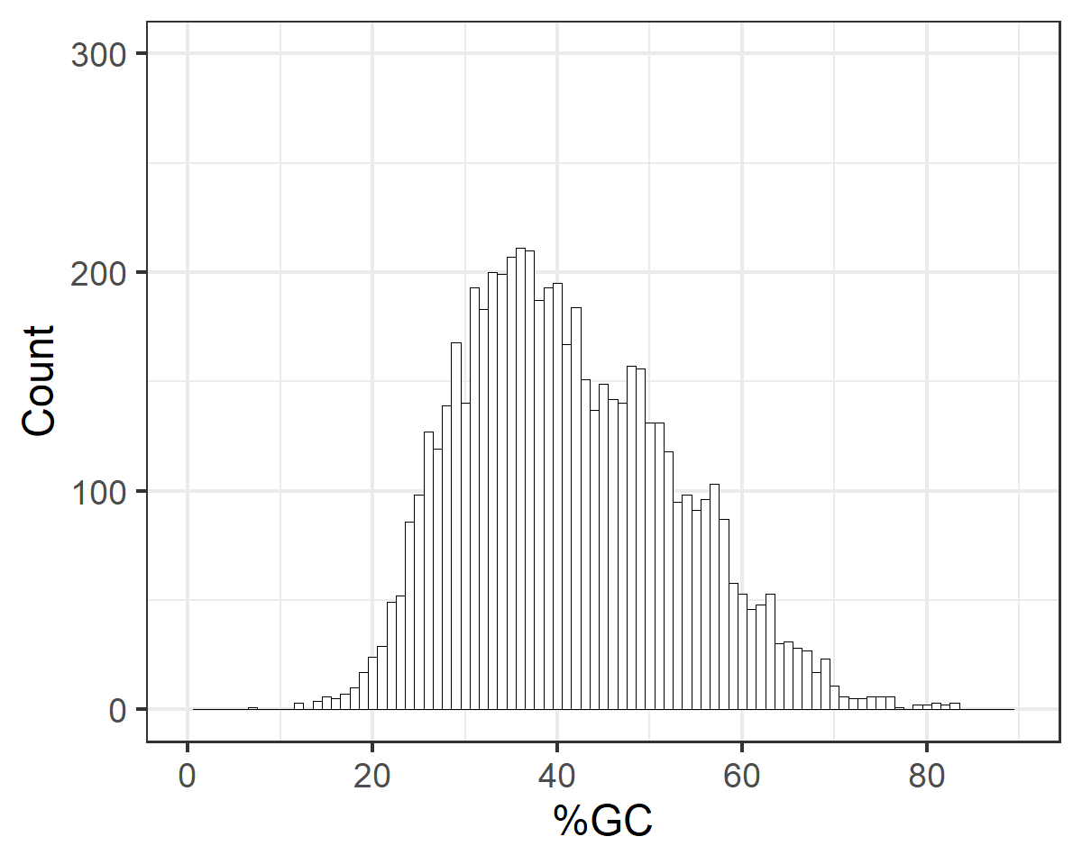
Figure S3. Percent of GC pairs in 100 nucleotides long sequences located (a) up-, (b) downstream duplications and (c) randomized set of 100 nucleotides long sequences representing Set 3.
a
c
b
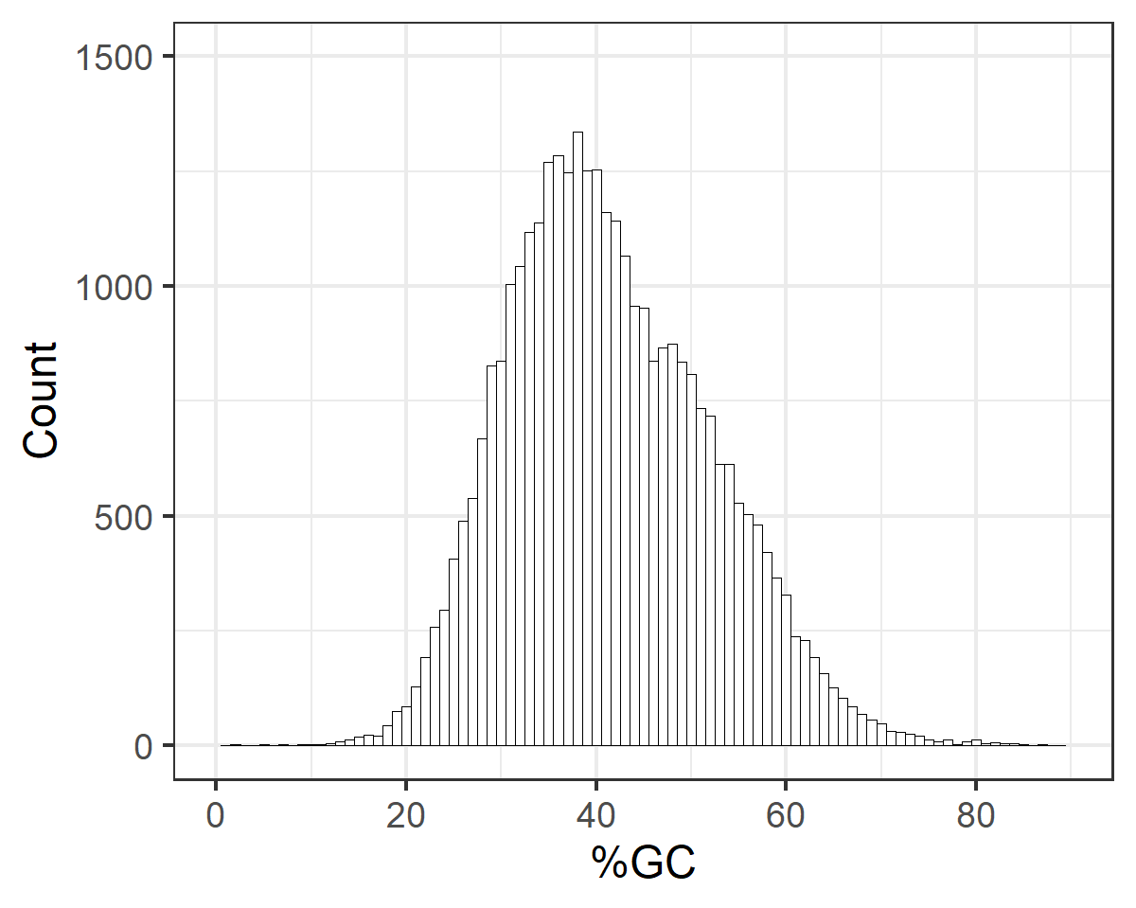
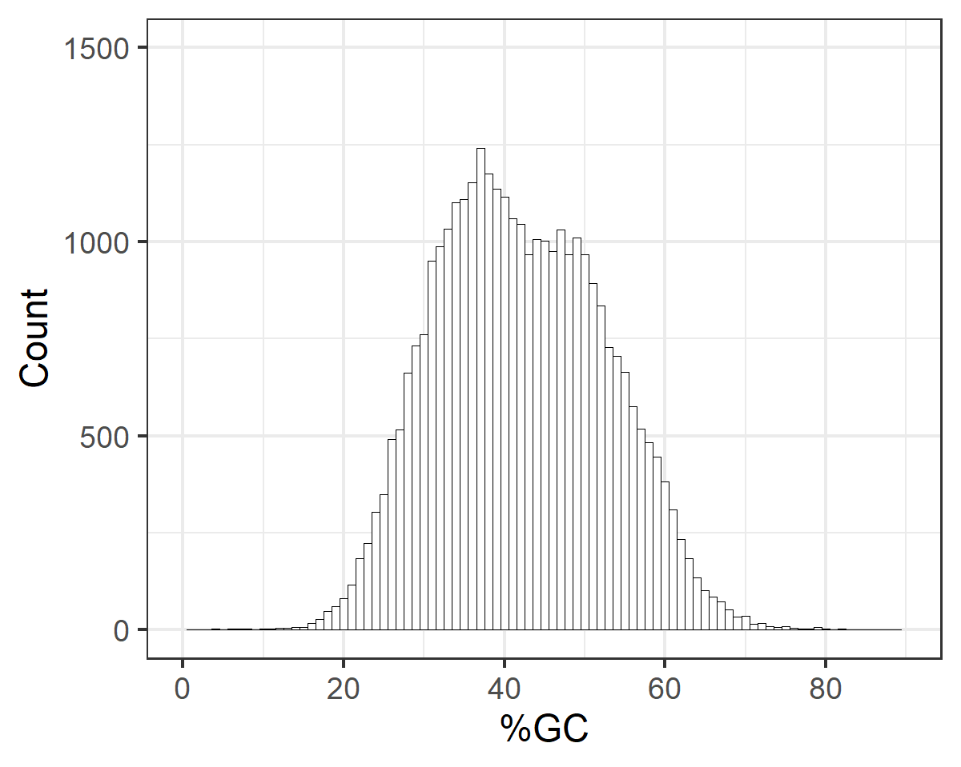
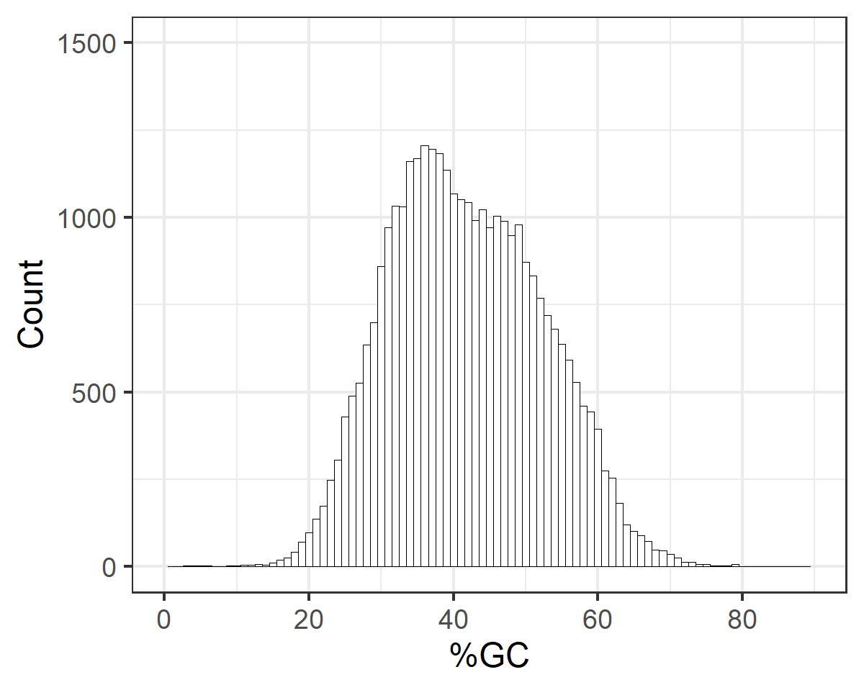
c
b
a
Figure S4. Percent of GC pairs in 100 nucleotides long sequences located (a) up-, (b) downstream deletions and (c) randomized set of 100 nucleotides long sequences representing Set 4.

