Additional File 1 – Accompanies Doughty et al.

Fig. S1
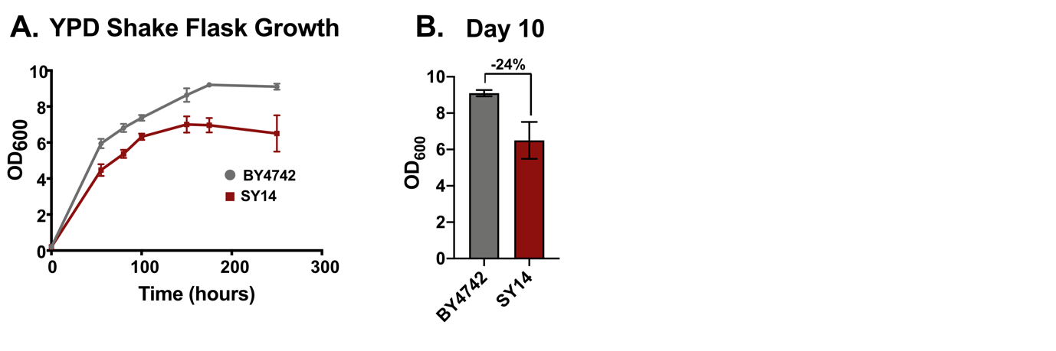

Fig. S2
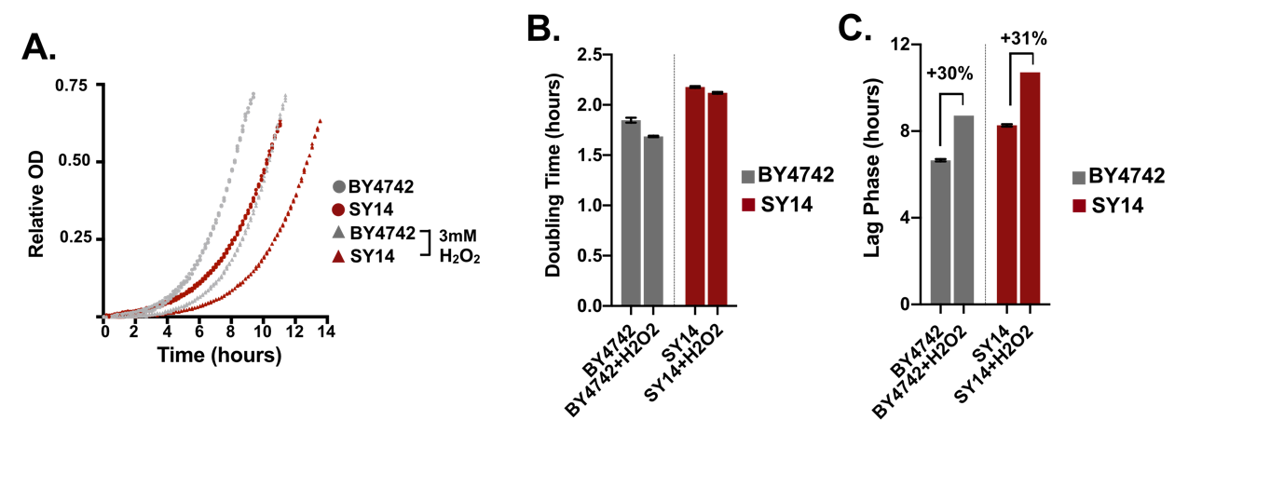
Fig. S3

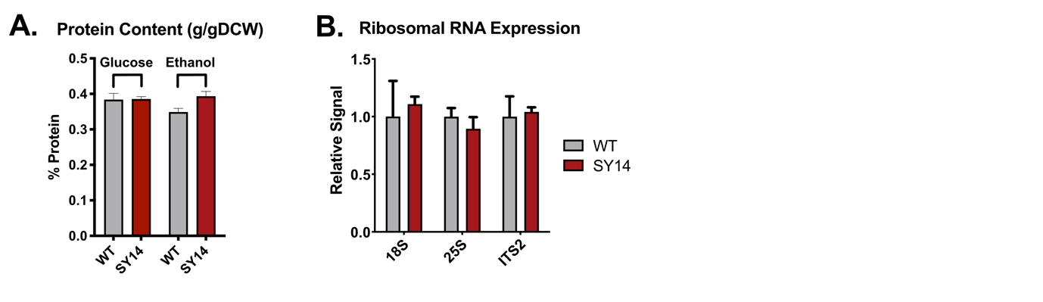

Fig. S4
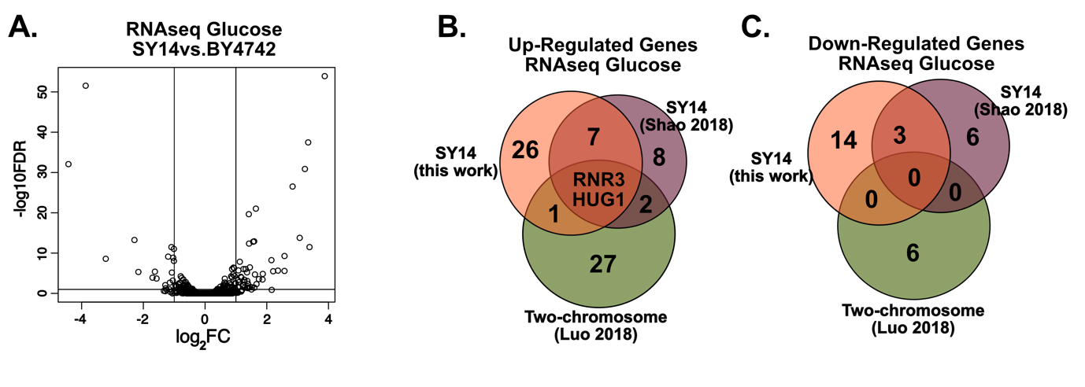

Fig. S5

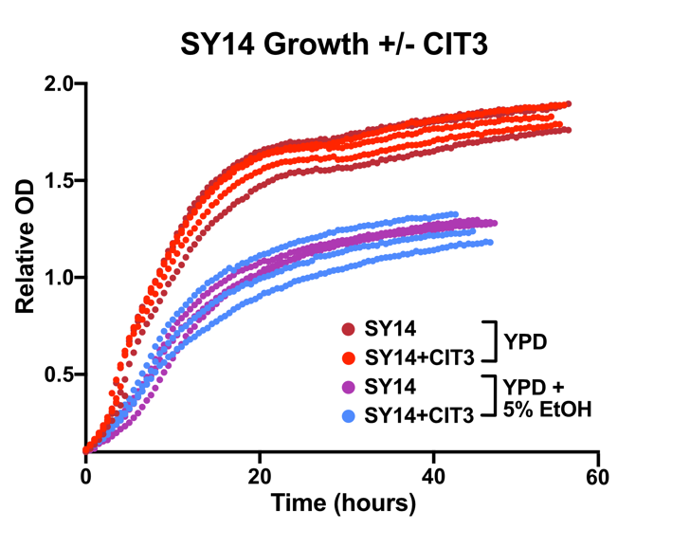

Fig. S6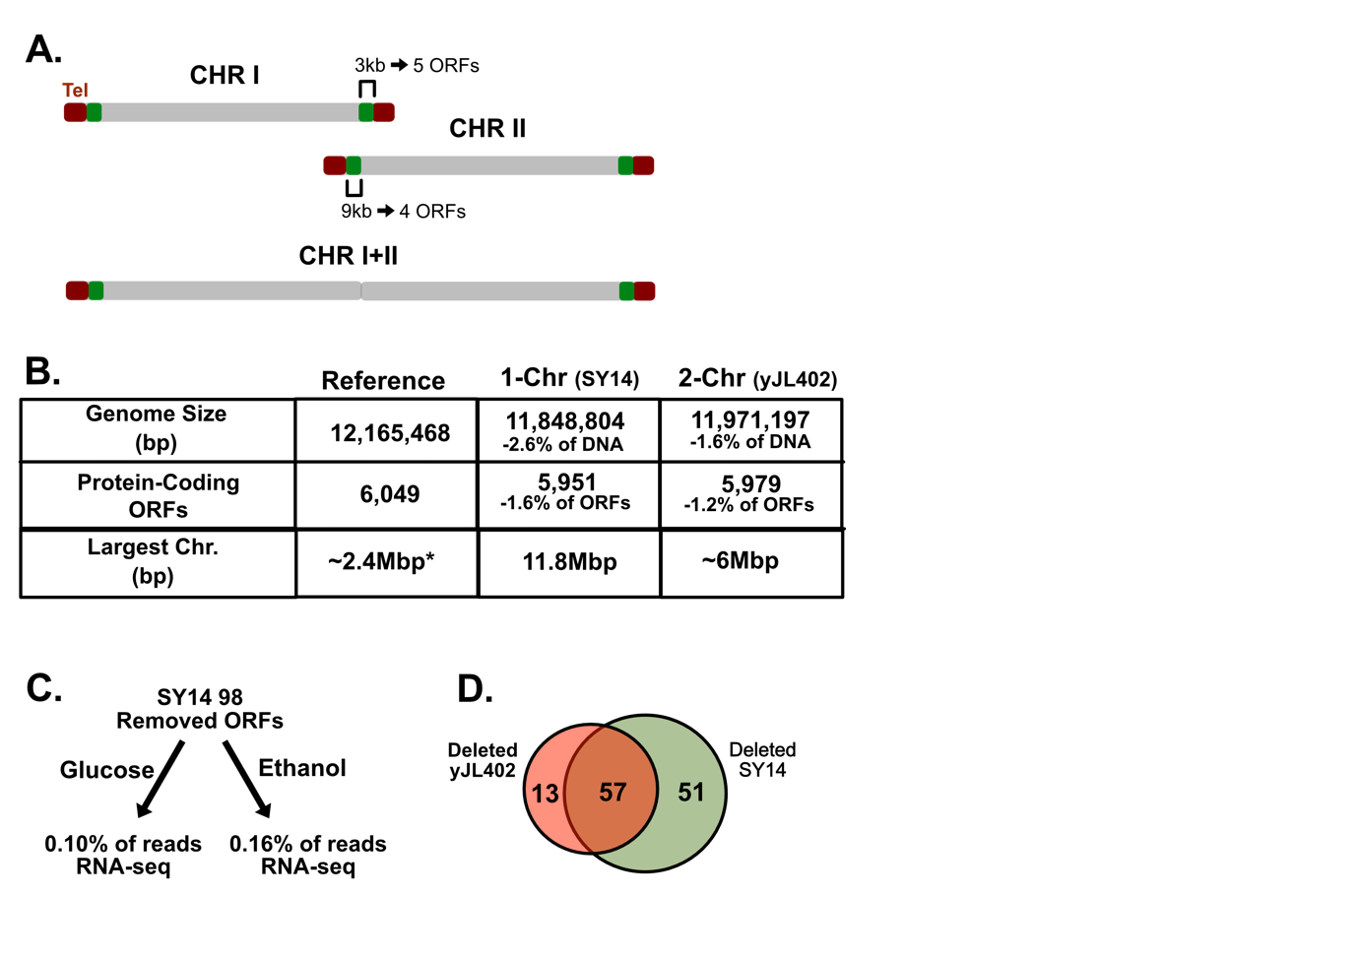

Fig. S7
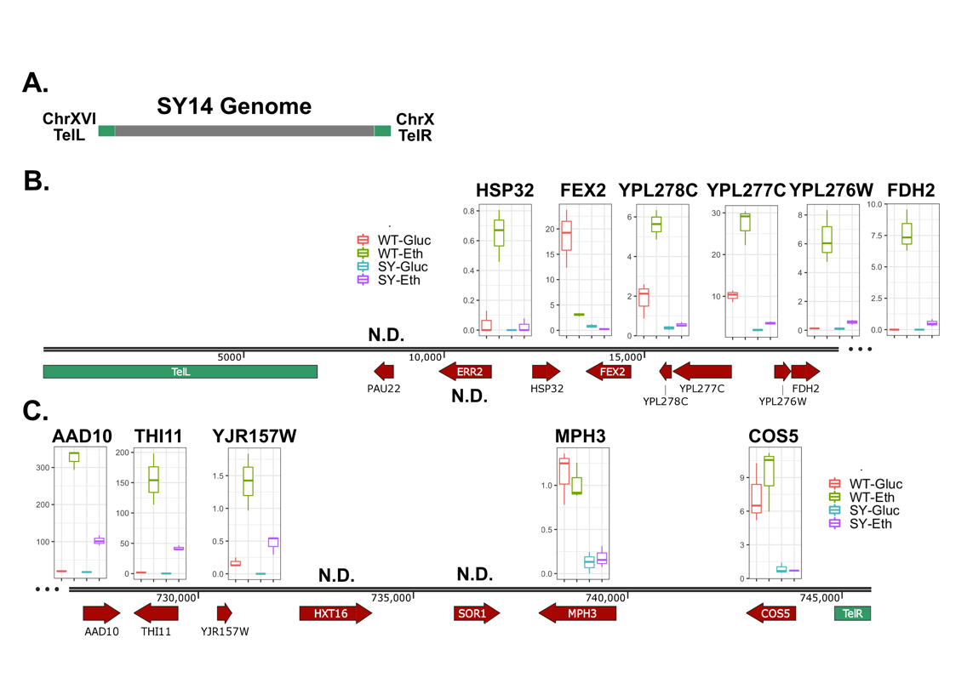

Fig. S8
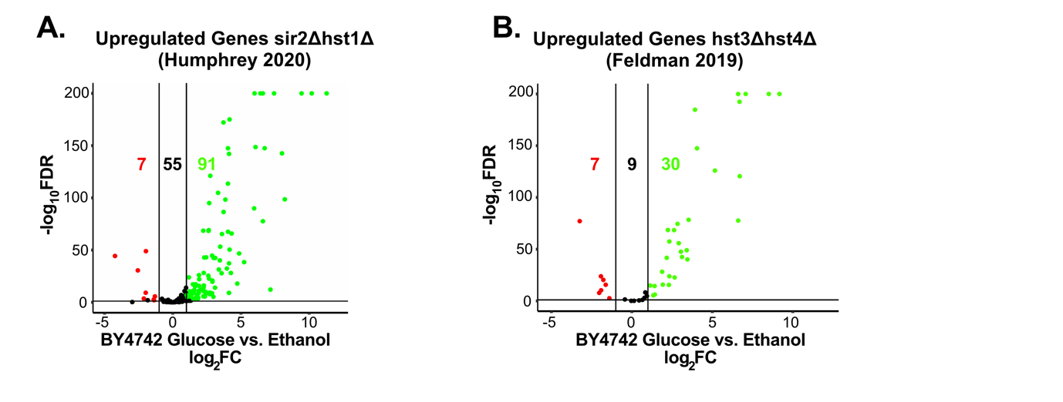

References
- Humphrey, K. M. et al. Evolution of Distinct Responses to Low NAD+ Stress by Rewiring the Sir2 Deacetylase Network in Yeasts. Genetics 214, 855 LP – 868 (2020).
- Feldman, J. L. & Peterson, C. L. Yeast Sirtuin Family Members Maintain Transcription Homeostasis to Ensure Genome Stability. Cell Rep. 27, 2978-2989.e5 (2019).

