Operando X-ray characterization platform to unravel catalyst degradation under accelerated stress testing in CO₂ electrolysis
Qiucheng Xu^{a,+}, José A. Zamora Zeledón^{b, +}, Bjørt Óladóttir Joensenª, Lena Trotochaud^{b}, Andrea Sartori^{c}, Lau Morten Kaas^{d}, Asger Backholt Mossª, Marta Mirolo^{c}, Luis Mairena^{b}, Sylvia Huynh^{b}, Sahil Gargª, Stig Helveg^{d}, Ib Chorkendorffª, Shuai Zhao^{b}, Brian Seger^{a,} *, Jakub Drnec^{c,} *
ªSurface Physics and Catalysis (Surf Cat) Section, Department of Physics, Technical University of Denmark, 2800 Kgs. Lyngby, Denmark
^{b}Twelve Benefit Corporation, 610 Bancroft Way, Berkeley, CA, USA
^{c}Experimental Division, European Synchrotron Radiation Facility, Grenoble, France
^{d}Center for Visualizing Catalytic Processes (VISION), Department of Physics, Technical University of Denmark, 2800 Kongens Lyngby, Denmark
*Corresponding author: Jakub Drnec, drnec@esrf.fr; Brian Seger, brse@fysik.dtu.dk;
+Qiucheng Xu and Jose A. Zamora Zeledon contributed equally.

Supplementary Figures
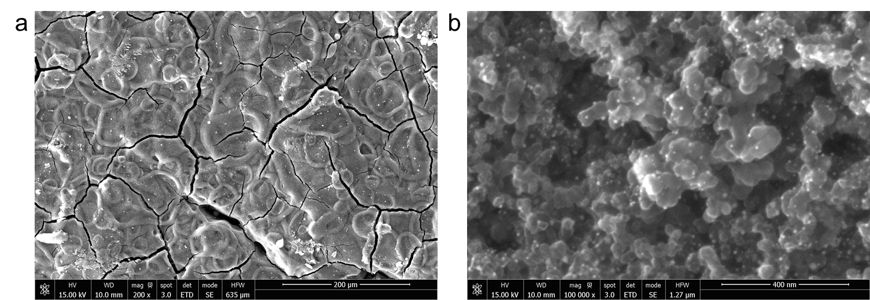
Supplementary Fig. 1. SEM images of Au nanoparticles loaded on carbon black spray-coated on a commercial gas diffusion layer (39BB from Sigracet).

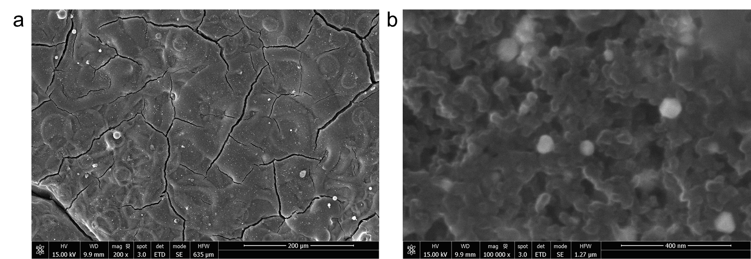
Supplementary Fig. 2. SEM images of Ag nanoparticles loaded on carbon black spray-coated on a commercial gas diffusion layer (39BB from Sigracet).

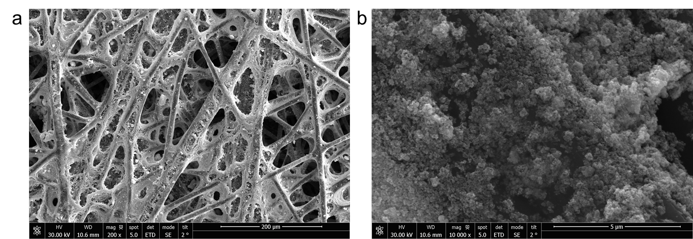
Supplementary Fig. 3. SEM images of commercial Ir/IrO_{x}-based GDE purchased from the Dioxide Materials.

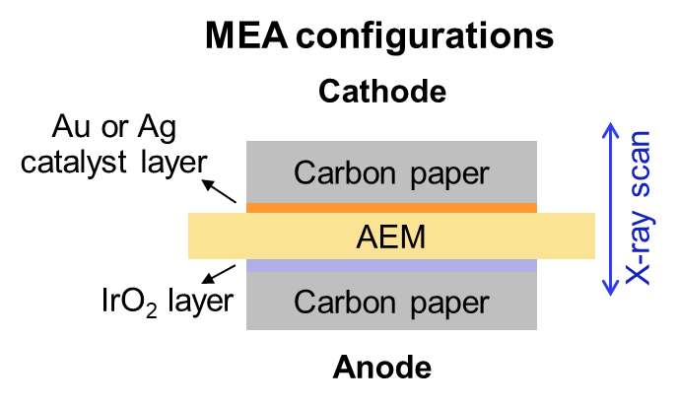
Supplementary Fig. 4. A zero-gap MEA configuration fabricated by sandwiching anion-exchange membrane (AEM) between anode and cathode.

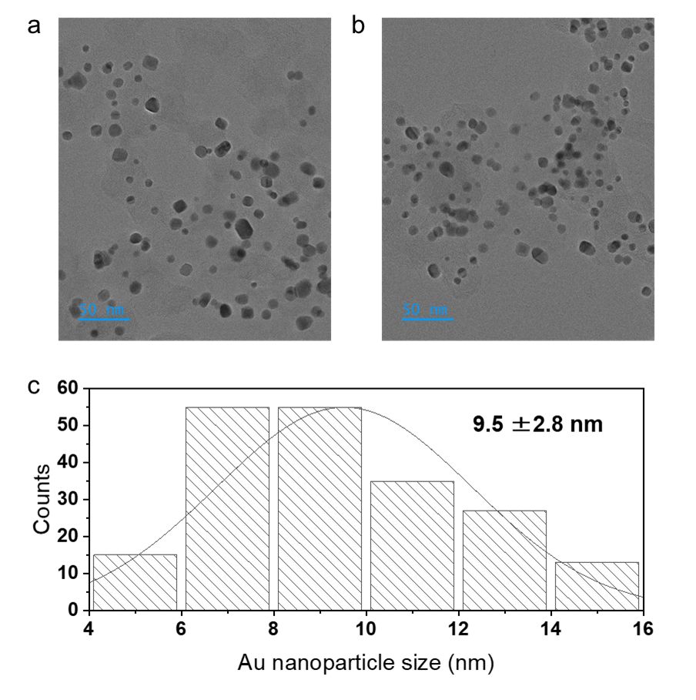
Supplementary Fig. 5. Size distribution analysis of Au nanoparticles. a-b, TEM images of Au nanoparticles loaded on carbon black. c, Particle size distribution analysis. The diameter of the particles was determined by manually fitting an oval to the particles and calculating the diameter of a circle of equivalent area based on multiple TEM images (two representative images are given here).

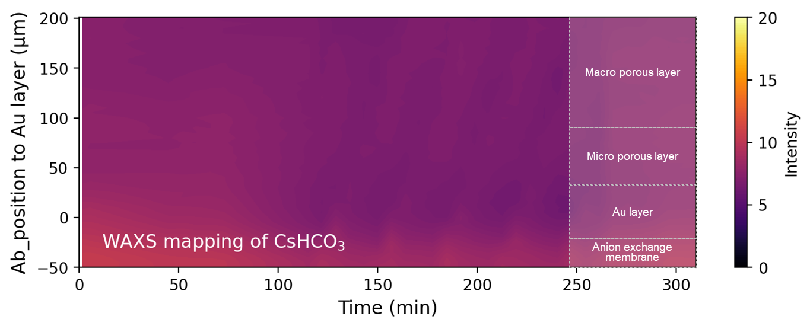
Supplementary Fig. 6. WAXS signal of CsHCO₃ as a function of operating time and scan depth of MEA during the pulsed AST by integrating WAXS patterns in the q-range of 1.46-1.50 Å⁻¹. No CsHCO₃ salt was formed since there is no obvious color lump.

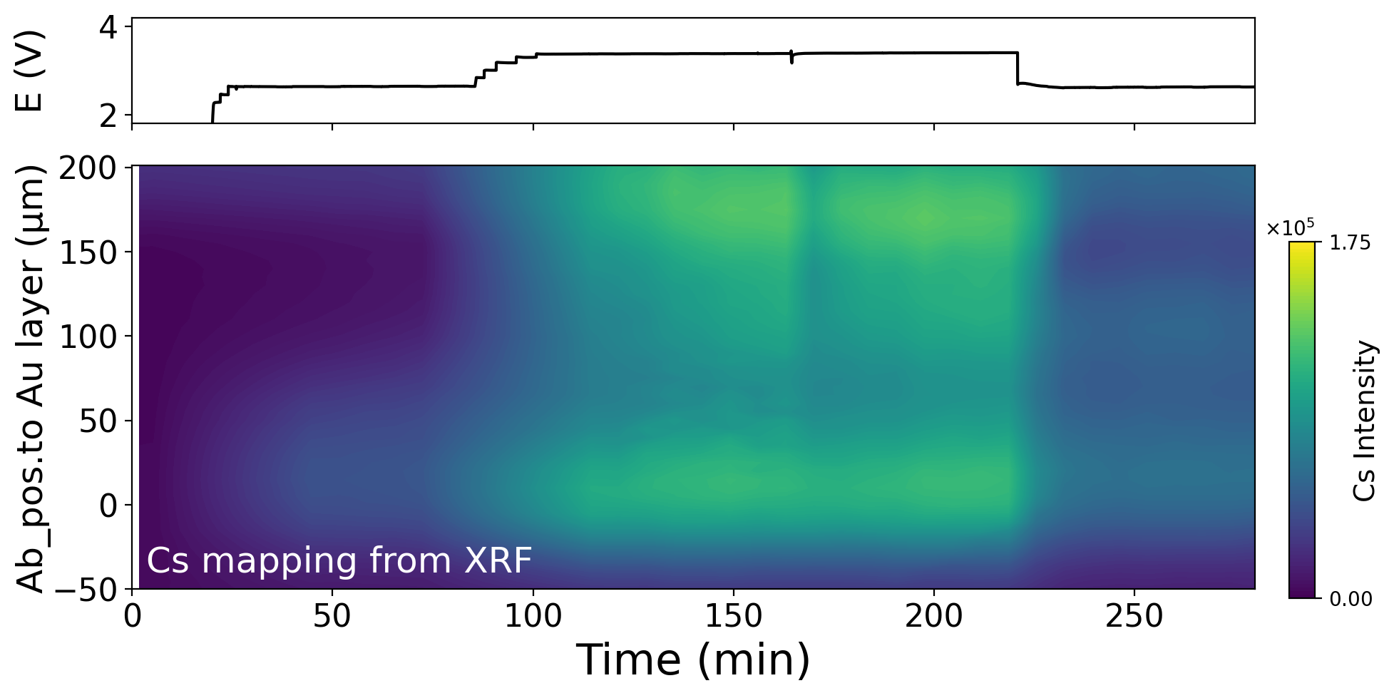
Supplementary Fig. 7. XRF signal of Cs as a function of operating time and scan depth of MEA during the traditional AST.

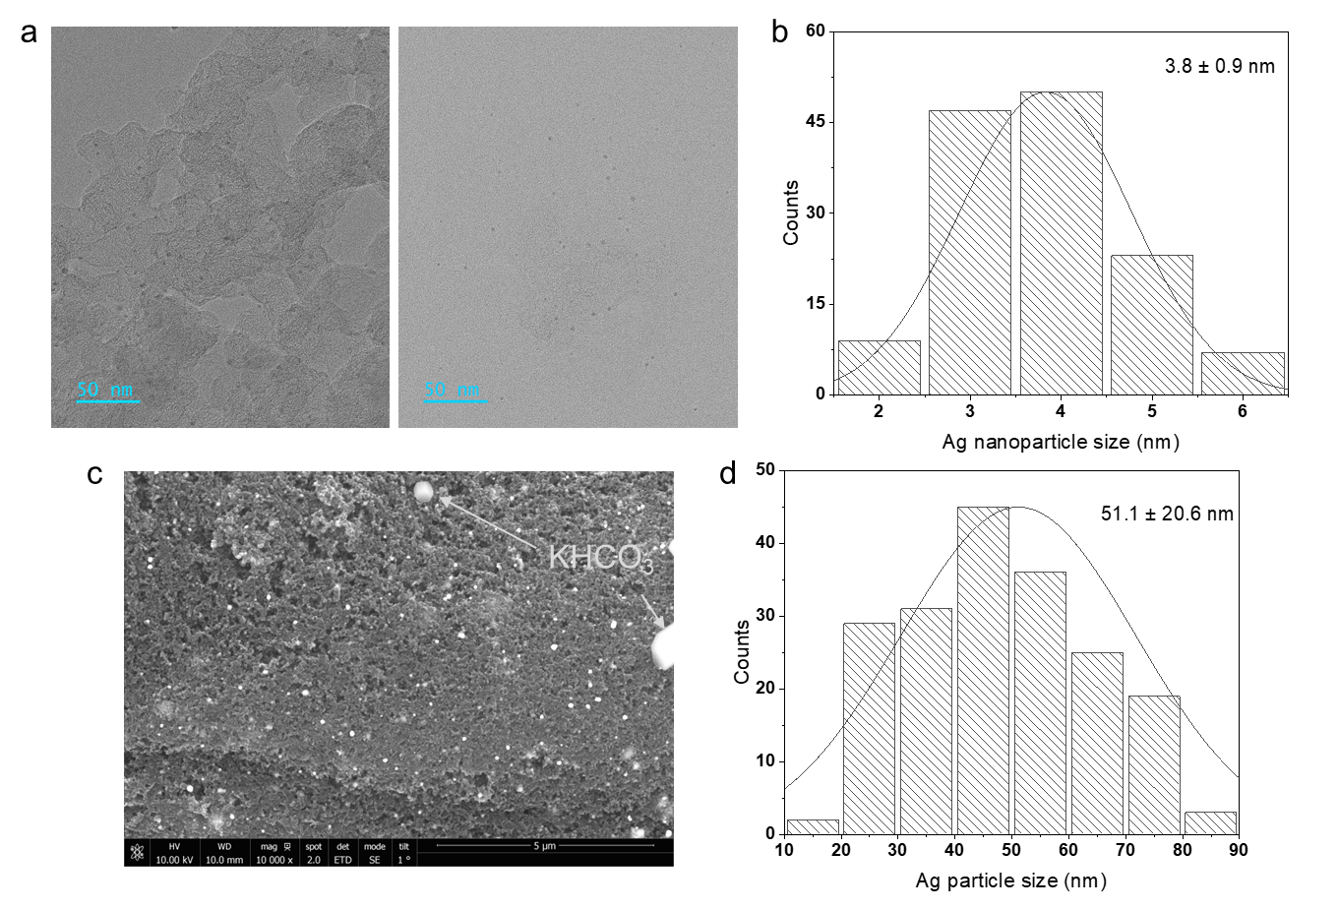
Supplementary Fig. 8. Ag nanoparticles with two types of size loaded on carbon black after loading on the electrode. a,b) TEM images of Ag nanoparticles and their size distribution; c,d) SEM images of large-scale Ag nanoparticles and their size distribution. In the c, it also shows two white KHCO₃ crystals, which comes from the soaking process for GDE (i.e., soak the GDE in the potassium bicarbonate solution). The point-mode EDS was used to identify the Ag nanoparticles and KHCO₃ crystals.

Supplementary Fig. 9. Pourbaix diagram of Ag at the condition of 25 ˚C and C_{total, Ag} = 6 atoms L⁻¹.

Supplementary Fig. 10. The change in facet ratios of Ag catalyst during the stability test.

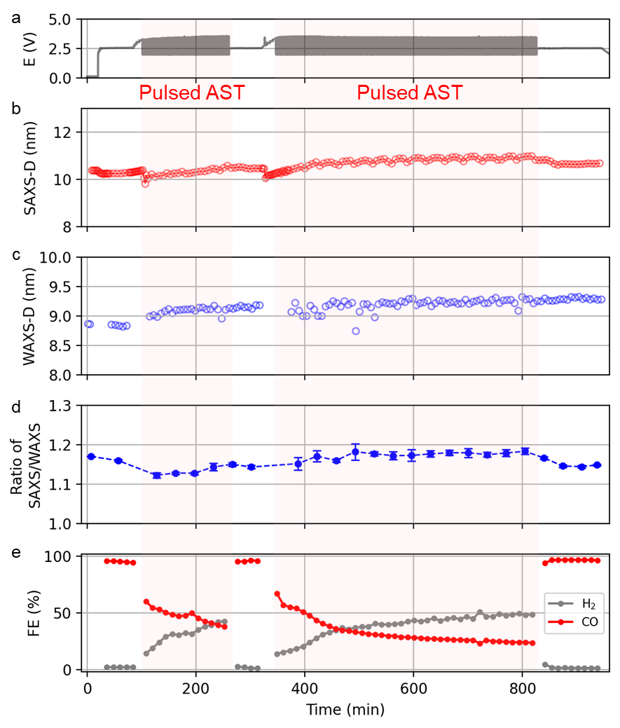
Supplementary Fig. 11. a-e, Cell voltage (a), measured SAXS diameter (b), measured WAXS diameter (c), ratio of measured diameters of SAXS/WAXS (d), faradaic efficiency (FE) of H₂ and CO (e) during the stress stability test including two pulsed AST periods (i_{react} region of 2 h or 6 h) for the Au catalyst.

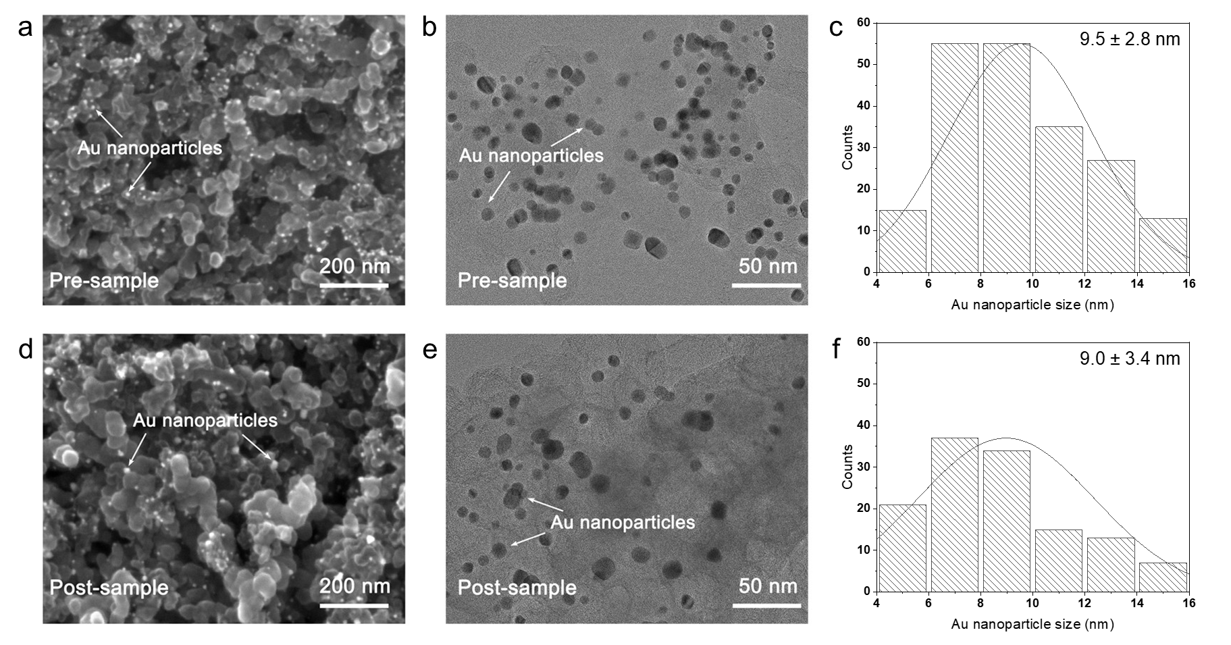
Supplementary Fig. 12. Au nanoparticle size change before and after the AST stability test. a-e, SEM image (a), TEM image (b) and corresponding size distribution from TEM (c) of Au nanoparticles pre-sample. SEM image (d), TEM image (e) and corresponding size distribution from TEM (f) of Au nanoparticles post-sample.

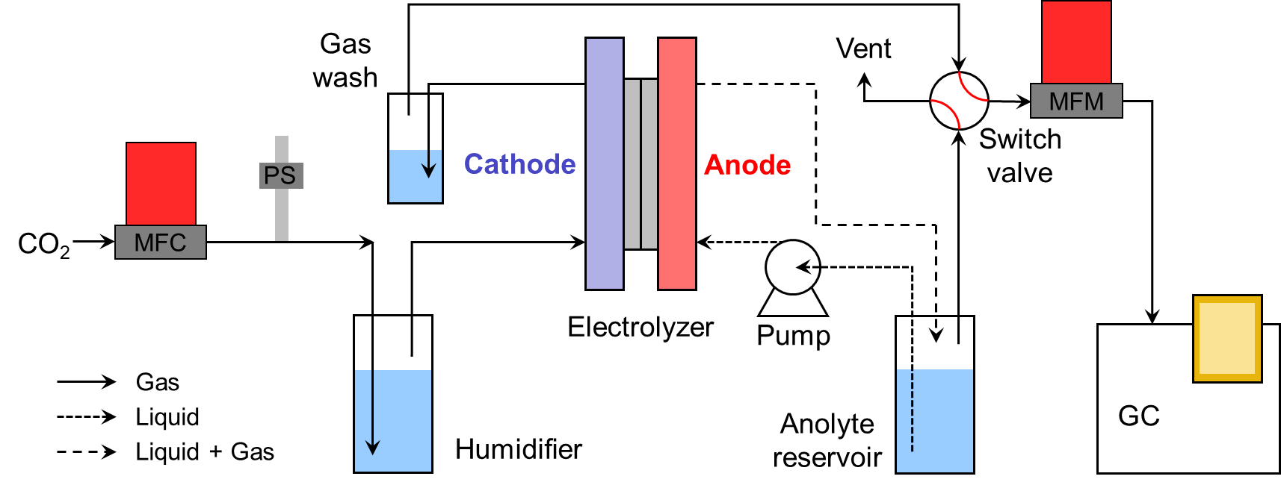
Supplementary Fig. 13. The flow diagram of the electrolysis setup. MFC is mass flow controller; MFM is mass flow meter; PS is pressure sensor; GC is gas chromatography.
Supplementary Note 1
Operando X-ray measurements:
All the operando beamline experiments were measured at the European Synchrotron Radiation Facility - Extremely Brilliant Source (ESRF-EBS), which is a 4th Generation synchrotron, allowing to investigate the MEA at grazing incidence geometry during operation. Supplementary Figure 14 exhibits a typical view of the grazing incidence measurement, in which the focused X-ray beam is parallel to the customized MEA-based reactor and its relative position to the WAXS, SAXS and XRF detectors. WAXS and SAXS detectors were in alignment with the incident beam; XRF detector was mounted at 90˚ relative to the incident beam. The reactor was positioned on a fixed holder, which helps the alignment process.
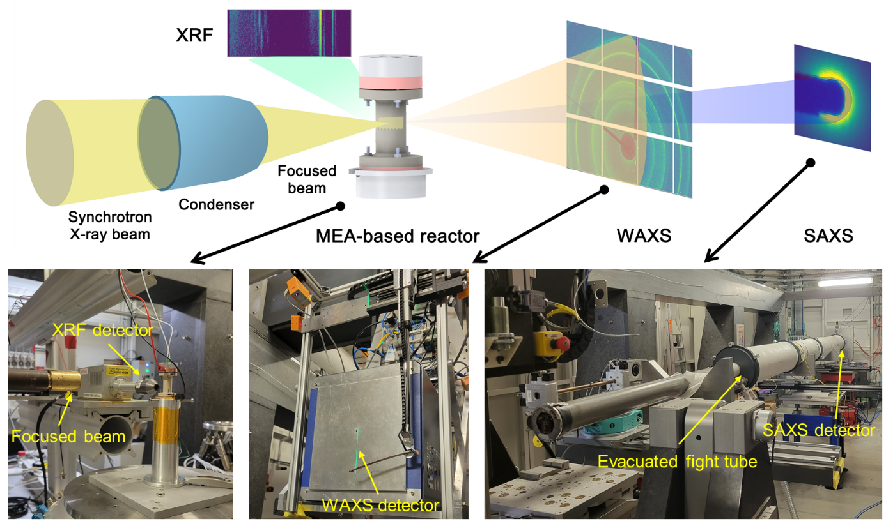
Supplementary Figure 14. Digital image of the focused X-ray beam facing to the customized MEA-based reactor, the WAXS, SAXS and XRF detectors.

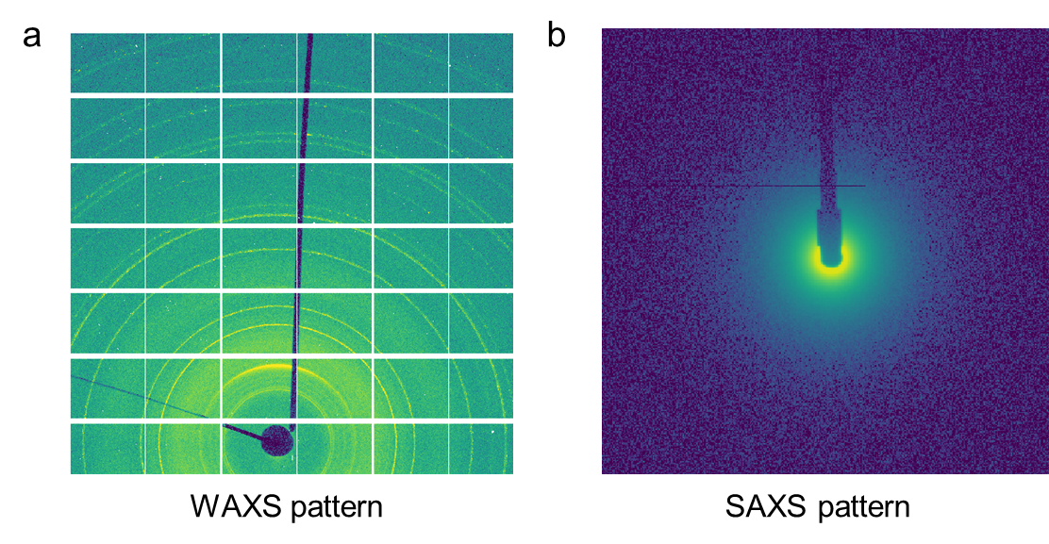
Supplementary Figure 15. WAXS (a) and SAXS (b) patterns.
In a typical measurement, the WAXS scan would go through the entire MEA from the IrO₂ anode through the membrane and all the way to the cathode flow field. Each scan takes ~220 s to acquire 100 WAXS patterns across the MEA region (step width of 5 μm, whole scan width of 500 μm). The SAXS scan only focuses on the cathode side including the membrane and cathodic GDE. Each scan takes ~140 s to acquire 50 SAXS patterns. WAXS and SAXS are applied by a continuous interleaved mode, ~60 s are required to exchange from one detector to the other by remotely controlling motors. The SAXS scan region is included in the WAXS scan region, thus a group of their data is comparable. XRF was recorded during the entire operation. A total time of ~7 min was required to acquire 100 WAXS patterns and 50 SAXS patterns across their respective MEA scan region and the accompanying 150 XRF spectra. After the measurement, typical WAXS and SAXS patterns are shown in Supplementary Figure 15. These 2D images were integrated to 1D lines by using pyFAI packages. All scattering rings in the WAXS pattern can be indexed to their characteristic crystalline phases.

Supplementary Note 2
X-ray data analyses:
Some python scripts were developed to implement the data analysis. In principle, these scripts allow to obtain the raw data of WAXS, SAXS and XRF from ‘h5’ formatted file, process the raw data to the as-required data for further drawing, correlate the electrochemical data, gas chromatography with the processed X-ray data. Detailed analysis methods for different X-ray data are given below:
- Processing WAXS data
WAXS patterns were analyzed by indexing their characteristic peaks to reference cards, which are downloaded from Inorganic Crystal Structure Database (ICSD). For Au, Ag, Ir and IrO₂, we use the ICSD-52700, ICSD-44387, ICSD-64992 and ICSD-84577 as reference cards, respectively. By integrating the peak intensity in the targeted q range, the WAXS mapping pattern can update in real-time accordingly. For example, the position of the Ag layer can be monitored by integrating WAXS patterns in the q-range of 2.64-2.68 Å⁻¹, which corresponds to the (111) crystal planes of fcc-structured Ag; the Ir phase can be identified by integrating WAXS patterns in the q-range of 2.84-2.85 Å⁻¹, which corresponds to the (111) crystal planes of fcc-structured Ir; water content (i.e., electrolyte) can be identified by noting changes in background scattering, which is done by integrating changes in the q-range between 2.40-2.46 Å⁻¹ since there are no diffraction peaks of any species in this range. It should be mentioned that the chosen peaks are not overlapping with peaks from other species. According to Debye–Scherrer equation mean crystal size = (kλ)/(β cos θ), the grain sizes of nanoparticle catalyst were calculated by using the full width at half maximum (FWHM) of specified peak.
- Processing SAXS data
SAXS patterns were collected using an evacuated tube between the detector and sample to reduce parasitic air scattering. The standard error was estimated for each Q bin during azimuthal integration, and was included in the structural refinement. The data analyses were implemented by using the SasView (https://www.sasview.org/). Supplementary Figure 16 shows a representative SAXS pattern and fitting result of the Au catalyst. A model of polydisperse nano-spheres loaded on carbon support was established for Au catalyst based on its actual morphology.
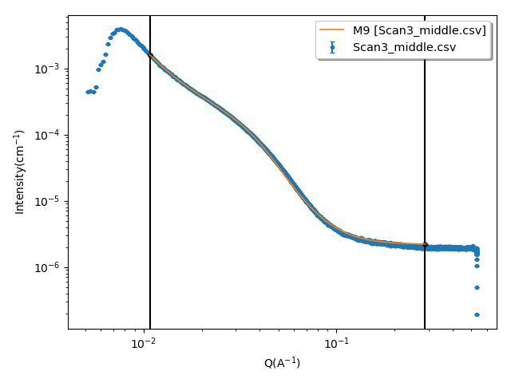
Supplementary Figure 16. Example of SAXS data fit with scattering model of dilute, polydisperse spheres with log-normal size polydispersity. Blue dots are the raw data and orange line is the fitting curve using SasView software.
- Processing XRF data
In our device, the XRF signals need to pass through the reactor before they can be collected by the detector. Therefore, the signals below 5 keV were not detectable in our case due to the absorption of the signal. To achieve the Cs mapping, the Cs K_{α} edge peak at energy range of 29-31 keV was integrated in function of space (the MEA depth) and time (electrolysis period).

Supplementary Note 3
Moiré pattern in the Cs mapping
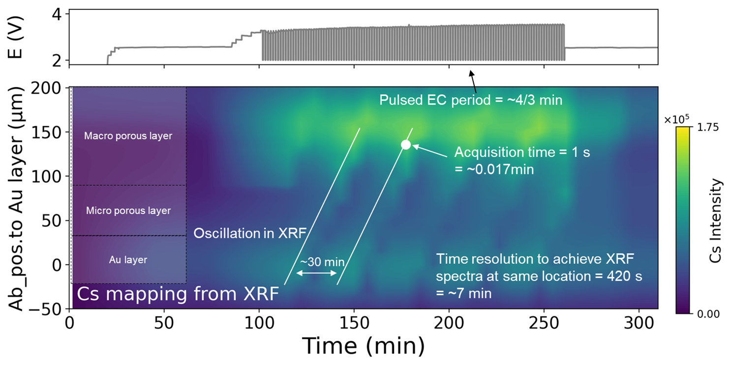
Supplementary Figure 17. XRF signal of Cs as a function of operating time and scan depth of MEA during the pulsed AST. Label provides the repetition periods of different behaviors during the scanning mode measurement.
Supplementary Figure 17 exhibits the XRF signal of Cs as a function of operating time and scan depth of MEA during the measurement. A continuous change in Cs intensity is observed when applying the galvanostatic method, while a Moiré pattern is displayed when applying the pulsed AST. Generally, Moiré patterns are responsible for large-scale interference patterns that can be produced when a partially opaque ruled pattern with transparent gaps is overlaid on another similar pattern. In our case, we speculate that the Moiré pattern arises from the mismatch between the rapid movement of Cs ions under the pulse period (~80 s) and a relatively low time resolution of the scanning mode (~420 s). In particular, the Moiré pattern shows a repetition interval of ~30 min; the time resolution to achieve a XRF spectrum at the same location under scanning mode measurement is ~7 min; the acquisition time for detector is ~0.017min; and the pulsed electrochemical (EC) method has a repetition period of ~1.33 min.
To explore the possibility of our assumption, we build a mathematical model comprising two as-designed equations, as depicted below:
$$f_{1}\left(x\right)=\left\{\begin{aligned}\sqrt{t} if t≤1 \left(i_{react} period\right) \\ {\left(2-\frac{3}{2}t\right)}^{2} if 1<t≤\frac{4}{3}(E_{no} period) \\ f_{1}\left(t-\frac{4}{3}\right) otherwise (iteration)\end{aligned}\right.$$
$$f_{2}\left(x\right)=\left\{\begin{aligned}0.01 if t≤0.017 (detecting at same position) \\ 2 if 0.017<t≤7 (detecting at other positions) \\ f_{1}\left(t-7\right) otherwise (iteration)\end{aligned}\right.$$
where f₁(x) is responsible for the change in Cs intensity during the pulsed EC method; f₂(x) is responsible for the detection period of XRF at the same position during the scanning mode. Here, t represents the total elapsed time. When plotting these two equations from t=10 to 80 min, the point of intersection represents the Cs intensity at that elapsed time, as shown in Supplementary Figure 18. If we consider the repetition period of Cs intensity around the same level (at dotted squares), it gives a value of ~28 min, which is close to our observed period of ~30 min.
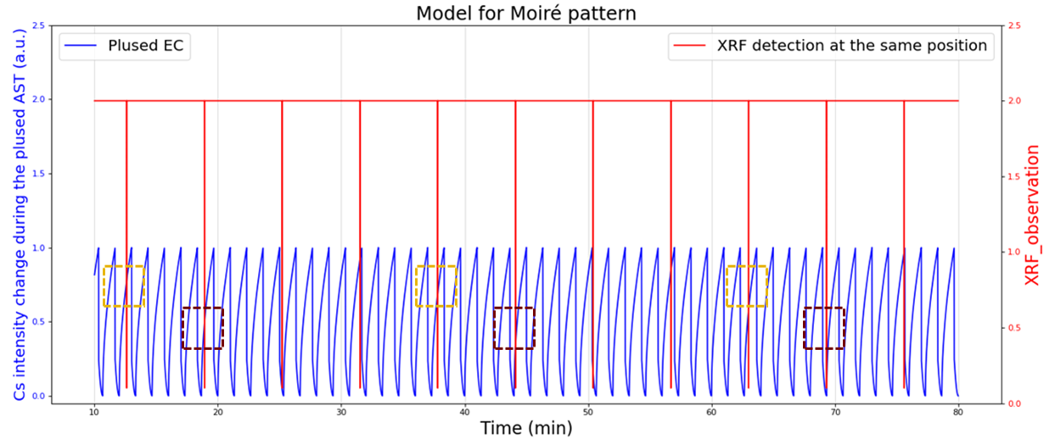
Supplementary Figure 18. A model to simulate the Moiré pattern by utilizing the repetition period of pulsed electrochemical method and XRF measurement.

