Supplementary Material for
Securely Stressed: Association between Attachment and Empathic Stress in Romantic Couples
Figure S1. Outlier Removal Process in HF-HRV Analysis. (A) Linear model including identified outliers. (B) Linear model after removing an outlier that rendered the result non-significant. (C) Second outlier removed for consistency, without affecting significance. The three figures show the association between HF-HRV changes of target and observer with observer attachment, modeled using residualized change scores (peak minus baseline). Observer attachment (colored lines) was assessed categorically (secure/insecure) using the Adult Attachment Interview (AAI; George et al., 1985). Shaded areas represent 95% confidence intervals.
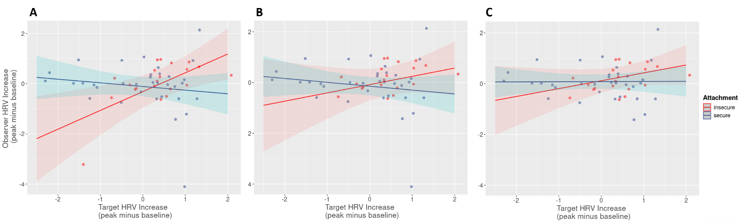

Table S1. Linear Models for dyadic correlations with attachment classification (secure/insecure) as predictor for acute subjective stress, autonomous markers heart rate (HR) and high-frequency heart rate variability (HF-HRV), and salivary cortisol.
 | Subjective Stress | HR | HF-HRV | Cortisol
Intercept | 0.54 | 0.49 | 0.71 | 0.34 .
Observer Attachment  (categorial: secure/insecure) | -0.11 | -0.02 | -0.08 | -0.17
BMI | - | -<0.01 | -0.01 | -
Sex | - | <0.01 | -0.15 | -0.07
Time of day | - | - | - | -0.0001
R² | 0.02 | 0.004 | 0.02 | 0.03
Note: ***p ≤.001, **p≤.01, *p≤.05;
for HR and HF-HRV after Bonferroni correction: ***p≤.0005, **p≤.005, *p≤.025, . p≤.05
Table S2. Linear Models for observers’ change score as dependent variable; targets’ change score, continuous attachment variable „coherence of transcript“ and their interaction as predictors, for acute subjective stress, autonomous markers heart rate (HR) and high-frequency heart rate variability (HF-HRV), and salivary cortisol.
 | Subjective Stress | HR | HF-HRV | Cortisol
Intercept | -0.26 | 1.77 | 0.56 | -0.15
Target Change Score | -0.40 | 0.20 | 0.63 | -0.71.
Observer Attachment  (continuous: coherence of transcript) | 0.05 | -0.03 | 0.01 | 0.12.
Target Change: Observer Attachment (continuous) | 0.06 | -0.06 | -0.10 | 0.22**
BMI | - | -0.07 | -0.03 | -
Sex | - | -0.14 | 0.09 | -0.45.
Time of day | - | - | - | -<0.01
R² | 0.03 | 0.04 | 0.08 | 0.23
Note: ***p ≤.001, **p≤.01, *p≤.05;
for HR and HF-HRV after Bonferroni correction: ***p≤.0005, **p≤.005, *p≤.025, . p≤.05
Table S3. Linear Models for dyadic correlations with continuos attachment variable „coherence of transcript“ as predictor for acute subjective stress, autonomous markers heart rate (HR) and high-frequency heart rate variability (HF-HRV), and salivary cortisol.
 | Subjective Stress | HR | HF-HRV | Cortisol
Intercept | 0.35 | 0.64 | 0.48 | -0.15
Observer Attachment  (continuous: coherence of transcript) | 0.03 | -<0.01 | 0.02 | 0.09*
BMI | - | -0.01 | -0.01 | -
Sex | - | -0.05 | -0.15 | 0.11
Time of day | - | - | - | <0.01
R² | 0.02 |  |  | 0.08
Note: ***p ≤.001, **p≤.01, *p≤.05;
for HR and HF-HRV after Bonferroni correction: ***p≤.0005, **p≤.005, *p≤.025, . p≤.05

References
George, C., Main, M., & Kaplan, N. (1985). Adult attachment interview (AAI)[Database record]. University of California, Berkeley: APA PsycTests.

