Supplementary information
Table S1 Lomas species retained from MaxEnt analysis, categorized by endemic status and elevation preference, with respective occurrence counts.
Nº | Species | Occurrences | Endemic | Elevational zone
1 | Acnistus arborescens | 165 | no | middle
2 | Adiantum chilense | 410 | no | low
3 | Ageratum conyzoides | 571 | no | middle
4 | Agrostis tolucensis | 32 | no | high
5 | Aloe vera | 53 | no | middle
6 | Alonsoa meridionalis | 403 | no | middle
7 | Alstroemeria caryophyllaea | 41 | no | low
8 | Alstroemeria lineatiflora | 199 | no | middle
9 | Alstroemeria paupercula | 38 | no | low
10 | Alternanthera porrigens | 238 | no | high
11 | Amaranthus viridis | 48 | no | low
12 | Ambrosia arborescens | 78 | no | high
13 | Amsinckia calycina | 178 | no | middle
14 | Anagallis arvensis | 58 | no | low
15 | Andropogon bicornis | 185 | no | low
16 | Aphyllocladus denticulatus | 248 | yes | middle
17 | Arenaria lanuginosa | 43 | no | high
18 | Argemone mexicana | 229 | no | low
19 | Argemone subfusiformis | 120 | no | middle
20 | Argylia radiata | 127 | yes | low
21 | Arundo donax | 211 | no | low
22 | Asclepias curassavica | 1328 | no | middle
23 | Baccharis caespitosa | 40 | no | high
24 | Baccharis latifolia | 681 | no | high
25 | Baccharis tricuneata | 133 | no | high
26 | Barnadesia arborea | 118 | no | high
27 | Bidens andicola | 152 | no | high
28 | Bidens pilosa | 310 | no | low
29 | Bomarea edulis | 65 | no | middle
30 | Brassica rapa | 58 | no | low
31 | Briza minor | 89 | no | low
32 | Bromus berteroanus | 62 | no | middle
33 | Bromus catharticus | 93 | no | low
34 | Browallia americana | 184 | no | middle
35 | Caesalpinia spinosa | 100 | yes | high
36 | Caiophora cirsiifolia | 34 | yes | high
37 | Calamagrostis intermedia | 45 | NA | high
38 | Carica candicans | 52 | yes | middle
39 | Castilleja arvensis | 424 | no | high
40 | Casuarina equisetifolia | 31 | no | middle
41 | Cenchrus clandestinus | 427 | no | high
42 | Centaurea melitensis | 58 | no | middle
43 | Chamaesyce hypericifolia | 40 | no | low
44 | Chaptalia nutans | 89 | no | low
45 | Chenopodium ambrosioides | 116 | no | middle
46 | Chenopodium murale | 62 | no | high
47 | Chuquiraga spinosa | 41 | yes | high
48 | Chusquea scandens | 162 | no | high
49 | Ciclospermum leptophyllum | 147 | no | low
50 | Conyza bonariensis | 263 | no | high
51 | Cordia lutea | 138 | yes | low
52 | Cotula australis | 210 | no | high
53 | Crotalaria incana | 100 | no | low
54 | Cucumis africanus | 99 | no | low
55 | Cumulopuntia leucophaea | 171 | no | middle
56 | Cumulopuntia sphaerica | 72 | no | high
57 | Cyclospermum leptophyllum | 146 | no | low
58 | Cylindropuntia tunicata | 67 | no | middle
59 | Cyrtocymura scorpioides | 95 | no | low
60 | Dichondra repens | 40 | no | high
61 | Dichondra sericea | 46 | no | low
62 | Digitaria ciliaris | 32 | no | low
63 | Distichlis spicata | 95 | no | low
64 | Dorobaea pimpinellifolia | 169 | yes | high
65 | Drymaria cordata | 344 | no | low
66 | Dysphania ambrosioides | 116 | no | middle
67 | Eclipta prostrata | 502 | no | low
68 | Elephantopus mollis | 194 | no | middle
69 | Eleusine indica | 112 | no | low
70 | Encelia canescens | 144 | no | low
71 | Erodium malacoides | 50 | no | low
72 | Erodium moschatum | 104 | no | low
73 | Euphorbia serpens | 94 | no | low
74 | Flaveria bidentis | 75 | no | middle
75 | Frankenia chilensis | 63 | no | low
76 | Fuertesimalva limensis | 102 | no | high
77 | Fumaria capreolata | 155 | no | low
78 | Furcraea andina | 206 | yes | high
79 | Galinsoga parviflora | 267 | no | middle
80 | Gamochaeta americana | 53 | no | high
81 | Gamochaeta purpurea | 59 | no | high
82 | Gilia laciniata | 34 | no | high
83 | Haageocereus acranthus | 69 | yes | low
84 | Haageocereus pseudomelanostele | 56 | yes | middle
85 | Heliotropium angiospermum | 89 | no | low
86 | Heliotropium arborescens | 54 | no | high
87 | Heliotropium curassavicum | 349 | no | low
88 | Ipomoea tricolor | 31 | no | middle
89 | Leonotis nepetifolia | 665 | no | high
90 | Lepidium virginicum | 40 | no | low
91 | Leptospron adenanthum | 43 | no | low
92 | Lycopersicon peruvianum | 75 | no | middle
93 | Malva parviflora | 95 | no | middle
94 | Marrubium vulgare | 995 | no | low
95 | Melia azedarach | 421 | no | low
96 | Melocactus peruvianus | 45 | yes | middle
97 | Melochia pyramidata | 111 | no | low
98 | Mesembryanthemum cordifolium | 74 | no | middle
99 | Mimosa albida | 247 | no | high
100 | Neoraimondia arequipensis | 55 | yes | middle
101 | Nicotiana glauca | 1393 | no | low
102 | Nothoscordum bivalve | 55 | no | low
103 | Oenothera rosea | 279 | no | middle
104 | Opuntia stricta | 43 | no | low
105 | Oreocereus hempelianus | 35 | no | high
106 | Oxalis latifolia | 291 | no | middle
107 | Oxalis megalorrhiza | 76 | no | low
108 | Oziroe biflora | 50 | no | low
109 | Parietaria debilis | 31 | no | low
110 | Parkinsonia aculeata | 601 | no | low
111 | Passiflora suberosa | 44 | no | low
112 | Pectocarya linearis | 57 | no | middle
113 | Pennisetum clandestinum | 118 | no | high
114 | Phyla nodiflora | 460 | no | low
115 | Picrosia longifolia | 61 | no | low
116 | Pitraea cuneato-ovata | 56 | no | middle
117 | Plagiochasma rupestre | 32 | no | middle
118 | Portulaca pilosa | 37 | no | low
119 | Quinchamalium chilense | 503 | yes | middle
120 | Ricinus communis | 2583 | no | low
121 | Sapindus saponaria | 1434 | no | low
122 | Schinus molle | 685 | no | low
123 | Sesuvium portulacastrum | 112 | no | low
124 | Sicyos baderoa | 55 | no | low
125 | Silene gallica | 225 | no | low
126 | Sisymbrium irio | 151 | no | middle
127 | Solanum americanum | 693 | no | low
128 | Solanum bukasovii | 245 | yes | high
129 | Solanum peruvianum | 75 | no | middle
130 | Solanum radicans | 92 | no | high
131 | Solanum tuberosum | 469 | no | middle
132 | Spergularia fasciculata | 50 | no | high
133 | Stachys arvensis | 78 | no | low
134 | Stellaria cuspidata | 31 | no | high
135 | Stenomesson flavum | 31 | yes | middle
136 | Tarasa operculata | 78 | no | high
137 | Tessaria integrifolia | 217 | no | low
138 | Tillandsia latifolia | 52 | yes | middle
139 | Tiquilia paronychioides | 33 | yes | middle
140 | Trixis cacalioides | 45 | no | middle
141 | Tropaeolum majus | 1106 | no | low
142 | Vachellia macracantha | 987 | no | low
143 | Vallesia glabra | 43 | no | low
144 | Vasconcellea candicans | 52 | yes | middle
145 | Verbena litoralis | 155 | no | middle
146 | Vigna luteola | 106 | no | low
147 | Villanova oppositifolia | 45 | no | high
148 | Weberbauerocereus weberbaueri | 42 | yes | high
149 | Zinnia peruviana | 197 | no | middle

Table S2 Species predicted to lose their entire habitat in Lomas systems under various SSP scenarios, identified using a 10% occurrence probability threshold in logistic maps. Endemic species are underlined
Nº | Species | Scenario
1 | Agrostis tolucensis | both scenarios
2 | Alonsoa meridionalis | both scenarios
3 | Argemone subfusiformis | both scenarios
4 | Baccharis caespitosa | both scenarios
5 | Bidens andicola | both scenarios
6 | Bidens pilosa | both scenarios
7 | Bromus catharticus | both scenarios
8 | Caesalpinia spinosa | both scenarios
9 | Castilleja arvensis | both scenarios
10 | Chuquiraga spinosa | both scenarios
11 | Ciclospermum leptophyllum | both scenarios
12 | Conyza bonariensis | both scenarios
13 | Cotula australis | both scenarios
14 | Cumulopuntia leucophaea | both scenarios
15 | Cyclospermum leptophyllum | both scenarios
16 | Dichondra repens | SPP3-7.0
17 | Drymaria cordata | SSP1-2.6
18 | Elephantopus mollis | SSP3-7.0
19 | Encelia canescens | SSP1-2.6
20 | Gamochaeta americana | SSP1-2.6
21 | Gamochaeta purpurea | SSP3-7.0
22 | Lepidium virginicum | SSP3-7.0
23 | Melia azedarach | SSP3-7.0
24 | Mesembryanthemum cordifolium | SSP3-7.0
25 | Nothoscordum bivalve | SSP3-7.0
26 | Oxalis megalorrhiza | SSP3-7.0
27 | Parietaria debilis | SSP3-7.0
28 | Passiflora suberosa | SSP1-2.6
29 | Pennisetum clandestinum | SSP3-7.0
30 | Picrosia longifolia | SSP3-7.0
31 | Quinchamalium chilense | SSP1-2.6
32 | Schinus molle | SSP1-2.6
33 | Silene gallica | SSP1-2.6
34 | Spergularia fasciculata | SSP3-7.0
35 | Vallesia glabra | SSP3-7.0
36 | Verbena litoralis | SSP1-2.6

Table S3 Overview of Lomas species considered for UG implementation in Lima, detailing native status, endemic status, conservation status, MaxEnt inclusion for analysis, and occurrence number for non-included species
Nº | Lomas species | Native status | Endemic status | Conservation Status | Included in MaxEnt | Occurrences for non-included
1 | Aloe vera | no | no | Introduced | yes
2 | Alternanthera halimifolia | yes | no | Not threatened | no | 18
3 | Atriplex rotundifolia | yes | yes | Urgent need for conservation | no | 1
4 | Begonia octopetala | yes | yes | Endangered | no | 18
5 | Chenopodium petiolare | NA | NA | Not threatened | no | 16
6 | Croton alnifolius | yes | no | Not threatened | no | 3
7 | Dicliptera tomentosa | yes | no | Urgent need for conservation | no | 3
8 | Distichlis spicata | yes | no | Not threatened/Least Concern | yes
9 | Erigeron leptorhizon | yes | no | Risk of decreasing in Lomas (loss of habitat due to mineral extraction, overgrazing) | no | 9
10 | Erodium moschatum | no | no | Not threatened - introduced | yes
11 | Grindelia glutinosa | yes | no | No specific data | no | 1
12 | Heliotropium angiospermum | yes | no | Not threatened | yes
13 | Heliotropium arborescens | yes | no | Not threatened | yes
14 | Ismene amancaes | yes | yes | Vulnerable | no | 8
15 | Nicotiana paniculata | yes | yes | Not threatened/Least Concern | no | 27
16 | Nolana humifusa | yes | yes | Risk of decreasing in Lomas (loss of habitat due to mineral extraction, pollution) | no | 3
17 | Ophryosporus peruvianus | yes | no | Not threatened | no | 4
18 | Ophryosporus pubescens | yes | yes | Urgent need for conservation/ Endangered | no | 1
19 | Oziroe biflora | yes | no | Risk of decreasing in Lomas | yes
20 | Philibertia solanoides | yes | yes | Not threatened | no | 14
21 | Phyla nodiflora | yes | no | Not threatened | yes
22 | Solanum peruvianum | yes | no | Not threatened/Least Concern | yes
23 | Stenomesson flavum | yes | yes | Species with decreasing trend in Lomas (loss of habitat). | yes
24 | Tillandsia latifolia | yes | yes | Species with decreasing trend in Lomas (minerals extraction)/Least Concern | yes
25 | Trixis cacalioides | yes | no | No specific data | yes
26 | Waltheria ovata | yes | yes | No specific data | no | 17

Table S4 List of species that were retained for the MaxEnt analysis, the number of occurrence records and the Continuous Boyce Index (CBI) of the best model that was subsequently utilized for model predictions. NA values denote missing values
Nº | Species | Occurrences | CBI
1 | Acnistus arborescens | 165 | 0.382
2 | Adiantum chilense | 410 | 0.391
3 | Ageratum conyzoides | 571 | 0.593
4 | Agrostis tolucensis | 32 | NA
5 | Aloe vera | 53 | 0.42
6 | Alonsoa meridionalis | 403 | 0.418
7 | Alstroemeria caryophyllaea | 41 | 0.591
8 | Alstroemeria lineatiflora | 199 | 0.521
9 | Alstroemeria paupercula | 38 | NA
10 | Alternanthera porrigens | 238 | 0.036
11 | Amaranthus viridis | 48 | 0.256
12 | Ambrosia arborescens | 78 | NA
13 | Amsinckia calycina | 178 | 0.348
14 | Anagallis arvensis | 58 | 0.222
15 | Andropogon bicornis | 185 | 0.347
16 | Aphyllocladus denticulatus | 248 | 0.221
17 | Arenaria lanuginosa | 43 | 0.256
18 | Argemone mexicana | 229 | 0.585
19 | Argemone subfusiformis | 120 | 0.34
20 | Argylia radiata | 127 | 0.377
21 | Arundo donax | 211 | 0.491
22 | Asclepias curassavica | 1328 | 0.737
23 | Baccharis caespitosa | 40 | NA
24 | Baccharis latifolia | 681 | 0.576
25 | Baccharis tricuneata | 133 | 0.543
26 | Barnadesia arborea | 118 | 0.174
27 | Bidens andicola | 152 | NA
28 | Bidens pilosa | 310 | 0.76
29 | Bomarea edulis | 65 | 0.485
30 | Brassica rapa | 58 | 0.175
31 | Briza minor | 89 | 0.329
32 | Bromus berteroanus | 62 | 0.412
33 | Bromus catharticus | 93 | 0.413
34 | Browallia americana | 184 | 0.406
35 | Caesalpinia spinosa | 100 | 0.675
36 | Caiophora cirsiifolia | 34 | 0.319
37 | Calamagrostis intermedia | 45 | NA
38 | Carica candicans | 52 | 0.248
39 | Castilleja arvensis | 424 | 0.543
40 | Casuarina equisetifolia | 31 | -0.258
41 | Cenchrus clandestinus | 427 | -0.018
42 | Centaurea melitensis | 58 | NA
43 | Chamaesyce hypericifolia | 40 | 0.358
44 | Chaptalia nutans | 89 | 0.22
45 | Chenopodium ambrosioides | 116 | 0.558
46 | Chenopodium murale | 62 | 0.047
47 | Chuquiraga spinosa | 41 | 0.283
48 | Chusquea scandens | 162 | 0.381
49 | Ciclospermum leptophyllum | 147 | 0.349
50 | Conyza bonariensis | 263 | 0.467
51 | Cordia lutea | 138 | 0.372
52 | Cotula australis | 210 | 0.442
53 | Crotalaria incana | 100 | 0.39
54 | Cucumis africanus | 99 | 0.535
55 | Cumulopuntia leucophaea | 171 | 0.401
56 | Cumulopuntia sphaerica | 72 | NA
57 | Cyclospermum leptophyllum | 146 | 0.246
58 | Cylindropuntia tunicata | 67 | 0.272
59 | Cyrtocymura scorpioides | 95 | 0.384
60 | Dichondra repens | 40 | 0.2
61 | Dichondra sericea | 46 | 0.391
62 | Digitaria ciliaris | 32 | -0.027
63 | Distichlis spicata | 95 | 0.358
64 | Dorobaea pimpinellifolia | 169 | 0.179
65 | Drymaria cordata | 344 | 0.523
66 | Dysphania ambrosioides | 116 | 0.558
67 | Eclipta prostrata | 502 | 0.683
68 | Elephantopus mollis | 194 | 0.258
69 | Eleusine indica | 112 | 0.025
70 | Encelia canescens | 144 | 0.401
71 | Erodium malacoides | 50 | 0.131
72 | Erodium moschatum | 104 | 0.262
73 | Euphorbia serpens | 94 | 0.357
74 | Flaveria bidentis | 75 | 0.27
75 | Frankenia chilensis | 63 | 0.307
76 | Fuertesimalva limensis | 102 | NA
77 | Fumaria capreolata | 155 | NA
78 | Furcraea andina | 206 | 0.015
79 | Galinsoga parviflora | 267 | 0.715
80 | Gamochaeta americana | 53 | 0.432
81 | Gamochaeta purpurea | 59 | 0.286
82 | Gilia laciniata | 34 | 0.434
83 | Haageocereus acranthus | 69 | 0.368
84 | Haageocereus pseudomelanostele | 56 | NA
85 | Heliotropium angiospermum | 89 | 0.402
86 | Heliotropium arborescens | 54 | 0.35
87 | Heliotropium curassavicum | 349 | 0.486
88 | Ipomoea tricolor | 31 | NA
89 | Leonotis nepetifolia | 665 | 0.464
90 | Lepidium virginicum | 40 | 0.221
91 | Leptospron adenanthum | 43 | 0.329
92 | Lycopersicon peruvianum | 75 | 0.256
93 | Malva parviflora | 95 | 0.555
94 | Marrubium vulgare | 995 | 0.492
95 | Melia azedarach | 421 | 0.366
96 | Melocactus peruvianus | 45 | NA
97 | Melochia pyramidata | 111 | 0.354
98 | Mesembryanthemum cordifolium | 74 | 0.332
99 | Mimosa albida | 247 | 0.079
100 | Neoraimondia arequipensis | 55 | 0.084
101 | Nicotiana glauca | 1393 | 0.75
102 | Nothoscordum bivalve | 55 | 0.423
103 | Oenothera rosea | 279 | 0.712
104 | Opuntia stricta | 43 | NA
105 | Oreocereus hempelianus | 35 | 0.433
106 | Oxalis latifolia | 291 | 0.593
107 | Oxalis megalorrhiza | 76 | 0.255
108 | Oziroe biflora | 50 | NA
109 | Parietaria debilis | 31 | 0.314
110 | Parkinsonia aculeata | 601 | 0.342
111 | Passiflora suberosa | 44 | NA
112 | Pectocarya linearis | 57 | 0.039
113 | Pennisetum clandestinum | 118 | 0.154
114 | Phyla nodiflora | 460 | 0.732
115 | Picrosia longifolia | 61 | NA
116 | Pitraea cuneato-ovata | 56 | 0.255
117 | Plagiochasma rupestre | 32 | 0.297
118 | Portulaca pilosa | 37 | 0.104
119 | Quinchamalium chilense | 503 | 0.642
120 | Ricinus communis | 2583 | 0.916
121 | Sapindus saponaria | 1434 | 0.144
122 | Schinus molle | 685 | 0.864
123 | Sesuvium portulacastrum | 112 | 0.534
124 | Sicyos baderoa | 55 | 0.27
125 | Silene gallica | 225 | 0.577
126 | Sisymbrium irio | 151 | 0.395
127 | Solanum americanum | 693 | 0.666
128 | Solanum bukasovii | 245 | 0.425
129 | Solanum peruvianum | 75 | 0.256
130 | Solanum radicans | 92 | 0.523
131 | Solanum tuberosum | 469 | 0.788
132 | Spergularia fasciculata | 50 | 0.257
133 | Stachys arvensis | 78 | 0.277
134 | Stellaria cuspidata | 31 | 0.701
135 | Stenomesson flavum | 31 | 0.213
136 | Tarasa operculata | 78 | 0.276
137 | Tessaria integrifolia | 217 | 0.745
138 | Tillandsia latifolia | 52 | 0.047
139 | Tiquilia paronychioides | 33 | NA
140 | Trixis cacalioides | 45 | 0.248
141 | Tropaeolum majus | 1106 | 0.843
142 | Vachellia macracantha | 987 | 0.405
143 | Vallesia glabra | 43 | 0.278
144 | Vasconcellea candicans | 52 | NA
145 | Verbena litoralis | 155 | 0.43
146 | Vigna luteola | 106 | 0.227
147 | Villanova oppositifolia | 45 | NA
148 | Weberbauerocereus weberbaueri | 42 | 0.29
149 | Zinnia peruviana | 197 | 0.353

Table S5 Mean and median values of the geographic range shifts, considering distance, elevation and angle, under the different scenarios for the Andes and Lomas regions
Region | Scenario | Statistics | Distance (km) | Elevation (km) | Angle (º)
Andes | SSP1-2.6 | Mean | 200.734 | -0.228 | 168.735
Andes | SSP1-2.6 | Median | 80.598 | -0.028 | 142.209
Andes | SSP3-7.0 | Mean | 169.974 | -0.122 | 178.237
Andes | SSP3-7.0 | Median | 79.159 | -0.005 | 155.723
Lomas | SSP1-2.6 | Mean | 162.98 | -0.473 | 200.646
Lomas | SSP1-2.6 | Median | 63.465 | -0.087 | 165.017
Lomas | SSP3-7.0 | Mean | 254.46 | -0.203 | 201.373
Lomas | SSP3-7.0 | Median | 170.112 | -0.089 | 165.695

Table S6 Mean and median values of the geographic range shifts, considering distance and elevation, under the different scenarios based on elevation preference in the Andes (A) and Lomas (B) regions
Elevation | Statistics | Distance (km) | Elevation (km)
A) Andes
SSP1-2.6
Low | Mean | 111.67 | -0.124
Low | Median | 59.75 | -0.004
Middle | Mean | 169.13 | -0.139
Middle | Median | 69.04 | -0.005
High | Mean | 410.19 | -0.544
High | Median | 276.54 | -0.217
SSP3-7.0
Low | Mean | 111.8 | -0.082
Low | Median | 51.39 | 0.000
Middle | Mean | 146.84 | -0.109
Middle | Median | 75.5 | -0.003
High | Mean | 315.22 | -0.220
High | Median | 276.54 | -0.109
B) Lomas
SSP1-2.6
Low | Mean | 88.117 | -0.274
Low | Median | 34.586 | -0.004
Middle | Mean | 153.487 | -0.345
Middle | Median | 61.446 | -0.005
High | Mean | 315.385 | -1.014
High | Median | 161.337 | -0.735
SSP3-7.0
Low | Mean | 222.076 | 0.063
Low | Median | 167.796 | -0.017
Middle | Mean | 257.856 | -0.22
Middle | Median | 169.19 | -0.053
High | Mean | 314.198 | -0.718
High | Median | 182.019 | -0.626

Table S7 Mean and median values of the geographic range shifts, considering distance and elevation, under the different scenarios based on endemic status in the Andes (A) and Lomas (B) regions
Endemic status | Statistics | Distance (km) | Elevation (km)
A) Andes
SSP1-2.6
Endemic | Mean | 250.814 | -0.014
Endemic | Median | 143.79 | 0.075
Not endemic | Mean | 192.464 | -0.263
Not endemic | Median | 79.527 | -0.119
SSP3-7.0
Endemic | Mean | 208.4 | 0.114
Endemic | Median | 123.322 | 0.113
Not endemic | Mean | 163.323 | -0.163
Not endemic | Median | 72.173 | -0.015
B) Lomas
SSP1-2.6
Endemic | Mean | 181.37 | -0.127
Endemic | Median | 65.218 | 0.111
Not endemic | Mean | 160.113 | -0.527
Not endemic | Median | 58.354 | -0.235
SSP3-7.0
Endemic | Mean | 254.248 | 0.337
Endemic | Median | 192.912 | 0.661
Not endemic | Mean | 254.497 | -0.299
Not endemic | Median | 165.48 | -0.179

Table S8 Mean and median values of the total habitat change (km²) and percentage of habitat change with outliers under the different scenarios based on endemic status in the Andes and Lomas regions
Region | Scenario | Statistics | Total habitat change (km²) | Habitat change (%) with outliers
Andes | SSP1-2.6 | Mean | -1,265,169 | 8.45
Andes | SSP1-2.6 | Median | -501,498 | -4.54
Andes | SSP3-7.0 | Mean | -802,753 | 22.00
Andes | SSP3-7.0 | Median | -52,498 | -0.31
Lomas | SSP1-2.6 | Mean | -572,625 | 6.99
Lomas | SSP1-2.6 | Median | -257,010 | -6.13
Lomas | SSP3-7.0 | Mean | -167,891 | 111.4
Lomas | SSP3-7.0 | Median | -229,069 | -0.08

Table S9 Mean and median values of habitat change (%) among species elevation preferences under two SSP scenarios for both Andes (A) and Lomas (B) regions
Elevation | Statistics | Habitat change (%)
A) Andes
SSP1-2.6
Low | Mean | -13.83
Low | Median | -55.36
Middle | Mean | 21.90
Middle | Median | -0.20
High | Mean | 31.66
High | Median | -0.81
SSP3-7.0
Low | Mean | 16.98
Low | Median | -11.85
Middle | Mean | 27.83
Middle | Median | -0.14
High | Mean | 23.39
High | Median | -0.31
B) Lomas
SSP1-2.6
Low | Mean | -2.71
Low | Median | -31.36
Middle | Mean | 10.10
Middle | Median | -1.52
High | Mean | 20.96
High | Median | -1.48
SSP3-7.0
Low | Mean | 16.98
Low | Median | -11.85
Middle | Mean | 27.83
Middle | Median | -0.14
High | Mean | 23.39
High | Median | -0.31

Table S10 Mean and median values of habitat change (%) among species endemic status under two SSP scenarios for both the Andes (A) and Lomas (B) regions
Endemic status | Statistics | Habitat change (%)
A) Andes
SSP1-2.6
Endemic | Mean | 66.14
Endemic | Median | 104.61
Not endemic | Mean | -1.08
Not endemic | Median | -16.54
SSP3-7.0
Endemic | Mean | 52.09
Endemic | Median | 102.93
Not endemic | Mean | 16.74
Not endemic | Median | -2.36
B) Lomas
SSP1-2.6
Endemic | Mean | 84.29
Endemic | Median | 108.3
Not endemic | Mean | -5.06
Not endemic | Median | -15.38
SSP3-7.0
Endemic | Mean | 52.09
Endemic | Median | 102.93
Not endemic | Mean | 16.74
Not endemic | Median | -2.36

Information S1 CHELSA bioclimatic variables considered before correlation analysis
The bioclimatic variables, retrieved from CHELSA were: mean annual temperature (BIO1), mean diurnal range (BIO2), isothermality (BIO3), temperature seasonality (BIO4), max temperature of warmest month (BIO5), min temperature of coldest month (BIO6), temperature annual range (BIO7), mean temperature of wettest quarter (BIO8), mean temperature of driest quarter (BIO9), mean temperature of warmest quarter (BIO10), mean temperature of coldest quarter (BIO11), annual precipitation (BIO12), precipitation of wettest month (BIO13), precipitation of driest month (BIO14), precipitation seasonality (BIO15), precipitation of wettest quarter (BIO16), precipitation of driest quarter (BIO17), precipitation of warmest quarter (BIO18), and precipitation of coldest quarter (BIO19).

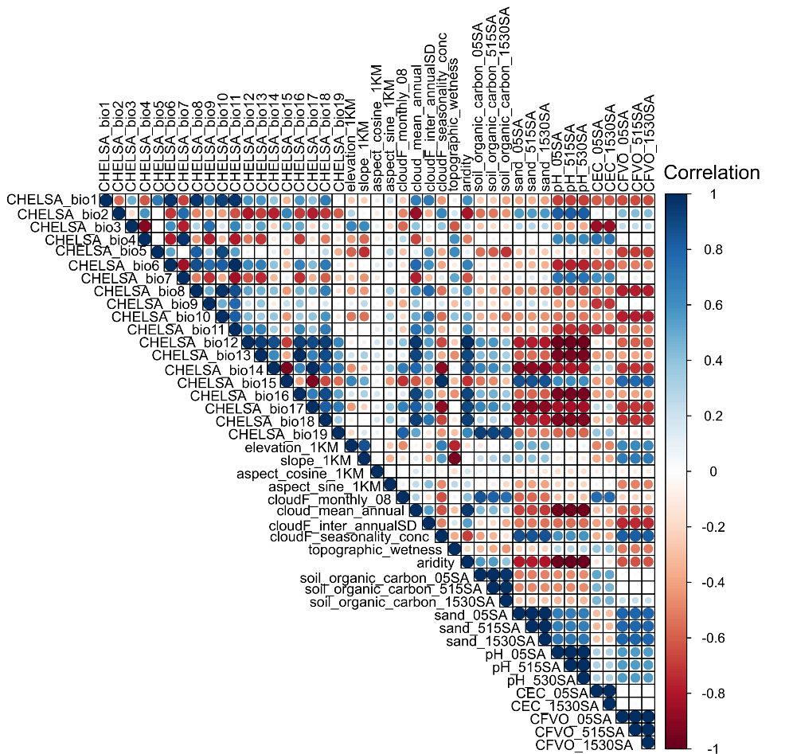
Figure S1 Correlation matrix of environmental variables, where darker colors denote stronger correlations (blue for positive and red for negative). Variables with Spearman's correlation coefficients exceeding 0.7 were excluded from the analysis

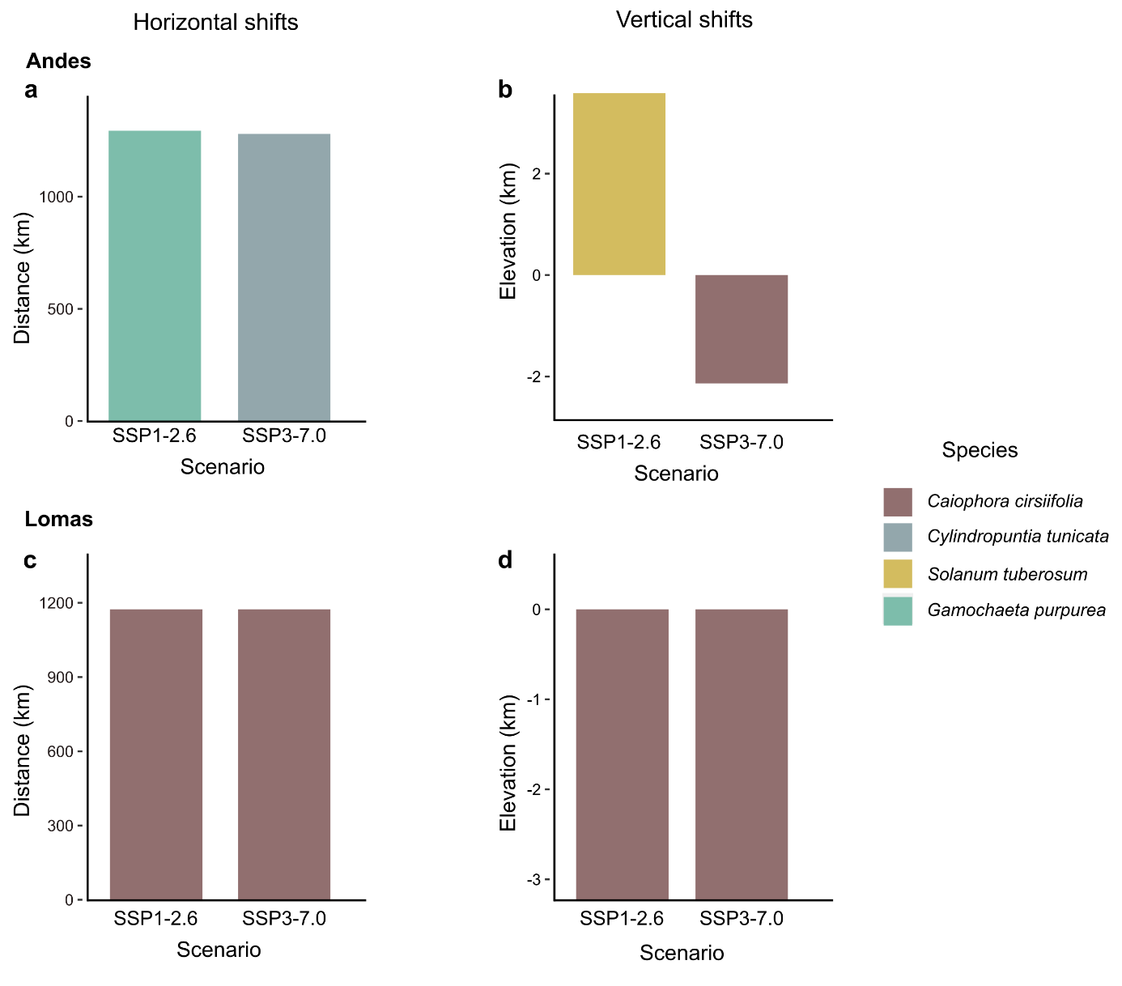
Figure S2 Maximum distribution shifts for Lomas species under SSP1-2.6 and SSP3-7.0 scenarios across Andes and Lomas regions, ranked by absolute horizontal and vertical shifts. Figures (a) and (c) show maximum horizontal (longitude and latitude) shifts in Andes and Lomas, respectively, while figures (b) and (d) show the maximum vertical (elevation) shifts in Andes and Lomas, respectively. Bar plots show calculated distance in kilometers per species

