Supporting Information
Natural phytoalexin stilbene compound resveratrol and its derivatives as anti-tobacco mosaic virus and anti-phytopathogenic fungus agents
Pengfei Song¹, Xiuling Yu^{*1}, Wenqiang Yang¹, Qingmin Wang^{*2, 3}
¹College of Pharmacy, Linyi University, Linyi 276000, People’s Republic of China.
²State Key Laboratory of Elemento-Organic Chemistry, Research Institute of Elemento-Organic Chemistry, College of Chemistry, Nankai University, Tianjin 300071, People’s Republic of China.
³Collaborative Innovation Center of Chemical Science and Engineering (Tianjin), Tianjin 300071, People’s Republic of China.
* Corresponding author: yxlwell@163.com (X.-L. Yu), wangqm@nankai.edu.cn (Q.-M. Wang).

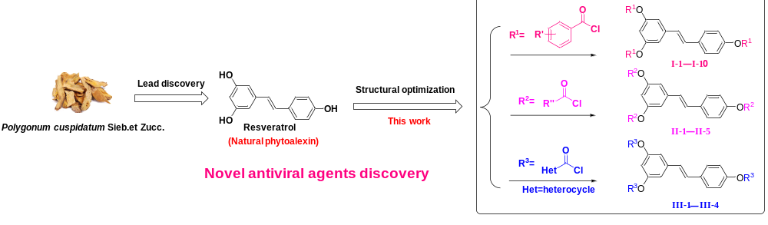Fig. 1 The design and synthesis of compounds I-1−I-10, II-1−II-5 and III-1−III-4.
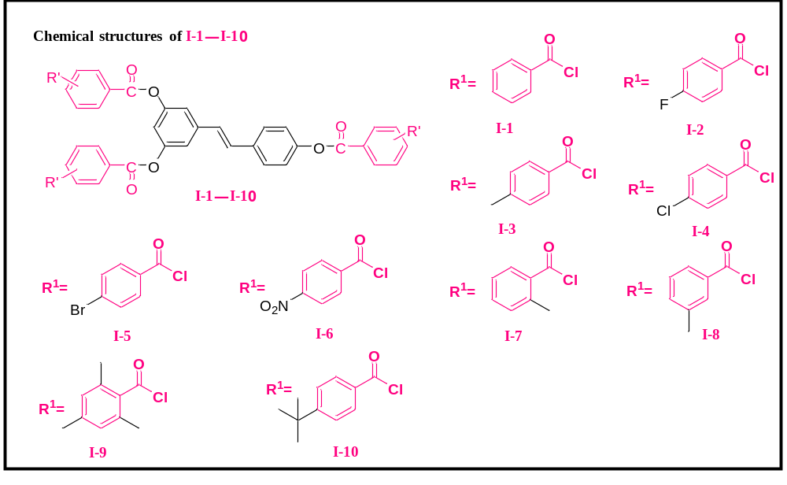 Fig. 2 Chemical structures of I-1−I-10.
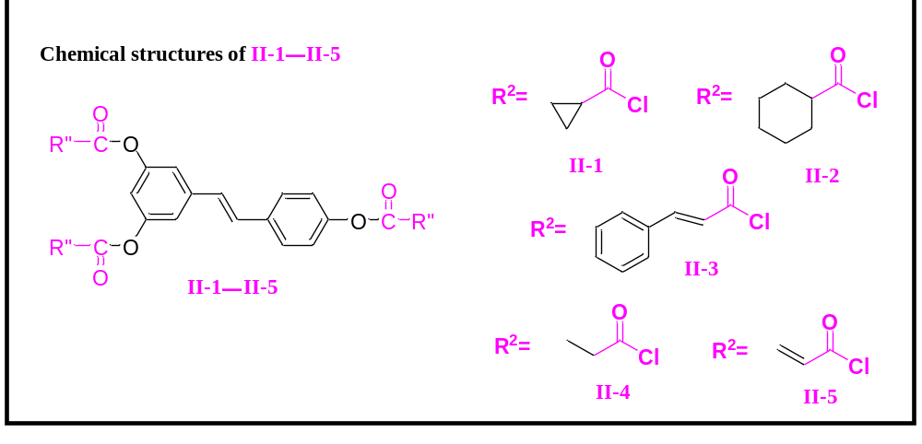
Fig. 3 Chemical structures of II-1−II-5.
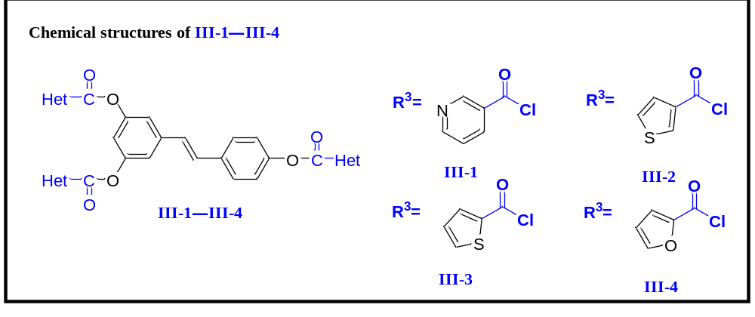 Fig. 4 Chemical structures of III-1−III-4.
¹H NMR spectrum and ¹³C NMR spectrum of target compounds
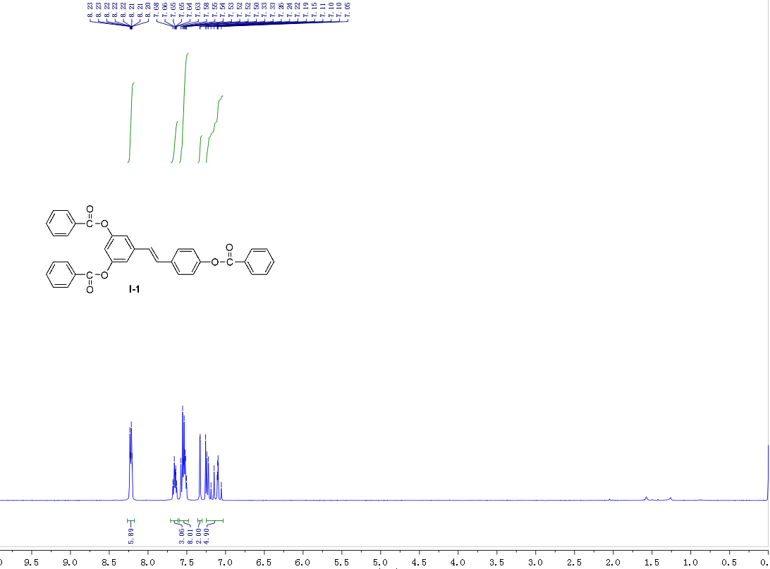
Fig. 5 ¹H NMR spectrum of I-1
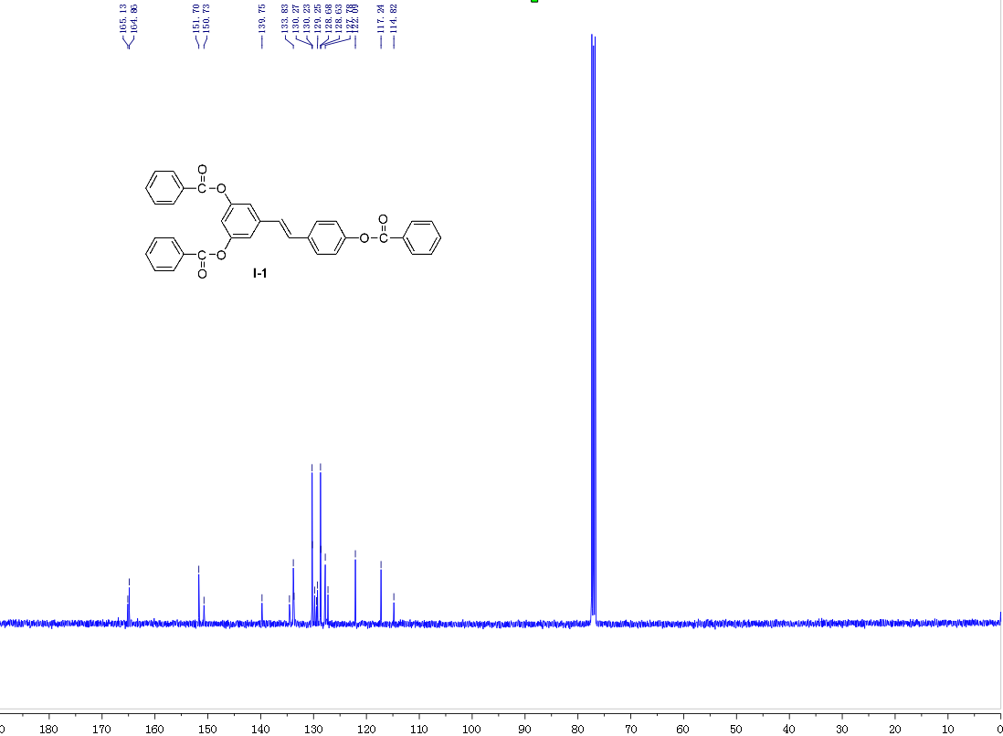
Fig. 6 ¹³C NMR spectrum of I-1
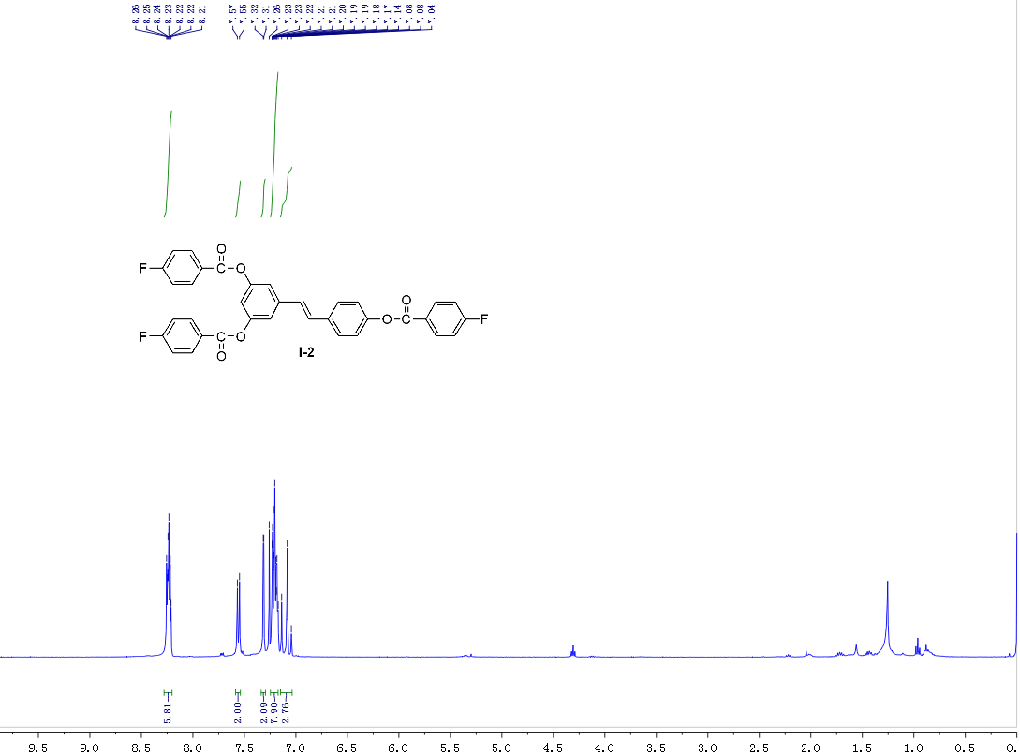
Fig. 7 ¹H NMR spectrum of I-2
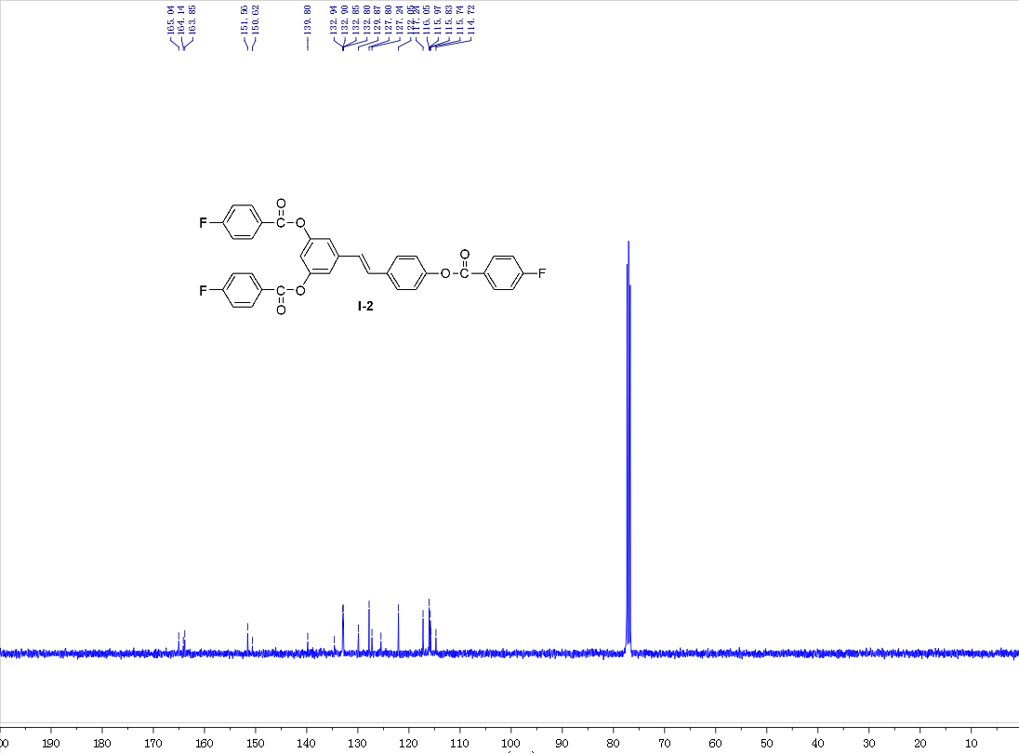
Fig. 8 ¹³C NMR spectrum of I-2
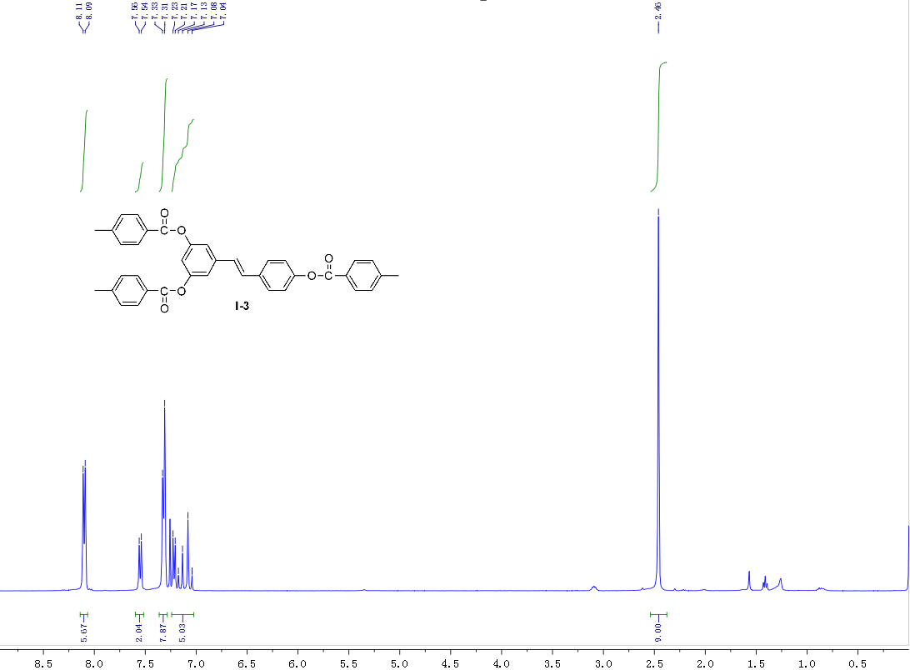
Fig. 9 ¹H NMR spectrum of I-3
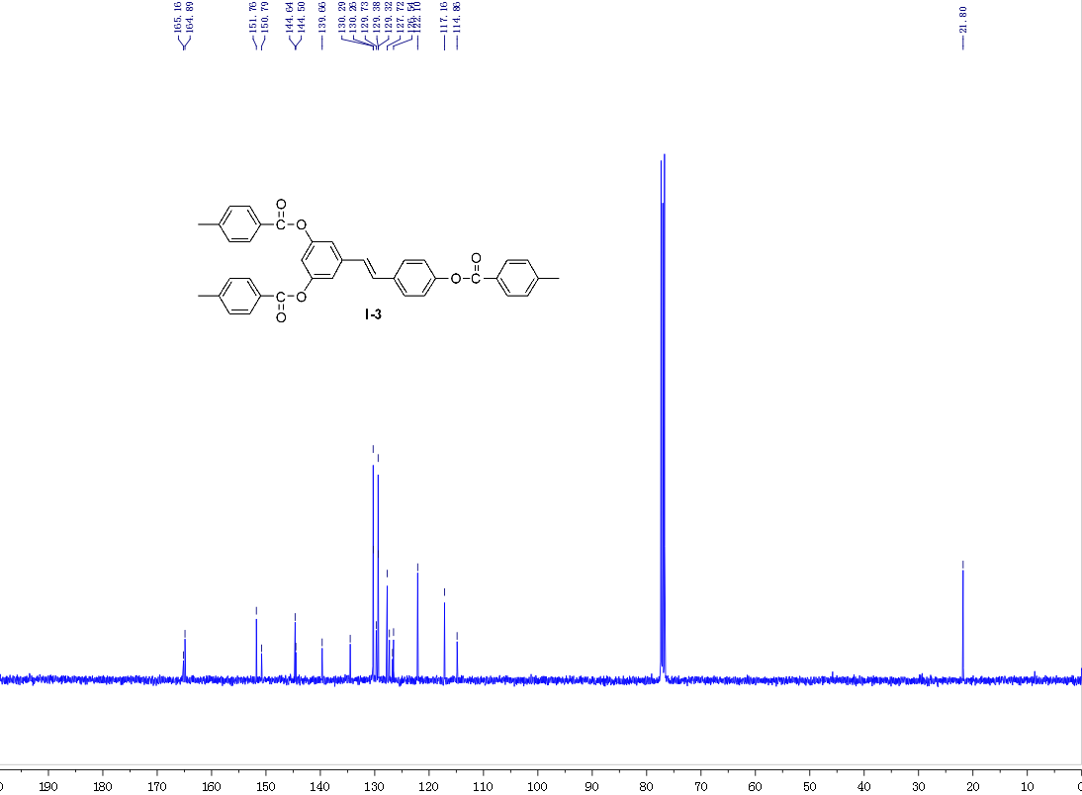
Fig. 10 ¹³C NMR spectrum of I-3
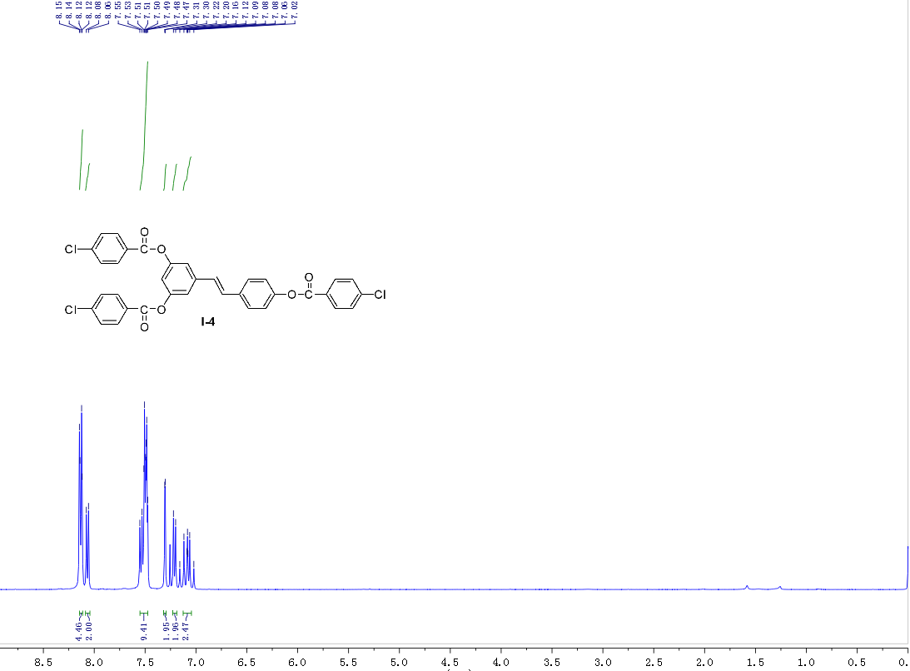
Fig. 11 ¹H NMR spectrum of I-4
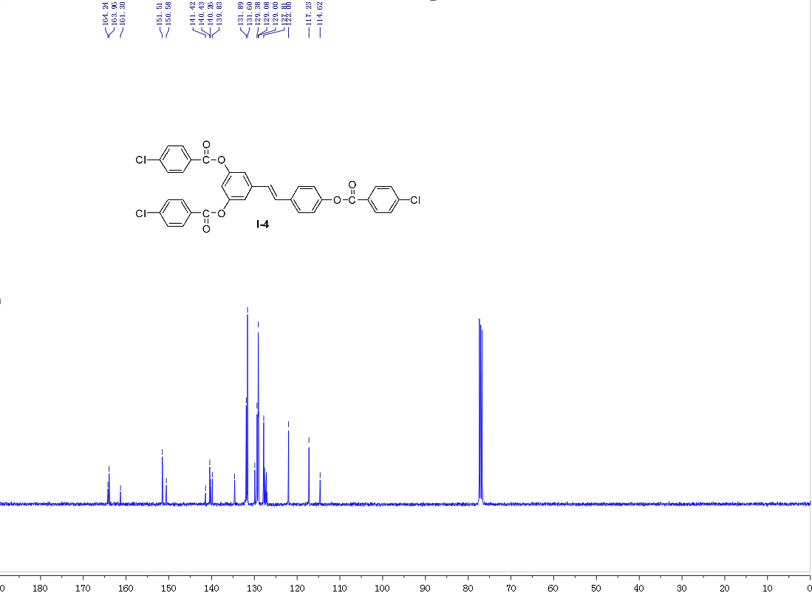
Fig. 12 ¹³C NMR spectrum of I-4
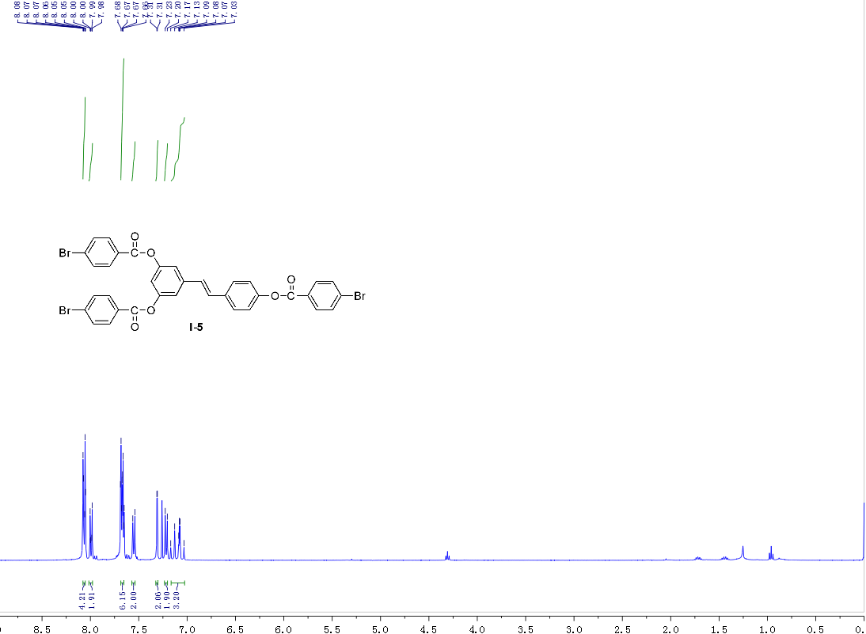
Fig. 13 ¹H NMR spectrum of I-5
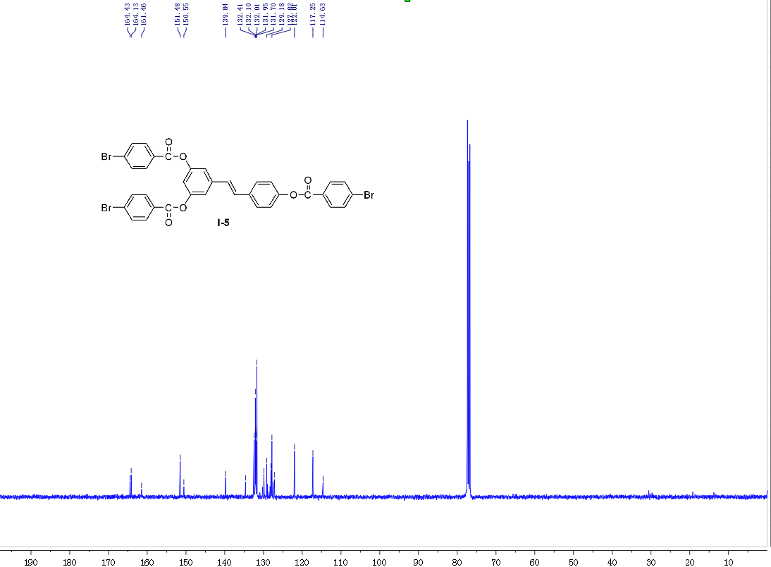
Fig. 14 ¹³C NMR spectrum of I-5
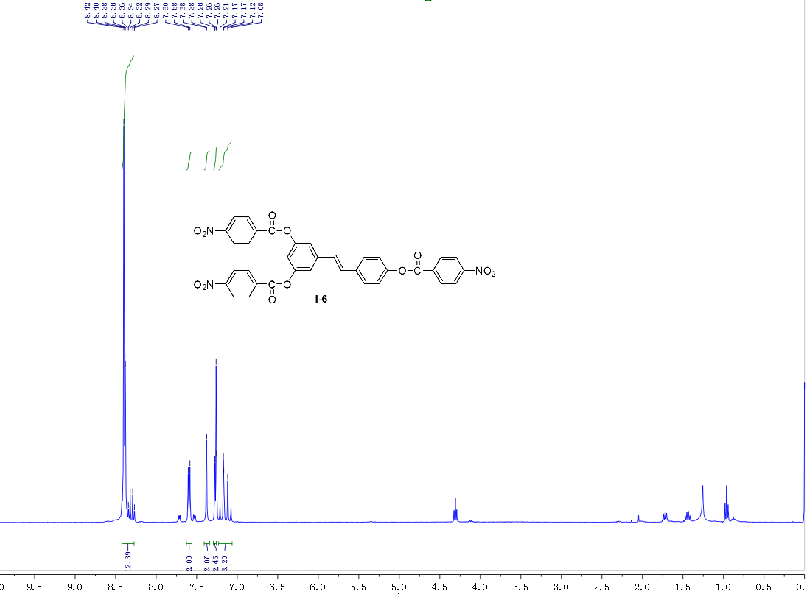
Fig. 15 ¹H NMR spectrum of I-6
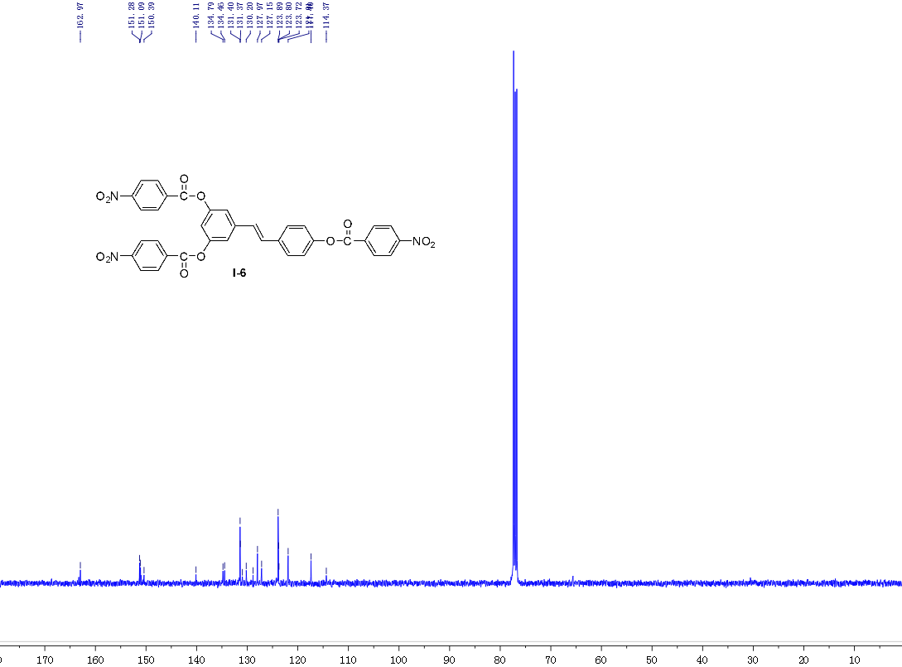
Fig. 16 ¹³C NMR spectrum of I-6
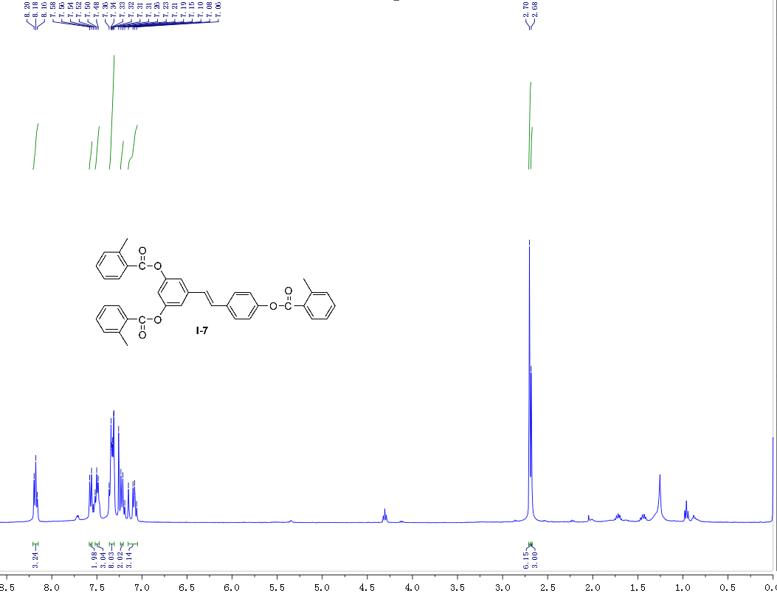
Fig. 17 ¹H NMR spectrum of I-7
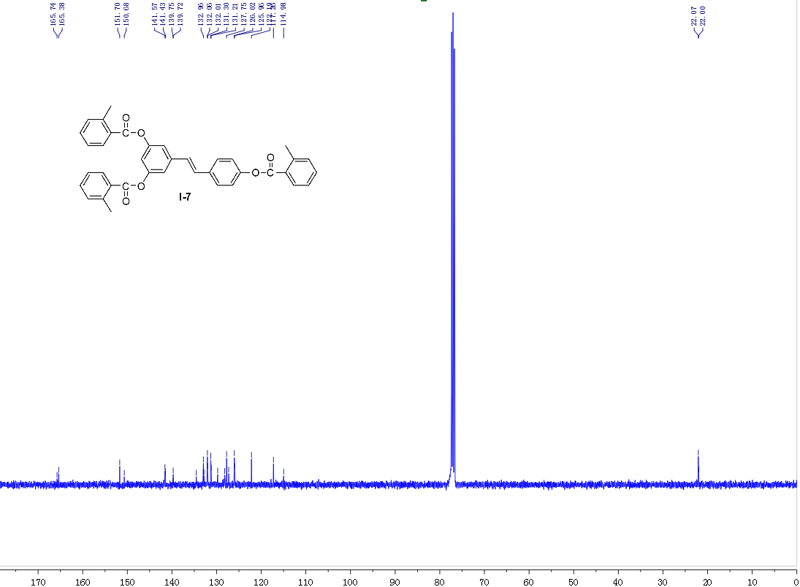
Fig. 18 ¹³C NMR spectrum of I-7
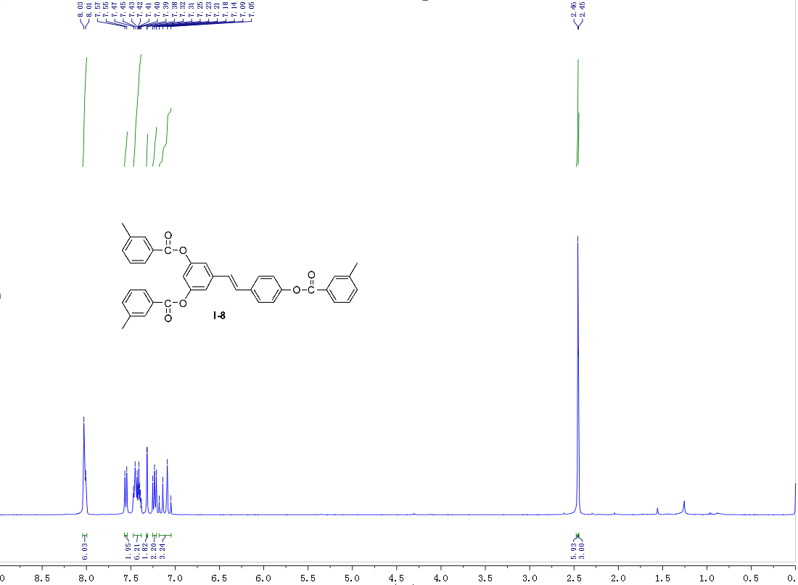
Fig. 19 ¹H NMR spectrum of I-8
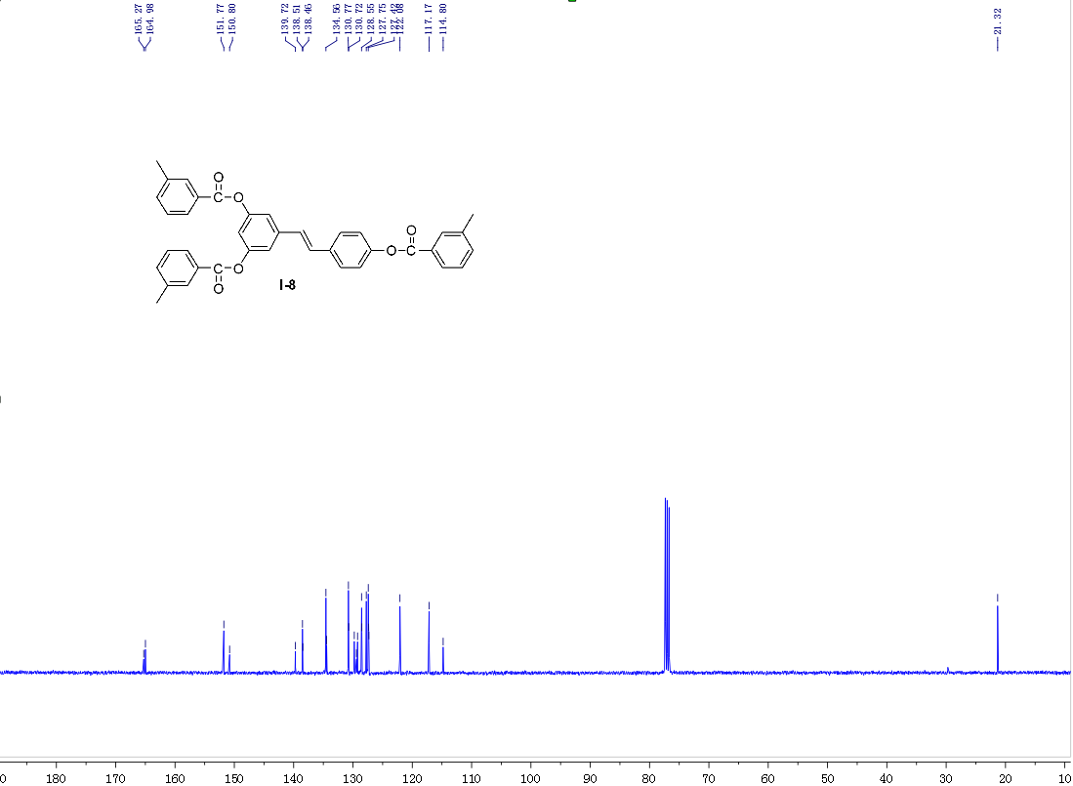
Fig. 20 ¹³C NMR spectrum of I-8
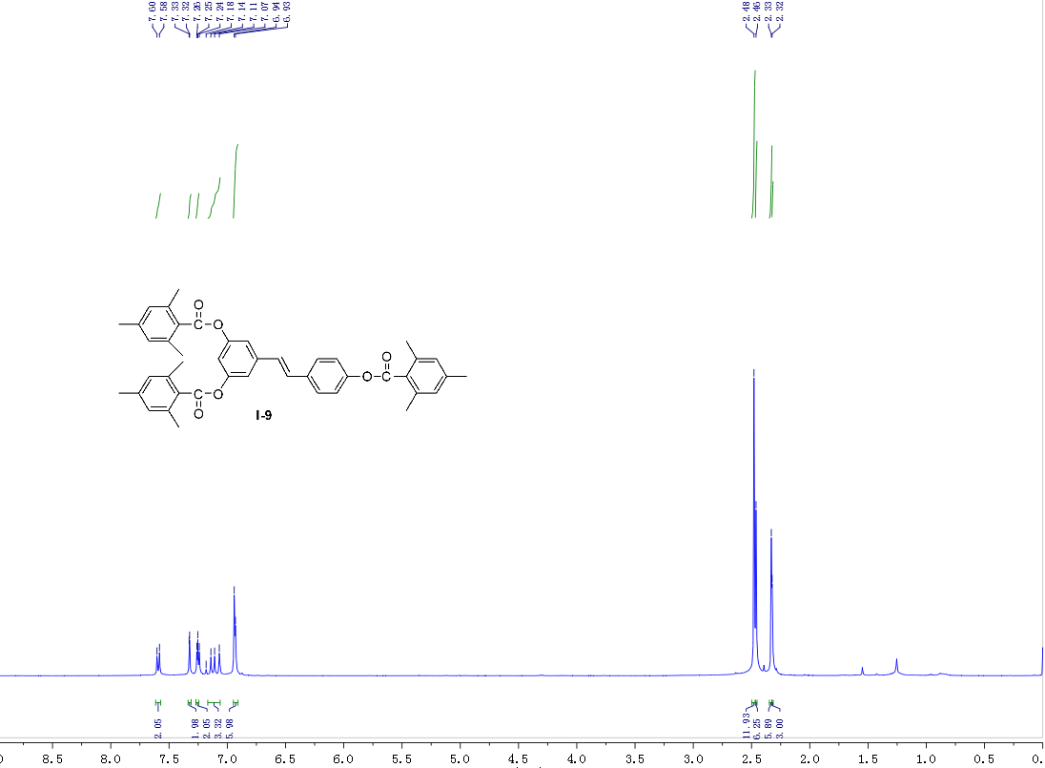
Fig. 21 ¹H NMR spectrum of I-9
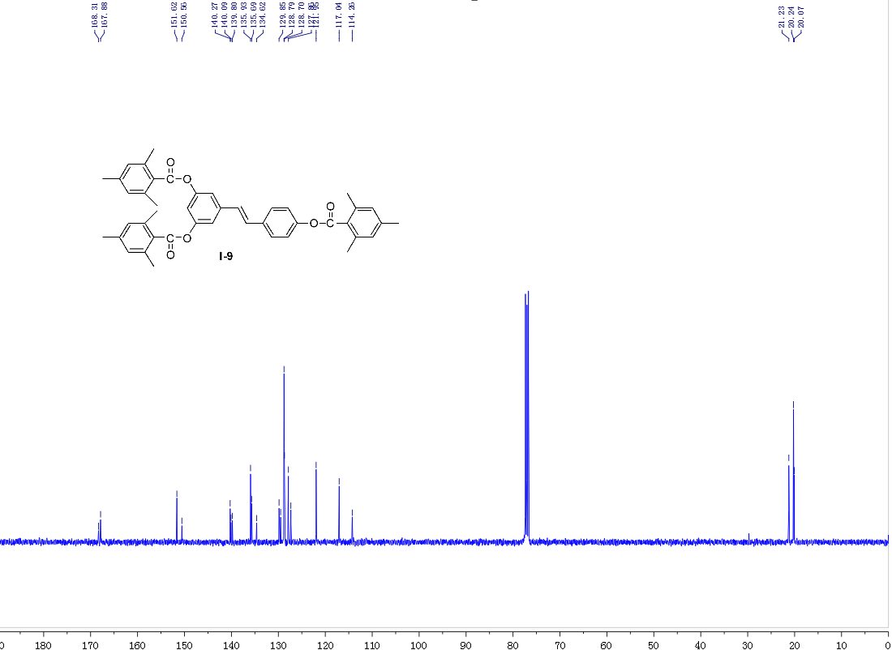
Fig. 22 ¹³C NMR spectrum of I-9
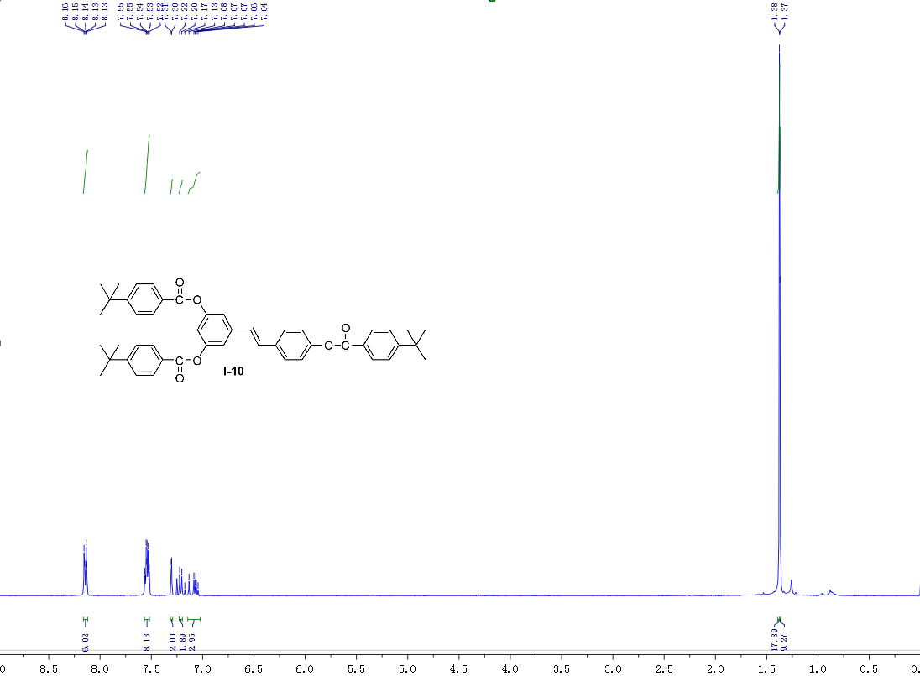
Fig. 23 ¹H NMR spectrum of I-10
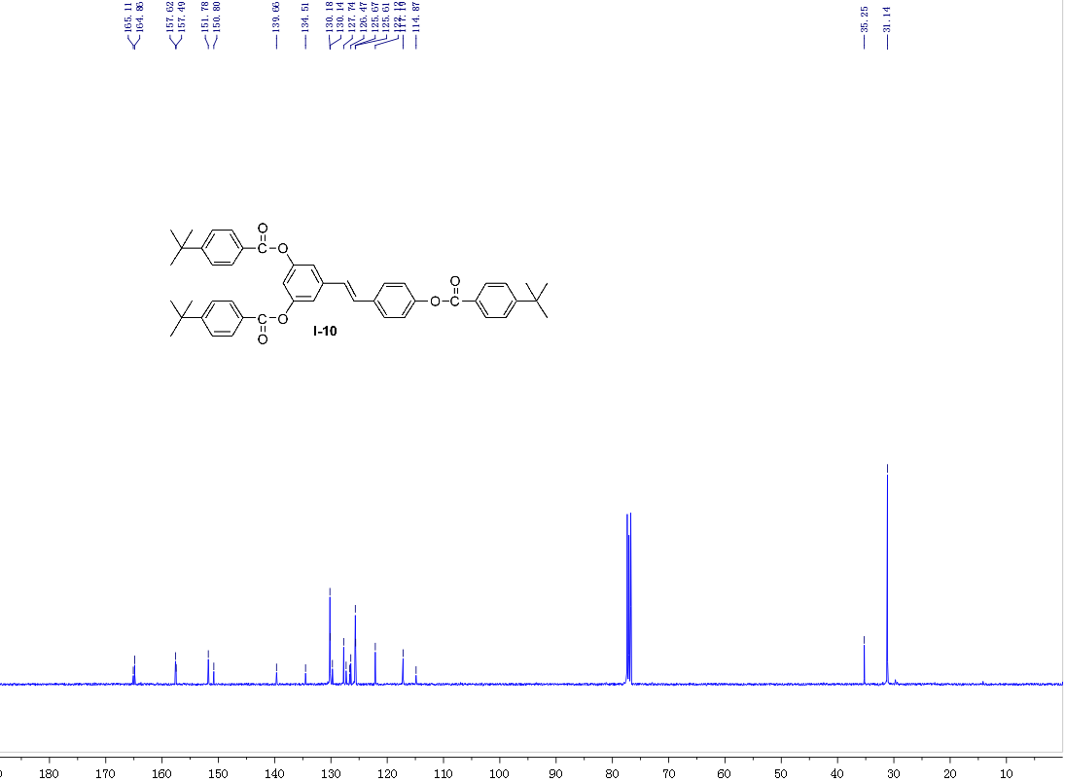
Fig. 24 ¹³C NMR spectrum of I-10
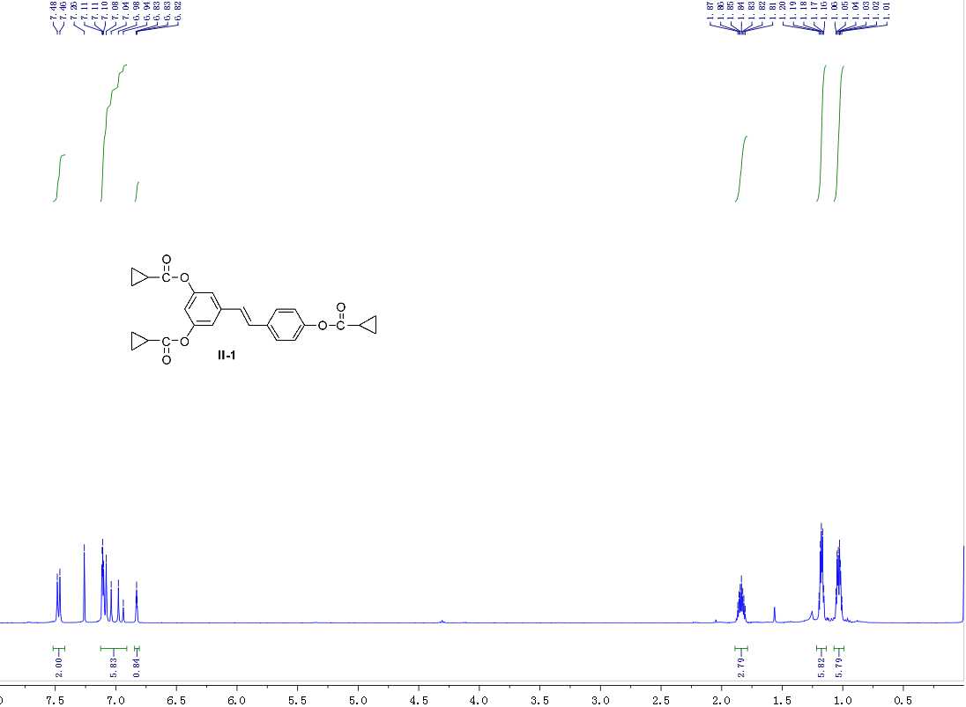
Fig. 25 ¹H NMR spectrum of II-1

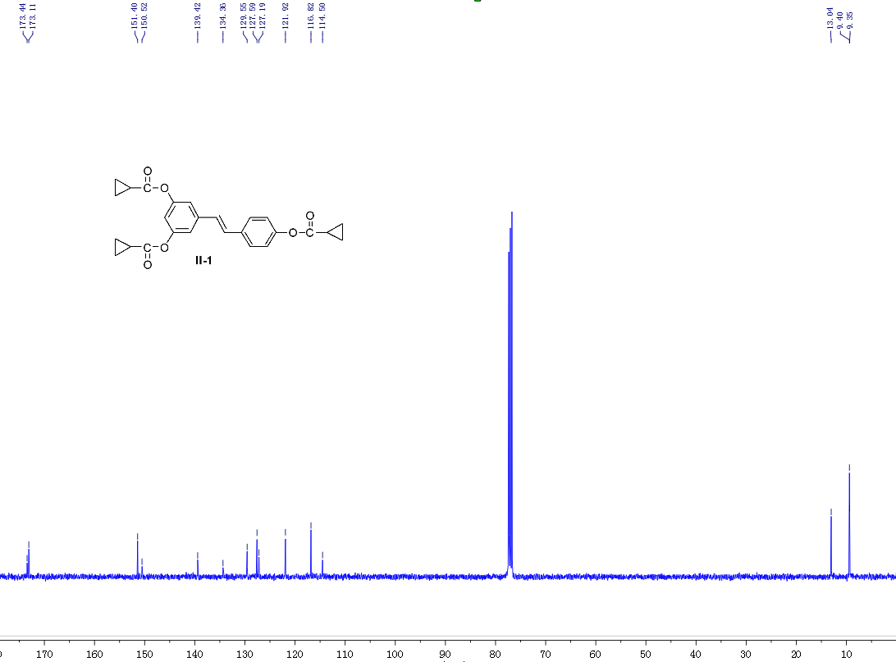
Fig. 26 ¹³C NMR spectrum of II-1
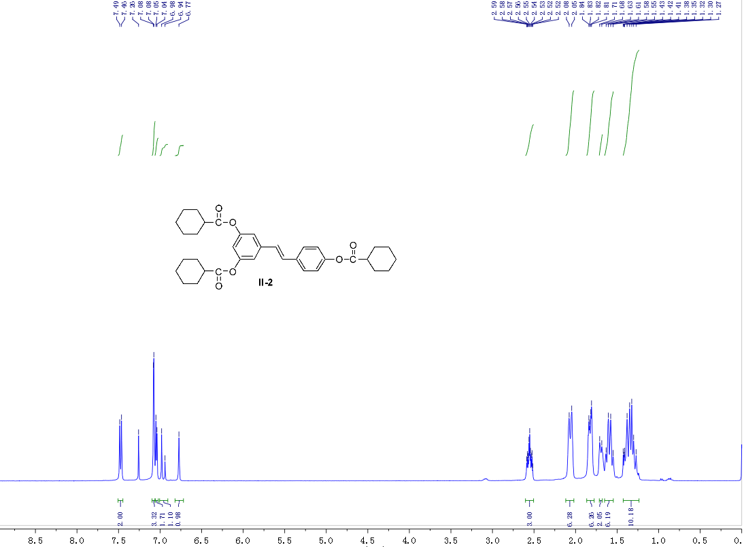
Fig. 27 ¹H NMR spectrum of II-2
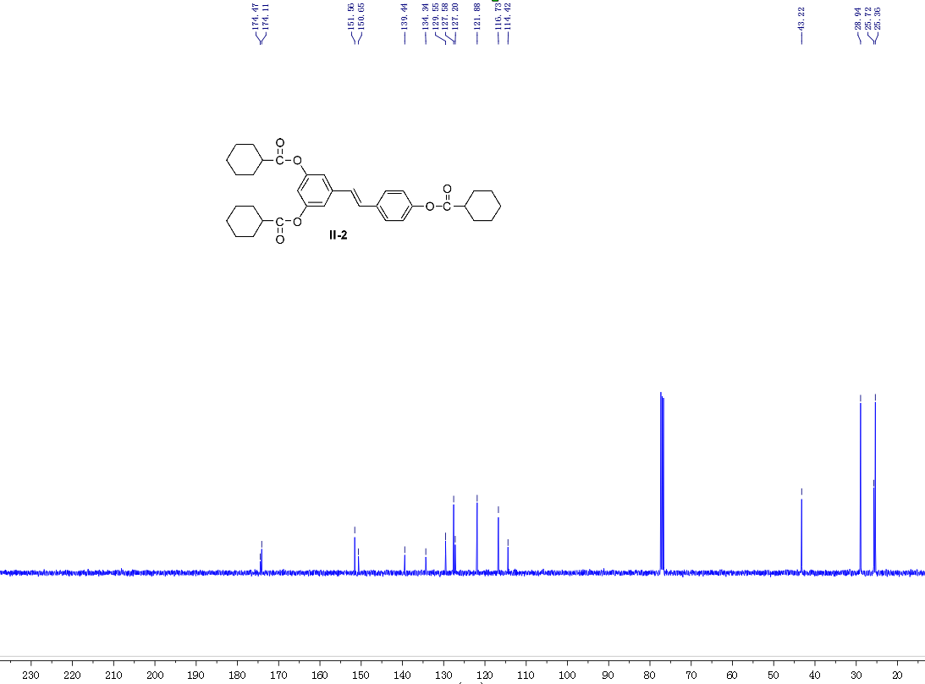
Fig. 28 ¹³C NMR spectrum of II-2
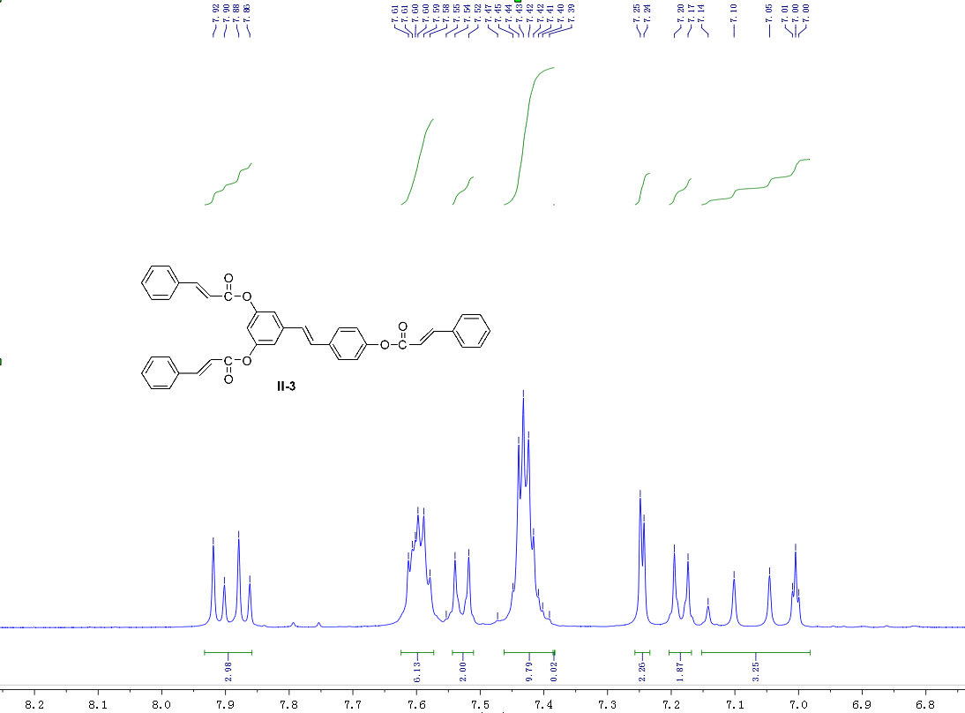
Fig. 29 ¹H NMR spectrum of II-3
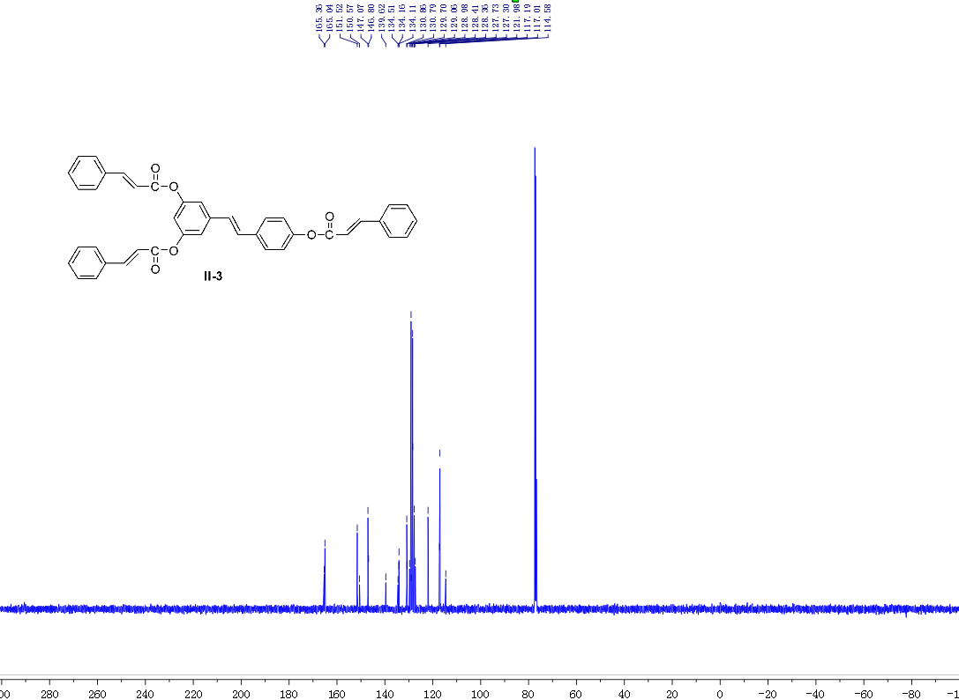
Fig. 30 ¹³C NMR spectrum of II-3
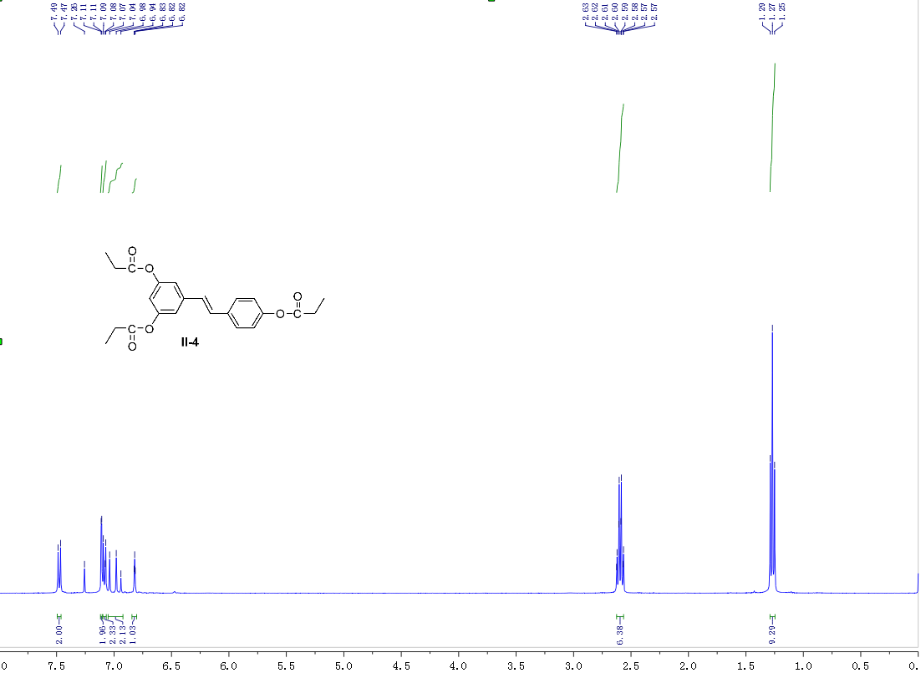
Fig. 31 ¹H NMR spectrum of II-4
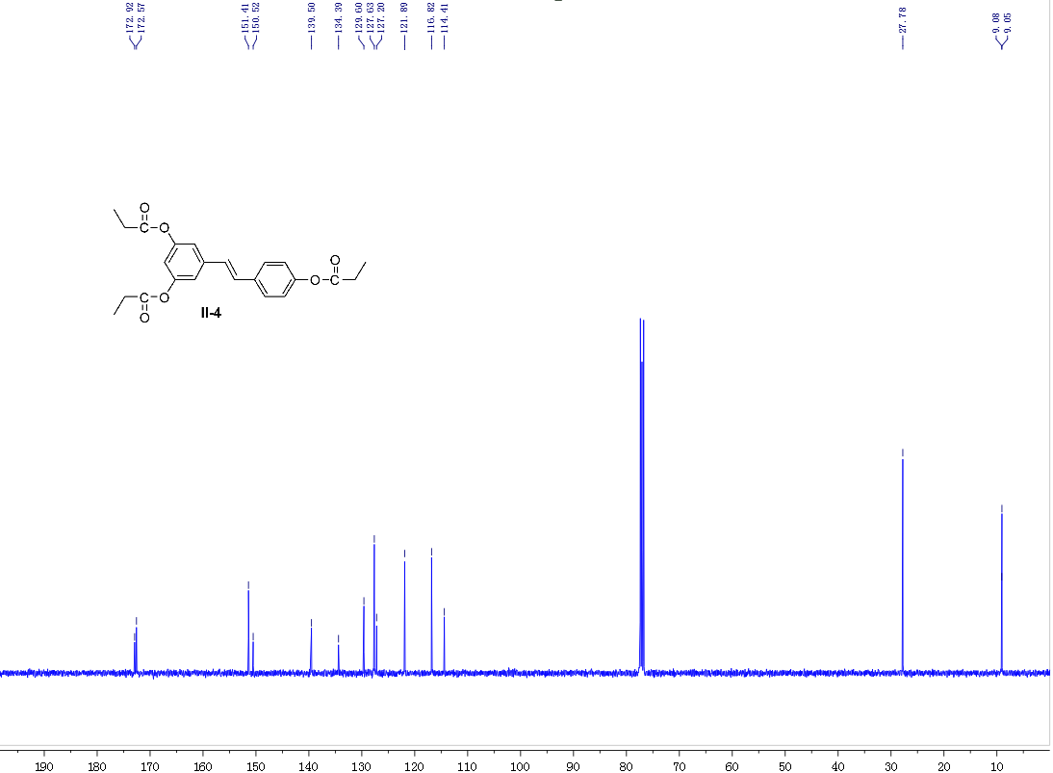
Fig. 32 ¹³C NMR spectrum of II-4
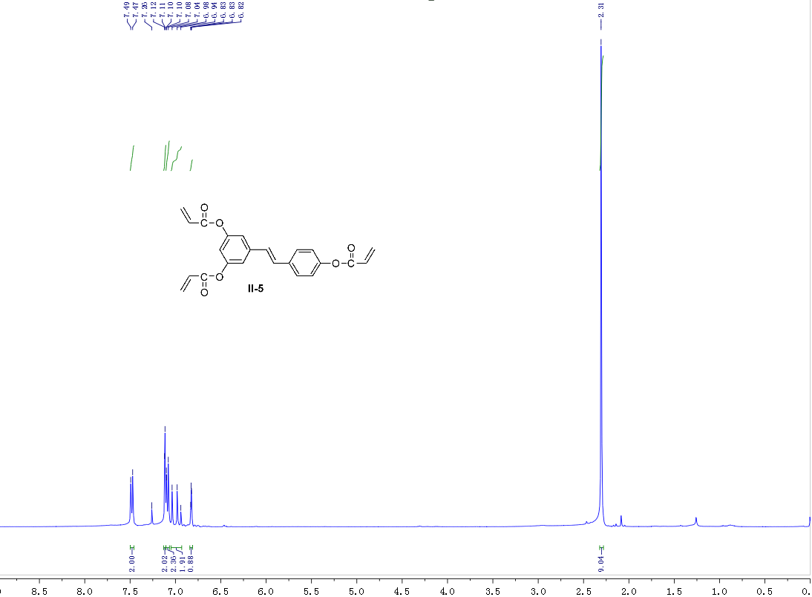
Fig. 33 ¹H NMR spectrum of II-5
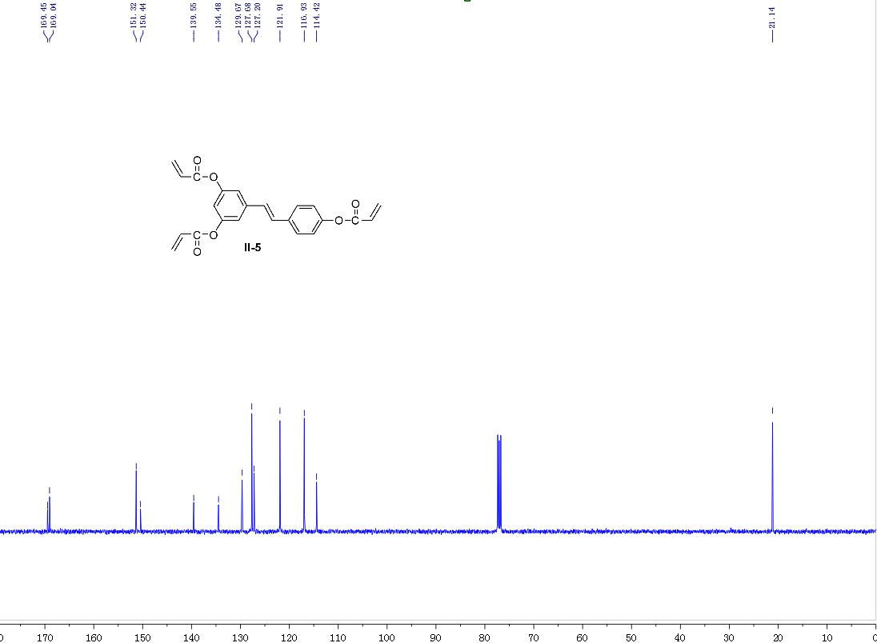
Fig. 34 ¹³C NMR spectrum of II-5
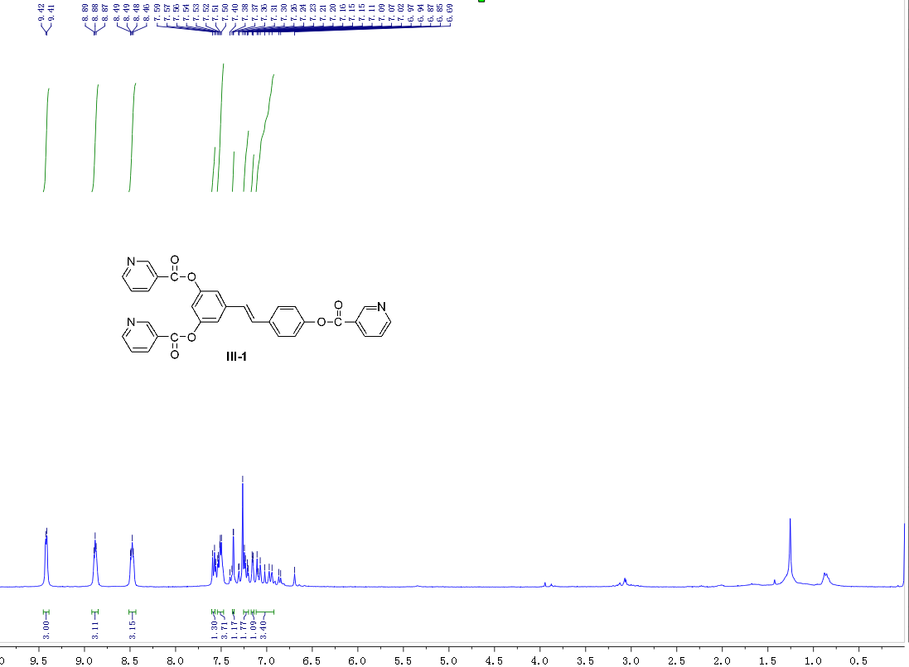
Fig. 35 ¹H NMR spectrum of III-1
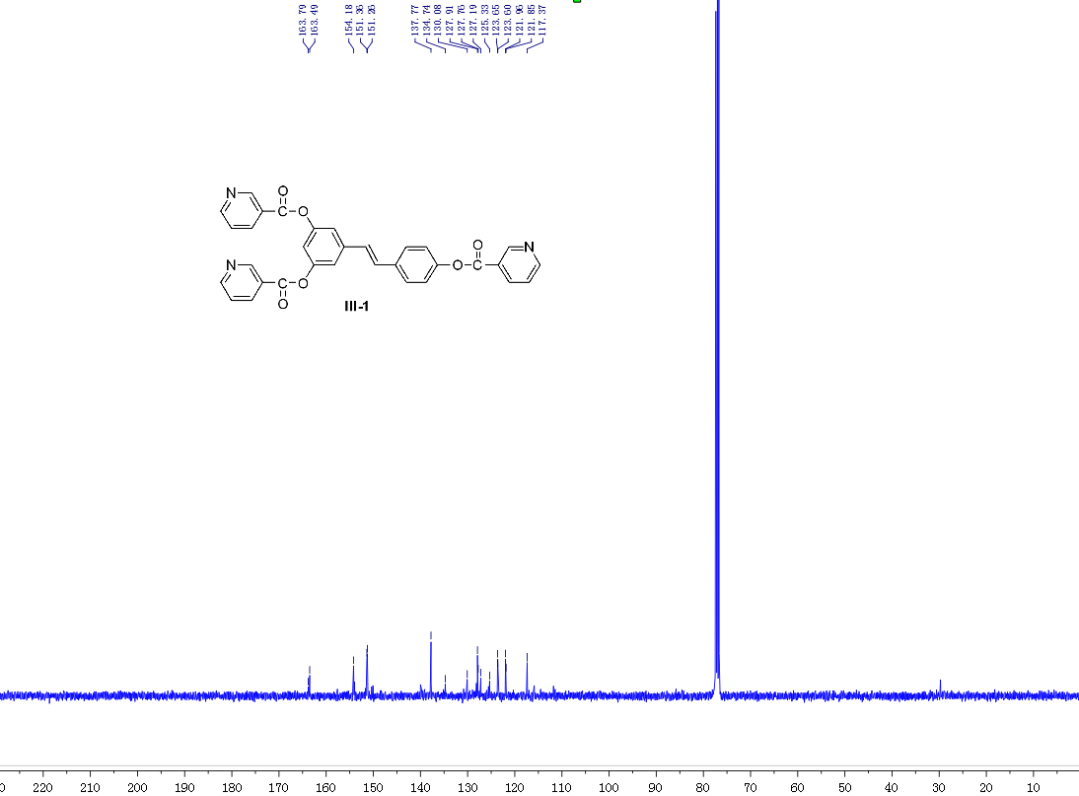
Fig. 36 ¹³C NMR spectrum of III-1
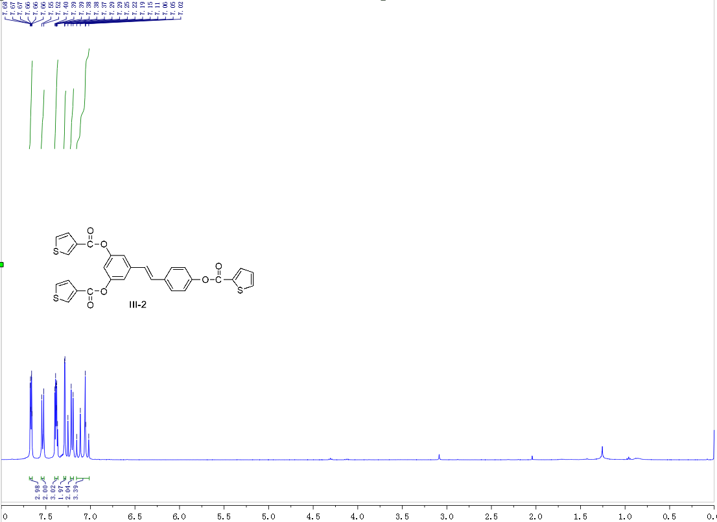
Fig. 37 ¹H NMR spectrum of III-2
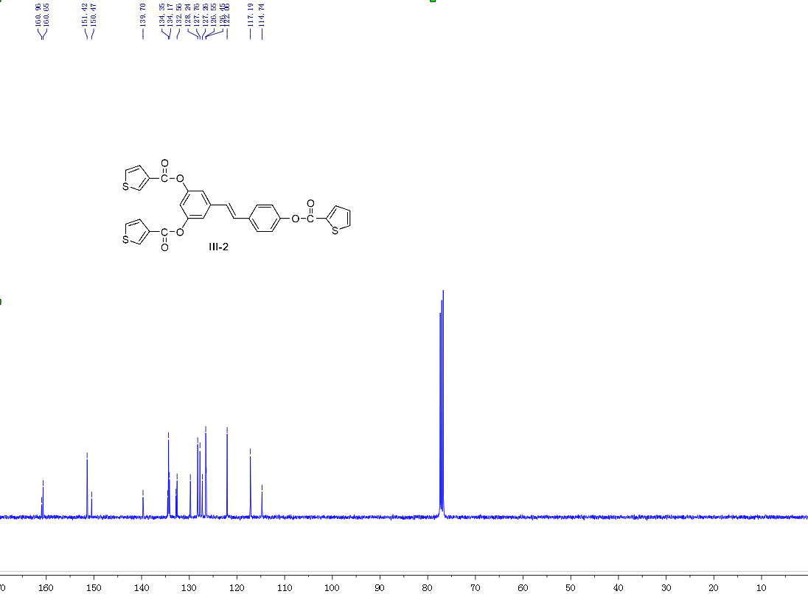
Fig. 38 ¹³C NMR spectrum of III-2
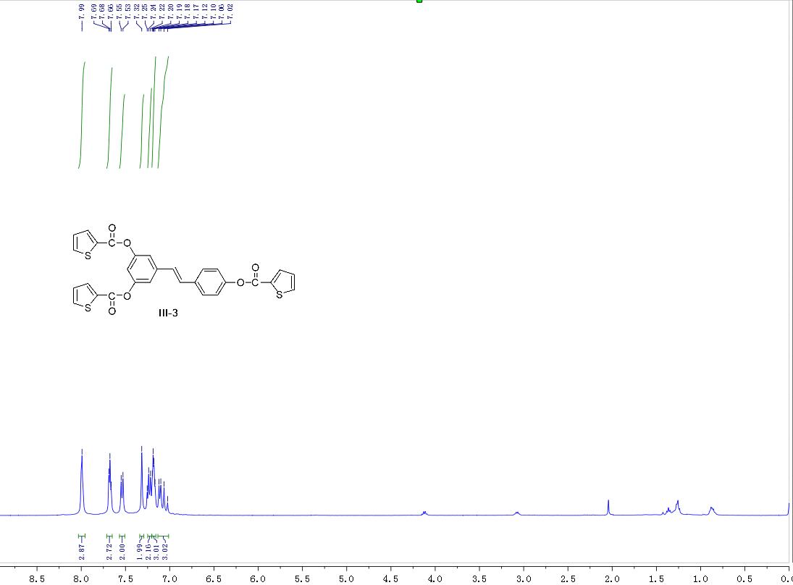
Fig. 39 ¹H NMR spectrum of III-3
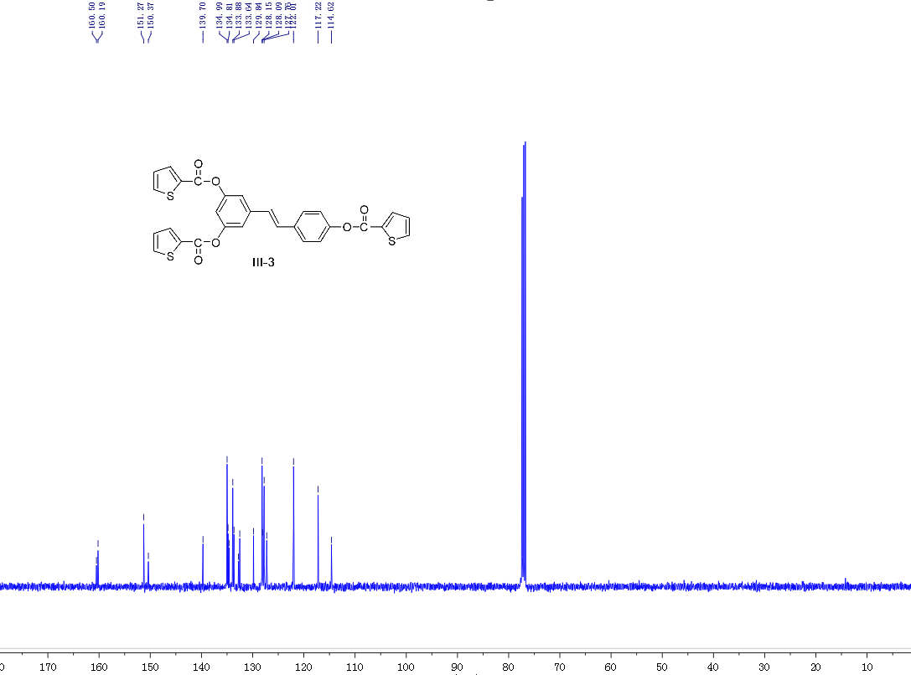
Fig. 40 ¹³C NMR spectrum of III-3
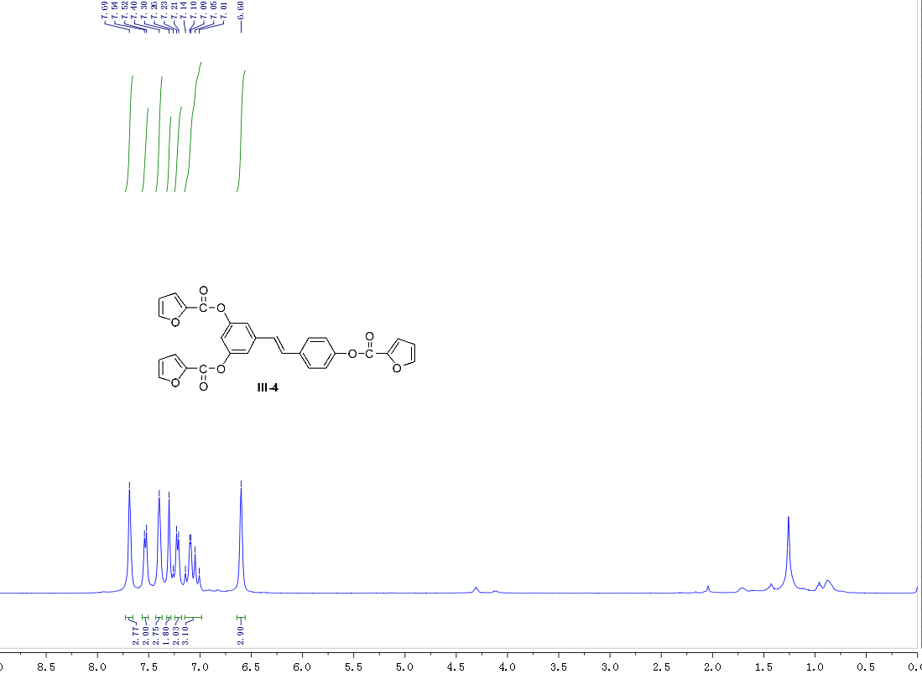
Fig. 41 ¹H NMR spectrum of III-4
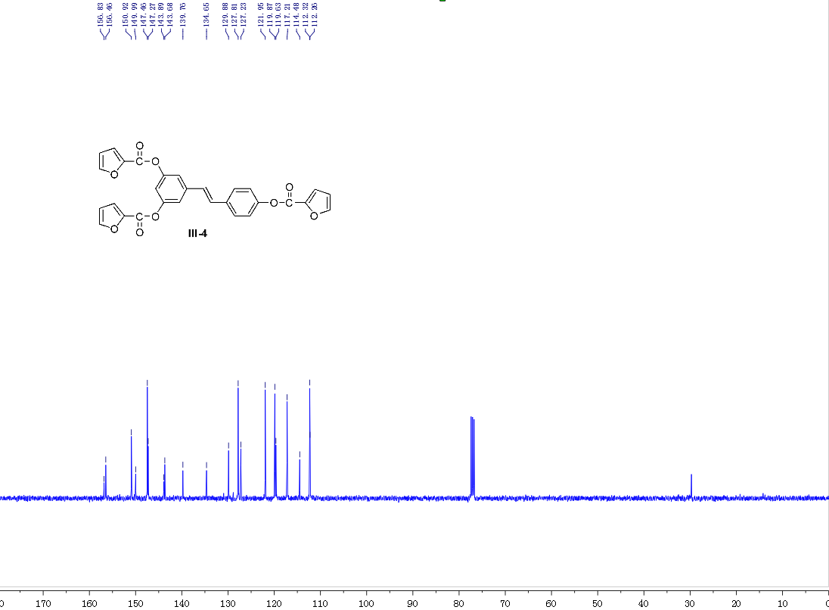
Fig. 42 ¹³C NMR spectrum of III-4
Biological assay
Detailed bioassay procedures for the anti-TMV activities. Compound solution preparation: Test compound was dissolved within a suitable amount of N,N-dimethyl formate and diluted with water containing 0.1% TW-80 to make a concentration of 500 μg/mL, and the aqueous solution was diluted to 100 μg/mL.
Antiviral Activity of Compounds against TMV in Vitro. Fresh leaf of the 5−6 growth stage of tobacco (N. tabacum L.) inoculated by the juice-leaf rubbing method (concentration of TMV was 6 × 10⁻³ μg/mL) was cut into halves along the main vein. The halves were immersed into the solution of test compounds and solvent (double-distilled water containing 0.1% TW-80) for 30 min, respectively, and then cultured at 25 °C for 72 h. The local lesion numbers were then counted. Each compound was replicated at least 3 times.
Protective Effect of Compounds against TMV in Vivo. The compound solution was smeared on the growing N. tabacum L. leaves of the same ages. Another pot was smeared with solvent for control. After 12 h, the leaves were inoculated by the juice-leaf rubbing method and then washed with water. The local lesion numbers appearing 3−4 days after inoculation were counted. There were three replicates for each compound.
Inactivation Effect of Compounds against TMV in Vivo. The virus was inhibited by mixing with the compound solution at the same volume for 30 min. The mixture was then inoculated on the growing leaves of the same ages, whereas another pot was inoculated with the mixture of solvent and the virus for control. The local lesion numbers were recorded 3−4 days after inoculation. There were three replicates for each compound.
Curative Effect of Compounds against TMV in Vivo. TMV (concentration of 6.0 × 10⁻³ mg/mL) was inoculated on the growing leaves of N. tabacum L. of the same ages. Then, the leaves were washed with water and dried. The compound solution was smeared on the leaves, whereas another pot was smeared with solvent for control. The local lesion numbers were then counted and recorded 3−4 days after inoculation. There were three replicates for each compound.
The in vitro and in vivo inhibition rates of the compound were then calculated according to the following formula (“av” means average, and controls were not treated with compound):
inhibition rate (%) = [(av local lesion number of control − av local lesion number of drugtreated)/av local lesion number of control] × 100%.
Detailed bioassay procedures for the fungicidal activities. The compounds were evaluated in mycelial growth tests in artificial media against 14 plant pathogens at rate of 50 mg L⁻¹. Test compound was dissolved within a suitable amount of acetone and diluted with water containing 0.1% TW-80 to the concentration of 500 mg L⁻¹. To each petri dish was added 1 mL such solution and 9 mL culture medium to make a 50 mg L⁻¹ of medicated tablet, whereas to another petri dish was added 1 mL sterilized water and 9 mL culture medium as blank control. A diameter of 4 mm of hyphae was cut by a hole puncher along the hyphae for bacteria to the outer plate and moved to the medicated tablet. Each treatment was performed three times. The dishes were stored in controlled environment cabinets (24±1°C) for 48 h, after which the diameter of mycelia growth was investigated and percentage inhibition was calculated.
Percentage inhibition (%) = (averaged diameter of mycelia in blank controls – averaged diameter of mycelia in medicated tablets) / averaged diameter of mycelia in blank controls
Detailed bioassay procedures for the insecticidal activities.
Larvicidal Activities against oriental armyworm (Mythimna separata), cotton bollworm (Helicoverpa armigera), corn borer (Ostrinia nubilalis):
Stock solutions of each test compound was prepared in dimethylformamide at a concentration of 600 mg L⁻¹ and then diluted to the required concentration (200, 100, 50, 25, 10, 5, 2, and 1 mg L⁻¹) with water containing TW-20.
Leaf-dip method was used. Leaf discs (5 cm × 3 cm) were cut from fresh cabbage leaves (or other leaves) and then dipped into the test solution for 3 s. After air-drying, the treated leaf discs were placed individually into vertical tube (or Petri dishes) and the discs were infested with 10 larvae (for example: 10 second-instar diamondback moth larvae, 10 fourth-instar oriental armyworm larvae). Percentage mortalities were evaluated 3 days after treatment.
Evaluations were based on a percentage scale of 0–100, where 0 equals no activity and 100 equals total kill. Each treatment was performed three times. Error of the experiments was about 5%.
Larvicidal Activities against Mosquito (Culex pipiens pallens). 20 fourth-instar mosquito larvae were put into the 10 mL of the test solution. Percentage mortalities were evaluated 8 days after treatment.
Evaluations were based on a percentage scale of 0–100, where 0 equals no activity and 100 equals total kill. Each treatment was performed three times. Error of the experiments was about 5%.

