Supplementary Figure 1: STARD7 deficiency leads to transcriptional reprogramming. Real-Time PCR analyses were conducted with total RNAs from control and STARD7-depleted T47D cells. The expression of each candidate in control cells was set to 1 and levels in cells lacking STARD7 was relative to that after normalization with GAPDH mRNA levels (mean +/- SD, one-way ANOVA, * = p <0.05, ** = p < 0.01, *** = p < 0.001).

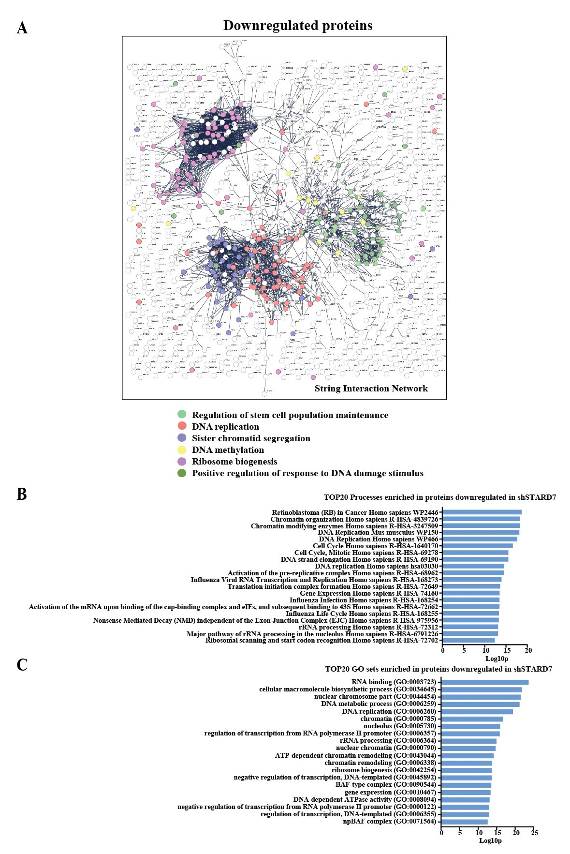
Supplementary Figure 2: STARD7 deficiency decreases levels of proteins linked to cell cycle progression. A string Interaction Network (A) and the top 20 processes and GO sets (C and B, respectively) enriched in breast cancer cells lacking STARD7 are illustrated.

Supplementary Figure 3: A ciliogenesis signature is linked to STARD7 deficiency in breast cancer cells. Real-Time PCR analyses were conducted with total RNAs from control and STARD7-depleted MCF7 or MDA-MB231 cells. The expression of each candidate in control cells was set to 1 and levels in cells lacking STARD7 was relative to that after normalization with GAPDH mRNA levels (mean +/- SD, one-way ANOVA, * = p <0.05, ** = p < 0.01, *** = p < 0.001).

Supplementary Figure 4: STARD7-depleted breast cancer cells undergo autophagy. Representative immunofluorescence analyses of control and STARD7-depleted MCF7 cells (shRNA Control and ShRNA STARD7#2) after an overnight treatment with Chloroquine (15 μM). Anti-LAMP1 (red) and -LC3B stainings were carried out. DAPI was used to for nuclei stainings. The bar graph shows a quantitative analysis of cells undergoing autophagy. The quantification shows the percentage of cells with more that 10 co-localized points to the total number of analysed cells (mean +/- SD, Student T-test, ** = p < 0.01).

