Supplementary information
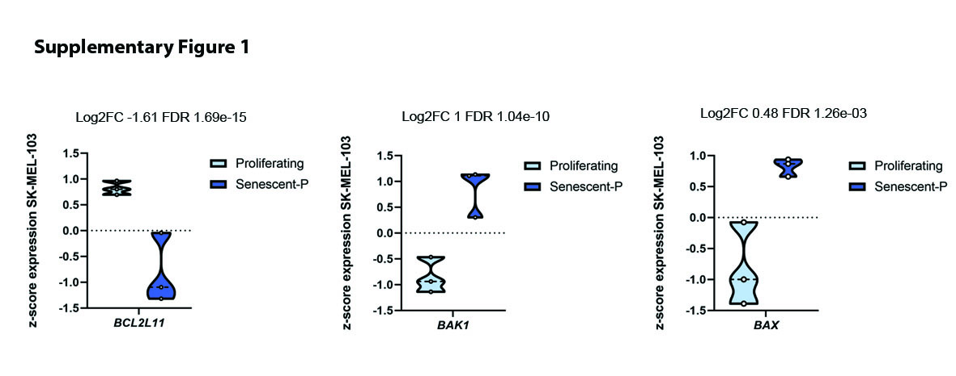
Supplementary Figure 1. Changes in protein levels in palbociclib-induced senescent SK-MEL-103 cells are due to changes in gene expression. Z-score values for BCL2L11 (BIM), BAK1 (BAK) and BAX in proliferating and palbociclib-induced senescent (senescent-P) SK-MEL-103 cells.
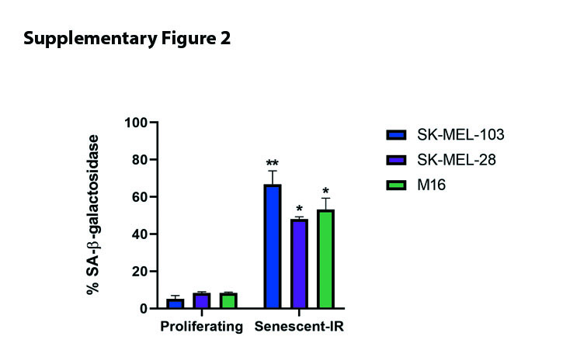
Supplementary Figure 2. SA-β-galactosidase expression in irradiated-induced senescent melanoma cells. Quantification of SA-β-galactosidase expression after 10Gy irradiation of melanoma cells by flow cytometry. Values indicate mean values ± SEM from at least three independent experiments. ** p<0.01, *p < 0.05 compared to control.

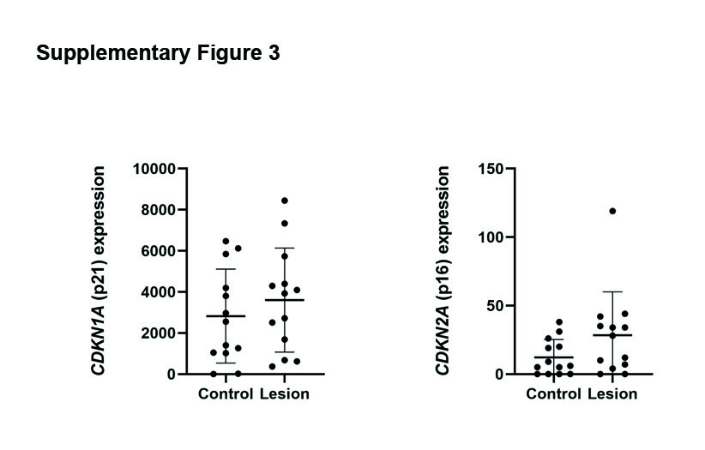
Supplementary Figure 3. Increased trend of CDKN1A (p21) and CDKN2A (p16) mRNA expression in photodamaged skin. mRNA expression of CDKN1A (p21) and CDKN2A (p16) in control and lesioned skin from healthy donors.

