Supplementary information for

2D Crystalline Monolayer Nanosheets Produced from 1D-Amorphous Metal-Organic Framework
Jiahui Wang, ^{1†} Pengfei Yang,^{1†} Lingmei Liu,^{2†} Bin Zheng,³ Jing Jiang,¹ Jian-ping Ma,⁴ Yi Yan,¹ Song Yang,³ Bin Lin,⁵ Luo Yang,⁶ Qi-Kui Liu,^{4*} Yu Han,² Yin Chen^{1,7*}

Methods

Synthesis of Bicyclocalix[2]arene[2]triazines tricarboxylic acid (BCTA):
BCTA was synthesized via the synthetic route as shown in scheme S1.⁴³

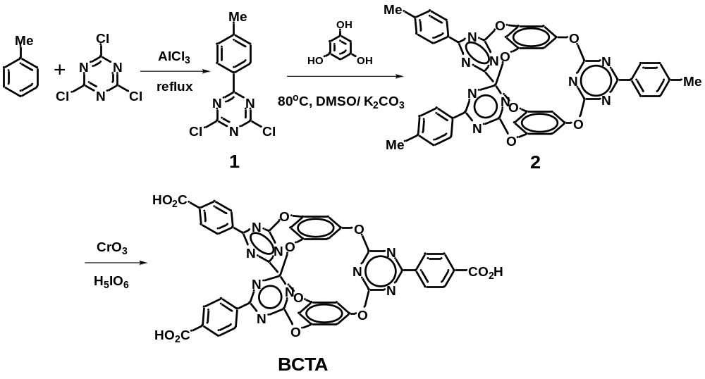
Scheme S1: The synthesis of BCTA.

Synthesis of compound 1：Cyanuric chloride(9.3g, 50mmol), anhydrous AlCl₃ (8.1g, 60mmol) and chlorobenzene (70ml, or bromobenzene 150ºC, toluene r.t.) were added to a 250ml single neck flask, the mixture was refluxed for 12 h until no more HCl gas released. Then, the mixture was cooled down and quenched by ice, the product was extracted by CH₂Cl₂ (60ml*3). The extract was boiled with charcoal and evaporated by rotating vacuum evaporator. The residue was recrystallized by the mixture of CH₂Cl₂ and petroleum ether to afford faint yellow crystal product 1 9.9g, yield 83%. m. p.: 146 ºC; MS (ESI) m/z (%) 240.0 [M+H⁺](100), 242.0 (63); ¹H NMR (300 MHz, CDCl₃) δ 8.39 (d, J = 8.4Hz, 6H), 7.33 (d, J = 8.4Hz, 6H), 2.46 (s, 3H); ¹³C NMR (75 MHz, CDCl₃) δ 174.8, 171.9, 146.0, 130.0, 130.0, 129.9, 21.9.

Synthesis of compound 2：Compound 1 (1.44g, 6mmol), phloroglucinol 0.25g(2mmol), gridded K₂CO₃ (0.84g, 6mmol) and 50ml acetone were added to a 50 ml single neck flask. The mixture was stirred at room temperature for 4 h, then another portion of phloroglucinol 0.25g(2mmol), gridded K₂CO₃ (0.84g, 6mmol) and 50 ml acetone were added and refluxed for 2 h. After filtration, the filtrate was evaporated and the residue was recrystallized by the mixture of CH₂Cl₂ and petroleum ether to afford faint yellow crystal product 2 0.64g, yield 48%. m. p. > 300 ºC; MS (MALDI-TOF) m/z (%) 754.2 [M+H⁺] (100), 755.2 (48), 756.2 (10); ¹H NMR (300 MHz, CDCl₃) δ 8.46 (d, J = 8.4Hz, 6H), 7.34 (d, J = 8.4Hz, 6H), 6.74 (s, 6H), 2.46 (s, 9H); ¹³C NMR (75 MHz, CDCl₃) δ 177.2, 173.1, 153.4, 144.8, 131.4, 129.6, 129.5, 115.2, 21.8; IR (KBr) ν 2973, 1565, 1531, 1373, 1160, 1085, 1002, 814cm⁻¹. Anal. Calcd. for C₄₂H₂₇N₉O₆: C, 66.93; H, 3.61; N, 16.73; Found: C, 67.14; H, 3.73; N, 16.61.

Synthesis of BCTA：CrO₃ (120mg, 1.2mmol), H₅IO₆ (320mg, 8.4mmol) were added to 40ml acetonitrile in a 100 ml single neck flask. After stirring for a while, the solid was dissolved, 2 (0.30g, 0.4mmol) dissolved in 10 ml acetonitrile/dichloromethane (1:1) was added to the flask dropwise in 15 min, and a yellow precipitate was generated upon the addition. The mixture was stirred for another 10 h and evaporated. The residue was washed with water and extracted with ethyl acetate, the extract was dried over Na₂SO₄ and evaporated to afford 0.29g off-white crude product with a yield of 90%. The crude product was recrystallized by the mixture of THF and acetonitrile to afford crystal product BCTA 0.30g, yield 89%. The BCTA crystal easily weathered in the air, with a BET surface area only as 5 m²/g. m. p. >300 ºC; MS (MALDI-TOF) m/z (%) 844.1 [M+H⁺] (100), 845.1 (48), 846.1 (13); ¹H NMR (300 MHz, DMSO-d₆) δ 13.36(s, 6H), 8.56 (d, J = 8.4Hz, 6H), 8.16 (d, J = 8.4Hz, 6H), 7.12 (s, 6H); ¹³C NMR (75 MHz, DMSO-d₆) δ 175.5, 173.3, 167.1, 135.4, 138.1, 135.5, 130.4, 129.4, 115.8; (Fig. S19, 20). IR (KBr) ν 3442, 1563, 1526, 1424, 1370, 1162, 1082, 1001, 814cm⁻¹. Anal. Calcd. for C₄₂H₂₁N₉O₁₂: C, 59.79; H, 2.51; N, 14.94; Found: C, 59.50; H, 2.62; N, 14.77.

Optimization of the condition of solvothermal reaction
Initial screen found that BCTA can react with MnCl₂, MnSO₄, Mn(NO₃)₂, Mn(ClO₄)₂ and Mn(CH₃CO₂)₂ to form crystals. MnCl₂ gave the best result. Other reaction conditions also have been screened, such as reaction time, reaction temperature, solvent and the volume, the amount of the Mn salt used. At 120 ºC, with MnCl₂ in ten times excess, MOFs can be prepared with the best yield in corresponding solvent after 72 h reaction (Table S1).

Table S1. Screen of the crystal growing condition
Entry | Solvent(1.5mL) | T/ºC | Tine/h | Result
1 | THF | 120 | 72 | Rod crystal
2 | MeOH | 120 | 72 | Yellow solution
3 | MeCN | 120 | 72 | White precipitate
4 | DMF | 120 | 72 | Cluster crystal
5 | DMF:H₂O(1:1) | 120 | 72 | Yellow solution

Preparation of IPM-1:
A mixture of ligand (5 mg, 5.9×10⁻⁶ mol) and MnCl₂·4H₂O(10 mg，5.05×10⁻⁵ mol) in 1.5 mL dimethylformamide (DMF) was sealed in a Schlenk tube and heated to 120 ºC at a rate of 1 ºC/min. After staying at 120 ºC for 72 h, it was cooled to room temperature at a rate of 0.1 ºC/min. The resulting colorless crystals were washed with DMF twice to afford IPM-1.
In a big sealed Schlenk flask, several grams of IPM-1 can be prepared in one batch with simplified reaction conditions.

Preparation of IPM-1 nanosheet suspension
The IPM-1 crystal was immersed in mixed ethanol/i-propanol (1:1) for 1-2 days, then treated by a JY96-IIN ultrasonic cell disrupter with a 100 W ultrasonic generator for 3 h (The ultrasonic generator worked for 3 seconds in every 10 seconds). A milk white nanosheet suspension was obtained. For large scale preparation, the IPM-1 crystal was ball-milled at 200 rpm for 80 min at first, then treated by the ultrasonic cell disrupter.

IPM-1 nanosheet suspension with high concentration:
After standed by for 1 day, the sediment in the as-prepared suspension was removed, and the IPM-1 nanosheet suspension with a concentration around 0.1-0.2 mg/ml was obtained.

IPM-1 nanosheet suspension with low concentration:
After standed by for 3 days more, a IPM-1 nanosheet suspension with a concentration around 5-10 μg/ml was obtained.
Activation of the samples for BET tests:
IPM-1 crystals were immersed in ethanol/dichloromethane=1:1 for 2 days and then activated at 120 ºC under vacuum for 6 h.
The IPM-1 nanaosheets were activated at 100 ºC under vacuum for 6 h.

Structural characterization:
NMR spectra were recorded on Bruker Avance III HD 400MHz spectrometers. Infrared spectra (transmission) were recorded on a Nicolet Magna 6700 FT spectrometer. UV-Vis spectra (transmission) were recorded on a Cary 8454 model. The single crystal data were collected on a Bruker APEX-II CCD model, with liquid Ga Kα radiation (λ=1.34139Å) or Mo Kα radiation (λ=0.71073Å). The powder XRD results were recorded on a Rigaku RU-200b X-ray powder diffractometer (XRD) with Cu Kα radiation (λ=1.5406 Å), 2-theta was run from 5º to 60º with a scan speed of 0.25º/s. Thermogravimetric analyses (TGA) were carried out on a NETZSCH STA 449 F3 modle with thermal analyzer heating from room temperature to 600 ºC at the rate of 5 ºCmin ⁻¹ in nitrogen. BET was tested on a Micromeritics ASAP 2020 model. High pressure BET was performed by the third party inspection institution – Beijing Beishide test center. Scanning electron microscopic (SEM) images were taken on FEI Inspect. TEM (Titan G260-300) were used to investigate the morphology and microstructure. For TEM investigation, the nanosheet suspension with low concentration was used. A drop of suspension was placed on a 200-mesh Cu grid support, which was dried in a vacuum oven at room temperature for 4 h. AFM images were taken on Bruker-Dimension Icon with nanosheet suspension with both low and high concentration.

Ditails for single crystal structure:
The structure of IPM-1 was determined by the single crystal XRD analysis at 193 K with liquid Ga Kα radiation (λ=1.34139Å, Table S2). IPM-1 crystallizes in the space group P-1 and features a 2D network structure (Fig. 1, S12, S13, S14). BCTA ligand binds the metal ions in a 2:3 ratio. There are two types of linear chain-like [Mn₃(O₂C)₆] clusters in the crystal structure, and there are also two types of octahedral Mn(II) centres in each [Mn₃(O₂C)₆] clusters. The middle Mn(II) centre adopts a typical [MnO₆] octahedral coordination geometry, bound to six oxygen atoms from six different carboxylate groups. The Mn–O bond lengths lie in the range of 2.128(4)-2.201(2) Å; and the bond angles of O–Mn–O at equatorial positions and apical positions are close to ideal 90 and 180^{ᵒ}. While the other two Mn(II) centre at both ends lie in a distorted [MnO₆] octahedral coordination environment, coordinated to four carboxylate O atoms and two solvent O atoms. The Mn–O bond lengths lie in the range of 2.101(5)-2.392(3) Å and the bond angles of O–Mn–O at equatorial positions and apical positions deviate much more from ideal 90 and 180^{ᵒ}. These 2D net layers are further stacked in a ABAB fashion along the crystallographic b axis through the weak interlayer O–H···O hydrogen bonds [d_{O-H…O} = 2.618 and 2.404 Å] between the coordinated water molecules and the carboxylate groups. IPM-1 was stable up to 440 ºC, and undergoes a slow weight loss around 20% upon heating to 250 °C (release of DMF in the channels and the coordinated DMF).

Table S2. Crystal Structure and Refinement Datasheet
Compound | IPM-1 | BCTA
Empirical formula | C₈₇H₄₉Mn₃N₁₉O₂₈ | C₄₂H₂₁N₉O₁₂
Chemical structure | Mn₃(BCTA)₂·DMF·3H₂O | BCTA
Formula weight | 1973.27 | 843.68
Temperature | 193(2) K | 173(2)
Wavelength | 1.34139 Å | 0.71073Å
Crystal system | Triclinic | Monoclinic
Space group | P-1 | C2/c
a [Å] | 21.4111(17) | 15.431(3)
b [Å] | 22.6255(17) | 21.027(4)
c [Å] | 23.2304(17) | 19.043(4)
α [deg] | 61.166(3) | 90
β [deg] | 64.616(3) | 94.54(3)
γ [deg] | 74.946(4) | 90
V[Å³] | 8886.7(12) | 6160(2)
Z | 2 | 4
ρ [g/cm3] | 0.737 | 0.910
Absorption coefficient | 1.429 mm-1 | 0.069 mm-1
F(000) | 2006 | 1728
Crystal size [mm³] | 0.100 x 0.050 x 0.030 | 0.50 x 0.28 x 0.21
Theta range for data collection | 1.944 to 52.999°. | 1.64 to 25°.
Index ranges | -25<=h<=25,  -26<=k<=26,  -27<=l<=27 | -17<=h<=18,  -24<=k<=24,  -22<=l<=21
Reflections collected | 408987 | 20566
Independent reflections | 31414  [R(int) = 0.1054] | 5419  [R(int) = 0.0362]
Refinement method | Full-matrix least-squares on F2 | Full-matrix least-squares on F2
Data / restraints / parameters | 31414 / 1 / 1239 | 5419/ 0 / 287
Goodness-of-fit | 1.066 | 1.083
R1,wR2 [I>2σ(I)] | 0.0772, 0.2480 | 0.0722, 0.0856
R1,wR2 (all data) | 0.0968, 0.2690 | 0.2177, 0.2301
Largest diff. peak and hole | 0.929 and -1.061 e.Å-3 | 0.247 and -0.276 e.Å-3

The optimization of the IPM-1 monolayer crystal structure
After exfoliation, the crystalline IPM-1 monolayer will be slightly different with IPM-1 crystal in cell parameters and structure. Single IPM-1 layer model was built by carving out the fragment from current experimental crystal structure, forming the dimension of 21.461 Å, 23.337 Å, and 30.000 Å along the x, y, and z directions (Fig. S21). And the periodic cell was fixed at α = β = 90.000° and γ = 64.373°. The geometry optimization calculations were performed utilizing the CASTEP code¹ based on density functional theory (DFT).²⁻³ The Broyden–Fletcher–Goldfarb–Shanno (BFGS) algorithm,⁴ with 500 eV cutoff energy and gamma point were employed. Generalized gradient approximation functional with Perdew–Burke–Ernzerhof parametrization (GGA-PBE)⁵ using Vanderbilt's ultrasoft pseudopotential⁶ and including dispersion corrections (TS) was chosen. The calculation achieves a total energy convergence lower than 1×10⁻⁵ eV per atom, a maximum Hellmann–Feynman force of 0.03 eV Å⁻¹, a maximum ionic displacement of 0.001 Å and a maximum stress of 0.05 GPa.

The DFT calculation of the hydrogen bond forming energy in IPM-1
Geometry optimization calculations of the cluster models were performed utilizing the Dmol3 code⁷⁻⁸ based on density functional theory (DFT). The exchange correlation energy was described by the PWE functional within the generalized gradient approximation (GGA-PBE).⁹ All electron potentials were used for all atoms, as were the double-numeric basis with polarization functions (DNP). The dispersion correction (TS) was employed to describe the long-range interactions. The convergence criteria for structure optimization and energy calculation were 1.0×10⁻⁶ for SCF, 1.0×10⁻⁵ au for energy, 2.0×10⁻³ au for maximum force, and 5.0×10⁻⁴ nm for maximum displacement. The orbital cutoff value is 0.37 nm. The hydrogen bond forming energy was calculated as the difference between the sum of the energies of isolated molecules and the energy of the binding configurations (Fig. S22).

The coordinate system for the simulated hydrogen bond model
Hydrogen Bond in Type I:
REMARK Materials Studio PDB file
ATOM 1 C 0 C 1 -1.388 1.299 -0.016 1.00 0.00 C
ATOM 2 H 0 C 1 -1.694 2.352 -0.035 1.00 0.00 H
ATOM 3 H 0 C 1 -1.855 0.769 -0.866 1.00 0.00 H
ATOM 4 H 0 C 1 -1.733 0.839 0.926 1.00 0.00 H
ATOM 5 C 0 C 1 0.571 -0.037 -0.002 1.00 0.00 C
ATOM 6 H 0 C 1 1.663 0.064 -0.029 1.00 0.00 H
ATOM 7 H 0 C 1 0.273 -0.512 0.949 1.00 0.00 H
ATOM 8 H 0 C 1 0.241 -0.675 -0.841 1.00 0.00 H
ATOM 9 O 0 C 1 0.033 1.278 -0.113 1.00 0.00 O
ATOM 10 O28 MOL 2 1.897 3.289 0.695 1.00 0.09 O
ATOM 11 3H35 MOL 2 2.059 3.754 -0.140 1.00 0.00 H
ATOM 12 4H35 MOL 2 1.202 2.638 0.465 1.00 0.00 H

Hydrogen Bond in Type II:
REMARK Materials Studio PDB file
ATOM 1 O28 MOL 2 18.933 35.117 10.199 1.00 0.09 O
ATOM 2 4H17 MOL 2 19.685 34.734 10.688 1.00 0.00 H
ATOM 3 5H17 MOL 2 18.797 35.980 10.620 1.00 0.00 H
ATOM 4 O28 MOL 2 19.458 33.026 12.056 1.00 0.09 O
ATOM 5 3H35 MOL 2 18.658 33.368 11.616 1.00 0.00 H
ATOM 6 4H35 MOL 2 19.606 32.167 11.630 1.00 0.00 H

The derivation of the equations:

Derivation of the formula for F_{s}:
F_{s} is composed by two parts, the impact force caused by the collision of solvent molecules (F_{m}) and the viscous force along the layer face (F_{v}). As illustrated in Fig. S1, according to the theory of Momentum, F_{m} equal to the impulse acting on unit area of MOF layer in one second. The collision between solvent molecules and the MOF layers can be treated as elastic collision, it can be concluded that F_{m} =2‧m‧v. Due to the random movement of the solvent molecules, the weight of the solvent molecule acting on the MOF layer in one second equal to d‧V‧cosθ. d is the density of the solvent, V is the volume of solvent and equal to l‧h‧v_{s}. Only the collision momentum component parallel to the MOF layers contribute to F_{m}. F_{v} is origin from the intermolecular interactions between the solvent molecules and the solid surface, which can be derived by Newton's law of viscous flow, $F=ηS\frac{dv}{dx}$. In exfoliation, the fluid velocity decreased along the w direction.
F_{s} is evaluated according to the following equation:
$F_{s}=2g∙l∙d∙h∙(1+∆∙w)\int_{-90}^{90}{\frac{dN_{θ}}{N}}\cos^{2}{θ}{v_{s}}^{2}+η∙w∙l\frac{dv_{s}}{dw}cosθ_{v}$ …… Equation S1
where g = ratio of gravity to mass
l = lateral size of the layer along the ultrasonic wave (m),
h = thickness of the layer (m), d = density of the solvent (kg/m³),
N = total number of the collided solvent molecules,
θ = angle (º) between the solvent molecule motion direction and the layer plane
Δ = coefficient of area increment in porous structure. For materials with uneven surface or big pores, the solvent molecules collide on the vertical part of the surface or the pore wall, which also contribute to the propulsive force, Δ presents the area increment coefficient along the layer surface in unit width.
v_{s} = increment of solvent molecule velocity relative to the solid material powered by ultrasonic treatment (m/s), v_{s} is proportional to the square root of power input (P_{i}), which is inversely proportional to r³ (r = the distance to the driving force source). In unit volume V, $P_{i}×t=\frac{1}{2}g×V×d×{v_{s}}^{2}$. Along the direction of w, v_{s} decreased proportional to r^{3/2}, here v_{s} can be treated as constant because w is in micrometer scale.
ƞ = coefficient of viscosity (N‧s/m²). In most cases, solvent used in exfoliation has low ƞ value. F_{v} only takes up a small proportion in F_{s} for porous material.
θ_{v} = angle (º) between the direction of V_{s} and the MOF layer plane (as shown in Figure S1)

In the moment of F_{s} > ${\vec{F}}_{i}$, the interlayer slippages and layer separation occur, which results in the formation of 2D monolayer material. F_{s} is decided by the maximum value, F_{v} can be omitted under this situation.
$$F_{s-max}≈F_{m}=2g∙l∙d∙h∙(1+∆∙w)∙{v_{s}}^{2}$$

Generally, the solvent molecules can be accelerated to 100-1000 m/s by the sonication. For IPM-1 layer, given a v_{s} = 200 m/s, the calculated F_{s} is up to 1E-9 N per 1 nm² area.

For bulky IPM-1, the crystal lattice suffers from the force caused by thermal motion of the solvent molecules in the channels.
At 20 ºC, according to Maxwell's Velocity distribution law:
$$v=\sqrt{8RT/πm}$$
The averaged thermal motion rate for ethanol molecule can be calculated as 367 m/s. According to the Stokes-Einstein equation, the Brownian motion was caused by the fluctuation of the molecule’s thermal motion. At moment t, the thermal motion of the solvent molecules give rise to a weak F_{s}, which can be evaluated by follow equation:
$$F_{s}=2g∙l∙d∙h∙(1+∆∙w){v_{s}}^{2}∙\frac{1}{\sqrt{N}}$$
When ethanol used as the solvent (the volume of ethanol molecule can be calculated as 97 Å³), around 150 solvent molecules can be filled in the pores of an area as 20 nm²(4 crystal cells, N=150), l = 4.5 nm, ∆∙w ≈ 2, the calculated F_{s} is around 1.5E-10 N/nm², which is in the same scale as the ${\vec{F}}_{i}$.

Derivation of the formula for ${\vec{F}}_{i}$:
The ${\vec{F}}_{i}$ can be calcualted based on the single crystal data, in one crystal cell, the type and quantity of the pairwise interactions between two adjacent layers can be listed, the equation for ${\vec{F}}_{i}$ can be derived as:
${\vec{F}}_{i}=l∙w∙[n_{1}\frac{-6C_{1}}{r_{1}^{7}}cosθ_{1}+n_{2}\frac{-6C_{2}}{r_{2}^{7}}cosθ_{2}+…]$ …………. Equation S2
l = length of the MOF layer (nm)
w = width of the MOF layer (nm)
n₁ = number of interaction pairs per square nanometer in type 1 (nm⁻²)
C₁ = London constant
r₁ = distance between the pairwise atoms under interaction in Type 1 (m)
θ₁, θ₂ = angles between the interaction direction and the MOF layer plane

For graphite, the main interaction between two adjacent layers is the π-π stacking, which has a binding energy around 10 KJ/mol,¹⁰ θ = 0º, n₁ = 19, the ${\vec{F}}_{i}$ value was calculated as 5.9E-9 N/nm².
In IPM-1, in one crystal cell, two weak interlayer O–H···O hydrogen bonding (d_{O-H…O} = 2.618 and 2.404 Å, Fig. 2A) were observed as the main interactions, and corresponding binding energy is 25 KJ/mol and 27 KJ/mol (based on the DFT calculation), the angle between these hydrogen bonds and the layer plane are 51.5º and 10.5º respectively. One crystal cell takes an area as 5 nm², n₁= n₂ =0.2, then the ${\vec{F}}_{i}$ value can be calculated as 2.1E-10 N/nm², which is nearly 1/30 of graphite.

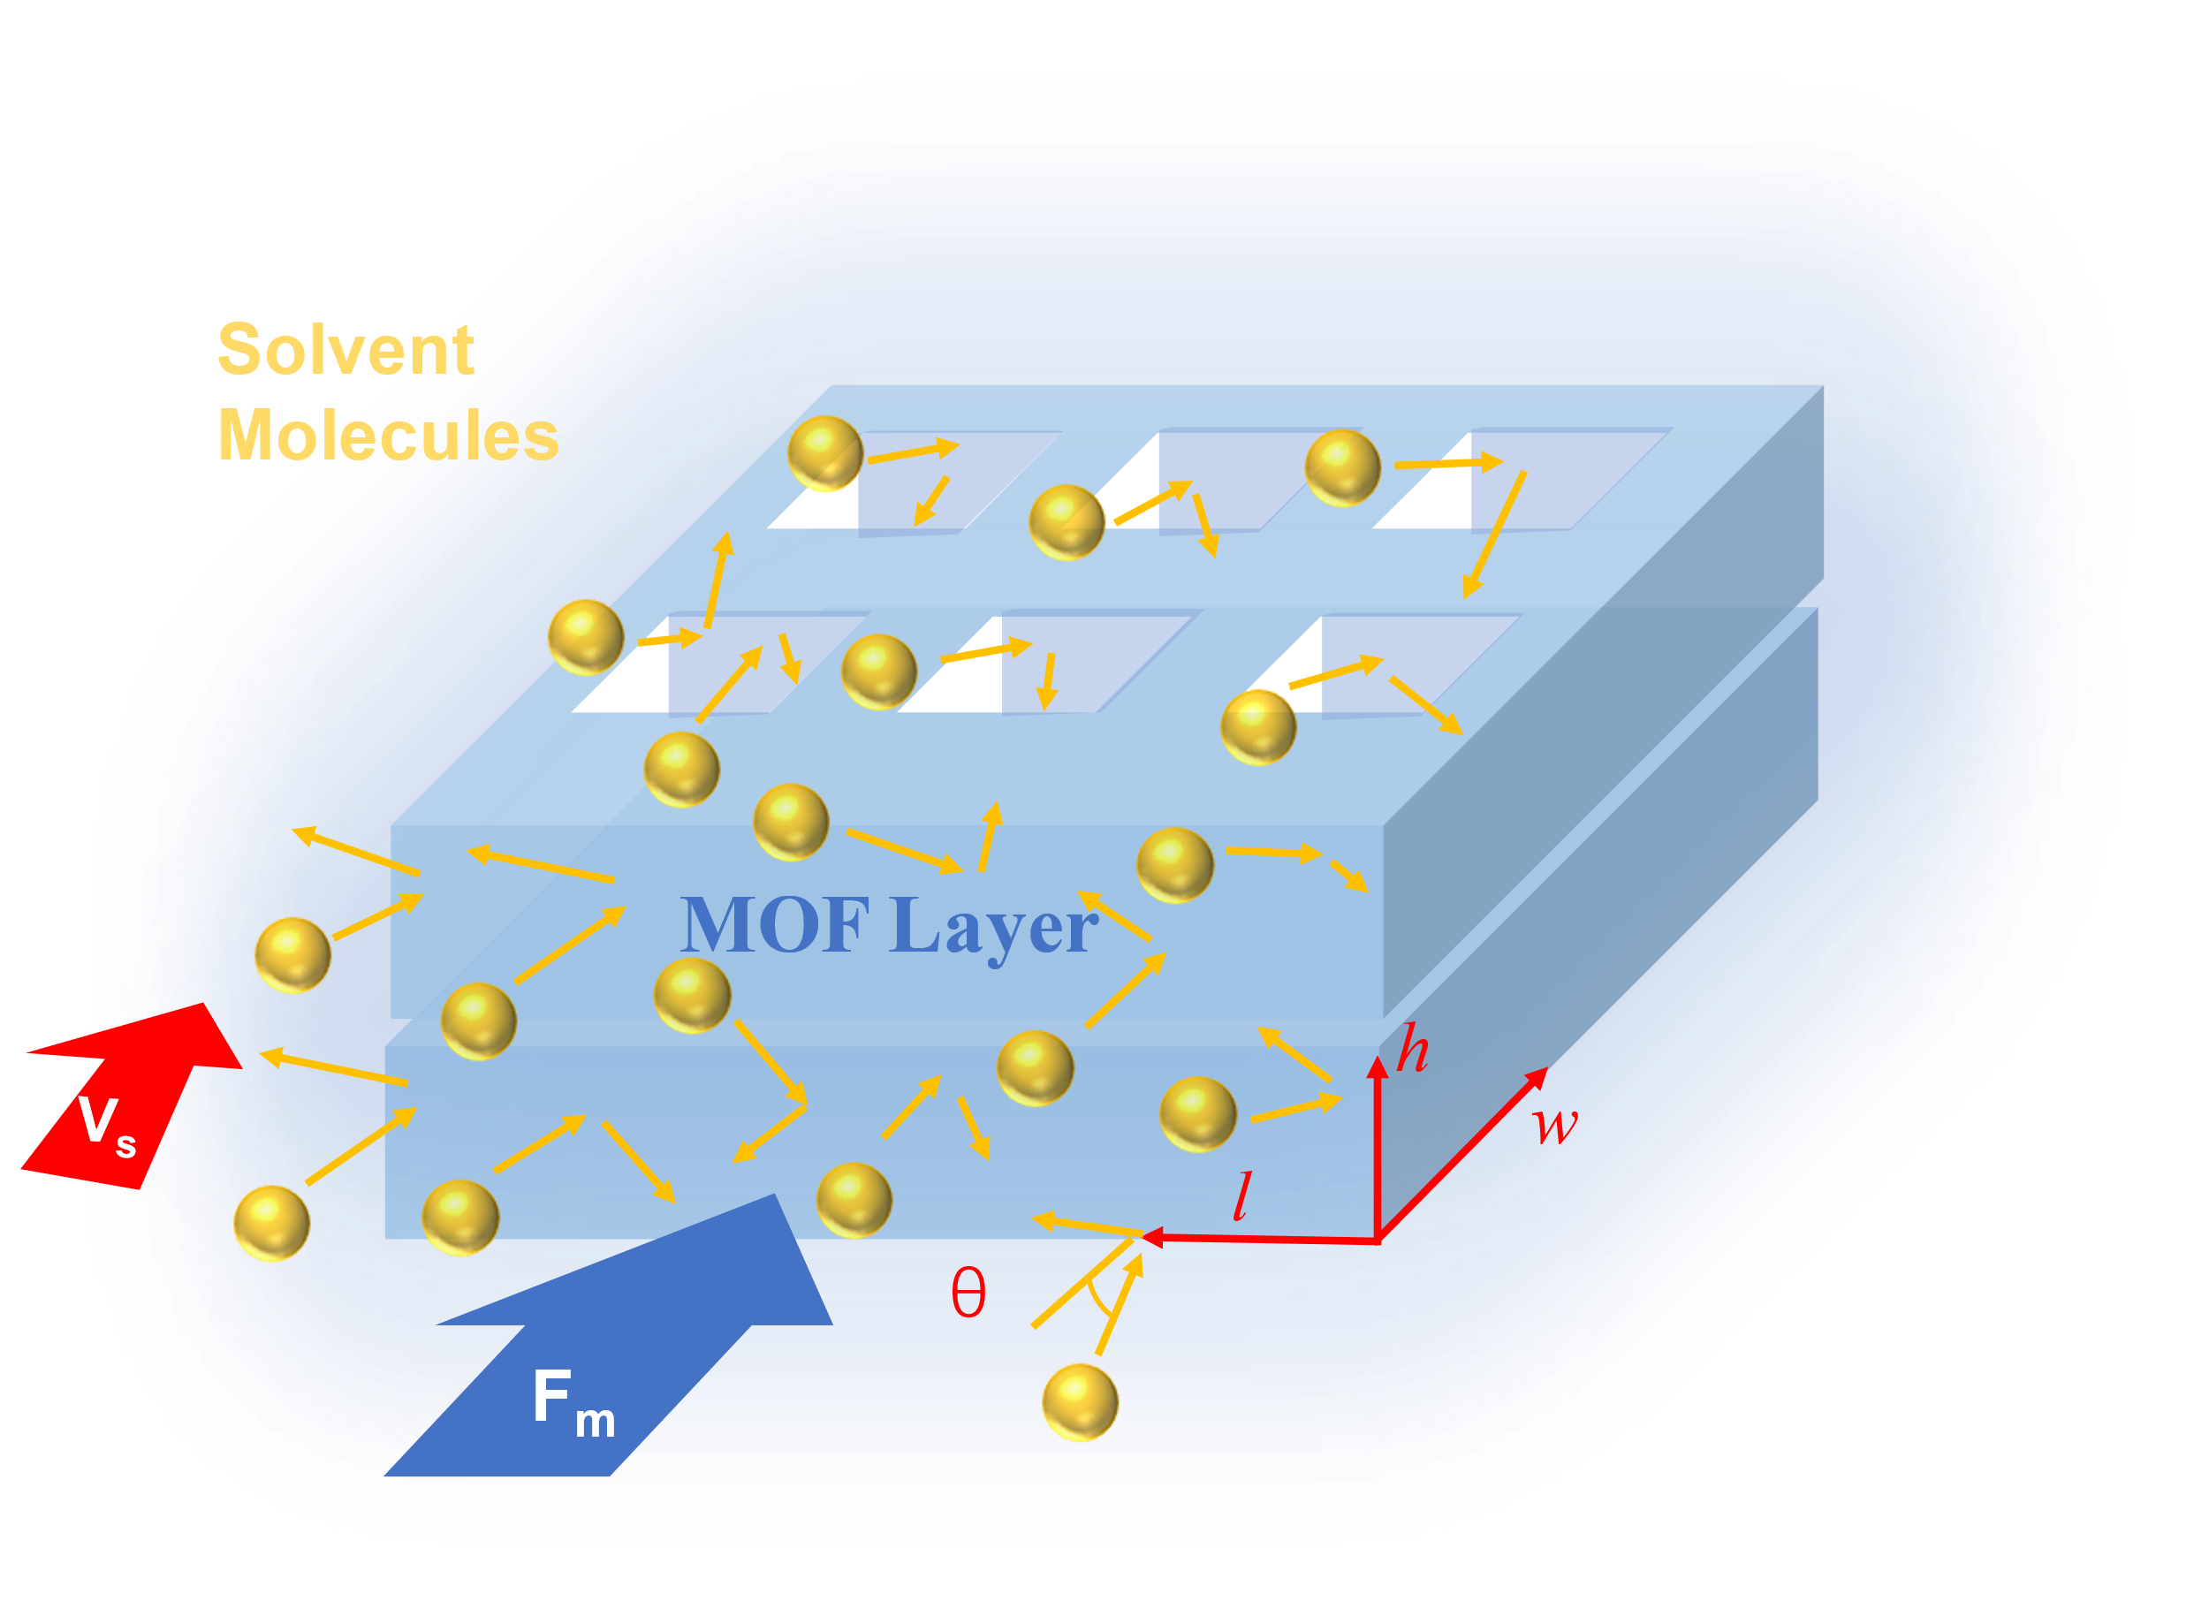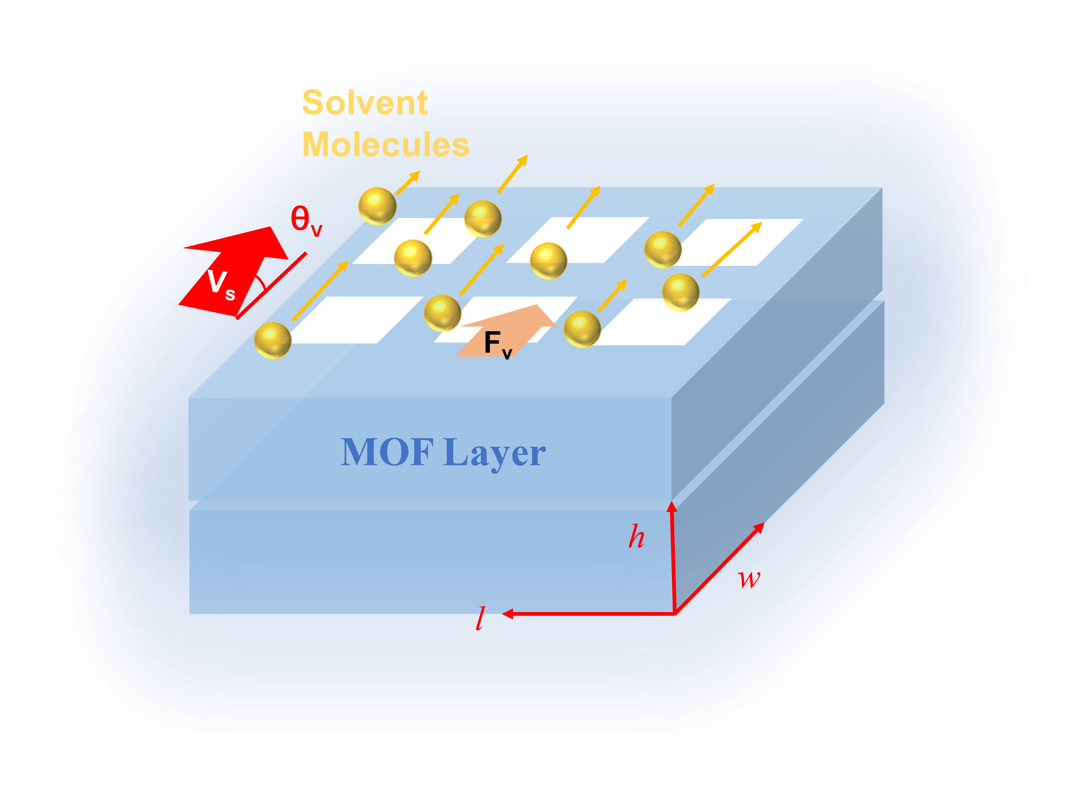
B
A

Fig. S1. The schematic illustration of the force in the exfoliation process, (A) F_{m}, (B) F_{v}. The golden balls represent the solvent molecules, the blue blocks represent MOF layer and locate in the lw plane.

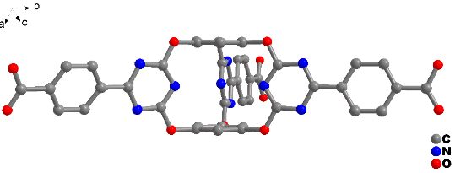
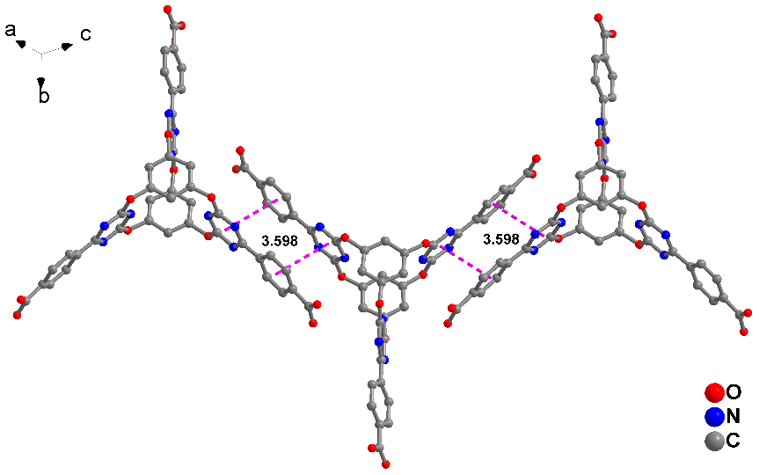
B
A
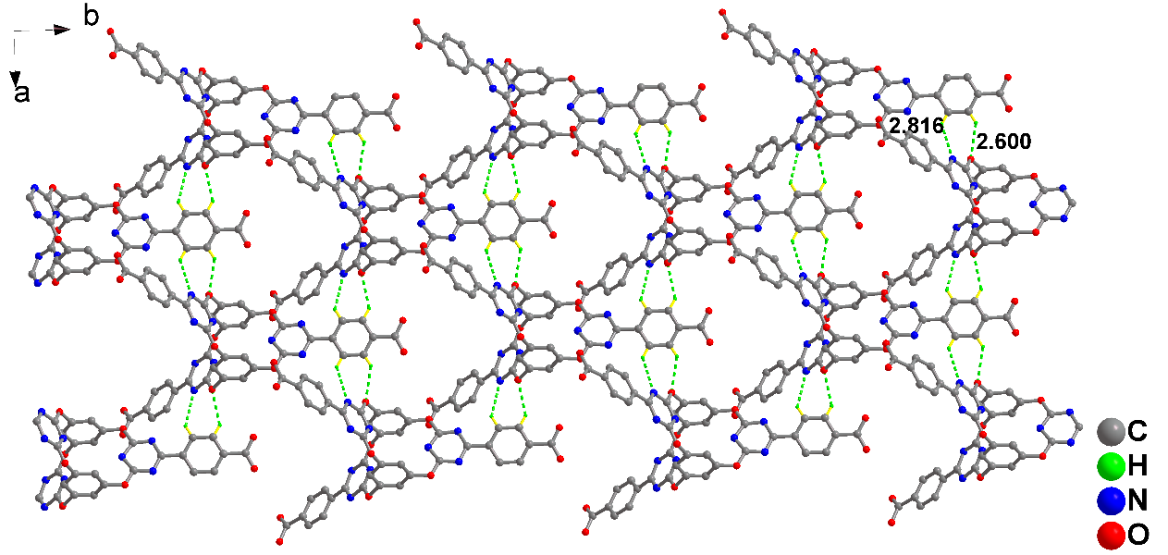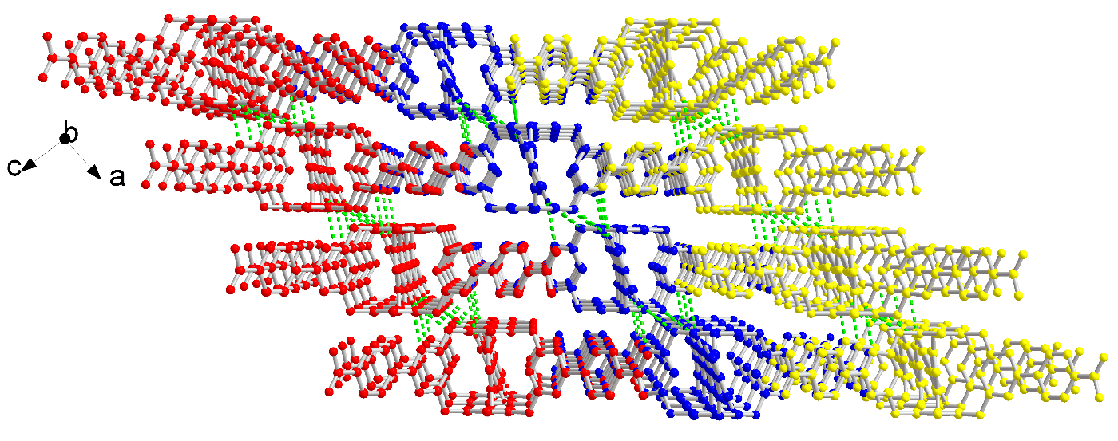
D
C

Fig. S2. Crystal structure of BCTA (A) Structure of single BCTA molecule. (B) The π -π stacking interaction between the BCTA chain in the layer. (C) The 2D layer structure connected via hydrogen bonds. (D) The 3D supramolecular framework constructed via hydrogen bonds and π -π stacking interaction.

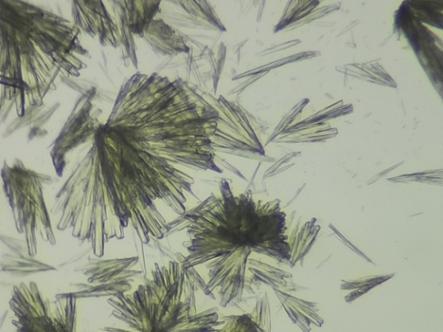

Fig. S3. Photos of IPM-1 crystals .

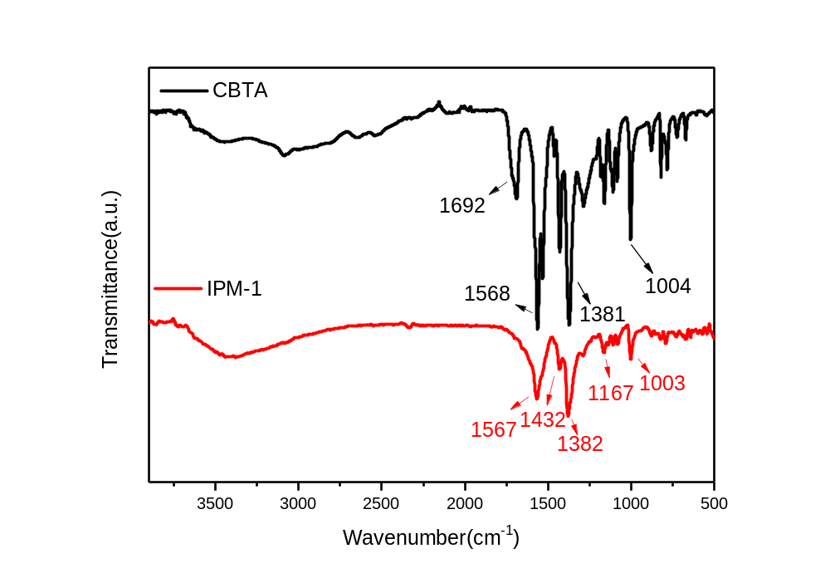

Fig. S4. Infrared spectra of BCTA (black), IPM-1 (red)

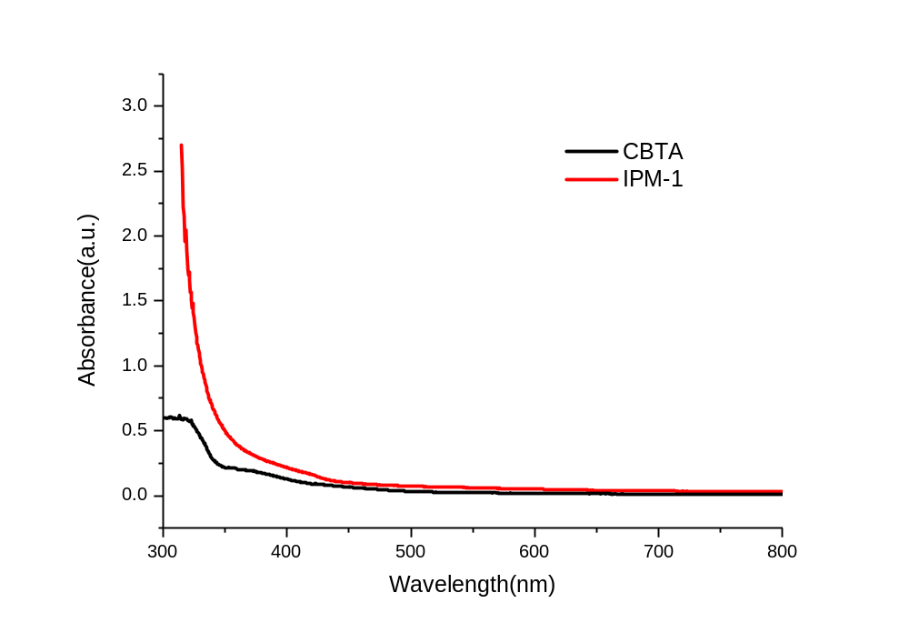

Fig. S5. UV-Vis spectra of BCTA (black), IPM-1 (red),

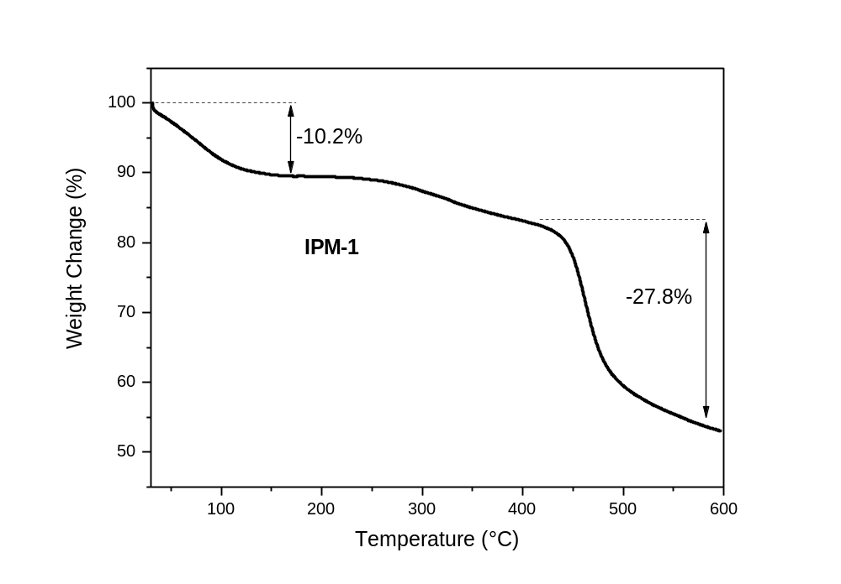

Fig. S6. TG analysis of IPM-1(A)

A
B

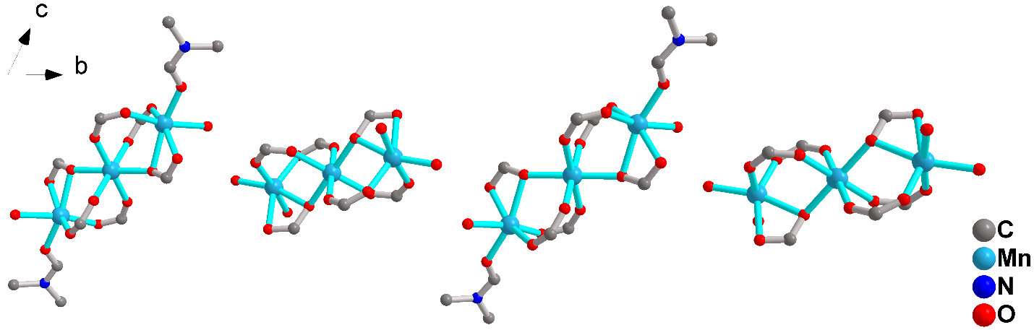

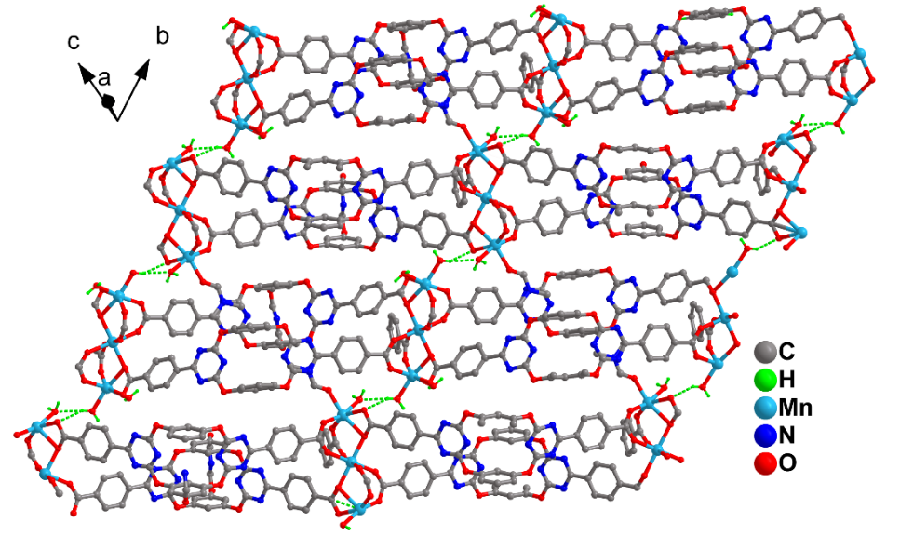
C
Fig. S7. (A) The presentation of one layer in IPM-1, view along [0, -1, 1] axis. (B) The hydrogen bonds chain in IPM-1 composed by the two kinds of linear chain-like [Mn₃(O₂C)₆] clusters. (C) The three-dimensional neutral supramolecular framework constructed via hydrogen bonds in IPM-1.

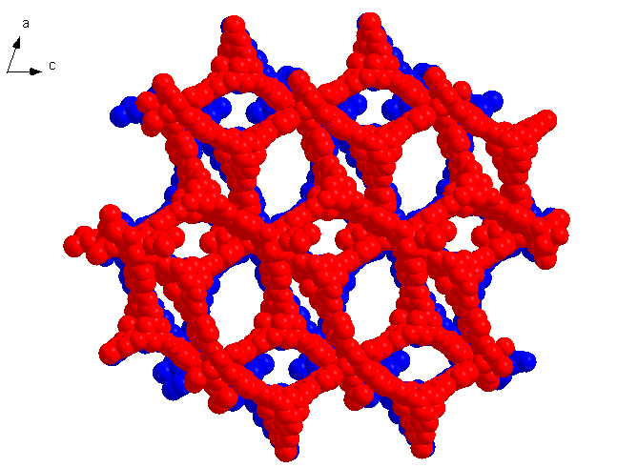
A
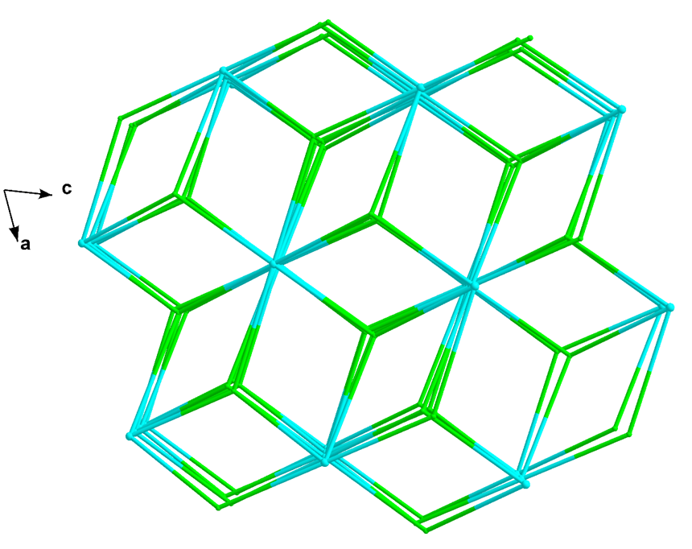
B
C

Fig. S8. (A) The three-dimensional framework with ellipsoid channels in IPM-1. (B) The three-dimensional framework with regular channels in IPM-1. (C) The ABAB stacking fashion with the 3,6-connected net nodes in IPM-1, view along [0, -1, 1] axis.

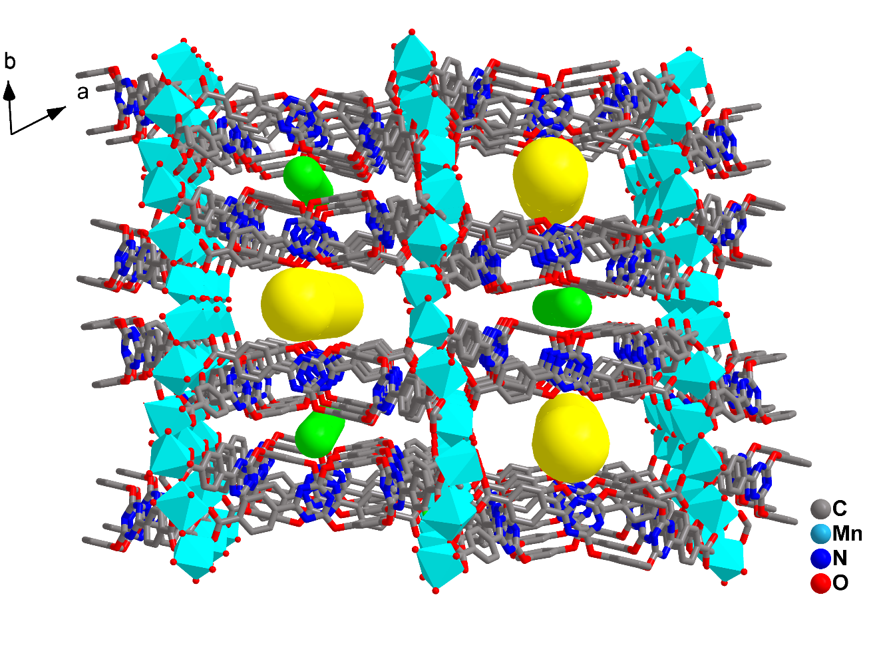
1.3*0.5nm
1.3*0.2nm

Fig. S9. Two types of channels with different size between the IPM-1 layers.

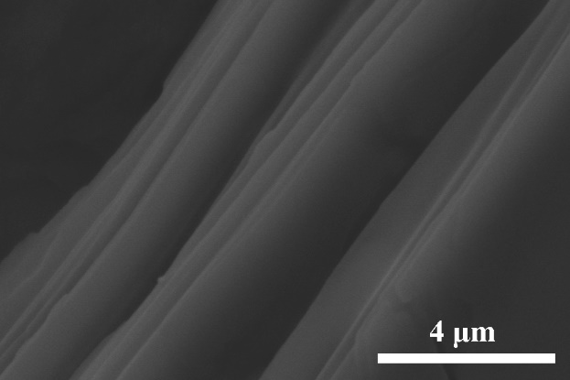
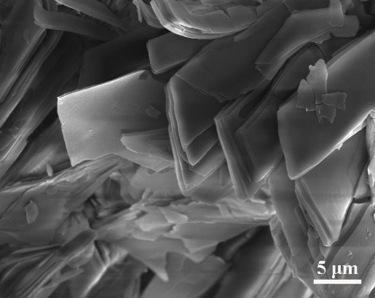
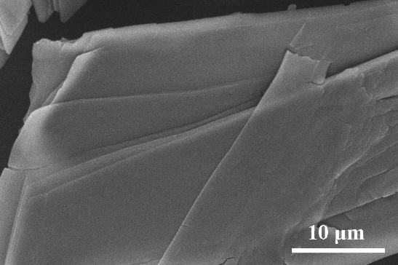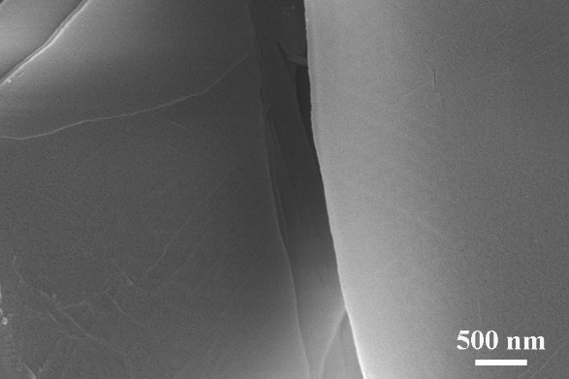

Fig. S10. The layered structure observed in the SEM images of IPM-1 crystal at different zoom levels.

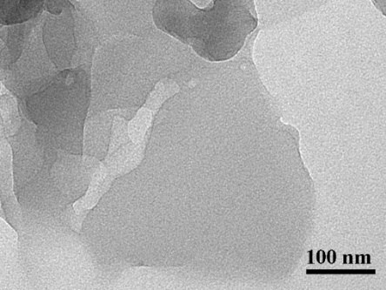
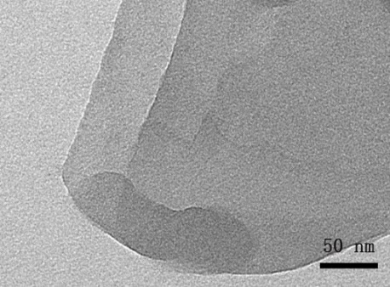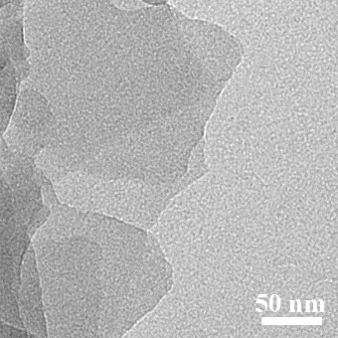
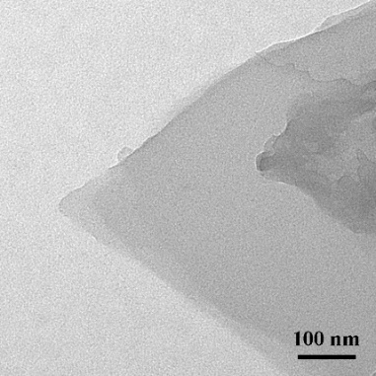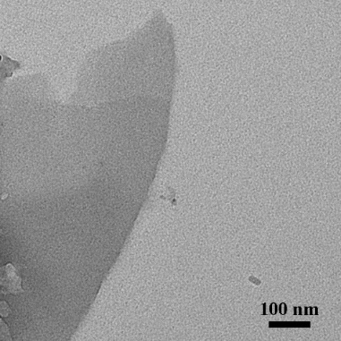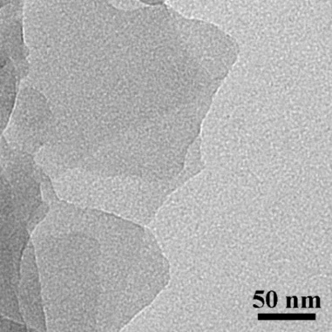

Fig. S11. TEM images of IPM-1 nanosheets.

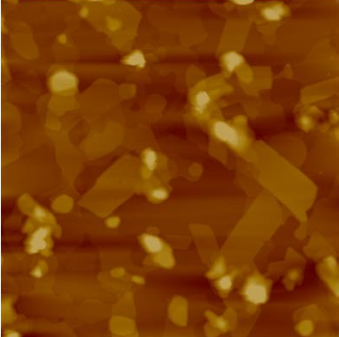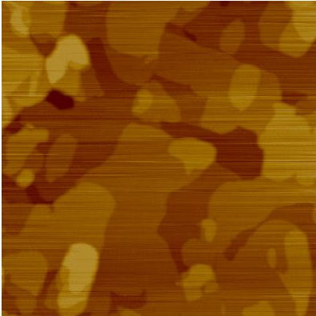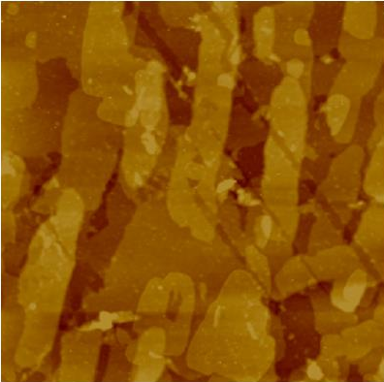
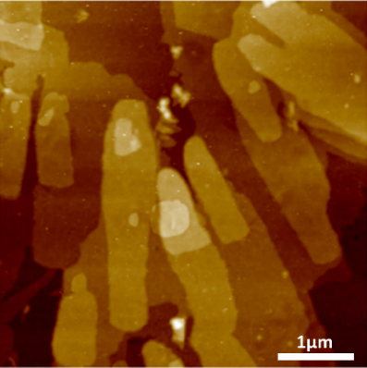
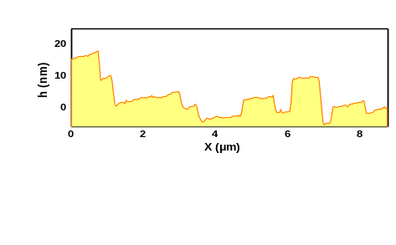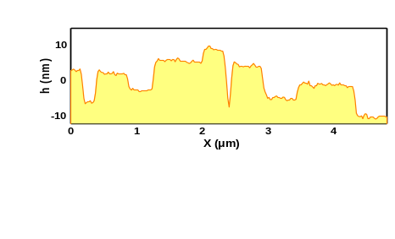

Fig. S12. AFM images of IPM-1 nanosheets suspension at high concentration.

Fig. S13. AFM images of IPM-1 nanosheets suspension at low concentration.

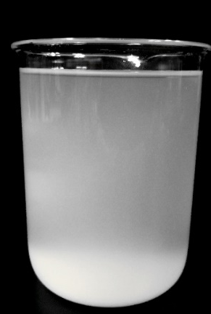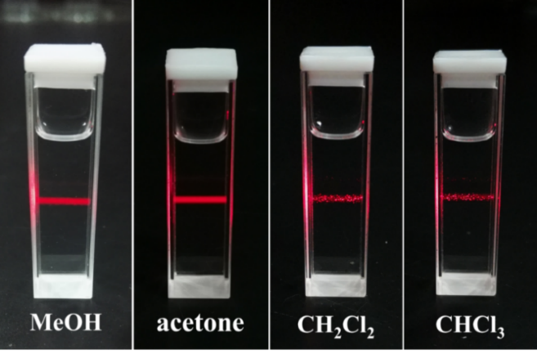
(A) (B)

Fig. S14. (A) The high concentration suspension (0.2-0.4mg/ml) of IPM-1 prepared in large batch (500 ml). (B) Tyndall effect of the low concentration suspension of IPM-1 prepared in different solvents.

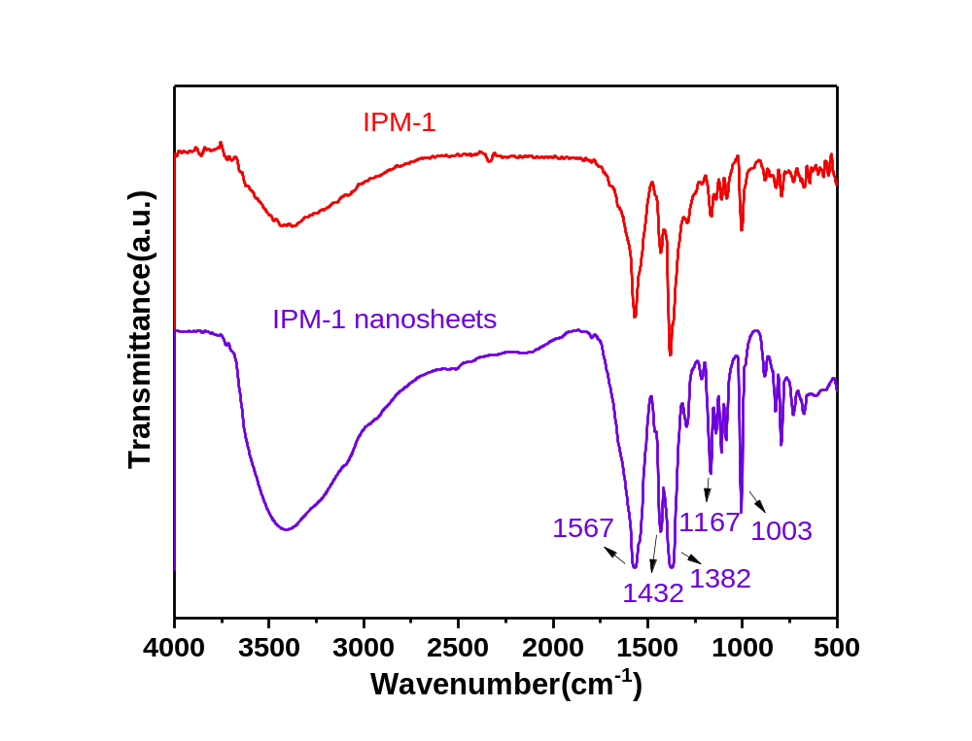

Fig. S15. Compare infrared spectra of IPM-1 (red) and IPM-1 nanosheet (purple)

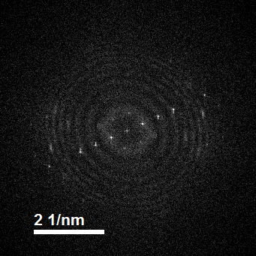
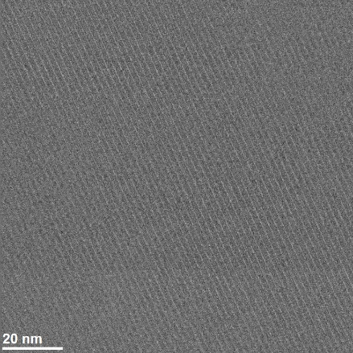

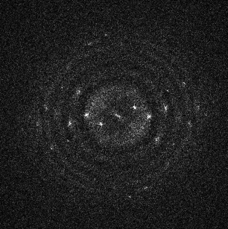
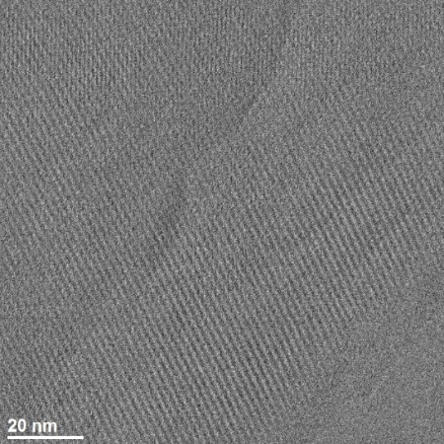
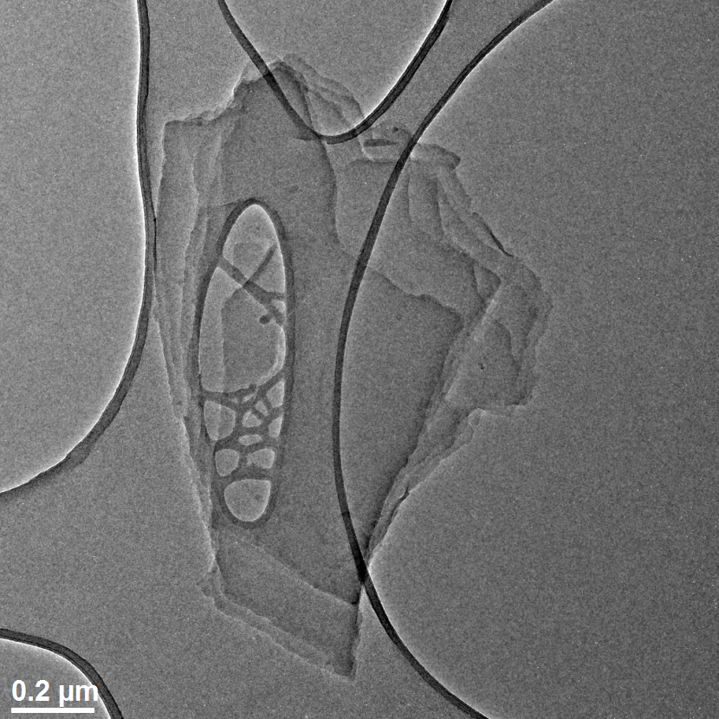

Fig. S16. Low-dose HR-TEM images of IPM-1 nanosheets.

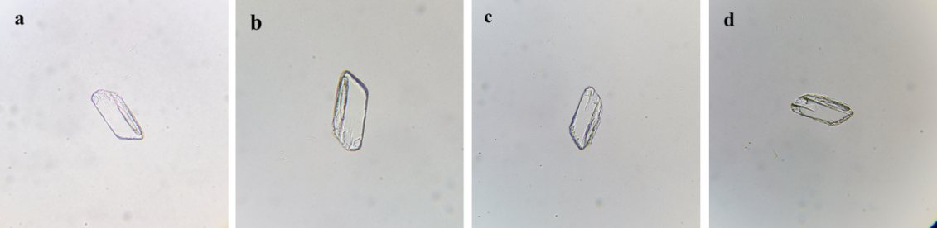

Fig. S17. The micrographs of one piece of IPM-1 crystal (a) as-prepared, (b) after washed by ethanol and dried, (c) after immersed in ethanol for 1 day, (d) after immersed in dichloromethane for 1 day.

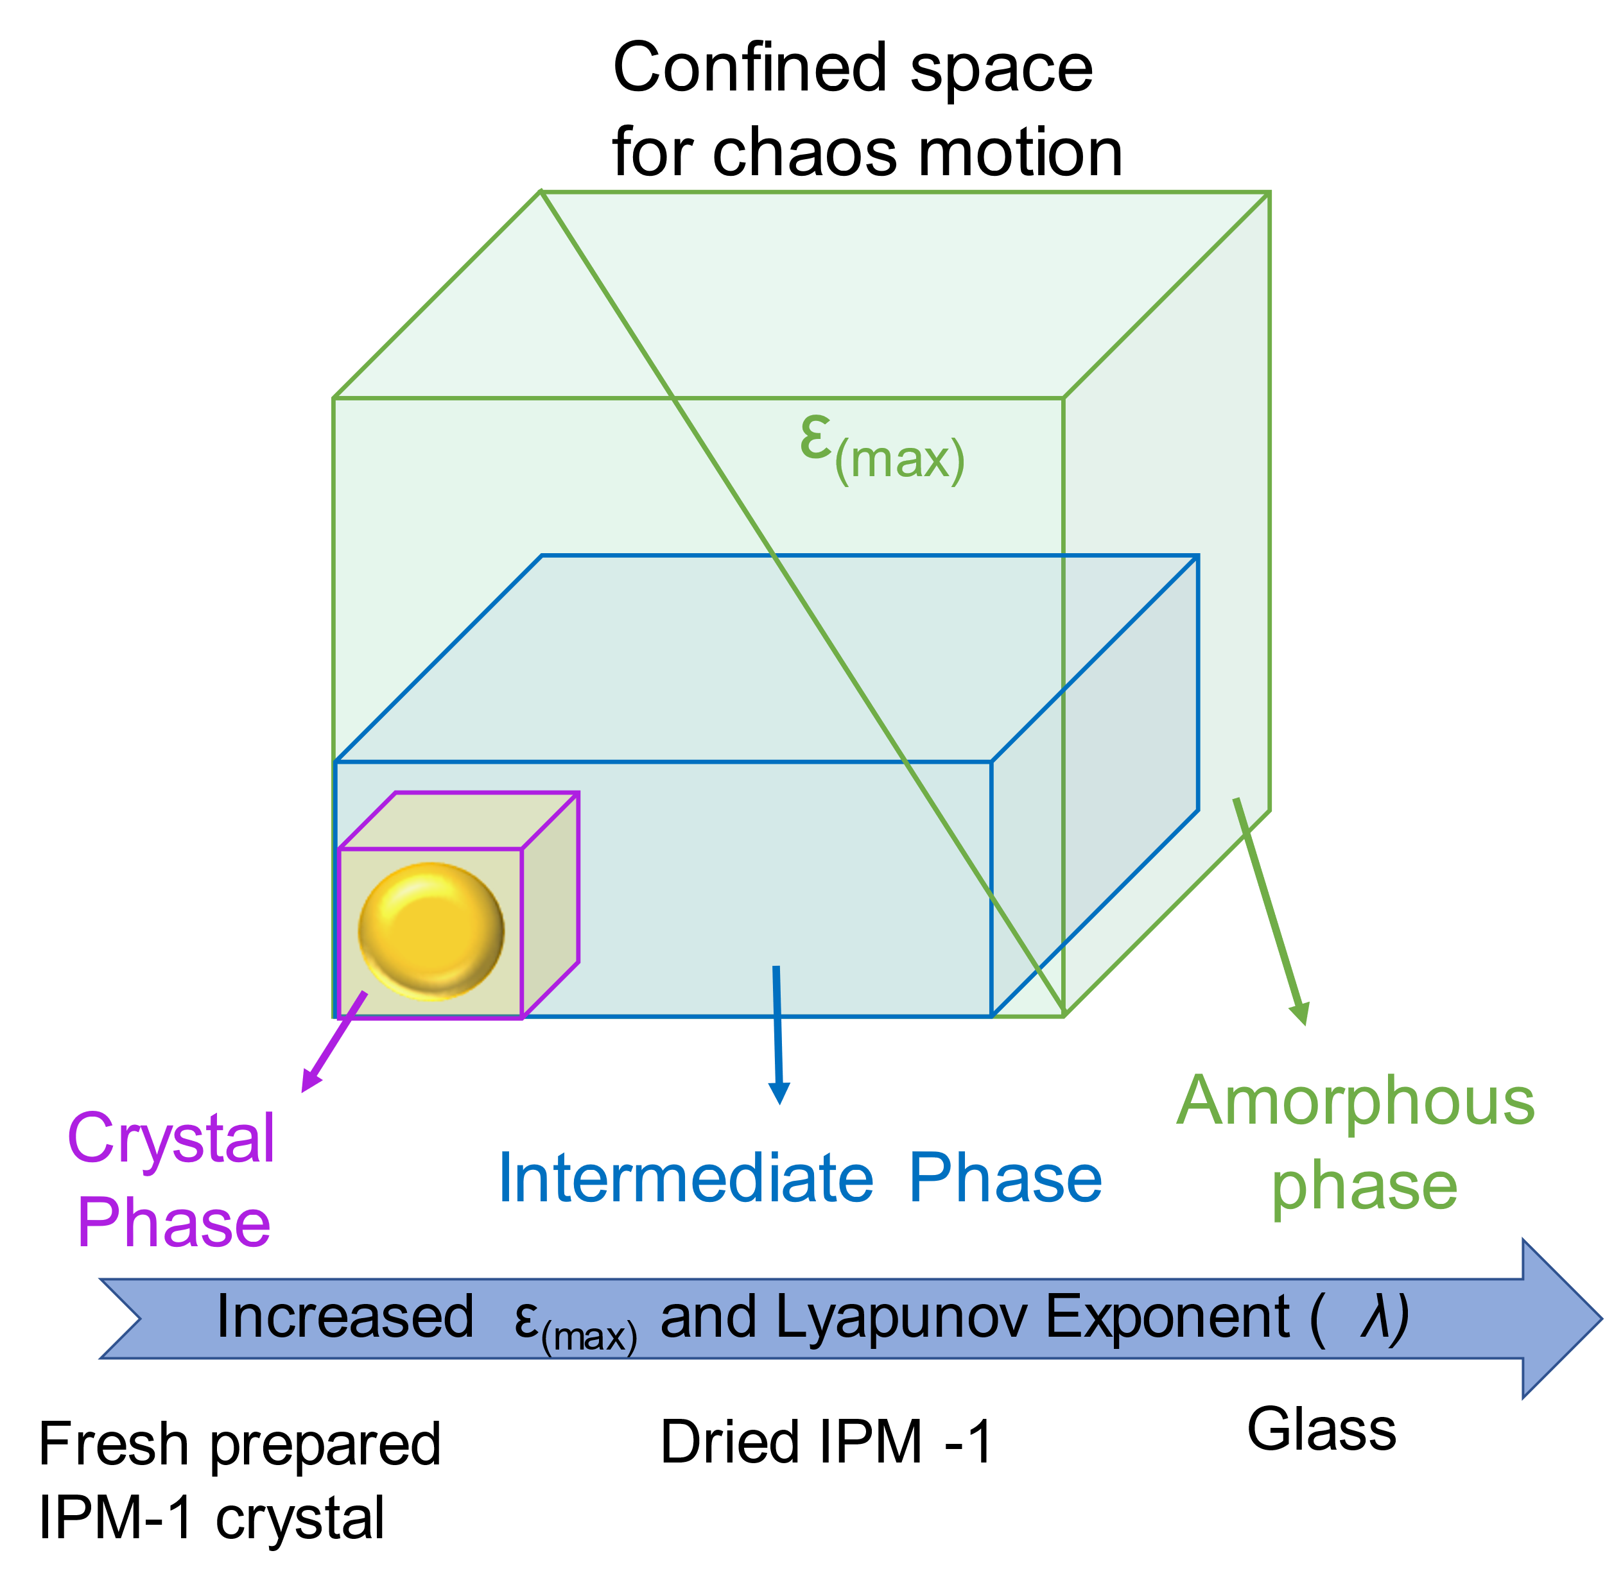

Fig. S18. The schematic illustration for the relationship between the confined space for chaos motion, ε_{(max)}, Lyapunov exponent and the corresponding material phase.

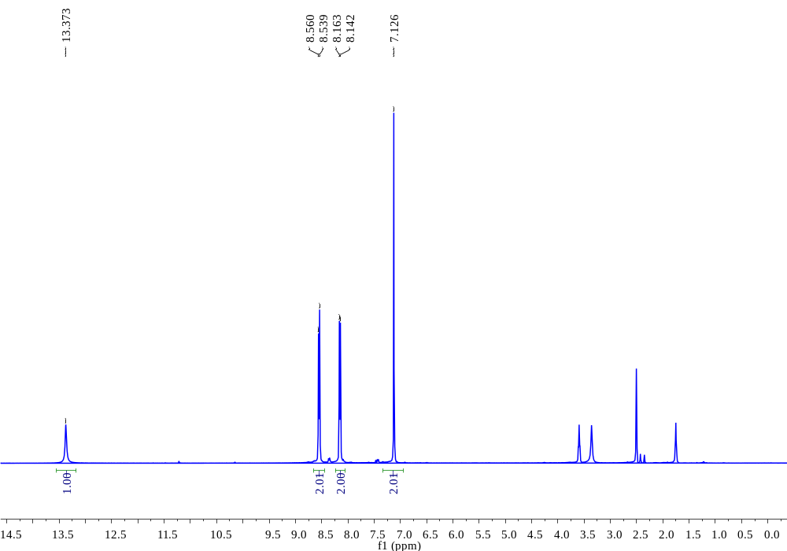

Fig. S19. ¹H-NMR spectrum of BCTA.

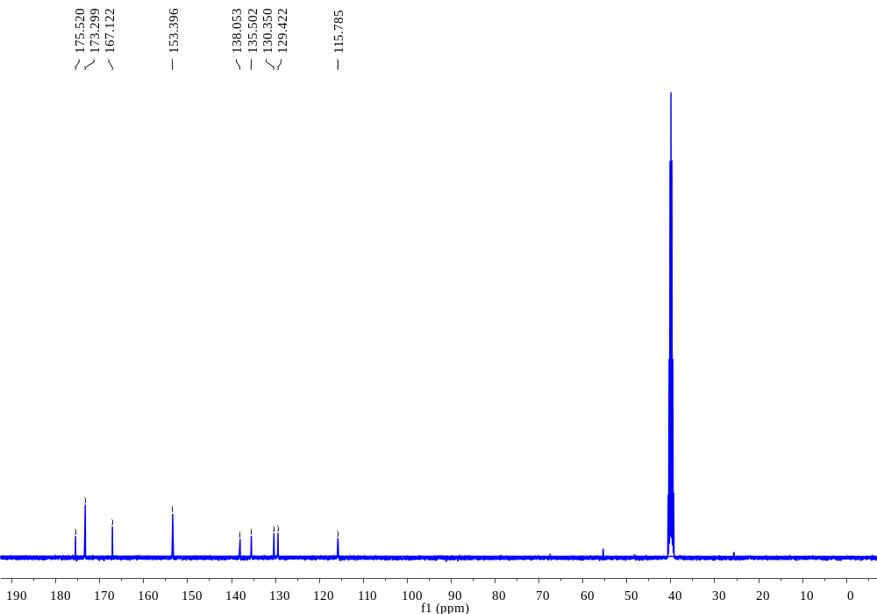

Fig. S20. ¹³C-NMR spectrum of BCTA.

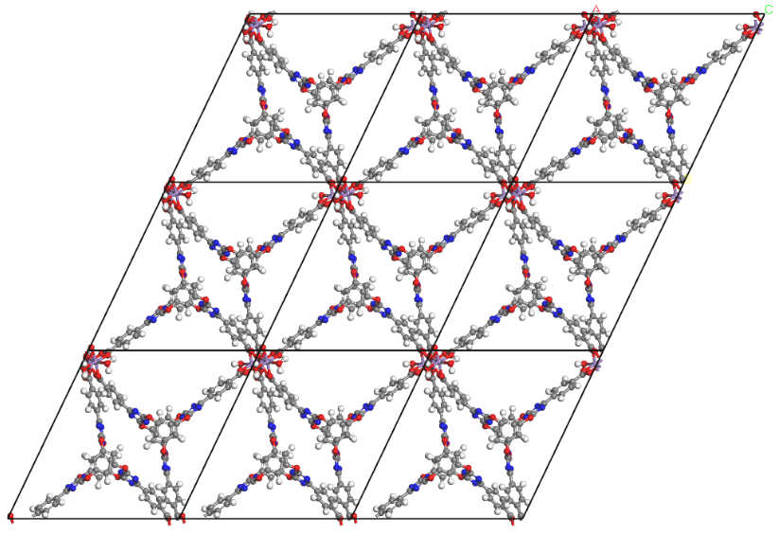
Figure S21. The 3×3×1 unit cells of the single layer model employed in current calculation.

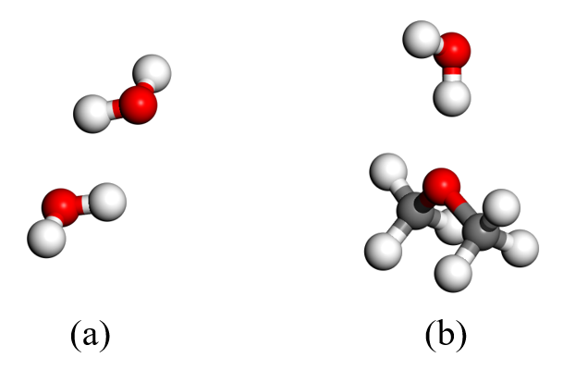
Figure S22. The computational models of hydrogen bonds formed between (a) two waters and (b) between water and ether.

Reference:

1. Clark, S. J.; Segall, M. D.; Pickard, C. J., First Principles Methods Using Castep. Z. Kristallogr. 2005, 220, 567-570.
2. Hohenberg, P.; Kohn, W., Inhomogeneous Electron Gas. Phys. Rev. 1964, 136, B864-B871.
3. Kohn, W.; Sham, L. J., Self-Consistent Equations Including Exchange and Correlation Effects. Phys. Rev. 1965, 140, A1133-A1138.
4. Pfrommer, B. G.; Côté, M.; Louie, S. G.; Cohen, M. L., Relaxation of Crystals with the Quasi-Newton Method. J. Comput. Phys. 1997, 131, 233-240.
5. Perdew, J. P.; Burke, K.; Ernzerhof, M., Generalized Gradient Approximation Made Simple. Phys. Rev. Lett. 1996, 77, 3865-3868.
6. Vanderbilt, D., Soft Self-Consistent Pseudopotentials in a Generalized Eigenvalue Formalism. Phys. Rev. B 1990, 41, 7892-7895.
7. B. Delley, J. Chem. Phys., 1990, 92, 508-517.
8. B. Delley, J. Chem. Phys., 2000, 113, 7756-7764.
9. Perdew, J. P.; Burke, K.; Ernzerhof, M., Generalized Gradient Approximation Made Simple. Phys. Rev. Lett. 1996, 77, 3865-3868.
7. Wang, L.-F.; Ma, T.-B.; Hu, Y.-Z.; Wang, H., Atomic-scale friction in graphene oxide: An interfacial interaction perspective from first-principles calculations. Phys. Rev. B 1990, 41, 7892-7895.

Data S1. Crystallographic information file of IPM-1

Data S2. Crystallographic information file of BCTA

Data S3. Crystallographic information file of monolayer IPM-1 and the DFT optimized monolayer IPM-1

