APPENDIX A – ANALYTICAL SOLUTION OF THE COMPLEX HEAT SOURCE BY MATLAB CODES

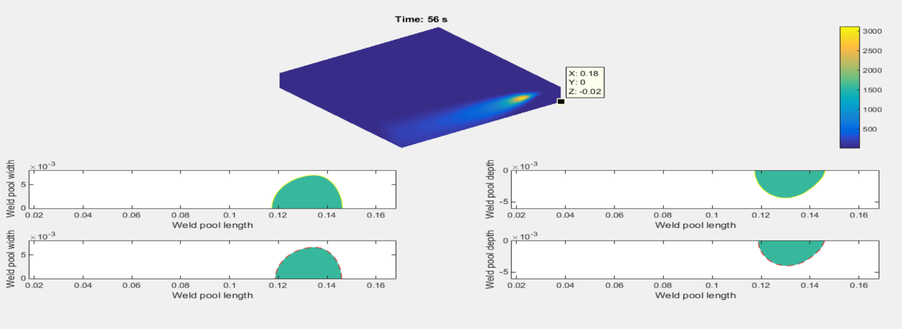

Figure 15 – Image of Matlab transient run for 2 paths – inc. Temp. contours and weld pool size
Figure 15 shows a captured screen of the Matlab code run display at the end of the path 2 of the bead-on-plate GMAW simulation. The temperature contour surrounding the heat source is shown on the steel plate cross section, cutting through the centre planes of the weld paths.

There are four small windows designated for the real time display of the weld pool shapes, i.e., showing the real time sizes of the weld pool length, with and depth with constant iso-boundary temperature depicted at 1,370ºC.

The top two windows (Left & Right) showing the weld pool boundary due to heat conduction-only transient temperature solution for the Goldak’s heat source by Nguyen et al. [5], using calibrated heat source parameters. The bottom two windows (Left & Right) showing the effective weld pool shape geometry (i.e., pool length, width and depth), determined from the approximate analytical transient solution for the complex heat source which incorporated all three modes of heat transfer, i.e., heat conduction, convection and radiation.

The approximate transient analytical solution of the complex heat source model was implemented by written Matlab codes, with calibrated Goldak’s heat source parameter [c_{hf}, c_{hb} a_{h} b_{h} ] = [10 20 10 1.5], typical heat convection film in quiet air h = 5 W/m²/ºC, grey body of steel plate with emissivity of 0.67 and radiative correction factor of k_{rad} = 0.02 for temperature solution reduction, due to radiative heat sink as per the approximate analytical solution for the complex heat source equations, developed in this work.

The transient temperature depicted at three selected point A, B and C and its corresponding temperature reductions due to convective and radiative heat sinks are shown in Fig. 16 (a) and 16(b), respectively.

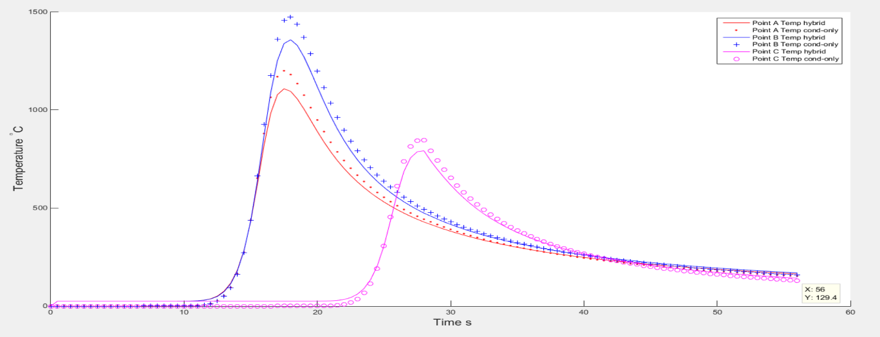
- Transient temperature at the 3 selected points A, B & C

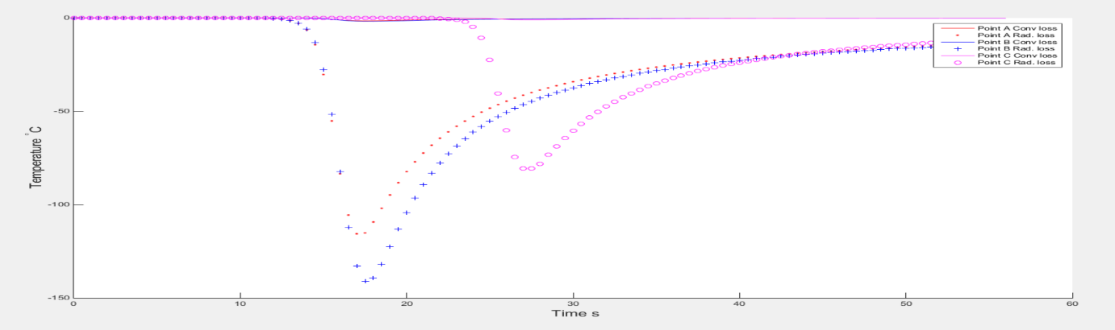
- Temperature reduction due to convective and radiative heat sink

Figure 16 - Transient Temperature at 3 selected points & temperature reductions due to convection & radiation

Figure 17 - Transient temperature by Matlab codes were benchmarked with the measured temperature data [5] to obtain
suitable heat source parameters for the complex heat source analytical solution

