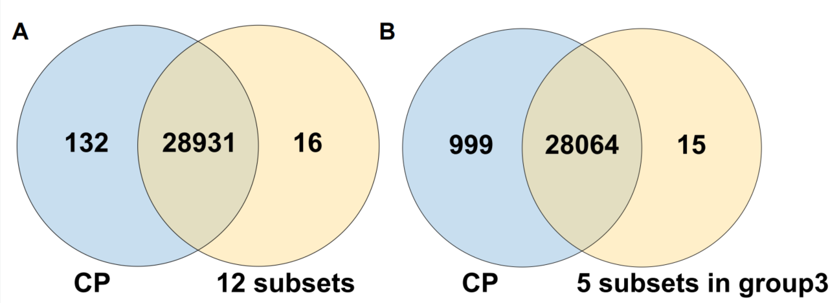

Supplemental Figure 1. Comparison of genes among CP and the 12 subsets. (A) Venn diagram illustrating the overlap between genes in cellular process (CP) and the 12 subsets. (B) Venn diagram illustrating the overlap between genes in CP and all the 5 subsets in group 3, including ‘cellular developmental process’, ‘cellular localization’, ‘cellular response to stimulus’, ‘cellular component organization or biogenesis’, and ‘cellular metabolic process’.

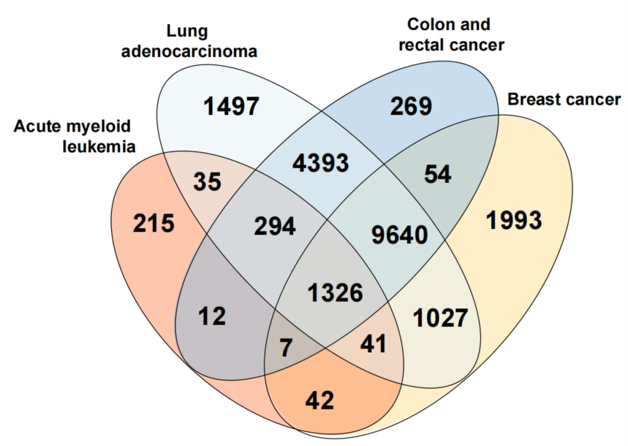
Supplemental Figure 2. Sharing genes among 4 cancer genomes. Venn diagrams illustrating the overlap among the 4 types of cancer genomes.

