Supplemental Figure 1 A different perspective of the AML|LAB with a view toward the north, which highlights apparent displacements of the imaged AML|LAB between Funnel B and C, with the latter located ~8 km from the caldera. The apexes of Funnels B and C are abruptly offset 3.5 km from each other. Funnels C and D also appear to be similarly offset (~5 km). Semi-transparent AML|LAB surfaces of Funnels A, B, C & D have been shaded by two-way travel time, where cold colours represent shallower parts of the structure, while warmer colours highlight the deepest areas; vertical color bar (two-way travel time) has been provided. Locations of hydrothermal fields are shown as magenta-filled circles¹⁸. Outlines of the 1998 (blue), 2011 (cyan) and 2015 (green) lava flows are overlain on the 3-D bathymetric map¹⁹. Supplementary Movie 3 provides a full 360° tour of the shape and geometry of the AML|LAB structures.
Supplemental Figure 2 A sculpted 3-D perspective of the AML|LAB structure beneath the southeast slope of Axial Volcano, highlighting the relationship between two distinct AML|LAB structures (Funnels B & C). (a) The embedded “chair-cut” visualisation highlights the top of the perched AML|LAB structure (see bulls-eye feature on upper time-slice). The primary front-facing slice is at Xline #2411. The shape of Funnel B can also be traced on the same time-slice. Dashed white lines outline the two rectangular chair-cuts. The lower chair-cut allows the viewer to see stacked sills beneath the perched AML|LAB. (b) Similar perspective where semi-transparent AML|LAB surfaces of Funnels B, C & D have been added and are shaded by two-way travel time, with cold colours representing shallower parts of the structure, while warmer colours highlight the deepest areas; vertical color bar (two-way travel time) has been provided. Edges of caldera are noted by arrows (black). Locations of hydrothermal fields are shown as magenta-filled circles¹⁸. Outlines of the 1998 (blue), 2011 (cyan) and 2015 (green) lava flows are overlain on the 3-D bathymetric map¹⁹. Seismic data below the primary seafloor multiple have been grayed out. Supplemental Movie 5 provides a tour of the shape and geometry of the AML|LAB structures beneath the southeast flank of Axial volcano.
Supplemental Figure 3 A complex, 3-D cut-out view of the seismic reflectivity volume (a) highlighting the structure of the AML|LAB across the four main magma bodies, except for the fifth body located near the CoAxial segment. The AML|LAB and underlying sills have been noted. (b) Similar perspective where semi-transparent AML|LAB surfaces of Funnels A, B, C & D have been added and are shaded by two-way travel time, with cold colours representing shallower parts of the structure, while warmer colours highlight the deepest areas; vertical color bar (two-way travel time) has been provided. Edges of caldera are noted by arrows (black). Locations of hydrothermal fields are shown as magenta-filled circles¹⁸. Outlines of the 2011 (cyan) and 2015 (green) lava flows are overlain on the 3-D bathymetric map¹⁹. Seismic data below the primary seafloor multiple have been grayed-out. Dashed white lines outline the complex rectangular chair-cuts.
Supplemental Figure 4 A 3-D view looking into the reflectivity volume towards the southwest, highlighting strong reflections beneath Axial Volcano. The 3-D volume has been divided into rectangular parallelepipeds or voxels, where only those voxels with the highest amplitudes, colored red-orange and green-blue, have been rendered. Two shallow points of AML|LAB structure are clearly visible near the northeastern wall of the caldera. The broad area of strong amplitudes at the AML|LAB interface is readily apparent across the southeast shoulder of Axial Volcano. Voxels have been rendered between 2.628 s and 3.3824 s two-way travel time. The perched AML farther to the southeast is also visible. A 2.5 km scale bar is provided (lower right), and a compass with Xline (XLn), Inline (ILn), depth (Z) and North (N) orientations is also displayed.
Supplemental Figure 5 An oblique 3-D view from an observation point southeast of Axial Volcano, highlighting the wide-spread presence of strong seismic amplitudes beneath the southeast flank of the volcano. The 3-D volume has been divided into voxels, where only those voxels with the highest amplitudes, colored red-orange and green-blue, have been rendered. A narrow melt ribbon along the northeast wall of the caldera contrasts with wide-spread strong reflectivity across the volcano’s southeast flank. Voxels have been rendered between 2.628 s and 3.3824 s two-way travel time. The perched AML farther to the southeast is also visible. A 2.5 km scale bar is provided (lower right), and a compass with Xline (XLn), Inline (ILn), depth (Z) and North (N) orientations is also displayed.

Supplemental Figure 1

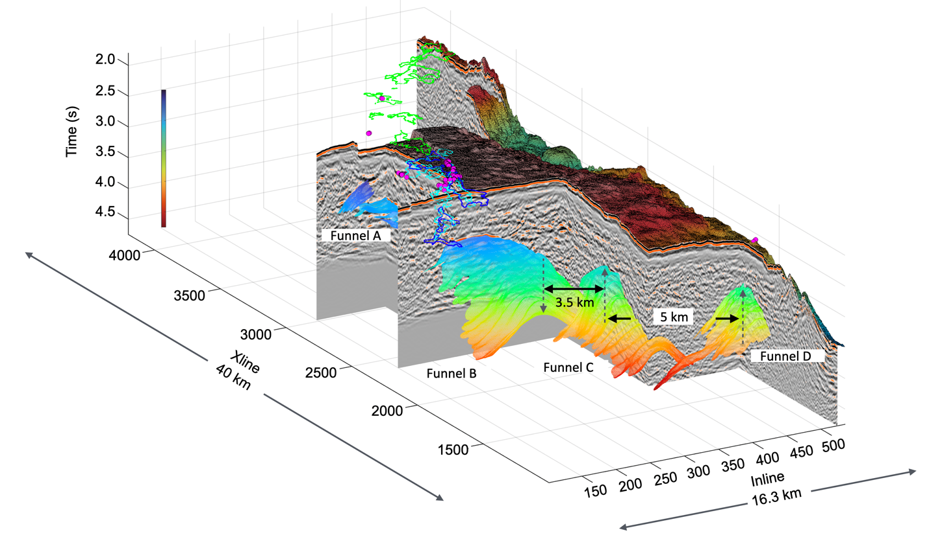

Supplemental Figure 2a

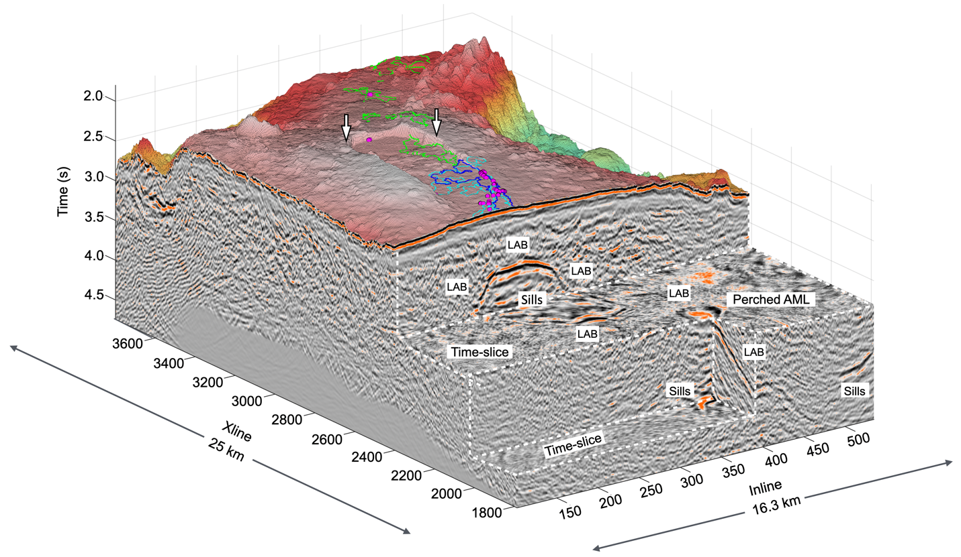

Supplemental Figure 2b

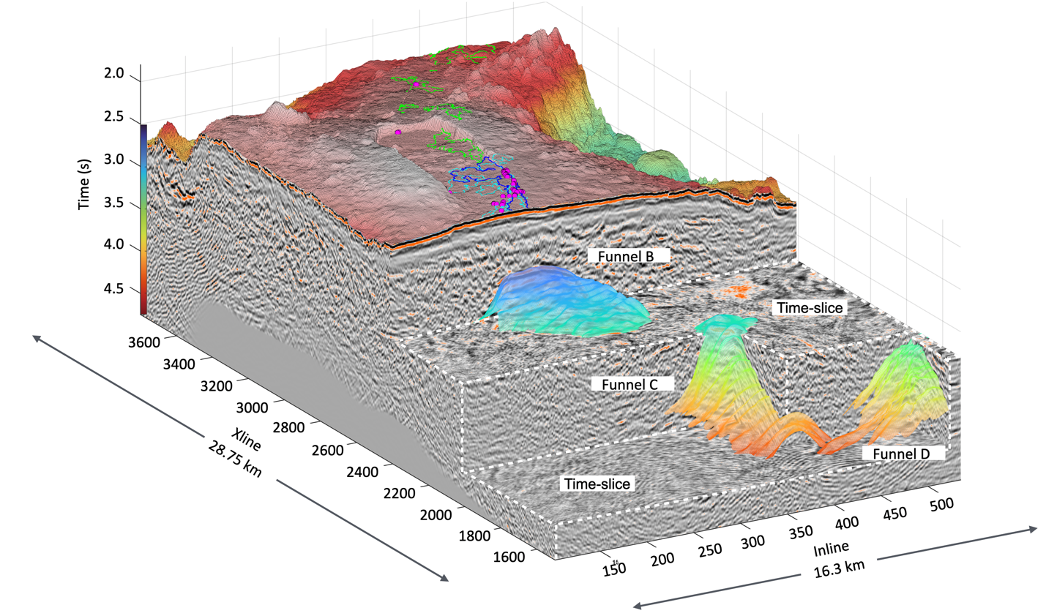

Supplemental Figure 3a

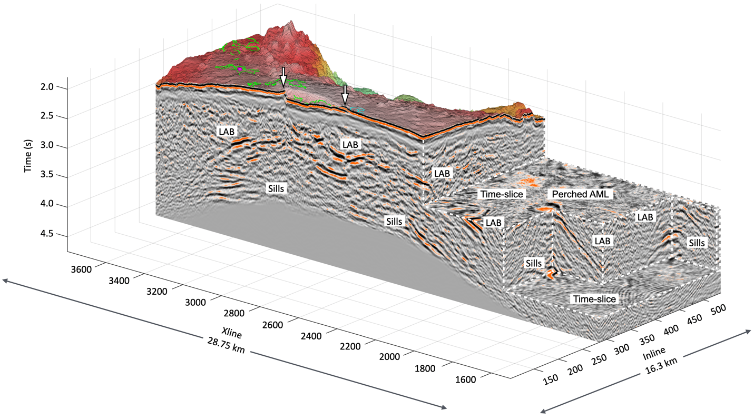

Supplemental Figure 3b

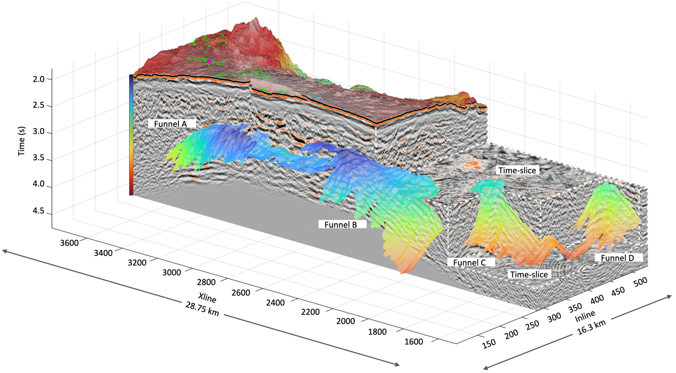

Supplemental Figure 4

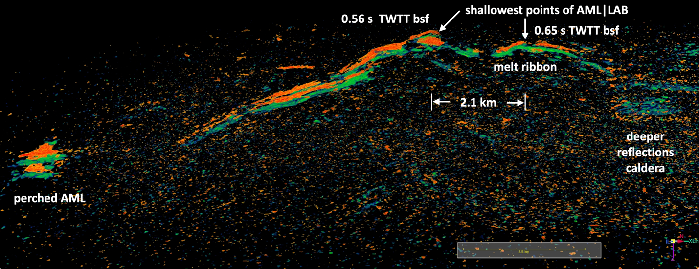

Supplemental Figure 5

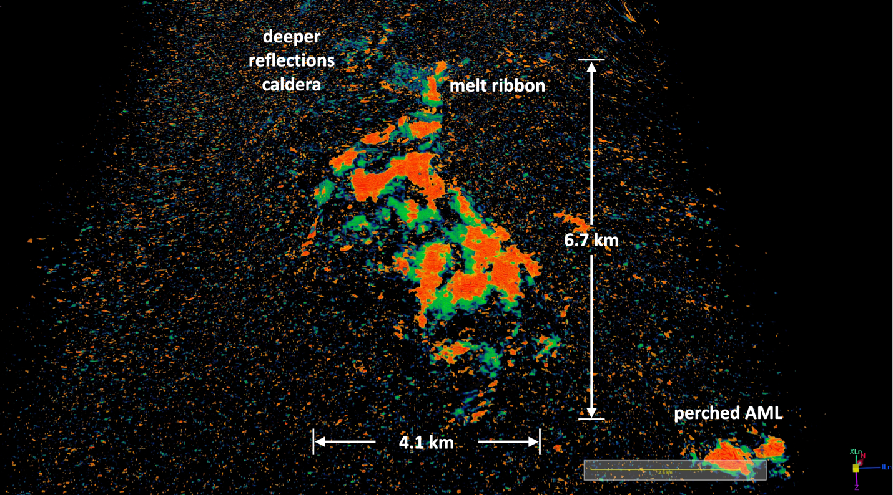

Supplemental Movies 1-5

Download Folder of MP4 movies at: https://nevada.box.com/s/3rgeb87x2jmiryz8gx4iajzg69sbkuvz

Supplemental Movie 1 Timepoint:

0 s start Inline slice 102
10 s Inline slice 201, domal shape of AML|LAB (Funnel A and B) beneath caldera becomes visible (center)
17 s Inline slice 275, centered on spine of Funnel B and melt ribbon (center-right)
19 s Inline slice 286, Fig. 2a, AML|LAB is 22.5 km in width; truncation of sills (left) becomes visible
22 s Inline slice 320, Funnel A disappears (left)
24 s Inline slice 355, Funnel B disappears (center-right), Funnel C appears (right)
28 s Inline slice 383, centered on spine of Funnel C AML|LAB beneath CoAxial Segment appears (far right)
34 s Inline slice 440, Funnel C disappears AML|LAB beneath CoAxial Segment appears (far right)
35 s Inline slice 450, dipping AML|LAB, east slope of north rift arm (left)
41 s Inline slice 515, appearance of AML|LAB at New Dymond (far right)
42 s Inline slice 525, appearance of CoAxial AML (center left)
43 s end Inline slice 535

Supplemental Movie 2 Timepoint:

0 s start Xline slice 1001
6 s Xline slice 1621, Funnel D becomes visible (far right)
10 s Xline slice 1747, Funnel C appears (center-right)
13 s Xline slice 1828, Funnel D disappears (far right)
17 s Xline slice 1954, bright sub-AML|LAB sill beneath Funnel C (center-right)
19 s Xline slice 2010, perched AML-LAB Funnel C (center-right)
21 s Xline slice 2060, Funnel B appears (center)
22 s Xline slice 2070, Funnel C disappears (center-right)
23 s Xline slice 2121, Funnel B at its widest, 5 km (center)
33 s Xline slice 2424, Fig. 2b, AML|LAB is 4.2 km wide, truncated sills (center)
36 s Xline slice 2521, Funnel B narrows forming melt ribbon (center)
43 s Xline slice 2729, flat AML|LAB and sills underlying caldera (center)
47 s Xline slice 2841, center of AML|LAB beneath caldera is depressed (travel time) (center)
53 s Xline slice 3055, AML|LAB beneath CoAxial Segment appears (far right)
58 s Xline slice 3171, AML|LAB beneath CoAxial Segment disappears (far right)
59 s Xline slice 3191, Funnel A appears (center)
1:00 s Xline 3251, AML|LAB beneath east flank of north rift arm appears (far right)
1:15 s Xline 3626, AML|LAB beneath east flank of north rift arm disappears (far right)
1:07 s Xline slice 3450, vertically stacked sills beneath Funnel A (center)
1:12 s Xline 3556, Funnel A disappears (center)
1:15 s end Xline slice 4200

Supplemental Movie 3 Timepoint:

0 s start First 360° orbit around the 3-D volume (Funnels not visualised)
24 s Next orbit with AML|LAB Funnels A, B, C & D now visualised
29 s Best view of Funnel B (center), Funnel C (center-right) & Funnel D (far right)
38 s AML|LAB beneath eastern flank of north rift axis (center)
41 s Funnel A is now centered (front)
47 s Flat AML|LAB is now centered (front)
47 s end Best view of offset between Funnels B & C (center-right)

Supplemental Movie 4 Timepoint:
0 s start reflection strength AML|LAB (Funnel B) southeast flank (center) and perched AML|LAB (Funnel C) seen (lower-right)
5 s side view of Funnel B looking northeast (center)
7 s side view of melt ribbon (center-left)
11 s view of reflection strength beneath caldera (center)
13 s view of reflection strength of Funnel A (center)
17 s end

Supplemental Movie 5 Timepoint:

0 s start First partial orbit of southeast flank, Axial Volcano (center)
2 s best view of AML|LAB associated with Funnels B, C & D (center-right)
10 s side view of Funnel D (far left) and AML|LAB beneath east flank of north rift arm (far right)
11 s reverse direction, visualise Funnels B, C & D and AML|LAB east flank of north rift arm
16 s best view of Funnels B, C & D (center)
21 s end sideview of Funnels B, C & D (center to left)

