Supplementary Information
Figures S1 and S2
Tables S1 and S2
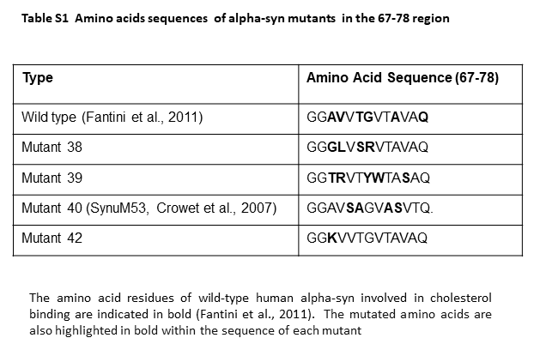

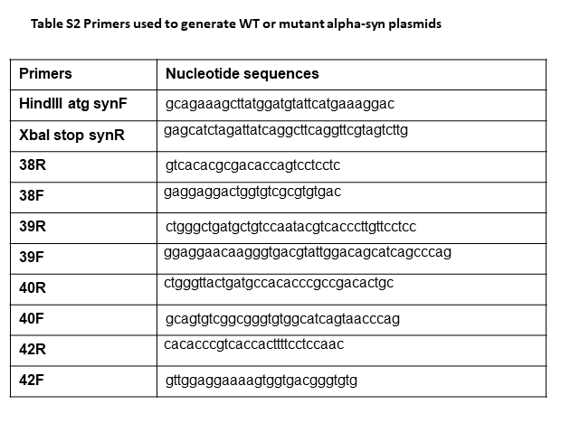

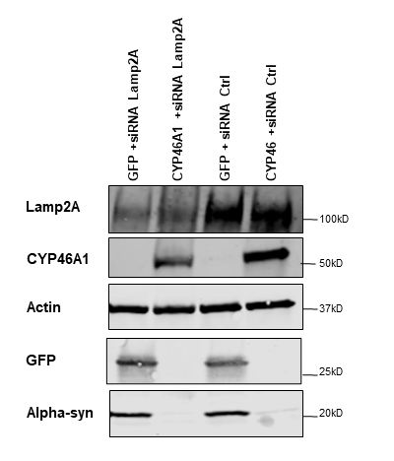
Fig S1 CYP46A1 does not induce the autophagy of alpha-syn via the CMA autophagy pathway. SH-SY5Y cells were co-transfected with either siRNA targeting Lamp2A or control siRNA along wild-type alpha-syn and either CYP46A1 or GFP for 48 hours. The western blot analysis revealed a reduction in Lamp2A expression following transfection with Lamp2A siRNA (50 nM) compared to cells transfected with control siRNA. Overexpression of human CYP46A1 resulted in a decrease in human alpha-syn levels. However, inhibition of chaperone-mediated autophagy pathway by siRNA targeting Lamp2A did not result in the accumulation of alpha-syn, suggesting that CYP46A1 does not induce CMA autophagy

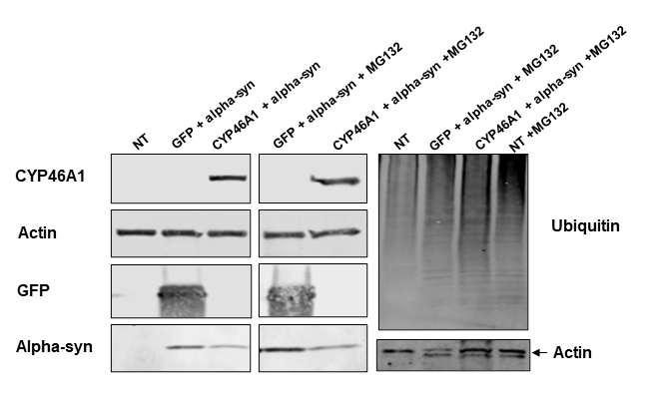

Fig. S2 CYP46A1 does not promote the degradation of alpha-syn by the proteasome. SH-SY5Y cells were co-transfected with alpha-syn and either GFP or CYP46A1 for 36 hours or left not transfected (NT), followed by treatment with the proteasome inhibitor MG132 or left untreated. Protein samples were analyzed by western blot using antibodies against HA, GFP, actin and human alpha-syn (left panel) and anti-ubiquitin and actin (right panel). Actin protein levels served as a loading control. The ratio of alpha-syn protein levels in the presence of CYP46A1 compared to those detected with GFP, which was 2.5, remained unchanged with or without MG132. The ubiquitin pattern of (right panel, last 3 lanes) exhibited a significant elevation in the presence of MG132 compared to the first lane without MG132, relative to the level of actin, indicating the effectiveness of the proteasome inhibitor MG132

