AuCePt porous hollow cascade nanozymes targeted delivery of disulfiram for alleviating hepatic insulin resistance
Huawei Shen^{a, b, 1}, Yafei Fu^{a, 1}, Feifei Liuª, Wanliang Zhangª, Yin Yuanª, Gangyi Yang^{c}, Mengliu Yang^{c, *}, Ling Li^{a, *}
ªKey Laboratory of Medical Diagnostics of Ministry of Education, Department of Laboratory Medicine, Chongqing Medical University, Chongqing, 400016, China
^{b}Chongqing Key Laboratory of Sichuan-Chongqing Co-construction for Diagnosis and Treatment of Infectious Diseases Integrated Traditional Chinese and Western Medicine, Chongqing Hospital of Traditional Chinese Medicine, Chongqing, 400021, China
^{c}Department of Endocrinology, The Second Affiliated Hospital, Chongqing Medical University, Chongqing, 400010, China

¹These authors contributed equally to this work.
*Corresponding author: Ling Li
Tel: +86-23-68485216/Fax: +86-23-68485239
E-mail: liling@cqmu.edu.cn

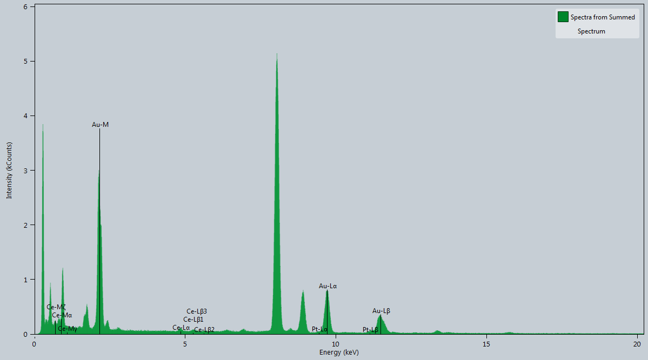
Figure S1. EDS analysis for AuCePt PHNs.

Figure S2. XPS fitted spectra of (A) Au4f, (B) Ce3d and (C) Pt4f in AuCePt PHNs.

Figure S3. (A) High magnification TEM image for AuCePt PHNs. (B) XRD patterns of AuCePt PHNs and Au PHNs.

Figure S4. Surface charge of AuCePt PHNs, AuCePt PHNs-L-Cys, and AuCePt PHNs-LA.

Figure S5. The stability of AuCePt PHNs and AuCePt PHNs-LA in different media.

Figure S6. Dissolved oxygen monitoring experiment for the CAT-like activity analysis: (A) Kinetic curve of O₂ generation from the decomposition of H₂O₂ in the presence of AuCePt PHNs (0 – 40 ug mL⁻¹). (B) Kinetic curves of O₂ generation from the decomposition of H₂O₂ in the presence of AuCePt PHNs, AuCe PHNs, AuPt PHNs and Au PHNs, respectively.

Figure S7. Effects of AuCePt PHNs on cellular ROS level induced by exogenous and endogenous stress. AML-12 cells were incubated with or without FFAs for 20 h and then treated with or without indicated substances. Fluorescence emission spectrum (A) and quantitative analysis (B). ROS, Reactive oxygen species; DCFH-DA, Dichlorodihydrofluorescein diacetate; SOD, Superoxide dismutase; CAT, Catalase. Data are expressed as mean ± standard deviation, n = 3 independent experiment; ***p<0.001, ****p <0.0001.

Figure S8. Intracellular anti-ROS mimic diagram and the different subcellular locations of SOD and CAT

Figure S9. Standard curve of DSF detected by HPLC.

Figure S10. CCK8 assay for the detection of cell viability. AML-12 cells were treated with the different concentrations of (A) AuCePt PHNs or (B) DSF for 3 to 72 h.

Figure S11. Flow cytometry for the detection of cell viability. AML-12 cells were treated with the different concentrations of (A) AuCePt PHNs or (B) DSF for 72 h.

Figure S12. Comparison of Akt phosphorylation level: AML-12 cells were incubated with FFAs for 20 h and then treated with Au PHNs, AuPt PHNs, AuCe PHNs and AuCePt PHNs.

Figure S13. (A) Quantitative analysis of AuCePt PHNs and AuCePt PHNs-LA distribution in different organs. (B) Quantitative analysis of AuCePt PHNs-LA distribution in different organs with time. Data are expressed as mean ± standard error of mean, * p <0.05, **p <0.01, ***p <0.001 vs. control.

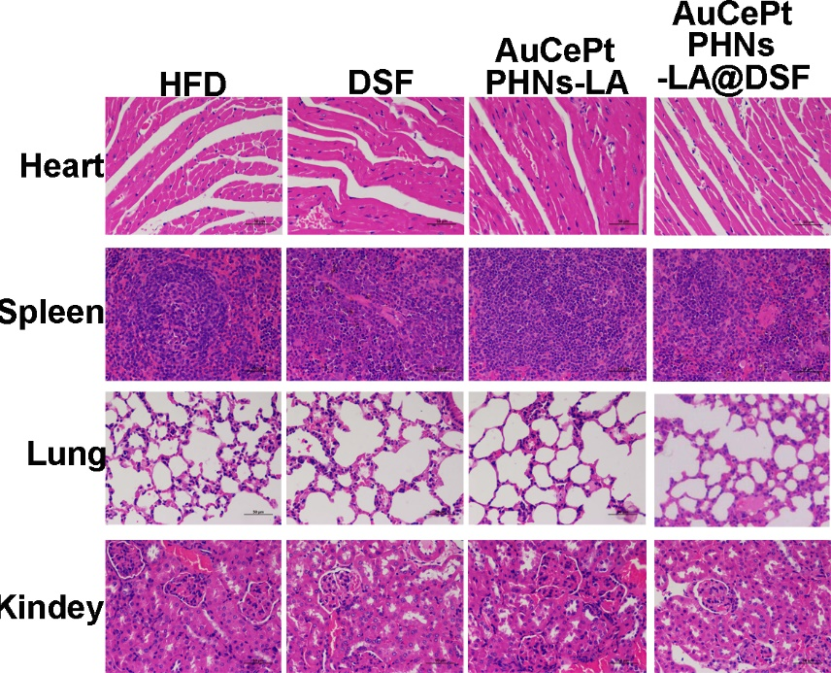
Figure S14. H&E staining of the different tissues of C75BL/6J mice in the groups of HFD, DSF, AuCePt PHNs-LA, and AuCePt PHNs-LA@DSF.

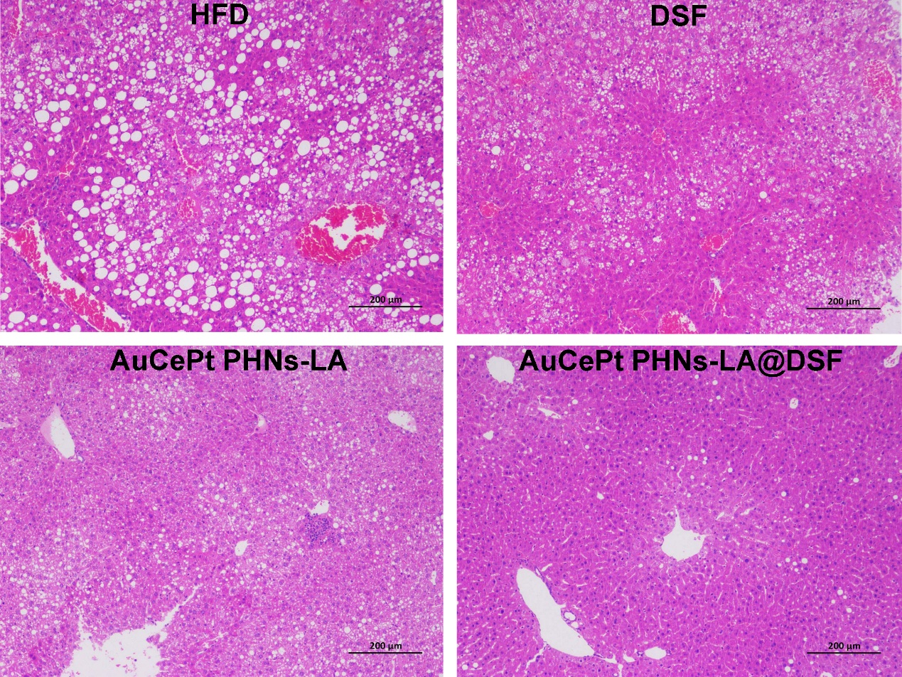
Figure S15. The liver HE staining of the C75BL/6J mice in the groups of HFD, DSF, AuCePt PHNs-LA, and AuCePt PHNs-LA@DSF.

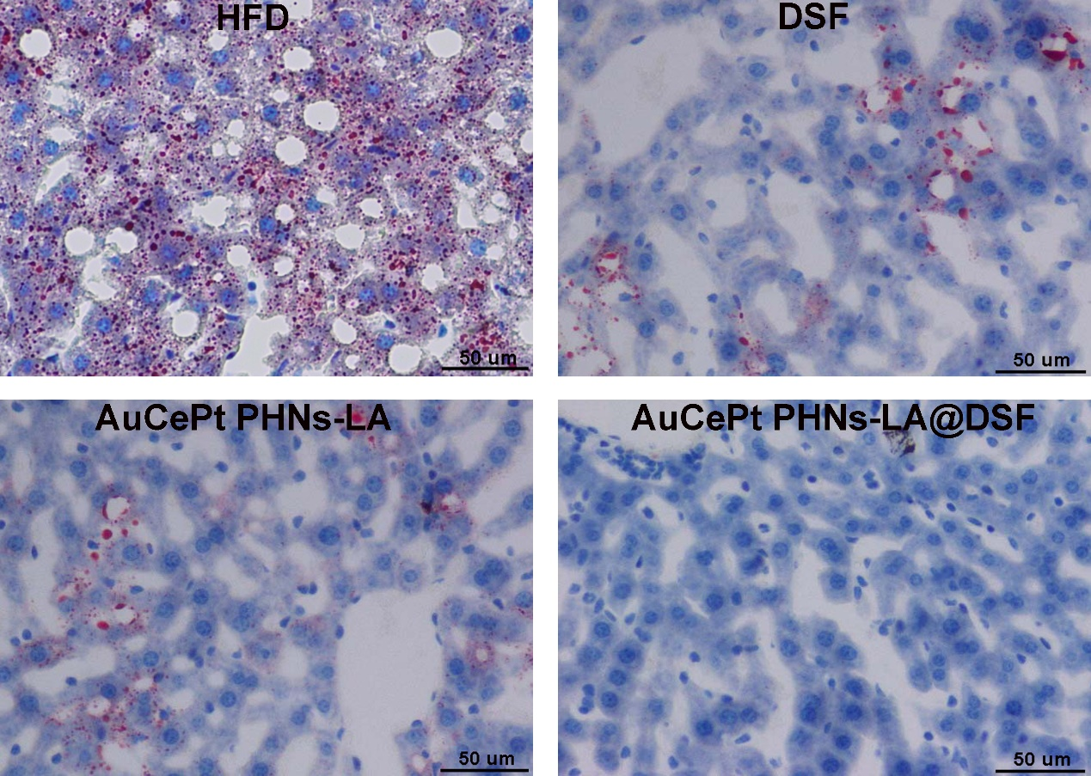
Figure S16. The liver oil-red staining of the C75BL/6J mice in the groups of HFD, DSF, AuCePt PHNs-LA, and AuCePt PHNs-LA@DSF.

Figure S17. Effect of AuCePt PHNs-LA@DSF on energy homeostasis. 24 h CO₂ production (A) and quantitative analysis (B), whole-body energy expenditure (C), and rectal temperature (D) of mice in the groups of HFD, DSF, AuCePt PHNs-LA, and AuCePt PHNs-LA@DSF. Data are expressed as mean ± standard error of mean, * p <0.05, **p <0.01, ***p <0.001 vs. control.

Figure S18. Fluorescent image of liver tissue stained with DCFH-DA. HFD-fed WT mice were treated with DSF, AuCePt PHNs-LA, or AuCePt PHNs-LA@DSF and fluorescent image for DCFH-DA staining was performed as indicated in the methods.

Figure S19. Effects of AuCePt PHNs-LA@DSF on the glucose and lipid metabolism in ob/ob mice. ob/ob mice were treated with or without AuCePt PHNs-LA@DSF, as indicated in the Methods. (A) Body weight curve. (B) Fasting insulin level. (C) Oil-Red-O staining in the liver. (D) Fluorescent image for DCFH-DA staining. Data are expressed as mean ± standard deviation, n = 6 mice for each group. ***p <0.001 vs. SD group.
Table S1. Blood biochemical and routine parameters of C57BL/6J mice in different treatment groups
 | HFD | DSF | AuCePt  PHNs-LA | AuCePt PHNs-LA@DSF
BUN (mmol/L) | 12.1 ± 1.1 | 10.4 ± 0.9 | 10.0 ± 1.2 | 11.9 ± 1.4
Cre (μmol/L)  CK (U/L)  CK-MB | 19.3 ± 2.9  111.0 ± 18.5  14.67 ± 3.04 | 21.3 ± 3.5  116.2 ± 21.6  12.33 ± 2.81 | 19.5 ± 3.1  119.7 ± 26.0  12.67 ± 4.31 | 18.8 ± 2.6  113.7 ± 12.3  11.83 ± 6.12
RBC (10¹²/L) | 8.66 ± 1.3 | 8.97 ± 1.0 | 8.48 ± 0.6 | 8.86 ± 0.7
WBC (10⁹/L) | 5.13 ± 0.8 | 4.00 ± 0.5 | 3.99 ± 0.7 | 4.54 ± 0.4
PLT (10¹¹/L) | 10.91 ± 1.4 | 10.12 ± 1.2 | 9.93 ± 1.3 | 10.33 ± 0.9
HGB (g/L) | 134.0 ± 16.0 | 138.7 ± 8.4 | 136.2 ± 6.7 | 138.5 ± 7.6
BUN: Blood urea nitrogen, Cre: Blood creatinine, CK: Creatine kinase, CK-MB: Creatine kinase isoenzyme MB, RBC: Red blood cell, WBC: White blood cell, PLT: Platelet, HGB: Hemoglobin

