Supporting Information
Reactive Extrusion of Cellulose Esters in Ionic Liquid: Exploring Properties and Performance Across Different Cellulose Types and Degree of Polymerizations
Elvira Tarasova¹, Illia Krasnou^{1*}, Giiguulen Enkhsaikhan², Ibrahim Abousharabia², Caio César Zandonadi Nunes², Darshni Karthegesu², Nutan Savale¹, Eero Kontturi² and Andres Krumme¹
C=11%
C=3%
Figure S1: Viscosity of cellulose solutions at different concentrations.

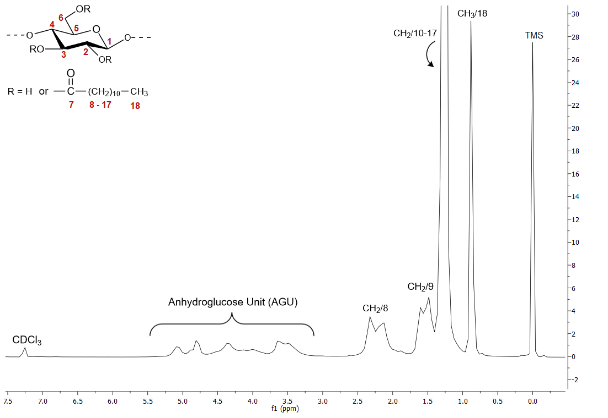
Figure S2. ¹H NMR spectrum of cellulose laurate R-CL-800 in Chloroform-d (400 MHz, 298 K)
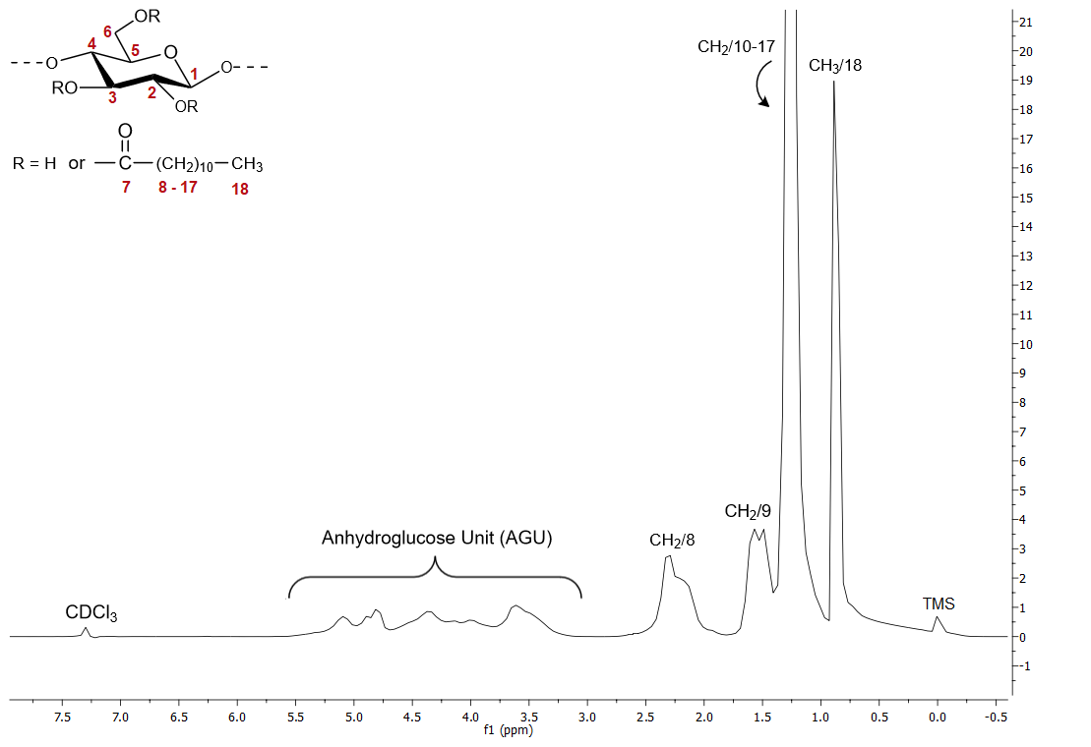
Figure S3. ¹H NMR spectrum of cellulose laurateR- CL-200 in Chloroform-d (400 MHz, 298 K)

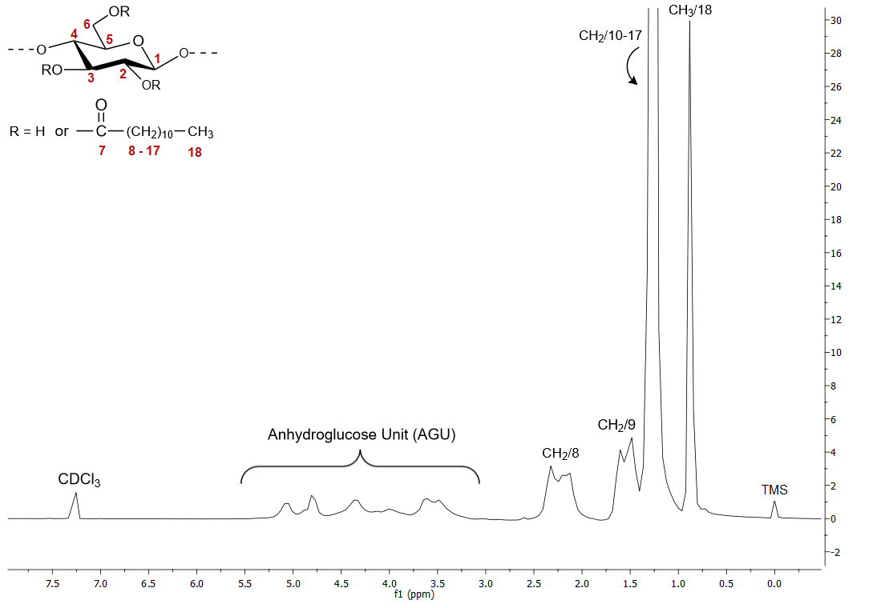
Figure S4. ¹H NMR spectrum of cellulose laurate R-CL-1000 in Chloroform-d (400 MHz, 298 K)
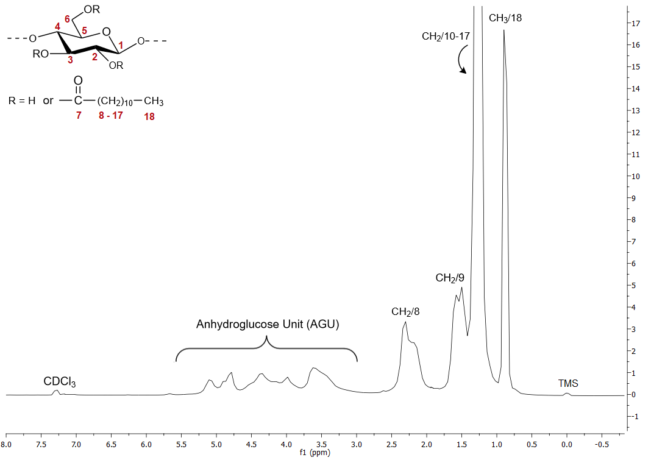
Figure S5. ¹H NMR spectrum of cellulose laurate R-CL-150 in Chloroform-d (400 MHz, 298 K)

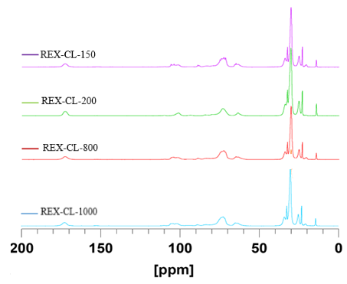
Figure S6. ssNMR spectra of REX-CLs.

Figure S7. The molar mass distribution of celluloses studied

Figure S8. Evolution of torque with time during reaction in micro-compounder

Figure S9. TGA analysis of R-CLs and REX-CLs

