Additional file for “Evaluating the cradle-to-gate Environmental Impact and cooling performance of Advanced Daytime Radiative Cooling Materials to Establish a Comparative Framework for a Novel Photonic Meta-Concrete”
Adams, N.*¹ , Carlosena, L.² & Allacker, K.¹
¹KU Leuven, Faculty of Engineering Science, Department of Architecture, Kasteelpark Arenberg 1 – box 2431, 3001 Leuven, Belgium
²Engineering Department, Public University of Navarre (UPNA), Arrosadia Campus, 31006 Pamplona, Spain
(*) Corresponding author: Nick Adams: nick.adams@kuleuven.be

This Additional file contains the impact of the selected radiative cooling materials in the five selected impact categories (Figure S1-S8), the relationship between the cooling performance and the impact in the five selected impact categories (Figure S9-S13), the input data to model the selected radiative cooling materials using the Ecoinvent v3.6 database (Table S1), the emissivity of the selected radiative cooling materials in 39 wavebands (Table S2), the calculation of the sputter deposition parameters (Table S3), and the environmental impact of the ten selected radiative cooling materials in all impact categories (Table S4.1-S4.10).

Figure S1. Particulate matter impact of the selected RC materials, showing the various components of the production process. | Figure S2. Particulate matter impact of the selected RC materials, showing the ratio of the various components in the production process.
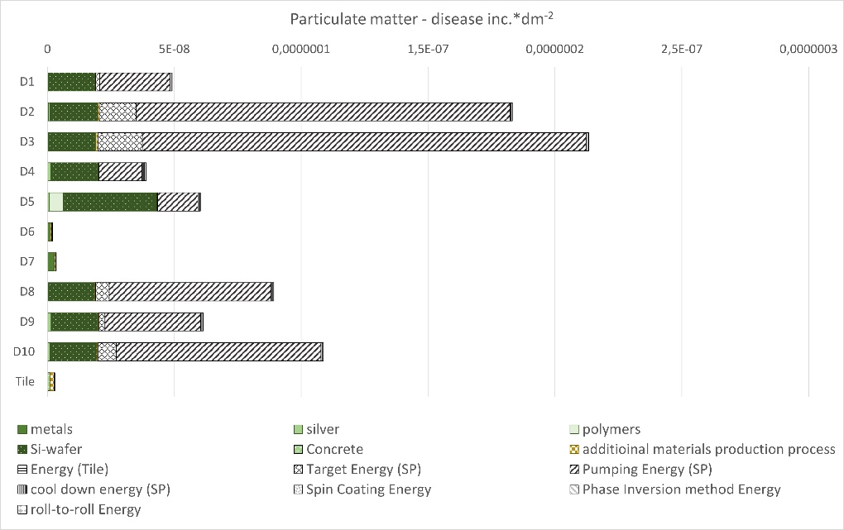 | 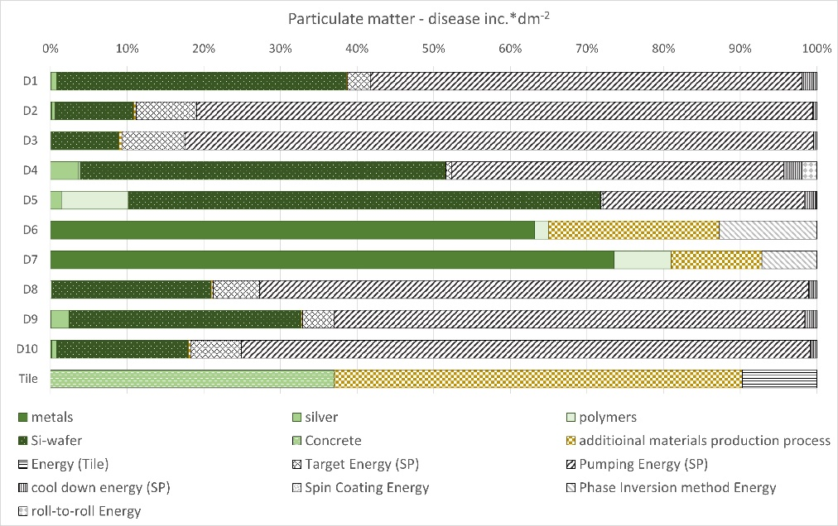

Figure S3. Acidification impact of the selected RC materials, showing the various components of the production process. | Figure S4. Acidification impact of the selected RC materials, showing the ratio of the various components in the production process.
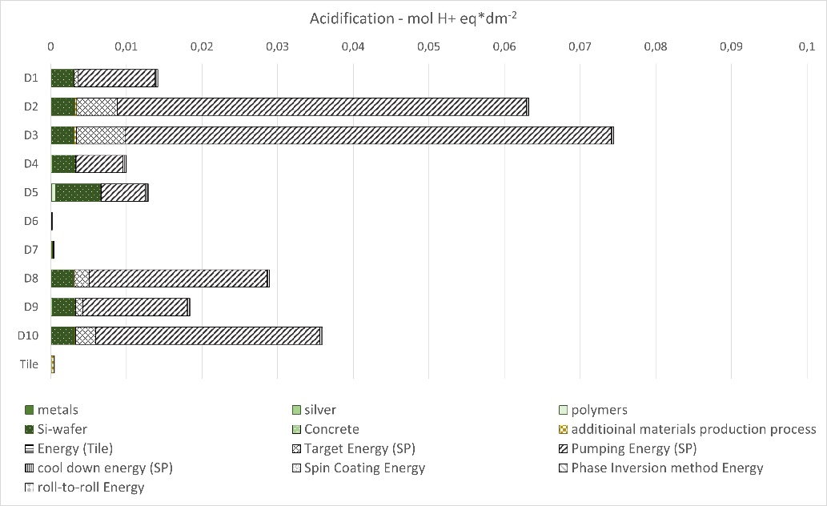 | 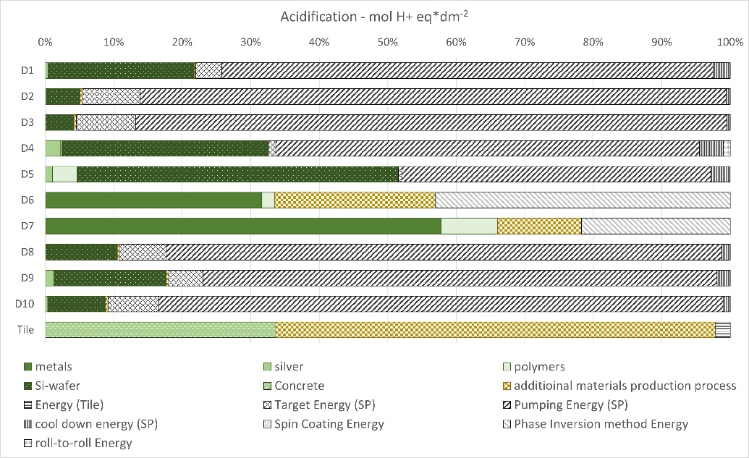

Figure S5. Resource use fossils impact of the selected RC materials, showing the various components of the production process. | Figure S6. Resource use fossils impact of the selected RC materials, showing the ratio of the various components in the production process.
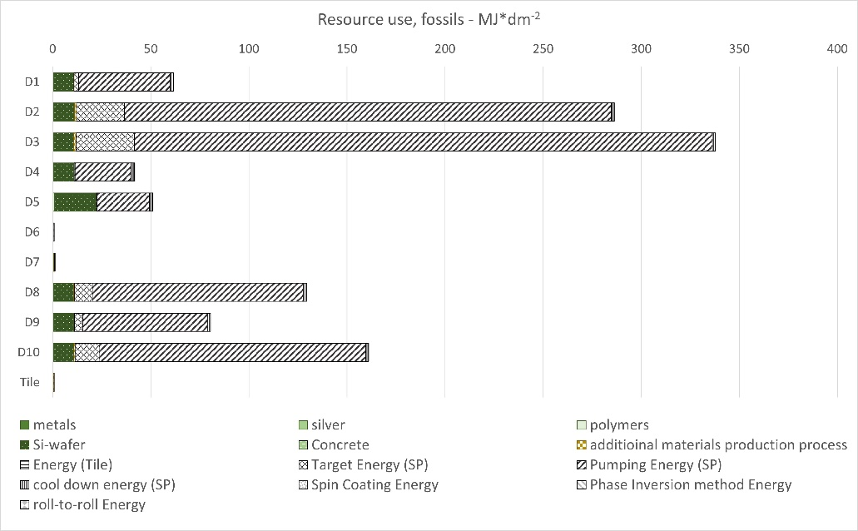 | 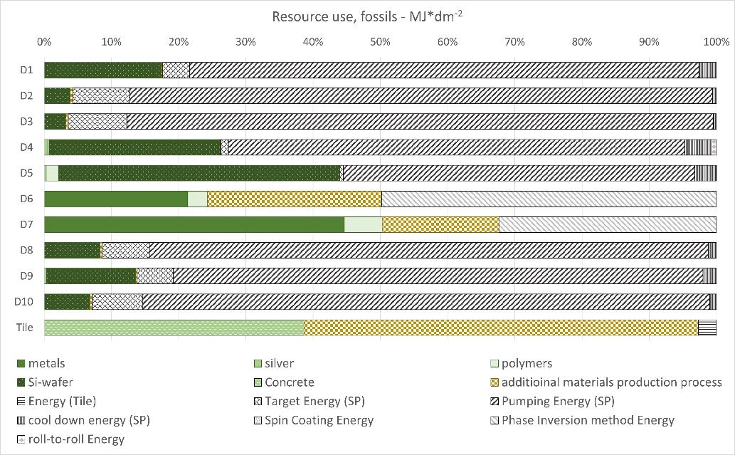

Figure S7. Resource use minerals and metals impact of the selected RC materials, showing the various components of the production process. | Figure S8. Resource use minerals and metals impact the selected RC materials, showing the ratio of the various components in the production process.
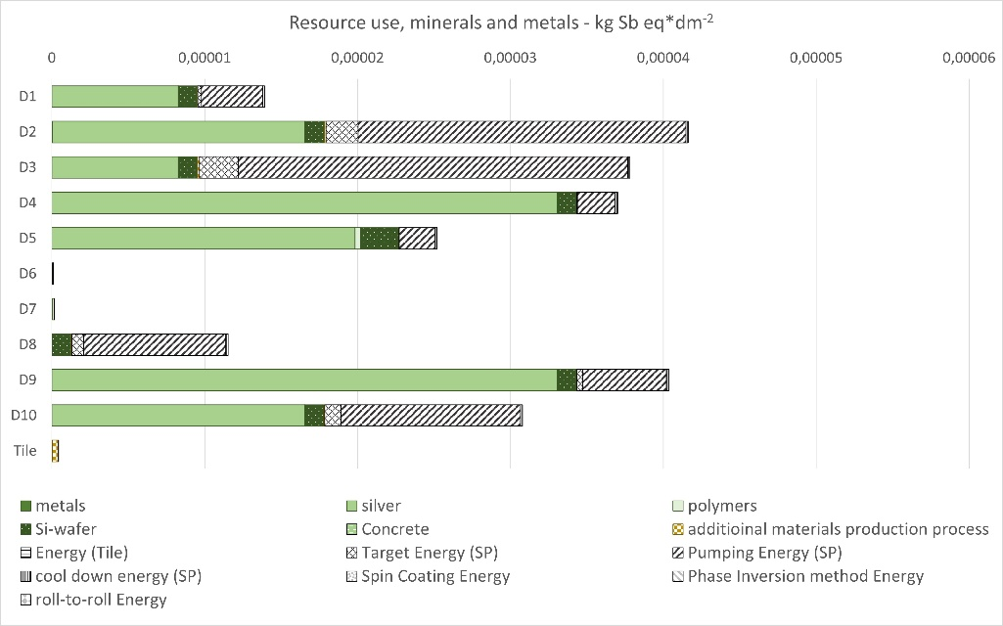 | 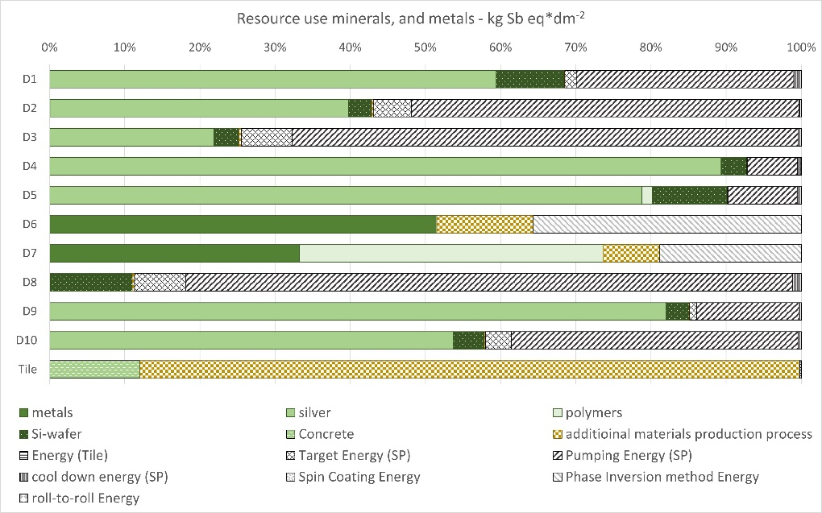

Figure S9. Relationship between accumulated radiated heat and solar gains (kWh·m⁻²) and global warming potential (kg CO2 eq.·dm⁻²), materials in the pareto front are highlighted with a border.
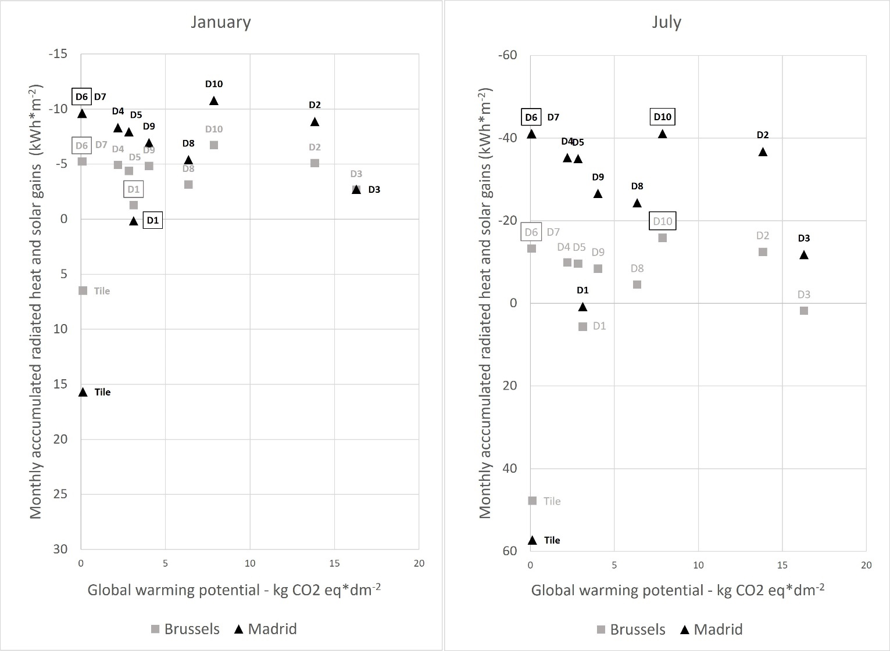

Figure S10. Relationship between accumulated radiated heat and solar gains (kWh·m⁻²) and particulate matter (disease inc.·dm⁻²), materials in the pareto front are highlighted with a border.
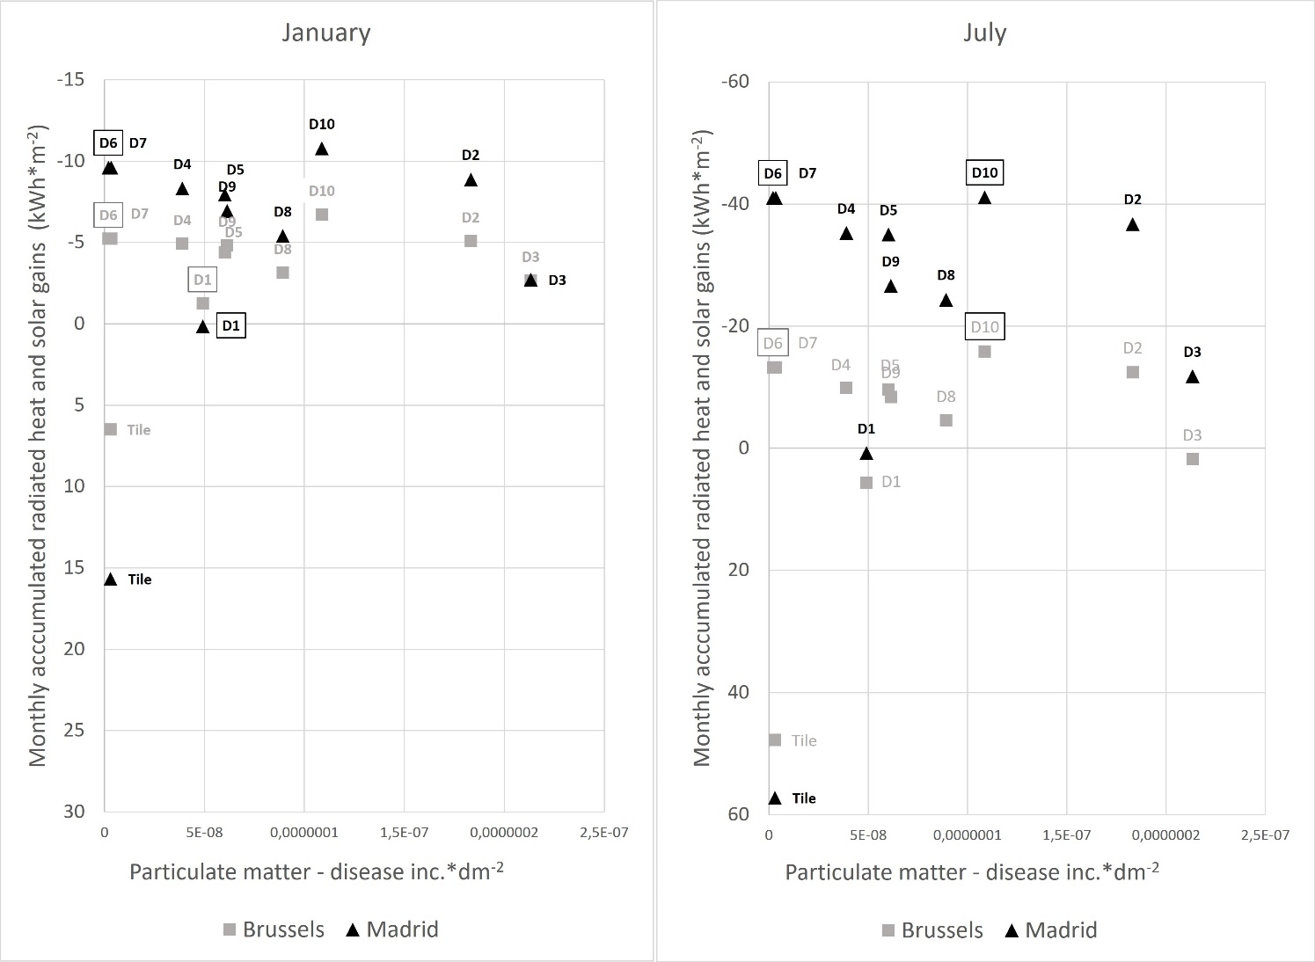

Figure S11. Relationship between accumulated radiated heat and solar gains (kWh·m⁻²) and acidification (mol H+ eq.·dm⁻²), materials in the pareto front are highlighted with a border.
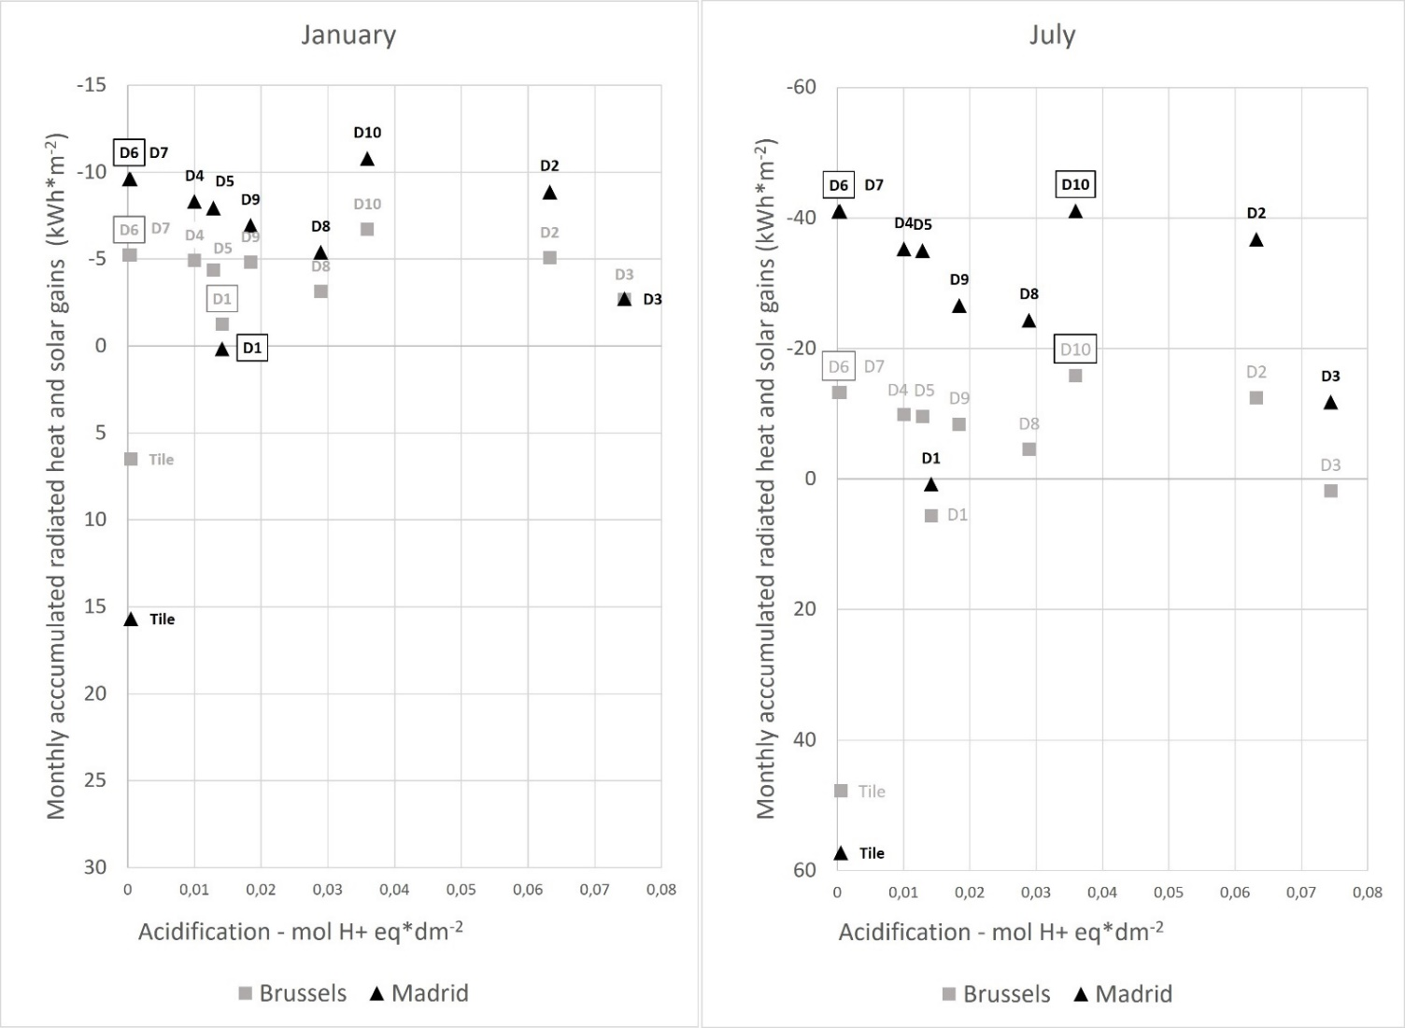

Figure S12. Relationship between accumulated radiated heat and solar gains (kWh·m⁻²) and resource use fossils (MJ·dm⁻²), materials in the pareto front are highlighted with a border.
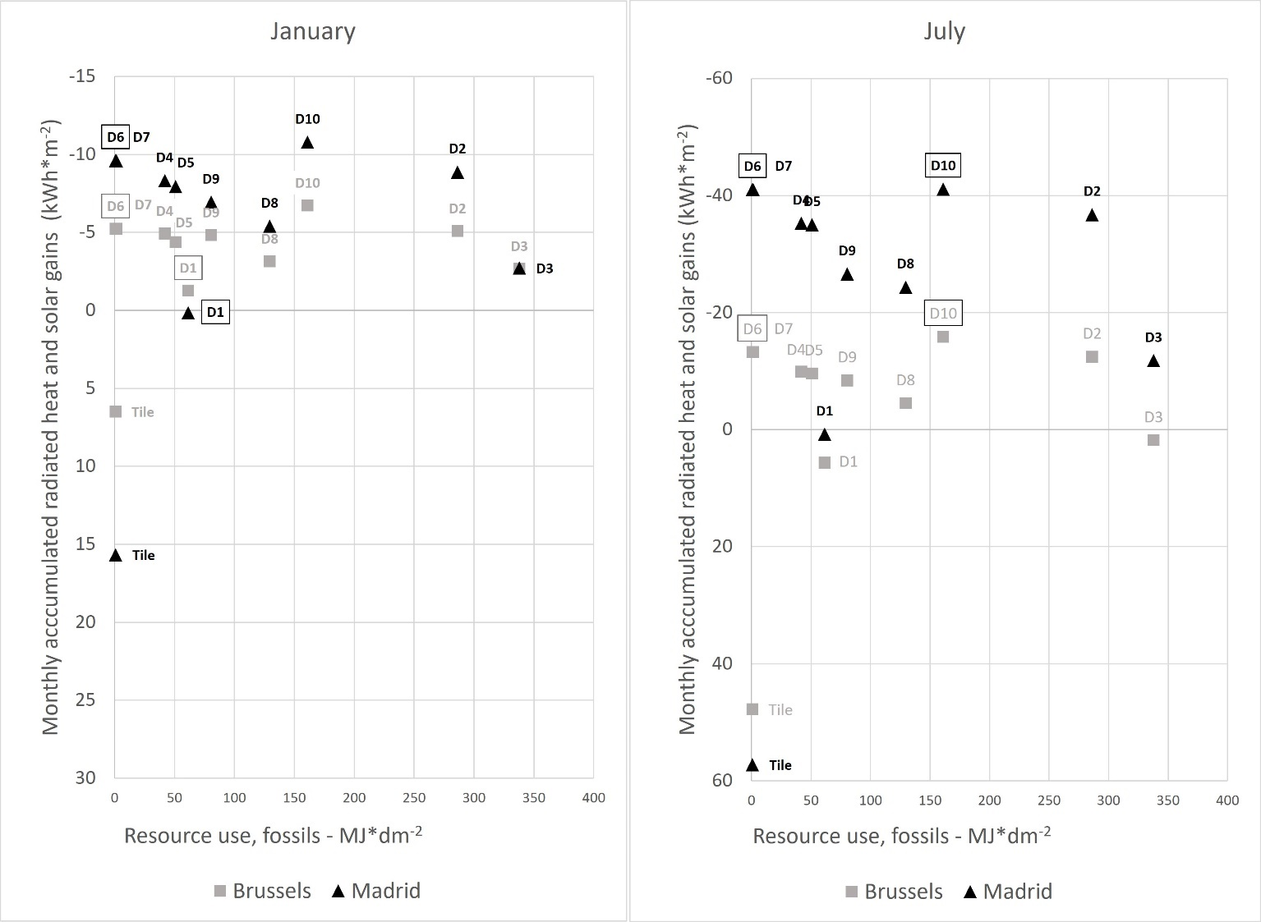

Figure S10. Relationship between accumulated radiated heat and solar gains (kWh·m⁻²) and resource use minerals and metals (kg Sb eq.·dm⁻²), materials in the pareto front are highlighted with a border.
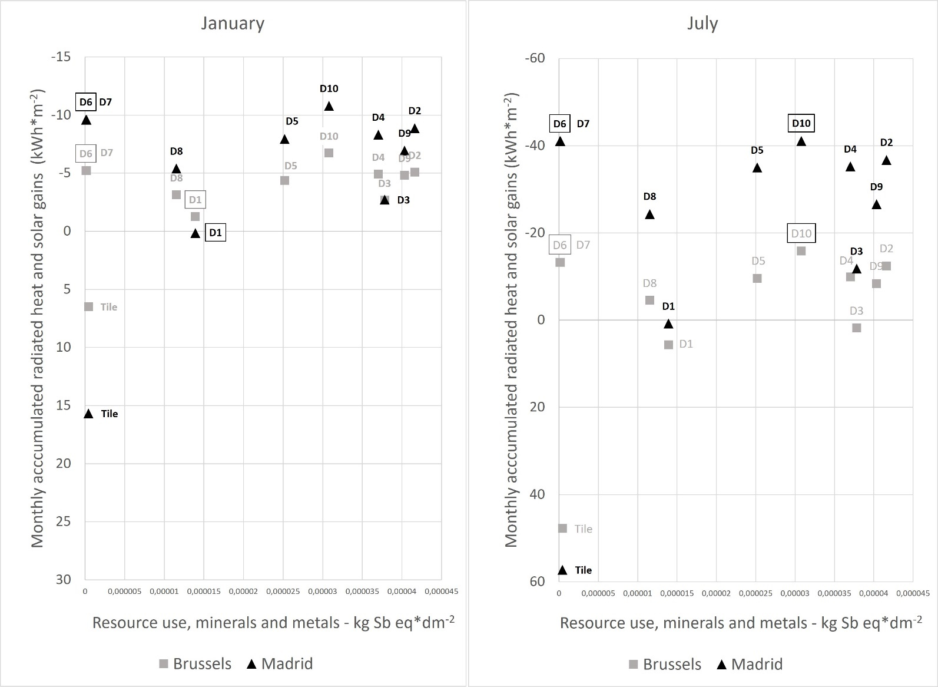
Table S1. Input data to model the selected radiative cooling materials using the Ecoinvent v3.6 database.
RC material | material/process | Ecoinvent v3.6 records | amount | unit | additional information
D1 | Titanium | Titanium, primary {GLO}| production | Cut-off, U (RER electricity) | 0,00005771 | kg
D1 | Silicon | Silicon, solar grade {RER}| silicon production, solar grade, modified Siemens process | Cut-off, U | 0,000014 | kg
D1 | silver | Silver {GLO}| market for | Cut-off, U | 0,0000105 | kg
D1 | Si-wafer | Multi-Si wafer, ribbon {RER}| multi-Si wafer production, ribbon | Cut-off, U | 0,01 | m2
D1 | electricity | Electricity, medium voltage {RER}| market group for | Cut-off, U | 6,42608101 | kWh
D1 | Argon gass | Argon, liquid {RER}| production | Cut-off, U | 1341,14 | cm3 | input and emissions
D2 | Silicon | Silicon, solar grade {RER}| silicon production, solar grade, modified Siemens process | Cut-off, U | 0,000308 | kg
D2 | Titanium | Titanium, primary {GLO}| production | Cut-off, U (RER electricity) | 0,000316 | kg
D2 | Silver | Silver {GLO}| market for | Cut-off, U | 0,000021 | kg
D2 | Si-wafer | Multi-Si wafer, ribbon {RER}| multi-Si wafer production, ribbon | Cut-off, U | 0,01 | m2
D2 | electricity | Electricity, medium voltage {RER}| market group for | Cut-off, U | 34,3301478 | kWh
D2 | Argon gass | Argon, liquid {RER}| production | Cut-off, U | 2513,02 | cm3 | input and emissions
D3 | Silicon | Silicon, solar grade {RER}| silicon production, solar grade, modified Siemens process | Cut-off, U | 0,0001197 | kg
D3 | titanium | Titanium, primary {GLO}| production | Cut-off, U (RER electricity) | 0,0000653 | kg
D3 | magnesiumsulfate | Magnesium sulfate {RER}| production | Cut-off, U | 0,0001828 | kg
D3 | silver | Silver {GLO}| market for | Cut-off, U | 0,0000105 | kg
D3 | Si-wafer | Multi-Si wafer, ribbon {RER}| multi-Si wafer production, ribbon | Cut-off, U | 0,01 | m2
D3 | electricity | Electricity, medium voltage {RER}| market group for | Cut-off, U | 40,7826218 | kWh
D3 | Argon gass | Argon, liquid {RER}| production | Cut-off, U | 2408,85 | cm3 | input and emissions
D3 | sheet rolling (only energy use) | Sheet rolling, aluminium {RER}| processing | Cut-off, U | 0,0000598 | kg
D4 | 4-methyl-2-pentanone | 4-methyl-2-pentanone {RER}| production | Cut-off, U | 0,00037694 | kg
D4 | silicon | Silicon, solar grade {RER}| silicon production, solar grade, modified Siemens process | Cut-off, U | 0,0000699 | kg
D4 | silver | Silver {GLO}| market for | Cut-off, U | 0,000042 | kg
D4 | sheet rolling (only energy use) | Sheet rolling, aluminium {RER}| processing | Cut-off, U | 0,044684 | kg
D4 | Si-wafer | Multi-Si wafer, ribbon {RER}| multi-Si wafer production, ribbon | Cut-off, U | 0,01 | m2
D4 | electricity | Electricity, medium voltage {RER}| market group for | Cut-off, U | 3,90700602 | kWh
D4 | Argon gass | Argon, liquid {RER}| production | Cut-off, U | 260,41 | cm3 | input and emissions
D5 | silver | Silver {GLO}| market for | Cut-off, U | 0,0000252 | kg
D5 | Polydimethylsiloxane | Polydimethylsiloxane {GLO}| polydimethylsiloxane production | Cut-off, U | 0,00483 | kg
D5 | Si-wafer | Multi-Si wafer, ribbon {RER}| production | Cut-off, U | 0,02 | m2
D5 | extrusion (only energy use) | Extrusion, plastic film {RER}| extrusion, plastic film | Cut-off, U | 0,00193 | kg
D5 | electricity | Electricity, medium voltage {RER}| market group for | Cut-off, U | 3,66420361 | kWh
D5 | Argon gass | Argon, liquid {RER}| production | Cut-off, U | 156,25 | cm3 | input and emissions
D6 | polystyrene | Polystyrene, general purpose {RER}| production | Cut-off, U | 0,0003 | kg
D6 | steel | Reinforcing steel {RER}| production | Cut-off, U | 0,0079 | kg
D6 | sheet rolling (only energy use) | Sheet rolling, steel {RER}| processing | Cut-off, U | 0,0079 | kg
D6 | electricity | Electricity, medium voltage {RER}| market group for | Cut-off, U | 0,0523 | kWh
D6 | Acetone | Acetone, liquid {RER}| production | Cut-off, U | 0,0025 | kg | input and emissions
D6 | Nitrogen | Nitrogen, liquid {RER}| market for | Cut-off, U | 0,0000021 | kg
D6 | water | Tap water {RER}| market group for | Cut-off, U | 5 | l | input and emissions
D7 | polyvinylfluoride | Polyvinylfluoride {RoW}| production | Cut-off, U | 0,0005 | kg
D7 | Aluminium | Aluminium, primary, ingot {IAI Area, EU27 & EFTA}| production | Cut-off, U | 0,0054 | kg
D7 | sheet rolling (only energy use) | Sheet rolling, aluminium {RER}| processing | Cut-off, U | 0,0054 | kg
D7 | electricity | Electricity, medium voltage {RER}| market group for | Cut-off, U | 0,0523 | kWh
D7 | Acetone | Acetone, liquid {RER}| production | Cut-off, U | 0,0025 | kg | input and emissions
D7 | Nitrogen | Nitrogen, liquid {RER}| market for | Cut-off, U | 0,00000351 | kg
D7 | water | Tap water {RER}| market group for | Cut-off, U | 5 | l | input and emissions
D8 | Silicon | Silicon, solar grade {RER}| silicon production, solar grade, modified Siemens process | Cut-off, U | 0,000178 | kg
D8 | Si-wafer | Multi-Si wafer, ribbon {RER}| production | Cut-off, U | 0,02 | m2
D8 | electricity | Electricity, medium voltage {RER}| market group for | Cut-off, U | 14,8725698 | kwh
D8 | Argon | Argon, liquid {RER}| production | Cut-off, U | 7826,35468 | l | input and emissions
D9 | Silicon | Silicon, solar grade {RER}| silicon production, solar grade, modified Siemens process | Cut-off, U | 0,00004862 | kg
D9 | titanium | Titanium, primary {GLO}| production | Cut-off, U (RER electricity) | 0,00004199 | kg
D9 | silver | Silver {GLO}| market for | Cut-off, U | 0,000042 | kg
D9 | Si-wafer | Multi-Si wafer, ribbon {RER}| production | Cut-off, U | 0,01 | m2
D9 | electricity | Electricity, medium voltage {RER}| market group for | Cut-off, U | 8,69324849 | kwh
D9 | Argon | Argon, liquid {RER}| production | Cut-off, U | 3647,37274 | l | input and emissions
D10 | Silicon | Silicon, solar grade {RER}| silicon production, solar grade, modified Siemens process | Cut-off, U | 0,000142 | kg
D10 | titanium | Titanium, primary {GLO}| production | Cut-off, U (RER electricity) | 0,000176 | kg
D10 | silver | Silver {GLO}| market for | Cut-off, U | 0,000021 | kg
D10 | Si-wafer | Multi-Si wafer, ribbon {RER}| production | Cut-off, U | 0,01 | m2
D10 | electricity | Electricity, medium voltage {RER}| market group for | Cut-off, U | 18,7877586 | kwh
D10 | Argon | Argon, liquid {RER}| production | Cut-off, U | 10474,1379 | l | input and emissions

Table S2. Emissivity of the selected daytime radiative cooling materials in the 39 wavebands used in the thermal radiation model for the ten selected radiative cooling materials and the concrete roof tile.
Waveband | Emissivity
 | D1 | D2 | D3 | D4 | D5 | D6/D7 | D8 | D9 | D10 | Concrete roof tile
1 | 0,345 | 0,080 | 0,570 | 0,840 | 0,875 | 0,024 | 0,440 | 0,370 | 0,032 | 0,642
2 | 0,454 | 0,086 | 0,570 | 0,501 | 0,518 | 0,021 | 0,045 | 0,371 | 0,006 | 0,642
3 | 0,239 | 0,024 | 0,239 | 0,034 | 0,023 | 0,021 | 0,026 | 0,031 | 0,005 | 0,594
4 | 0,036 | 0,019 | 0,067 | 0,026 | 0,023 | 0,029 | 0,005 | 0,023 | 0,022 | 0,599
5 | 0,074 | 0,077 | 0,030 | 0,041 | 0,047 | 0,060 | 0,233 | 0,013 | 0,007 | 0,647
6 | 0,047 | 0,005 | 0,040 | 0,098 | 0,129 | 0,225 | 0,582 | 0,013 | 0,031 | 0,850
7 | 0,003 | 0,016 | 0,101 | 0,519 | 0,188 | 0,405 | 0,785 | 0,226 | 0,058 | 0,921
8 | 0,017 | 0,057 | 0,162 | 0,742 | 0,668 | 0,479 | 0,698 | 0,225 | 0,018 | 0,928
9 | 0,085 | 0,058 | 0,103 | 0,404 | 0,465 | 0,383 | 0,854 | 0,020 | 0,014 | 0,926
10 | 0,106 | 0,062 | 0,169 | 0,373 | 0,532 | 0,450 | 0,957 | 0,016 | 0,019 | 0,928
11 | 0,047 | 0,062 | 0,077 | 0,386 | 0,825 | 0,497 | 0,879 | 0,018 | 0,135 | 0,929
12 | 0,021 | 0,087 | 0,390 | 0,678 | 0,948 | 0,730 | 0,903 | 0,082 | 0,108 | 0,933
13 | 0,030 | 0,154 | 0,078 | 0,947 | 0,951 | 0,978 | 0,813 | 0,136 | 0,489 | 0,888
14 | 0,158 | 0,580 | 0,457 | 0,873 | 0,952 | 0,977 | 0,968 | 0,377 | 0,962 | 0,923
15 | 0,428 | 0,923 | 0,787 | 0,913 | 0,983 | 0,966 | 0,704 | 0,726 | 0,837 | 0,938
16 | 0,494 | 0,719 | 0,667 | 0,933 | 0,985 | 0,973 | 0,633 | 0,744 | 0,798 | 0,943
17 | 0,682 | 0,629 | 0,520 | 0,951 | 0,941 | 0,972 | 0,699 | 0,811 | 0,860 | 0,945
18 | 0,864 | 0,687 | 0,631 | 0,954 | 0,889 | 0,977 | 0,749 | 0,871 | 0,898 | 0,943
19 | 0,969 | 0,763 | 0,851 | 0,948 | 0,897 | 0,964 | 0,793 | 0,750 | 0,599 | 0,937
20 | 0,599 | 0,795 | 0,686 | 0,956 | 0,901 | 0,941 | 0,802 | 0,627 | 0,611 | 0,918
21 | 0,203 | 0,762 | 0,684 | 0,912 | 0,935 | 0,922 | 0,860 | 0,655 | 0,722 | 0,913
22 | 0,170 | 0,864 | 0,631 | 0,931 | 0,969 | 0,946 | 0,896 | 0,520 | 0,783 | 0,915
23 | 0,177 | 0,957 | 0,684 | 0,955 | 0,955 | 0,947 | 0,883 | 0,520 | 0,832 | 0,922
24 | 0,172 | 0,955 | 0,790 | 0,935 | 0,906 | 0,947 | 0,880 | 0,561 | 0,884 | 0,923
25 | 0,160 | 0,963 | 0,798 | 0,883 | 0,899 | 0,949 | 0,893 | 0,502 | 0,919 | 0,925
26 | 0,151 | 0,961 | 0,609 | 0,865 | 0,930 | 0,956 | 0,903 | 0,445 | 0,923 | 0,928
27 | 0,154 | 0,959 | 0,730 | 0,850 | 0,941 | 0,949 | 0,924 | 0,427 | 0,903 | 0,928
28 | 0,174 | 0,972 | 0,528 | 0,848 | 0,952 | 0,973 | 0,904 | 0,362 | 0,606 | 0,931
29 | 0,170 | 0,960 | 0,248 | 0,898 | 0,960 | 0,989 | 0,877 | 0,341 | 0,447 | 0,900
30 | 0,170 | 0,960 | 0,393 | 0,927 | 0,965 | 0,990 | 0,862 | 0,346 | 0,421 | 0,900
31 | 0,170 | 0,960 | 0,536 | 0,889 | 0,965 | 0,995 | 0,844 | 0,339 | 0,316 | 0,900
32 | 0,170 | 0,960 | 0,826 | 0,907 | 0,955 | 0,990 | 0,853 | 0,325 | 0,351 | 0,900
33 | 0,170 | 0,960 | 0,748 | 0,959 | 0,977 | 0,990 | 0,936 | 0,317 | 0,265 | 0,900
34 | 0,170 | 0,960 | 0,701 | 0,933 | 0,952 | 0,990 | 0,668 | 0,328 | 0,257 | 0,900
35 | 0,170 | 0,960 | 0,628 | 0,924 | 0,943 | 0,990 | 0,668 | 0,370 | 0,227 | 0,900
36 | 0,170 | 0,960 | 0,684 | 0,944 | 0,983 | 0,990 | 0,728 | 0,427 | 0,288 | 0,900
37 | 0,170 | 0,960 | 0,791 | 0,877 | 0,967 | 0,990 | 0,764 | 0,400 | 0,546 | 0,900
38 | 0,170 | 0,960 | 0,682 | 0,850 | 0,950 | 0,990 | 0,760 | 0,400 | 0,500 | 0,900
39 | 0,170 | 0,960 | 0,650 | 0,850 | 0,950 | 0,990 | 0,760 | 0,400 | 0,000 | 0,900

Table S3. Calculation of the different sputter deposition parameters for the selected radiative cooling materials.
Material | D1 | D2 | D3 | D4 | D5 | D6 | D7 | D8 | D9 | D10
Sputtering rate (nm/s) | 0,406 |  |  |  |  |  |  | 0,406
sputter power (kW) | 0,436 |  |  |  |  |  |  | 0,436
total sputter thickness (nm) | 1030,000 | 10224,000 | 12350,000 | 200,000 | 120,000 |  |  | 3813,000 | 1777,000 | 5103,000
Sputter efficiency (%) | 50,000
Sputter time (s) | 2536,946 | 25182,266 | 30418,719 | 492,611 | 295,567 |  |  | 9391,626 | 4376,847 | 12568,966
target energy (kWh) | 0,307 | 3,050 | 3,684 | 0,060 | 0,036 |  |  | 1,137 | 0,530 | 1,522
Argon rate (cc/min) | 50,000
amount of argon (cc) | 2114,122 | 20985,222 | 25348,933 | 410,509 | 246,305 |  |  | 7826,355 | 3647,373 | 10474,138
pumping time (s) | 2700,000
total pumping time (s) | 5236,946 | 27882,266 | 33118,719 | 3192,611 | 2995,567 |  |  | 12091,626 | 7076,847 | 15268,966
pumping power (kW) | 4,000
Pumping energy (kWh) | 5,819 | 30,980 | 36,799 | 3,547 | 3,328 |  |  | 13,435 | 7,863 | 16,966
cooling energy (kWh) | 0,300
Total energy use (kWh) | 6,426 | 34,330 | 40,783 | 3,907 | 3,664 |  |  | 14,873 | 8,693 | 18,788

Table 4. Environmental impact of the ten selected radiative cooling materials using the impact categories of the EN15804+A2 standard.
Table S4.1. Radiative cooling material D1.
Radiative cooling material D1
Impact Category | Unit | Total | Titanium | Silicon | Silicon | Titanium | Silver | Energy deposition | Silicon wafer | Argon | Energy cooling system | Energy pumps
Climate change | kg CO2 eq | 3,12E+00 | 1,12E-03 | 5,95E-04 | 7,93E-05 | 7,44E-05 | 4,96E-03 | 1,17E-01 | 6,93E-01 | 5,13E-03 | 7,67E-02 | 2,22E+00
Ozone depletion | kg CFC11 eq | 5,70E-08 | 8,67E-11 | 2,27E-11 | 3,02E-12 | 5,78E-12 | 7,93E-11 | 1,92E-09 | 1,72E-08 | 8,84E-11 | 1,25E-09 | 3,63E-08
Ionising radiation | kBq U-235 eq | 5,23E-01 | 1,09E-04 | 5,33E-05 | 7,10E-06 | 7,30E-06 | 2,11E-04 | 2,24E-02 | 6,11E-02 | 9,71E-04 | 1,46E-02 | 4,23E-01
Photochemical ozone formation | kg NMVOC eq | 7,52E-03 | 4,35E-06 | 1,59E-06 | 2,13E-07 | 2,90E-07 | 4,85E-05 | 2,71E-04 | 1,87E-03 | 1,19E-05 | 1,77E-04 | 5,14E-03
Particulate matter | disease inc. | 4,91E-08 | 5,56E-11 | 1,09E-11 | 1,46E-12 | 3,71E-12 | 3,55E-10 | 1,46E-09 | 1,86E-08 | 6,47E-11 | 9,56E-10 | 2,77E-08
Human toxicity, non-cancer | CTUh | 2,98E-08 | 6,49E-11 | 7,12E-12 | 9,49E-13 | 4,33E-12 | 2,45E-10 | 1,05E-09 | 7,84E-09 | 4,63E-11 | 6,86E-10 | 1,98E-08
Human toxicity, cancer | CTUh | 1,04E-09 | 5,12E-13 | 4,46E-13 | 5,95E-14 | 3,41E-14 | 5,82E-12 | 3,34E-11 | 3,44E-10 | 1,48E-12 | 2,19E-11 | 6,33E-10
Acidification | mol H+ eq | 1,42E-02 | 5,70E-06 | 2,31E-06 | 3,08E-07 | 3,80E-07 | 5,61E-05 | 5,37E-04 | 3,02E-03 | 2,34E-05 | 3,51E-04 | 1,02E-02
Eutrophication, freshwater | kg P eq | 2,61E-04 | 7,42E-08 | 2,97E-08 | 3,96E-09 | 4,95E-09 | 1,42E-06 | 1,04E-05 | 4,43E-05 | 4,54E-07 | 6,83E-06 | 1,98E-04
Eutrophication, marine | kg N eq | 2,03E-03 | 8,94E-07 | 3,80E-07 | 5,07E-08 | 5,96E-08 | 1,61E-05 | 7,29E-05 | 5,05E-04 | 3,19E-06 | 4,77E-05 | 1,38E-03
Eutrophication, terrestrial | mol N eq | 2,33E-02 | 9,99E-06 | 4,26E-06 | 5,69E-07 | 6,66E-07 | 2,05E-04 | 8,41E-04 | 5,71E-03 | 3,68E-05 | 5,50E-04 | 1,59E-02
Ecotoxicity, freshwater | CTUe | 5,37E+00 | 5,25E-03 | 1,36E-03 | 1,81E-04 | 3,50E-04 | 2,51E-01 | 1,75E-01 | 1,49E+00 | 7,76E-03 | 1,15E-01 | 3,32E+00
Land use | Pt | 1,02E+01 | 7,82E-03 | 2,34E-03 | 3,12E-04 | 5,21E-04 | 5,66E-02 | 3,70E-01 | 2,51E+00 | 1,62E-02 | 2,42E-01 | 7,01E+00
Resource use, fossils | MJ | 6,15E+01 | 1,72E-02 | 9,43E-03 | 1,26E-03 | 1,15E-03 | 6,27E-02 | 2,46E+00 | 1,07E+01 | 1,08E-01 | 1,61E+00 | 4,66E+01
Resource use, minerals and metals | kg Sb eq | 1,39E-05 | 4,02E-09 | 6,84E-10 | 9,12E-11 | 2,68E-10 | 8,27E-06 | 2,13E-07 | 1,26E-06 | 1,01E-08 | 1,39E-07 | 4,03E-06

Table S4.2. Radiative cooling material D2.
Radiative cooling material D2
Impact Category | Unit | Total | Silicon | Titanium | Silver | Energy deposition | Argon | Silicon wafer | Energy cooling system | Energy pumps
Climate change | kg CO2 eq | 1,38E+01 | 1,31E-02 | 6,52E-03 | 9,93E-03 | 1,16E+00 | 5,09E-02 | 6,93E-01 | 7,67E-02 | 1,18E+01
Ozone depletion | kg CFC11 eq | 2,33E-07 | 5,00E-10 | 5,07E-10 | 1,59E-10 | 1,90E-08 | 8,78E-10 | 1,72E-08 | 1,25E-09 | 1,93E-07
Ionising radiation | kBq U-235 eq | 2,56E+00 | 1,17E-03 | 6,40E-04 | 4,23E-04 | 2,22E-01 | 9,64E-03 | 6,11E-02 | 1,46E-02 | 2,25E+00
Photochemical ozone formation | kg NMVOC eq | 3,24E-02 | 3,51E-05 | 2,54E-05 | 9,70E-05 | 2,69E-03 | 1,18E-04 | 1,87E-03 | 1,77E-04 | 2,73E-02
Particulate matter | disease inc. | 1,83E-07 | 2,41E-10 | 3,25E-10 | 7,11E-10 | 1,45E-08 | 6,42E-10 | 1,86E-08 | 9,56E-10 | 1,47E-07
Human toxicity, non-cancer | CTUh | 1,26E-07 | 1,57E-10 | 3,79E-10 | 4,90E-10 | 1,04E-08 | 4,59E-10 | 7,84E-09 | 6,86E-10 | 1,06E-07
Human toxicity, cancer | CTUh | 4,11E-09 | 9,83E-12 | 2,99E-12 | 1,16E-11 | 3,32E-10 | 1,47E-11 | 3,44E-10 | 2,19E-11 | 3,37E-09
Acidification | mol H+ eq | 6,32E-02 | 5,09E-05 | 3,33E-05 | 1,12E-04 | 5,33E-03 | 2,33E-04 | 3,02E-03 | 3,51E-04 | 5,41E-02
Eutrophication, freshwater | kg P eq | 1,22E-03 | 6,54E-07 | 4,34E-07 | 2,84E-06 | 1,04E-04 | 4,51E-06 | 4,43E-05 | 6,83E-06 | 1,05E-03
Eutrophication, marine | kg N eq | 8,70E-03 | 8,38E-06 | 5,23E-06 | 3,22E-05 | 7,24E-04 | 3,16E-05 | 5,05E-04 | 4,77E-05 | 7,35E-03
Eutrophication, terrestrial | mol N eq | 1,00E-01 | 9,40E-05 | 5,84E-05 | 4,11E-04 | 8,35E-03 | 3,65E-04 | 5,71E-03 | 5,50E-04 | 8,48E-02
Ecotoxicity, freshwater | CTUe | 2,17E+01 | 2,99E-02 | 3,07E-02 | 5,02E-01 | 1,74E+00 | 7,71E-02 | 1,49E+00 | 1,15E-01 | 1,77E+01
Land use | Pt | 4,41E+01 | 5,16E-02 | 4,57E-02 | 1,13E-01 | 3,68E+00 | 1,61E-01 | 2,51E+00 | 2,42E-01 | 3,73E+01
Resource use, fossils | MJ | 2,86E+02 | 2,08E-01 | 1,00E-01 | 1,25E-01 | 2,44E+01 | 1,07E+00 | 1,07E+01 | 1,61E+00 | 2,48E+02
Resource use, minerals and metals | kg Sb eq | 4,16E-05 | 1,51E-08 | 2,35E-08 | 1,65E-05 | 2,11E-06 | 1,00E-07 | 1,26E-06 | 1,39E-07 | 2,14E-05

Table S4.3. Radiative cooling material D3.
Radiative cooling material D3 (part 1)
Impact Category | Unit | Total | Silicon | Silicon | Titanium | MagnesiumSulfate | Titanium | MagnesiumSulfate | Titanium | MagnesiumSulfate
Climate change | kg CO2 eq | 1,63E+01 | 9,41E-04 | 4,15E-03 | 2,33E-04 | 1,32E-06 | 4,65E-04 | 2,64E-06 | 6,51E-04 | 3,96E-06
Ozone depletion | kg CFC11 eq | 2,73E-07 | 3,59E-11 | 1,58E-10 | 1,81E-11 | 2,11E-14 | 3,61E-11 | 4,22E-14 | 5,06E-11 | 6,32E-14
Ionising radiation | kBq U-235 eq | 3,03E+00 | 8,43E-05 | 3,72E-04 | 2,28E-05 | 2,37E-07 | 4,56E-05 | 4,74E-07 | 6,39E-05 | 7,10E-07
Photochemical ozone formation | kg NMVOC eq | 3,81E-02 | 2,52E-06 | 1,11E-05 | 9,05E-07 | 4,01E-09 | 1,81E-06 | 8,02E-09 | 2,53E-06 | 1,20E-08
Particulate matter | disease inc. | 2,16E-07 | 1,73E-11 | 7,64E-11 | 1,16E-11 | 2,40E-13 | 2,32E-11 | 4,81E-13 | 3,24E-11 | 7,21E-13
Human toxicity, non-cancer | CTUh | 1,48E-07 | 1,13E-11 | 4,97E-11 | 1,35E-11 | 1,24E-14 | 2,70E-11 | 2,47E-14 | 3,79E-11 | 3,71E-14
Human toxicity, cancer | CTUh | 4,80E-09 | 7,06E-13 | 3,11E-12 | 1,07E-13 | 4,06E-16 | 2,13E-13 | 8,12E-16 | 2,99E-13 | 1,22E-15
Acidification | mol H+ eq | 7,47E-02 | 3,66E-06 | 1,61E-05 | 1,19E-06 | 6,96E-09 | 2,38E-06 | 1,39E-08 | 3,33E-06 | 2,09E-08
Eutrophication, freshwater | kg P eq | 1,43E-03 | 4,70E-08 | 2,07E-07 | 1,55E-08 | 1,13E-10 | 3,09E-08 | 2,26E-10 | 4,33E-08 | 3,39E-10
Eutrophication, marine | kg N eq | 1,03E-02 | 6,02E-07 | 2,66E-06 | 1,86E-07 | 1,14E-09 | 3,73E-07 | 2,27E-09 | 5,22E-07 | 3,41E-09
Eutrophication, terrestrial | mol N eq | 1,18E-01 | 6,75E-06 | 2,98E-05 | 2,08E-06 | 1,42E-08 | 4,16E-06 | 2,83E-08 | 5,83E-06 | 4,25E-08
Ecotoxicity, freshwater | CTUe | 2,54E+01 | 2,15E-03 | 9,47E-03 | 1,09E-03 | 2,25E-06 | 2,19E-03 | 4,49E-06 | 3,06E-03 | 6,74E-06
Land use | Pt | 5,19E+01 | 3,71E-03 | 1,63E-02 | 1,63E-03 | 4,39E-06 | 3,26E-03 | 8,77E-06 | 4,56E-03 | 1,32E-05
Resource use, fossils | MJ | 3,38E+02 | 1,49E-02 | 6,59E-02 | 3,58E-03 | 2,68E-05 | 7,17E-03 | 5,36E-05 | 1,00E-02 | 8,04E-05
Resource use, minerals and metals | kg Sb eq | 3,80E-05 | 1,08E-09 | 4,78E-09 | 8,39E-10 | 2,52E-12 | 1,68E-09 | 5,05E-12 | 2,35E-09 | 7,57E-12

Radiative cooling material D3 (part 2)
Impact Category | Unit | Silver | Energy deposition | Argon | GlassSubstrate | Silicon wafer | Energy cooling system | Energy pumps | sheet rolling
Climate change | kg CO2 eq | 4,96E-03 | 1,41E+00 | 6,15E-02 | 3,16E-02 | 6,93E-01 | 7,67E-02 | 1,40E+01 | 3,06E-05
Ozone depletion | kg CFC11 eq | 7,93E-11 | 2,30E-08 | 1,06E-09 | 6,82E-10 | 1,72E-08 | 1,25E-09 | 2,30E-07 | 6,15E-13
Ionising radiation | kBq U-235 eq | 2,11E-04 | 2,68E-01 | 1,16E-02 | 3,73E-04 | 6,11E-02 | 1,46E-02 | 2,68E+00 | 2,47E-06
Photochemical ozone formation | kg NMVOC eq | 4,85E-05 | 3,25E-03 | 1,42E-04 | 1,66E-04 | 1,87E-03 | 1,77E-04 | 3,25E-02 | 1,11E-07
Particulate matter | disease inc. | 3,55E-10 | 1,75E-08 | 7,76E-10 | 3,11E-09 | 1,86E-08 | 9,56E-10 | 1,75E-07 | 9,90E-13
Human toxicity, non-cancer | CTUh | 2,45E-10 | 1,26E-08 | 5,55E-10 | 2,28E-10 | 7,84E-09 | 6,86E-10 | 1,26E-07 | 4,01E-13
Human toxicity, cancer | CTUh | 5,82E-12 | 4,01E-10 | 1,77E-11 | 6,48E-12 | 3,44E-10 | 2,19E-11 | 4,00E-09 | 1,90E-14
Acidification | mol H+ eq | 5,61E-05 | 6,43E-03 | 2,81E-04 | 3,06E-04 | 3,02E-03 | 3,51E-04 | 6,43E-02 | 1,33E-07
Eutrophication, freshwater | kg P eq | 1,42E-06 | 1,25E-04 | 5,45E-06 | 5,01E-07 | 4,43E-05 | 6,83E-06 | 1,25E-03 | 1,47E-09
Eutrophication, marine | kg N eq | 1,61E-05 | 8,74E-04 | 3,82E-05 | 4,94E-05 | 5,05E-04 | 4,77E-05 | 8,73E-03 | 2,06E-08
Eutrophication, terrestrial | mol N eq | 2,05E-04 | 1,01E-02 | 4,41E-04 | 6,03E-04 | 5,71E-03 | 5,50E-04 | 1,01E-01 | 2,30E-07
Ecotoxicity, freshwater | CTUe | 2,51E-01 | 2,10E+00 | 9,31E-02 | 3,21E-01 | 1,49E+00 | 1,15E-01 | 2,10E+01 | 5,57E-05
Land use | Pt | 5,66E-02 | 4,44E+00 | 1,94E-01 | 9,74E-02 | 2,51E+00 | 2,42E-01 | 4,44E+01 | 6,43E-05
Resource use, fossils | MJ | 6,27E-02 | 2,95E+01 | 1,29E+00 | 3,25E-01 | 1,07E+01 | 1,61E+00 | 2,95E+02 | 4,68E-04
Resource use, minerals and metals | kg Sb eq | 8,27E-06 | 2,55E-06 | 1,21E-07 | 1,76E-07 | 1,26E-06 | 1,39E-07 | 2,55E-05 | 5,81E-11

Table S4.4. Radiative cooling material D4.
Radiative cooling material D4
Impact Category | Unit | Total | 4-methyl-2-pentanone | Sheet rolling | Silver | Silicon | Energy deposition | Argon | Silicon wafer | Energy cooling system | Energy pumps
Climate change | kg CO2 eq | 2,19E+00 | 1,02E-03 | 2,29E-02 | 1,99E-02 | 2,97E-03 | 2,28E-02 | 9,96E-04 | 6,93E-01 | 7,67E-02 | 1,35E+00
Ozone depletion | kg CFC11 eq | 4,19E-08 | 1,47E-11 | 4,59E-10 | 3,17E-10 | 1,13E-10 | 3,73E-10 | 1,72E-11 | 1,72E-08 | 1,25E-09 | 2,21E-08
Ionising radiation | kBq U-235 eq | 3,41E-01 | 3,43E-05 | 1,85E-03 | 8,46E-04 | 2,66E-04 | 4,34E-03 | 1,89E-04 | 6,11E-02 | 1,46E-02 | 2,58E-01
Photochemical ozone formation | kg NMVOC eq | 5,53E-03 | 1,21E-05 | 8,28E-05 | 1,94E-04 | 7,97E-06 | 5,27E-05 | 2,31E-06 | 1,87E-03 | 1,77E-04 | 3,13E-03
Particulate matter | disease inc. | 3,89E-08 | 3,44E-11 | 7,40E-10 | 1,42E-09 | 5,47E-11 | 2,84E-10 | 1,26E-11 | 1,86E-08 | 9,56E-10 | 1,69E-08
Human toxicity, non-cancer | CTUh | 2,22E-08 | 1,44E-11 | 2,99E-10 | 9,79E-10 | 3,56E-11 | 2,03E-10 | 8,99E-12 | 7,84E-09 | 6,86E-10 | 1,21E-08
Human toxicity, cancer | CTUh | 8,00E-10 | 1,62E-12 | 1,42E-11 | 2,33E-11 | 2,23E-12 | 6,49E-12 | 2,87E-13 | 3,44E-10 | 2,19E-11 | 3,86E-10
Acidification | mol H+ eq | 1,00E-02 | 4,11E-06 | 9,94E-05 | 2,25E-04 | 1,16E-05 | 1,04E-04 | 4,55E-06 | 3,02E-03 | 3,51E-04 | 6,19E-03
Eutrophication, freshwater | kg P eq | 1,81E-04 | 3,14E-08 | 1,10E-06 | 5,67E-06 | 1,48E-07 | 2,03E-06 | 8,82E-08 | 4,43E-05 | 6,83E-06 | 1,21E-04
Eutrophication, marine | kg N eq | 1,49E-03 | 6,33E-07 | 1,54E-05 | 6,45E-05 | 1,90E-06 | 1,42E-05 | 6,19E-07 | 5,05E-04 | 4,77E-05 | 8,42E-04
Eutrophication, terrestrial | mol N eq | 1,72E-02 | 7,15E-06 | 1,72E-04 | 8,21E-04 | 2,13E-05 | 1,63E-04 | 7,14E-06 | 5,71E-03 | 5,50E-04 | 9,71E-03
Ecotoxicity, freshwater | CTUe | 4,72E+00 | 6,95E-03 | 4,16E-02 | 1,00E+00 | 6,78E-03 | 3,41E-02 | 1,51E-03 | 1,49E+00 | 1,15E-01 | 2,02E+00
Land use | Pt | 7,40E+00 | 2,17E-03 | 4,80E-02 | 2,26E-01 | 1,17E-02 | 7,19E-02 | 3,14E-03 | 2,51E+00 | 2,42E-01 | 4,28E+00
Resource use, fossils | MJ | 4,18E+01 | 2,37E-02 | 3,50E-01 | 2,51E-01 | 4,72E-02 | 4,78E-01 | 2,10E-02 | 1,07E+01 | 1,61E+00 | 2,84E+01
Resource use, minerals and metals | kg Sb eq | 3,70E-05 | 6,90E-09 | 4,34E-08 | 3,31E-05 | 3,42E-09 | 4,13E-08 | 1,96E-09 | 1,26E-06 | 1,39E-07 | 2,46E-06

Table S4.5. Radiative cooling material D5.
Radiative cooling material D5
Impact Category | Unit | Total | Silver | Polydimethylsiloxane | Silicon wafer | Energy deposition | Extrusion | Argon | Energy cooling system | Energy pumps | Energy spin coating
Climate change | kg CO2 eq | 2,84E+00 | 1,19E-02 | 8,21E-02 | 1,39E+00 | 1,37E-02 | 6,34E-04 | 5,97E-04 | 7,67E-02 | 1,27E+00 | 1,37E-03
Ozone depletion | kg CFC11 eq | 5,60E-06 | 1,90E-10 | 5,54E-06 | 3,44E-08 | 2,24E-10 | 1,37E-11 | 1,03E-11 | 1,25E-09 | 2,08E-08 | 2,25E-11
Ionising radiation | kBq U-235 eq | 3,84E-01 | 5,07E-04 | 1,70E-03 | 1,22E-01 | 2,61E-03 | 9,56E-05 | 1,13E-04 | 1,46E-02 | 2,42E-01 | 2,62E-04
Photochemical ozone formation | kg NMVOC eq | 7,31E-03 | 1,16E-04 | 3,08E-04 | 3,73E-03 | 3,16E-05 | 1,90E-06 | 1,38E-06 | 1,77E-04 | 2,94E-03 | 3,18E-06
Particulate matter | disease inc. | 6,02E-08 | 8,53E-10 | 5,27E-09 | 3,71E-08 | 1,70E-10 | 1,74E-11 | 7,54E-12 | 9,56E-10 | 1,58E-08 | 1,71E-11
Human toxicity, non-cancer | CTUh | 3,03E-08 | 5,87E-10 | 1,83E-09 | 1,57E-08 | 1,22E-10 | 6,83E-12 | 5,39E-12 | 6,86E-10 | 1,14E-08 | 1,23E-11
Human toxicity, cancer | CTUh | 1,15E-09 | 1,40E-11 | 6,14E-11 | 6,88E-10 | 3,89E-12 | 5,25E-13 | 1,72E-13 | 2,19E-11 | 3,62E-10 | 3,92E-13
Acidification | mol H+ eq | 1,29E-02 | 1,35E-04 | 4,58E-04 | 6,04E-03 | 6,25E-05 | 3,09E-06 | 2,73E-06 | 3,51E-04 | 5,81E-03 | 6,29E-06
Eutrophication, freshwater | kg P eq | 2,15E-04 | 3,40E-06 | 2,02E-06 | 8,85E-05 | 1,22E-06 | 5,28E-08 | 5,29E-08 | 6,83E-06 | 1,13E-04 | 1,22E-07
Eutrophication, marine | kg N eq | 1,98E-03 | 3,87E-05 | 8,65E-05 | 1,01E-03 | 8,49E-06 | 4,97E-07 | 3,71E-07 | 4,77E-05 | 7,90E-04 | 8,54E-07
Eutrophication, terrestrial | mol N eq | 2,27E-02 | 4,93E-04 | 9,57E-04 | 1,14E-02 | 9,80E-05 | 5,76E-06 | 4,28E-06 | 5,50E-04 | 9,11E-03 | 9,86E-06
Ecotoxicity, freshwater | CTUe | 2,34E+01 | 6,02E-01 | 1,78E+01 | 2,98E+00 | 2,04E-02 | 1,72E-03 | 9,04E-04 | 1,15E-01 | 1,90E+00 | 2,05E-03
Land use | Pt | 9,82E+00 | 1,36E-01 | 3,43E-01 | 5,03E+00 | 4,31E-02 | 1,23E-02 | 1,89E-03 | 2,42E-01 | 4,01E+00 | 4,34E-03
Resource use, fossils | MJ | 5,10E+01 | 1,50E-01 | 9,22E-01 | 2,13E+01 | 2,87E-01 | 1,32E-02 | 1,26E-02 | 1,61E+00 | 2,67E+01 | 2,88E-02
Resource use, minerals and metals | kg Sb eq | 2,52E-05 | 1,98E-05 | 3,56E-07 | 2,52E-06 | 2,48E-08 | 1,73E-09 | 1,17E-09 | 1,39E-07 | 2,30E-06 | 2,49E-09

Table S4.6. Radiative cooling material D6.
Radiative cooling material D6
Impact Category | Unit | Total | Polystyrene | Steel | Sheet rolling | Energy | water | Acetone | nitrogen
Climate change | kg CO2 eq | 4,88E-02 | 1,17E-03 | 1,74E-02 | 2,58E-03 | 2,00E-02 | 1,64E-03 | 6,09E-03 | 4,61E-07
Ozone depletion | kg CFC11 eq | 7,72E-10 | 5,14E-13 | 3,39E-10 | 6,11E-11 | 3,27E-10 | 4,33E-11 | 1,78E-12 | 7,59E-15
Ionising radiation | kBq U-235 eq | 4,36E-03 | 5,48E-08 | 2,24E-04 | 1,41E-04 | 3,81E-03 | 1,87E-04 | 2,58E-07 | 8,63E-08
Photochemical ozone formation | kg NMVOC eq | 1,71E-04 | 2,89E-06 | 8,23E-05 | 1,11E-05 | 4,62E-05 | 5,74E-06 | 2,24E-05 | 1,12E-09
Particulate matter | disease inc. | 1,96E-09 | 3,65E-11 | 1,24E-09 | 1,15E-10 | 2,49E-10 | 7,71E-11 | 2,44E-10 | 6,39E-15
Human toxicity, non-cancer | CTUh | 8,50E-10 | 2,57E-12 | 5,08E-10 | 3,98E-11 | 1,78E-10 | 9,80E-11 | 1,24E-11 | 4,21E-15
Human toxicity, cancer | CTUh | 1,33E-10 | 1,18E-13 | 1,08E-10 | 1,12E-11 | 5,69E-12 | 6,77E-12 | 5,80E-13 | 1,37E-16
Acidification | mol H+ eq | 2,12E-04 | 4,07E-06 | 6,71E-05 | 1,03E-05 | 9,13E-05 | 8,39E-06 | 3,11E-05 | 2,12E-09
Eutrophication, freshwater | kg P eq | 3,19E-06 | 9,90E-10 | 8,45E-07 | 1,21E-07 | 1,78E-06 | 1,11E-07 | 3,36E-07 | 4,04E-11
Eutrophication, marine | kg N eq | 3,57E-05 | 6,32E-07 | 1,47E-05 | 2,09E-06 | 1,24E-05 | 1,39E-06 | 4,49E-06 | 3,01E-10
Eutrophication, terrestrial | mol N eq | 4,03E-04 | 6,84E-06 | 1,64E-04 | 2,36E-05 | 1,43E-04 | 1,57E-05 | 4,91E-05 | 3,46E-09
Ecotoxicity, freshwater | CTUe | 1,64E-01 | 2,67E-04 | 1,08E-01 | 7,69E-03 | 2,99E-02 | 6,17E-03 | 4,66E-03 | 7,45E-07
Land use | Pt | 1,24E-01 | 1,66E-05 | 4,74E-02 | 7,63E-03 | 6,30E-02 | 6,01E-03 | 6,56E-05 | 1,53E-06
Resource use, fossils | MJ | 8,41E-01 | 2,44E-02 | 1,80E-01 | 3,61E-02 | 4,19E-01 | 2,76E-02 | 1,55E-01 | 9,61E-06
Resource use, minerals and metals | kg Sb eq | 1,02E-07 | 1,23E-10 | 5,22E-08 | 3,73E-09 | 3,62E-08 | 8,06E-09 | 1,24E-09 | 9,12E-13

Table S4.7. Radiative cooling material D7.
Radiative cooling material D7
Impact Category | Unit | Total | Polyvinylfluoride | Aluminium | Sheet rolling | Energy | water | Acetone | nitrogen
Climate change | kg CO2 eq | 7,93E-02 | 8,35E-03 | 4,05E-02 | 2,76E-03 | 2,00E-02 | 1,64E-03 | 6,09E-03 | 7,71E-07
Ozone depletion | kg CFC11 eq | 1,64E-09 | 7,61E-11 | 1,14E-09 | 5,55E-11 | 3,27E-10 | 4,33E-11 | 1,78E-12 | 1,27E-14
Ionising radiation | kBq U-235 eq | 7,80E-03 | 1,97E-04 | 3,38E-03 | 2,23E-04 | 3,81E-03 | 1,87E-04 | 2,58E-07 | 1,44E-07
Photochemical ozone formation | kg NMVOC eq | 2,37E-04 | 1,81E-05 | 1,34E-04 | 1,00E-05 | 4,62E-05 | 5,74E-06 | 2,24E-05 | 1,87E-09
Particulate matter | disease inc. | 3,46E-09 | 2,58E-10 | 2,55E-09 | 8,94E-11 | 2,49E-10 | 7,71E-11 | 2,44E-10 | 1,07E-14
Human toxicity, non-cancer | CTUh | 2,12E-09 | 1,04E-10 | 1,68E-09 | 3,62E-11 | 1,78E-10 | 9,80E-11 | 1,24E-11 | 7,03E-15
Human toxicity, cancer | CTUh | 1,38E-10 | 2,26E-12 | 1,21E-10 | 1,71E-12 | 5,69E-12 | 6,77E-12 | 5,80E-13 | 2,29E-16
Acidification | mol H+ eq | 4,21E-04 | 3,47E-05 | 2,43E-04 | 1,20E-05 | 9,13E-05 | 8,39E-06 | 3,11E-05 | 3,55E-09
Eutrophication, freshwater | kg P eq | 4,62E-06 | 2,23E-07 | 2,04E-06 | 1,33E-07 | 1,78E-06 | 1,11E-07 | 3,36E-07 | 6,75E-11
Eutrophication, marine | kg N eq | 5,31E-05 | 4,77E-06 | 2,82E-05 | 1,86E-06 | 1,24E-05 | 1,39E-06 | 4,49E-06 | 5,04E-10
Eutrophication, terrestrial | mol N eq | 5,91E-04 | 5,35E-05 | 3,09E-04 | 2,08E-05 | 1,43E-04 | 1,57E-05 | 4,91E-05 | 5,79E-09
Ecotoxicity, freshwater | CTUe | 1,86E-01 | 1,65E-02 | 1,17E-01 | 5,03E-03 | 2,99E-02 | 6,17E-03 | 4,66E-03 | 1,25E-06
Land use | Pt | 1,29E-01 | 1,29E-02 | 4,10E-02 | 5,80E-03 | 6,30E-02 | 6,01E-03 | 6,56E-05 | 2,56E-06
Resource use, fossils | MJ | 1,29E+00 | 7,30E-02 | 5,78E-01 | 4,23E-02 | 4,19E-01 | 2,76E-02 | 1,55E-01 | 1,61E-05
Resource use, minerals and metals | kg Sb eq | 1,92E-07 | 7,77E-08 | 6,39E-08 | 5,25E-09 | 3,62E-08 | 8,06E-09 | 1,24E-09 | 1,52E-12

Table S4.8. Radiative cooling material D8.
Radiative cooling material D8
Impact Category | Unit | Total | Argon | Energy deposition | Energy pumps | Energy cooling system | Silicon | Silicon wafer
Climate change | kg CO2 eq | 6,36E+00 | 1,90E-02 | 4,34E-01 | 5,13E+00 | 7,67E-02 | 7,56E-03 | 6,93E-01
Ozone depletion | kg CFC11 eq | 1,10E-07 | 3,27E-10 | 7,10E-09 | 8,39E-08 | 1,25E-09 | 2,88E-10 | 1,72E-08
Ionising radiation | kBq U-235 eq | 1,14E+00 | 3,60E-03 | 8,28E-02 | 9,78E-01 | 1,46E-02 | 6,77E-04 | 6,11E-02
Photochemical ozone formation | kg NMVOC eq | 1,50E-02 | 4,40E-05 | 1,00E-03 | 1,19E-02 | 1,77E-04 | 2,03E-05 | 1,87E-03
Particulate matter | disease inc. | 8,92E-08 | 2,39E-10 | 5,41E-09 | 6,39E-08 | 9,56E-10 | 1,39E-10 | 1,86E-08
Human toxicity, non-cancer | CTUh | 5,85E-08 | 1,71E-10 | 3,88E-09 | 4,58E-08 | 6,86E-10 | 9,04E-11 | 7,84E-09
Human toxicity, cancer | CTUh | 1,96E-09 | 5,47E-12 | 1,24E-10 | 1,46E-09 | 2,19E-11 | 5,67E-12 | 3,44E-10
Acidification | mol H+ eq | 2,89E-02 | 8,68E-05 | 1,99E-03 | 2,35E-02 | 3,51E-04 | 2,93E-05 | 3,02E-03
Eutrophication, freshwater | kg P eq | 5,48E-04 | 1,68E-06 | 3,87E-05 | 4,57E-04 | 6,83E-06 | 3,77E-07 | 4,43E-05
Eutrophication, marine | kg N eq | 4,03E-03 | 1,18E-05 | 2,70E-04 | 3,19E-03 | 4,77E-05 | 4,83E-06 | 5,05E-04
Eutrophication, terrestrial | mol N eq | 4,64E-02 | 1,36E-04 | 3,11E-03 | 3,68E-02 | 5,50E-04 | 5,42E-05 | 5,71E-03
Ecotoxicity, freshwater | CTUe | 9,97E+00 | 2,87E-02 | 6,49E-01 | 7,67E+00 | 1,15E-01 | 1,72E-02 | 1,49E+00
Land use | Pt | 2,04E+01 | 5,99E-02 | 1,37E+00 | 1,62E+01 | 2,42E-01 | 2,97E-02 | 2,51E+00
Resource use, fossils | MJ | 1,29E+02 | 4,00E-01 | 9,11E+00 | 1,08E+02 | 1,61E+00 | 1,20E-01 | 1,07E+01
Resource use, minerals and metals | kg Sb eq | 1,15E-05 | 3,73E-08 | 7,87E-07 | 9,30E-06 | 1,39E-07 | 8,69E-09 | 1,26E-06

Table S4.9. Radiative cooling material D9.
Radiative cooling material D9 (Part 1)
Impact Category | Unit | Total | Silicon | Titanium | Silicon | Titanium | Silicon | Titanium | Silicon | Silver
Climate change | kg CO2 eq | 4,03E+00 | 4,56E-04 | 9,02E-04 | 1,36E-03 | 2,42E-05 | 1,45E-04 | 6,32E-05 | 1,07E-04 | 1,99E-02
Ozone depletion | kg CFC11 eq | 7,19E-08 | 1,74E-11 | 7,01E-11 | 5,20E-11 | 1,88E-12 | 5,52E-12 | 4,91E-12 | 4,08E-12 | 3,17E-10
Ionising radiation | kBq U-235 eq | 6,94E-01 | 4,08E-05 | 8,85E-05 | 1,22E-04 | 2,37E-06 | 1,30E-05 | 6,20E-06 | 9,59E-06 | 8,46E-04
Photochemical ozone formation | kg NMVOC eq | 9,73E-03 | 1,22E-06 | 3,51E-06 | 3,66E-06 | 9,41E-08 | 3,88E-07 | 2,46E-07 | 2,87E-07 | 1,94E-04
Particulate matter | disease inc. | 6,13E-08 | 8,39E-12 | 4,49E-11 | 2,51E-11 | 1,20E-12 | 2,66E-12 | 3,15E-12 | 1,97E-12 | 1,42E-09
Human toxicity, non-cancer | CTUh | 3,85E-08 | 5,46E-12 | 5,25E-11 | 1,63E-11 | 1,41E-12 | 1,73E-12 | 3,68E-12 | 1,28E-12 | 9,79E-10
Human toxicity, cancer | CTUh | 1,31E-09 | 3,42E-13 | 4,14E-13 | 1,02E-12 | 1,11E-14 | 1,08E-13 | 2,90E-14 | 8,03E-14 | 2,33E-11
Acidification | mol H+ eq | 1,84E-02 | 1,77E-06 | 4,61E-06 | 5,29E-06 | 1,24E-07 | 5,62E-07 | 3,23E-07 | 4,16E-07 | 2,25E-04
Eutrophication, freshwater | kg P eq | 3,45E-04 | 2,28E-08 | 6,00E-08 | 6,81E-08 | 1,61E-09 | 7,22E-09 | 4,20E-09 | 5,34E-09 | 5,67E-06
Eutrophication, marine | kg N eq | 2,63E-03 | 2,92E-07 | 7,23E-07 | 8,72E-07 | 1,94E-08 | 9,26E-08 | 5,07E-08 | 6,85E-08 | 6,45E-05
Eutrophication, terrestrial | mol N eq | 3,03E-02 | 3,27E-06 | 8,08E-06 | 9,78E-06 | 2,16E-07 | 1,04E-06 | 5,66E-07 | 7,68E-07 | 8,21E-04
Ecotoxicity, freshwater | CTUe | 7,46E+00 | 1,04E-03 | 4,24E-03 | 3,11E-03 | 1,14E-04 | 3,30E-04 | 2,97E-04 | 2,44E-04 | 1,00E+00
Land use | Pt | 1,32E+01 | 1,79E-03 | 6,32E-03 | 5,37E-03 | 1,69E-04 | 5,70E-04 | 4,43E-04 | 4,21E-04 | 2,26E-01
Resource use, fossils | MJ | 8,05E+01 | 7,23E-03 | 1,39E-02 | 2,16E-02 | 3,73E-04 | 2,30E-03 | 9,74E-04 | 1,70E-03 | 2,51E-01
Resource use, minerals and metals | kg Sb eq | 4,03E-05 | 5,24E-10 | 3,25E-09 | 1,57E-09 | 8,72E-11 | 1,66E-10 | 2,28E-10 | 1,23E-10 | 3,31E-05

Radiative cooling material D9 (Part 2)
Impact Category | Unit | Titanium | Energy deposition | Argon | Silicon wafer | Energy cooling system | Energy pumps
Climate change | kg CO2 eq | 6,31E-05 | 2,05E-01 | 8,95E-03 | 6,93E-01 | 7,67E-02 | 3,02E+00
Ozone depletion | kg CFC11 eq | 4,90E-12 | 3,35E-09 | 1,54E-10 | 1,72E-08 | 1,25E-09 | 4,94E-08
Ionising radiation | kBq U-235 eq | 6,20E-06 | 3,90E-02 | 1,69E-03 | 6,11E-02 | 1,46E-02 | 5,76E-01
Photochemical ozone formation | kg NMVOC eq | 2,46E-07 | 4,73E-04 | 2,07E-05 | 1,87E-03 | 1,77E-04 | 6,99E-03
Particulate matter | disease inc. | 3,14E-12 | 2,55E-09 | 1,13E-10 | 1,86E-08 | 9,56E-10 | 3,76E-08
Human toxicity, non-cancer | CTUh | 3,67E-12 | 1,83E-09 | 8,07E-11 | 7,84E-09 | 6,86E-10 | 2,70E-08
Human toxicity, cancer | CTUh | 2,90E-14 | 5,83E-11 | 2,58E-12 | 3,44E-10 | 2,19E-11 | 8,61E-10
Acidification | mol H+ eq | 3,23E-07 | 9,36E-04 | 4,09E-05 | 3,02E-03 | 3,51E-04 | 1,38E-02
Eutrophication, freshwater | kg P eq | 4,20E-09 | 1,82E-05 | 7,92E-07 | 4,43E-05 | 6,83E-06 | 2,69E-04
Eutrophication, marine | kg N eq | 5,06E-08 | 1,27E-04 | 5,56E-06 | 5,05E-04 | 4,77E-05 | 1,88E-03
Eutrophication, terrestrial | mol N eq | 5,65E-07 | 1,47E-03 | 6,42E-05 | 5,71E-03 | 5,50E-04 | 2,17E-02
Ecotoxicity, freshwater | CTUe | 2,97E-04 | 3,06E-01 | 1,35E-02 | 1,49E+00 | 1,15E-01 | 4,52E+00
Land use | Pt | 4,42E-04 | 6,46E-01 | 2,83E-02 | 2,51E+00 | 2,42E-01 | 9,54E+00
Resource use, fossils | MJ | 9,73E-04 | 4,29E+00 | 1,88E-01 | 1,07E+01 | 1,61E+00 | 6,34E+01
Resource use, minerals and metals | kg Sb eq | 2,28E-10 | 3,71E-07 | 1,76E-08 | 1,26E-06 | 1,39E-07 | 5,48E-06

Table S4.10. Radiative cooling material D10.
Radiative cooling material D10
Impact Category | Unit | Total | Silicon | Titanium | Silver | Energy deposition | Argon | Silicon wafer | Energy cooling system | Energy pumps
Climate change | kg CO2 eq | 7,87E+00 | 6,03E-03 | 3,64E-03 | 9,93E-03 | 5,81E-01 | 2,54E-02 | 6,93E-01 | 7,67E-02 | 6,47E+00
Ozone depletion | kg CFC11 eq | 1,35E-07 | 2,30E-10 | 2,83E-10 | 1,59E-10 | 9,50E-09 | 4,38E-10 | 1,72E-08 | 1,25E-09 | 1,06E-07
Ionising radiation | kBq U-235 eq | 1,43E+00 | 5,41E-04 | 3,57E-04 | 4,23E-04 | 1,11E-01 | 4,81E-03 | 6,11E-02 | 1,46E-02 | 1,23E+00
Photochemical ozone formation | kg NMVOC eq | 1,85E-02 | 1,62E-05 | 1,42E-05 | 9,70E-05 | 1,34E-03 | 5,89E-05 | 1,87E-03 | 1,77E-04 | 1,50E-02
Particulate matter | disease inc. | 1,09E-07 | 1,11E-10 | 1,81E-10 | 7,11E-10 | 7,24E-09 | 3,20E-10 | 1,86E-08 | 9,56E-10 | 8,07E-08
Human toxicity, non-cancer | CTUh | 7,26E-08 | 7,22E-11 | 2,12E-10 | 4,90E-10 | 5,19E-09 | 2,29E-10 | 7,84E-09 | 6,86E-10 | 5,79E-08
Human toxicity, cancer | CTUh | 2,40E-09 | 4,52E-12 | 1,67E-12 | 1,16E-11 | 1,66E-10 | 7,33E-12 | 3,44E-10 | 2,19E-11 | 1,85E-09
Acidification | mol H+ eq | 3,59E-02 | 2,34E-05 | 1,86E-05 | 1,12E-04 | 2,66E-03 | 1,16E-04 | 3,02E-03 | 3,51E-04 | 2,96E-02
Eutrophication, freshwater | kg P eq | 6,85E-04 | 3,01E-07 | 2,42E-07 | 2,84E-06 | 5,17E-05 | 2,25E-06 | 4,43E-05 | 6,83E-06 | 5,77E-04
Eutrophication, marine | kg N eq | 4,99E-03 | 3,86E-06 | 2,92E-06 | 3,22E-05 | 3,61E-04 | 1,58E-05 | 5,05E-04 | 4,77E-05 | 4,02E-03
Eutrophication, terrestrial | mol N eq | 5,76E-02 | 4,33E-05 | 3,26E-05 | 4,11E-04 | 4,17E-03 | 1,82E-04 | 5,71E-03 | 5,50E-04 | 4,65E-02
Ecotoxicity, freshwater | CTUe | 1,27E+01 | 1,38E-02 | 1,71E-02 | 5,02E-01 | 8,69E-01 | 3,85E-02 | 1,49E+00 | 1,15E-01 | 9,68E+00
Land use | Pt | 2,53E+01 | 2,38E-02 | 2,55E-02 | 1,13E-01 | 1,83E+00 | 8,02E-02 | 2,51E+00 | 2,42E-01 | 2,04E+01
Resource use, fossils | MJ | 1,61E+02 | 9,57E-02 | 5,61E-02 | 1,25E-01 | 1,22E+01 | 5,35E-01 | 1,07E+01 | 1,61E+00 | 1,36E+02
Resource use, minerals and metals | kg Sb eq | 3,08E-05 | 6,94E-09 | 1,31E-08 | 1,65E-05 | 1,05E-06 | 4,99E-08 | 1,26E-06 | 1,39E-07 | 1,17E-05

