FIGURES

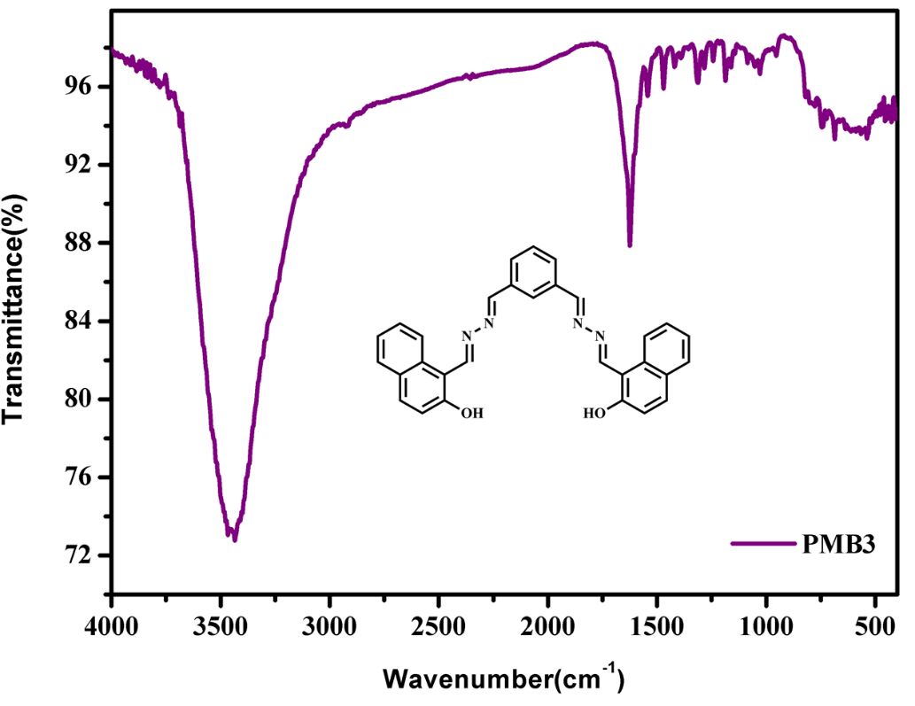

Fig.S1 FT-IR spectra of PMB3

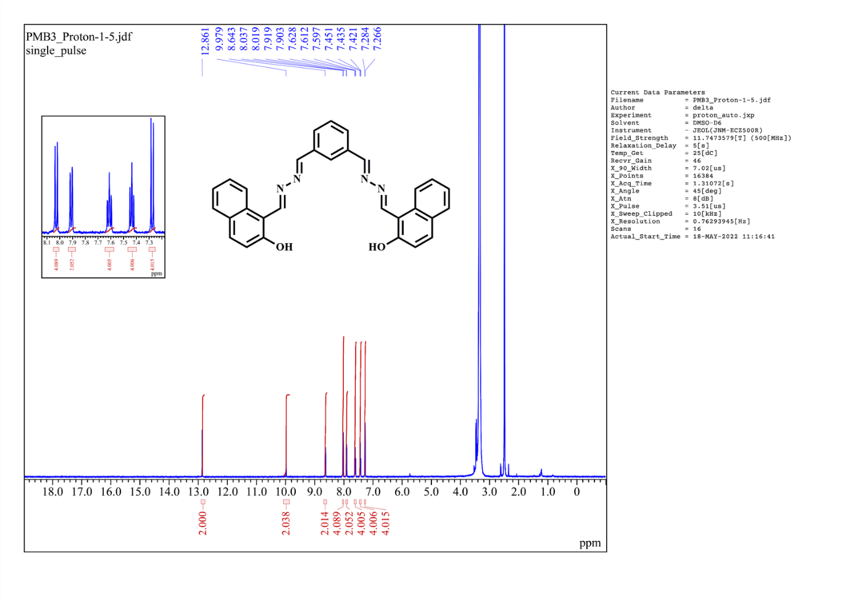
Fig.S2 ¹H NMR spectra of PMB3

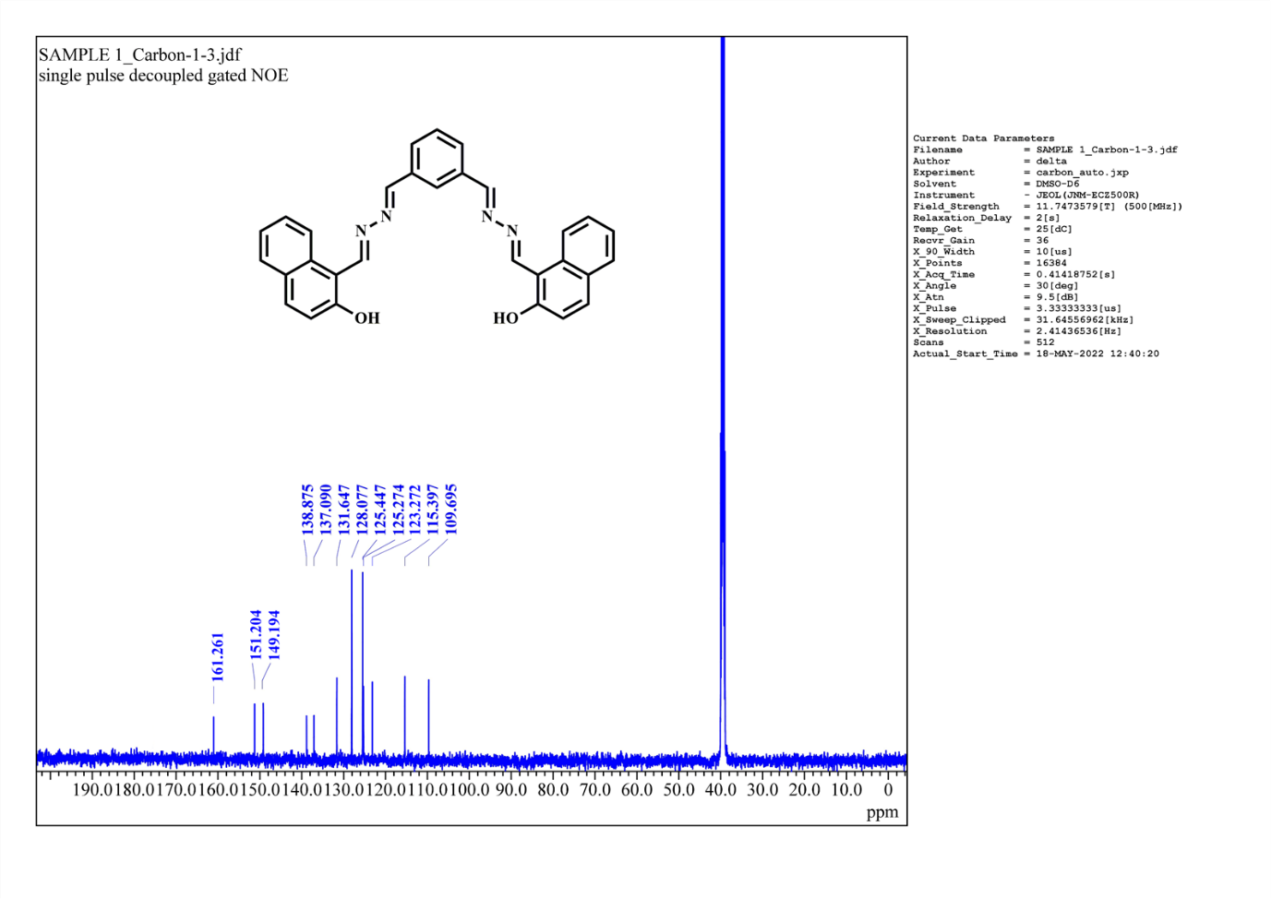
Fig. S3 ¹³C NMR spectra of PMB3

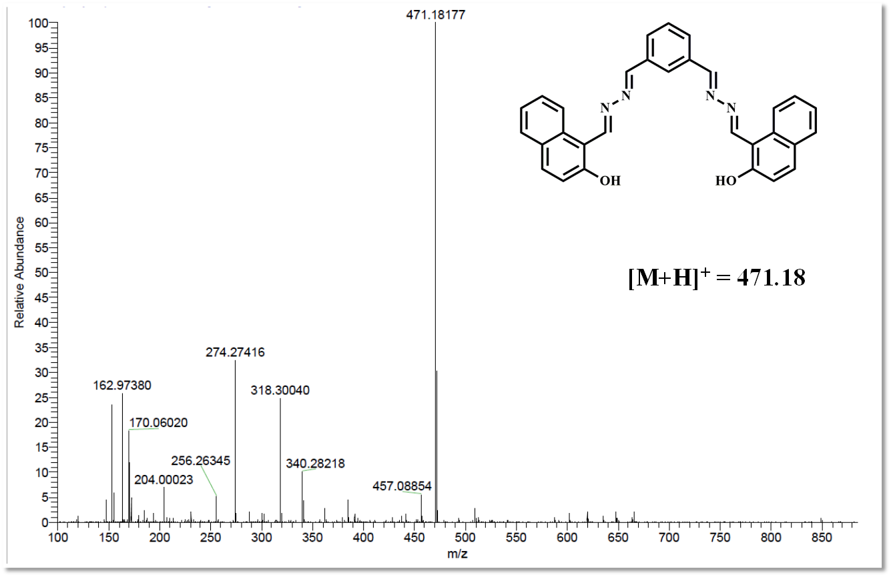
Fig. S4 HR-MS(ESI) spectra of PMB3

TABLES
Table S1: Molar absorptivity values for each absorbance value of PMB3 with Cu²⁺

Concentration of Cu²⁺(M) | Absorbance | Molar absorptivity
1.94×10⁻⁷ | 0.0081 | 0.004175
3.94×10⁻⁷ | 0.0122 | 0.003096
5.90×10⁻⁷ | 0.0146 | 0.002475
7.85×10⁻⁷ | 0.0179 | 0.002280
9.80×10⁻⁷ | 0.0187 | 0.001908
11.74×10⁻⁷ | 0.022 | 0.001874
13.67×10⁻⁷ | 0.0252 | 0.001843
15.59×10⁻⁷ | 0.0301 | 0.001931
17.51×10⁻⁷ | 0.0326 | 0.001862
19.41×10⁻⁷ | 0.0359 | 0.001850
21.31×10⁻⁷ | 0.0391 | 0.001835
23.21×10⁻⁷ | 0.0424 | 0.001827
25.09×10⁻⁷ | 0.0465 | 0.001853
26.97×10⁻⁷ | 0.0498 | 0.001846
28.84×10⁻⁷ | 0.053 | 0.001838
30.71×10⁻⁷ | 0.0571 | 0.001859
32.56×10⁻⁷ | 0.0612 | 0.001880
34.41×10⁻⁷ | 0.0653 | 0.001898
36.26×10⁻⁷ | 0.0694 | 0.001914
38.09×10⁻⁷ | 0.0718 | 0.001885
39.92×10⁻⁷ | 0.0750 | 0.001879
41.74×10⁻⁷ | 0.0792 | 0.001897
43.56×10⁻⁷ | 0.0817 | 0.001876
45.36×10⁻⁷ | 0.0849 | 0.001872
47.17×10⁻⁷ | 0.0874 | 0.001853

Table S2: Molar absorptivity values for each absorbance value of PMB3 with Ni²⁺

Concentration of Ni²⁺(M) | Absorbance | Molar absorptivity
1.94×10⁻⁷ | 0.0055 | 0.002835
3.94×10⁻⁷ | 0.0096 | 0.002437
5.90×10⁻⁷ | 0.0137 | 0.002322
7.85×10⁻⁷ | 0.0169 | 0.002153
9.80×10⁻⁷ | 0.0210 | 0.002143
11.74×10⁻⁷ | 0.0243 | 0.002070
13.67×10⁻⁷ | 0.0276 | 0.002019
15.59×10⁻⁷ | 0.0308 | 0.001976
17.51×10⁻⁷ | 0.0349 | 0.001993
19.41×10⁻⁷ | 0.0374 | 0.001927
21.31×10⁻⁷ | 0.0415 | 0.001947
23.21×10⁻⁷ | 0.0439 | 0.001891
25.09×10⁻⁷ | 0.0456 | 0.001817
26.97×10⁻⁷ | 0.0488 | 0.001809

